Compendium Readme

#81：Integrated smartphone and cloud speech recogniser

Zhengyi Hu, Shenghao Lu

Dr Catherine Watson

# Client Side

## How to run

1. Download and install Android Studio. <https://developer.android.com/sdk/index.html>
2. Open Android Studio and choose 'Open an existing Android Studio project'
3. Open the 'Client' project

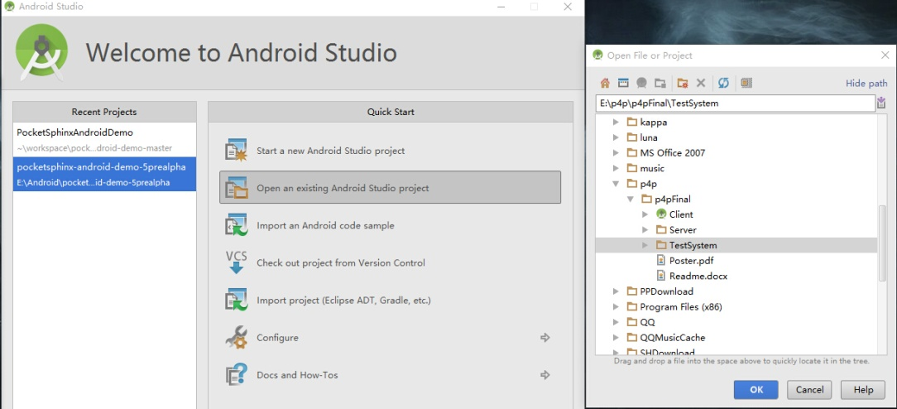

1. Go to app -> java -> edu.cmu.pocketsphinx.demo -> Main Activity
2. Connect an Andriod phone to the computer
3. Run the app (shift+F10)
4. Select the device and choose 'OK'

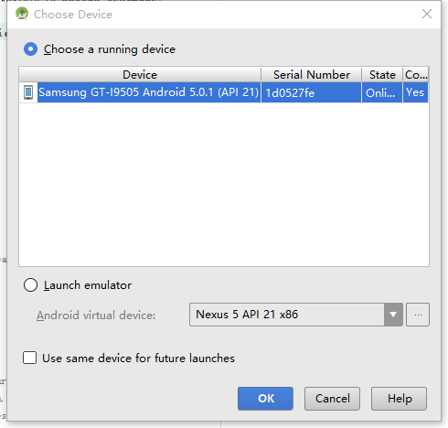

# Server Side

how to run

how to switch to NZ acoustic model

# Test System

how to test

# Future Work

1. Support other languages by training acoustic models
2. improve the recognition accuracy of the NZ acoustic model by using a larger amount of data to retrain the model.
3. Better UI design