**Logistic Regression:**

In **Polynomial logistic Regression** Model When using parameters **solver = ‘lbfgs’ , multi_calss = ‘auto’**



It gives a warning that solver lbfgs failed to converge with accuracy in degree 2 : 0.6712962962962963



And for degree 3 it gives the same warning with accuracy : 0.673804012345679



Where when using **solver** = ‘***newton-cg’ , multi_calss = ‘multinomial’***



It runs without any warnings and for degree 2 it gives accuracy : 0.6714891975308642 which is slightly increased by 0.0002



And also for degree 3 the accuracy becomes : 0.6763117283950617 which is higher than the one above with 0.003



So, we decided to set **solver** = ‘***newton-cg’ , multi_calss = ‘multinomial’***  because this gives the highest accuracy since multinomial minimizes the loss fit across the entire probability distribution and ***newton-cg*** to handle multinomial loss

**Polynomial Logistic Regression After applying PCA:**

we have tried to select features from 1 to 10 what we have noticed is that when selecting 6 features we get the best accuracy but, it failed to converge in polynomial of degree 3;

When we increase selected features it still fails to converge at degree 3 also the accuracy decreases too where when decrease the number of selected features the accuracy decreases although, it starts to converge at degree 3 when select 3 features or below .

Here are some of our test

When selecting 3 features the accuracy is

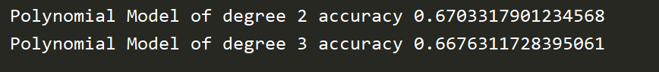

When selecting 6 features it the accuracy is



When selecting 7 features it gives accuracy



When selecting 8 features



From the above observation we noticed that when selecting 6 features this gives the best accuracy for degree 3 but, it fails to converge where when select 7 features gives higher accuracy for degree 2.

One of the solutions to solve the convergence problem is to increase the number of iterations but, when we tried this solution the code never stopped running that’s why we excluded this solution .

**Adaboost:**

In **Adaboost** without applying PCA using decision tree when setting hyper parameter algorithm = ‘SAMME’, n_estimators = 200 the accuracy was 0.6772762345679012



And when applying PCA the accuracy decreased to be : 0.6649305555555556



When changing hyper parameter algorithm to be = ‘SAMME.R’ , n_estimators = 200



the accuracy becomes : 0.6412037037037037 (without applying PCA)



Also when decreasing the value of n_estimators to 100



The accuracy decreased to be : 0.6342592592592593



When applying PCA to Adaboost with hyper parameters be algorithm = ‘SAMME.R’ , n_estimators = 200

the accuracy becomes : 0.6564429012345679



When decreasing n_estimators to be 100



The accuracy becomes : 0.6651234567901234



When setting algorithm = ‘SAMME.R’ , n_estimators = 50



Without PCA the accuracy becomes : 0.6844135802469136



When applying PCA it becomes : 0.6670524691358025



For algorithm = ‘SAMME’ , n_estimators = 50



The accuracy before applying PCA was



And after applying PCA becomes



So, we finally decided to set algorithm = ‘SAMME.R’ , n_estimators = 50 which is the best observation

Also because SAMME.R algorithm is faster to converge than SAMME algorithm and When we start to decrease n_estimator to be under 50 or above 50 the accuracy decreased too

**Here is our final code**



And our final accuracy before applying PCA



The accuracy after applying PCA



When we tried ADABOOST on SVM (One Vs One , One Vs Rest , Linear , without kernals) it did not work as it take too much time to run and it did not stop at the end which we did not find an explanation for this and based on this observation we decided to exclude it



For Logistic Regression with ADABOOST it also did not stop and when we search for the reason we found out a new algorithm that work as ADABOOST for logistic regression which is Gradiant Boosting it works typically as ADABOOST it combines weak "learners" into a single strong learner in an iterative fashion but, what differs is that ADABOOST works on classifiers that give output (0,1), where logistic regression outputs probabilities from (-1 to 1) that’s why we apply Gradiant boosting it minimizes the differentiable loss functions by constructing a new model that adds an estimator  to provide a better model.

 Gradiant Boosting shows how sklearn code allows for a choice between deviance loss for logistic regression and exponential loss for AdaBoost, and documents functions to predict probabilities from the gradient-boosted model.

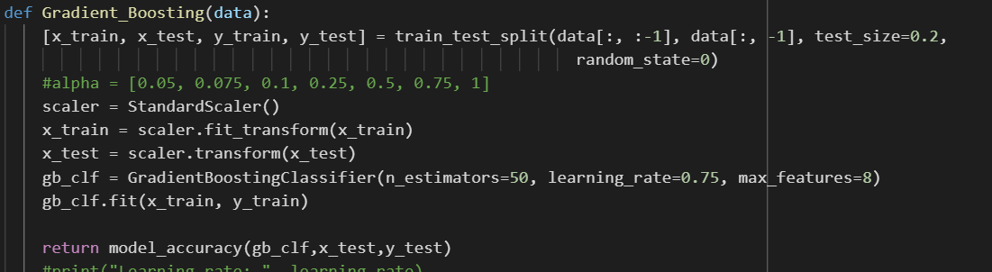

We have tried random values (0.05, 0.075, 0.1, 0.25, 0.5, 0.75, 1) for the learning rate and what we have noticed is that 0.75 gives the best accuracy.

Gradiant Boosting have its own way for selecting features which is parameter max_features we have tried from 1 to 10 for selecting features and what we have got is that selecting 8 features gives the best accuracy.



**Decision Tree:**

When setting max_depth = 1



The accuracy was the same before and after applying PCA





And when setting max_depth = 2



The accuracy increased by 0.003 before applying PCA and increased by 0.002





But when we increased max_depth to be 3

The accuracy increased before applying PCA to be



But decreased by 0.0009 after applying PCA to be



When we increased max_depth to be 4



The accuracy increased in both before and after applying PCA





We noticed that when increasing max_depth to be above 4 the accuracy after applying PCA decreases and increases before applying PCA

So, we finally decided to set max_depth to be 4

**KNN:**

## **Before PCA:**

When applying KNN with different value for ( number of neighbors) **k**=**1** to **200** , we have noticed that the best accuracy was given when **k**=**72** with accuracy = 0.6674382716049382‬

**After PCA:**

The Best accuracy was the same before PCA with also **k**=72

**SVM**:

**Gaussian Kernel**:

**Before applying PCA**

When applying SVM via **One VS Rest (OVR)** method with a **Gaussian** Kernel and with hyperparameter **sigmma (σ)** =**0.2** with the same **c** the accuracy was equal 0.6660879629629



Also it was observed that when **σ** = **0.3 ,0.4, 0.5 , 0.6** or **0.7** with the same **c**  the accuracy increased by 0.00019 and was equal to 0.6662808641975309



and when **c**=1 and **σ**=0.4 the accuracy with also equal 0.6662808641975309



Then when we set **σ**=0.2 and change **c** with values : 100 ,1000,10000 ,the accuracy decreased and become 0.6660879629629629



After that we apply SVM via **One VS One (OVO)** method with **σ=**0.4 and **c**= 1, 100 and 1000000



It gives the same accuracy of OVR with **σ**=0.4 and **c**=1 , but since that the training data required for each class is balanced in OVO and we have only 3 classes , also The training and testing time was less than OVR , so we decide to apply SVM via OVO with **σ=0.4** and **c=1**





**After applying PCA:**

with **n_components=7 ,**we observed that the accuracy obviously increased to become = 0.6745756172839507 inOVRand become **=** 0.6745756172839507 in OVO



and when **n_components=9 it** decreased in OVR and become **=** 0.673804012345679 in OVR but increased in OVO and become =0.6751543209876543



when **n_components=9 it** gives the best accuracy in OVR and become **=** 0.6739969135802469 and in = OVO become =0.6763117283950617



So ,the conclusion is that SVM gives its best accuracy when applying PCA with n_components=9

**Linear Kernel**:

**Before PCA:**

It takes too long time to give the results

**After PCA :**

It gives an accuracy which is equal to 0.6662808641975309 so it does not increase more than SVM with Gaussian kernel , so we decide to not apply it



**Without Kernel:**

**Before PCA:**

It gives a bad accuracy which is equal to 0.4525462962962963



**After PCA:**

It takes a long time to run so we decide to not apply SVM without kernel especially since it gives bad accuracy before PCA

**Selective Feature:**

We used ‘**SelectKBest’** Selection Method and give it ‘**ANOVA**’ as statistical measure

**Polynomial Logistic Regression:**

when trying different values for no. of features (**K**) , we noticed that the accuracy didn’t get better , On the Country it was less than the accuracy before selective feature.



**Other Models**:

We tried different values for **K** (Number of selected feature) from 1 to 10 and we got that is the best accuracy was given when we selected all the ten feature.

When **k= 6**

When **k=8**

**PCA:**

The accuracy before PCA

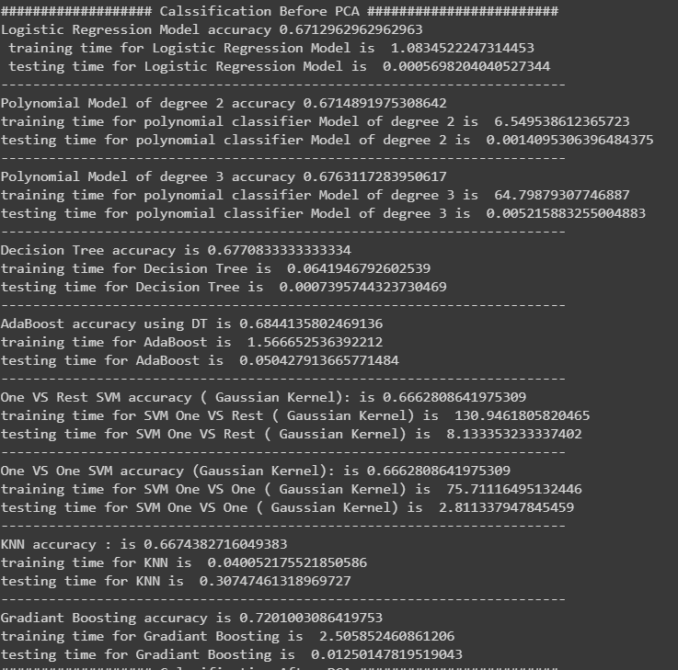

When n_components = 7

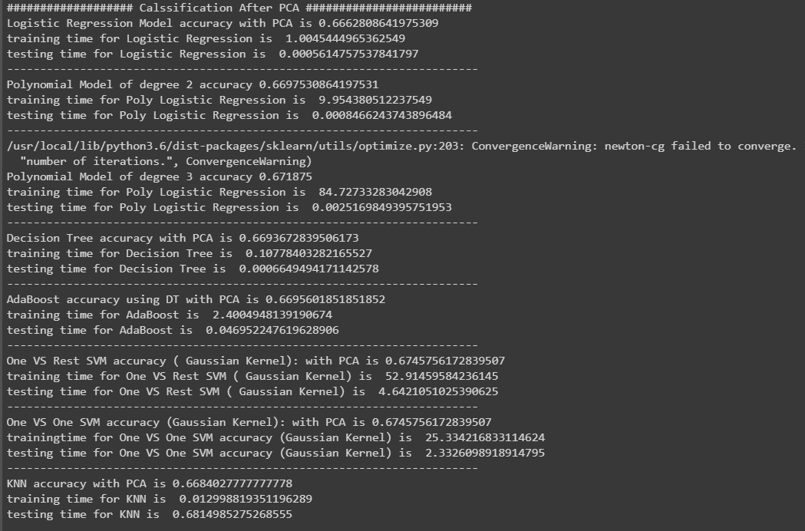

When n_estimsators = 9

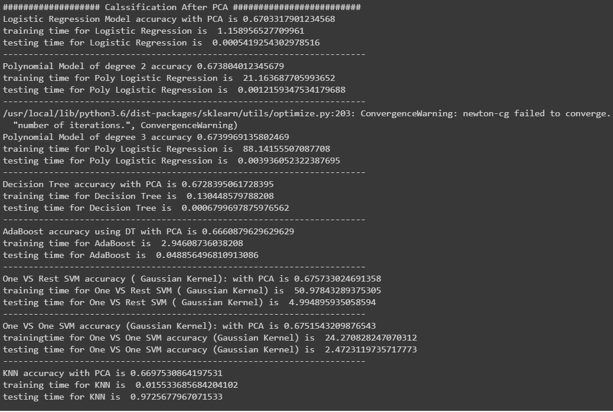

When n_estimators = 10

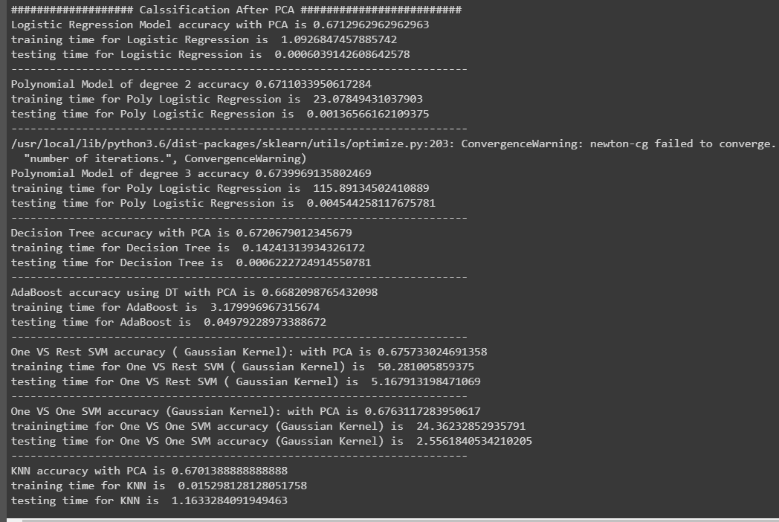

From trials we noticed that the best 3 values of selected features is 7 , 9 , 10 because they give the best accuracy since for the observation over the 3 values is as follows :

The 3 values increase the accuracy for SVM One Vs Rest , SVM One Vs One and KNN Models with some differences

1. For 7 features gives the highest accuracy for **AdaBoost** and **SVM One Vs Rest** classifiers
2. For 9 features gives the best accuracy for **Polynomial Regression of (degree 2 , degree 3)** and **ADABOOST**
3. For 10 features gives the best accuracy for **Logistic Regression** , **Polynomial logistic regression of degree 3, KNN** and **SVM One Vs One**

**Obviously, the observation shows that selecting 10 features is the best choice**.

**NOTE:** we decided to leave polynomial logistic regression of degree 3 with its warning because when we tried to solve the convergence problem by increasing number of iterations it did not stop running.

**Plots:**

* **Before applying PCA:**

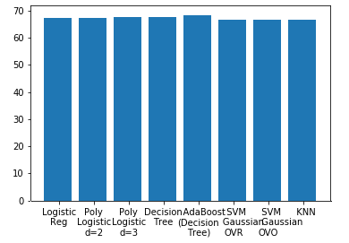

Figure .Accuracy Figure 2.Training Time

Figure 3.Testing Time

* **After applying PCA:**

When PCA=7

Figure .Accuracy Figure 5.Training Time

Figure 6.Testing Time

When PCA=9

Figure 7.Accuracy Figure 8.Training Time

Figure 9.Testing Time

When PCA=10

Figure 10.Accuracy Figure 11.Training Time

Figure 12.Testing Time