Traffic Management Workforce Dispatch Optimization - Discovery Knowledge Document
Prepared from client discovery meeting notes and screenshots.
Version: Draft 0.1

1. Executive Summary
The client operates a US traffic management workforce dispatching business. The objective is to build an AI-assisted workforce allocation and scheduling platform that recommends the best Traffic Controllers (TCs), installers, leads, drivers, and supporting crews for service orders while respecting certifications, skills, customer requirements, labor rules, availability, vehicle requirements, hour balancing, and profitability considerations.

2. Core Business Problem
For each dispatch/service order, the system must determine required workforce roles, identify eligible personnel, score candidates, and generate optimized assignments across all jobs while respecting hard constraints and maximizing overall fit.

3. Workforce Allocation Logic
- Each job requires specific certifications and skills.
- Certain certifications are mandatory for all assigned personnel.
- Some certifications apply only to lead personnel.
- Jobs may have location-specific or safety-specific certification requirements.
- Remote work may require additional certifications for the lead worker.
- Apprentice-to-journeyman ratios must be enforced.
- Crew composition rules vary by service type.

4. Apprentice / Journeyman Rules
Example rule discussed: For a 5-person crew, the allocation may require 3 Journeymen and 2 Apprentices. These ratios act as hard constraints during scheduling.

5. TC Bucket Model
The client uses a bucket-based workforce model. Service types determine the lead qualification required. Example: For a Single Lane Closure, the lead must hold the Single Lane Installer qualification while remaining crew members may be General Assistants.

6. Dispatch Selection Process
- Determine required TC bucket from service order scope.
- Apply mandatory certifications and skill requirements.
- Apply customer-specific requirements.
- Apply branch, region, job, and TC-level rules.
- Generate eligible candidate pool.
- Score candidates using best-fit criteria.
- Optimize assignments across all open dispatches.

7. Best-Fit Scoring Factors (Phase 1)
- Customer preferred employees.
- Employees who should not be scheduled together.
- Prior experience on similar jobs.
- Prior experience on the same customer/job.
- Balanced TC hours up to previous day.
- Required customer certifications and skills.
- Cost-sensitive assignments based on TC pay rates and margins.

8. Planned Phase 2 Enhancements
- New employee retention optimization.
- Hour maximization for long-term employees.
- Take-home truck allocation based on distance.
- Contribution margin optimization.
- Profitability optimization.
- Training recommendations and skill-development assignments.

9. Optimization Objective
The system should maximize total assignment score across all dispatches while ensuring no dispatch falls below a configurable minimum threshold score.

10. Driver & Vehicle Requirements
Vehicle assignments introduce additional constraints. Each vehicle requires a qualified driver. Different vehicle types (service trucks, TMA trucks, AFAD units, light towers, etc.) require specific driver classifications and certifications.

11. Rule Hierarchy
- Region Level Rules
- Traffic Controller (TC) Level Rules
- Job Specific Rules
- Branch Level Rules
- Customer Level Rules
- Service Order Level Rules

12. Example Rule Categories
- Employee skills and certifications
- Driver certifications
- Personnel notes
- Availability
- Hour balancing
- Labor mix
- Senior TC requirements
- Training requirements
- Customer-required skills
- Customer preferred employees
- Customer banned employees

13. Architectural Observation
This is primarily a workforce optimization and dispatch planning problem. A mathematical optimization engine should make assignment decisions, while an AI assistant can extract requirements, explain recommendations, support planners, and perform what-if analysis.

14. Reference Screenshot
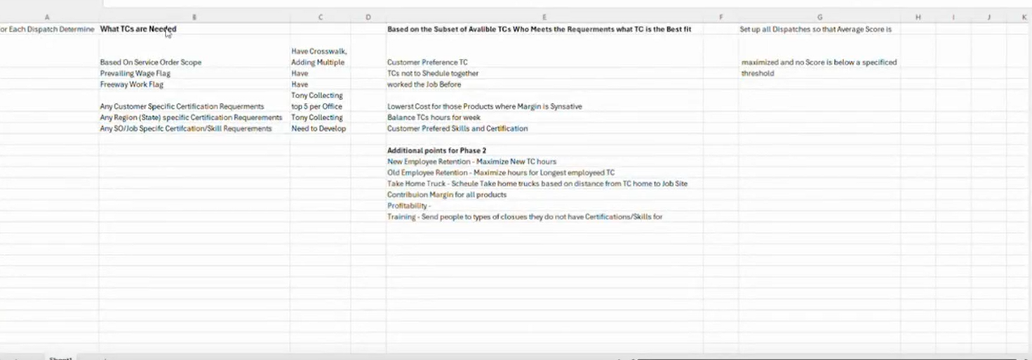
Screenshot captured from discovery materials.
