Gravitational Waves and their discovery

Student Name
1st December 2025

Abstract
The modern understanding of Gravitational Waves (GWs) has undergone rapid development over the last ten years since the experimental proof in 2015. GWs are the ripples through the fabric of spacetime caused by rapid acceleration of Neutron Stars (NSs) and/or Black Holes (BHs).

  - Keywords
Gravitational waves; Black holes

Introduction
GWs are a result of massive objects such as NSs and/or BHs accelerating as they approach collision. GWs first appeared as an integral of the gravity equations [1] stemming from the theory of general relativity [2]. GWs produced in a phase transition is made primary, and secondary component, shown in Equation 1
$$Ω_{GW}h^{2}≈{1.6×{10}^{-5}\left[\frac{g_{*}}{100}\right]\left[\frac{g_{*s}}{100}\right]}^{-\frac{3}{4}}[Ω_{PGW}+Ω_{SGW}]$$
Equation 1
[3] These waves travel through the universe leaving ripples though different gravitational fields, meaning they are detectable by incredibly precise and accurate devices.

Discovery
The experimental proof of GWs came from the Laser Interferometer Gravitational Wave Observatory (LIGO) [4], which consists of two different laboratories located in Livingston, and Hanford, USA. The two sites consist of an identical setup: a basic Michelson Interferometer [5] shown in Figure 1.
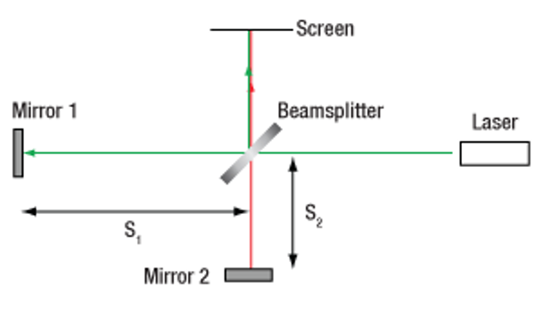
Figure 1

LIGO has allowed Scientists to explore other theories such as the merging of subsolar mass compact objects; there has been results in LIGO and other GW detectors that indicate the possibility of these hypothetical bodies experiencing such an event. There has been a false alarm rate (FAR) too high for the results to be validated proof, however one detection, SSM200308, has had the most significant results, the results of SSM200308 are shown in Table 1alongside another candidate to show the difference in FAR.[6]
Table 1
Candidate | m₁[M©] | m₂[M©] | SNR_{tot} | FAR [yr⁻¹ ]
SSM200308 | 0.78 | 0.23 | 8.90 | 0.20

References

[1] A. Einstein, N. Rosen, On gravitational waves,
Journal of the Franklin Institute, Volume 223, Issue 1,1937, Pages 43-54,
(https://www.sciencedirect.com/science/article/pii/S0016003237905830)
Last accessed 01.12.2025

[2] A. Einstein, Die Grundlage der allgemeinen Relativitätstheorie,
Annalen Der Physik, fourth episode, volume 49 1916, pages 769-822
Last accessed 01.12.2025

[3] M. Lewicki, P. Toczek, V. Vaskonen, Black holes and gravitational waves from phase transitions in realistic models,
Physics of the Dark Universe, Volume 50, 2025,
(https://www.sciencedirect.com/science/article/pii/S2212686425002687)
Last accessed 01.12.2025

[4] J. Aasi et al. (LIGO Scientific Collaboration), Advanced LIGO
Classical Quantum Gravity, Volume 32, 2015 074001
Last accessed 01.12.2025

[5] M. Trainer, Gravitational waves discovery, intellectual property and technology transfer,
World Patent Information, Volume 51, 2017, Pages 1-6,
(https://www.sciencedirect.com/science/article/pii/S0172219016301259)
Last accessed 01.12.2025

[6] M. Prunier, G. Morrás, José Francisco Nuño Siles, Sebastien Clesse, Juan García-Bellido, Ester Ruiz Morales,
Analysis of the subsolar-mass black hole candidate SSM200308 from the second part of the third observing run of Advanced LIGO-Virgo,
Physics of the Dark Universe,
Volume 46,
2024,
(https://www.sciencedirect.com/science/article/pii/S221268642400164X)

Figure 1 MeitalBergerzon - Own work, CC BY-SA 4.0, (https://commons.wikimedia.org/w/index.php?curid=86769398)

