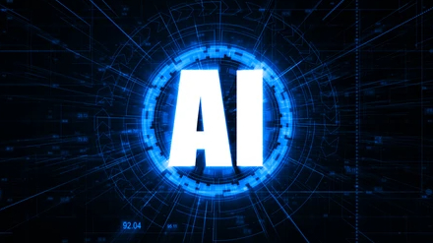
ARTIFICIAL INTELLEGENCE

Introduction to Artificial Intelligence:

Artificial Intelligence (AI) is the branch of computer science that develops systems capable of performing tasks that normally require human intelligence. These tasks include learning, reasoning, problem solving, language understanding, decision-making and pattern recognition. AI improves productivity, automates repetitive work and helps organizations make better decisions.
Learning Outcomes:
• Understand AI concepts.
• Identify AI applications.
• Explain machine learning basics.
• Recognize business value of AI.

Why AI?
AI increases efficiency, reduces errors, supports faster decisions, improves customer experience and enables innovation across industries.

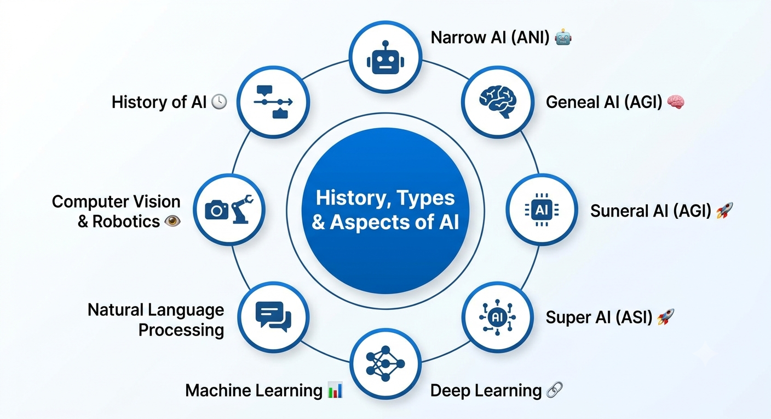
History, Types and Aspects of AI:

AI began in the 1950s with the Dartmouth Conference. Important milestones include expert systems, machine learning, deep learning and modern generative AI.

- Types of AI: Narrow AI, General AI (theoretical), and Super AI (hypothetical).
- Technical View: AI combines algorithms, data, computing power and models.
- Aspects of AI include perception, reasoning, planning, learning and natural language processing.

Machine Learning:
- Machine Learning is a subset of AI where computers learn from data.
- Supervised Learning uses labeled data for classification and regression
- Classification predicts categories while regression predicts numerical values.

Common algorithms:
• Decision Tree
• Support Vector Machine (SVM)
• K-Nearest Neighbours (KNN)
• Logistic Regression
Deep Learning uses Artificial Neural Networks (ANN) with multiple layers for image, speech and text processing.

Advanced AI Concepts:

Overfitting occurs when a model memorizes training data, while underfitting occurs when it fails to learn important patterns. Techniques like regularization and cross-validation help improve performance.

Ensemble Learning combines multiple models, such as Random Forest, to improve prediction accuracy and reliability.

Unsupervised Learning discovers hidden patterns and groups in unlabelled data using techniques like clustering.

Reinforcement Learning enables agents to learn through rewards and penalties, making it useful for robotics, gaming, and autonomous systems.

Time Series Forecasting predicts future values based on historical data and is widely used in finance, sales, and weather forecasting.

Machine Learning Process includes data collection, preprocessing, feature engineering, model training, evaluation, deployment, and continuous monitoring.

Model Evaluation uses metrics such as accuracy, precision, recall, and F1-score to measure performance.

Feature Engineering improves model accuracy by selecting and transforming relevant data features.

AI in Business:

AI in Retail:
Artificial Intelligence is widely used in the retail industry to improve customer experience and business operations. It helps recommend products based on customer preferences, manages inventory, predicts demand, and provides customer support through AI-powered chatbots. These applications increase sales and improve customer satisfaction.

AI in Healthcare:
AI is transforming healthcare by helping doctors diagnose diseases, analyse medical images, monitor patients, and discover new medicines. It improves the accuracy of treatments, reduces human errors, and enhances the quality of healthcare services.
AI in Banking:
Banks use AI for fraud detection, credit scoring, customer support, and financial risk analysis. AI-powered chatbots provide instant customer assistance, while intelligent systems help make faster and more secure financial decisions

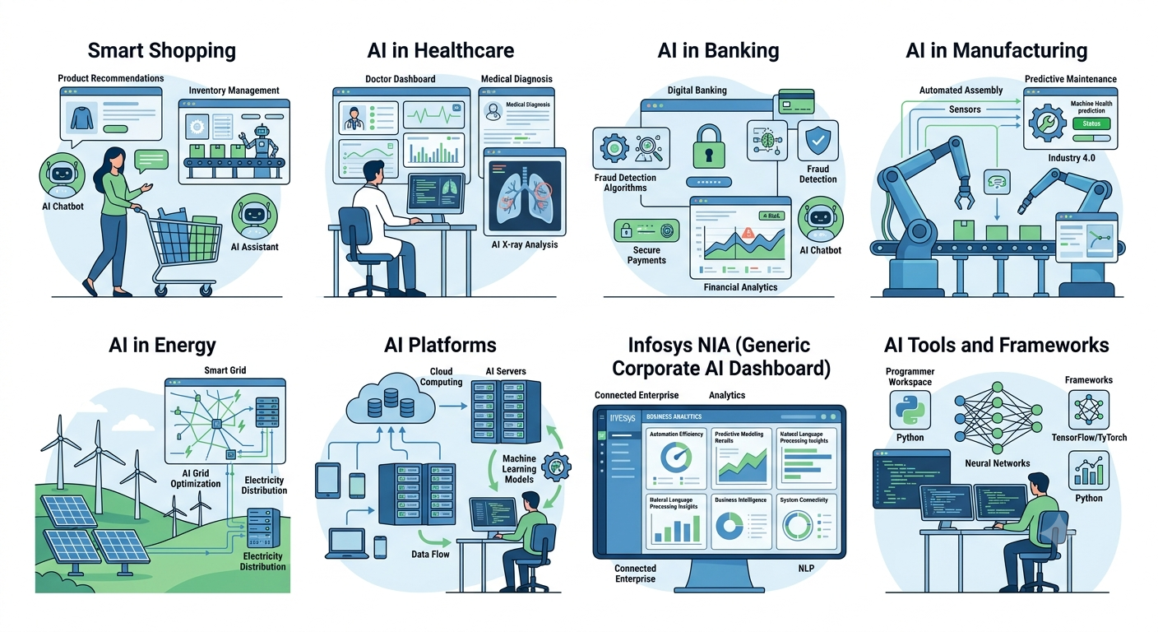

AI in Manufacturing:
AI improves manufacturing by automating production processes, predicting machine failures, and inspecting product quality. It helps industries reduce downtime, increase productivity, and lower operational costs.
AI in Energy:
In the energy sector, AI is used to forecast electricity demand, manage smart grids, optimize renewable energy resources, and detect equipment faults. This helps improve energy efficiency and reliability.
AI Platforms:
AI platforms provide the tools needed to develop, train, and deploy Artificial Intelligence applications. Popular platforms include Google Vertex AI, Microsoft Azure AI, Amazon SageMaker, IBM Watson, and Infosys NIA. These platforms simplify AI development and deployment.
Infosys NIA:
Infosys NIA is an enterprise Artificial Intelligence platform developed by Infosys. It combines Machine Learning, Natural Language Processing (NLP), automation, and data analytics to help businesses improve efficiency and make intelligent decisions. It is widely used in industries such as banking, healthcare, retail, and manufacturing.

AI Tools and Frameworks:
Developers use AI tools and frameworks such as TensorFlow, PyTorch, Scikit-learn, Keras, OpenCV, Pandas, and NumPy to build and train AI models. These tools simplify the development of machine learning and deep learning applications.
What I Learned:
During this course, I gained a strong understanding of the fundamentals of Artificial Intelligence and its importance in modern technology. I learned how AI enables machines to perform intelligent tasks and how it is transforming various industries through automation and data-driven decision-making.
Key Learnings:
- Understood the basic concepts and history of Artificial Intelligence.
- Learned about the different types of AI and their applications.
- Gained knowledge of Machine Learning, Deep Learning, and Artificial Neural Networks (ANN).
- Studied Supervised, Unsupervised, and Reinforcement Learning techniques.
- Learned about AI algorithms such as Decision Tree, SVM, KNN, and Logistic Regression.
- Understood AI applications in retail, healthcare, banking, manufacturing, and energy.
- Explored AI platforms like Infosys NIA and tools such as TensorFlow, PyTorch, and Scikit-learn.
This course helped me understand how Artificial Intelligence is used to solve real-world problems, improve business processes, and create innovative solutions. It has also provided me with a strong foundation for learning advanced AI technologies in the future.

Conclusion
Artificial Intelligence is one of the fastest-growing technologies in the world. It has applications in healthcare, banking, retail, manufacturing, energy, and many other sectors. Learning AI concepts and technologies prepares students for future careers and helps organizations achieve digital transformation.

