# **7PAM2000-0901-2023 - Applied Data Science 1**

# Assignment 2: Statistics and trends

**CLIMATE CHANGE ANALYSIS ON WORLD BANK DATA**

**ASSIGNMENT REPORT**

Submitted by

GEETHA BABU

Student id : 22073072

Email: [gb23aam@herts.ac.uk](mailto:gb23aam@herts.ac.uk)

[Github](https://github.com/gb23aam/ads-1-assignment-2)

**World Bank’s Climate Change Data Analysis**

The world bank’s climate change data consists of information about the various economical, demographic, geographical parameters for a country from 1960 to 2022. I have considered some developed and developing countries for this analysis report. Also, I have selected eleven indicators out of seventy-six, which are,

Population, total, Urban population (% of total population), Total greenhouse gas emissions (% change from 1990), Total greenhouse gas emissions (kt of CO2 equivalent), Energy use (kg of oil equivalent per capita), Electric power consumption (kWh per capita), Renewable energy consumption (% of total final energy consumption), Foreign direct investment, net inflows (% of GDP), Agricultural land (% of land area), Arable land (% of land area), Forest area (% of land area).

As many of the indicators were evaluated from the year 1990, so all the data for this analysis is considered is after 1990.

The indicators where selected based on three aims:

* Understanding factor causing the climate change
* Analyzing demography and its impact
* Understanding a global view for the climate change

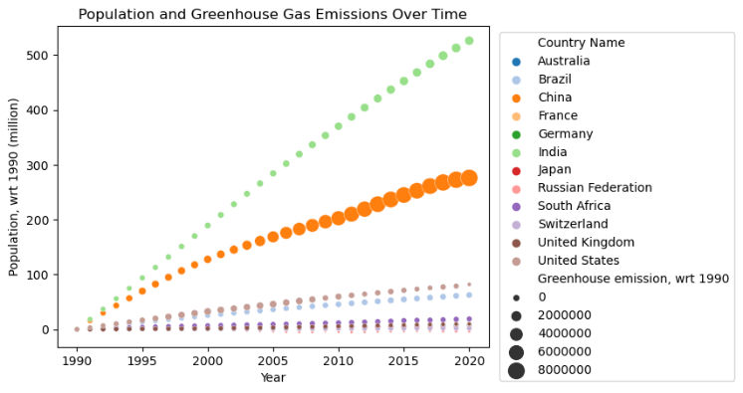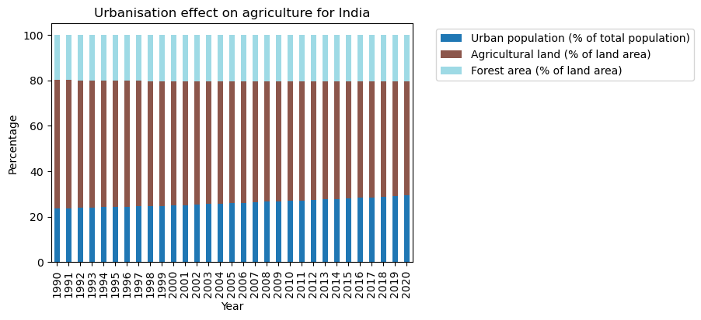First, the impact of population is analyzed on climate change. Instead of considering the absolute value of the total greenhouse gas emissions (GE) and population, a relative value is considered taking the year 1990 as base. This helps to better understand the growth of greenhouse gas emissions with population. The below graph shows the population in millions wrt. to year 1990, over all the years. India has the highest growth in population, followed by China and USA. In case of China, the increase in GE is highest. Though, the population growth in India is highest, the GE is not growing as much as China. Also, for the USA, the size of the circles is reducing, indicating that GE is decreasing. As the population of the countries is increasing over the years, they need to produce enough energy to match the demand. The energy produced from non-renewable sources like coal and oil will produce the

GE, while renewable energy like solar and wind with be healthy for the environment. The below chart shows the use of renewable energy for the countries from 1990 to 2020.

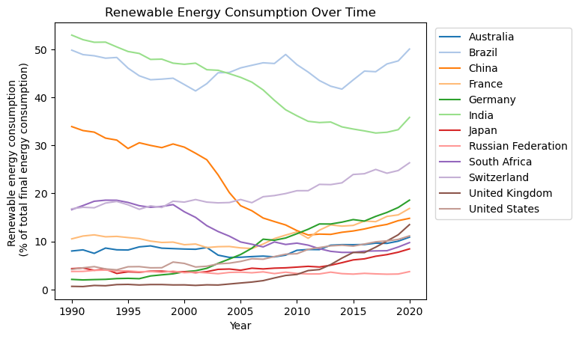

Almost 40-50% of the total energy consumed by Brazil is coming from its renewable resources. Although there is a decrease in this percentage for India over the years, it seems to be rising again from 2018-19. Switzerland, UK, France, and Japan have shown continuous increase in use of renewable energy after 2005. For the India and specially for China, which are having rapid growth in the population, the countries couldn’t mange to scale the use renewable energy, and thus the increased population’s demand for the energy was satisfied with non-renewable energy. Due to this, there is a rise in GE as observed in the population and GE graph.

As a country progresses, its urbanization impacts its agricultural and thus forest areas. To understand the effects of urbanization, India was considered. As it is fast growing and highly populus, its urbanization will have a significant impact on its agriculture. The below plot shows the effect of urbanization on the agricultural land and the forest land. It is plotted as percentage of them, to understand their relationship over the years.

There is a constant increase in the urban population which is represented as a percentage of total population. The urbanization of a country has its impact on the agricultural and this is also true here. There is a decline in the agricultural land represented as a percentage of land area. As the urban area increase, there is an increase in the parks and gardens, which is contributing for the increase in forest area. Though the agriculture land is reducing, the slight increase in the forest area is helping in the reduction of the GE (overall there is still an A colorful circle with numbers and text
increase in GE). This can be observed in the population and GE graph for India.

As the agricultural land reduces, thus the arable land also. The below chart describes the arable land as a percentage of land area for India and USA.

As the seen previously also, for India, there is decline in agricultural land and thus the arable land, which can be observed from above. For the USA, till 2012-13, there was also a decline but after that there is a slight increase. This is also observed in the population and GE graph for USA, that there is a reduction in relative GE, which is inversely proportional to the arable land.

Many countries have been analyzed based on their past records i.e. independently so to understand a global view, they are compared in the below chart based on their GE. The value of GE was normalized based on the population for fair evaluation. The comparison was made from the data of 1990 and 2020 to understand the changes over the years. The below plot is the comparison for the GE per capita in 1990.

This shows that Australia, Russia, and USA were top in GE. The next plot is the comparison for the GE per capita in 2020. Here also, the top three remain the same with slight decrease in their values. In 30 years, for China, the GE per capita has increased four times, while for India and Brazil it is almost two times. These observations where matching with the population and GE graph. The indicators were compared for the India and China. It is again clear that, the urban population is highly correlated with GE, while the Agricultural land and Renewable energy is what countries should focus on to reduce the GE.



