**Acknowledgement**

The internship opportunity I had with DICT LC II was a great chance for learning and professional development. Therefore, I consider myself as a very lucky individual as I was provided with an opportunity to be a part of it. I am also grateful for having a chance to meet so many wonderful people and professionals who led me though this internship period.

I express my deepest thanks to Mikko Rhey Alfonso ‘PDO II’ and Engr. Jacob Santos ‘Engineer I’ for taking part in useful decision & giving necessary advices and guidance and arranged all facilities to make life easier. I choose this moment to acknowledge their contributions gratefully.

I perceive as this opportunity as a big milestone in my career development. I will strive to use gained skills and knowledge in the best possible way, and I will continue to work on their improvement, in order to attain desired career objectives. Hope to continue cooperation with all of you in the future.

**Dedication**

I dedicate this to my beloved parents Jennifer M. De Guzman and Roberto R. De Guzman, for all their love & attention which has made it possible for me to make it up to this point.

**Introduction**

The internship is an integral platform for anyone to gain experience in an actual workplace. Thus, this internship is a good opportunity for students to learn, to gain experience and also to make preparation. Men learn through experience, and a real life is full of different kinds of experiences. We will encounter many difficulties and obstacles, and with experiences we are expected to be able to encourage and complete the cleansing process. Experience in my eyes is a very valuable thing in life because we need to be brave in taking risks. It is also not something that we simply create, but we need to undergo through it. By doing my internship in an actual workplace, it helps me to know and discover myself from different angle. It also helps me to control and develop my attitude and behavior in dealing with different kinds of people and situation.

Apart from that, I really want to gain professional knowledge and skills by taking the internship course. At the same time, I also want to improve my communication skills and ability to interact with people. I realize that by being part of working society, I will need to meet different people around the office and I will have to communicate with them to settle their needs. Undergoing internship also helps to make me learn on how to work in a systematic organization. It helps me to learn how to be independent in accomplishing my tasks. Besides, all knowledge that I have learnt through my learning in classroom can be implemented through internship. Not only that, by doing internship, I am able to undergo challenges which is normal in working life setting.

I go through my internship course for the duration of approximately 14 weeks excluding holidays. I chose DICT LC II as my host agency for me to complete my internship. I have several reasons onto choosing this place to do my internship. First of all, my house is nearby. Thus, it would be much easier for me to go to work. Secondly, I wanted to have a full of excitement and experiences period of internship. I had never gone to a government institution in my whole lifetime until I start doing my internship there. The environment was so much different and new to me. Perhaps, all the experiences while having internship in DICT LC II will be beneficial in future.

**TABLE OF CONTENTS**

**Chapter I: Description of the Cooperating Agency ---------------------------------------------**

1. History **----------------------------------------------------------------------------------**
2. Mission and Vision **-------------------------------------------------------------------**
3. Rules and Regulations **----------------------------------------------------------------**
4. Administration and Staff **-------------------------------------------------------------**

**Chapter II: Narration ---------------------------------------------------------------------------------**

1. Reflection on Fieldwork Experiences **----------------------------------------------**
2. Working with my Cooperating Officer/Immediate Supervisor **-----------------**
3. Daily Log of Activities **---------------------------------------------------------------**

**Chapter III: Conclusion and Recommendation -------------------------------------------------**

1. Conclusion **-----------------------------------------------------------------------------**
2. Recommendation **----------------------------------------------------------------------**

**Chapter IV: Appendices and Evaluation ----------------------------------------------------------**

1. Appendices **------------------------------------------------------------------------------**
2. Evaluation of Grades **-------------------------------------------------------------------**

**Chapter V: Pictures ------------------------------------------------------------------------------------**

**Chapter I: Description of the Cooperating Agency**

**History**

The [Commission on Information and Communications Technology](https://en.wikipedia.org/wiki/Commission_on_Information_and_Communications_Technology), a preceding agency, was created on January 12, 2004, by virtue of Executive Order No. 269, signed by [President](https://en.wikipedia.org/wiki/President_of_the_Philippines) [Gloria Macapagal-Arroyo](https://en.wikipedia.org/wiki/Gloria_Macapagal-Arroyo), as a transitory measure to the creation of a Department of Information and Communications Technology (DICT). The CICT was composed of the National Computer Center (NCC), the Telecommunications Office (TELOF), and all other operating units of the [Department of Transportation and Communications](https://en.wikipedia.org/wiki/Department_of_Transportation_and_Communications_(Philippines)) (DOTC) dealing with communications. The [National Telecommunications Commission](https://en.wikipedia.org/wiki/National_Telecommunications_Commission_(Philippines)) (NTC) and the [Philippine Postal Corporation](https://en.wikipedia.org/wiki/PhilPost) (PhilPost) were also attached to the CICT for policy coordination. The CICT took over the functions of the Information Technology and Electronic Commerce Council (ITECC), which was subsequently abolished through Executive Order No. 334 on July 20, 2004.

Executive Order No. 454, signed on August 16, 2005, transferred the [NTC](https://en.wikipedia.org/wiki/National_Telecommunications_Commission_(Philippines)) back to the [DOTC](https://en.wikipedia.org/wiki/Department_of_Transportation_and_Communications_(Philippines)). According to EO 454, the transfer "will streamline bureaucracy operations." While the reasons for the transfer were unclear, there were discussions that placing the [NTC](https://en.wikipedia.org/wiki/National_Telecommunications_Commission_(Philippines)) under the CICT would be a bureaucratic anomaly since it is unusual for a commission to fall under another commission.

Executive Order No. 603, signed on February 17, 2007, transferred the TELOF and all other operating units of the CICT dealing with communications back to the [DOTC](https://en.wikipedia.org/wiki/Department_of_Transportation_and_Communications_(Philippines)). According to EO 603, the transfer "is necessitated by the present demands of national development and concomitant development projects as it will streamline bureaucracy operations and effectively promote fast, efficient and reliable networks of communication system and services." The transfer of the TELOF to the [DOTC](https://en.wikipedia.org/wiki/Department_of_Transportation_and_Communications_(Philippines)) left the CICT with just two agencies--the NCC and the [PhilPost](https://en.wikipedia.org/wiki/PhilPost" \o "PhilPost).

Executive Order No. 648, signed on August 6, 2007 but published only on December 24, 2008, transferred the [NTC](https://en.wikipedia.org/wiki/National_Telecommunications_Commission_(Philippines)) back to the CICT.

Executive Order No. 780, signed on January 29, 2009, transferred the TELOF and all other operating units of the DOTC dealing with communications back to the CICT, thereby returning the CICT to its original composition.

Several bills in the [Philippine Congress](https://en.wikipedia.org/wiki/Philippine_Congress) have been filed creating a Department of Information and Communications Technology (DICT), which would transform the CICT into an [executive department](https://en.wikipedia.org/wiki/Executive_Departments_of_the_Philippines). In the [House of Representatives](https://en.wikipedia.org/wiki/House_of_Representatives_of_the_Philippines), a consolidated bill, House Bill No. 4300, was approved on third and final reading on August 5, 2008 and transmitted to the [Senate](https://en.wikipedia.org/wiki/Senate_of_the_Philippines) on August 11, 2008.

In the [Senate](https://en.wikipedia.org/wiki/Senate_of_the_Philippines), a consolidated bill, Senate Bill No. 2546, was approved by the Senate Committee on Science and Technology on August 19, 2008, but had not made it past second reading by the time Congress adjourned session on February 5, 2010, which means the bill is as good as dead. It will have to be refiled in both the [House of Representatives](https://en.wikipedia.org/wiki/House_of_Representatives_of_the_Philippines) and the [Senate](https://en.wikipedia.org/wiki/Senate_of_the_Philippines) in the next Congress. With the failure of Congress to pass the DICT Bill, the legal basis of the CICT remains an executive order, which means the next President can abolish the CICT.

Executive Order No. 47 was signed by President Aquino III in June 23, 2011. The order states that: "Reorganizing, renaming and transferring the Commission on Information and Communications Technology and its attached agencies to the Department of Science and Technology, directing the implementation thereof and for other purposes." Furthermore, "the positions of Chairman and Commissioners of the CICT are hereby abolished." The BPO stakeholders were surprised with the order and unhappy with the change.

The law creating the DICT, [Republic Act](https://en.wikipedia.org/wiki/Republic_Act) No. 10844 or "An Act Creating the Department of Information and Communications Technology", was signed on May 20, 2016 during the administration of President [Benigno Aquino III](https://en.wikipedia.org/wiki/Benigno_Aquino_III" \o "Benigno Aquino III). Several agencies from other executive departments, notably from the [Department of Transportation and Communications](https://en.wikipedia.org/wiki/Department_of_Transportation_and_Communications_(Philippines)) (DOTC), dealing with communications functions and responsibilities will either be abolished or transferred to the newly created department. The DOTC will then be renamed "Department of Transportation." The law provides for a 6-month transition period “for the full implementation of the transfer of functions, assets and personnel.” The law took effect in June 9, 2016 which marked the establishment of the DICT.

**Mission & Vision**

**DICT Mission**

“DICT of the people and for the people.”   
The Department of Information and Communications Technology commits to:

* Provide every Filipino access to vital ICT infrastructure and services
* Ensure sustainable growth of Philippine ICT-enabled industries resulting to creation of more jobs
* Establish a One Digitized Government, One Nation
* Support the administration in fully achieving its goals
* Be the enabler, innovator, achiever and leader in pushing the country’s development and transition towards a world-class digital economy.

**DICT Vision**

“An innovative, safe and happy nation that thrives through and is enabled by Information and Communications Technology.”   
  
DICT aspires for the Philippines to develop and flourish through innovation and constant development of ICT in the pursuit of a progressive, safe, secured, contented and happy Filipino nation.

**Rules and Regulations**

DEPARTMENT OF INFORMATION AND COMMUNICATIONS TECHNOLOGY ACT OF 2015

Pursuant to Section 21 of Republic Act (R.A.) No. 10844 (“An Act Creating the Department of Information and Communications Technology, Defining Its Powers and Functions Appropriating Funds Therefore, and for Other Purposes”), the following Implementing Rules and Regulations (IRR) are hereby promulgated:

Section 1.Title- These Rules shall be known as the Implementing Rules and Regulations of R.A. No. 10844, otherwise known as the Department of Information and Communication Technology Act of 2015

Section 2.Declaration of Policy

(a) To recognize the vital role of information and communication in nation-building;

(b) To ensure the provision of strategic, reliable, cost-efficient and citizen-centric information and communications technology (ICT) infrastructure, systems and resources as instruments of good governance and global competitiveness;

(c) To ensure universal access to quality, affordable, reliable and secure ICT services;

(d) To promote the development and widespread use of emerging ICT and foster and accelerate the convergence of ICT and ICT-enabled facilities;

(e) To ensure the availability and accessibility of ICT services in areas not adequately served by the private sector

(f) To foster an ICT sector policy environment that will promote a broad market-led development of the ICT and ICT-enabled services (ICT-ES) sectors, a level playing field, partnership between the public and private sectors, strategic alliance with foreign investors and balanced investments between high-growth and economically depressed areas;

(g) To promote and assist the development of local ICT content, applications and services, which may include support for ICT-based start-up enterprises through strategic partnerships:

(h) To promote the use of ICT for the enhancement of key public services, such as education, public health and safety, revenue generation, and socio-civic purposes;

(i) To encourage the use of ICT for the development and promotion of the country’s arts and culture, tourism and national identity;

(j) To promote digital literacy, ICT expertise, and knowledge building among citizens to enable them to participate and compete in an evolving ICT age:

(k) To empower, through the use of ICT, the disadvantaged segments of the population, including the elderly, persons with disabilities and indigenous and minority groups;

(l) To ensure the rights of individuals to privacy and confidentiality of their personal information;

(m) To ensure the security of critical ICT infrastructures including information assets of the government, individuals and businesses; and

(n) To provide oversight over agencies governing and regulating the ICT sector and ensure consumer protection and welfare, data privacy and security, foster competition and the growth of the ICT sector.

Section 3. Definition of Terms

(a) Information and Communications Technology or ICT shall mean the totality of electronic means to access, create, collect, store, process, receive, transmit, present and disseminate information:

(b) Convergence shall mean the interface between and among various telephony, radio, video, broadcasting and multimedia infrastructure, devices and services, enabling users or subscribers thereof to communicate with one another;

(c) Electronic Government or E-Government shall mean the use of ICT by the government and the public to enhance the access to and delivery of government services to bring about efficient, responsive, ethical, accountable and transparent government service:

(d) ICT Sector shall mean those engaged in providing goods and services primarily intended to fulfill or enable the function of information processing and communication by electronic means. The ICT sector includes telecommunications and broadcast information operators, ICT equipment manufacturers, multimedia content developers and providers, ICT solution providers, internet service providers, ICT training institutions, software developers and ICT-ES providers;

(e) ICT-Enabled Services or ICT-ES Sector shall mean those engaged in providing services that require the intrinsic use of Id’s including engineering or architectural design, informatics service providers. Offshoring and outsourcing service providers such as call centers, back office processing, software development, medical or legal transcription, animation, game development, and other services that require the intrinsic use of a networked information infrastructure; and

(f) Chief Information Officer or CIO shall mean a senior officer in all national government agencies (NGAs), including constitutional offices, state universities and colleges (SUCs), government-owned and -controlled corporations (GOCCs), and government financial institutions (GFIs) responsible for the development and management of the agency’s ICT systems and applications.

Section 4. Mandate- the Department shall be the primary policy, planning, coordinating, implementing, and administrative entity of the Executive Branch of the government that will plan, develop, and promote the national ICT development agenda

Section 5. Powers and Functions

I. Policy and Planning

(a) Formulate, recommend and implement national policies, plans, programs and guidelines that will promote the development and use of ICT with due consideration to the advantages of convergence and emerging technologies;

(b) Formulate policies and initiatives, in coordination with the Department of Education (DepED), the Commission on Higher Education (CHED), and the Technical Education and Skills Development Authority (TESDA), to develop and promote ICT in education consistent with the national goals and objectives, and responsive to the human resource needs of the ICT and ICT-ES sectors;

(c) Provide an integrated framework in order to optimize all government ICT resources and networks for the identification and prioritization of all E-Government systems and applications as provided for the E-Government Masterplan and the Philippine Development Plan (PDP);

II. Improved Public Access

(d) Prescribe rules and regulations for the establishment, operation and maintenance of ICT infrastructures in unserved and underserved areas, in consultation with the local government units (LGUs), civil society organizations (CSOs). Private sector, and the academe;

(e) Establish a free internet service that can be accessed in government offices and public areas using the most cost effective telecommunications technology, through partnership with private service providers as may be necessary;

III. Resource-sharing and Capacity-building

(f) Harmonize and coordinate all national ICT plans and initiatives to ensure knowledge, information and resource sharing, database-building and agency networking linkages among government agencies, consistent with E-Government objectives in particular, and national objectives in general;

(g) Ensure the development and protection of integrated government ICT infrastructures and designs, taking into consideration the inventory of existing manpower, plans, programs, software, hardware, and installed systems;

(h) Assist and provide technical expertise to government agencies in the development of guidelines in the enforcement and administration of laws, standards, rules, and regulations governing ICT;

(i) Assess, review and support ICT research and development programs of the government in coordination with the Department of Science and Technology (DOST) and other institutions concerned;

(j) Prescribe the personnel qualifications and other qualification standards essential to the effective development and operation of government ICT infrastructures and systems;

(k) Develop programs that would enhance the career advancement opportunities of ICT workers in government;

(l) Assist in the dissemination of vital information essential to disaster risk reduction through the use of ICT:

(m) Represent and negotiate for Philippine interest on matters pertaining to ICT in international bodies, in coordination with the Department of Foreign Affairs (DFA) and other institutions concerned;

IV. Consumer Protection and Industry Development

(n) Ensure and protect the rights and welfare of consumers and business users to privacy, security and confidentiality in matters relating to ICT, in coordination with agencies concerned, the private sector and relevant international bodies;

(o) Support the promotion of trade and investment opportunities in the ICT and ICT-ES sectors, in coordination with the Department of Trade and Industry (DTI) and other relevant government agencies and the private sector;

(p) Establish guidelines for public-private partnerships in the implementation of ICT projects for government agencies; and

(q) Promote strategic partnerships and alliances between and among local and international ICT, research and development, educational and training institutions, to speed up industry growth and enhance competitiveness of Philippine workers, firms, and small and medium enterprises in the global markets for ICT and ICT-ES.

V. Cybersecurity Policy and Program Coordination

(r) To formulate a national cybersecurity plan and extend immediate assistance for the suppression of real-time commission of cybercrime offenses through a computer 27

Emergency response team (CERT);

(s) To coordinate the preparation of appropriate and effective measures to prevent and suppress cybercrime activities as provided for in R.A. No. 10175;

(t) To monitor cybercrime cases being handled by participating law enforcement and prosecution agencies;

(u) To facilitate international cooperation on intelligence, investigations, training and capacity building related to cybercrime prevention, suppression and prosecution;

(v) To coordinate the support and participation of the business sector, local government units and nongovernment organizations in cybercrime prevention programs and other related projects;

(w) To recommend the enactment of appropriate laws, issuances, measures and policies;

(x) To call upon any government agency to render assistance in the accomplishment of the Department’s mandated tasks and functions; and

(y) To perform all other matters related to cybercrime prevention and suppression, including capacity building and such other functions and duties as may be necessary for the proper implementation of R.A. No. 10175.

Section 6. Composition–The Department shall be headed by a

Secretary. The Department proper shall be composed of the Office of the Secretary, the Offices of the Undersecretaries and the assistant secretaries.

Section 7.Secretary –The Secretary shall be appointed by the President, subject to confirmation by the Commission on Appointments. The Secretary shall have the following functions:

(a) Provide executive direction and supervision over the entire operations of the Department and to its attached agencies as provided in E.O. No. 292 series of 1987;

(b) Establish policies and standards for the effective, efficient and economical operation of the Department, in accordance with the programs of government;

(c) Review and approve requests for financial and manpower resources of all operating offices of the Department:

(d) Designate and appoint officers and employees of the Department, excluding the undersecretaries, assistant secretaries, and regional and assistant regional directors, in accordance with the civil service laws, rules and regulations;

(e) Exercise disciplinary powers over officers and employees of the Department in accordance with law, including their investigation and the designation of a committee or officer to conduct such investigation:

(f) Coordinate with LGUs, other agencies and public and private interest groups, including nongovernment organizations (NGOs) and people’s organizations (POs) on Department policies and initiatives;

(g) Prepare and submit to the President through the Department of Budget and Management (DBM) an estimate of the necessary expenditures of the Department during the next fiscal year, based on the reports and estimates submitted by bureaus and offices under him/her;

(h) Serve as a member of the Government Procurement Policy Board (GPPB) as established by Republic Act No. 9184;

(i) Advise the President on the promulgation of executive and administrative orders and formulation of regulatory and. Legislative proposals on matters pertaining to ICT development;

(j) Formulate such rules and regulations and exercise such other powers as may be required to implement the objectives of R.A. No 10844: and

(k) Perform such other tasks as may be provided by law or assigned by the President.

Section 8. Undersecretaries – The Secretary shall be assisted by 23 three (3) undersecretaries, who shall be appointed by the President 24 upon the recommendation of the Secretary: Provided, That two (2) of the undersecretaries shall be career officers. The powers and duties of the Undersecretaries shall be in accordance with the E.O. No. 292 of 1987.

Section 9. Assistant Secretaries –The Secretary shall be assisted by four (4) assistant secretaries who shall be appointed by the President upon the recommendation of the Secretary: Provided, That two (2) of the assistant secretaries shall be career officers: Provided, further. That at least one (1) of the assistant secretaries shall be a licensed Professional Electronics Engineer (PECE), or any suitably qualified person in accordance with Civil Service Commission (CSC) rules and regulations. The powers and duties of the Assistant secretaries shall be in accordance with the E.O. No. 292 of 1987.

Section 10. Qualifications of Secretary, Undersecretaries and Assistant Secretaries- No person shall be appointed Secretary, Undersecretary, or Assistant Secretary of the Department unless he or she is a citizen and resident of the Philippines. Of good moral character, of proven integrity and with at least seven (7) years of 7competence and expertise in any of the following: information and 8 communications technology, information technology service management, information security management, cybersecurity, data privacy. E-Commerce, or human capital development in the ICT 11

Sector.

Section11. Regional Offices –The Department may establish, operate, and maintain a regional office in the different administrative regions of the country as the need arises. Each regional office shall be headed by a Regional Director, who may be assisted by one (1) Assistant Regional Director. The Regional Director and Assistant Regional Director shall be appointed by the President. The regional offices shall have, within their respective administrative regions, the following functions:

(a) Implement laws, policies, plans, programs, projects, rules and regulations of the Department:

(b) Provide efficient and effective service to the people:

(c) Coordinate with regional offices of other departments, offices, and agencies;

(d) Coordinate with the LGUs; and

(e) Perform such other functions as may be provided by law or assigned by the Secretary.

Section12. CIO Council- the Department shall facilitate the creation of the CIO Council, which shall consist of CIOs, with the Secretary serving as the Chairman, to assist the Department in the implementation of government ICT initiatives.

Section13. Sectoral and Industry Task Force -- The Department may create sectoral and industry task forces, technical working groups, advisory bodies or committees for the furtherance of its objectives. Additional private sector representatives, such as from the academe, CSOs, and federation of private industries directly involved in ICT, as well as representatives of other NGAs. LGUs and GOCCs may be appointed to these working groups. Government IT professionals may also be tapped to partake in the work of the Department through, these working groups.

Section14. Transfer of Agencies and Personnel:

(a) The following agencies are hereby abolished, and their powers and functions, applicable funds and appropriations, records, equipment, property, and personnel transferred to the Department:

(1) Information and Communications Technology Office;

(2) National Computer Center;

(3) National Computer Institute;

(4) Telecommunications Office:

(5) National Telecommunications Training Institute; and

(6) All operating units of the Department of Transportation and Communications (DOTC) with functions and responsibilities dealing with communications. All offices, services, divisions, units and personnel not otherwise covered by R.A. No. 10844 for transfer to the Department shall be retained under the DOTC which is hereby renamed the Department of Transportation. The Department shall assume representations and membership of the abolished agencies and operating units in different international and local organizations, councils, committees, inter-agency working groups, task forces and other organizations as provided by law and applicable rules and regulations.

(b) The following agencies are hereby attached, to the Department for policy and program coordination, and shall continue to operate and function in accordance with the charters, laws or orders creating them, insofar as they are not inconsistent with R.A. No. 10844:

(1) National Telecommunications Commission;

(2) National Privacy Commission; and

(3) Cybercrime Investigation and Coordination Center (CICC)

The CICC shall be chaired by the DICT Secretary.

The Department’s administrative relationship with its attached agencies shall be governed by Section 38 of Executive Order No. 292 series of 1987.

(c) The laws and rules on government reorganization as provided for in Republic Act No. 6656, otherwise known as the Reorganization Law, shall govern the reorganization process of the Department.

Section15. Separation and Retirement from Service- Employees who are separated from service within six (6) months from the effectivity of R.A. No. 10844 as a result of the consolidation and/or reorganization under the provisions of R.A. No. 10844 shall receive separation benefits to which they may he entitled under Executive Order No. 366, s. 2004: Provided, That those who are qualified to retire under existing retirement laws shall be allowed to retire and receive retirement benefits to which they may be entitled under applicable laws and issuances.

Section16. Structure and Staffing Pattern- Subject to the approval of the DBM, the Department shall determine its organizational structure and create new divisions or units as it may deem necessary, and shall appoint officers and employees of the Department in accordance with the civil service law, rules, and regulations.

Section17. Application of R.A. No. 8439 - Qualified employees of the Department and its attached agencies shall be covered by Republic Act No. 8439, which provides a magna carta for scientists, engineers, researchers and other science and technology personnel in the government.

Section18. Transition Period - The transfer of functions, assets, funds, equipment, properties, transactions, and personnel of the affected agencies, and the formulation of the internal organic structure, staffing pattern, operating system, and revised budget of the Department shall be completed within six (6) months from the effectivity of R.A. No. 10844, during which time. The existing personnel shall continue to assume their posts in holdover capacities until new appointments are issued. Provided that after the abolition of the agencies as specified in Section 15(a) of R.A. No. 10844, the Department, in coordination with the DBM, shall determine and create new positions, the funding requirements of which shall not exceed the equivalent cost of positions abolished.

Section19. Appropriation- The amount needed for the initial implementation of R.A. No. 10844 shall be taken from the current fiscal year’s appropriation of the ICTO and all agencies herein absorbed by or attached to the Department. Thereafter, the amount needed for the operation and maintenance of the Department shall be included in the General Appropriations Act

Section20. Reparability Clause- If any provision of R.A. No. 10844 and/or this Implementing Rules and Regulations shall be declared unconstitutional or invalid, the other provisions not otherwise affected shall remain in full force and effect.

Section21. Repealing Clause - All laws, decrees, executive orders, rules and regulations and other issuances or parts thereof, which are inconsistent with R.A. No. 10844 and this Implementing Rules and Regulations, are hereby repealed, amended or modified accordingly.

Section22. Effectivity - These Rules shall take effect fifteen (15) days after its publication in the Official Gazette or in two (2) national newspapers of general circulation and upon filing of three (3) certified true copies with the Office of the National Administrative Register, University of the Philippines Law Center.

**Administration and Staff**

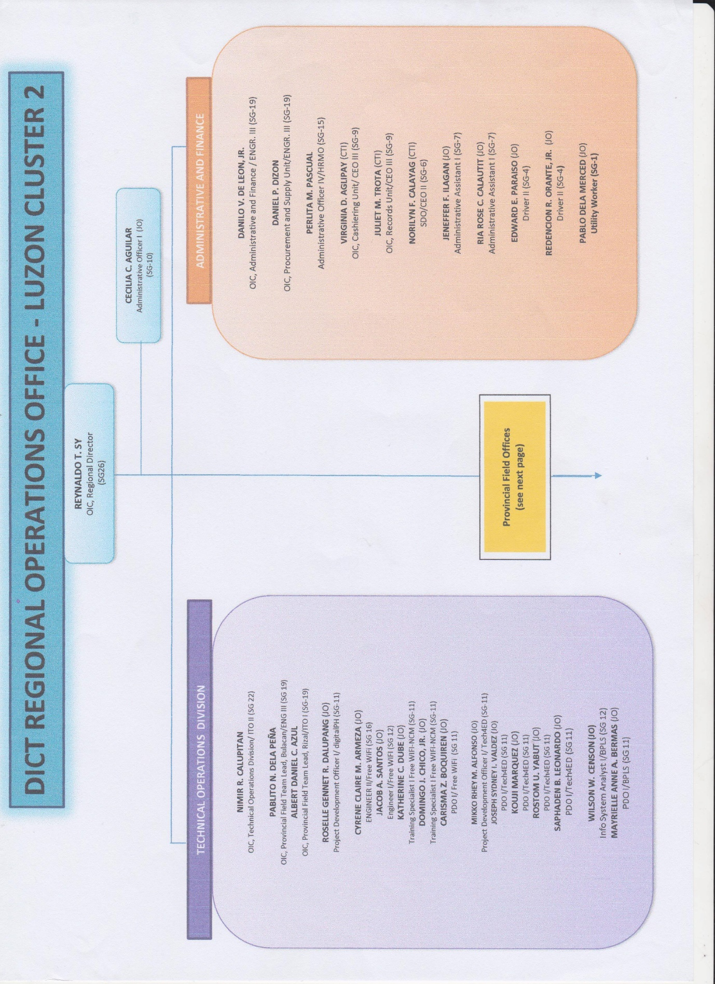

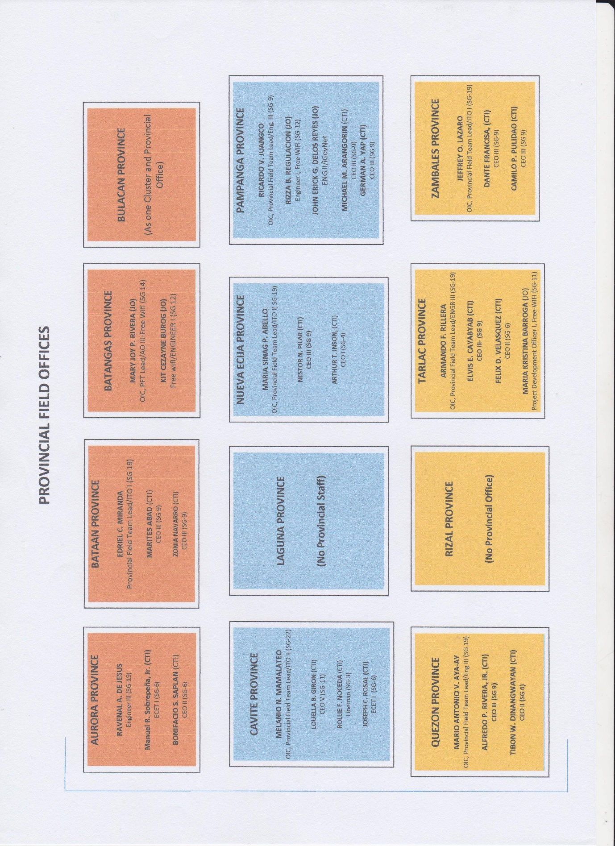

**Chapter II: Narration**

**Reflection of Fieldwork Experiences**

The DICT Luzon Cluster II is the regional office of DICT located in Malolos, Bulacan who handles Central Luzon and CALABARZON. The DICT Field Operations office is mandated to give free training, which they called Digital Literacy, which is included in one of their 4 main projects titled Tech4Ed they also conduct an Internet and Media Literacy Training as they install free public Wi-Fi access points in different 3rd to 6th class municipality around their subordinates.

The working environment of the DICT is located at the second floor of a commercial building in the capitol compound. The office is divided into 2 offices, the main office itself where the regional director is located and a PKI training center where the Assistant Regional Director office located.

DICT usually have field operation wherein they conduct training and some ocular visits around the central Luzon and CALABARZON. In usual office days, they do their office works, liquidation, canvass, meeting and etc... For the OJT or interns their usual office day they took in charge of the Online Government Service. Aside from Online Government Service, Office works such as compiling different Memorandum of Agreements and other normal office works is given to the interns.

Last September, one of the big event of DICT LC2 happened four of the nine interns were selected to witness the event. Tech4Ed Conference, different Tech4ED center managers from different provinces. Media coverage, technical support and registration, the interns have different tasked to do to help the man power of DICT LC2 in making the event a success. Field Operations are necessary to the regional office of the DICT, it is either Tech4Ed Digital Literacy or Internet Media and Information Literacy Training. DICT deploys their Project Development Officers or Training Officer to the provinces to conduct free training to them.

Tech4ED aims to lessen the range of digital divide, they look upon teaching people in the rural areas how technology works and how complex the computer is.

**Working With My Cooperating Officer/Immediate Superior**

During my time as an intern in DICT LC II I was tasked to different works. The first day I was tasked to create a raffle application to be used in Tech4ED Conference conducted on September 19, 2018 at Royce Hotel & Casino in Clark, Pampanga. I was also tasked to create a website for the DICT LC II based on the criteria of their web auditing.

Most of the interns are also tasked to go to their outside projects like Digital Literacy Training, Rural Impact Sourcing, Internet Media Information Literacy, Center Manager Training, and other more projects. This projects are conducted in municipalities of Central Luzon and CALABARZON; regions that DICT LC II manages.

On September 3, 5&6, 2018 together with one of my co-intern we are tasked to come with one of our superior to conduct a Digital Literacy Training in Obando, Bulacan. It’s a 3-day training where we discuss about the basics of a computer, what and how to use one, teach them how to use Microsoft Office such as Word, PowerPoint and Excel. On September 25 to 27, 2018 I and two of my co-intern and my supervisor is tasked to go in another Digital Literacy Training conducted at Dinalupihan, Bataan. It’s a 3-day training again where we stay in a hotel. On October 24 to 26 Me and together with my two co-intern and my supervisor we assists in conducting a Center Managers Training held at Tarlac City, Tarlac we also have accommodations their like free foods and hotel to stay in, just like the other trainings.

I am also tasked to assist in the National ICT Ecosystem Framework held on November 6, 2018 at Hiyas, Malolos, Bulacan. On November 12 to 16, 2018 together with two of my co-interns and three superiors we conducted eBPLS (Electronic Business Permit and Licensing System) end Users training and Orientation in Calamba, Laguna. It’s a 5-day training where we stay at a resort.

**Chapter III: Conclusion and Recommendation**

**Conclusion**

At the end of the internship period. The trainee experienced many things and med from it. He gained knowledge about the work of Information Technology Assistant. During this time, the trainee experienced how to deal with the people around him with her co-workers. It is important that one team should have camaraderie so that they can work well and attain their goal. He observed that is was different when you were in school and when you were in real world. Because most of the time, you just learned in school is different in the real world.

**Recommendations**

I therefore conclude that every trainee must focus to their work. They should listen carefully with the instructions of their supervisor. If they do not understand something, they should ask for help. You should be aggressive in order to learn. You would be the one who take initiative that you want to learn. Deal with your problem with calmness, so that everything will tum all right. Trainees should always observe the proper attitude while working because your attitude will also affect your co employees. Last, be confident on your Job.