Setting Up a Telnet Server on Kali Linux
A Verified, Step-by-Step Lab Guide for Students
Based on a real terminal session — screenshots verified and arranged in chronological order
⚠ SECURITY WARNING: Telnet sends everything — including usernames and passwords — as plain, unencrypted text over the network. It must NEVER be used on a production system or exposed to the internet. Only run it inside an isolated lab/VM environment for learning purposes (e.g., practicing packet sniffing, protocol analysis, or understanding legacy remote-access services).

1. Overview
This guide documents a complete, working Telnet server setup on Kali Linux using xinetd, reconstructed and verified step-by-step from an actual terminal session. Every command below was confirmed against a screenshot, in the exact order it was run, ending in a successful Telnet login.

2. Installing and Configuring Telnet via xinetd

Step 1: Install xinetd and the Telnet daemon
sudo apt install inetutils-telnetd xinetd -y
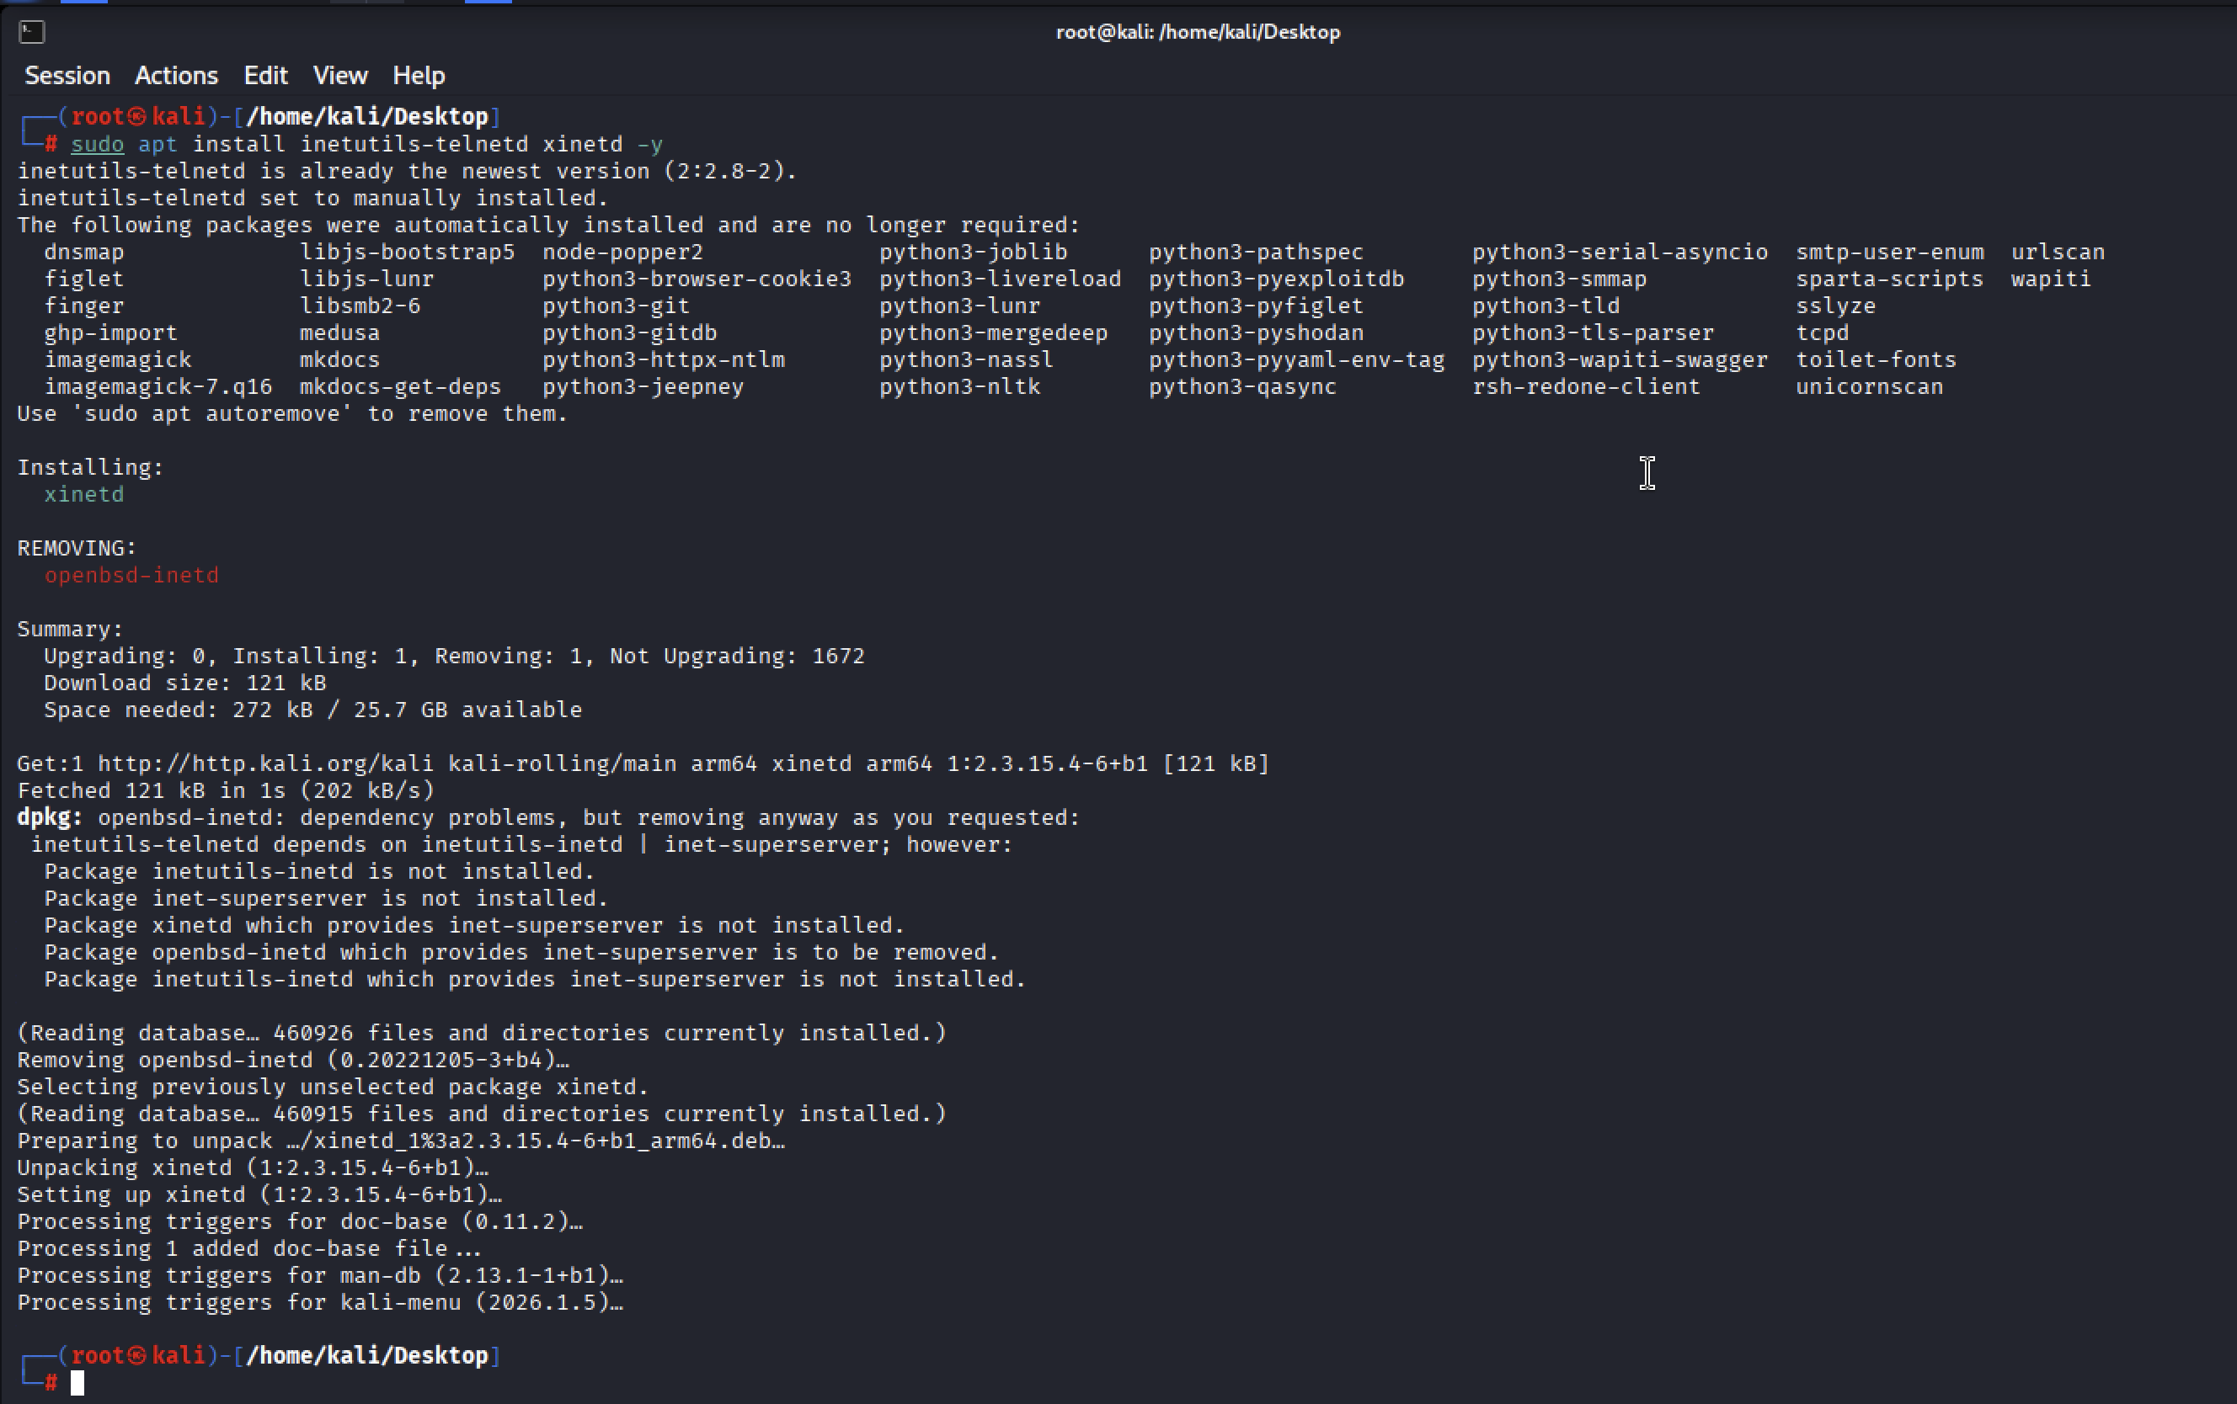
Screenshot 1: xinetd installed; openbsd-inetd is removed to avoid two super-servers conflicting over the same ports.
NOTE: apt shows a dependency warning while removing openbsd-inetd — this is expected and safe here, since xinetd is being installed in its place as the super-server that will manage Telnet.

Step 2: Create the Telnet service definition for xinetd
sudo nano /etc/xinetd.d/telnet
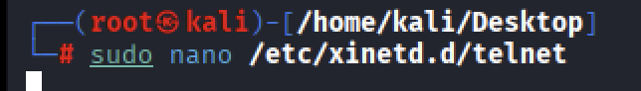
Screenshot 2: Opening (creating) the xinetd Telnet service file.

Step 3: Fill in the service definition
service telnet
{
disable = no
flags = REUSE
socket_type = stream
wait = no
user = root
server = /usr/sbin/in.telnetd
log_on_failure += USERID
}
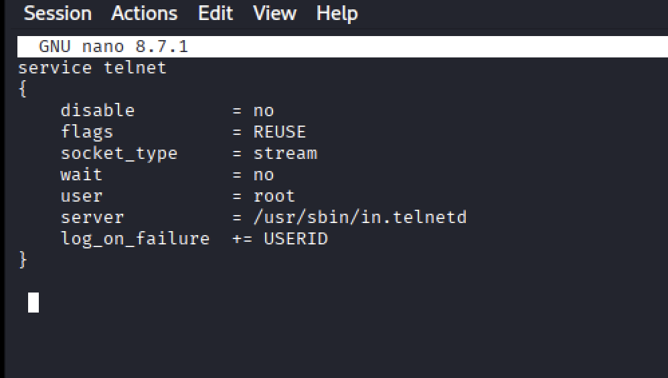
Screenshot 3: Completed /etc/xinetd.d/telnet configuration: disable = no, using /usr/sbin/in.telnetd as the server binary.

Step 4: Restart and enable xinetd
sudo systemctl restart xinetd
sudo systemctl enable xinetd
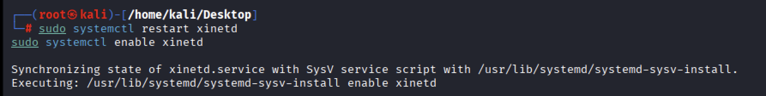
Screenshot 4: xinetd restarted and enabled, synchronized with the SysV-style service script.

Step 5: Allow Telnet through the firewall
sudo iptables -A INPUT -p tcp --dport 23 -j ACCEPT
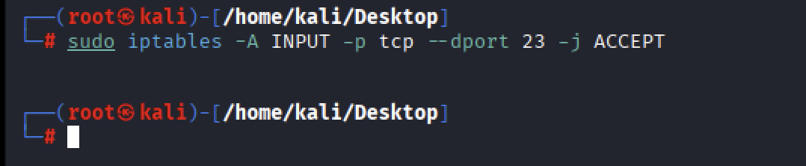
Screenshot 5: iptables rule added to accept inbound TCP traffic on port 23 (Telnet).

Step 6: Re-check the configuration file
sudo nano /etc/xinetd.d/telnet
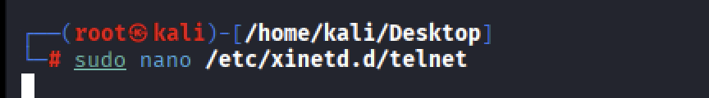
Screenshot 6: Reopening the file to verify the configuration before the final restart.

Step 7: Restart xinetd once more to apply changes
sudo systemctl restart xinetd
sudo systemctl enable xinetd
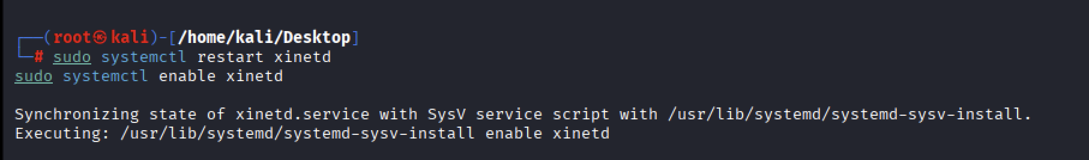
Screenshot 7: xinetd restarted again, confirming the service is synchronized and enabled.

Step 8: Verify Telnet is listening
sudo ss -tuln | grep :23
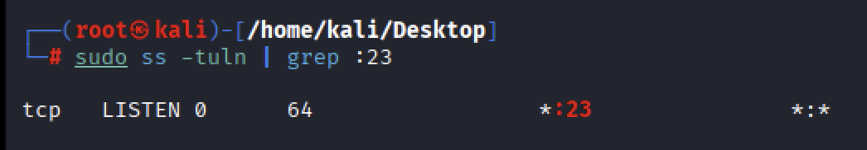
Screenshot 8: Port 23 is LISTENing on *:23 (all interfaces), served by xinetd.

3. Final Test — Logging in over Telnet
telnet 127.0.0.1
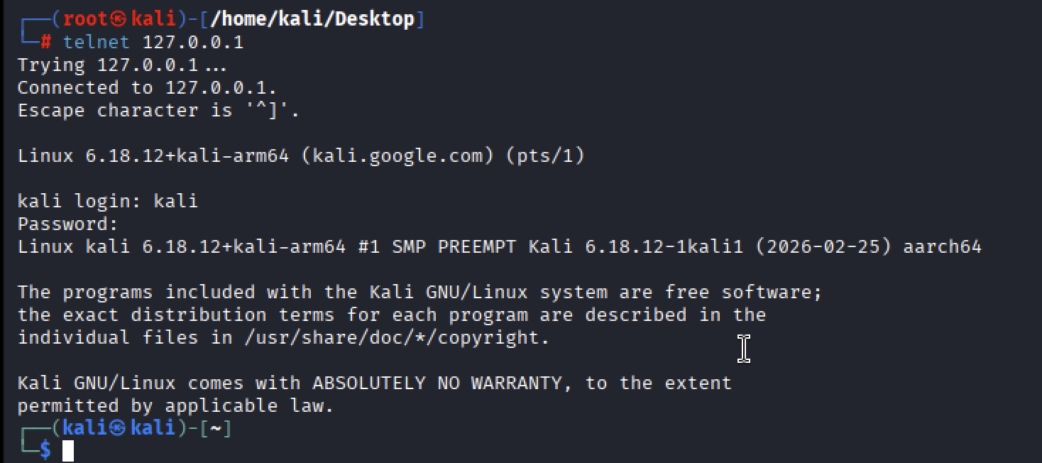
Screenshot 9: Successful Telnet connection to 127.0.0.1: login prompt, valid credentials (user "kali"), and a working shell — confirming the Telnet server is fully operational.
This final screenshot is the proof of success: the client connects, receives the login banner, accepts the username and password, and drops into a normal shell prompt. The Telnet server is now fully functional.

4. Summary Checklist
- Install a Telnet daemon (telnetd / inetutils-telnetd) and a super-server (xinetd recommended over inetd on modern Kali).
- Point the service definition at the correct binary: /usr/sbin/in.telnetd.
- Set disable = no in /etc/xinetd.d/telnet.
- Restart and enable the super-server (systemctl restart/enable xinetd).
- Open the firewall for TCP port 23 (iptables -A INPUT -p tcp --dport 23 -j ACCEPT).
- Confirm the port is listening with ss -tuln | grep :23.
- Test the login end-to-end with telnet 127.0.0.1 (or the machine's IP).
⚠ SECURITY WARNING: Once you're done practicing, disable and remove the Telnet service (sudo systemctl disable --now xinetd) and revert the firewall rule. Leaving Telnet running is a serious security risk on any network you don't fully control.

