CBR-73 MP Work Breakdown Structure (WBS)

Introduction
Versions 1.0 and 2.0 of VIPA did not allow activities depicted in the Gantt Chart to have any structure or for one activity to have any explicit relationship with another.
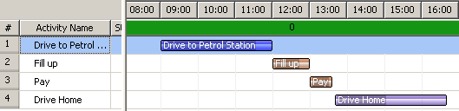
Figure 1 Unstructured Activities

The current task (CBR-73) is to prototype some new use-cases that are available when activities are allowed to have a hierarchical tree-structure.
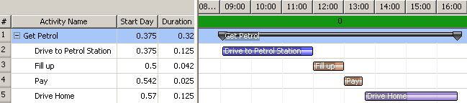
Figure 2 Tree-Structure for Activities

A more compact view of the plan
The benefits of a tree-structure are not obvious for a simple plan; however the ability to collapse branches of the tree produces valuable gains in usability for large, complex plans.

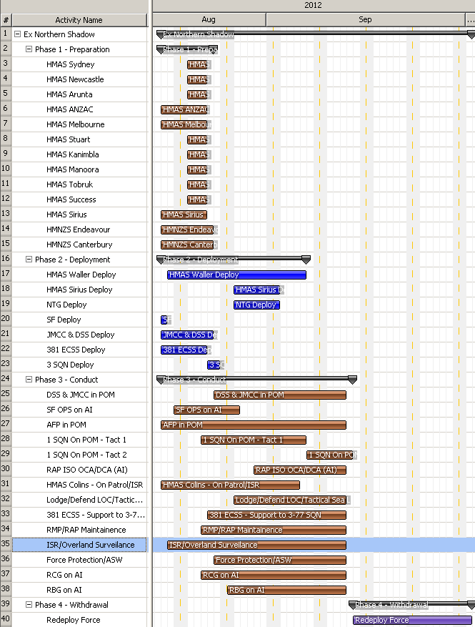
Figure 3 Ex Northern Shadow (fully expanded)

Note:
- Large plan becomes unwieldy and visually overwhelming.
- If the user zooms / pans the Gantt Chart to focus on detail, they will lose the context (can no longer see the big picture).

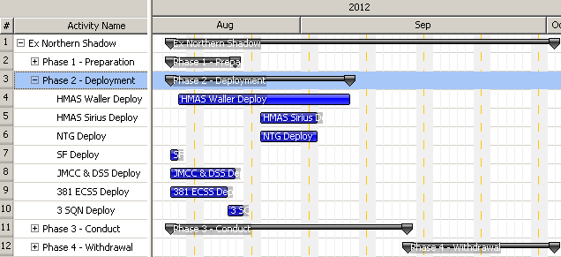
Figure 4 Ex Northern Shadow (mostly collapsed)

Note:
- User can focus on details of Phase 2 (Deployment) and still easily see where other phases fit (context).
- Current VIPA Phase functionality could become obsolete if users are happy to model phases as high-level activities.

Top-down decomposition of tasks/activities.
The ability to model sub-activities enables users to accomplish planning with an iterative top-down approach. High-level mission-oriented activities can be defined with broad objectives and rough timeframes at first and then these can be broken down with increasing details at a later stage.

Complete decomposition
Complete decomposition of a task occurs when a parent task is equivalent to the sum of its child tasks. For example in Figure 1 above, the parent task “Get Petrol” is equivalent to the sum of all its child tasks. In Gantt chart terminology, the “Get Petrol” task is referred to as a “Summary Element”. The Summary Element simply presents a named summary of a collection of child elements.

The JIDE Gantt UI component has good inbuilt support for this kind of Summary Element (as depicted in the prototype screenshots above).

Partial decomposition
The software should facilitate a staged or partial decomposition of high level activities into detailed activities. In other words, fleshing out a high-level activity into more detailed component activities should not need to be done by a user in a single atomic step. Instead, a user should be allowed to flesh-out one detailed component (sub-activity) at a time. Alternatively one user could flesh-out some sub-activities for an area in which they have special expertise and then pass the plan onto another user to flesh out different sub-activities.

Returning to the Get Petrol example, one user may be a subject matter expert on most activities conducted at petrol stations but not particularly qualified in how to get there and back. Their partial decomposition of “Get Petrol” might look like the following:
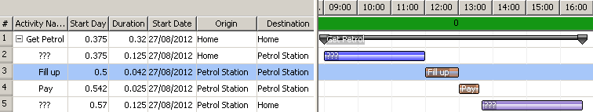
Figure 5 Partial Decomposition with System-Generated placeholders

In this case, we suppose the user explicitly added 2 sub-activities to the “Get Petrol” parent, and the system automatically creates two placeholder sub-activities so that 100% of the duration of “Get Petrol” is accounted for.
Based on the parent activity starting and finishing at location “Home” and the user-created sub-activities both starting and finishing at location “Petrol Station”, the system infers that the first placeholder starts at Home and finishes at the Petrol Station, and the second placeholder starts at the Petrol Station and finishes at Home.
The first user is able to complete details of activities “Fill up” and “Pay” with great accuracy and then pass the plan onto someone else to fill in the placeholder activities.

Accounting for 100% of time and resources
Extending the current example further, suppose that the original “Get Petrol” task had 2 distinct resources assigned to it. Name these resources A and B. The first user knows that resource A is sufficient to accomplish his tasks at the Petrol Station. Resource B provides some kind of transport or support but those details are for the second user to flesh-out.
When the user creates his sub-activities and does not assign all of the parent activities resources to each of the sub-activities, the system must generate at least one additional placeholder activity to account for 100% of time and resources. The following two screenshots illustrate a couple of alternative possibilities here.
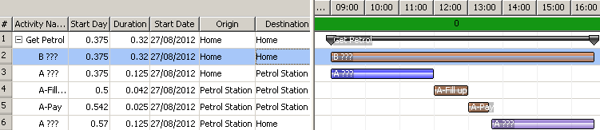
Figure 6 Untasked Resources left behind

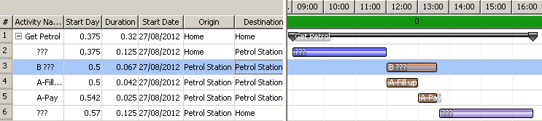
Figure 7 Untasked Resources deployed

The problem is that it is unspecified whether the remaining resources (B) are to remain at the original location or are required to accompany resource A on its deployment to the Petrol Station. Potentially resource B will be composed of smaller units with some needing to deploy and others needing to remain behind. In a more complex scenario, some elements of B might need to deploy as an advance party to secure the Petrol Station. The solution becomes obvious if we invoke the power of the SEP field (someone else’s problem). The system should default to leaving resource B at home (as depicted in Figure 6 above) and it is the second user’s job to work out what resource B is required to do (and when) to support resource A in its mission.

