Website Proposal

**Team:** Baedee, Leh Baedee

**Project Statement:**

Design and create an ecommerce website that will accept payments and show users what the company is all about.

**Stakeholders:**

Shawn and Sekou Henry

**Users:**

Everyone that needs the company’s services

**Risks:**

1. Delay in project completion due to time mismanagement.

2. Stagnation of project status due to steep learning curve.

**Assumptions:**

Users have trouble running the programming application. Will it be “user friendly” (Think about the users’ ability). Time assigned to each tasks, goal and experience.

**Vision Statement:**

T2 Aerospace is a Veteran Owned and Operated company that provides excellent customer service, high quality support services, and superior imaging, videography, and photography. We are dedicated to utilizing this technology in a responsible, safely, and environmentally friendly manner while advancing the use of Unmanned Aerial Systems (sUAS) to the benefit of society.

**List of Features:**

Display what the company is all about

Show price

Accept payment

**Sample Use Cases:**

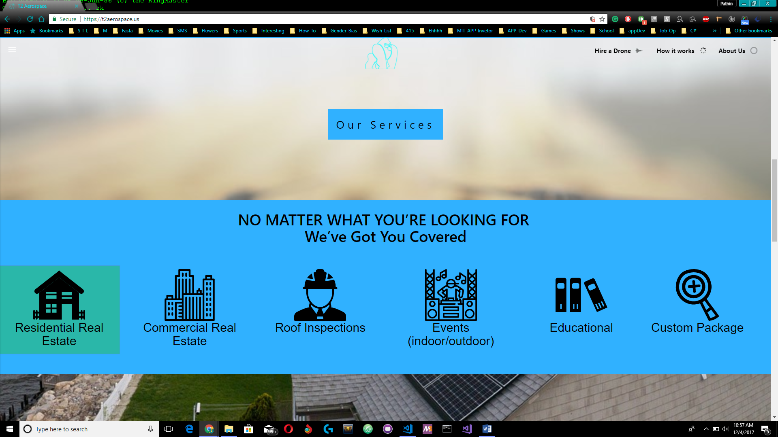

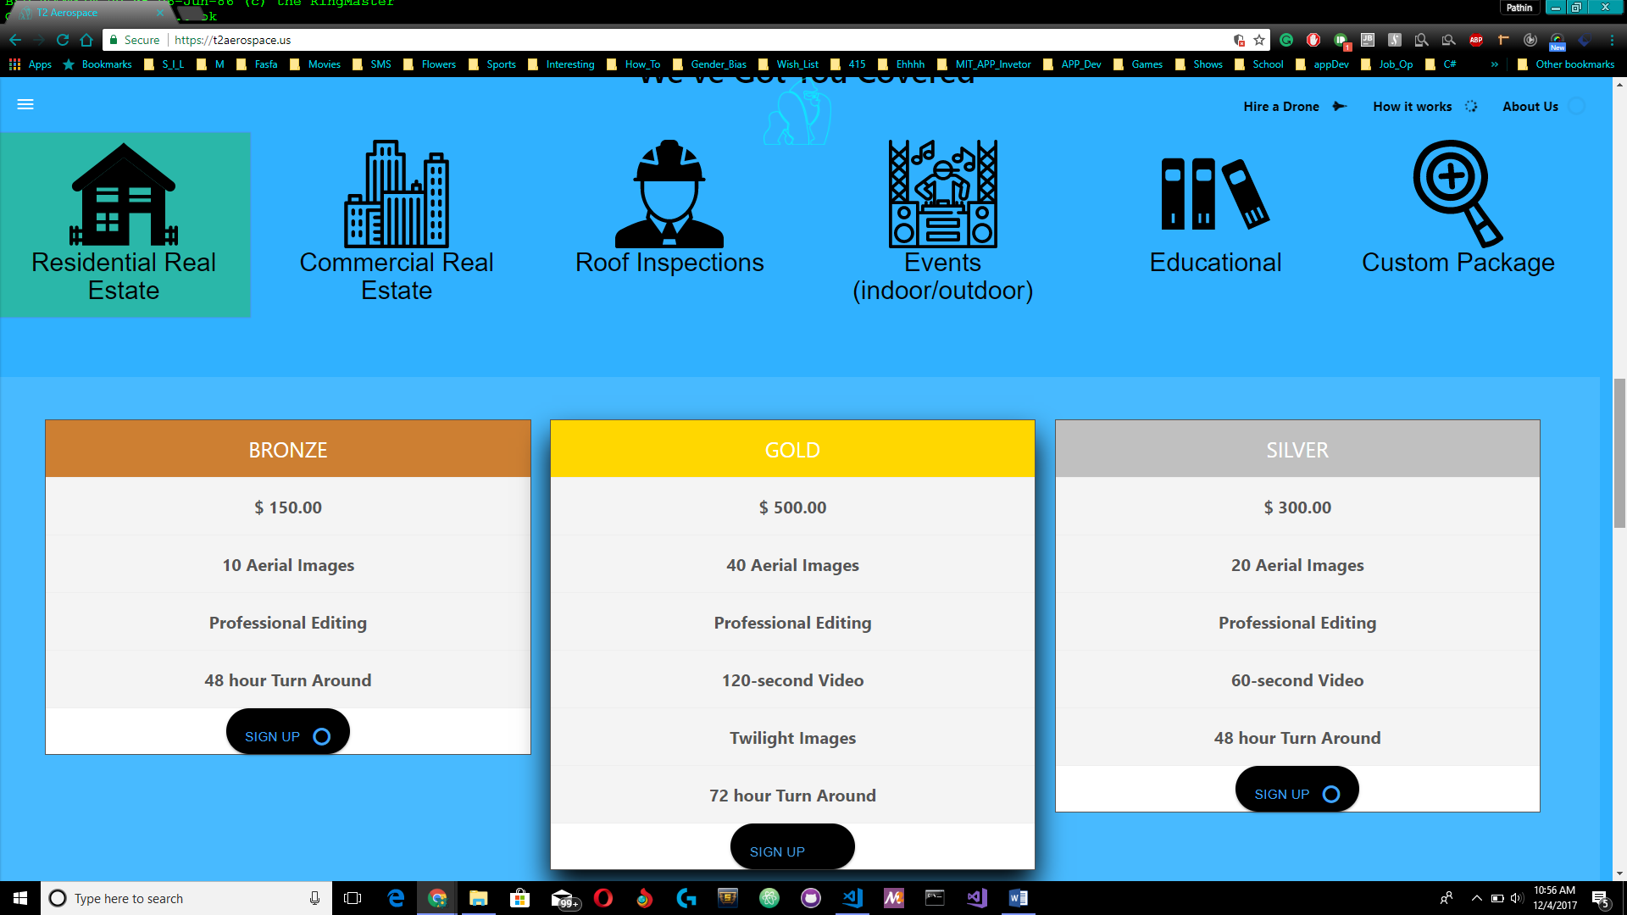

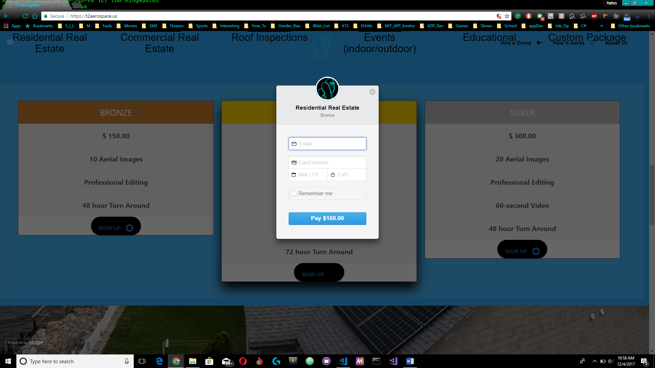

**Requirements**

**Functional**

Accept payments

**Non-Functional**

Ease of Use

Cross-functionality & portability: Run across multiple devices such as desktops, mobile phones, and embedded systems.

**Design**

**Modules:**

Stripe API

Heroku

Mailchimp

**Error Management**

Handles arithmetic errors by throwing arithmetic exceptions and handling them appropriately.

**UI**

Site background color sky blue

Full screen video background