Personal AI Dot Platform
Architecture concept using Deep Agents, Azure Container Apps Sandboxes, durable state, events, and MCP
This document summarizes the architecture discussed for building a personal equivalent of OpenAI's persistent agent concept: a long-lived logical agent that can wake on schedules, external events, direct conversations, or messages from other agents, while keeping its durable identity and knowledge outside disposable compute.

1. Architecture at a glance
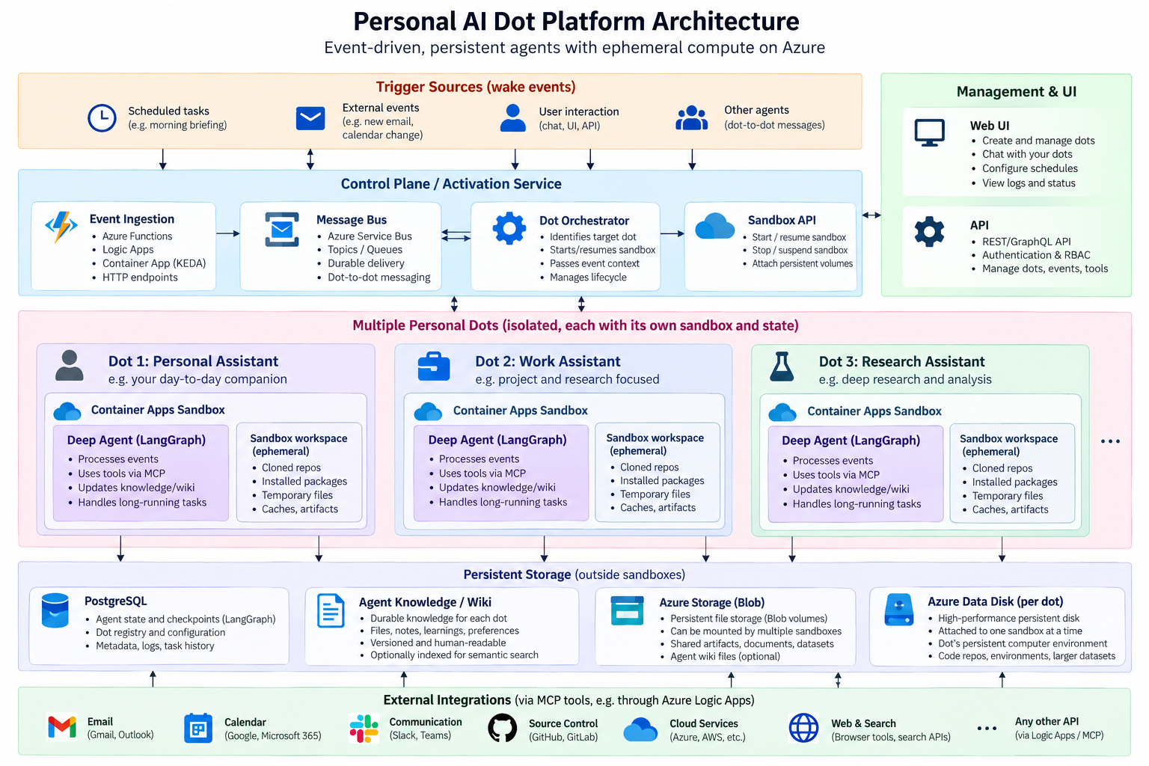
Figure 1. Proposed personal AI dot platform architecture.

2. Core design principle
The dot is persistent as a logical entity, but its compute does not need to run continuously. Identity, goals, memory, knowledge, configuration, checkpoints, and important artifacts are durable. The sandbox is the dot's computer: useful and potentially resumable, but replaceable.
- Persistent agent: identity, personality/instructions, goals, permissions, schedules, knowledge, task history, and checkpoints.
- Ephemeral or resumable compute: an Azure Container Apps Sandbox that runs the Deep Agent when work is required.
- Durable activation: schedules, user messages, SaaS events, webhooks, and dot-to-dot messages all become wake events.
- Externalized state: the dot must survive complete loss and recreation of its sandbox.

3. Agent runtime and sandbox
Deep Agents/LangGraph provides the agent runtime. A sandbox supplies an isolated computer where the agent can run code, use a browser, manipulate files, clone repositories, install packages, and produce artifacts.
The sandbox workspace can retain useful working state, but the architecture should not depend on it. A newly created sandbox should be able to rehydrate the dot from durable stores.

Storage model
- PostgreSQL: LangGraph checkpoints, agent/task state, dot registry and configuration, metadata, and task history.
- Agent knowledge/wiki: durable notes, preferences, decisions, lessons learned, project knowledge, and other long-term semantic memory.
- Azure Blob volume: durable files and artifacts, including data that may be shared across sandboxes.
- Azure Data Disk, optional per dot: higher-performance persistent workspace that is single-attached to one sandbox at a time.
- Sandbox local workspace: caches, temporary downloads, cloned repositories, build outputs, and other disposable scratch data.

4. Wake-up and event model
Scheduling should live outside the agent. The dot does not need a permanently running process that waits for the next task. Instead, an external activation layer wakes or creates the sandbox and passes the event to the agent.
- Scheduled events: morning briefing, periodic research, recurring maintenance.
- External events: incoming email, calendar change, GitHub activity, webhook, or SaaS event.
- Direct interaction: a chat/UI/API request from the user.
- Agent-to-agent events: one dot sends a durable message to another dot.
A practical Azure flow is: trigger source → Azure Function/Logic App/KEDA-scaled Container App → Service Bus → activation/orchestration service → Sandbox API → start/resume target sandbox → invoke Deep Agent → persist results → suspend/stop when idle.

5. Why an external activator is needed
A suspended sandbox cannot poll Service Bus because its code is not executing. Container Apps Sandboxes do not behave like ordinary KEDA-scaled Container Apps for Service Bus activation. A thin external component therefore consumes the event and calls the Sandbox lifecycle API. This also gives scheduled, HTTP, webhook, and message-based activation one consistent path.

6. Connectors and tools
For a personal implementation there is no need to reproduce a general-purpose connector ecosystem. Start with the integrations actually needed, such as Gmail, Microsoft 365/Outlook/Calendar, GitHub, Azure, and web search.
MCP is a useful agent-facing abstraction. Behind MCP, Azure Logic Apps can handle many SaaS-specific concerns such as OAuth, token refresh, connector APIs, retries, and triggers. The agent sees stable tools such as search_email, get_calendar_events, or search_files rather than provider-specific implementation details.

7. Durable knowledge and learning
The agent's long-term knowledge should be separate from execution checkpoints. LangGraph checkpointing answers 'where was this run?', while a wiki-like knowledge layer answers 'what has this agent learned over time?'.
- Keep the wiki outside the sandbox and mount, synchronize, or retrieve it when the dot wakes.
- Use human-readable files/notes for transparency and inspectability.
- Optionally index the wiki for semantic retrieval as it grows.
- Let the agent update durable knowledge after tasks when a fact, decision, preference, or lesson is likely to matter later.

8. Multiple dots
A web UI and API can turn the design into a small personal agent control plane. Each dot can have its own personality, goals, permissions, knowledge namespace, schedules, tools, storage, and sandbox lifecycle.
Dot-to-dot communication should use durable messaging rather than direct sandbox-to-sandbox calls. A message can be placed on Service Bus, which wakes the destination dot through the same activation mechanism used for every other event. Access policies can restrict which dots may communicate.

9. Suggested first implementation
1. Build one dot using Deep Agents/LangGraph with PostgreSQL checkpointing.
2. Add a durable knowledge/wiki store and Blob-backed artifact storage.
3. Run the agent in an Azure Container Apps Sandbox.
4. Create a small activation service that can start/resume the sandbox and deliver an event.
5. Use Service Bus as the durable inbox and event backbone.
6. Add one scheduled workflow, for example a morning briefing.
7. Expose only a few MCP tools initially, for example email, calendar, GitHub, and web search.
8. Add a simple UI/API for chat, configuration, schedules, logs, and status.
9. Generalize to multiple dots only after the single-dot lifecycle is reliable.

10. Key architectural takeaway
Persistent agent + durable memory + event-driven activation + replaceable sandbox.
The sandbox is the dot's computer, not the dot itself. This keeps the system resilient while still allowing a dot to have a rich, reusable working environment.

References
- Microsoft Learn, Azure Container Apps Sandboxes overview: https://learn.microsoft.com/azure/container-apps/sandboxes-overview
- Microsoft Learn, Azure Container Apps storage mounts: https://learn.microsoft.com/azure/container-apps/storage-mounts
- LangChain / LangGraph documentation and Deep Agents project materials: https://docs.langchain.com/ and https://github.com/langchain-ai/deepagents

