## 

## 

## **Document management system**

Created by: illegal_team_exception

## **Users manual**

## **Introduction**

Document management system is designed for enterprise use to increase productivity and ease of use when it comes to handling day-to-day documents in medium or large size companies. This user manual will teach you how to effectively incorporate a document management system in your daily tasks.

## **Main functions**

Document management system is designed to:

* Help manage your operation by creating user profiles, user groups and different document types
* Simplify the process of creating, submitting, accepting and rejecting internal documents
* Display information associated with user profiles and created documents
* Tracking statistics of all activities related to user information and documents created within the system

## **Table of contents**

**Getting started 3**

**Creating documents 5**

**Processing documents 6**

**Users document list 7**

**First time login 8**

**Administrator functions 10**

**Create new user 11**

**Create new group 12**

**Create new document type 13**

**System overview 14**

**Edit User 14**

**Edit Group 15**

**Edit Document Type 16**

**Statistics 17**

## **Getting started**

To start working with a document management system first you will have to log in to the system. You can easily do that by opening your browser and inputting web address provided to you by your company in the browsers address bar as shown below:

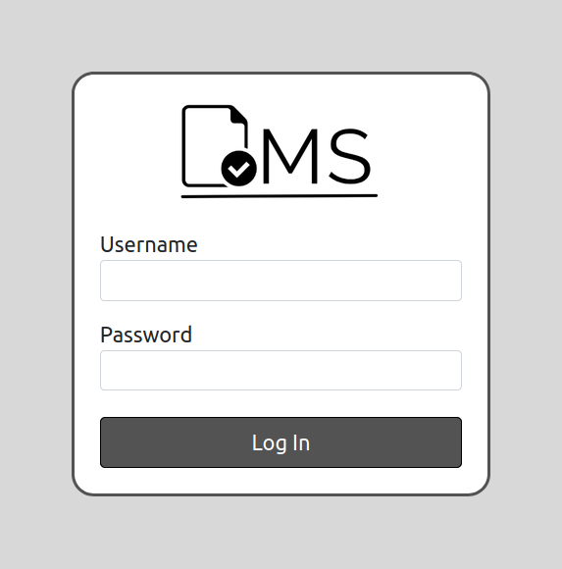

You will see the login screen such as the one on the right. Here you have to input your username and password provided to you by your superior. Afterwards click on Log In button to access the system.

After logging into the system you will be presented with the main page from which you can navigate to all functions available to you (image below). Clicking Create Document (no. 1 in the image) will take you to a form which will assist you in creating a new document. Sign Document buttons (no. 2 in the image) will take you to the list of all documents that are awaiting your attention. Clicking My Documents (no. 3 in the image) will let you see detailed information on your created documents as well as their current status.

Profile (no. 4 in the image) button will display a short summary of your profile information. And lastly, you can finish working in the system by clicking the Logout button (no. 5 in the image)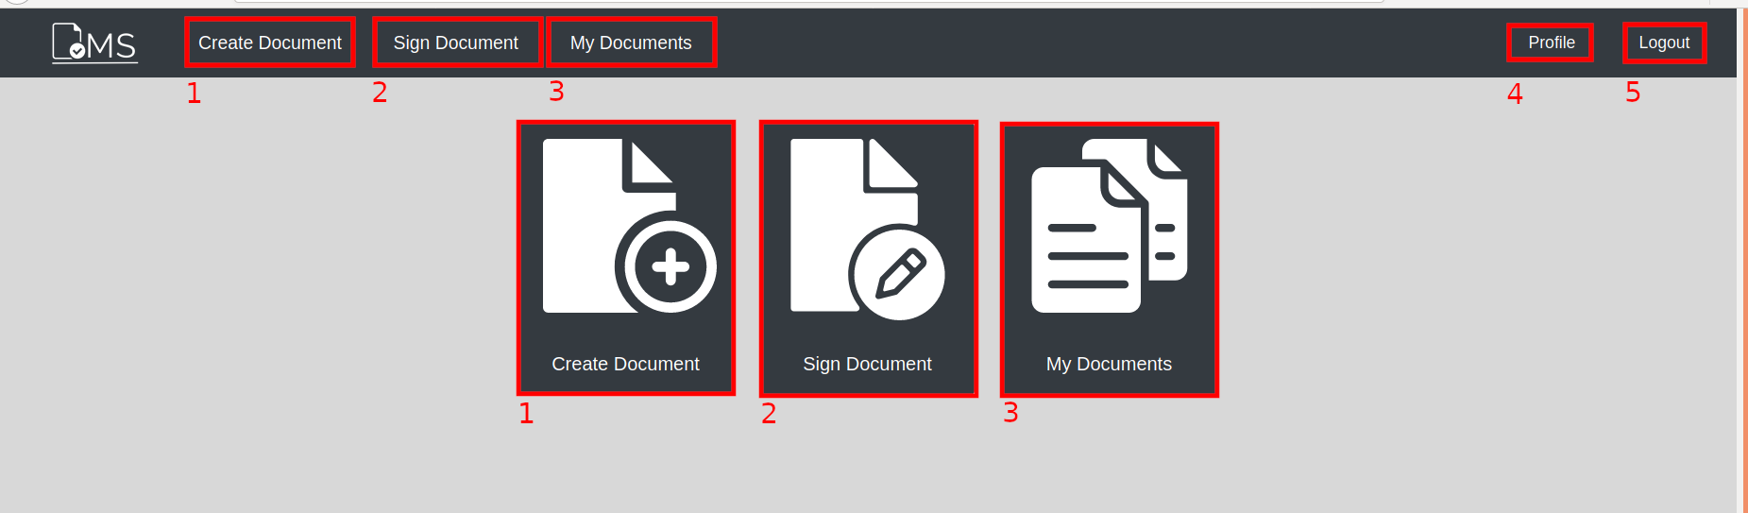

## **Creating documents**

Creating documents using the Document Management System is very straightforward:

* First, enter the desired name for the document you want to create in the Document name field (no. 1), which has to be between 1 and 50 characters long.
* Second, describe the document in the Document description field (no. 2), description has a maximum of 500 characters.
* Lastly, select appropriate document type from the Document type list (no. 3).
* Optionally, you can attach files while creating the document by clicking on **Browse** button (no. 4) or you can do that later by editing your created document form.

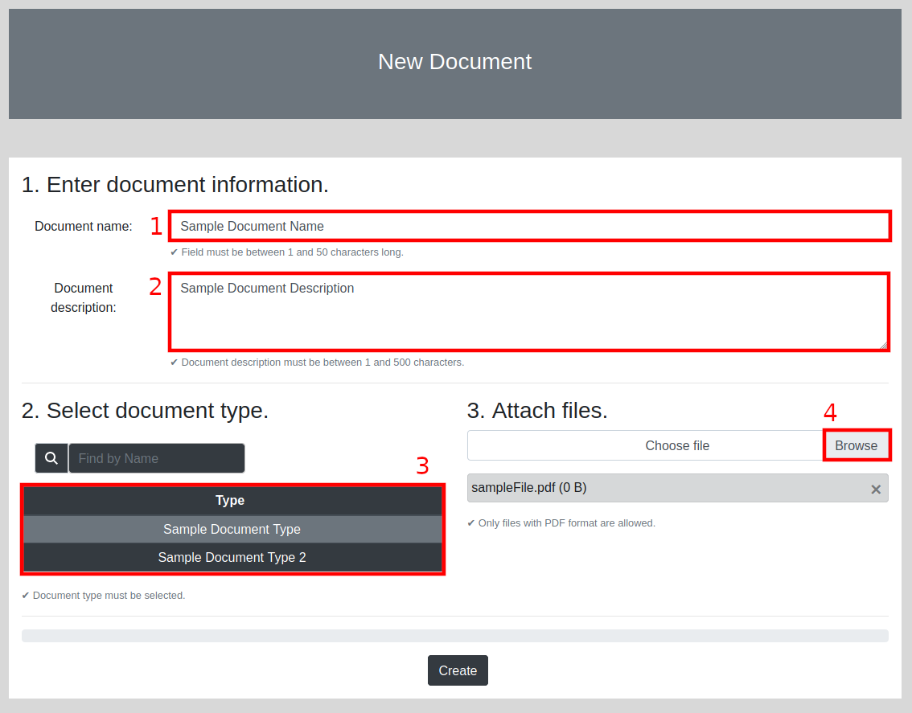

## **Processing documents**

All documents you have the rights to process are displayed in the list you can access by clicking the Sign Document button. Afterwards, the list will be populated with documents that are pending approval or rejection. Here you can see detailed information about each document. Starting from the left list fields display:

* Unique document ID number
* Name of the document (assigned by author of the document)
* Document type
* Date the document was submitted (date of creation might be different)
* Name and surname of the author
* Hovering over the highlighted file icon in file field will display the names of attached files

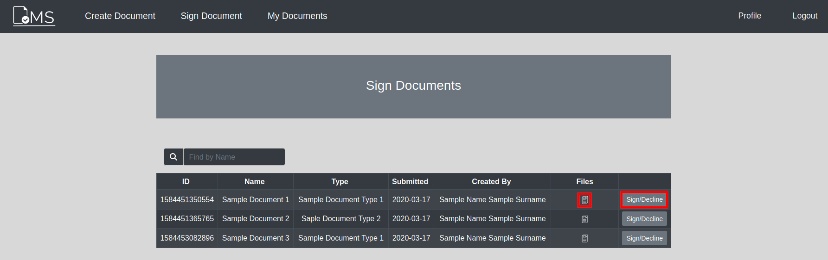

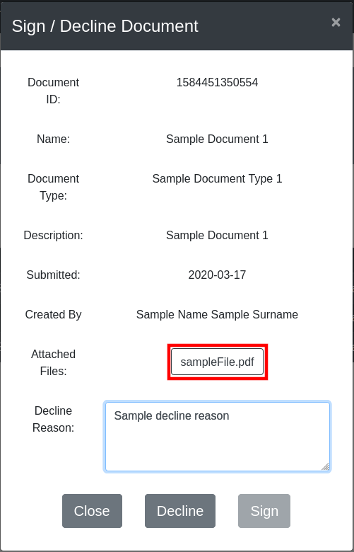

Clicking the **Sign/Decline** button will take you to a form where you can accept or reject the submitted document.

This form contains the same information which was presented in the list. Also you can click on individual files (highlighted in the image on the right) to download attached files.

On the bottom of the form you can close the form, Sign the document or Decline the document. To decline a document you have to present a detailed reason for declining the document (the field has a maximum character length of 3000). Signing the document does **NOT** require an explanation.

## **Users document list**

Navigating to My Documents will present you with a list which displays all documents you have created. This list displays information about a particular document. Fields (starting from the left) display:

* Unique document ID number
* Name of the document
* Document type
* Current status of the document
* Date of creation
* File list (hover over the file icon to display attached file names)

Lastly you can edit/view your document or Submit it for processing. Please note that you can freely edit a document any number of times before submitting it. However, once the document was submitted you will **NOT** be able to edit the document any longer. All changes to documents are finalised on submit.

Above the table you can see the filters (no. 1) to display documents by their status (default set to display all documents).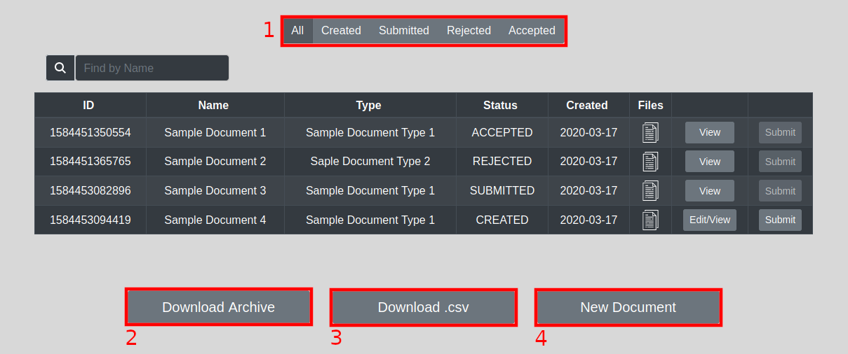

Under the table you can see buttons to download all files and generated .csv file in a .zip archive (no. 2), download only generated .csv file containing information about your documents and lastly the new document button will take you to the Create Document form where you can create new documents.

## **First time login**

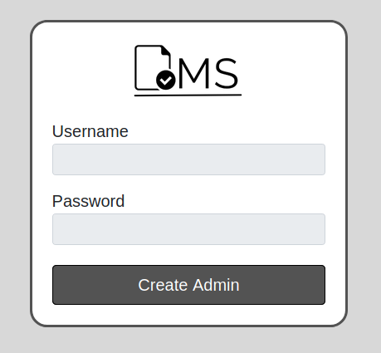

After the application is installed and put into the server, it has no administrative accounts on it. When accessing an application for the first time, you will not be able to login.

You will need to create an administrative account first. It can be done by pressing the Create **Admin** button. After pressing the button you will see a modular window which will ask you to fill necessary details: *First Name, Last Name, Username, Password.* After all information is filled press **Create** button.

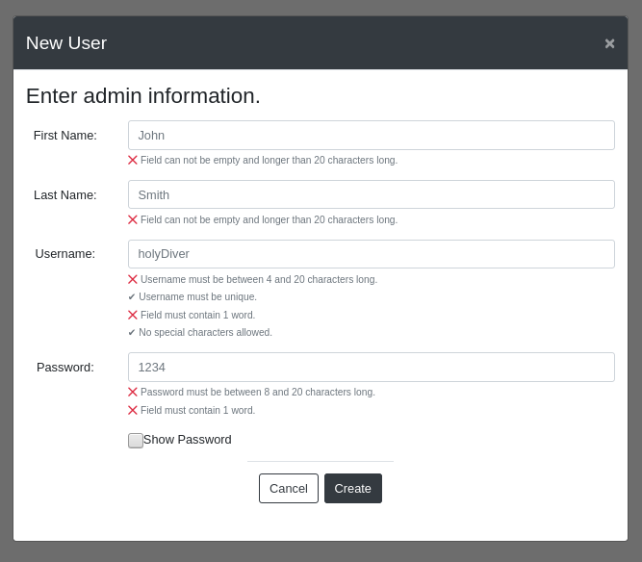

After the administrative account is created, you can simply login to the system using credentials of the account you just created.



## 

## **Administrator functions**

Once you login to the system with a user which has an administrator role you will notice that the user interface has all the functionality described in the user functions paragraph. Furthermore, you will see two additional buttons titled: Admin. These buttons will let you access administrative functions such as:

* Create and edit Users
* Create and edit Groups
* Create and edit Document types

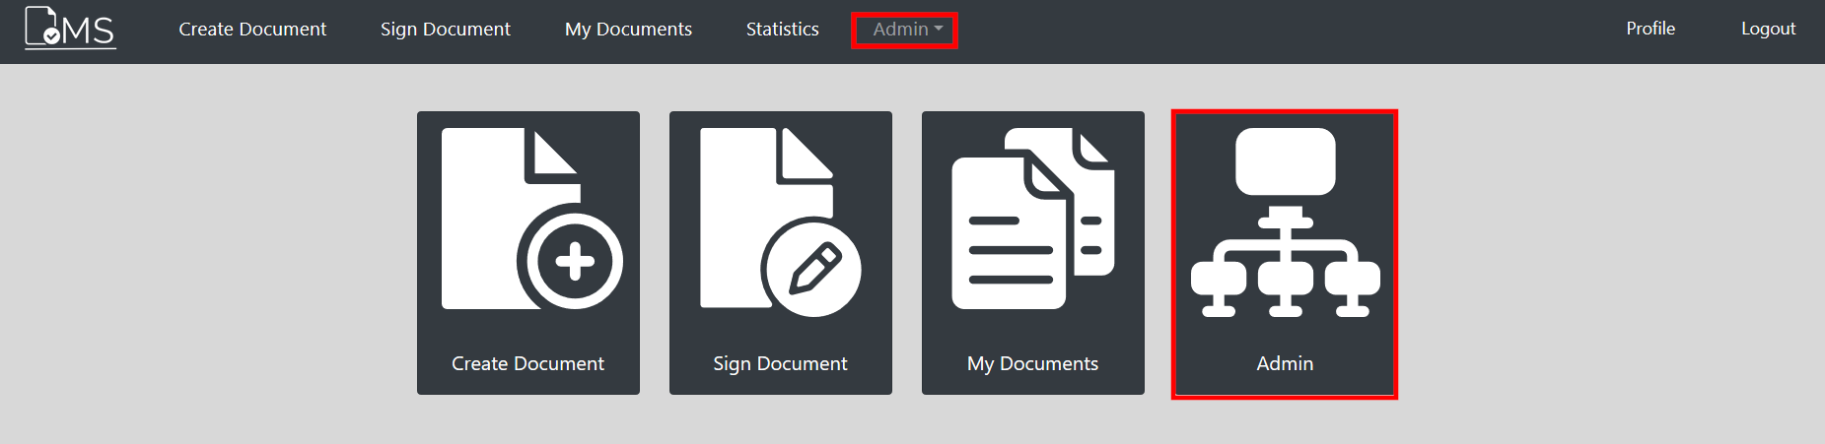

Clicking the button on the navigation bar will present you with a drop-down list where you can select the desired function while clicking the large button will present you with a set of large buttons for those same functions. Both options will lead you to the exact same forms and will yield identical results.

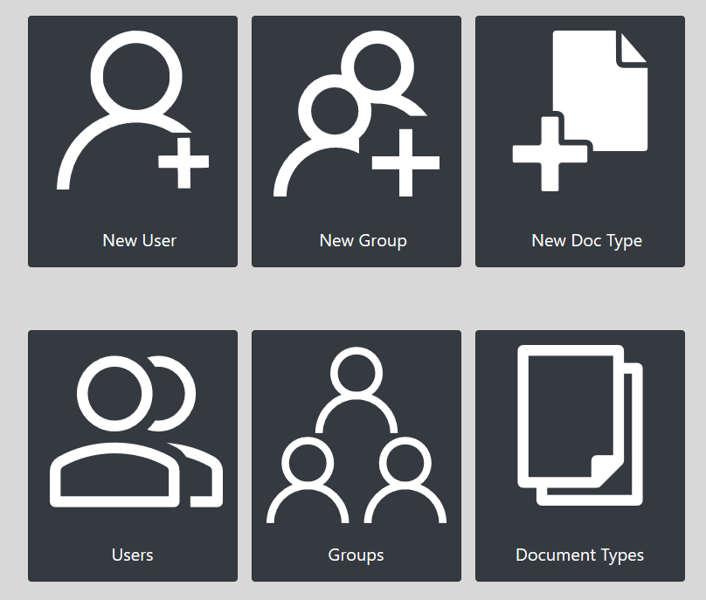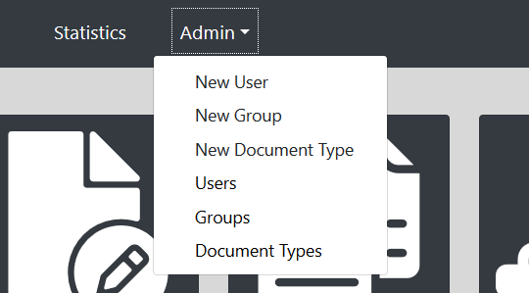

## **Create new user**

Clicking the New User button will take you to a form which will assist you in creating a new user in the system. Here you will have to fill in all required information into corresponding fields.

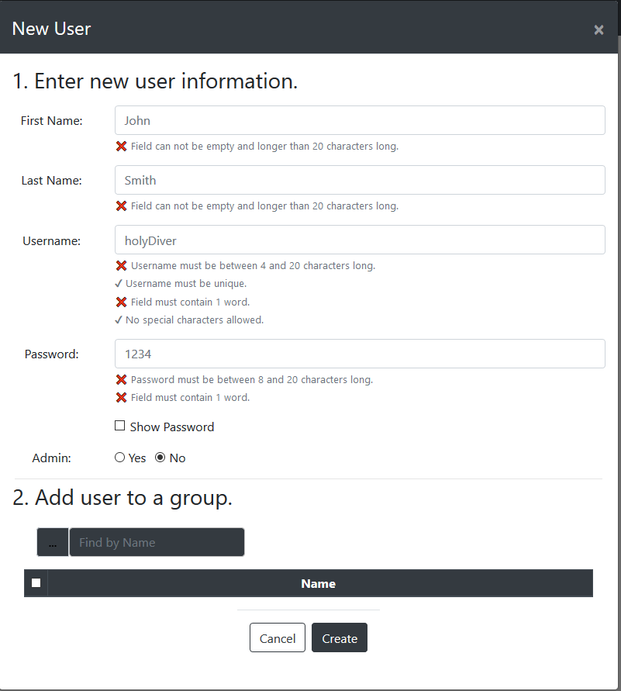

* First Name should contain users first name which has to be between 1 and 20 characters long
* Last Name should contain users surname which has to be between 1 and 20 characters long
* Username should contain desired username which must be unique for each user and has to be between 4 and 20 characters long
* Password must be between 8 and 20 characters long. Spaces are not allowed.
* Afterwards you can select the role for the user. There are admin users and regular users within the system so you should select YES if the user you are creating is going to have administrator privileges and select NO if you are creating a regular user.
* Optionally, you can select groups from the presented group list to add the new user to.

## **Create new group**

Clicking New Group button will take you to a form which will help you create a new group for your system. The form field are as follows: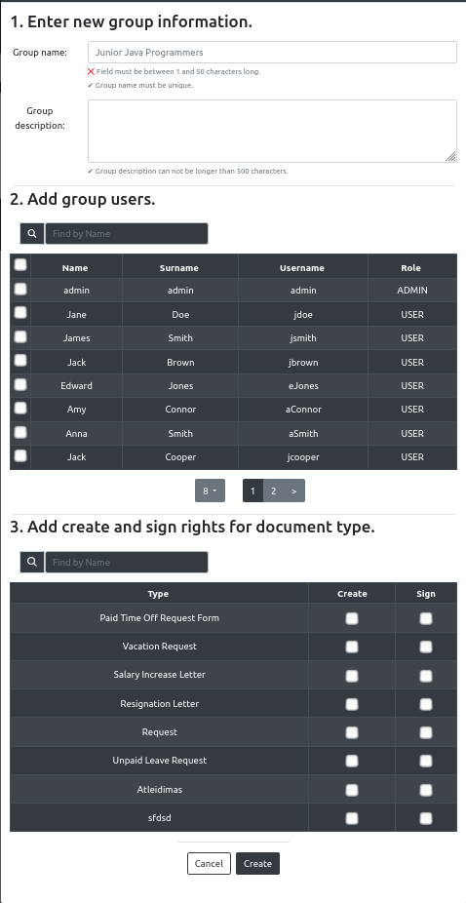

1. Here you will have to input a unique name for the group and description. Description length is limited to 500 characters, while group name MUST be unique and should not be longer than 50 characters.
2. You have an option to select users to add to the group from the currently created user list. The field with magnifying glass next to the list can be used to quickly search the whole list for a specific user.
3. You can assign document types and functions for this group. If you want the group to be able to create a certain type of document please check the box next to the document type. Same works with signing, if you wish the group you are creating to be able to sign the document make sure to check the box for that document type. You can select any number of document types to sign or create. Also a group can be able to create and sign the same document type, but that is not recommended.

## **Create new document type**

Clicking New Document Type button will take you to a form which will help you create a new document type for your system. The form field are as follows:

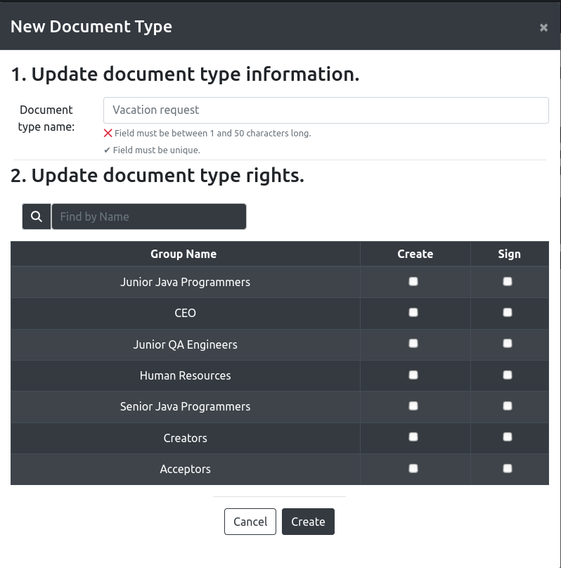

1. Here you will have to input a unique name for the new document type. Name MUST be unique and should not be longer than 50 characters.
2. Here you can select which groups have which rights for this particular document type. For example if you check Create next to a groups name the group will be able to create, but not sign, the newly created document type. Alternatively, groups that you check Sign for will be able to approve or reject documents of this newly created document type. Take not that you are able to select Create and Sign for the same group, but this is NOT advised.

## 

## **System overview**

As an administrator you are able to see the list of all users, groups and document types by clicking on Users, Groups or Document Types respectively. The following window will display a list with all system users, groups or document types. You can cycle through the list by clicking on the corresponding name above the list. 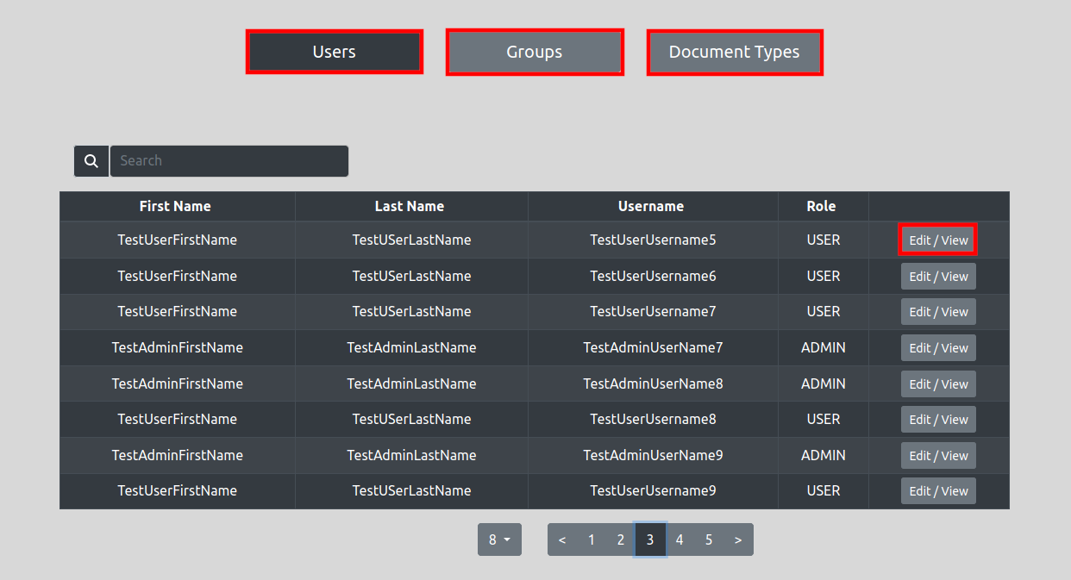

* You can search for users by name or username. Clicking Edit/View will open a form to modify selected user
* Both document types and groups can be searched by their name. Clicking Edit/View button will take you to the form to modify selected item

## **Edit User**

1. You can edit users' first or last name. You only have to input information if you want to modify it. To update users’ password you have to check the Update password checkbox. A field will be displayed to change users’ password. Lastly, you can change users’ role
2. Here you can update users’ groups. Clicking on a group the user is not a part of will add user to the group and clicking a group the user is a part of will remove the user from the group

Finally, clicking the Update button will save the changes while clicking Cancel will discard the changes made.

## **Edit Group**

1. You can edit groups’ name and description here. You only have to input information if you want to modify it. Name MUST be unique and between 1 and 50 characters long. Description must be no longer than 500 characters
2. Here you can add or remove users. You can use a search field to find a specific user. Users that are already in the group will have an orange checkbox checked next to their name. Adding a user is very easy. Just click on the users’ name you want to add to the group or click on the user you want to remove from the group to change their status
3. Finally, you can modify what document types the groups’ members can create or sign. Checking a Create box next to a groups name will let the group Create selected document type documents and checking the Sign box will let the group members approve or reject documents of selected type. You can have a group creating and signing the same type of documents, but this is NOT advised. Alternatively, you can remove a check from the document type to remove corresponding rights.

After you are done modifying group details you can click the Update button to save the changes or Cancel button to discard the changes.

## 

## **Edit Document Type**

1. You can update the Document Type name here. The name has to be between 1 and 50 characters long and unique
2. Here you can specify which groups can create and sign this type of document. Checking the box permits creating/signing and unchecking denies creating/signing of this document type

After modifying the document type you can click the Update button to save the changes or click Cancel to discard your changes.

## **Statistics**

Every user who belongs to a group which can approve documents, can see statistics based on users or document types.

Statistics can be accessed via **Statistics** button via navigation bar.

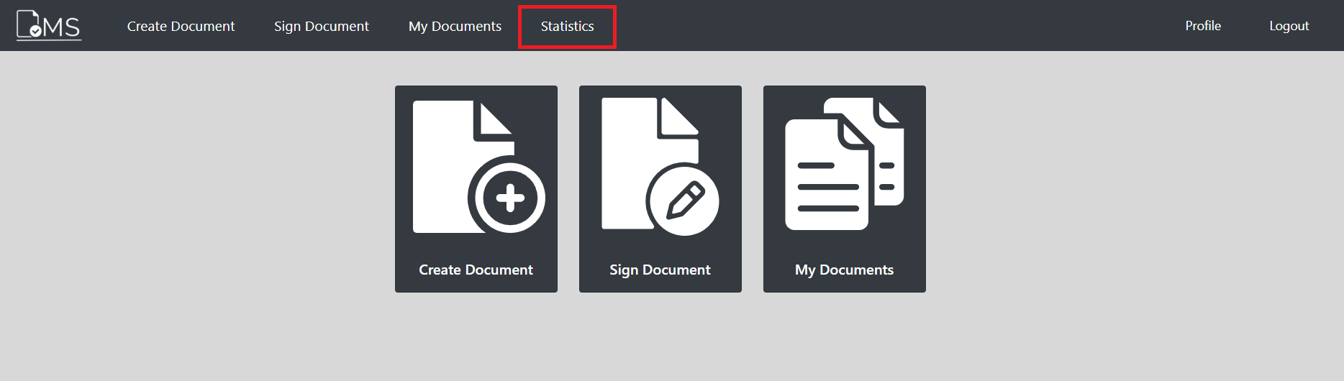

In the Statistics window, there are two types of data that can be shown:

* Statistics **By Document Types**
* Statistics **By Users**



If **By Document Types** selected:



There is an option to filter statistics by date (By default all documents are shown):

* Select date range and mark **Use Date Filter**



You will be shown data that consists of *Document Type Name* and number of *Submitted*, *Accepted* and *Declined* documents of that document type.

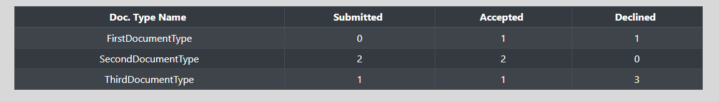

You can rearrange columns by selecting **Doc. Type Name**, **Submitted**, **Accepted**, **Declined**.

For example:

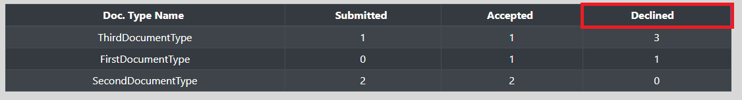

There is an option to search by typing document type name.

For example:

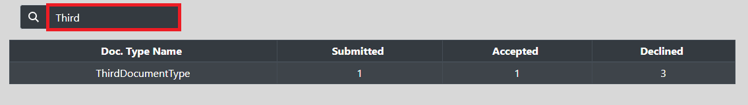

If **By Users** selected:



You will be shown data of users' First *Name*, *Last Name* and *Number Of Documents the user* has created.

For example:

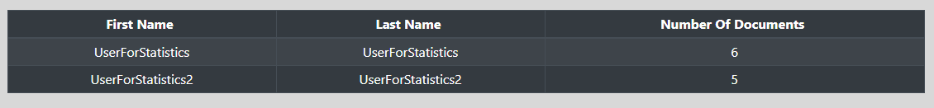

You can rearrange columns by selecting **First Name**, **Last Name** or **Number Of Documents**

For example:

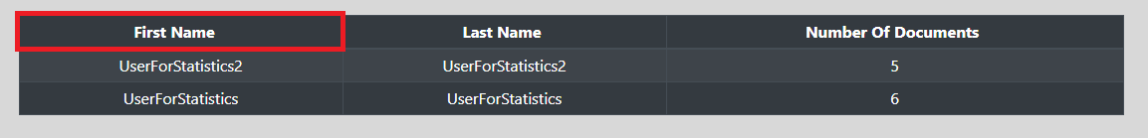

There is an option to search by typing the user's *First Name* or *Last Name*.

For example:

