## 

## 

## **Document management system**

Created by: illegal_team_exception

## **Installation instruction**

## **Prerequisites**

Instructions in blue text boxes such as this one are supposed to be written in Linux terminal. Feel free to substitute Tomcat 9 and Open JDK version numbers with the ones present in your system.

To install Document Management System you need a server running Linux OS with tomcat 9 and Open JDK 8 installed. If you already have prerequisites installed feel free to skip to the next section of installation guide.

Tomcat 9 can be downloaded from <https://tomcat.apache.org/download-90.cgi> while Open JDK 8 can be installed on debian based systems can be installed using:

$ sudo apt-get install openjdk-8-jdk

## **Installing Tomcat 9**

For this installation you will need to have Tomcat 9 files in your servers “/tmp” directory.

Create a user called "tomcat" to own the Tomcat installation. Also create a directory called "/u01" to hold all the config, and make sure that it is owned by the new "tomcat" user.

# useradd tomcat

# mkdir -p /u01

# chown tomcat:tomcat /u01

Install the JDK from the tarball under the "/u01/java" directory or copy the contents of etc/java-8-openjdk to "/u01/java".

# su - tomcat

$ mkdir -p /u01/java

$ cd /u01/java

Install Tomcat from the tarball under the "/u01/tomcat" directory. Unzip it to create a new directory, which includes the version number, but use a symbolic link so you could always use the same path for the CATALINA_HOME environment variable, regardless of the version.

$ mkdir -p /u01/tomcat

$ cd /u01/tomcat

$ tar xzf /tmp/apache-tomcat-9.0.14.tar.gz

$ ln -s apache-tomcat-9.0.14 latest

You should separate the config from the binaries, to make future upgrades easier, to that end you should create a new directory to act as the CATALINA_BASE location, and seed it by copying the relevant directories to the new directory. For example, you could use subdirectory called "instance1" to allow for multiple instances, but that is not necessary if you only plan to have a single Tomcat instance running.

$ mkdir -p /u01/config/instance1

$ cp -r /u01/tomcat/latest/conf /u01/config/instance1/

$ cp -r /u01/tomcat/latest/logs /u01/config/instance1/

$ cp -r /u01/tomcat/latest/temp /u01/config/instance1/

$ cp -r /u01/tomcat/latest/webapps /u01/config/instance1/

$ cp -r /u01/tomcat/latest/work /u01/config/instance1/

Set the following environment variables and append them to the "/home/tomcat/.bash_profile" so they are set for subsequent logins.

export JAVA_HOME=/u01/java/

export CATALINA_HOME=/u01/tomcat/latest

export CATALINA_BASE=/u01/config/instance1

You can start and stop Tomcat using the following scripts.

$ $CATALINA_HOME/bin/startup.sh

$ $CATALINA_HOME/bin/shutdown.sh

The Tomcat logs are written to the "$CATALINA_BASE/logs/" directory by default.

Once Tomcat is started, the following URL should be available. Configuration for the management URLs is discussed below.

http://localhost:8080/

http://localhost:8080/manager/html

http://localhost:8080/manager/status

Remember to open up the port on the firewall if you want to access the site from other servers on the network.

## 

## **Opening ports to be accessed from outside the server**

First, open a command-line terminal. Once you have a terminal open, you have to obtain root access to change firewall settings. Do this by typing:

su -

You will be prompted for your root password.

In the following examples, substitute the port number you want to open for the **###** in the command.

If you want to open an incoming TCP port, type the following:

iptables -I INPUT -p tcp --dport ### --syn -j ACCEPT

If you want to open a UDP port, type the following:

iptables -I INPUT -p udp --dport ### -j ACCEPT

After you are done opening ports in your firewall, you can save your changes so they will be applied when you restart your computer by typing the following command:

service iptables save

## 

## **Deploying .war file**

You can access Tomcat 9 manager dashboard by visiting: *http://localhost:8080/manager*.

The dashboard has five different sections: *Manager*, *Applications*, *Deploy*, *Diagnostics*, and *Server Information.* If you go to the *Deploy* section, you will find two subsections.

If the WAR file is located on the server where the Tomcat instance is running, then you can fill the required *Context Path* field preceded by a forward slash “/”. If you want your application to be accessed from the browser with the URL *http://localhost:8080/dms*, then your context path field will have */dms.*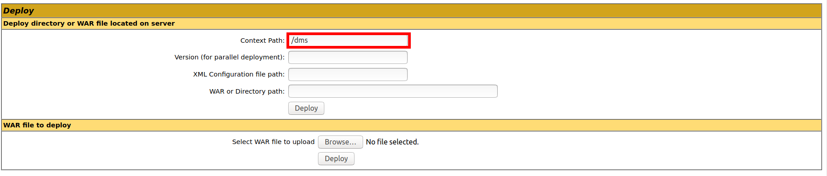

Now you have to enter the absolute URL to the Web Archive file as it appears on your server including file extension.

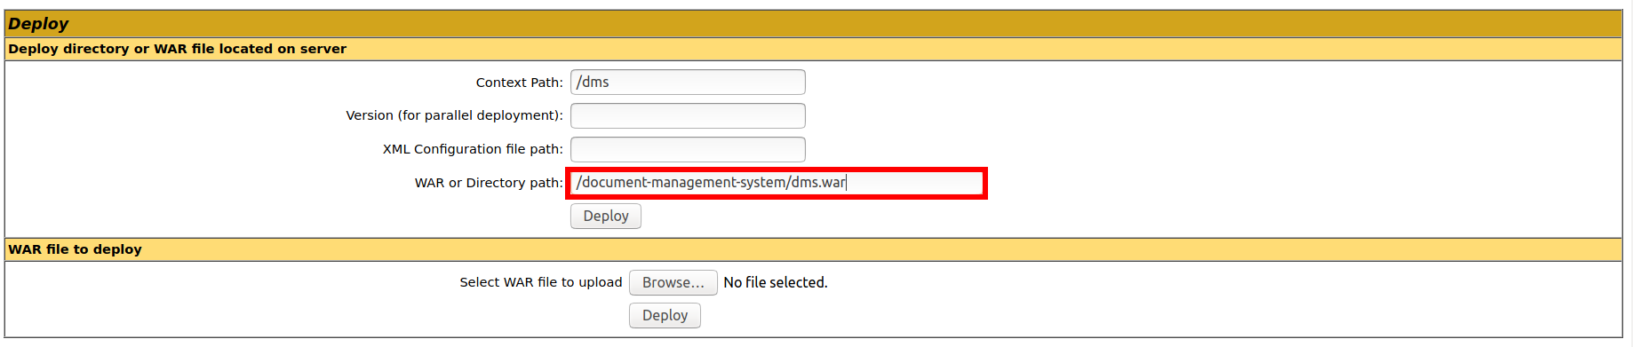

After that, you can click the deploy button. The page will reload, and you should see the message:

OK - Deployed application at context path /dms

Additionally, your application should also appear in the *Applications* section of the page.

Alternatively you can deploy a .war file from a remote computer by navigating to your file and clicking Deploy button:

