Aprima - EMR Report Download Guide
Contents
EMR Report Download Guide 1
MCA EMR Reports RAW File download 2
Patients With Visits by Insurance (Insurance Data, Last Visited, Provider Data) 3
Patients By Insurance (Insurance Detailed) 7
Patients By Diagnosis (Diagnosis and ICD Codes) 10
Patients-List (All Patients Demographic data) 11
Appointment Report (Next Visit Details) 12
Copay Report (Copay Details) 14

MCA EMR Reports RAW File download
- Connect to MCA RDP
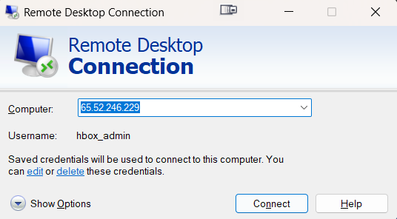

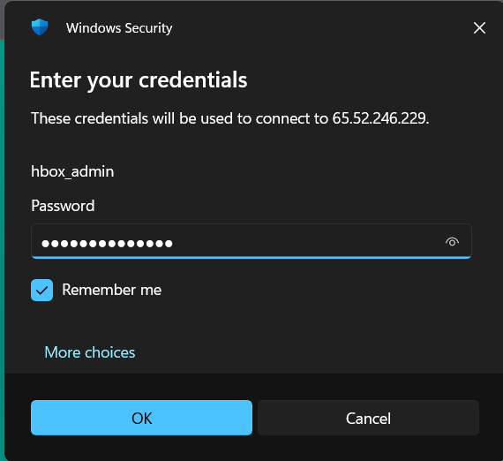

- Open CGM Aprima app from desktop
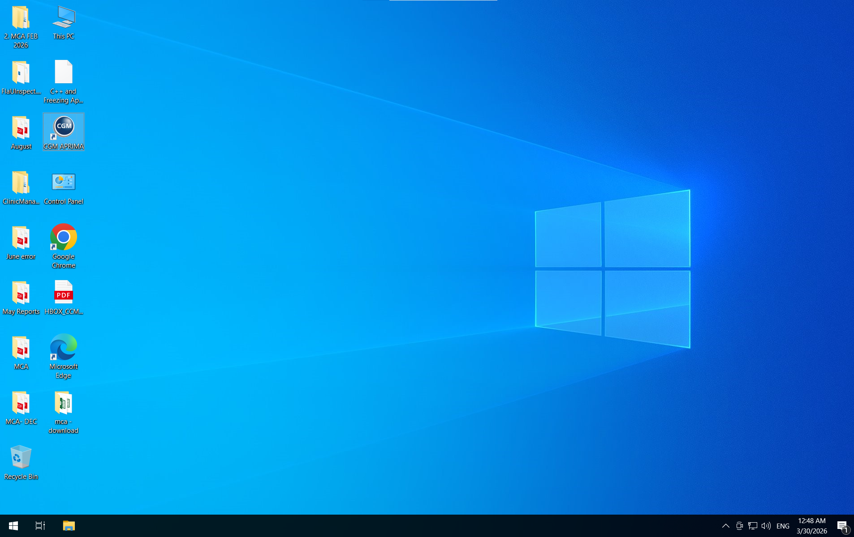
- Login with valid password to application

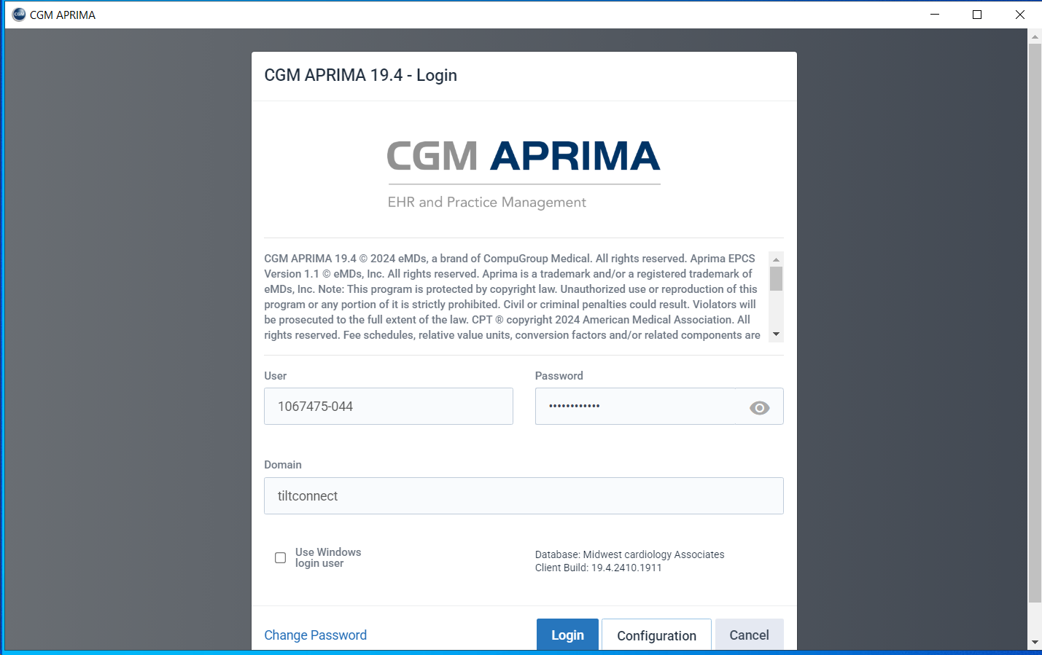

Patients With Visits by Insurance (Insurance Data, Last Visited, Provider Data)
- Navigate to Reports > Reports
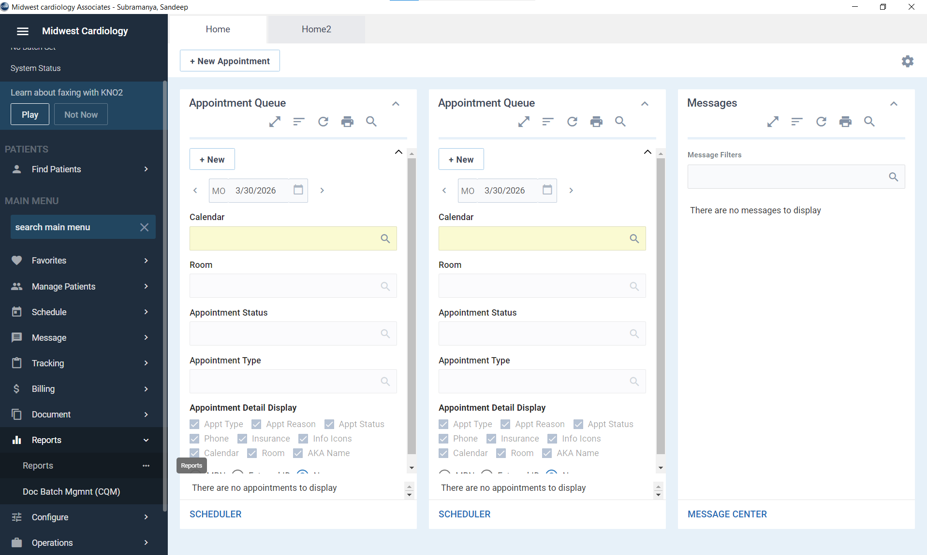

- Navigate to Reports > Reports > Clinical Quality
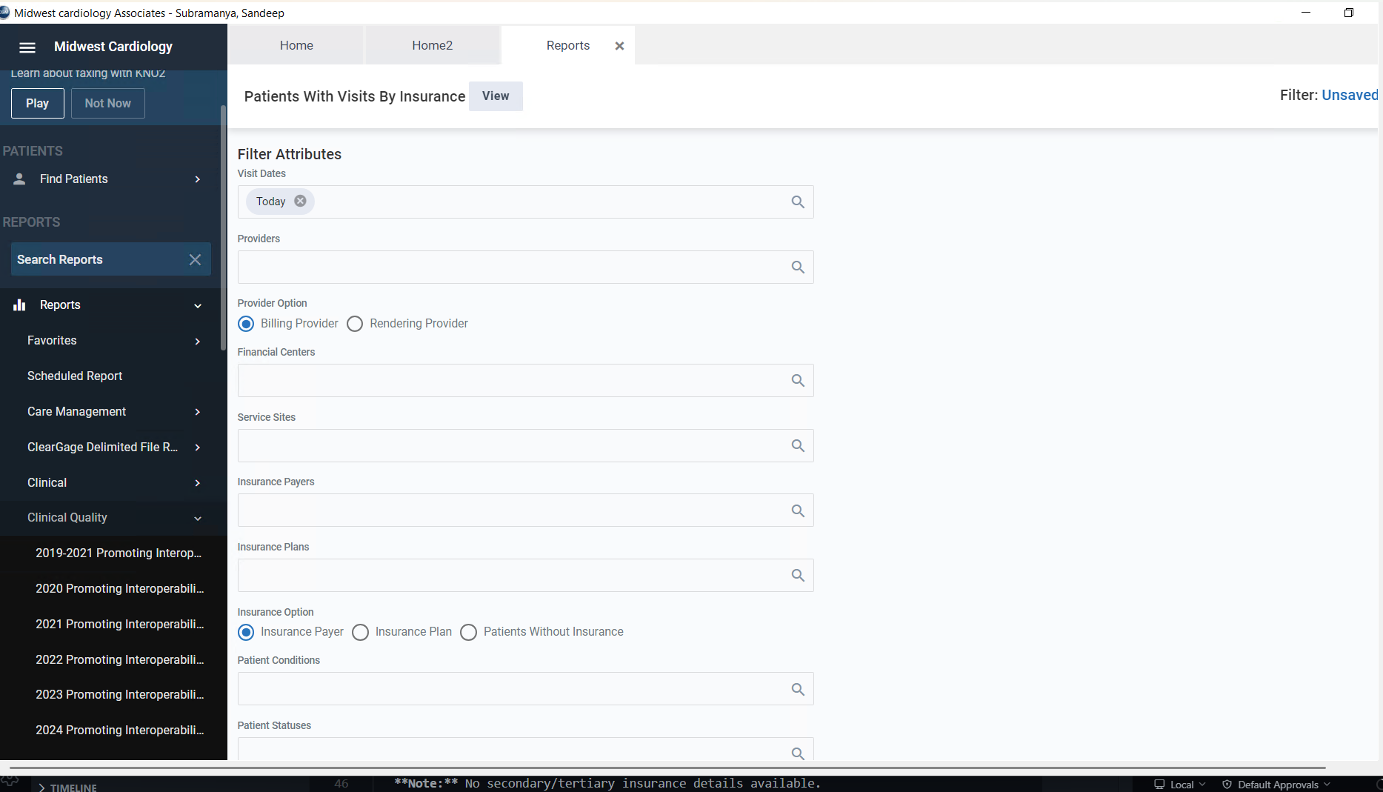

- Navigate to Reports > Reports > Clinical Quality > Patient With Visits By Insurance
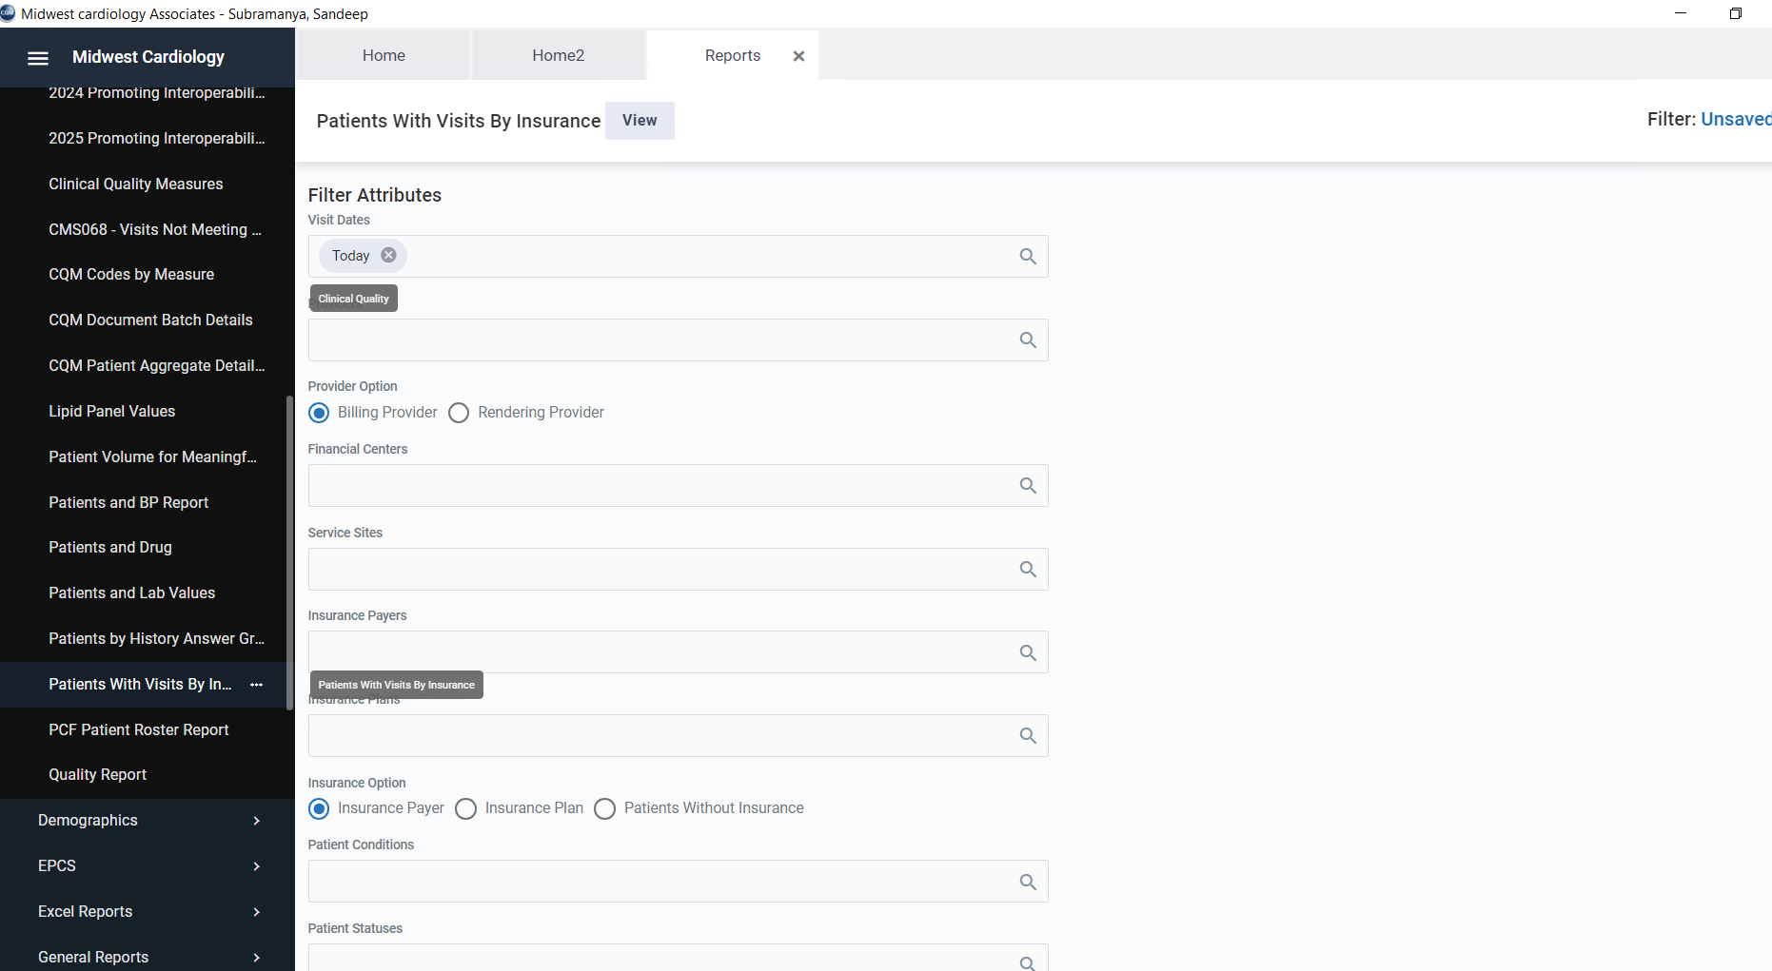

- Apply the filter as shown in picture (Visit dates past 1 year)
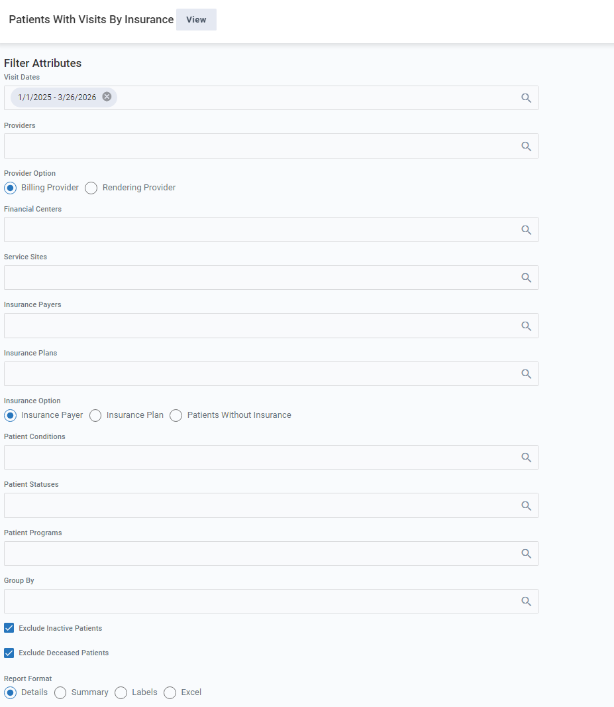
- Reports will be opened in new tab
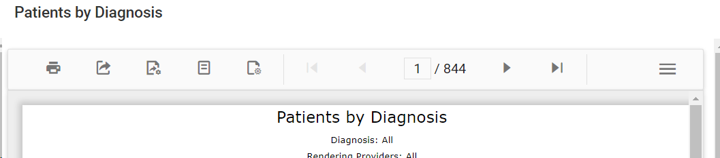

- Click export button and export as excel
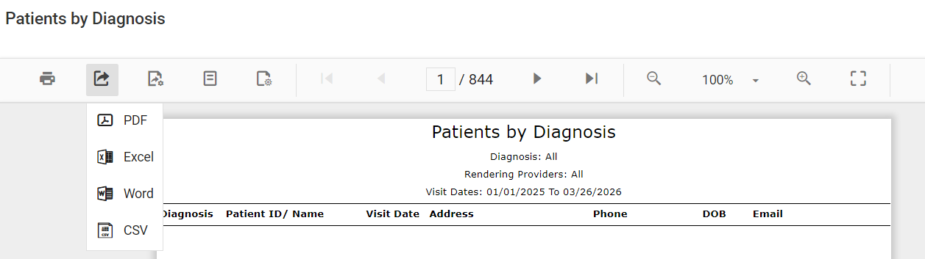

Patients By Insurance (Insurance Detailed)
- Navigate to Reports > Reports > General Reports
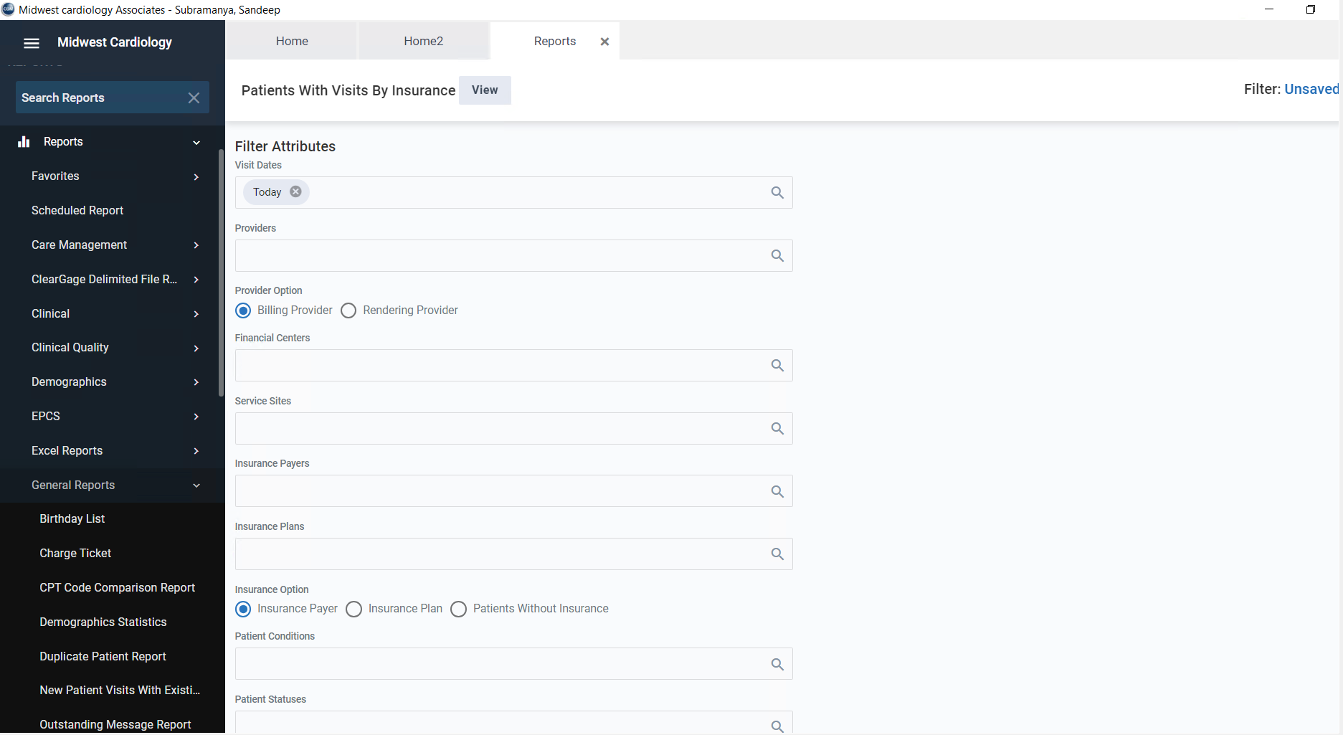

- Navigate to Reports > Reports > General Reports > Patients By Insurance
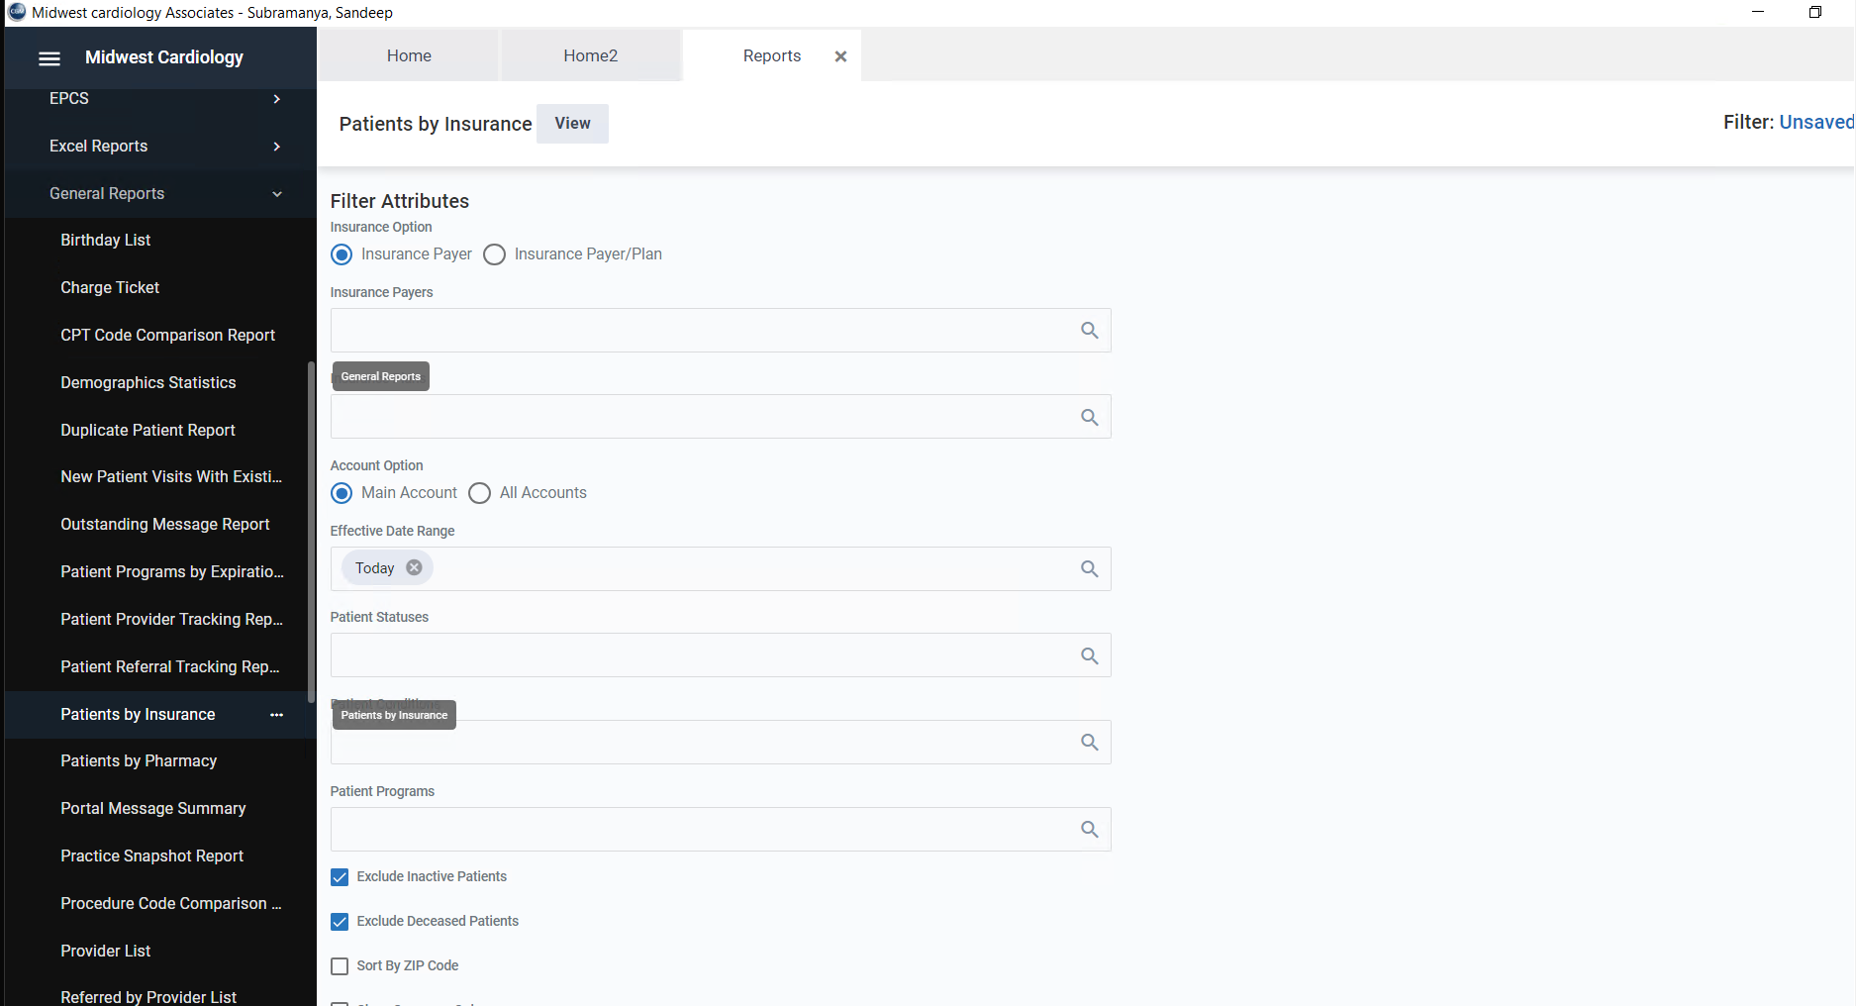

- Apply the filter as shown below, (all accounts, Effective Date Range – past 1 year, exclude, inactive, exclude deceased patients**** (This is important filter) ) and click on view, then the report will open in new tab, export the report as excel
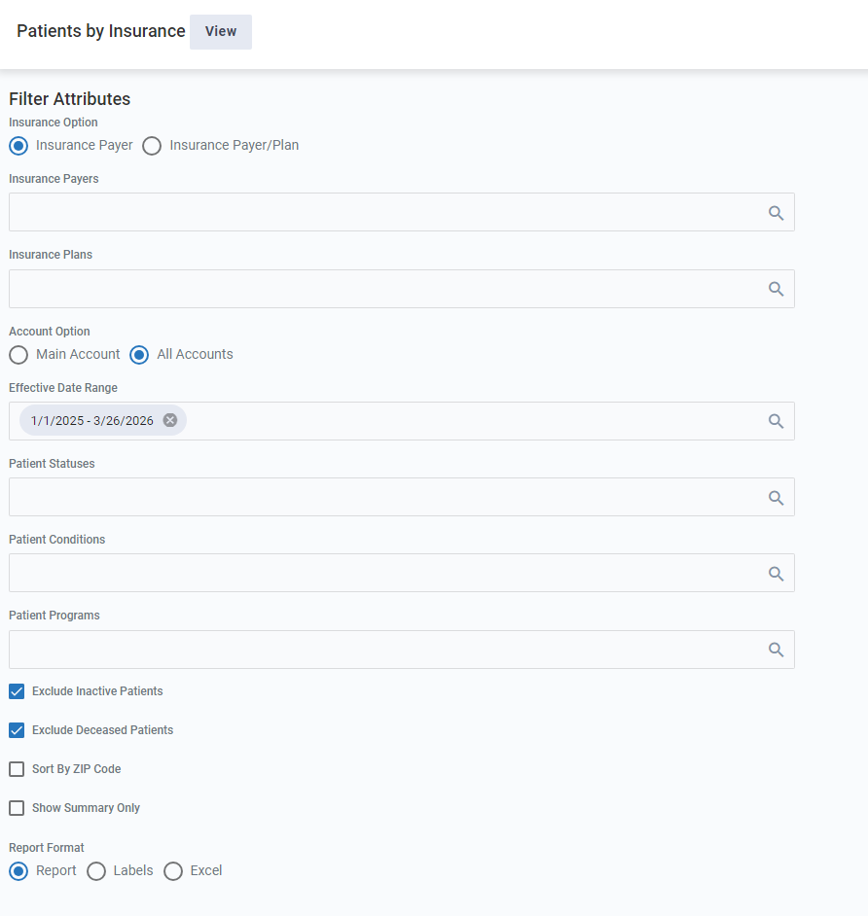

Patients By Diagnosis (Diagnosis and ICD Codes)
- Navigate to Reports > Reports > Clinical
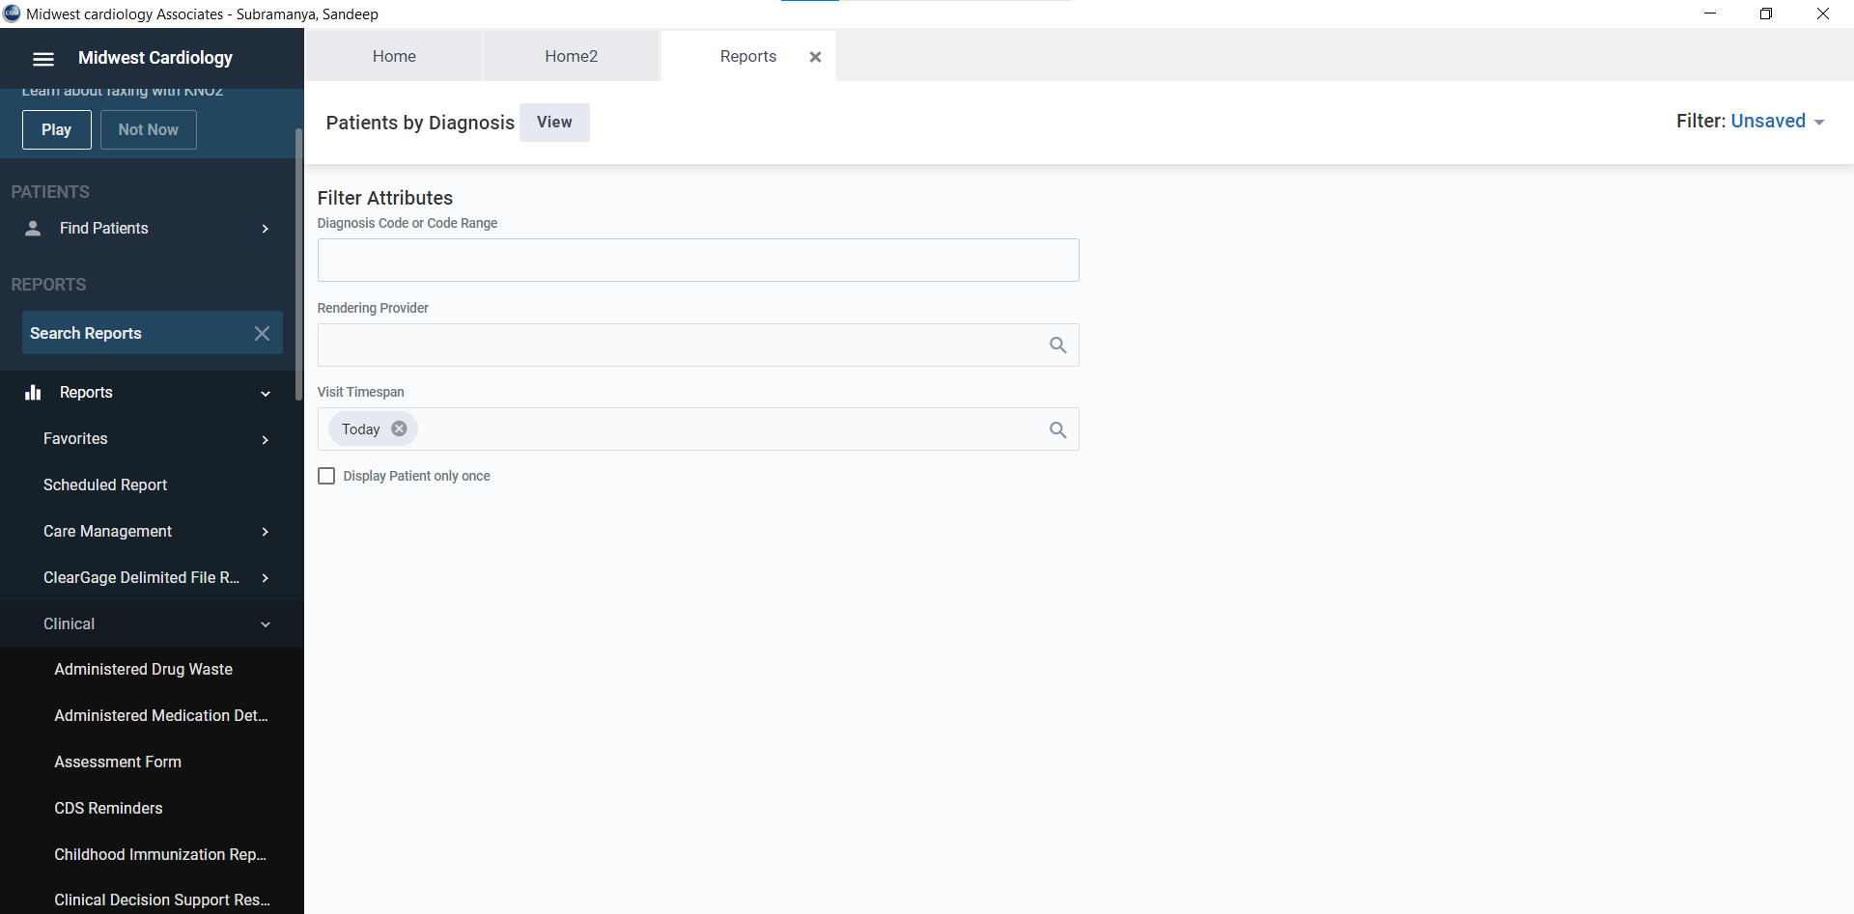

- Navigate to Reports > Reports > Clinical > Patient By Diagnosis and apply as shown in filter, and click on view, then the report will open in new tab, export the report as excel.
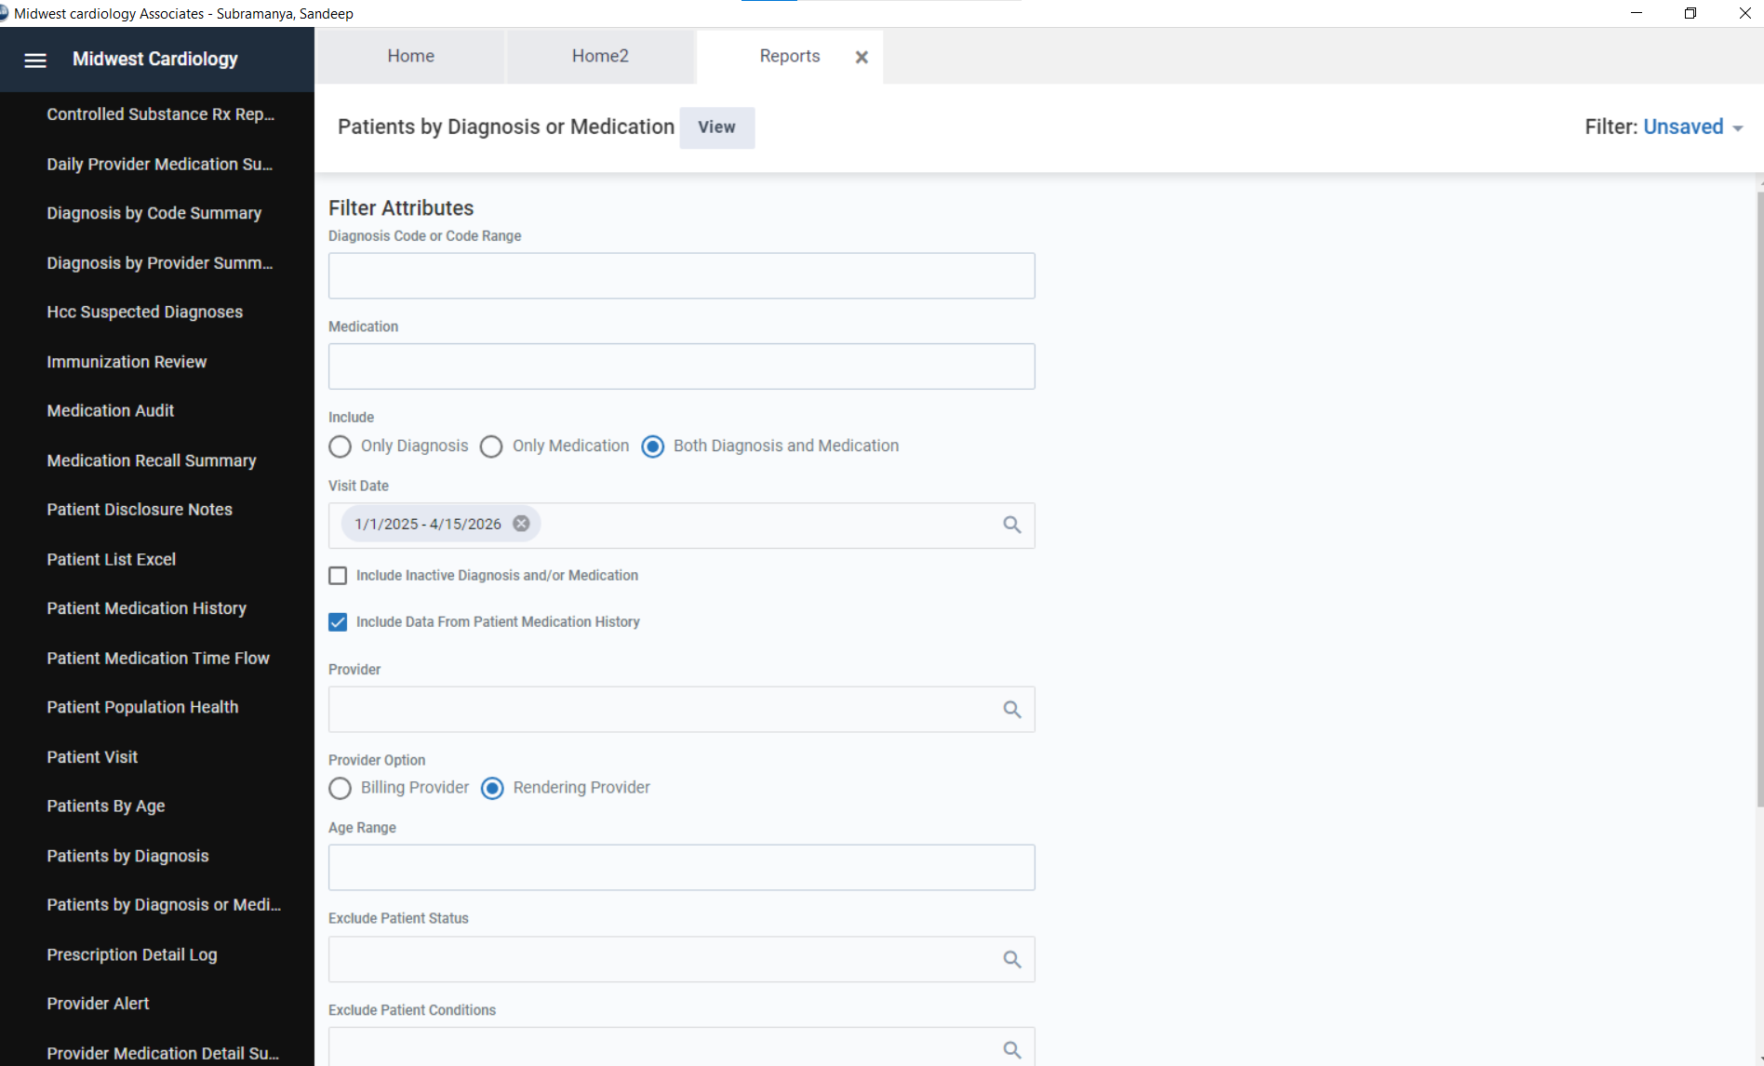

Patients-List (All Patients Demographic data)
- Navigate to Manage Patients > Patient Center
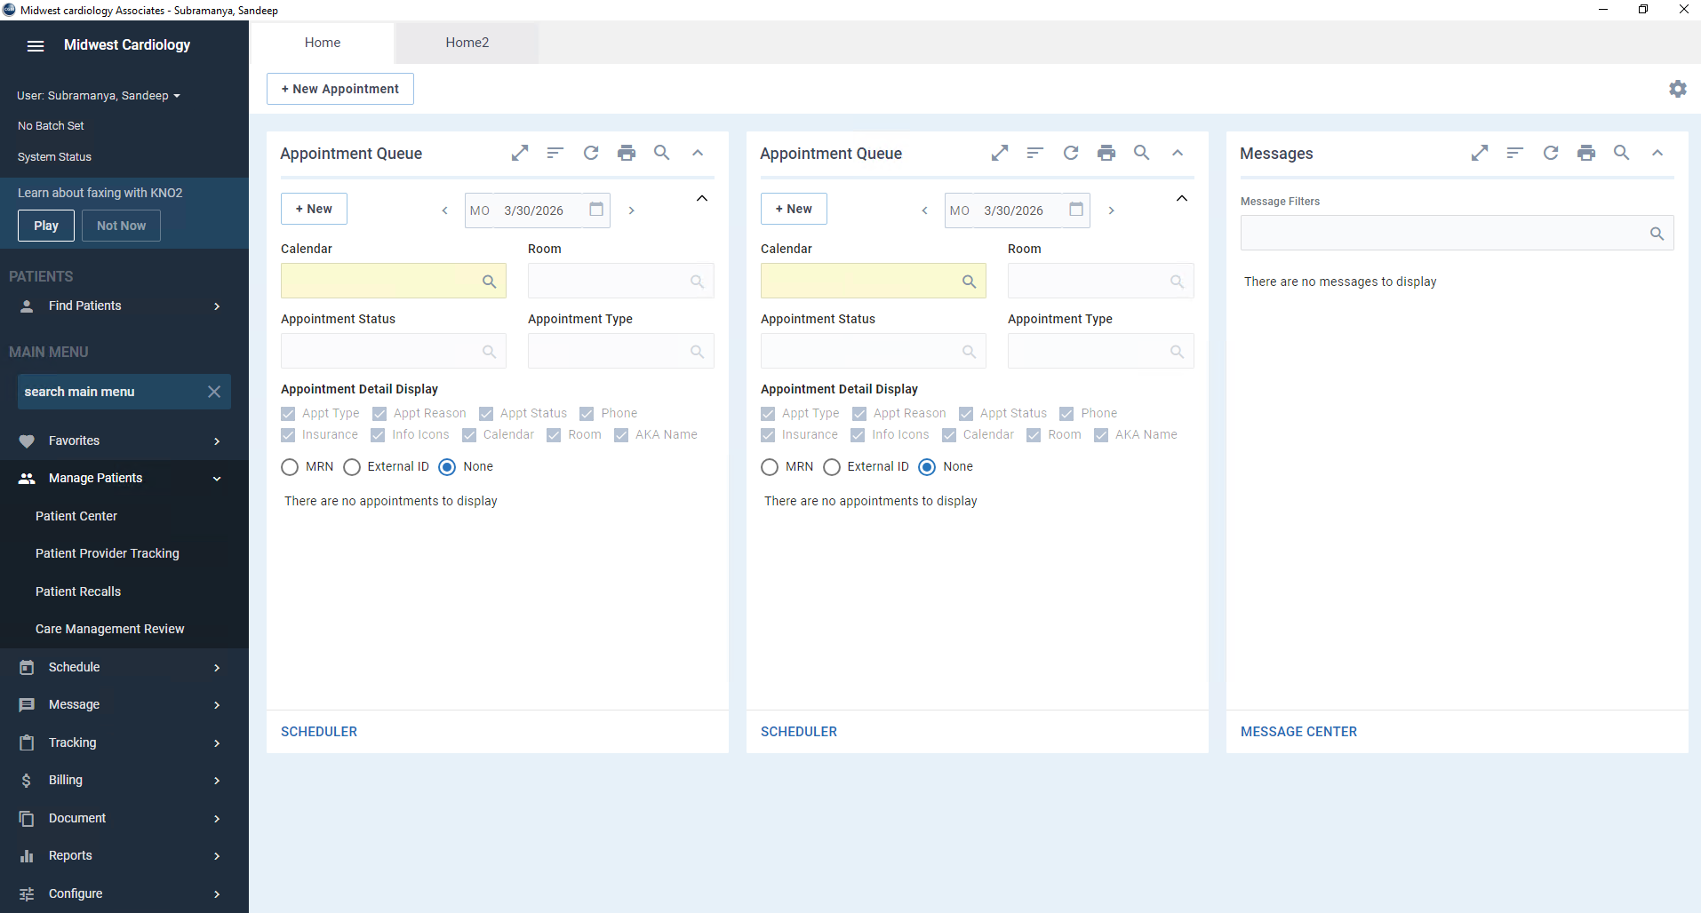

- Enter the page limit to -1 for all list and click search
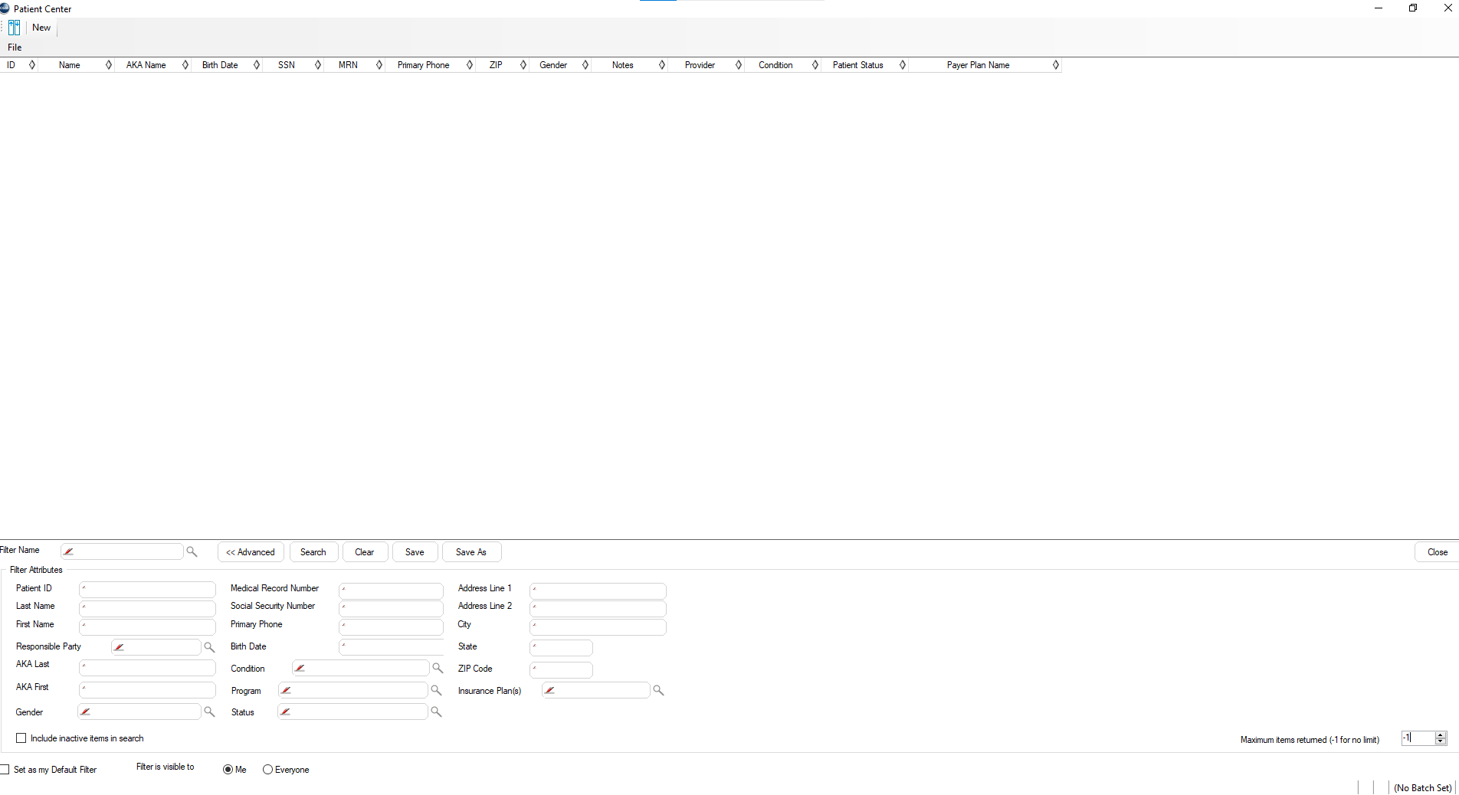
- File > Export To Excel…
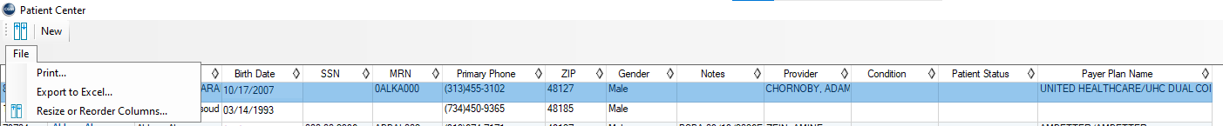
- Important save the file name as shown in below

Appointment Report (Next Visit Details)
- Navigate to Reports > Reports > Scheduling Reports
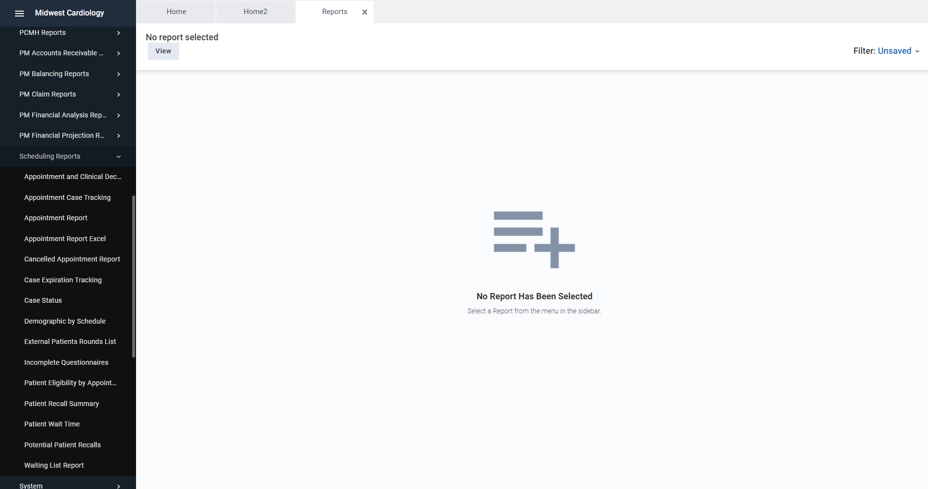
- Navigate to Reports > Reports > Scheduling Reports > Appointment Report
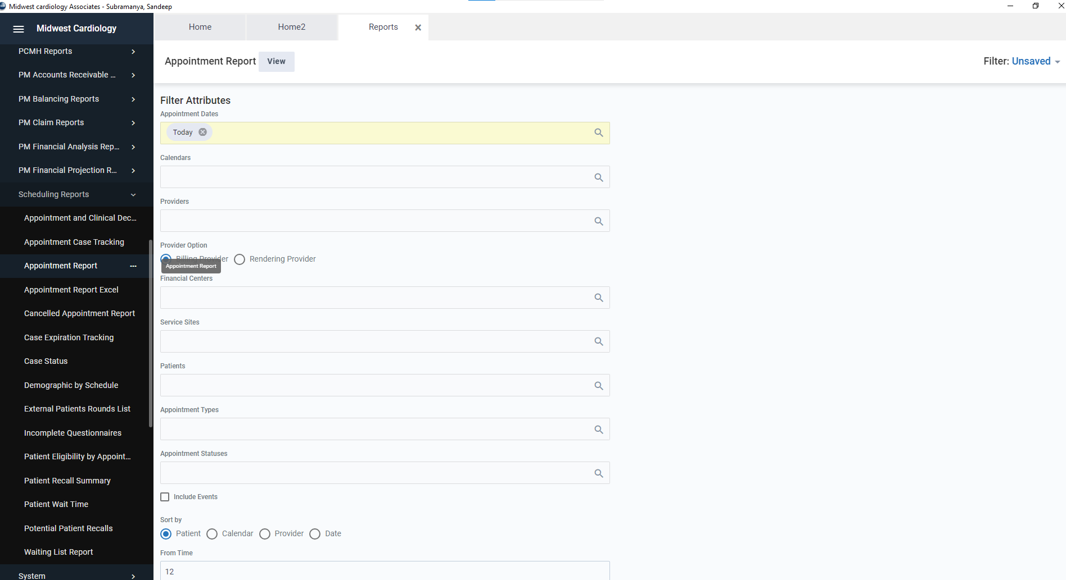
- Apply filter as shown below (Appointment Dates past 1 year), and click on view, then the report will open in new tab, export the report as excel.
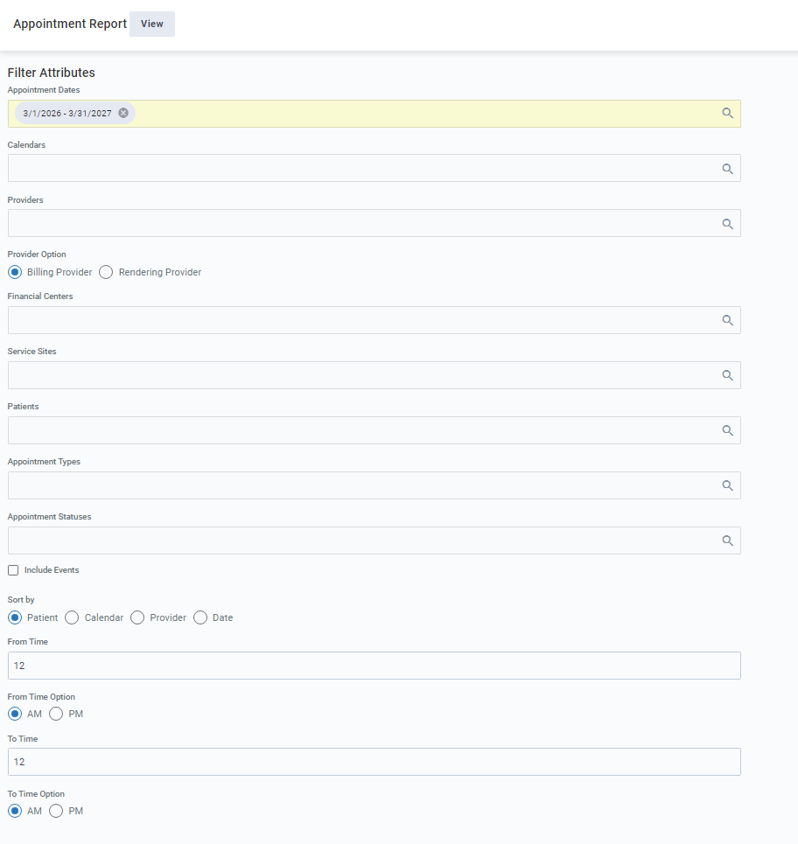

Copay Report (Copay Details)

- Navigate to Reports > Reports > PM Financial Analysis Reports
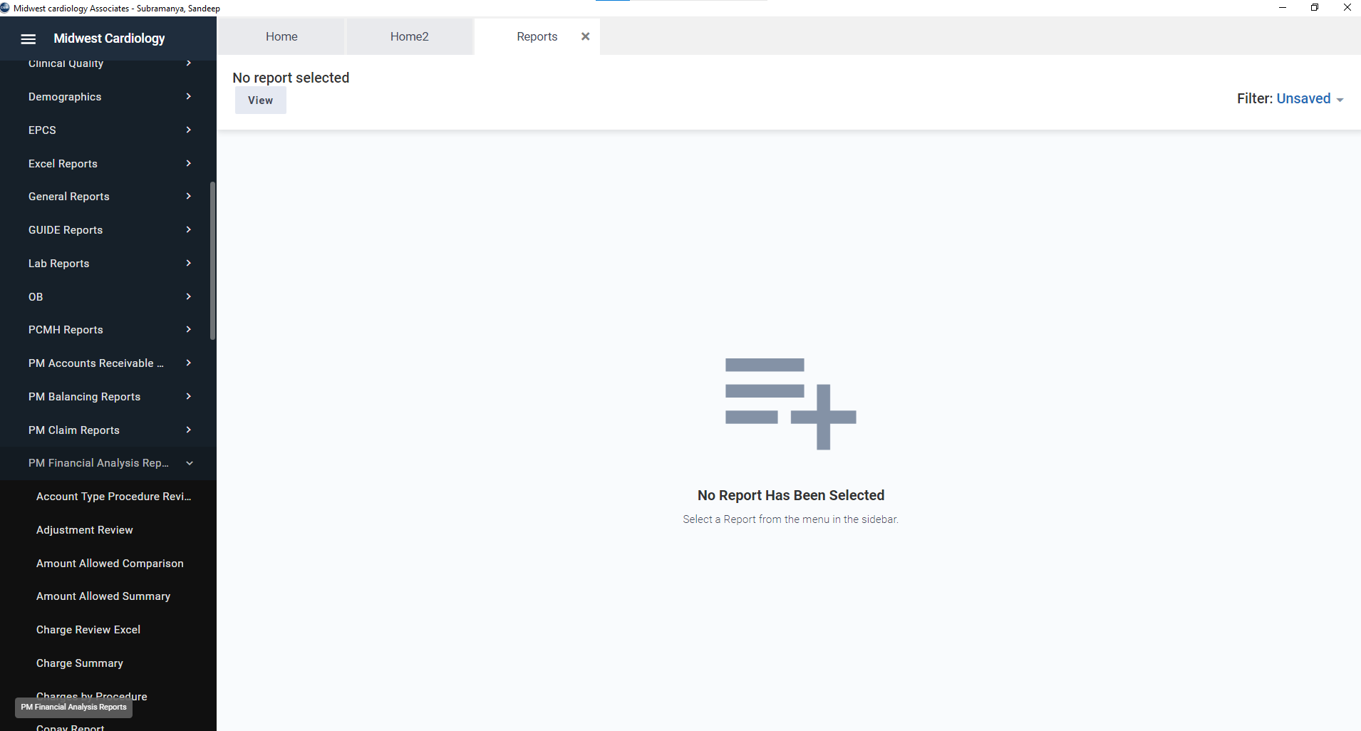
- Navigate to Reports > Reports > PM Financial Analysis Reports > Copay Report
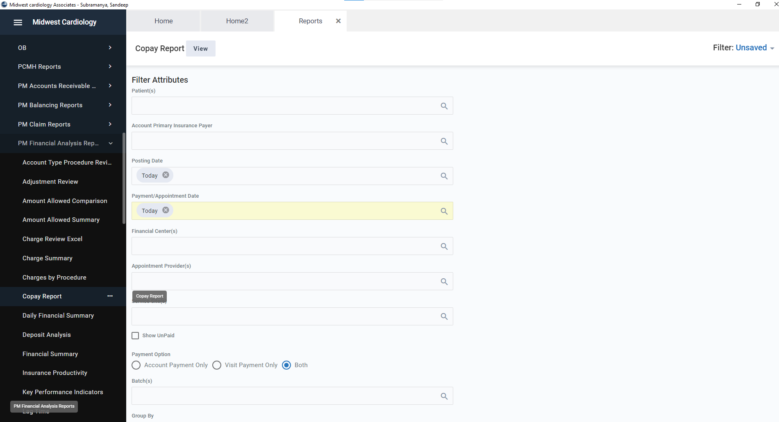

- Apply the filter as shown below (Payment/Appointment date past 1 year)
