Gabi Ballardo

ENVIRON 859

2 November 2022

Problem Set 4

Task 4:

Result for shapefile:

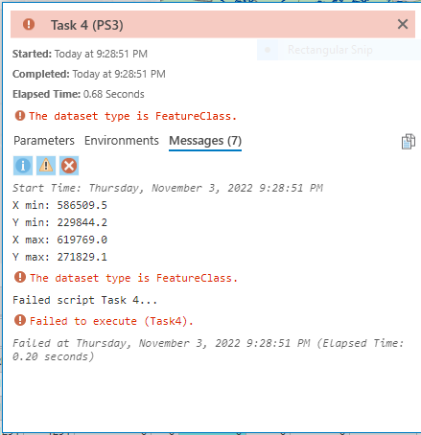

Result for raster dataset:

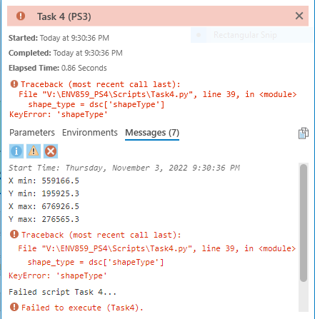

Task 5:

