Marked on Paper, Unmarked in Practice? Stress-Testing Audio Watermarks for AI Music Against the EU AI Act
Table of Contents
Part I. Document on Watermark Testing (lead: Antonia) 3
1. Purpose and Research Questions (Antonia) 3
2. How the AI Songs Were Created (Griffin; summary) 4
3. Watermarks (Antonia) 5
4. Attacks (group; written up by Antonia) 7
5. Measures and Decision Rules (Antonia) 8
6. Results (group data; analysis by Antonia) 9
7. Limitations and Next Steps (Antonia) 13
Part II. Policy White Paper: My Sections 14
A. Technical Section: Watermarks, Method, and Results (Antonia) 14
B. From Mark to Label: Does Labeling Work, and for Whom? (Antonia) 15
C. EU Section (for the final project: Antonia, Kelly, Diya) 17
D. Comparison with California (Griffin) and China (Yinuo) 19
E. Gaps (final project: group, all) 20
F. Recommendations (final project: group, all) 21
Conclusion 21
AI Use Statement 23
References 23
Appendix A: Code and Data 27
Appendix B: AWARE Results by Song 28
Appendix C: Protocols (from our attacks.md) 29
Appendix D: Notebook Output 29
Appendix E: Terminal Record of My Test Runs 41

Part | Section | Lead
Watermark testing document | Purpose, watermarks, measures, results, limitations | Antonia
Watermark testing document | How the AI songs were created | Griffin
Watermark testing document | Attacks (edit list and scripts) | Group
Policy white paper | Technical section (watermarks, method, results, robustness, imperceptibility) | Antonia
Policy white paper | EU | Antonia, Kelly, Diya
Policy white paper | California | Griffin
Policy white paper | China | Yinuo
Policy white paper | Background, gaps, recommendations | Group
Code | AWARE test, model availability check, results notebook | Antonia
Code | AudioSeal, WavMark, audiowmark, Perth, CRAW, SynthID checks | Teammates

Part I. Document on Watermark Testing (lead: Antonia)

1. Purpose and Research Questions (Antonia)
Since August 2, 2026, the EU AI Act and California's AI Transparency Act have required providers of generative AI systems to mark synthetic content in a way machines can read (Regulation (EU) 2024/1689, Art. 50(2); Chambers, 2026). Both laws assume that a mark survives until someone checks it. Music, however, rarely stays in the form in which it was generated. Songs are compressed for streaming, turned down by platforms, cut into short clips, sped up or slowed down for social media, and split into stems for karaoke and remixes. Neither law says which of these everyday operations a mark must survive.
Why does this matter? The volume of AI music has grown faster than the tools to identify it. In July 2026, Deezer reported that about 90,000 fully AI-generated tracks reach the service every day, more than half of all new uploads (Stassen, 2026). These tracks draw only 1% to 3% of all streams, yet according to Deezer, "up to 85% of the streams generated by fully AI-generated tracks were fraudulent in 2025" (Stassen, 2026). Fraudulent streams draw on the same royalty pool that pays human artists, so marking is a question of fair pay as well as transparency. Platforms handle the problem differently. Deezer began tagging AI-generated music in June 2025 and tagged more than 13.4 million AI tracks that year (Stassen, 2026), while Spotify, unlike its competitors, "doesn't explicitly label AI or AI-assisted music" (King, 2026). The EU grounds its marking duty in the "risks of misinformation and manipulation at scale, fraud, impersonation and consumer deception" (Regulation (EU) 2024/1689, Recital 133, p. 34). Three groups have a stake in the answer: listeners, who have a right to know what they hear; human artists, whose pay and reputation depend on not being confused with or crowded out by synthetic tracks; and platforms, which need a reliable signal to act on. A watermark can serve all three only if it survives the way music actually circulates, and that is what we tested.
Our project partner, the RIAA, asked us to test in practice which audio watermarks survive realistic edits, how audible they are, and which laws depend on them (RIAA project brief, personal communication, November 2026). Music is a harder case than speech. It covers a wider frequency range, and "even subtle watermark-induced perturbations can degrade perceived musical quality" (Yun et al., 2026, p. 1). Most published audio watermarks were nonetheless built and evaluated on speech, and the most systematic benchmark so far, RAW-Bench, finds that neural compression is their hardest challenge (Özer et al., 2025).
Three research questions guide the project. RQ1 asks whether current audio watermarks survive ordinary music processing and at what cost to sound quality. RQ2 asks how the EU, California, and China define "robust" marking. RQ3 asks who gains real power from marking. My working hypothesis was that if routine processing defeats the marks, the "technically feasible" qualifier in both laws turns a transparency duty into formal compliance, so that content is marked on paper but unlabeled in practice. Part I answers RQ1; Part II carries the results into RQ2 and RQ3.

2. How the AI Songs Were Created (Griffin; summary)
We generated eight instrumental and vocal tracks with Google Flow Music, the service that was called ProducerAI until April 20, 2026, when Google renamed it and described it as "still powered by Gemini and Lyria 3" (Romero, 2026). Our repository records the model as Lyria 3.5. We wrote four prompts covering contrasting musical textures (dense Berlin techno, sparse solo piano, indie pop with a female lead vocal, and slow ambient pads) and kept two takes of each (Table 1). All files are 48 kHz stereo WAV and between 2:29 and 3:02 long. Only the pop prompt asked for vocals, which matters for the vocal-removal edit described in Section 4.
Because the tracks come from Google's generator, they already carry Google's SynthID watermark. Google states that "All tracks generated in the Gemini app are embedded with SynthID" (Yawili & Hamed Torres, 2026), and our own checks in Gemini confirmed SynthID on all four tracks we tested. Every open-source watermark we added therefore sits on top of an existing mark. This mirrors how AI music circulates in reality, but it also means our results describe marks in a crowded signal, not in clean audio.
Track | Style (prompt) | Length | Vocals
lyria_ambient_1 / _2 | Evolving ambient pads, rain textures, no drums | 2:29 / 2:53 | No
lyria_dense_1 / _2 | Berlin techno, about 132 BPM, acid line | 2:56 / 3:02 | No
lyria_pop_1 / _2 | Indie pop, 110 BPM, female lead vocal | 2:58 / 2:47 | Yes
lyria_sparse_1 / _2 | Solo piano, 70 BPM, close-mic | 2:46 / 2:41 | No
Table 1. Test corpus. Lengths computed from the WAV files; prompts from the repository file attacks.md.

3. Watermarks (Antonia)

3.1 What a watermark does
Two technical approaches are often mixed up in policy debates. A watermark hides a signal in the sound itself. Provenance metadata, such as C2PA Content Credentials, leaves the sound untouched and attaches a signed record to the file; as T. M. Liu (2026) puts it, "Rather than altering the content, they attach a record alongside it." The difference matters because the two fail in different ways. A watermark travels with the audio when the file is re-saved but can be damaged by edits to the sound, while metadata is unaffected by edits to the sound but disappears whenever a program writes a new file.
Watermarks also differ in when they are applied. A post-hoc watermark is added after the music has been generated, so "the post-hoc watermarking step can be bypassed or ignored" (Yun et al., 2026, p. 1). A generative watermark is built into the way the model produces the audio, which is the approach MusicMark proposes for music (Yun et al., 2026) and the approach Google takes with SynthID in its own generator (Yawili & Hamed Torres, 2026).
Finally, a detector can answer two different questions. The first is whether a mark is present at all, usually a score compared with a threshold. The second is what the mark says, meaning whether its hidden message (the payload bits, which can encode a provider or file ID) can be read back intact. The distinction is not only technical. Article 50(2) of the AI Act asks for outputs "detectable as artificially generated" (p. 82), which is a detection question, while California requires a latent disclosure that carries the provider's name, the system name and version, the time of creation, and a unique identifier (Chambers, 2026), which is a payload question. We therefore recorded both outcomes for every test.

3.2 Which watermarks we tested
We started from the ten watermarks named in the RIAA brief and ran every one for which a usable public model exists (Table 2). The tested set covers three types. SynthID is closed and applied during generation, and it can only be checked by uploading a file to Gemini. AudioSeal, WavMark, Perth, CRAW, and AWARE are neural watermarks added after generation. AudioSeal and WavMark carry 16-bit messages, AWARE 20 bits, and CRAW 10 bits, while Perth returns only a detection score. AWARE is unusual because it does not ship a trained embedding model but optimizes the mark separately for each file, which took three to four minutes per song on a laptop. audiowmark is a classic signal-processing watermark that carries a 128-bit message.
Watermark | Source | Type | Message | Status in our bench
SynthID | Google DeepMind | Closed; in generation | Not readable by users | Tested by hand in Gemini, 4 songs x 9 edits
AudioSeal | San Roman et al. (2024) | Neural, post-hoc, 16 kHz | 16 bits | Tested, 8 songs x 11 edits
WavMark | Chen et al. (2023) | Neural, post-hoc, 16 kHz | 16 bits | Tested, 8 songs x 9 edits
audiowmark | Westerfeld (n.d.) | Signal processing (patchwork) | 128 bits | Tested, 8 songs x 9 edits
Perth | Resemble AI (n.d.) | Neural, post-hoc | Score only | Tested, 8 songs x 10 edits
CRAW | Chernin & Fetaya (2026) | Neural, codec-robust, trained on speech | 10 bits | Tested on 30-second clips, 4 edits
AWARE | Pavlović et al. (2025) | Optimized per file, 16 kHz | 20 bits | Tested, 8 songs x 10 edits
WAKE | Xu et al. (2025) | Neural | n/a | Not testable: no released model
IDEAW | Li et al. (2024) | Neural | n/a | Not testable: no released model
DeAR | C. Liu et al. (2022) | Neural, re-recording resilient | n/a | Not run
Table 2. Watermarks named in the RIAA brief and their status in our bench. Sources: tool papers and repositories; our repository files.

3.3 Two peer-reviewed watermarks nobody outside the lab can test
Two watermarks on the list could not be tested at all. WAKE was presented at Interspeech 2025 (Xu et al., 2025), and its repository promises the model files "upon the acceptance of our paper." More than a year after acceptance, the latest change to the repository dates from May 28, 2025, and no model file has been released. IDEAW was published at EMNLP 2024 (Li et al., 2024); its repository contains training code only, its code expects a model that the user must supply, and its README explains that the final code ran on a company server and "cannot be copied out." We documented both findings with a script that downloads each repository fresh and searches it for model files (check_model_availability.py, run on November 10, 2026; Appendix A).
Training these models ourselves would require a large dataset, a GPU, and weeks of work, and the result would be our model, not the authors'. This is a finding in its own right. Both methods passed peer review on the strength of robustness results that no one outside the authors' labs can reproduce. Article 50(2) ties robustness to "the generally acknowledged state of the art" (p. 82), and I return to this problem in Part II.

4. Attacks (group; written up by Antonia)
We use "attack" for any edit applied to a marked song, whether it is malicious or routine. Our edit list was revised on November 1, 2026, against RAW-Bench (Özer et al., 2025). Where our edits overlap with the benchmark (noise level, volume change, MP3 and AAC compression, time stretching, and polarity inversion), we borrowed its settings so that our AudioSeal results can be compared with the published ones. We did not run RAW-Bench directly, because it cannot test SynthID and its evaluation code had not been released when we designed the tests.
RAW-Bench was built for audio in general, so we added edits that are specific to how music circulates. These are a pitch shift of two semitones, the "slowed + reverb" fan edit, vocal removal with the stem-separation tool Demucs, and 30-second excerpts like those that short-form platforms play. These edits are not exotic. The #slowedandreverb hashtag alone "currently has 735M views on TikTok" (Arevalo, 2022). Table 3 lists every edit with the real-world use it imitates and whether, in my reading, the EU Code of Practice names it as a typical processing operation that marks should withstand.
Edit (ID) | What it does | Real-world analogue | Named in Code Measure 3.3?
MP3 128 kbps (mp3128) | Encode and decode MP3 at 128 kbps | Downloads and re-uploads | yes
AAC 128 kbps (aac128) | Encode and decode AAC at 128 kbps | YouTube, Apple Music, Instagram | yes
Volume -6 dB (gain6db) | Halve amplitude | Platform turns a loud track down | –
30-second excerpt (clip30) | Keep 0:30 to 1:00 | Short-form platforms | –
Noise at 20 dB SNR (noise20db) | Add white noise at 20 dB SNR | Hiss, low-quality capture | –
Polarity inverted (polarity) | Invert the waveform | Mixing accident; inaudible | –
Vocals removed (Demucs) (stemsplit) | Remove vocals with Demucs, keep the rest | Karaoke and instrumental versions | no
Tempo +5% (timestretch5) | Tempo +5%, pitch unchanged | DJ tempo matching | yes
Speed +10% (tempo and pitch) (speedup10) | Play 10% faster | "Sped up" short-form edits | partly
Speed -15% plus reverb (slowreverb) | Play 15% slower, add reverb | "Slowed + reverb" fan edits | partly
Pitch +2 semitones (pitch2) | Raise pitch, keep tempo | Key changes in remixes | yes
Table 3. Edits from our attacks.py and attacks.md. Last column from my reading of the Code of Practice, Measure 3.3 (European Commission, 2026a, p. 18); "partly" means the edit combines a tempo change and a pitch change; a dash means I did not assess the edit against the Code.
Two kinds of attack are still missing. We have not yet tested neural-codec re-synthesis, which both RAW-Bench and MusicMark identify as the most damaging case (Özer et al., 2025; Yun et al., 2026, p. 1), and we have not played files aloud and re-recorded them, as the Indicator and WITNESS team did when testing provider detectors (Mantzarlis et al., 2026).

5. Measures and Decision Rules (Antonia)
For each marked song and each edit, we recorded two outcomes. A mark counts as detected when the tool's own detection score reaches its default threshold, which is 0.5 for AudioSeal, AWARE, and Perth in our scripts. For SynthID, which has no public interface, one of us uploaded each file to Gemini in a new chat and asked the same fixed question every time (Appendix C); Gemini answers yes, no, or partial, with a time range. A message counts as exact when every embedded bit is recovered. Bit accuracy near 50% means the message is lost, and accuracy well below 50% means the bits came back inverted. To measure false alarms, we ran every detector on the unmarked original of each song.
To measure audibility, we used ViSQOL v3 in its audio mode at 48 kHz, which compares a reference and a test file and reports a predicted listening-quality score (MOS-LQO) (Chinen et al., 2020). In our runs, two identical files score 4.732, which serves as the practical ceiling.
Eight songs is a small sample, so every result carries real uncertainty. I report Wilson 95% intervals (Table 5). They show that a difference between 5 of 8 and 3 of 8 songs is within noise, while a difference between 8 of 8 and 0 of 8 is not. My October plan had included a logistic regression, but with only eight songs and many results at exactly 0 or 8, the model cannot be estimated meaningfully, so the analysis stays descriptive.

6. Results (group data; analysis by Antonia)
Table 4 summarizes all tests. Each cell shows on how many of the tested songs a mark was detected or its full message recovered. Five findings stand out.
Edit | Code 3.3 | SynthID  detected | AudioSeal  detected | AudioSeal  exact | WavMark  exact | audiowmark  exact | Perth  detected | AWARE  detected | AWARE  exact | CRAW exact  (30 s)
No edit | n/a | see note | 8/8 | 5/8 | 8/8 | 8/8 | 8/8 | 8/8 | 8/8 | 8/8
Control (unmarked original) | n/a | 0/1 (Suno) | 0/8 | 0/8 | 0/8 | 0/8 | 1/8 | 0/8 | 0/8 | 0/8
MP3 128 kbps | yes | 4/4 | 8/8 | 5/8 | 8/8 | 8/8 | 8/8 | 8/8 | 8/8 | 8/8
AAC 128 kbps | yes | not run | 8/8 | 4/8 | not run | not run | 8/8 | 8/8 | 8/8 | not run
Volume -6 dB | – | 4/4 | 8/8 | 5/8 | 8/8 | 8/8 | 8/8 | 8/8 | 8/8 | 8/8
30-second excerpt | – | 4/4 | 8/8 | 3/8 | 8/8 | 8/8 | 8/8 | 7/8 | 8/8 | not run
Noise at 20 dB SNR | – | 3/4 + 1 partial | 8/8 | 3/8 | 5/8 | 8/8 | 8/8 | 8/8 | 8/8 | 6/8
Polarity inverted | – | 4/4 | 7/8 | 0/8 | 8/8 | 8/8 | 8/8 | 8/8 | 8/8 | 8/8
Vocals removed (Demucs) | no | 4/4 | 8/8 | 5/8 | 8/8 | 8/8 | not run | not run | not run | not run
Tempo +5% | yes | not run | 0/8 | 0/8 | not run | not run | 8/8 | 8/8 | 8/8 | not run
Speed +10% (tempo and pitch) | partly | 4/4 | 0/8 | 0/8 | 8/8 | 0/8 | 3/8 | 0/8 | 0/8 | not run
Speed -15% plus reverb | partly | 4/4 | 0/8 | 0/8 | 0/8 | 0/8 | 1/8 | 0/8 | 0/8 | not run
Pitch +2 semitones | yes | 4/4 | 0/8 | 0/8 | 0/8 | 0/8 | 3/8 | 0/8 | 0/8 | not run
Table 4. Survival matrix: songs on which the mark was detected or its full message recovered, out of the songs tested. Green means all, amber some, red none; on the control row, green means no false alarm. SynthID clean files were checked separately (findings.md). Stem split is missing for Perth and AWARE because Demucs was not installed. Perth was run with the group's unchanged run_perth.py. AWARE: 8 songs. Sources: result files in our repository.
Result | 0/8 | 1/8 | 3/8 | 5/8 | 7/8 | 8/8
Wilson 95% interval (%) | 0–32 | 2–47 | 14–69 | 31–86 | 53–98 | 68–100
Table 5. Wilson score intervals for eight songs (computed in draft_tables.ipynb, Appendix D).
Everyday distribution edits are survived. After MP3 and AAC compression and a volume cut, every tool found or read its mark on every song we tested. After the 30-second cut, every tool did so on every song but one (AWARE on ambient_2). The hidden message was less stable than the mark itself. AudioSeal recovered its full message on only five of eight songs after MP3 compression and four of eight after AAC, although it detected the mark on all eight.
Pitch is the shared blind spot of the open-source marks. After a pitch shift of two semitones, AudioSeal, WavMark, audiowmark, and AWARE recovered nothing on any of the eight songs, and Perth detected its mark on only three. The slowed + reverb edit was just as damaging, with zero of eight for AudioSeal, WavMark, audiowmark, and AWARE, and one of eight for Perth. The tools did not fail in identical ways. WavMark kept its full message on all eight songs after a 10% speed-up, and Perth and AWARE survived the 5% tempo stretch that defeated AudioSeal on every song. Changing pitch, however, defeated every open-source mark that we could run on that edit, either completely or on most songs.
The closed mark survived everything. SynthID was detected on all 36 edited files, including after the pitch shift, the speed changes, and vocal removal. It was found across the full length of 35 files and partly on one (sparse_1 with added noise, detected from 0:00 to 2:42 of 2:46). Gemini also answered "not detected" for a Suno track made from the identical pop prompt, which shows that it detects Google's mark specifically and not AI-generated pop in general.
This comparison has limits. SynthID was tested on four songs rather than eight, with nine edits, and Gemini reports only a verdict, not a score, so we cannot see how close a file came to the detection threshold or what else Gemini may weigh in its answer. The result shows that a robust music watermark exists, not how much more robust SynthID is than the open-source marks.
A mark can be present without being readable, and the reverse. After polarity inversion, an edit that is inaudible, AudioSeal detected its mark on seven of eight songs but recovered the exact message on none; only 16% of the bits were correct, which means they came back flipped. Even without any edit, AudioSeal's exact message came back on only five of eight songs, and our shortcut test ruled out our embedding method as the cause. AWARE showed the opposite case. On ambient_2 after the 30-second cut, its confidence was only 0.28, below the threshold, yet all 20 bits were correct. I call this the detection–payload gap, and it matters because California's disclosure depends on the payload, not only on detection.
False alarms were rare but not absent. Perth scored 0.85 on the unmarked original of sparse_2, above its 0.5 threshold, while the other seven unmarked originals scored between 0.03 and 0.39. No other tool raised a false alarm. One case in eight is weak evidence (the Wilson interval runs from 2% to 47%), so it should be rechecked on human-made music. Still, a false positive is not a technical footnote. It would label a human artist's work as machine-made.
Audibility was not the bottleneck. AudioSeal-marked files scored 4.723 to 4.729 against 4.732 for an identical file, while a single MP3 encode at 128 kbps cost up to 0.77 points (Table 6). In other words, one ordinary compression step changes the sound far more than the watermark does. AWARE's mark is more audible than AudioSeal's, with scores ranging from 4.587 (sparse_1) to 4.718 (dense_2). On six of the eight songs, the AWARE mark cost less than one MP3 encode. On the two solo-piano tracks it cost more, probably because quiet, sparse passages leave little sound in which to hide a mark.
Track | Identical | AudioSeal marked | AWARE marked | MP3 128 kbps | MP3 loss
lyria_ambient_1 | 4.732 | 4.727 | 4.697 | 3.961 | 0.77
lyria_ambient_2 | 4.732 | 4.727 | 4.699 | 4.136 | 0.60
lyria_dense_1 | 4.732 | 4.728 | 4.699 | 4.488 | 0.24
lyria_dense_2 | 4.732 | 4.729 | 4.718 | 4.571 | 0.16
lyria_pop_1 | 4.732 | 4.728 | 4.683 | 4.382 | 0.35
lyria_pop_2 | 4.732 | 4.728 | 4.700 | 4.428 | 0.30
lyria_sparse_1 | 4.732 | 4.723 | 4.587 | 4.634 | 0.10
lyria_sparse_2 | 4.732 | 4.728 | 4.708 | 4.729 | 0.00
Table 6. ViSQOL v3 audio mode (MOS-LQO) on the same 30-second excerpt (0:30 to 1:00), from aseal/visqol_results.csv and aware/visqol_aware_results.csv. Higher is better; 4.732 is the identical-file score.
The provenance metadata was the weakest layer of all. Gemini reported the C2PA credentials on the original Flow Music downloads as "present but invalid" and found none after any of our edits (Table 7). That second result says little about the edits themselves, because our tools write new files that contain only audio. It does show, however, how easily the metadata layer disappears in ordinary handling. In an additional check during testing, simply copying the audio into a new container without re-encoding it removed the credential, while the title and artist tags survived; we will confirm this with the official c2patool.
File | C2PA verdict | Source
Flow Music original (Lyria) | Present but invalid | Gemini, findings.md
Same file after any of our edits | Not present | Gemini, findings.md
Same audio, lossless remux (no re-encode) | Credential gone; title and artist tags kept | Check during testing; to be confirmed with c2patool
Suno original (control) | Present but invalid | Gemini, findings.md
Table 7. Provenance metadata checks. That Gemini gave two providers the identical verdict may mean Gemini cannot validate audio C2PA (findings.md).

7. Limitations and Next Steps (Antonia)
Our results come from eight songs, one generator, mostly instrumental music, the tools' default settings, and one run per tool. SynthID could only be checked by hand in Gemini, which allows about ten audio checks per day per account (attacks.md) and gives no score, only a verdict. Our open-source marks were added on top of SynthID, vocal removal is still missing for Perth and AWARE, and CRAW ran only on 30-second clips. Most importantly, we have not yet tested neural-codec re-synthesis, which RAW-Bench identifies as the hardest challenge (Özer et al., 2025).
Before the final submission on December 10, we plan to add a human-made control track for SynthID and Perth, install Demucs for the missing vocal-removal tests, compute ViSQOL scores for WavMark and audiowmark, confirm the C2PA result with c2patool, and add one neural-codec edit. None of these steps is likely to change the main pattern, but they would close the gaps a skeptical reader will notice first.

Part II. Policy White Paper: My Sections

A. Technical Section: Watermarks, Method, and Results (Antonia)
For readers outside audio engineering, a useful picture is a banknote. A watermark is like a pattern woven into the paper, while a C2PA credential is like a signed receipt stapled to it. If the note is photocopied, the weave usually survives and the receipt is gone. If the paper is stretched, the weave may tear. Our tests asked, for eight AI-generated songs and up to eleven everyday edits, whether the weave could still be found and whether its message could still be read (Part I, Sections 4 to 6).
Table 8 condenses the results into the three marking layers that Recital 133 of the AI Act lists as possible techniques (p. 34). Each layer failed in a different way. Open-source watermarks survived compression and volume changes but failed when pitch or tempo changed. Google's watermark survived every edit we made. C2PA metadata survived nothing that rewrote the file. Fingerprinting and logging were outside our test.
Layer | How it works | Survived in our tests | Failed in our tests | Hook in the AI Act
Open-source watermark | Signal added to the audio after generation | Compression, volume, trimming, most polarity | Pitch, slowed + reverb, often speed | Recital 133: "watermarks" (p. 34)
Closed watermark in generation (SynthID) | Signal from Google's generator | All nine edits | Not yet tested on neural codecs or human controls | Same
Provenance metadata (C2PA) | Signed record inside the file | Nothing that rewrites the file | Every re-save, even a lossless remux | Recital 133: "metadata identifications, cryptographic methods" (p. 34); can be re-linked by a watermark
Fingerprinting and logging | Provider stores a record of each output | Not tested | Not tested | Recital 133: "logging methods, fingerprints" (p. 34)
Table 8. Three layers, three failure patterns (my synthesis of Tables 4 and 7 and Regulation (EU) 2024/1689, Recital 133).
Because the layers fail differently, they are more useful together than alone. Mantzarlis et al. (2026), who examined thirteen AI providers and tested their public detection tools, conclude that "No single signal is reliable on its own" and that watermarks "can help identify origin and potentially reattach content credentials that have been stripped." The C2PA standard already describes this mechanism, which it calls a soft binding, as a way to "recover C2PA Manifests using an invisible watermark embedded in an asset" (Coalition for Content Provenance and Authenticity [C2PA], n.d., Section 1.2.1.1). Our results suggest that this only works if the watermark itself survives, which in our test was true for SynthID but not for the open-source marks after pitch and tempo changes.
Two broader points frame these results. First, robustness and audibility barely traded off in our data. AudioSeal's mark was almost inaudible to ViSQOL, and AWARE's mark cost less than an ordinary MP3 encode on most songs, with quiet solo piano as the exception, so the binding constraint is robustness. Second, watermarks are not a complete answer to AI deception. Susser et al. (2026, Section 3.2) note that "Skeptics warn that watermarks are brittle," and they propose judging marks by what they reveal about a media ecosystem as a whole rather than by whether they can prove the origin of every single file. Lisinska (2024) argues that watermarking offers "little value" in urgent cases such as voice fraud. Our results support a middle position. Watermarks can carry useful information through most of a song's ordinary life, but not through all of it, and not equally for every provider.

B. From Mark to Label: Does Labeling Work, and for Whom? (Antonia)

B.1 The chain from mark to label
A watermark is only the first link in a longer chain. For a mark to protect anyone, it has to survive the song's distribution, a detector has to find it, a platform has to turn the result into a visible label, and listeners have to respond to that label in a way that changes what they believe, stream, or pay for. Our tests cover only the first two links. They show where the chain breaks first for music. Open-source marks are lost when a song is sped up, slowed down, or shifted in pitch, which are the edits that carry songs across short-form platforms (Arevalo, 2022). The third link depends on platforms, and they differ. Deezer tags AI music, while Spotify does not label it (King, 2026; Stassen, 2026). California will require large online platforms to detect and show provenance data from January 1, 2027 (Chambers, 2026), whereas Article 50 of the AI Act places its duties on providers and deployers, not on the platforms where most listening happens.

B.2 What labels do to listeners
The fourth link is the listener. The strongest experimental evidence comes from Wittenberg et al. (2025), who tested labels on misleading AI-generated images with 7,579 Americans. All labels they tested "significantly decreased participants' belief in the presented claims" (p. 1), but labels that only said content was AI-generated "tended to have little impact" on whether people would engage with it (p. 1). Labels therefore change what people believe more than what they do, which matters for music, where the relevant behavior is streaming. The study also warns about incomplete labeling. When only some content carries a label, unlabeled content may gain credibility, an "implied authenticity" effect, while labels wrongly applied to reliable content "could degrade trust in authentic information" (Wittenberg et al., 2025, p. 8).
Both risks appear in our data. A pitch-shifted or slowed-down song whose mark has disappeared does not simply go unlabeled; next to labeled songs, it may look more trustworthy than before. Perth's false alarm on an unmarked file points to the reverse case. If the same error occurred on a human recording, a human artist's song would carry an AI label. The study used images and an American sample, so its effects on music still need to be tested. Still, it shows that labeling works only as well as the marks are complete and accurate, which is exactly what our tests measure.

B.3 Who gains power from marking? (RQ3)
The justice framework from my first reflective essay judges a creative system by whether people have "a genuine opportunity to participate and meaningful authority over the use, representation, and value of their work and identity." It yields three tests. Access asks who can verify a mark. In our tests, verification was free but fragmented. SynthID could only be checked through Gemini, at about ten audio checks a day, and provider detectors mostly recognize only their own content (Mantzarlis et al., 2026). Agency asks who controls the mark. The provider decides whether and how to mark, two peer-reviewed methods (WAKE and IDEAW) keep their models inside the authors' labs, and a watermark identifies the output, not the human works a model was trained on. Value asks who benefits financially. Detection changes who is paid only if platforms act on it, for example by keeping fraudulent streams out of the royalty pool (Stassen, 2026). On all three tests, power currently sits with the largest providers. This is what I mean by proprietary compliance. The marks that work best are the ones that only their owners can check.

C. EU Section (for the final project: Antonia, Kelly, Diya)

C.1 The legal obligation
Article 50(2) of the AI Act requires providers of AI systems "generating synthetic audio, image, video or text content" to "ensure that the outputs of the AI system are marked in a machine-readable format and detectable as artificially generated or manipulated" (Regulation (EU) 2024/1689, p. 82). The same paragraph requires the technical solutions to be "effective, interoperable, robust and reliable as far as this is technically feasible," taking into account "the costs of implementation and the generally acknowledged state of the art" (p. 82). Recital 133 names possible techniques, including "watermarks, metadata identifications, cryptographic methods for proving provenance and authenticity of content, logging methods, fingerprints or other techniques" (p. 34). Breaches can lead to fines of up to EUR 15 million or 3% of worldwide annual turnover (Art. 99(4)(g), p. 115), and the rules apply from August 2, 2026 (Art. 113, p. 123).
A second provision matters especially for music. Under Article 50(4), deployers who publish deep fakes must disclose them, but where the content is part of an "evidently artistic, creative, satirical, fictional" work, disclosure is limited to "an appropriate manner that does not hamper the display or enjoyment of the work" (p. 82). For AI music, the visible label can therefore be light. That places more of the burden on the machine-readable mark under Article 50(2), and it makes the robustness of that mark more important for music than for many other kinds of content.

C.2 The Code of Practice and the Digital Omnibus
The AI Office supports these duties with a Code of Practice on transparency of AI-generated content, published in its final version on June 10, 2026, and signed by about 190 organizations by the end of July 2026 (European Commission, 2026b). The Code is voluntary, but the Commission stresses that "the transparency requirements under article 50 of the AI Act are legal obligations" (European Commission, 2026b). Measure 3.3 asks for robustness against "typical processing operations," including "(re)compression," time stretching, and pitch shifting (European Commission, 2026a, p. 18). The Code also concedes that relevant interoperability standards "are yet to be developed" (p. 18), and it lets providers test their solutions against "internal benchmarks" (p. 21). It further asks signatories to assess adversarial robustness against "copying, removal, regeneration, and modification attacks on the markings" (as cited in Mantzarlis et al., 2026).
The timeline was adjusted shortly before the obligations began. The Digital Omnibus on AI, Regulation (EU) 2026/1744 of July 8, 2026, gives providers whose systems were already on the market before August 2, 2026, until December 2, 2026, to meet the marking duty in Article 50(2) (Agustinoy & Sala, 2026; Bahr, 2026). Mantzarlis et al. (2026) report the same December 2 deadline. Table 9 summarizes the key dates.
Date | Step
June 13, 2024 | AI Act signed (Regulation (EU) 2024/1689)
June 10, 2026 | Final Code of Practice published
July 27, 2026 | Digital Omnibus on AI in force
August 2, 2026 | Art. 50 applies; California AI Transparency Act operative (Chambers, 2026)
December 2, 2026 | End of transition for systems already on the market
January 1, 2027 | California platform duties begin (Chambers, 2026)
Table 9. Timeline (sources as cited; Art. 113, p. 123).

C.3 What the legal terms mean in a test
The legal text uses five qualities but defines none of them. Table 10 translates each into a test case and sets our evidence next to it. Read this way, the EU standard is partly met and partly empty. Marks are machine-readable and detectable on unedited files, and most survive the compression that dominates distribution. But pitch shifting, which the Code lists as a typical operation, defeated every open-source mark we tested on that edit, while only Google's closed mark survived it. Reliability is undefined, because neither the Act nor, as far as I can see, the Code sets a limit for false alarms on human music. Interoperability is weak, because Google's mark can only be checked through Gemini and the metadata layer disappears on re-saving. And the "state of the art" cannot be verified where peer-reviewed methods have no public model.
Art. 50(2) term | How we tested it | What we found | Gap
"marked in a machine-readable format" | Detector reads the mark on unedited files | All tools found their mark; AudioSeal recovered the exact message on only 5/8 | A mark can be present without its message
"detectable" and "robust" | Detection after the edits in Table 3 | Pitch +2: 0/8 for four open tools, 3/8 Perth; SynthID 4/4 | Pitch shifting is listed as typical processing, yet no open tool survived it reliably
"reliable" | False alarms on unmarked originals; exact message | Perth 1/8 false alarm; AudioSeal polarity 7/8 found, 0/8 exact | No stated false-alarm limit for human music
"interoperable" | Can a third party check it? | SynthID only through Gemini, about 10 checks a day; C2PA lost on re-save | Detectors mostly recognize only their own content (Mantzarlis et al., 2026)
"generally acknowledged state of the art" | Can the state of the art be reproduced? | WAKE and IDEAW: peer-reviewed, no public model | Robustness claims that no one outside the lab can check
Table 10. Translating Art. 50(2) (p. 82) into test cases, with our evidence (Tables 4 and 7).
This leads me to refine my hypothesis. I expected routine processing to defeat the marks so that compliance would become a formality. Our data show something different and, in a sense, more troubling. Robust marking is technically feasible, but in our test only the largest provider achieved it, and only that provider can verify it. The risk is less formal compliance than proprietary compliance, meaning robustness that is real but concentrated in one firm and checkable only through that firm's interface. This links RQ1 to RQ3, because whoever controls the most robust mark also controls the means of checking it.

D. Comparison with California (Griffin) and China (Yinuo)
The three regimes ask different questions of a mark (Table 11). The EU asks for a mark that is machine-readable and detectable but does not say what it must contain. California requires the latent disclosure to carry specific information, namely the provider, the system and version, the time, and a unique identifier (Chambers, 2026), and requires it to be "permanent or extraordinarily difficult to remove" as far as technically feasible (Cal. Bus. & Prof. Code § 22757.3(a)). The California Attorney General's legal advisory summarizes the law as an obligation to provide free detection tools and to mark AI-generated content (California Office of the Attorney General, n.d., p. 6). Because California's disclosure depends on the payload, the detection–payload gap from Part I becomes a legal problem there. China takes the opposite approach for audio and requires an audible label, a voice prompt or rhythmic tone at the start, end, or middle of the content, alongside an implicit label in the file's metadata (CASRAI Editorial Board, 2026). An audible tone is easy to notice and would plausibly survive a pitch shift, although this was not part of our test, but anyone can cut it out.
Question | European Union | California | China
What must the mark carry? | Machine-readable, detectable (Art. 50(2)) | Provider, system and version, time, unique ID (Chambers, 2026) | Generation attributes, provider name or code, content ID (CASRAI Editorial Board, 2026)
Robustness wording | "effective, interoperable, robust and reliable" as far as feasible | "permanent or extraordinarily difficult to remove" as far as feasible | Malicious removal banned; no robustness test (CASRAI Editorial Board, 2026)
Audio rule | None specific | None specific | Audible voice prompt or rhythmic tone (CASRAI Editorial Board, 2026)
Penalty | Up to EUR 15M or 3% (Art. 99(4)(g)) | $5,000 per violation per day (Chambers, 2026) | Under existing laws (CASRAI Editorial Board, 2026)
Table 11. Comparison of the three regimes (Griffin and Yinuo lead the California and China sections).

E. Gaps (final project: group, all)
Taken together, our tests reveal five gaps in the current rules. First, no regime sets a public, music-specific test, so providers judge robustness against their own internal benchmarks (European Commission, 2026a, p. 21). Second, pitch shifting is listed as a typical operation, yet no open-source tool in our test survived it reliably. Third, the laws treat detection and payload as one question, although our results show that they diverge, and California's disclosure depends on the payload. Fourth, verification is bottlenecked at the provider. The most robust mark can only be checked through its owner's interface, with daily limits, and provider detectors mostly recognize only their own content (Mantzarlis et al., 2026). Fifth, no rule addresses false alarms on human music. This matters because labels shape belief. In two survey experiments, all labels tested "significantly decreased participants' belief in the presented claims" (Wittenberg et al., 2025, p. 1). A false AI label on a human artist's song is therefore a real harm, not a statistical curiosity.

F. Recommendations (final project: group, all)
Our evidence supports six recommendations, each addressed to the actor best placed to act on it.
- R1. A public, versioned music robustness benchmark. The AI Office should reference it in any implementing act under Art. 50(7) (p. 83). It should include pitch, tempo, slowed + reverb, stem separation, and neural codecs (Part I, Finding 2; Özer et al., 2025).
- R2. Three numbers instead of one. Providers should report the share of files detected, the share with an intact message, and the false-alarm rate on human music (Findings 4 and 5).
- R3. Verification without gatekeeping. Free, cross-provider checks without daily caps for researchers and rights holders, building on California's requirement of upload, URL, and API access (Chambers, 2026).
- R4. Layer and re-link. Regulators should require that watermarks be paired with C2PA credentials through the standard's existing soft-binding mechanism, so that stripped credentials can be recovered (C2PA, n.d.; Mantzarlis et al., 2026).
- R5. No robustness claim without a testable model. Code signatories should give accredited testers access to their detectors, which would cover SynthID as well as methods like WAKE and IDEAW.
- R6. A label is never a license. Detecting AI music should not be read as permission to use the human works on which the model was trained (Human Artistry Campaign, n.d.). Unlike R1 to R5, this is a normative point rather than a result of our tests.

Conclusion
Our tests answer the first research question with a qualified yes. Current audio watermarks survive most of the ordinary handling a song receives, at little cost to sound quality, but they fail when pitch or tempo changes, and the one mark that survived everything belongs to the largest provider and can only be checked through its own interface. Whether marks then protect listeners depends on links our tests did not cover. Labels lower belief in false claims but barely change engagement, and incomplete labeling can make unlabeled content look authentic (Wittenberg et al., 2025). For the EU, this means that the robustness standard in Article 50(2) is technically achievable but not yet testable, verifiable, or evenly distributed. A public benchmark, separate reporting of detection and payload, and verification without gatekeeping would turn "technically feasible" from a provider's claim into a standard others can check.

AI Use Statement
I used Claude (Opus 5.5, Anthropic) in the Claude app between November 8 and November 10, 2026. I asked Claude to explain how to test audio watermarks in Python and Jupyter; to write test scripts for AWARE and for checking whether WAKE and IDEAW have released models; to check the progress of my AWARE run; to verify citations and page numbers. Claude drafted run_aware.py, run_aware.ipynb, check_model_availability.py, visqol_aware.py, draft_tables.ipynb, and their README files; ran our group's unchanged run_perth.py on our eight tracks in its own computing environment; produced the tables from our result files. I ran the AWARE test, the AWARE ViSQOL test, and the notebook on my own computer, read and revised the draft, and checked the numbers against our result files. The test design, the edit list, and all results other than AWARE come from our group's repository; the research questions and hypothesis come from my October 15 outline.

References
Agustinoy, A., & Sala, M. (2026, July 24). Digital Omnibus on AI has been published. Cuatrecasas. https://www.cuatrecasas.com/en/portugal/intellectual-property/art/digital-omnibus-ai-has-been-published
Arevalo, A. (2022, November 21). Nightcore and slowed & reverb remixes spur a 2010s revival. Chartmetric. https://hmc.chartmetric.com/nightcore-slowed-reverb-tiktok-remix/
Bahr, C. (2026, July 31). EU AI Act deal: Digital Omnibus now in force. Usercentrics. https://usercentrics.com/knowledge-hub/eu-ai-act-high-risk-delay-article-50-transparency-consent/
California AI Transparency Act, Cal. Bus. & Prof. Code §§ 22757–22757.6 (2024, as amended by A.B. 853, 2025). https://leginfo.legislature.ca.gov/faces/codes_displayText.xhtml?lawCode=BPC&division=8.&title=&part=&chapter=25.&article=
CASRAI Editorial Board. (2026, September 20). China's AI regulation: Interim measures to the 2025 labeling rules. CASRAI. https://casrai.org/guides/china-ai-regulation-explained
California Office of the Attorney General. (n.d.). California Attorney General's legal advisory on the application of existing California laws to artificial intelligence [Legal advisory]. California Department of Justice.
Chambers, H. (2026, July 30). California AI Transparency Act: Requirements, deadlines, and compliance steps. OneTrust. https://www.onetrust.com/blog/california-ai-transparency-act-requirements-deadlines-and-compliance-steps/
Chen, G., Wu, Y., Liu, S., Liu, T., Du, X., & Wei, F. (2023). WavMark: Watermarking for audio generation (arXiv:2308.12770). arXiv. https://doi.org/10.48550/arXiv.2308.12770
Chernin, D., & Fetaya, E. (2026). CRAW: Codec robust audio watermarking (arXiv:2609.03107). arXiv. https://arxiv.org/abs/2609.03107
Chinen, M., Lim, F. S. C., Skoglund, J., Gureev, N., O'Gorman, F., & Hines, A. (2020). ViSQOL v3: An open source production ready objective speech and audio metric (arXiv:2004.09584). arXiv. https://doi.org/10.48550/arXiv.2004.09584
Coalition for Content Provenance and Authenticity. (n.d.). C2PA soft binding API (Version 2.3). Retrieved November 10, 2026, from https://spec.c2pa.org/specifications/specifications/2.3/softbinding/Decoupled.html
European Commission. (2026a). Code of practice on transparency of AI-generated content [Final version, June 10, 2026]. https://ec.europa.eu/newsroom/dae/redirection/document/129555
European Commission. (2026b, October 19). Code of practice on transparency of AI-generated content. Shaping Europe's Digital Future. https://digital-strategy.ec.europa.eu/en/policies/code-practice-ai-generated-content
Human Artistry Campaign. (n.d.). Core principles for artificial intelligence applications in support of human creativity & accomplishment. Retrieved September 17, 2026, from https://www.humanartistrycampaign.com/
King, A. (2026, July 28). Spotify won't label AI music—so third-parties are cropping up to categorize it instead. Digital Music News. https://www.digitalmusicnews.com/?p=349751
Li, P., Zhang, X., Xiao, J., & Wang, J. (2024). IDEAW: Robust neural audio watermarking with invertible dual-embedding. In Proceedings of the 2024 Conference on Empirical Methods in Natural Language Processing (pp. 4500–4511). Association for Computational Linguistics. https://doi.org/10.18653/v1/2024.emnlp-main.258
Lisinska, J. (2024, October 18). Audio watermarking won't solve the real dangers of AI voice manipulation. Center for Data Innovation. https://datainnovation.org/2024/10/audio-watermarking-wont-solve-the-real-dangers-of-ai-voice-manipulation/
Liu, C., Zhang, J., Fang, H., Ma, Z., Zhang, W., & Yu, N. (2022). DeAR: A deep-learning-based audio re-recording resilient watermarking (arXiv:2212.02339). arXiv. https://arxiv.org/abs/2212.02339
Liu, T. M. (2026, August 13). Understanding AI marks: Watermarking, provenance, and what they mean for information management. AIIM. https://info.aiim.org/aiim-blog/understanding-ai-marks-watermarking-provenance-and-what-they-mean-for-information-management
Mantzarlis, A., Santos, B., & Castellanos, J. (2026, August 12). AI generators are now required to offer detection tools. We tested them (and they need work). Indicator. https://indicator.media/p/ai-generators-are-now-required-to-offer-detection-tools-we-tested-them-and-they-need-work
Özer, Y., Choi, W., Serrà, J., Singh, M. K., Liao, W.-H., & Mitsufuji, Y. (2025). A comprehensive real-world assessment of audio watermarking algorithms: Will they survive neural codecs? (arXiv:2505.19663). arXiv. https://doi.org/10.48550/arXiv.2505.19663
Pavlović, K., Stanarević, L., Nedić, P., Nešović, E., Kovačević, S., & Djurović, I. (2025). AWARE: Audio watermarking with adversarial resistance to edits (arXiv:2510.17512). arXiv. https://arxiv.org/abs/2510.17512
Regulation (EU) 2024/1689 of the European Parliament and of the Council of 13 June 2024 laying down harmonised rules on artificial intelligence (Artificial Intelligence Act). (2024). Official Journal of the European Union, L 2024/1689. http://data.europa.eu/eli/reg/2024/1689/oj
Regulation (EU) 2026/1744 of the European Parliament and of the Council of 8 July 2026 amending Regulations (EU) 2024/1689, (EU) 2018/1139 and (EU) 2023/1230 (Digital Omnibus on AI). (2026). Official Journal of the European Union. http://data.europa.eu/eli/reg/2026/1744/oj
Resemble AI. (n.d.). Perth [Computer software]. GitHub. Retrieved November 10, 2026, from https://github.com/resemble-ai/perth
Romero, A. (2026, April 20). Google renames brand-new ProducerAI music editor to 'Google Flow Music'. 9to5Google. https://9to5google.com/2026/04/20/producerai-becomes-google-flow-music/
San Roman, R., Fernandez, P., Elsahar, H., Défossez, A., Furon, T., & Tran, T. (2024). Proactive detection of voice cloning with localized watermarking. In Proceedings of the 41st International Conference on Machine Learning (Proceedings of Machine Learning Research, Vol. 235). PMLR. https://github.com/facebookresearch/audioseal
Stassen, M. (2026, July 21). 90,000 AI tracks flood Deezer daily – passing 50% of all new music uploads for the first time. Music Business Worldwide. https://www.musicbusinessworldwide.com/90000-ai-tracks-flood-deezer-daily-passing-half-of-new-music-uploads-for-the-first-time/
Susser, D., Thickstun, J., & Vidan, G. (2026). From forensics to ecosystems: Rethinking watermarks for generative AI oversight (arXiv:2608.07337). arXiv. https://arxiv.org/abs/2608.07337
Westerfeld, S. (n.d.). audiowmark: Audio watermarking [Computer software]. GitHub. Retrieved October 15, 2026, from https://github.com/swesterfeld/audiowmark
Wittenberg, C., Epstein, Z., Péloquin-Skulski, G., Berinsky, A. J., & Rand, D. G. (2025). Labeling AI-generated media online. PNAS Nexus, 4, Article pgaf170. https://doi.org/10.1093/pnasnexus/pgaf170
Xu, Y., Yu, J., Chen, H., Wu, Z., Wu, X., Yu, D., Gu, R., & Luo, Y. (2025). WAKE: Watermarking audio with key enrichment. In Proceedings of Interspeech 2025 (pp. 5093–5097). https://doi.org/10.21437/Interspeech.2025-642
Yawili, J., & Hamed Torres, M. (2026, February 18). A new way to express yourself: Gemini can now create music. Google. https://blog.google/innovation-and-ai/products/gemini-app/lyria-3/
Yun, S., Yun, J., Kim, Y., Lee, J., & Kim, S. (2026). MusicMark: A robust generative watermarking framework for music generation (arXiv:2607.11117). arXiv. https://arxiv.org/abs/2607.11117

Appendix A: Code and Data
All files are in our group repository (watermark-stress-test). Run commands from the repository folder in the conda environment wm.
File | What it does | Written by | Run with | Output
attacks.py, attacks.md | Applies the shared edits; documents settings | Teammates | Imported by the run scripts | Edited WAV files
run_audioseal.py, shortcut_test.py, visqol_scores.py | AudioSeal test; embedding check; ViSQOL | Teammates | python run_audioseal.py | aseal/*.csv
run_wavmark.py | WavMark test | Teammates | python run_wavmark.py | wavmark/wavmark_results.csv
run_audiowmark.py | audiowmark test (Docker) | Teammates | python run_audiowmark.py | audiowmark/audiowmark_results.csv
run_perth.py | Perth test | Teammates | python run_perth.py | perth_results_mono/
run_craw_30s.py | CRAW test on 30-second clips | Teammates | python run_craw_30s.py | craw/craw_results_30s.csv
make_synthid_copies.py | Makes edited copies for manual Gemini checks | Teammates | python make_synthid_copies.py | synthid_copies/; synthid_results.csv (logged by hand)
run_aware.py, run_aware.ipynb | AWARE test (embed, edit, detect) | Drafted with Claude; run by me | python run_aware.py --track lyria_*.wav | aware/runs/<time>/results.csv, settings.json, terminal_log.txt
visqol_aware.py | ViSQOL quality scores for AWARE (same method as visqol_scores.py) | Drafted with Claude; run by me | .venv-visqol/bin/python visqol_aware.py | aware/visqol_aware_results.csv
check_model_availability.py | Checks WAKE, IDEAW, and Perth repositories for model files | Drafted with Claude; run by me | python check_model_availability.py | model_availability/availability_<date>.csv
draft_tables.ipynb | Rebuilds Tables 4 to 6 and Appendix B from the result files | Drafted with Claude; run by me | Jupyter: Run All, then File, Save and Export As, HTML or PDF | Tables in the notebook; HTML or PDF for this appendix
Table A1. Code and data files.

Appendix B: AWARE Results by Song
Song | none | control | mp3 | aac | -6 dB | clip30 | noise | polarity | tempo+5% | speed+10% | slow+rev | pitch+2
ambient_1 | 1.00 ✓ | 0.02 | 1.00 ✓ | 1.00 ✓ | 1.00 ✓ | 1.00 ✓ | 0.97 ✓ | 1.00 ✓ | 1.00 ✓ | 0.04 | 0.04 | 0.04
ambient_2 | 1.00 ✓ | 0.03 | 1.00 ✓ | 1.00 ✓ | 1.00 ✓ | 0.28 ✓ | 0.99 ✓ | 1.00 ✓ | 1.00 ✓ | 0.04 | 0.04 | 0.02
dense_1 | 1.00 ✓ | 0.03 | 1.00 ✓ | 1.00 ✓ | 1.00 ✓ | 1.00 ✓ | 1.00 ✓ | 1.00 ✓ | 1.00 ✓ | 0.03 | 0.03 | 0.05
dense_2 | 1.00 ✓ | 0.04 | 1.00 ✓ | 1.00 ✓ | 1.00 ✓ | 1.00 ✓ | 0.96 ✓ | 1.00 ✓ | 1.00 ✓ | 0.03 | 0.06 | 0.07
pop_1 | 1.00 ✓ | 0.02 | 1.00 ✓ | 1.00 ✓ | 1.00 ✓ | 1.00 ✓ | 1.00 ✓ | 1.00 ✓ | 1.00 ✓ | 0.02 | 0.02 | 0.02
pop_2 | 1.00 ✓ | 0.02 | 1.00 ✓ | 1.00 ✓ | 1.00 ✓ | 1.00 ✓ | 1.00 ✓ | 1.00 ✓ | 1.00 ✓ | 0.02 | 0.04 | 0.03
sparse_1 | 1.00 ✓ | 0.04 | 1.00 ✓ | 1.00 ✓ | 1.00 ✓ | 0.55 ✓ | 0.72 ✓ | 1.00 ✓ | 1.00 ✓ | 0.03 | 0.08 | 0.03
sparse_2 | 1.00 ✓ | 0.03 | 1.00 ✓ | 1.00 ✓ | 1.00 ✓ | 1.00 ✓ | 0.72 ✓ | 1.00 ✓ | 1.00 ✓ | 0.04 | 0.03 | 0.06
Table B1. AWARE detection confidence per song and edit (threshold 0.5); ✓ means all 20 bits recovered. Stem split not run (Demucs missing). Source: aware/runs/20261110_183744_325036/results.csv; the full Terminal output of the run is in terminal_log.txt in the same folder and is printed in the exported notebook (draft_tables.ipynb, section "AWARE run record").

Appendix C: Protocols (from our attacks.md)
- SynthID check: one new Gemini chat per file, uploaded from synthid_copies/, with this exact prompt (v2): "Check this audio file for AI provenance signals and report two results separately: 1. SynthID watermark: detected or not, and the time range if detected. 2. C2PA / Content Credentials metadata: present or not, and whether it is valid. Base your answer only on these detection results, not on how the audio sounds."
- Generation prompts (Flow Music, Lyria 3.5): dense, Berlin techno around 132 BPM; sparse, slow solo piano at 70 BPM; pop, upbeat indie pop at 110 BPM with a female lead vocal; ambient, slow evolving soundscape without drums. Full wording in attacks.md.

Appendix D: Notebook Output
The results notebook draft_tables.ipynb as I ran it on my Mac on November 10, 2026. It rebuilds Tables 4 to 6 and Appendix B from our result files, shows the WAKE and IDEAW model check, and prints the AWARE settings and run log. The pages below are the notebook's own output.
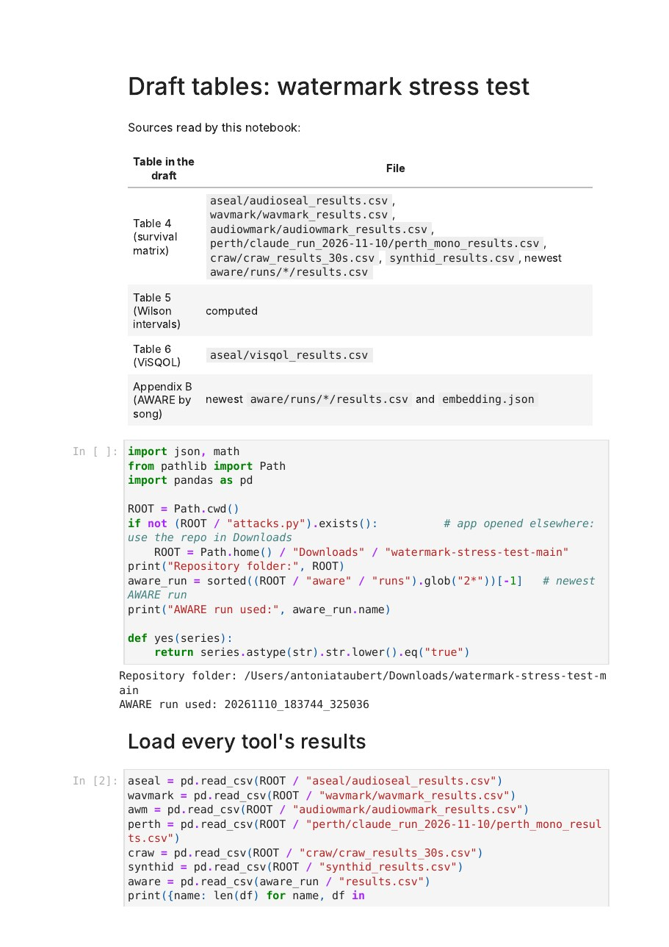
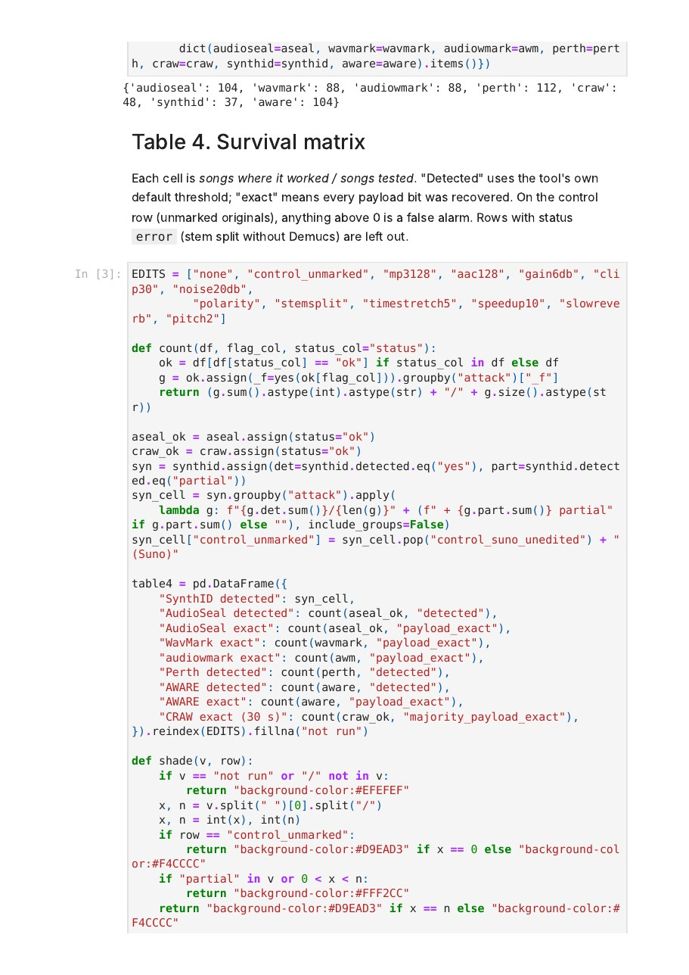
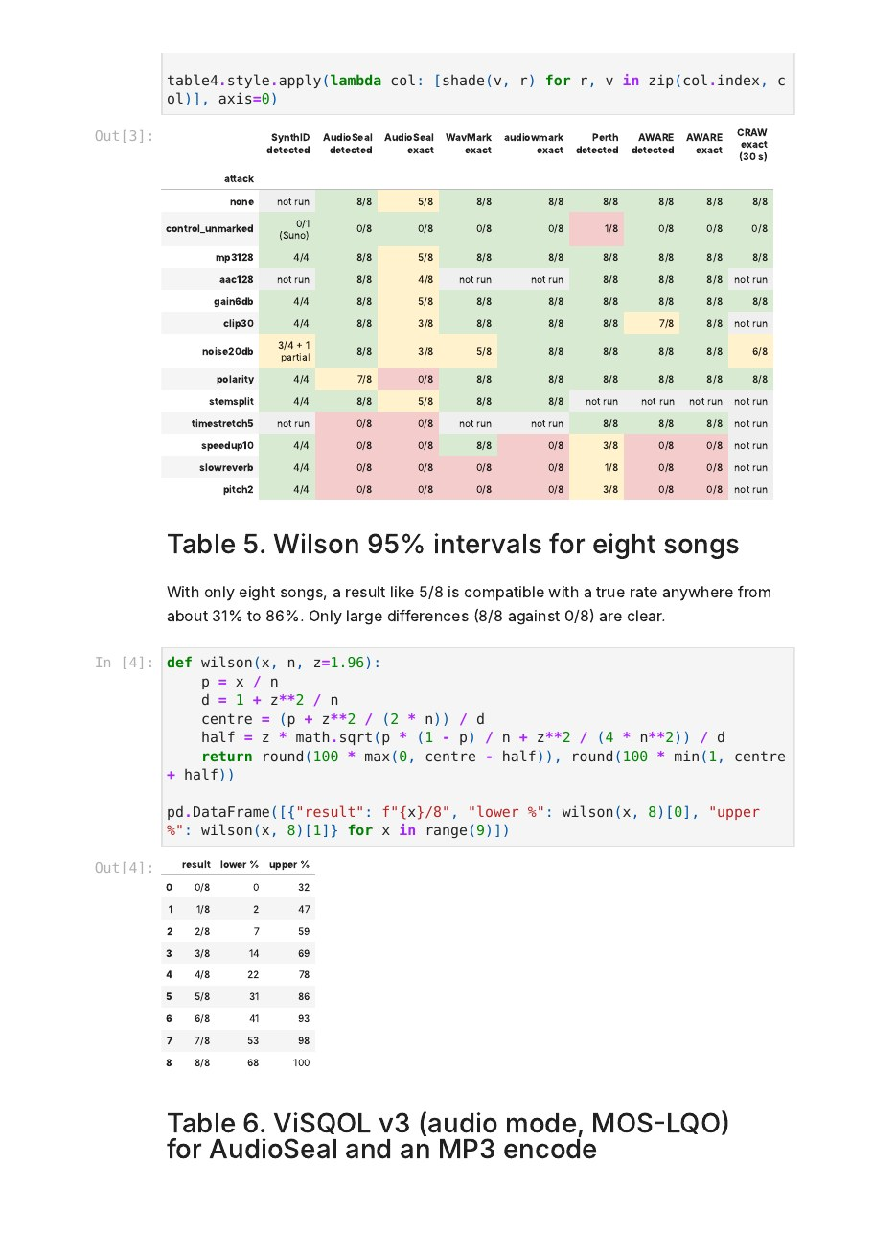
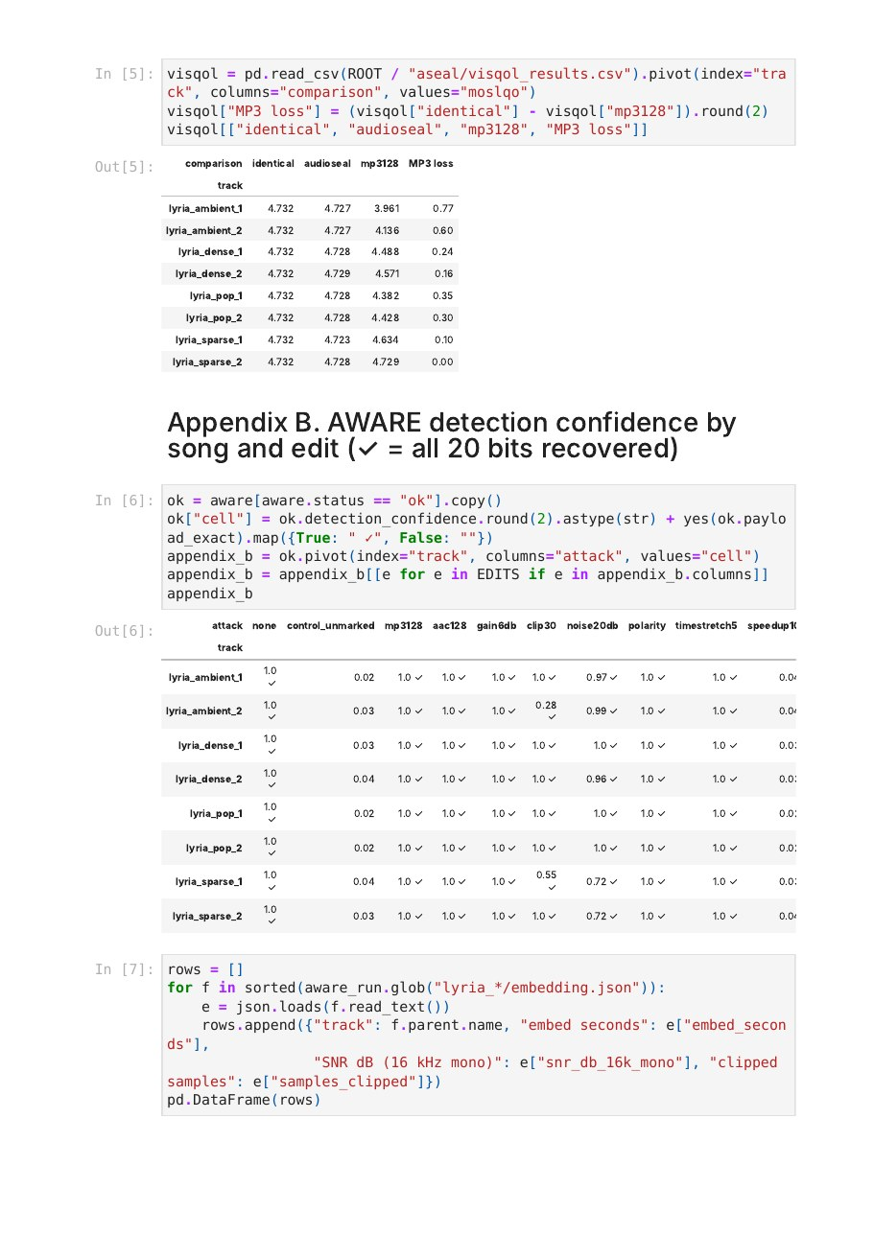
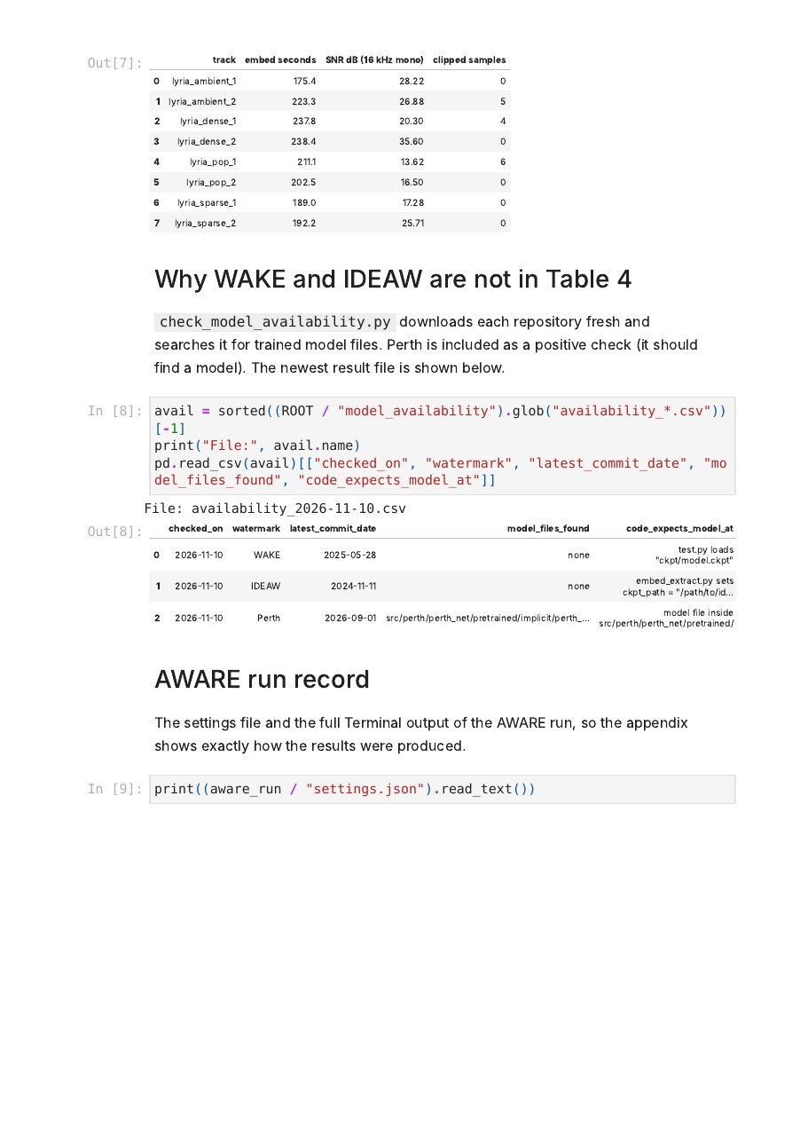
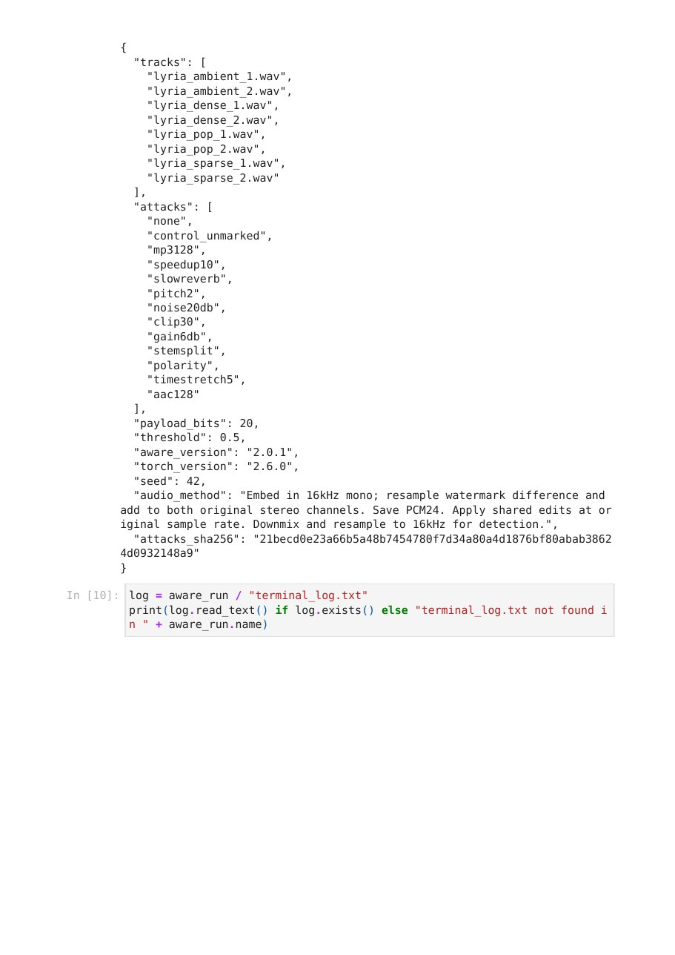
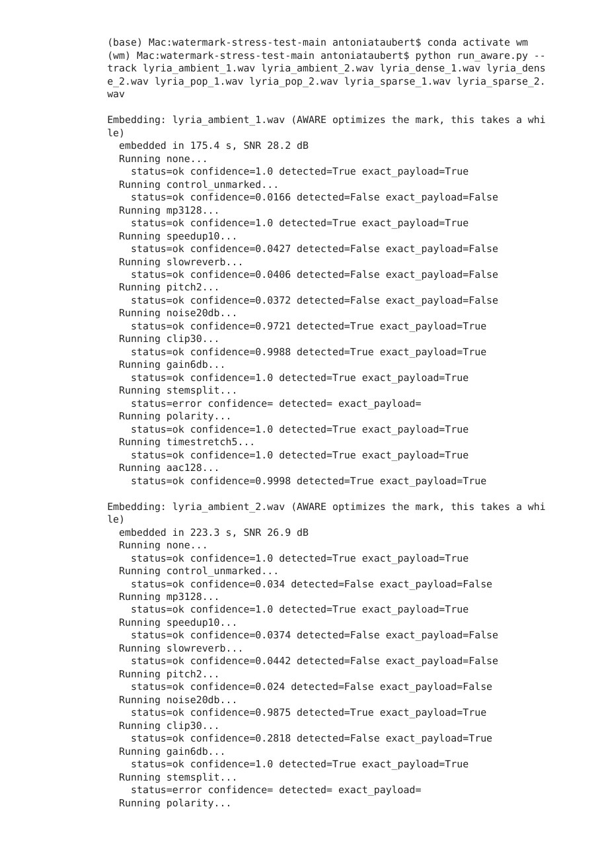
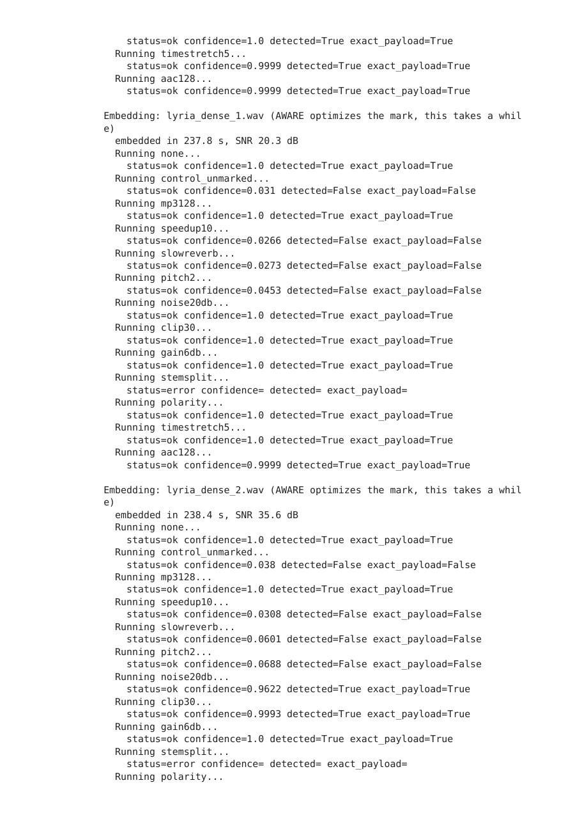
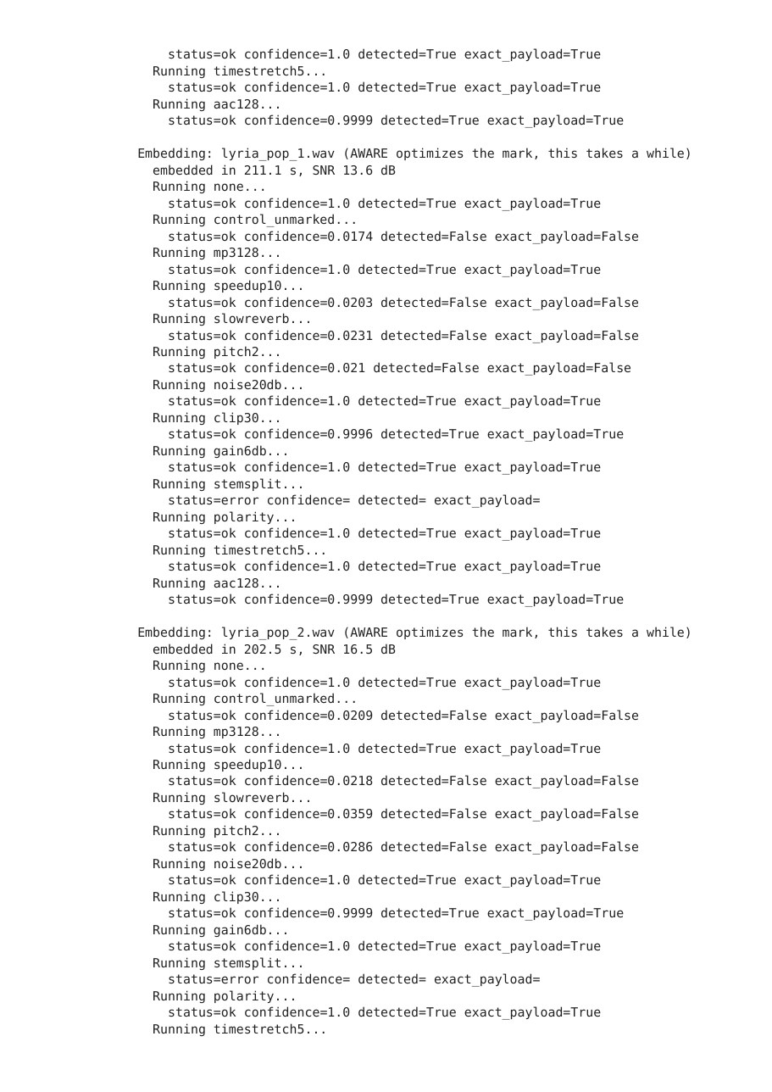
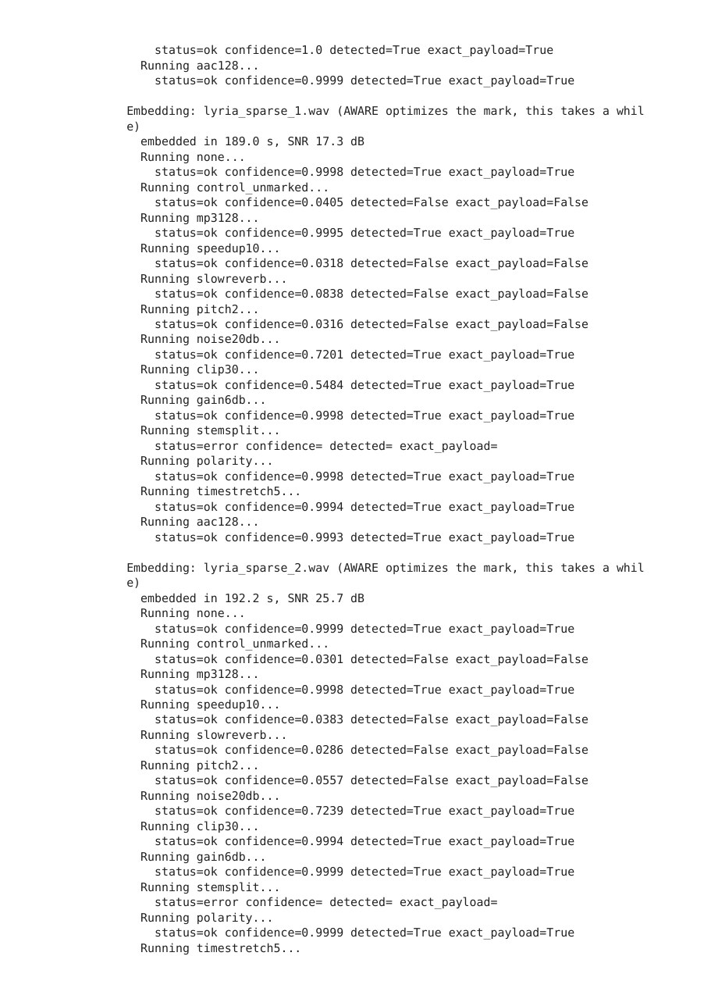
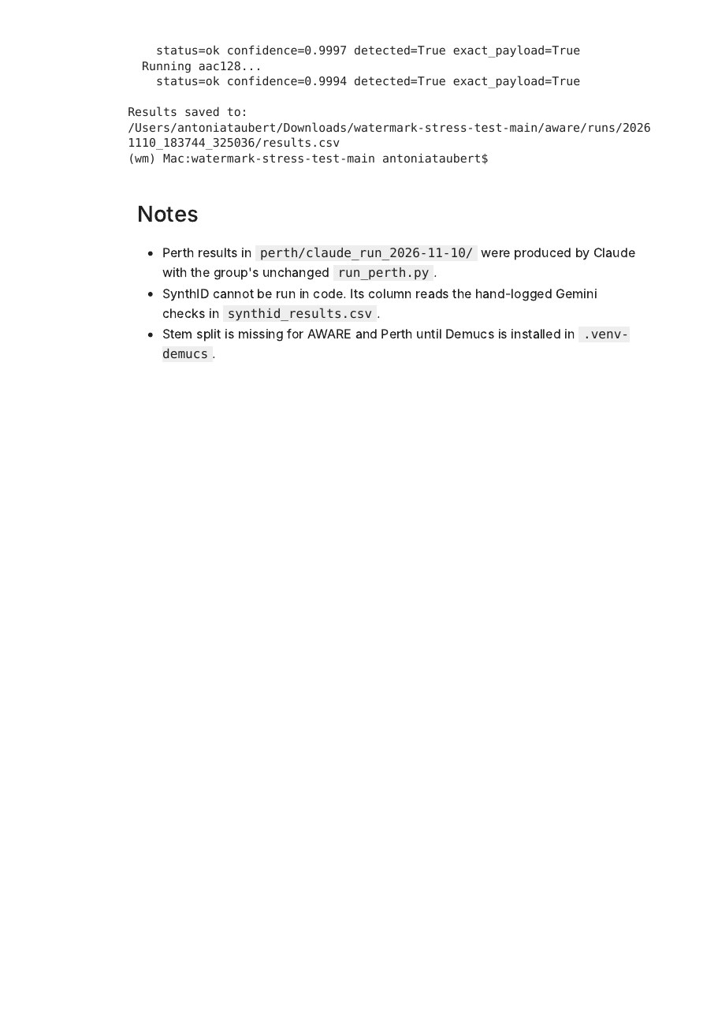

Appendix E: Terminal Record of My Test Runs
Terminal output from my Mac (conda environment wm) on November 10, 2026, copied from the Terminal window. It documents the AWARE installation and pilot test, the full AWARE run on our eight tracks, the WAKE and IDEAW model check, the Jupyter setup for the results notebook, and the ViSQOL sound-quality test for AWARE. Long package-download listings were shortened and a private access token was removed; nothing else was changed. A text copy is in our repository (appendix/terminal_record_2026-11-10.txt).
Part 1. AWARE installation and pilot test on a 10-second clip (S1_clearbluewater), November 10, 2026
(base) Mac:C1_bach_control antoniataubert$ conda activate wm
(wm) Mac:C1_bach_control antoniataubert$ pip install --no-deps aware==2.0.1
Collecting aware==2.0.1
Downloading aware-2.0.1-py3-none-any.whl.metadata (4.3 kB)
Downloading aware-2.0.1-py3-none-any.whl (31 kB)
Installing collected packages: aware
Successfully installed aware-2.0.1
(wm) Mac:C1_bach_control antoniataubert$ pip install webrtcvad-wheels resampy
Collecting webrtcvad-wheels
Downloading webrtcvad_wheels-2.0.14.post1-cp312-cp312-macosx_11_0_arm64.whl.metadata (5.9 kB)
Requirement already satisfied: resampy in /Users/antoniataubert/miniforge3/envs/wm/lib/python3.12/site-packages (0.4.3)
Requirement already satisfied: numpy>=1.17 in /Users/antoniataubert/miniforge3/envs/wm/lib/python3.12/site-packages (from resampy) (2.5.4)
Requirement already satisfied: numba>=0.53 in /Users/antoniataubert/miniforge3/envs/wm/lib/python3.12/site-packages (from resampy) (0.68.1)
Requirement already satisfied: llvmlite<0.51,>=0.50.0dev0 in /Users/antoniataubert/miniforge3/envs/wm/lib/python3.12/site-packages (from numba>=0.53->resampy) (0.50.0)
Downloading webrtcvad_wheels-2.0.14.post1-cp312-cp312-macosx_11_0_arm64.whl (29 kB)
Installing collected packages: webrtcvad-wheels
Successfully installed webrtcvad-wheels-2.0.14.post1
(wm) Mac:C1_bach_control antoniataubert$ cd ~/Downloads/watermark_tests/S1_clearbluewater
(wm) Mac:S1_clearbluewater antoniataubert$ python ~/Downloads/watermark_kit/test_neural.py aware S1_clearbluewater_clip.wav
checking 1 of 14: 00_none.wav
checking 2 of 14: 01_mp3_128k.wav
checking 3 of 14: 02_mp3_64k.wav
checking 4 of 14: 03_aac_64k.wav
checking 5 of 14: 04_trim_first_2s.wav
checking 6 of 14: 05_quieter_half.wav
checking 7 of 14: 06_noise_light.wav
checking 8 of 14: 07_noise_strong.wav
checking 9 of 14: 08_tempo_plus5pct.wav
checking 10 of 14: 09_pitch_up_1_semitone.wav
checking 11 of 14: 10_lowpass_4k.wav
checking 12 of 14: 11_highpass_500.wav
checking 13 of 14: 12_reverb.wav
checking 14 of 14: 13_polarity_flip.wav
Results table: results_aware_S1_clearbluewater_clip.csv
S1_clearbluewater_clip aware control_clean_no_watermark 0.024 no
S1_clearbluewater_clip aware 00_none 1.000 yes
S1_clearbluewater_clip aware 01_mp3_128k 1.000 yes
S1_clearbluewater_clip aware 02_mp3_64k 1.000 yes
S1_clearbluewater_clip aware 03_aac_64k 1.000 yes
S1_clearbluewater_clip aware 04_trim_first_2s 1.000 yes
S1_clearbluewater_clip aware 05_quieter_half 1.000 yes
S1_clearbluewater_clip aware 06_noise_light 0.999 yes
S1_clearbluewater_clip aware 07_noise_strong 0.031 no
S1_clearbluewater_clip aware 08_tempo_plus5pct 1.000 yes
S1_clearbluewater_clip aware 09_pitch_up_1_semitone 0.023 no
S1_clearbluewater_clip aware 10_lowpass_4k 1.000 yes
S1_clearbluewater_clip aware 11_highpass_500 1.000 yes
S1_clearbluewater_clip aware 12_reverb 1.000 yes
S1_clearbluewater_clip aware 13_polarity_flip 1.000 yes
(wm) Mac:S1_clearbluewater antoniataubert$

Part 2. Full AWARE run on the eight Lyria tracks (results: aware/runs/20261110_183744_325036/results.csv)
(A first attempt failed because the wm environment was not active; it is omitted here.)
(base) Mac:watermark-stress-test-main antoniataubert$ conda activate wm
(wm) Mac:watermark-stress-test-main antoniataubert$ python run_aware.py --track lyria_ambient_1.wav lyria_ambient_2.wav lyria_dense_1.wav lyria_dense_2.wav lyria_pop_1.wav lyria_pop_2.wav lyria_sparse_1.wav lyria_sparse_2.wav

Embedding: lyria_ambient_1.wav (AWARE optimizes the mark, this takes a while)
embedded in 175.4 s, SNR 28.2 dB
Running none...
status=ok confidence=1.0 detected=True exact_payload=True
Running control_unmarked...
status=ok confidence=0.0166 detected=False exact_payload=False
Running mp3128...
status=ok confidence=1.0 detected=True exact_payload=True
Running speedup10...
status=ok confidence=0.0427 detected=False exact_payload=False
Running slowreverb...
status=ok confidence=0.0406 detected=False exact_payload=False
Running pitch2...
status=ok confidence=0.0372 detected=False exact_payload=False
Running noise20db...
status=ok confidence=0.9721 detected=True exact_payload=True
Running clip30...
status=ok confidence=0.9988 detected=True exact_payload=True
Running gain6db...
status=ok confidence=1.0 detected=True exact_payload=True
Running stemsplit...
status=error confidence= detected= exact_payload=
Running polarity...
status=ok confidence=1.0 detected=True exact_payload=True
Running timestretch5...
status=ok confidence=1.0 detected=True exact_payload=True
Running aac128...
status=ok confidence=0.9998 detected=True exact_payload=True

Embedding: lyria_ambient_2.wav (AWARE optimizes the mark, this takes a while)
embedded in 223.3 s, SNR 26.9 dB
Running none...
status=ok confidence=1.0 detected=True exact_payload=True
Running control_unmarked...
status=ok confidence=0.034 detected=False exact_payload=False
Running mp3128...
status=ok confidence=1.0 detected=True exact_payload=True
Running speedup10...
status=ok confidence=0.0374 detected=False exact_payload=False
Running slowreverb...
status=ok confidence=0.0442 detected=False exact_payload=False
Running pitch2...
status=ok confidence=0.024 detected=False exact_payload=False
Running noise20db...
status=ok confidence=0.9875 detected=True exact_payload=True
Running clip30...
status=ok confidence=0.2818 detected=False exact_payload=True
Running gain6db...
status=ok confidence=1.0 detected=True exact_payload=True
Running stemsplit...
status=error confidence= detected= exact_payload=
Running polarity...
status=ok confidence=1.0 detected=True exact_payload=True
Running timestretch5...
status=ok confidence=0.9999 detected=True exact_payload=True
Running aac128...
status=ok confidence=0.9999 detected=True exact_payload=True

Embedding: lyria_dense_1.wav (AWARE optimizes the mark, this takes a while)
embedded in 237.8 s, SNR 20.3 dB
Running none...
status=ok confidence=1.0 detected=True exact_payload=True
Running control_unmarked...
status=ok confidence=0.031 detected=False exact_payload=False
Running mp3128...
status=ok confidence=1.0 detected=True exact_payload=True
Running speedup10...
status=ok confidence=0.0266 detected=False exact_payload=False
Running slowreverb...
status=ok confidence=0.0273 detected=False exact_payload=False
Running pitch2...
status=ok confidence=0.0453 detected=False exact_payload=False
Running noise20db...
status=ok confidence=1.0 detected=True exact_payload=True
Running clip30...
status=ok confidence=1.0 detected=True exact_payload=True
Running gain6db...
status=ok confidence=1.0 detected=True exact_payload=True
Running stemsplit...
status=error confidence= detected= exact_payload=
Running polarity...
status=ok confidence=1.0 detected=True exact_payload=True
Running timestretch5...
status=ok confidence=1.0 detected=True exact_payload=True
Running aac128...
status=ok confidence=0.9999 detected=True exact_payload=True

Embedding: lyria_dense_2.wav (AWARE optimizes the mark, this takes a while)
embedded in 238.4 s, SNR 35.6 dB
Running none...
status=ok confidence=1.0 detected=True exact_payload=True
Running control_unmarked...
status=ok confidence=0.038 detected=False exact_payload=False
Running mp3128...
status=ok confidence=1.0 detected=True exact_payload=True
Running speedup10...
status=ok confidence=0.0308 detected=False exact_payload=False
Running slowreverb...
status=ok confidence=0.0601 detected=False exact_payload=False
Running pitch2...
status=ok confidence=0.0688 detected=False exact_payload=False
Running noise20db...
status=ok confidence=0.9622 detected=True exact_payload=True
Running clip30...
status=ok confidence=0.9993 detected=True exact_payload=True
Running gain6db...
status=ok confidence=1.0 detected=True exact_payload=True
Running stemsplit...
status=error confidence= detected= exact_payload=
Running polarity...
status=ok confidence=1.0 detected=True exact_payload=True
Running timestretch5...
status=ok confidence=1.0 detected=True exact_payload=True
Running aac128...
status=ok confidence=0.9999 detected=True exact_payload=True

Embedding: lyria_pop_1.wav (AWARE optimizes the mark, this takes a while)
embedded in 211.1 s, SNR 13.6 dB
Running none...
status=ok confidence=1.0 detected=True exact_payload=True
Running control_unmarked...
status=ok confidence=0.0174 detected=False exact_payload=False
Running mp3128...
status=ok confidence=1.0 detected=True exact_payload=True
Running speedup10...
status=ok confidence=0.0203 detected=False exact_payload=False
Running slowreverb...
status=ok confidence=0.0231 detected=False exact_payload=False
Running pitch2...
status=ok confidence=0.021 detected=False exact_payload=False
Running noise20db...
status=ok confidence=1.0 detected=True exact_payload=True
Running clip30...
status=ok confidence=0.9996 detected=True exact_payload=True
Running gain6db...
status=ok confidence=1.0 detected=True exact_payload=True
Running stemsplit...
status=error confidence= detected= exact_payload=
Running polarity...
status=ok confidence=1.0 detected=True exact_payload=True
Running timestretch5...
status=ok confidence=1.0 detected=True exact_payload=True
Running aac128...
status=ok confidence=0.9999 detected=True exact_payload=True

Embedding: lyria_pop_2.wav (AWARE optimizes the mark, this takes a while)
embedded in 202.5 s, SNR 16.5 dB
Running none...
status=ok confidence=1.0 detected=True exact_payload=True
Running control_unmarked...
status=ok confidence=0.0209 detected=False exact_payload=False
Running mp3128...
status=ok confidence=1.0 detected=True exact_payload=True
Running speedup10...
status=ok confidence=0.0218 detected=False exact_payload=False
Running slowreverb...
status=ok confidence=0.0359 detected=False exact_payload=False
Running pitch2...
status=ok confidence=0.0286 detected=False exact_payload=False
Running noise20db...
status=ok confidence=1.0 detected=True exact_payload=True
Running clip30...
status=ok confidence=0.9999 detected=True exact_payload=True
Running gain6db...
status=ok confidence=1.0 detected=True exact_payload=True
Running stemsplit...
status=error confidence= detected= exact_payload=
Running polarity...
status=ok confidence=1.0 detected=True exact_payload=True
Running timestretch5...
status=ok confidence=1.0 detected=True exact_payload=True
Running aac128...
status=ok confidence=0.9999 detected=True exact_payload=True

Embedding: lyria_sparse_1.wav (AWARE optimizes the mark, this takes a while)
embedded in 189.0 s, SNR 17.3 dB
Running none...
status=ok confidence=0.9998 detected=True exact_payload=True
Running control_unmarked...
status=ok confidence=0.0405 detected=False exact_payload=False
Running mp3128...
status=ok confidence=0.9995 detected=True exact_payload=True
Running speedup10...
status=ok confidence=0.0318 detected=False exact_payload=False
Running slowreverb...
status=ok confidence=0.0838 detected=False exact_payload=False
Running pitch2...
status=ok confidence=0.0316 detected=False exact_payload=False
Running noise20db...
status=ok confidence=0.7201 detected=True exact_payload=True
Running clip30...
status=ok confidence=0.5484 detected=True exact_payload=True
Running gain6db...
status=ok confidence=0.9998 detected=True exact_payload=True
Running stemsplit...
status=error confidence= detected= exact_payload=
Running polarity...
status=ok confidence=0.9998 detected=True exact_payload=True
Running timestretch5...
status=ok confidence=0.9994 detected=True exact_payload=True
Running aac128...
status=ok confidence=0.9993 detected=True exact_payload=True

Embedding: lyria_sparse_2.wav (AWARE optimizes the mark, this takes a while)
embedded in 192.2 s, SNR 25.7 dB
Running none...
status=ok confidence=0.9999 detected=True exact_payload=True
Running control_unmarked...
status=ok confidence=0.0301 detected=False exact_payload=False
Running mp3128...
status=ok confidence=0.9998 detected=True exact_payload=True
Running speedup10...
status=ok confidence=0.0383 detected=False exact_payload=False
Running slowreverb...
status=ok confidence=0.0286 detected=False exact_payload=False
Running pitch2...
status=ok confidence=0.0557 detected=False exact_payload=False
Running noise20db...
status=ok confidence=0.7239 detected=True exact_payload=True
Running clip30...
status=ok confidence=0.9994 detected=True exact_payload=True
Running gain6db...
status=ok confidence=0.9999 detected=True exact_payload=True
Running stemsplit...
status=error confidence= detected= exact_payload=
Running polarity...
status=ok confidence=0.9999 detected=True exact_payload=True
Running timestretch5...
status=ok confidence=0.9997 detected=True exact_payload=True
Running aac128...
status=ok confidence=0.9994 detected=True exact_payload=True

Results saved to:
/Users/antoniataubert/Downloads/watermark-stress-test-main/aware/runs/20261110_183744_325036/results.csv

Part 3. Check whether WAKE and IDEAW have released trained models (results: model_availability/availability_2026-11-10.csv)
(wm) Mac:watermark-stress-test-main antoniataubert$ cd ~/Downloads/watermark-stress-test-main
(wm) Mac:watermark-stress-test-main antoniataubert$ conda activate wm
(wm) Mac:watermark-stress-test-main antoniataubert$ python check_model_availability.py
WAKE: latest commit 2025-05-28, model files: none
IDEAW: latest commit 2024-11-11, model files: none
Perth: latest commit 2026-09-01, model files: src/perth/perth_net/pretrained/implicit/perth_net_250000.pth.tar

Saved: /Users/antoniataubert/Downloads/watermark-stress-test-main/model_availability/availability_2026-11-10.csv
(wm) Mac:watermark-stress-test-main antoniataubert$

Part 4. Jupyter setup for the results notebook (package download lines shortened)
(wm) Mac:watermark-stress-test-main antoniataubert$ cd ~/Downloads/watermark-stress-test-main
(wm) Mac:watermark-stress-test-main antoniataubert$ conda activate wm
(wm) Mac:watermark-stress-test-main antoniataubert$ pip install notebook jinja2
[pip output shortened: Jupyter Notebook 7.6.5 and its dependencies were installed; jinja2 3.1.6 was already present]
(wm) Mac:watermark-stress-test-main antoniataubert$ python check_model_availability.py
WAKE: latest commit 2025-05-28, model files: none
IDEAW: latest commit 2024-11-11, model files: none
Perth: latest commit 2026-09-01, model files: src/perth/perth_net/pretrained/implicit/perth_net_250000.pth.tar

Saved: /Users/antoniataubert/Downloads/watermark-stress-test-main/model_availability/availability_2026-11-10.csv
(wm) Mac:watermark-stress-test-main antoniataubert$ jupyter notebook draft_tables.ipynb
[Jupyter server log omitted; it contains a private local access token]

Part 5. ViSQOL sound-quality scores for AWARE (results: aware/visqol_aware_results.csv)
(wm) (base) Mac:watermark-stress-test-main antoniataubert$ cd ~/Downloads/watermark-stress-test-main
(wm) (base) Mac:watermark-stress-test-main antoniataubert$ conda activate wm
(wm) (base) Mac:watermark-stress-test-main antoniataubert$ python3 -m venv .venv-visqol
(wm) (base) Mac:watermark-stress-test-main antoniataubert$ .venv-visqol/bin/pip install visqol-python==3.8.0 soundfile numpy
[pip output shortened: visqol-python 3.8.0, soundfile 0.14.0 and numpy 2.5.4 installed in .venv-visqol]
(wm) (base) Mac:watermark-stress-test-main antoniataubert$ .venv-visqol/bin/python visqol_aware.py

.venv-visqol/bin/python visqol_aware.py
AWARE run used: aware/runs/20261110_183744_325036

song aware audioseal mp3128
(check) lyria_ambient_1 identical = 4.732

lyria_ambient_1 4.697 4.727 3.961
lyria_ambient_2 4.699 4.727 4.136
lyria_dense_1 4.699 4.728 4.488
lyria_dense_2 4.718 4.729 4.571
lyria_pop_1 4.683 4.728 4.382
lyria_pop_2 4.700 4.728 4.428
lyria_sparse_1 4.587 4.723 4.634
lyria_sparse_2 4.708 4.728 4.729

Done. Results saved to aware/visqol_aware_results.csv
(The command was entered twice, so the script ran a second time; the second run gave identical scores and is omitted.)

