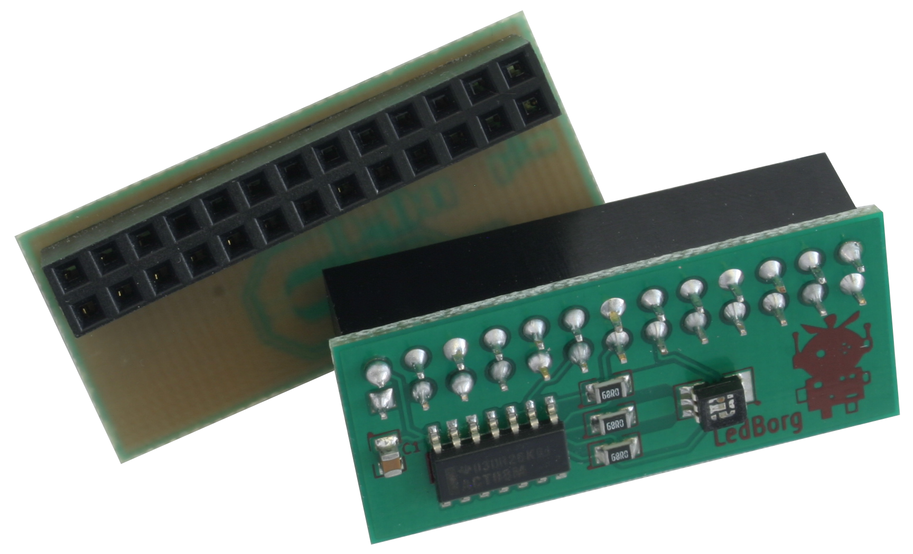
LEDBorg

The LEDBorg is a small PCB that slots onto the GPIO header on the Raspberry Pi. It contains an RGB (Red, Green, Blue) LED. When the colours are combined with the LED, a full range of colours can be produced.

The LEDBorg uses 3 GPIO pins on the Raspberry Pi,
Pins 11, 13, and 15.
Each of these pins controls a single primary colour, Red, Green and Blue
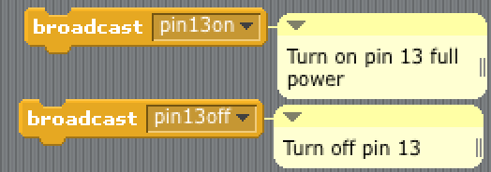
Fully on or fully off, use a broadcast
E.G. to turn pin 11 completely on, use pin11on

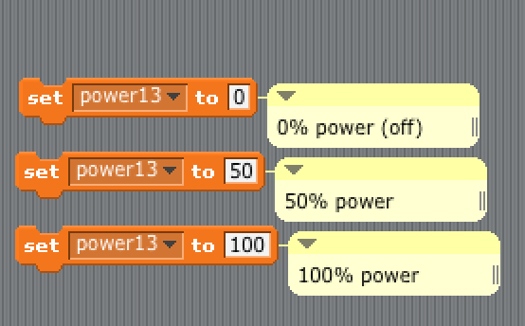
To change the brightness of the colours, create a variable naming it power followed by the pin number
e.g. power15 will set the power for pin 15
You can set these to any number between 0 (fully off) and 100 (fully on)

Tasks
- Figure out which of the 3 pins controls each colour (Pin 11, 13 and 15)
- Bring each different primary colour on one after each other
- Secondary colours
  - Create purple
  - Create white

- Light show! – Develop a creative multi-coloured light show! Hint – The wait block may be helpful

