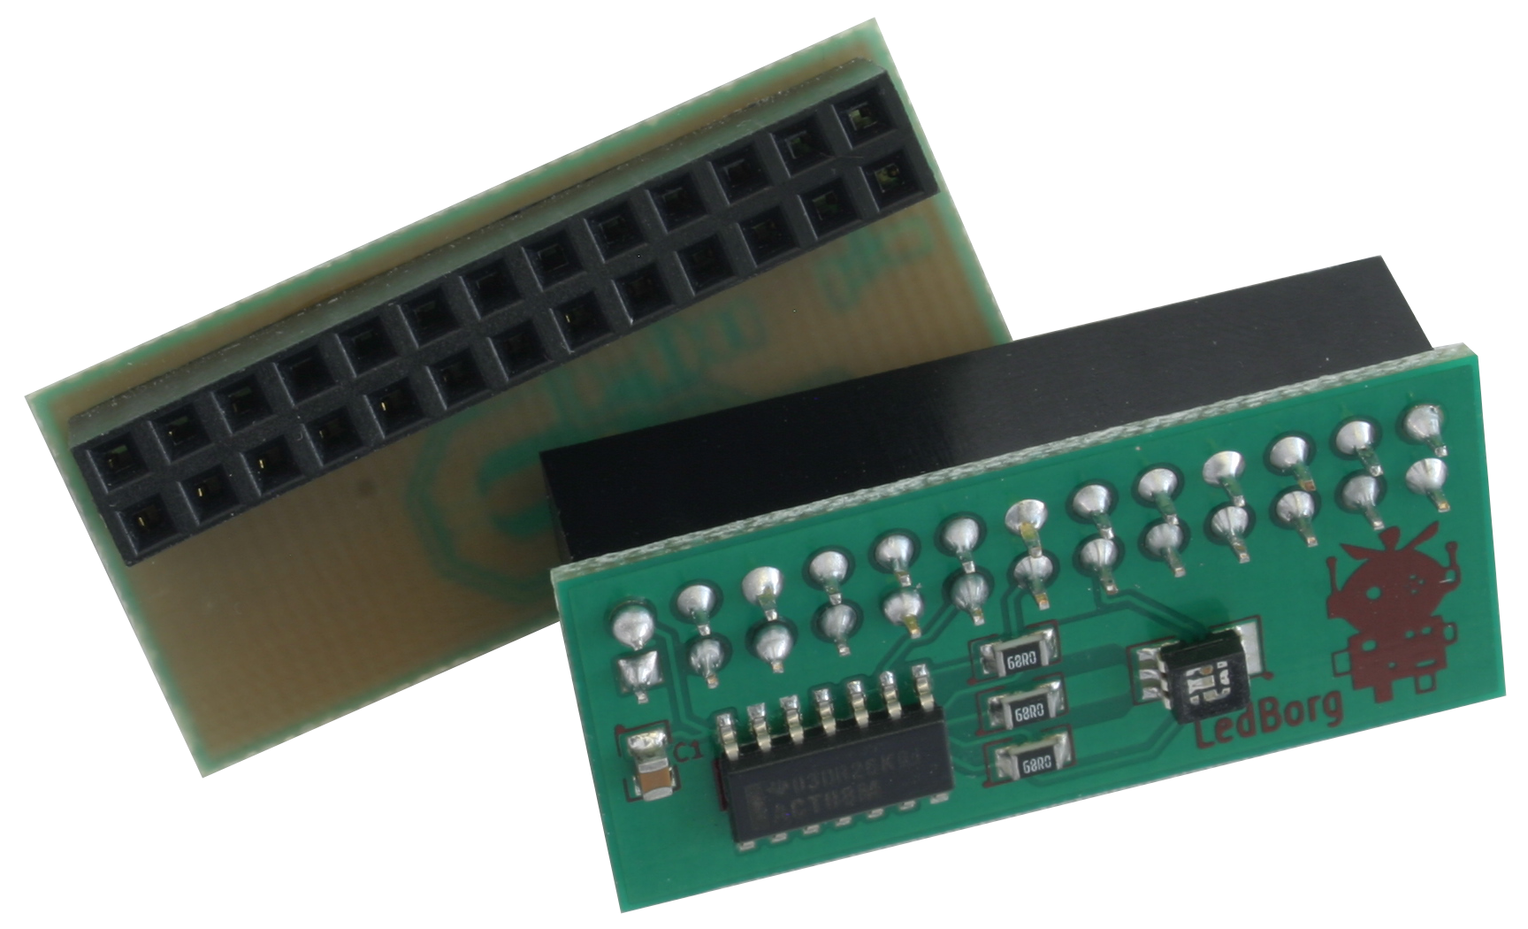
LEDBorg

The LEDBorg is a small PCB that slots onto the GPIO header on the Raspberry Pi. It contains an RGB (Red, Green, Blue) LED. When the colours are combined with the LED, a full range of colours can be produced.

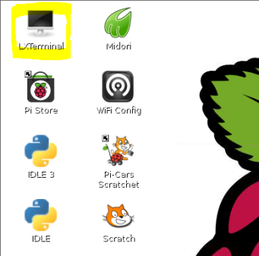
We will be using Scratch GPIO to operate the LEDBorg.
First we need to download Scratch GPIO
Visit http://goo.gl/jjrFe (Case sensitive) on your Raspberry Pi. Scroll down to find the install command. Copy and paste the command into an LXTerminal.

The command will download and install Scratch GPIO and a new “ScratchGPIO icon will be placed on your desktop.

The LEDBorg uses 3 GPIO pins on the Raspberry Pi.
Physical pins 11, 13, and 15.

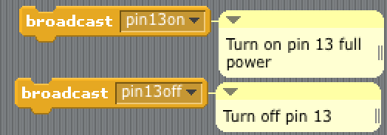
To turn on a pin in Scratch GPIO, boardcast “pin<pinnum>on” or “pin<pinnum>off”

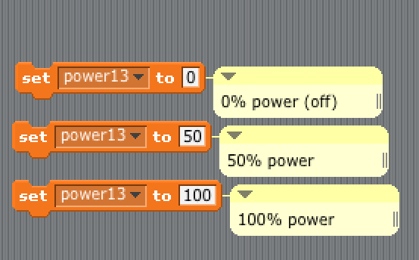
To use different power settings for each colour, create a variable called power<pinname> and set it anywhere from 0 to 100

