ChatGPT Processing UI Design Alternatives
VideoHoarder - Designs retained for future reference
Selected implementation: Design 1 - Sidebar Command Center
This document intentionally preserves the four non-selected layouts. They are not part of the current implementation specification, but can be reconsidered later if package volume, user roles, or workflow needs change.

Design 2 - Guided Top-Step Console
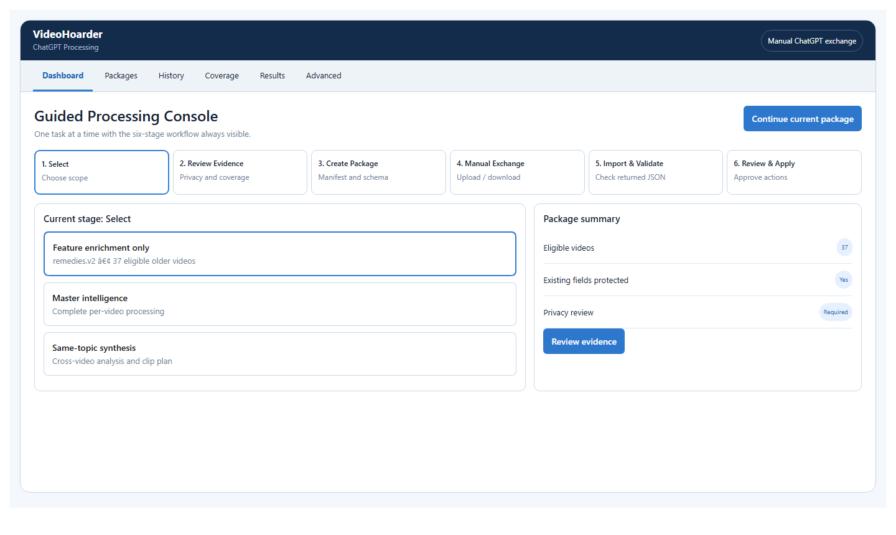
Figure 1 - Design 2: Guided Top-Step Console
Best for: Best for users who want the application to lead them through one package at a time.
Strength: The six-stage flow stays prominent, with fewer competing panels. It is strong for first-time and occasional use.
Tradeoff: History, coverage, and advanced tools are less continuously visible and require tab changes.

Design 3 - Three-Pane Package Workbench
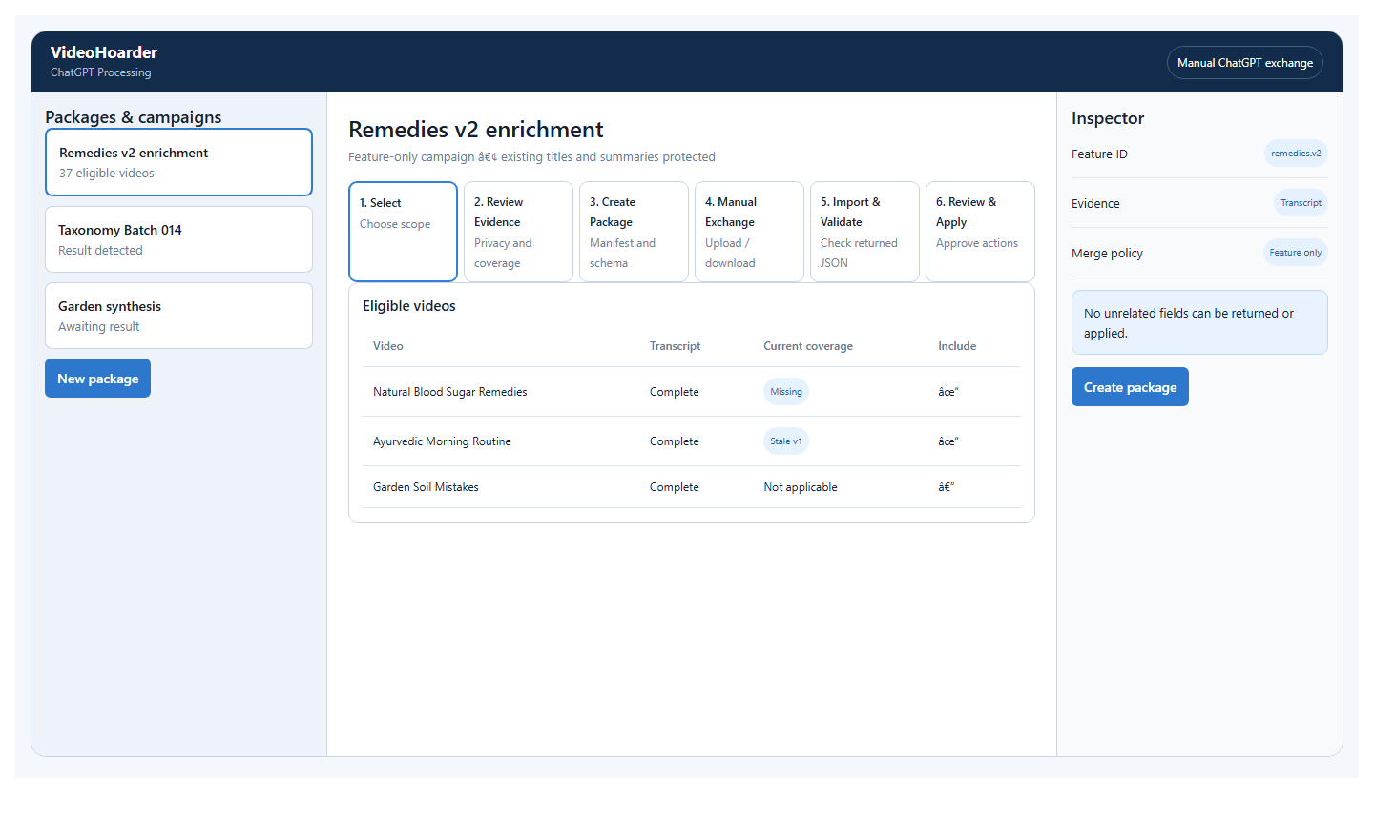
Figure 2 - Design 3: Three-Pane Package Workbench
Best for: Best for high-volume package creation and feature-enrichment campaigns.
Strength: Package list, current work, and inspector remain visible together; excellent for evidence and coverage decisions.
Tradeoff: More complex and best suited to wider desktop windows; can feel dense for simple one-off tasks.

Design 4 - Package Lifecycle Board
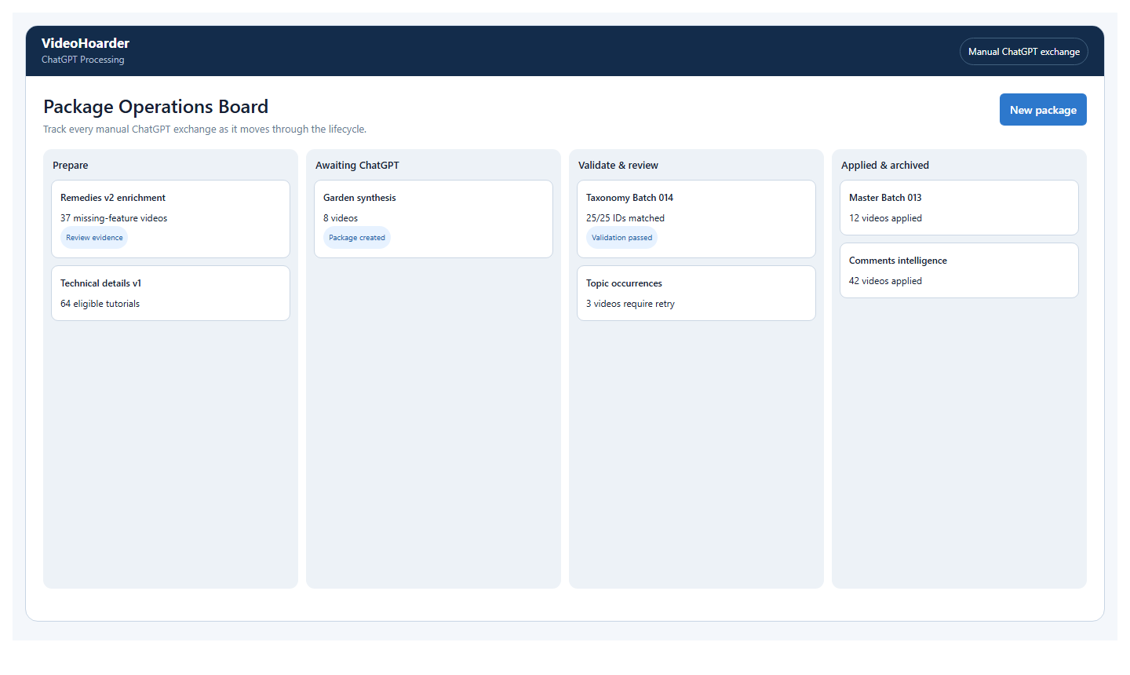
Figure 3 - Design 4: Package Lifecycle Board
Best for: Best for monitoring many packages at different stages.
Strength: Makes Prepare, Awaiting ChatGPT, Validate/Review, and Applied/Archived states instantly understandable.
Tradeoff: Less suitable for detailed evidence review and field-level editing; another detail view is still required.

Design 5 - Dense Operations and Coverage Console
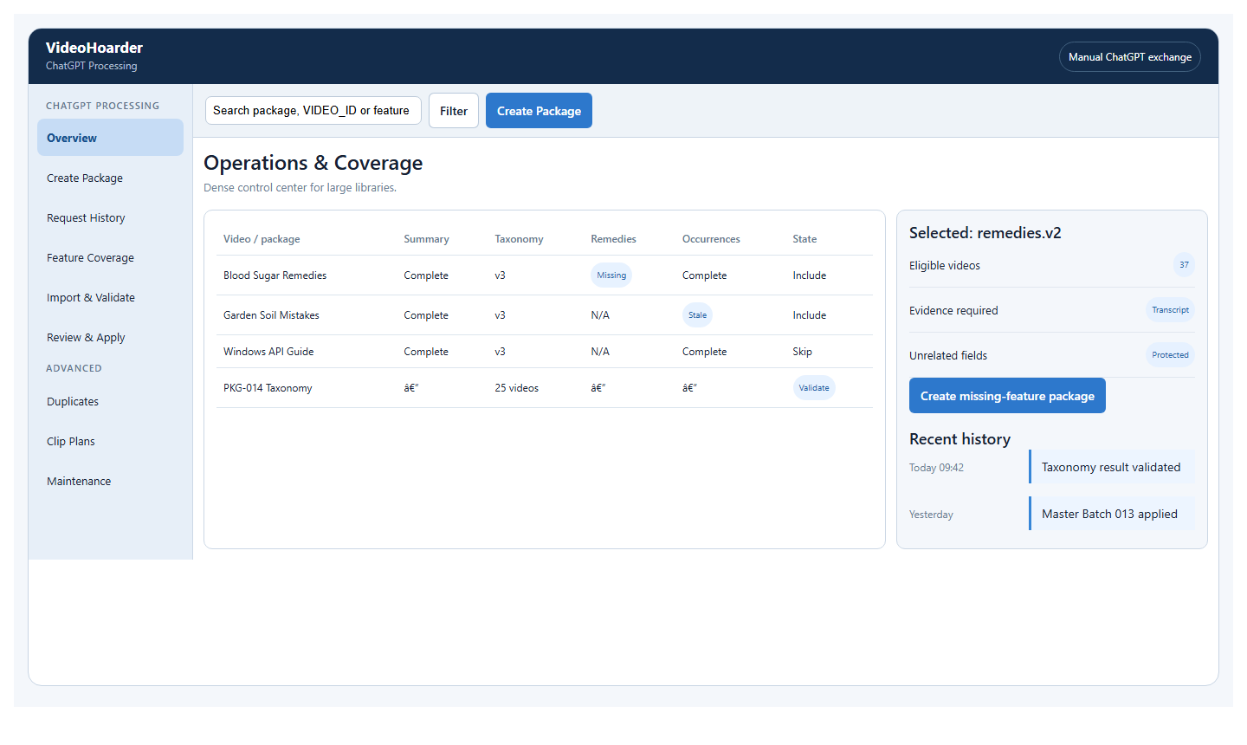
Figure 4 - Design 5: Dense Operations and Coverage Console
Best for: Best for expert users with thousands of videos and frequent incremental processing.
Strength: Combines search, feature coverage, package state, and history in a compact data-oriented workspace.
Tradeoff: Highest learning curve and least approachable for users who prefer a guided workflow.

When to Revisit These Alternatives
Revisit Design 2 if the primary need becomes guided, low-frequency use. Revisit Design 3 for a specialist workflow with frequent package construction and evidence review. Revisit Design 4 if package monitoring becomes the main daily task. Revisit Design 5 for expert teams operating very large libraries.

