UsherPipe: a genome-wide multi-evidence pipeline for prioritizing candidate genes in Usher syndrome and related ciliopathies
Article type: Research Article
Authors: Jing-Rung Huang^{1,*} (ORCID: 0000-0003-4776-3550); Yung-Hao Ching² (ORCiD: 0000-0002-5767-6701; yching@gms.tcu.edu.tw); Wen-Hsiang Lu¹ (ORCID: 0009-0002-5149-6790)
Corresponding author: Jing-Rung Huang, MD; gbanyan.huang@gmail.com; Department of Computer Science and Information Engineering, National Cheng Kung University, No. 1, University Road, Tainan 701, Taiwan. ORCID: 0000-0003-4776-3550
Affiliations: ¹ Department of Computer Science and Information Engineering, National Cheng Kung University, No. 1, University Road, Tainan 701, Taiwan; ² Department of Molecular Biology and Human Genetics, Tzu Chi University, No. 701, Sec. 3, Zhongyang Rd., Hualien City, Hualien County 970, Taiwan (R.O.C.).

Abstract

Background
Usher syndrome is the most common genetic cause of combined deafness-blindness, yet a subset of clinically diagnosed patients remains unresolved after testing. Existing tools make different design choices about prior disease genes, patient-specific data, and missing evidence. UsherPipe integrates cilia- and sensory-relevant evidence across the protein-coding genome while preserving missingness explicitly.

Results
UsherPipe integrates six evidence layers in a NULL-aware weighted mean across 20,081 analysis labels derived from 20,116 protein-coding IDs. Scoring uses no training labels or similarity seeds; curated known-gene annotations remain inputs. A downstream, control-calibrated gate defines the heuristic HIGH priority tier. The nine established Usher controls and 28 SYSCILIA controls had median raw percentile ranks of 97.8% and 91.9%; only two and one, respectively, entered HIGH. The final output contains 62 HIGH, 9,673 MEDIUM and 8,652 LOW labels. Housekeeping genes ranked at a median 94.8th percentile, demonstrating limited raw-score specificity. In a separately frozen comparison matched on publication and GO counts, 27 comparators matched to Usher controls and 84 matched to SYSCILIA controls had medians of 64.2% and 60.3%. Paired control advantage fell to 55.6% and 57.1% after joint animal/literature omission. Across equal weights and 24 modest perturbations, only 41 default top-100 genes remained in every configuration. In a retrospective temporal evaluation of historical analogues, 41 of 45 provisionally literature-screened later-association genes were in the historical protein-coding universe; neither co-primary version recovered a case in the top 100. Clinical classifications await case-by-case human verification.

Conclusions
UsherPipe organizes cilia/sensory-aware hypotheses for follow-up in the Usher context. Scores and HIGH membership reflect available annotations and weighting choices, rather than calibrated disease probabilities. Internal recovery, matched comparisons and weak later-association recovery do not establish reliable novel disease-gene discovery. Code, evidence profiles and derived replay inputs are available in the repository.
Keywords: Usher syndrome, ciliopathy, gene prioritization, missing data, bioinformatics pipeline, hypothesis generation

Background
Usher syndrome (USH) is a major cause of hereditary combined deafness and blindness. Reported prevalence varies by population; Boughman et al. estimated 4.4 per 100,000 in the United States [1]. Patients present with sensorineural hearing loss, vestibular dysfunction, and progressive retinitis pigmentosa. Established clinical subtypes include USH1, USH2, and USH3, with validated gene–disease relationships involving MYO7A, USH1C, CDH23, PCDH15, USH1G, USH2A, ADGRV1, WHRN, and CLRN1 [2]. The historical assignment of CIB2 to USH1J is not treated as established in this analysis because current gene–disease curation is mixed [3], and it is therefore excluded from the established positive-control set used here. These genes encode proteins that form multi-protein complexes in the stereocilia of inner ear hair cells and the connecting cilium of retinal photoreceptors [4]. In one European cohort, causal biallelic variants were identified in 92.7% of clinically diagnosed patients [5].
Even after comprehensive genomic screening—including targeted gene panels, whole-exome sequencing (WES), whole-genome sequencing (WGS), and copy-number-variant (CNV) analysis—the molecular cause remains unresolved for a subset of individuals with clinically diagnosed Usher syndrome. Possible explanations include novel disease genes, noncoding or deep intronic variants, complex structural variants, and regulatory alterations; the relative contribution of these mechanisms is not established here. A prioritization score can organize hypotheses for follow-up, but absence of annotation or publication is not evidence that a gene is genuinely under-studied, nor is a high score evidence of a causal gene–disease relationship. Throughout, we use candidate to mean a proposed but not yet established gene–disease relationship; this operational use is distinct from ClinGen’s formal gene–disease validity classifications [6].

Usher syndrome as a specialized sensory ciliopathy
Ciliopathies comprise a genetically and phenotypically heterogeneous class of inherited disorders arising from structural or functional aberrations in primary cilia, motile cilia, or their anchor proteins [7]. Given that cilia serve as indispensable hubs for developmental signaling cascades, sensory perception, and fluid homeostasis, ciliary dysfunction characteristically manifests as pleiotropic, multisystemic pathologies. These conditions frequently impair the retina, kidneys, central nervous system, skeleton, liver, and reproductive tracts, spanning a clinical spectrum from isolated sensory deficits to complex, syndromic phenotypes with profound clinical overlap.
Several Usher proteins participate in hair-cell stereociliary complexes and in photoreceptor connecting-cilium or periciliary regions [8, 9, 10, 11]. These shared mechanisms motivate considering Usher syndrome within the sensory ciliopathy spectrum [2, 4, 7], while recognizing that stereocilia are actin-based structures rather than true cilia. However, Usher-specific gene prioritization should not be treated as equivalent to broad ciliopathy gene prioritization: broad ciliopathies arise from general defects in ciliary assembly, transport, or signaling, whereas Usher syndrome is defined by the combined auditory–retinal phenotype. The combined auditory–retinal phenotype requires evidence beyond general ciliary function. The present score supplies cilia/sensory-aware hypotheses for follow-up in an Usher context; it is not a classifier that distinguishes Usher syndrome from other ciliopathies.

Ciliary and stereociliary biology underlying Usher syndrome
In the retina, the photoreceptor outer segment is a highly specialized primary cilium that contains the membrane proteins and signaling components required for phototransduction. Because the outer segment lacks protein-synthesis machinery, newly synthesized proteins and membrane components must be transported from the inner segment through the connecting cilium. Several Usher proteins localize to the connecting-cilium, periciliary, or calyceal-process regions, where they contribute to photoreceptor compartmentalization, protein trafficking, and outer-segment maintenance. Defects in these proteins disrupt photoreceptor structure and homeostasis, leading to progressive photoreceptor degeneration and retinitis pigmentosa [8, 9, 12].
In the inner ear, the hair bundle is a mechanosensory structure composed of actin-based stereocilia arranged in a precise staircase-like pattern. Although stereocilia are not true cilia, their development is coordinated with the microtubule-based kinocilium and basal body. Usher proteins form interacting complexes that are essential for hair-bundle cohesion, orientation, maturation, and mechanotransduction. When these proteins are absent or dysfunctional, stereocilia may become fragmented, misoriented, unevenly organized, or poorly connected. These developmental abnormalities impair mechanotransduction and cause the sensorineural hearing loss characteristic of Usher syndrome [10, 13, 14].
The shared molecular basis of the retinal and auditory phenotypes lies in the Usher protein interactome, in which different proteins assemble into distinct but interconnected functional complexes. USH1 proteins, including myosin VIIa, harmonin, cadherin 23, protocadherin 15, and SANS, contribute to transient lateral links, tip-link-associated structures, and their attachment to the stereociliary actin cytoskeleton. These complexes are required for hair-bundle cohesion, orientation, and maturation [13, 15].
USH2 proteins, including usherin, ADGRV1, whirlin, and PDZD7, form the ankle-link complex at the base of developing hair-cell stereocilia. In photoreceptors, usherin, ADGRV1, and whirlin assemble at the periciliary membrane complex near the connecting cilium, where they are thought to support protein trafficking and cargo delivery to the outer segment [9, 16, 11]. CLRN1, a tetraspan-like membrane protein associated with USH3A, is required for normal hair-bundle organization [17]. In a zebrafish clrn1 model, a retinal maintenance role was linked to Müller glia–mediated support of photoreceptors [18]. Together, Usher proteins participate in cell adhesion, macromolecular scaffolding, intracellular trafficking, cytoskeletal organization, and membrane compartmentalization in both sensory systems [8, 19].

Limitations of existing gene prioritization approaches
Computational gene prioritization has become a standard approach for narrowing candidate gene lists in rare disease research. Existing approaches address different tasks, including variant interpretation, phenotype matching and similarity to previously characterized disease genes. These design differences motivate a complementary framework for organizing genome-wide biological hypotheses; they do not establish that UsherPipe discovers novel disease genes more effectively.
Seed-gene-dependent tools. Endeavour [20] and ToppGene [21] rank candidates by functional similarity to a set of known disease genes (seed genes). While effective for diseases with well-characterized genetic architecture, this approach inherently favors genes that resemble known USH genes, which may already have been investigated. Candidates with distinct molecular functions or expression patterns may be deprioritized; avoiding similarity seeds does not itself establish improved novel-gene recovery.
Patient-variant-centric tools. Exomiser [22] and AMELIE [23] require patient sequencing data (VCF files) and phenotype descriptions as input. These tools excel at clinical diagnosis but are not designed for hypothesis-generating genome-wide screens. They cannot be applied when the goal is to identify candidate genes before patient data is available.
Cilia-specific databases. CiliaCarta [24] and CilioGenics [25] integrate multi-evidence data to predict whether a gene encodes a ciliary protein. CiliaCarta uses genomic, proteomic, transcriptomic, and evolutionary data in a Bayesian predictive score, while CilioGenics (published 2024) combines scRNA-seq, protein-protein interactions, comparative genomics, transcription-factor network analysis, and text mining. The published descriptions do not establish a disease-specific tissue-weighted Usher score or a gnomAD constraint layer for either resource. Both tools therefore address a different question (“Is this gene ciliary?” rather than “Is this gene a candidate for Usher syndrome?”).
Genome-wide multi-evidence tools. mantis-ml [26] is the closest genome-wide comparator, integrating over 1,200 features into a stochastic semi-supervised learning framework. Its published preprocessing discards features with more than 25% missingness and imputes remaining gaps with zero or feature medians; the paper also describes disease- and tissue-filtered feature categories. These choices differ from UsherPipe’s NULL-preserving score. The published method does not establish a Usher-specific cilia-localization layer or the particular retina/proxy expression panel used here.
Table 1 summarizes documented feature categories across these approaches; a dash means that no explicit implementation of the named feature was located in the primary method description.
Table 1. Comparison of gene prioritization approaches for rare disease research.
Feature | Endeavour | ToppGene | Exomiser | AMELIE | CiliaCarta | CilioGenics | mantis-ml | UsherPipe
Genome-wide screening | ✓ | ✓ | — | — | ✓ | ✓ | ✓ | ✓
No user-supplied disease seeds | — | — | ✓ | ✓ | ✓ | ✓ | — | ✓
Explicit retina/proxy expression layer | — | — | — | — | — | — | — | ✓
Patient-variant (VCF) interpretation | — | — | ✓ | ✓ | — | — | — | —
Machine-learned scoring | — | — | — | ✓ | ✓ | — | ✓ | —
NULL-aware scoring | — | — | — | — | — | — | — | ✓
Cilia/centrosome localization | — | — | — | — | ✓ | — | — | ✓
gnomAD constraint | — | — | — | — | — | — | ✓ | ✓
Animal model phenotypes | — | — | ✓ | — | — | — | ✓ | ✓
Publication-volume normalization | — | — | — | — | — | — | — | ✓
Feature labels are intentionally narrow: Exomiser’s gnomAD allele-frequency features are not treated as gene-level constraint, and phenotype matching is not treated as disease-specific tissue weighting. AMELIE is marked for its documented learned/model-based scoring, and CiliaCarta is marked because its published Bayesian predictive score is model-based; CilioGenics is not labelled machine-learned without an explicit machine-learning model in the cited method description.
Here, we present UsherPipe, a bioinformatics pipeline that makes three explicit design choices: (1) genome-wide screening of protein-coding genes across six complementary evidence layers with cilia/sensory-related dimensions relevant to hypotheses in the Usher context (no training labels or similarity seeds required); (2) NULL-aware weighted scoring that preserves missing evidence rather than imputing it as negative evidence at the layer level; and (3) literature mining with publication-volume normalization that attenuates dominance by heavily published genes. The resulting composite is a multi-evidence support score; a transparent cilia-signal gate defines a higher-priority tier for experimental follow-up, but neither score nor tier is a clinical or causal assertion.

Methods

Study design and setting
This was a retrospective computational methods study asking whether a transparent, seed-free integration of publicly available biological annotations can prioritize genome-wide hypotheses for Usher syndrome and related ciliopathies. The production analysis used locally cached inputs and configured version labels with a fixed protein-coding gene universe; the optional analyses were evaluated after production tier assignment and did not change production scores or tiers. These labels document the configured inputs but do not prove that the sources are immutable. No participants were recruited, no new human specimens or animal experiments were performed, and no patient-level data are reported. The study setting is the locally executed pipeline described below. The revision preserves the submission scores and supplies a schema-checked derived-input replay bundle; it does not claim complete regeneration from every original raw source. Stage-level execution metadata, the configuration hash, and report outputs are recorded in repository artifacts, but source-level provenance for the original production run is incomplete: its reproducibility manifest records six source records and six checksums, but only two source URLs, two versions, and no retrieval times. Missing fields are not inferred, so the manifest does not establish that every upstream source version or retrieval event is recorded.

Architecture
UsherPipe is implemented in Python (≥3.11) as a modular command-line pipeline using Click for CLI orchestration, DuckDB for persistent storage, and Polars for data manipulation. The pipeline consists of four sequential stages: (1) gene universe construction, (2) six separately computed evidence layers, (3) composite scoring integration, and (4) report generation with validation (Figure 1).
Each evidence layer follows a uniform fetch-transform-load architecture. The fetch module downloads source data with retry logic (exponential backoff via tenacity) and persistent HTTP caching (requests-cache with SQLite backend) or streaming downloads (httpx for large files). The transform module performs data cleaning, quality filtering, and normalization to a 0–1 score. The load module persists results to DuckDB using idempotent CREATE OR REPLACE TABLE operations, enabling checkpoint-restart: any layer can be re-executed without affecting others.
All pipeline state resides in a single DuckDB database file (pipeline.duckdb). DuckDB was chosen over SQLite for its columnar storage, native Parquet export, and efficient analytical query performance on the tabular gene data. As DuckDB supports only single-writer access, evidence layers must be executed sequentially, though their computations are independent and could be parallelized with a multi-database architecture in future work.

Gene universe
The gene universe is loaded from the locally cached Ensembl 113 GRCh38 GTF input; mygene.info [27] is used for identifier annotation rather than as the authoritative source of the protein-coding universe. The configured Ensembl release label documents the input selection but does not prove source immutability. The final input contained 20,116 Ensembl 113 protein-coding IDs and yielded 20,081 analysis labels after 35 duplicate-symbol consolidations. The 573 unresolved gene names use their Ensembl IDs as fallback labels. The remaining names derive from the Ensembl GTF gene_name field or an exact-ID lookup in the legacy mapping cache; neither source is treated as validation of a current canonical HGNC symbol. The scoring stage retains one record per analysis label using a three-tier preference: (1) NCBI MANE Select mappings (v1.3), (2) gnomAD-recognized Ensembl IDs, and (3) the lowest Ensembl ID as tiebreaker. Additional file 1 (Table S1) contains the 35 merged-symbol mappings: 34 use a MANE Select mapping and one uses the gnomAD-recognized-or-lowest-Ensembl fallback. Strict filtering of gene_biotype == protein_coding excludes noncoding and locus records from the production universe.
Additional file 2 lists excluded labels; Additional file 3 provides supplementary methods; Additional file 4 records original production provenance. Additional file 5 supplies optional expression-shortlist candidates, Additional file 6 its report, Additional file 7 strategy summaries, Additional file 8 the fetal cochlear matrix, and Additional file 9 its local provenance. Additional file 10 checks actual delivered additional-file bytes; Additional file 11 supplies revision diagnostics and derived replay inputs; Additional file 12 supplies the historical temporal evaluation. These resources have distinct scopes, detailed below.

Evidence layers
The six evidence layers are detailed below. All scores are normalized to the [0, 1] interval, with NULL indicating missing evidence.
gnomAD constraint (weight: 0.20). Loss-of-function intolerance is quantified using the LOEUF metric (loss-of-function observed/expected upper bound fraction) from the locally cached input labeled gnomAD v4.1 [28]. The configured label does not prove source immutability. Lower LOEUF values indicate stronger evolutionary constraint, suggesting functional importance. Scores are computed as the inverted normalization: loeuf_normalized = (LOEUF_max − LOEUF) / (LOEUF_max − LOEUF_min). Genes for which gnomAD v4.1 reports no usable LOEUF estimate receive NULL scores rather than imputed values. Where gnomAD publishes per-gene coverage metrics, the pipeline additionally sets genes below a mean sequencing depth of 30× or 90% CDS coverage to NULL; the v4.1 constraint release used here does not include these per-gene coverage fields, so for this run a NULL gnomAD score reflects the absence of a usable LOEUF estimate.
Tissue expression (weight: 0.20). The production layer uses a restricted panel of retina and cerebellum targets, with testis and fallopian tube as backgrounds, from HPA [29] and GTEx v8 [30], plus separately ranked Census photoreceptor expression [31]. Cerebellum is an adult neural proxy, not cochlear evidence. Quantitative enrichment and Tau are computed within source and restricted panel; ordinal HPA immunohistochemistry levels are not used as quantitative expression ratios or Tau inputs. The three components are enrichment percentile (0.4), mean available quantitative source Tau (0.3), and maximum target/source percentile (0.3), renormalized over available components. No production hair-cell measurements were available in the local Census inputs. Details and source coverage are in Supplementary Methods S3 and Results, “Expression dependence”.
Functional annotation completeness (weight: 0.15). The implemented score is 0.5 × normalized log₂(GO count + 1) [32] + 0.3 × UniProt annotation score/5 [33] + 0.2 × pathway presence from KEGG/Reactome through mygene.info [27, 34, 35]. Missing subcomponents contribute zero; only absence of all three produces NULL. This measures annotation depth, not disease specificity or causal validity.
Subcellular localization (weight: 0.15). HPA antibody-staining annotations are graded by ciliary proximity: direct cilia/centrosome/basal-body/transition-zone/stereocilia evidence scores 1.0, and recognized adjacent compartments score 0.5. Enhanced/Supported reliability receives a factor of 1.0; Approved/Uncertain receives 0.6. The latter are antibody-evidence categories, not computational predictions. Embedded curated cilia/centrosome lists supply a fallback proximity of 0.3. Recognized HPA reliability takes precedence for its evidence factor; compendium-only evidence receives 0.5. These are undated author-curated literal lists, not a downloaded CiliaCarta or proteomics dataset. Their original compilation dates, source assay tables and derivation from other ciliary lists are not documented. Exact symbols, alias rules and control overlaps are supplied in Additional file 11. Absence of usable localization evidence yields NULL; observed non-ciliary localization can be zero. The HIGH gate uses specific source flags, rather than any positive aggregate localization score.
Animal model phenotypes (weight: 0.15). HCOP [36] ortholog mappings link MGI/IMPC mouse [37, 38] and ZFIN zebrafish [39] sensory annotations. Distinct relevant mouse phenotype term names are unioned across MGI and IMPC. The score is (0.4 × mouse sensory-phenotype presence × mouse confidence + 0.3 × zebrafish sensory-phenotype presence × zebrafish confidence) multiplied by log₂(combined sensory count + 1)/log₂(global maximum combined count + 1), with confidence factors 1.0/0.7/0.4. The combined count sums distinct mouse terms and zebrafish counts. No ortholog yields NULL; a mapped ortholog with no relevant recorded phenotype can yield zero. Cross-species annotations provide mechanistic support but can reflect the same disease-curation literature as human evidence, so are not independent disease-gene validation.
Literature mining (weight: 0.15). NCBI gene2pubmed [40] links genes to publications, intersected with cilia, sensory, cytoskeletal and polarity PubMed contexts (the sensory query includes Usher syndrome terms) (weights 2, 2, 1 and 1). Direct evidence requires a single PMID in both the experimental and cilia/sensory sets. Implemented tier precedence is direct experimental, high-throughput, functional, incidental, then none, with factors 1.0, 0.3, 0.6, 0.1 and 0. Raw contextual evidence is divided by log₂(total publications + 1), then positive values are rank-normalized. This adjusts one publication-volume dimension without removing ascertainment or research-intensity bias; tier labels do not establish gene–disease causality.

NULL-aware composite scoring
The composite score integrates all six layers using a weighted average computed only over layers with non-NULL scores:
composite_score = Σ(score_i × weight_i) / Σ(weight_i), for all i where score_i ≠ NULL
The final weights are heuristic design choices, not fitted or demonstrated optimal values. Constraint and expression receive a modest five-percentage-point emphasis for general functional relevance and sensory-tissue plausibility; the other four layers receive equal weights. This rationale does not establish superiority over equal or animal-only weights. We retain the original configuration and report alternatives rather than select weights using the same controls. Weights (summing to 1.0) are: gnomAD 0.20, expression 0.20, annotation 0.15, localization 0.15, animal model 0.15, literature 0.15. The denominator normalizes by available weight, ensuring that a gene with evidence in only three layers is scored on those three layers alone, without penalty for missing data. The evidence_count field (0–6) records how many layers contributed, enabling downstream filtering by data completeness.
Genes are classified into priority tiers: HIGH (composite ≥ 0.7, evidence ≥ 3 layers, and a cilia-signal gate; see below), MEDIUM (≥ 0.4, ≥ 2 layers), LOW (≥ 0.2), with remaining genes excluded. Quality flags (sufficient_evidence ≥ 4, moderate ≥ 2, sparse ≥ 1) provide additional granularity.
The excluded-gene listing is provided as Additional file 2 (Table S2).
The HIGH tier additionally requires a cilia-signal gate: a positive recorded source flag for cilia, centrosome, basal body, transition zone or stereocilia, membership in either embedded cilia/centrosome compendium, or an animal-model score at least 0.1276571325. The animal threshold is the nearest-method 75th percentile of positive animal scores among the 20,081 retained labels. Adjacent-compartment evidence alone does not pass. The broader reporting flag has_cilia_signal is not equivalent to this gate. A gene meeting the composite-score and evidence-count thresholds but failing this gate is placed in MEDIUM rather than HIGH. The gate is a transparent post-hoc calibration filter applied after the raw score; it does not change composite scores or percentile ranks. Because the gate was selected after inspection of negative controls, it is not an independent validation and its apparent housekeeping-gene separation should be interpreted as an internal calibration result. The gate does not establish causality, clinical utility, or experimental actionability.
In this manuscript, seed-free means that known disease/control genes were not used as training labels or similarity seeds. It does not mean that every downstream decision was independent of the controls: the cilia-signal gate was selected after inspection of control and negative-control behavior. Known-gene annotations nevertheless enter the score: 26 of 28 SYSCILIA controls occur in the embedded ciliary compendium, which contributes both localization score and gate passage; none of the nine Usher controls occurs there. SYSCILIA recovery is therefore partly circular. Literature contexts also include the disease name. Accordingly, seed-free here does not mean knowledge-free or control-independent.

Optional post-hoc shortlist refinement
The production pipeline stops at the 62-gene HIGH tier. We additionally evaluated optional annotations within HIGH: Tau tissue specificity and exploratory fetal cochlear hair-cell expression derived from GSE135913 [41]. The local-only GSE output is restricted to 15,608 of the 20,081 current analysis labels, and 61 of 62 HIGH labels have a non-NULL aggregate. Hair-cell clusters were identified using a prespecified marker-guided rule that excluded Usher positive-control genes; the 23-week sample was excluded for insufficient marker separation. These annotations did not alter composite scores or tier assignments and should be treated as exploratory experimental-prioritization views, not validation. Full cluster-selection criteria, sensitivity results, and local-input provenance are provided in Additional file 3 (Supplementary Methods).
This design uses a different missing-data policy from tools that impute missing values. In mantis-ml, features with >25% missingness are discarded entirely, and remaining gaps are filled with zero or median values [26]. Zero imputation treats “unknown” as “no evidence,” which can lower the rank of genes with incomplete measurements. Our NULL-preservation approach instead acknowledges epistemic uncertainty: a missing localization score means the protein’s location has not been determined, not that it is absent from cilia.

Retrospective evaluation of historical analogues
We evaluated whether reconstructed pre-2021 evidence ranks genes with later human sensory or ciliopathy associations. The evidence cutoff was 31 December 2020, selected as the common boundary for the available dated archives; clinical ascertainment extended through 6 October 2026. The score design and control-calibrated gate were developed after the cutoff, so this is a retrospective temporal stress test rather than a prospectively developed predictor. Historical substitutions also prevent interpreting it as an exact production replay.
RetNet [42] and ten relevant PanelApp panels [43] supplied a catalog-based ascertainment frame. The Europe PMC REST API [44] supported gene/alias searches; primary reports were reviewed for the earliest public proposed target association, including preprints and online publication. Principal eligibility required a post-cutoff first proposed target association, genotype/phenotype evidence in at least two unrelated target-phenotype families, consistent inheritance, and functional support or replication in a new family. Cases with no earlier human disease report located in the adopted audit (category A) were distinguished from first target associations after another disease phenotype (category B); earlier target candidates subsequently confirmed were classified as maturation. Original Usher/SYSCILIA development controls and three previously inspected pilot examples were excluded from principal recovery. Source files, implementation, rules and 45 principal cases were fixed in Git before new ranking calculation. Cases were not selected using their scores, but modern production outputs were accessible in the workspace and the assessment was not blinded. The 45 principal clinical and date classifications were screened with AI assistance and have not yet been individually verified by a human author; their eligibility and the resulting temporal estimates remain provisional. This was not registered prospectively, and the adopted searches do not establish exhaustive clinical ascertainment.
The historical universe comprised 19,167 Approved protein-coding genes with unique nonempty Ensembl IDs in the 1 October 2020 HGNC archive. Sources were gnomAD v2.1.1, HPA v20, GTEx v8, GO December 2020, archived MGI/IMPC/ZFIN and June 2020 gene2pubmed. The photoreceptor feature was reconstructed from original 2019 retinal matrices and author labels [45], replacing modern Census. Undated compendia were excluded; historical HCOP confidence votes and complete UniProt/pathway channels were unavailable. We evaluated two co-primary variants: five available families without literature, and six families with date-bounded literature context sets queried from modern title/abstract text. The latter uses Europe PMC MEDLINE records (SRC:MED), with FIRST_PDATE (earliest electronic/print publication) and FIRST_IDATE (first indexing in Europe PMC search) both at or before the cutoff. Preprints enter clinical date screening separately but not these MEDLINE context sets. Modern text retains possible post-cutoff revision bias. A guarded GTEx identifier repair preserved distinct canonical and _PAR_Y keys and was committed at 53da295 before the successful outcome run; the original freeze remains preserved. We used the production weights without fitting and executed 21 additional specified comparisons. Supplementary Methods S6 and Additional file 12 provide source differences, clinical/date decisions, all endpoints and sensitivities.
Top-K recovery used each scheme’s full scored ranking, with deterministic Ensembl tie-breaking and separate tie-inclusive and whole-tie boundary results. The historical-universe denominator included any unscored eligible case as a failure; the all-eligible denominator additionally retained out-of-universe cases as failures. HIGH was evaluated separately at score ≥0.7, at least three observed families, including zero, with weight > 0, and direct historical HPA signal or positive-animal Q75 using production-compatible nearest interpolation. Gate design remained control-informed. No verified clinical negative cohort was constructed, so clinical specificity, precision and false-positive rates were not estimated.

Statistical analysis
Control/robustness diagnostics, comparator matching and historical outcomes used separately frozen protocols before their respective new outcome calculations. Matched comparator concordance is descriptive; the subsequent common-layer and joint-omission diagnostics are explicitly post-outcome. Comparator selection and exact covariates are detailed in S5.
All reported statistics are descriptive summaries of the stated gene universes and ascertained sets. Temporal score percentiles use ascending average tied ranks scaled as 100 × (rank−1)/(n−1); production/revision diagnostics using minimum tied ranks remain separately defined in S4. Temporal Spearman correlations use shared scored genes, while top-K overlap uses each complete ranking. Wilson 95% intervals summarize observed recovery within the nonrandom temporal cohort and are not population-level validation intervals. Percentile ranks were calculated within the relevant comparison universe; rank robustness was summarized with Spearman correlation and top-100 Jaccard similarity; coverage, medians, recall at stated thresholds, and rank shifts were reported directly. No inferential P values were used to support causal or clinical claims. A prospective power calculation was not applicable to this computational ranking and internal-control analysis because the evaluated gene universe and control sets were defined by the study design rather than sampled participants.

Reproducibility
The revision package supplies four canonical derived-input tables with schemas and SHA-256 hashes, an exact dependency lock tested on Python 3.13.1/macOS arm64, immutable baseline prose, explicit database/cache/output options and commands for numerical replay. Control/robustness diagnostics, matched-comparator outcomes and the restricted pilot were replayed alongside the database rebuilt from the bundle; the expanded temporal analogues were reconstructed separately from their historical raw sources. Original retrieval dates remain unknown where not recorded. Live ClinGen/HGNC comparator exports are frozen separately; dated historical resources have URLs and hashes. These facilities reproduce reported numerical analyses, not the entire original raw acquisition. Supplementary Methods S7 and the revision replay guide document scope and commands.
UsherPipe records stage-level execution metadata, configuration, and report outputs. Where emitted and accepted, JSON sidecars record timestamps, input/output counts, and processing parameters. Configuration is specified in a YAML file with configured data-source version labels (Ensembl 113, gnomAD v4.1, GTEx v8, HPA v23.0, and CELLxGENE Census 2025-11-08) and a SHA-256 configuration hash for change detection. These labels describe the configured/local inputs but do not prove that upstream sources are immutable. The original production run’s source-level provenance coverage is incomplete: data/report/reproducibility.json records six source records and six checksums, but only two source URLs, two versions, and no retrieval times; missing fields are not inferred. Literature and expression layers support checkpointed reprocessing from local caches without forcing a download.
The human-readable reproducibility report is retained in the public repository, and the machine-readable provenance manifest is provided as Additional file 4. The manifest records the available source metadata and checksums; source-level provenance remains incomplete for some third-party inputs, as described above.

Use of artificial intelligence tools
OpenAI Codex (GPT-6) assisted code review, source acquisition, literature screening, clinical case/date classification, analysis implementation, integrity checks and document preparation. OpenAI gpt-6-astra (high reasoning) performed additional protocol, clinical/date and numerical AI-agent audits. Anthropic Claude Opus 5.5 performed separate internal revision audits. These are AI-agent checks, not human clinical adjudication or external peer review. The 45-case literature-screened cohort has not yet been individually verified by a human author and remains provisional. The authors retain responsibility for all content, analyses and interpretation; no AI system is an author.

Usage
UsherPipe is installed from source and executed as a sequential CLI pipeline:
pip install -e ".[dev,expression]" # Include the optional CELLxGENE integration
usher-pipeline setup # Build gene universe (~2 min)
usher-pipeline evidence gnomad # gnomAD constraint (~5 min)
usher-pipeline evidence expression # HPA + GTEx expression (~10 min)
usher-pipeline evidence annotation # GO/UniProt/pathway (~3 min)
usher-pipeline evidence localization # Subcellular localization (~5 min)
usher-pipeline evidence animal-models # MGI/ZFIN/IMPC phenotypes (~8 min)
usher-pipeline evidence literature \
--email user@example.com # Bulk literature mining (~5 min)
usher-pipeline score # Composite scoring (<1 min)
usher-pipeline report # TSV/Parquet + figures (<1 min)
usher-pipeline validate # Validation report (<1 min)
Runtime depends on network conditions, cache state, and the execution environment. Subsequent --reprocess-cached runs recompute transforms from local caches without re-downloading source files. The CELLxGENE Census query uses the configured build label 2025-11-08 and is cached locally after the first run; the label does not prove source immutability. All outputs are written to data/report/, including candidates.tsv, candidates.parquet, and visualization plots.

Results

Pipeline output
Applying UsherPipe to the human protein-coding gene universe (20,116 Ensembl 113 IDs) produced 20,081 analysis labels after 35 duplicate-symbol consolidations, including 573 unresolved ENSG fallback labels. The remaining names derive from the Ensembl GTF gene_name field or exact-ID legacy-cache fallback; these are not validated current canonical HGNC symbols. Of these analysis labels, 20,053 had non-NULL composite scores and 28 had no evidence in any layer. Tier classification assigned 18,387 analysis labels to a non-excluded tier: 62 HIGH, 9,673 MEDIUM, and 8,652 LOW (Figure 2). The remaining 1,694 labels were excluded (1,666 with composite score < 0.2 and 28 with no evidence in any layer; Additional file 2, Table S2).
Evidence-layer coverage is reported in the tracked score table and remains layer-specific (Fig. 3); the localization gap reflects the limited availability of systematic subcellular localization data. Genes without a layer score receive NULL and are evaluated on remaining layers. Missing gnomAD values correspond to genes for which gnomAD v4.1 reports no usable LOEUF estimate.

Optional refinement of the HIGH-tier shortlist
The optional expression/protein refinements produced different biological trade-offs (Table 2). Within the 62-gene HIGH tier, photoreceptor and fetal cochlear Q75 views each retained 16 genes, their intersection retained five, HPA-retina concordance was not evaluable because the HPA-retina threshold was unavailable in the local inputs, direct cilia/centrosome protein evidence retained 23, the OR strategy retained 34, and the AND strategy retained five. GSE135913 coverage was 61/62 HIGH labels; the local-only aggregate was restricted to 15,608 analysis labels. No optional view is therefore promoted to a production gate. These analyses remain exploratory annotations rather than evidence that excluded genes lack sensory relevance. The supporting expression-shortlist candidate table, report, and strategy summary are Additional files 5, 6, and 7, respectively; the GSE135913 matrix and local-input provenance are Additional files 8 and 9. Additional file 10 records artifact checksums.
Table 2. Optional post-hoc refinement of the 62-gene HIGH tier.
These are alternative, non-nested strategies rather than a sequential filtering cascade (although the Tau thresholds are nested within their own group).
Refinement family | Alternative strategy | Genes retained | Established Usher controls retained among 2 present in HIGH | SYSCILIA controls retained among 1 present in HIGH
Baseline | None (production HIGH tier) | 62 | 2/2 | 1/1
Disease-cell enrichment | Fetal cochlear hair-cell expression ≥ Q75 | 16 | 2/2 | 0/1
Disease-cell enrichment | Photoreceptor expression ≥ Q75 | 16 | 1/2 | 1/1
Disease-cell enrichment | Hair-cell and photoreceptor expression ≥ Q75 | 5 | 1/2 | 0/1
Disease-cell enrichment | Photoreceptor and HPA retina ≥ Q75 | NA | NA | NA
Protein/expression | Direct cilia/centrosome protein evidence | 23 | 0/2 | 1/1
Protein/expression | Photoreceptor ≥ Q75 OR direct protein | 34 | 1/2 | 1/1
Protein/expression | Photoreceptor ≥ Q75 AND direct protein | 5 | 0/2 | 1/1

Top candidate genes
Among candidates with at least four non-NULL layers, the highest-scoring entries in the current candidates.tsv were DYNC1H1 (0.8001, six layers), VEGFA (0.7983, five layers), VANGL2 (0.7941, five layers), DYNC1LI1 (0.7899, six layers), and ATP1A1 (0.7888, five layers) (Figure 4). The next entries were ATP1B1 (0.7855), ATP2B2 (0.7853), PKD1 (0.7775), NEUROD1 (0.7692), and AHI1 (0.7672). These values describe model prioritization only. In particular, broad constraint, expression, annotation, and publication signals can elevate genes with no established Usher gene–disease relationship; the cilia-signal gate does not remove that limitation.
VANGL2 is a planar-cell-polarity gene involved in developmental morphogenesis and noncanonical Wnt signaling [46, 47]. Its final score (0.7941) combines strong animal-model, literature, expression, annotation, and constraint signals, while localization is NULL. Human evidence currently supports a susceptibility or multifactorial role in neural-tube defects rather than a highly penetrant monogenic Usher relationship [48]. It is therefore a mechanistic hypothesis for follow-up, not a proposed diagnostic gene.
DYNC1H1 encodes the cytoplasmic dynein heavy chain and has established neurodevelopmental and neuromuscular disease associations [49, 50]. Its score (0.8001) is supported across all six layers, including a localization score of 1.0 and literature score of 0.998. The animal-model signal is modest and is not specifically evidence for Usher disease. ATP2B2 (0.7853, five layers) is already associated with human progressive hearing impairment [51], as well as hearing/vestibular phenotypes in mutant mice [52]. Its possible combined auditory–retinal involvement is a phenotype-extension hypothesis, not a novel hearing-loss-gene prediction or an established human Usher relationship. These examples illustrate how the output should be used to formulate testable hypotheses rather than to infer disease causality.
The appearance of ATP1B1 and ATP1A1 among the top entries is likewise an exploratory pathway-level observation, not independent evidence of Usher involvement. Candidate-specific experimental validation—especially localization and sensory-cell perturbation assays—would be required before assigning disease relevance.

Internal control recovery
To assess internal recovery of biologically established genes (Figure 5), we evaluated 37 controls: nine established Usher genes (ADGRV1, CDH23, CLRN1, MYO7A, PCDH15, USH1C, USH1G, USH2A, and WHRN) and a curated subset of 28 well-characterized ciliary genes from the SYSCILIA Gold Standard v2 (SCGSv2) [53]. The full SCGSv2 resource contains 686 genes; this fixed subset was selected to span core ciliary functional categories and is therefore not an independent random validation sample. All 37 controls were present in the scored set. The evidence layers, target tissues, and default weights were specified from Usher/ciliary biology rather than fitted to these controls, but the subsequent cilia-signal gate was informed by control and negative-control behavior; results are consequently described as internal control recovery, not independent validation.
The nine Usher controls had a median raw percentile rank of 97.77%, with 9/9 in the top quartile; the 28 SYSCILIA controls had a median of 91.93%, with 26/28 in the top quartile (20,053 non-NULL labels). Final tiers were Usher: 2 HIGH/7 MEDIUM; SYSCILIA: 1 HIGH (CEP290)/27 MEDIUM. Neither group had LOW or excluded controls. All seven non-HIGH Usher genes failed composite ≥0.70; WHRN and USH1G additionally failed the gate. None failed the minimum three-layer criterion. Table 3 gives the complete Usher trace; the frozen control-trace table provides all 28 SYSCILIA traces.
Table 3. Established Usher control recovery and final priority tiers. Percentiles describe raw scores; passing the gate alone is insufficient for HIGH.
Gene | Composite | Raw percentile | Layers | Gate passes | Tier
ADGRV1 | 0.634564 | 97.67 | 6 | Yes | MEDIUM
CDH23 | 0.712617 | 99.64 | 5 | Yes | HIGH
CLRN1 | 0.526886 | 84.54 | 5 | Yes | MEDIUM
MYO7A | 0.671676 | 98.94 | 5 | Yes | MEDIUM
PCDH15 | 0.717960 | 99.72 | 5 | Yes | HIGH
USH1C | 0.527641 | 84.67 | 6 | Yes | MEDIUM
USH1G | 0.527175 | 84.61 | 5 | No | MEDIUM
USH2A | 0.688831 | 99.29 | 5 | Yes | MEDIUM
WHRN | 0.637145 | 97.77 | 5 | No | MEDIUM
With the gate and minimum three-layer requirement fixed, score thresholds 0.60/0.65/0.70/0.75/0.80 yielded 366/170/62/11/1 HIGH labels, retaining 5/4/2/0/0 Usher and 6/1/1/0/0 SYSCILIA controls. These are descriptive threshold sensitivities, not selection of a revised optimum.

Negative controls
Thirteen housekeeping genes (GAPDH, ACTB, B2M, UBC, PPIA, YWHAZ, HPRT1, TBP, SDHA, PGK1, RPLP0, RPL13A, RPL32) were evaluated as negative controls. Their median percentile rank was 94.8%, and 11 of 13 (84.6%) ranked in the top quartile. This is a specificity failure: the raw composite is not specific to Usher/ciliary biology and warrants cautious interpretation.
Per-layer analysis reveals why: housekeeping genes score high on non-specific layers such as constraint, annotation, and literature, reflecting strong evolutionary constraint, thorough functional characterization, and extensive publication history. Their median raw percentile remains high after gating; the gate only relabels tiers. Two housekeeping genes met the raw composite ≥0.70 threshold, but none remained HIGH after the cilia-signal gate. This is an internal specificity calibration result, not evidence that the gate generalizes to independent negative controls.
This pattern suggests that the cilia-specific layers provide useful additional specificity for the selected controls, but does not demonstrate general discrimination between disease-relevant and well-studied genes. The output includes a has_cilia_signal flag indicating whether each gene has non-zero evidence in at least one cilia-specific layer (localization or animal model). Among the 9,673 MEDIUM-tier candidates, the flag can be used to identify candidates with recorded cilia-specific signal; the remainder lack recorded direct cilia-specific evidence and should be interpreted with additional caution, not treated as biologically negative.
The cilia-signal gate is applied only to the HIGH tier and not to the genome-wide ranking or the MEDIUM tier. It retains a small set of candidates with recorded cilia-proximity or sensory-model evidence, but it cannot recover genes for which such evidence is unavailable and should not be described as a proof of shortlist trustworthiness. Restricting the gate to HIGH preserves the raw ranking for users who want a more permissive hypothesis-generating list, while the has_cilia_signal flag lets users apply their own stringency to MEDIUM candidates.

Matched unrelated-disease comparators
Before outcome inspection, we froze a ClinGen Strong/Definitive disease-gene pool [54] with unambiguous HGNC mappings [55] and excluded curated auditory, ocular and ciliary disease/phenotype annotations using HPO [56]. Of 420 eligible genes, 418 had both matching covariates. Three unique comparators per control were assigned by maximum-cardinality/minimum-distance matching on standardized log(1+x)-transformed publication and GO counts, with a 0.75-SD caliper per covariate and no comparator reuse. The frozen 111 pairs comprise 27 comparators for nine Usher controls and 84 for 28 SYSCILIA controls (Supplementary Methods S5).
Comparator median raw percentiles were 64.21% and 60.30%, respectively, versus control medians 97.77% and 91.93%. Controls outranked comparators in 24/27 Usher pairs (88.9%) and 72/84 SYSCILIA pairs (85.7%). None of the 111 comparators entered HIGH, but 110 already failed the raw ≥0.70 threshold; only GRIA2 was removed solely by the gate. Thus this comparison does not independently validate gate specificity. The full 420-gene pool contained three HIGH genes (CRB2, ATP1A1, DYNC1H1), retained after outcome inspection; a subsequent source audit identified sensory overlap absent from eligibility annotations. Eligibility-negative disease annotations are not biological negatives, and these counts are not a clinical false-positive rate.
A post-outcome diagnostic prompted by independent AI-assisted methodological review retained every frozen pair without rematching. Pair-specific common-observed-layer means preserved control advantage in 23/27 and 75/84 pairs. Leaving out animal evidence reduced concordance to 21/27 and 64/84; leaving out literature to 18/27 and 55/84; joint omission to 15/27 (55.6%) and 48/84 (57.1%). This demonstrates dependence on sensory-model/literature features and their curation, rather than independent novel-gene validity. All six leave-one-layer-out results and source-observation balances are reported in S5; common-layer comparisons are pair-dependent scores, not genome-wide ranks or AUCs.

Impact of missing data handling
To empirically assess the impact of NULL-aware scoring (Figure 6A–B), we compared rankings under three imputation strategies: NULL-preserve (current design), zero-impute (NULL → 0.0), and median-impute (NULL → per-layer median). All three strategies use identical weights and evidence data; only the treatment of missing values differs.
The choice of imputation strategy redistributes percentile rank between well-covered and sparsely-covered genes. In the current artifact, zero- and median-imputation comparisons use the same layer values and weights but different denominators from the NULL-preserving analysis. NULL-preservation changes the ranking according to available evidence; it should not be interpreted as proof that sparse-evidence genes are biologically novel or disease-relevant.
The impact on established genes is also heterogeneous. Among the nine established Usher controls, genes with missing localization can lose percentile rank under zero imputation, whereas fully observed genes can move in the opposite direction. For example, USH1G and CLRN1 show NULL-preservation advantages of approximately 15 percentile points, while several fully observed SCGSv2 controls rank higher under imputation. This confirms that the choice of missing-data treatment materially affects comparisons and should be reported rather than framed as universally beneficial.
Among the top 25 candidates with sufficient evidence (≥4 layers), rank differences between strategies were small (approximately within ±1.0 percentile point in the numerical replay). This is a descriptive robustness result for the current data snapshot, not evidence that the same behavior will hold after future source updates.
All 62 HIGH labels had five or six observed layers (33 and 29, respectively); raising the minimum to four or five therefore changed none, whereas six retained 29. Eight one-layer genes appeared in the raw top 100, all classified LOW. Composite score correlated positively with layer count (Spearman ρ=0.2402; n=20,053). These checks do not establish that sparse means are unbiased. The largest observed layer correlation was annotation–literature (ρ=0.3704; n=19,114), followed by constraint–expression (0.3417) and constraint–literature (0.3341); modest correlations do not imply biological independence (S4).

Sensitivity analysis
To assess the robustness of rankings to weight selection, we perturbed each layer’s weight by absolute ±0.05 and ±0.10 weight points (24 perturbations total; these are not relative ±5% or ±10% changes). Each raw delta was applied to one weight and then all six weights were renormalized to sum to one, so the final change is not literally the raw delta and the other weights also change. We measured the Spearman rank correlation between the top 100 genes under perturbed versus baseline weights. Because this statistic is computed after restricting each ranking to its top 100, it is conditional on the overlapping genes; top-100 Jaccard similarity is reported alongside it.
Of the 24 perturbations, 16 met the stability criterion (Spearman ρ ≥ 0.85) and 8 did not; ρ ranged from 0.6051 to 0.9770 with a mean of 0.8548 (Figure 7). On this conditional top-100 correlation, animal-model perturbation was the most sensitive and annotation the least sensitive. Whole-universe correlation was instead lowest for the -0.10 literature perturbation (ρ=0.9598), and top-100 membership was lowest for the -0.10 localization perturbation (59 shared genes). These results indicate that the ranking is not invariant to weight choice; the default weights should therefore be regarded as one biologically motivated configuration rather than an optimum. Because Spearman top-100 overlap is conditional, the accompanying Jaccard statistic should be used when assessing list membership. The pipeline reports per-gene layer contributions so that rankings can be re-evaluated under alternative weightings. Data-driven fitting was not adopted because the post-hoc internal analyses concentrated weight on the selected controls and would introduce circularity.
Across equal weights plus the 24 perturbations, whole-universe rank correlations ranged from 0.9598 to 0.9994, yet only 8/25, 17/50 and 41/100 members of the corresponding default shortlists persisted in all 25 configurations. These are frequencies over a finite configuration family, not inclusion probabilities. Equal weighting gave whole-ranking ρ=0.9952 and 86/100 default top-100 members. Six leave-one-layer-out rankings gave ρ=0.8867–0.9928 and 37–83 shared top-100 members. High global correlations therefore coexist with substantial shortlist movement.
Simple baselines also limit interpretation: the default top 100 recovered two Usher and one SYSCILIA control; animal-only recovered four and eleven, respectively. Expression-only recovered neither group in the top 100; localization-only recovered no Usher and one SYSCILIA control, with only two Usher controls observed in that layer. Literature-only recovered two Usher and 21 SYSCILIA controls in the top 100, with median percentiles 99.13%/99.78% and all nine Usher controls in its top 10%. Thus it gave the strongest SYSCILIA recovery, while animal-only gave the strongest Usher recovery. Disease-term/curation dependence can explain this internal recovery; neither baseline independently predicts novel Usher genes. Logistic-regression weights changed the full ranking substantially (ρ=0.646) and concentrated 90.3% weight on animal evidence; these were not adopted because fitting and evaluation reuse the selected controls (S2).

Expression dependence
Expression supplied 15.5–27.5% of the weighted contribution for individual Usher controls. The stored source table contained no usable HPA quantitative-retina or GTEx-retina observations; HPA retinal protein measurements were observed for 112 universe IDs. Census photoreceptor values were observed for 20,078 of 20,116 IDs, including zeros. The production layer therefore does not provide balanced evidence from both affected sensory systems.
Removing cerebellum and recomputing the implemented within-source transforms yielded whole-ranking ρ=0.9496 and a median absolute shift of 4.92 percentile points. HIGH decreased from 62 to 60 but shared only 37 genes: 25 left and 23 entered. USH2A and MYO7A entered, CDH23 left and PCDH15 remained. Background-only quantitative observations can still supply restricted-panel Tau when no retinal target is measured. Proxy choice thus affects both scores and shortlist membership; this is not evidence that either version better predicts Usher disease.

Retrospective temporal evaluation
The expanded evaluation fixed 45 provisional, AI-assisted literature-screened later target associations before ranking; their clinical eligibility and dates await individual human verification. Forty-one were in the historical protein-coding universe and all were scored; four noncoding genes (RNU4-2, RNU6-2, RNU6-8, RNU6-9) remained nonrecoveries in the 45-case end-to-end denominator. The five-layer version scored 19,157 of 19,167 historical genes; adding observed literature evidence, including zero, yielded 19,167 scored genes. These variants reconstruct historical analogues under a disclosed source contract (S6), not the complete modern production inputs.
Neither co-primary version recovered a principal case in the top 100 or HIGH tier (0/41, and 0/45 end-to-end); the descriptive Wilson 95% interval for 0/41 is 0–8.6%. Five-/six-layer top 1,000 recovery was 2/41 (4.9%)/3/41 (7.3%), and top 10% recovery was 5/41 (12.2%)/6/41 (14.6%) (Table 4; Figure 8). Median ascending score percentiles were 46.23/44.95. The five-layer top 1,000 cases were TP73 (662) and PLCG1 (879); the six-layer cases were PLCG1 (474), TP73 (629) and SAXO6 (historical MDM1; 646). PLCG1 represents a first target-domain association after another phenotype, not first-ever human disease association.
Genome-wide historical HIGH counts were zero/five in the five-/six-layer versions, making principal HIGH nonrecovery weakly informative as an independent endpoint. GO-only annotation capped at 0.5, omitted undated compendia and altered expression semantics affect score scale. All 41 scored principal cases had at least four observed weighted families, but none met composite >=0.7 (maximum 0.506/0.562). Thus zero HIGH recovery cannot be attributed solely to the gate or family-count requirement. Only one case had direct historical HPA signal and three met the animal-Q75 gate. No principal case reached HIGH under any of the 23 schemes. Single-localization and localization-weight-omission sensitivities each recovered one case at top 100; these outcomes were retained without promoting those schemes to primary status. Five-versus-six full-ranking correlation was 0.870708, with only 57 genes shared in their full top 100 lists. Previously inspected Usher controls had top-100 recovery 0/9 versus 2/9 and top-1,000 recovery 3/9 versus 5/9; SYSCILIA controls had 0/28 versus 1/28 and 7/28 versus 13/28. They are reference groups, not untouched tests. In category A (36 in-universe genes; no earlier human disease report located), top-1,000 recovery was 1/36 versus 2/36 and top-10% recovery was 4/36 in both. Category B (five first-target associations after another phenotype) had top-1,000 recovery 1/5 in both. Exploratory candidates, unresolved novelty and phenotype expansions were reported separately (Additional file 12).
Table 4. Later target-association recovery under historical analogues. In-universe counts use 41 principal cases; end-to-end counts retain all 45. The four out-of-universe noncoding genes fail every endpoint. Top-percent cutoffs are rounded upward within each scheme’s scored universe.
Endpoint | Five layers, in universe | Six layers, in universe | Five layers, all eligible | Six layers, all eligible
Top100 | 0/41 | 0/41 | 0/45 | 0/45
Top500 | 0/41 | 1/41 | 0/45 | 1/45
Top1000 | 2/41 | 3/41 | 2/45 | 3/45
Top1% | 0/41 | 0/41 | 0/45 | 0/45
Top5% | 2/41 | 3/41 | 2/45 | 3/45
Top10% | 5/41 | 6/41 | 5/45 | 6/45
HIGH | 0/41 | 0/41 | 0/45 | 0/45
An earlier four-layer pilot used three manually selected examples (CEP162, CFAP20, LRRC45), ranked 8,289/11,004/253, with unavailable animal/literature and no historical HIGH evaluation. Those previously inspected examples were not reused as principal cases in the expanded assessment. Its original protocol and outputs remain preserved, with subsequent date clarifications documented in S6.

Old-versus-new impact audit
The pre-rebuild artifact was compared with the current output only to quantify shortlist impact. HIGH overlap: 54 genes; old-only: 14; new-only: 8; shared-candidate rank Spearman correlation: 0.9881. The pre-rebuild run contained mismatched cached evidence and was therefore contaminated and is not treated as a valid benchmark or validation reference. These figures are an audit of artifact change, not evidence that either run is biologically superior.

Comparison with mantis-ml
To place UsherPipe alongside its closest methodological peer, we evaluated the repository’s cached mantis-ml v1.6.5 prediction files [26]. The benchmark script reads per-classifier *.mantis-ml_predictions.csv outputs, averages mantis_ml_proba across the six cached classifier files to form a cached-output consensus, and uses known_gene flags to identify mantis-ml seeds; it does not train or rerun the stochastic procedure. The comparison uses the 16,821 genes present in both gene universes. The updated curated set contains 37 controls; 35 were present in the shared universe, and 33 were flagged as mantis-ml seeds. All benchmark metrics below are computed on the 35 shared controls. Because the original stochastic procedure was not rerun and its complete training configuration is not available in this repository, this is an exploratory cached-output comparison rather than an independently reproducible benchmark.
mantis-ml ranked these 35 controls at a median 99.7th percentile (33/35 in the top quartile, recall 88.6% at the top 5%, 91.4% at the top 10%, 94.3% at the top 20%, ROC-AUC 0.9551), compared with UsherPipe’s 91.7th percentile (33/35 in the top quartile, recall 28.6%, 54.3%, and 77.1% at the same thresholds, AUC 0.8839) on the same shared universe. This is not a like-for-like estimate of novel-gene performance: mantis-ml is a seed-based learner, and 33 of the 35 shared controls were used as training seeds. Only two controls were not mantis-ml seeds, too few to support a meaningful held-out comparison. UsherPipe uses no training labels or similarity seeds, but its curated localization and literature annotations reuse known biology and its gate was control-calibrated; recovery remains an internal diagnostic.
The negative controls are more directly comparable, since housekeeping genes are seeds for neither tool. On the shared 16,821-gene universe, all 13 housekeeping genes were present; mantis-ml ranked them lower than UsherPipe (median percentile 82.3% versus 94.2%; Figure 9). Both shared-universe medians remain in the upper tail. The difference should therefore be interpreted as a limitation of the transparent six-layer score in this negative-control set, not as proof that either tool separates ubiquitous genes from disease candidates.
The cached benchmark describes different tool designs and reuse of known labels; it establishes no superiority. The separate temporal assessment does not compare mantis-ml predictions, and its weak later-case recovery limits any inference that seed-free ranking reliably discovers new disease genes. A fair head-to-head comparison with harmonized sources and untouched disease labels remains unperformed.

Discussion

Comparison with existing approaches
UsherPipe occupies a distinct application niche among gene prioritization tools (Table 1). Unlike seed-gene-dependent methods (Endeavour, ToppGene), which may deprioritize candidates dissimilar to known disease genes, UsherPipe scores the protein-coding universe without disease similarity seeds. Unlike patient-variant-centric tools (Exomiser, AMELIE), it operates without patient sequencing data, enabling hypothesis generation prior to cohort studies. And unlike cilia-specific databases (CiliaCarta, CilioGenics), it combines retina/proxy expression and genetic constraint with cilia/sensory evidence to organize hypotheses for follow-up. These additions do not establish Usher-specific discrimination.
The most informative comparison is with mantis-ml [26], which shares the genome-wide multi-evidence paradigm. The critical distinction lies in missing-data handling: mantis-ml drops features with high missingness and imputes remaining gaps with zeroes or medians depending on feature type. To illustrate the practical consequence, we re-scored our own gene set under zero imputation (Figure 6B) as a controlled simulation rather than a head-to-head reconstruction of mantis-ml. Several established Usher and ciliary controls lose percentile rank when localization is replaced by zero, whereas fully observed controls may move in the opposite direction. The effect is therefore a property of the missing-data policy, not evidence that every incompletely characterized gene is novel or disease-relevant. We additionally evaluated the cached mantis-ml predictions on a shared gene universe (Results, “Comparison with mantis-ml”), while recognizing that the seed-based comparator has limited held-out evaluation in this disease space. The comparisons against the remaining tools in Table 1 are conceptual, grounded in documented tool design.

The NULL-aware design
The decision to preserve NULL values rather than impute them has a measurable impact on pipeline output. The current ablation artifact compares NULL-preserving, zero-imputed, and median-imputed scores using the same evidence table and records separate rank denominators for each treatment. Top-ranked candidates with sufficient evidence (≥4 layers) show relatively small changes in this snapshot, but this is not a guarantee under future source updates. The evidence_count field provides transparency: users can apply their own minimum-evidence thresholds, and should inspect evidence gaps before interpreting a high rank.
This design also enables progressive enrichment. As new data sources become available (e.g., expanded single-cell atlases for cochlear hair cells or improved proteomics coverage), genes previously scored on fewer layers can gain additional evidence without requiring retroactive correction of imputed values.

Optional refinement versus exclusion
The post-hoc analyses show that tissue specificity and disease-cell expression are parallel prioritization axes rather than universal eligibility criteria. Hair-cell enrichment generated a tractable 16-gene experimental-priority group, while the dual sensory-cell intersection retained five; HPA-retina concordance was not evaluable because its threshold was unavailable. We therefore preserve the production HIGH tier and expose these refinements as optional annotations. Treating low or unavailable cell-type expression as hard negative evidence would reproduce the epistemic error that NULL-aware scoring was designed to avoid: low fetal cochlear expression does not establish absence of function in the adult cochlea, just as missing localization evidence does not establish absence from cilia.

Limitations
The raw composite blends general importance and research coverage with cilia/sensory evidence. Constraint and annotation depth are not Usher-specific; publication-volume normalization cannot remove research-intensity bias. The housekeeping median of 94.8% exposes this limitation. The gate changes HIGH labels without repairing raw ranks and was calibrated on the same controls used for internal recovery. HIGH is therefore a heuristic priority tier, not a calibrated confidence estimate. Independently validated novel Usher-gene discovery has not been demonstrated.
The matched comparison balances only two recorded covariates in a well-curated disease-gene pool. Controls and comparators differ in localization coverage and layer counts; common-layer diagnostics retain separation, but joint animal/literature removal markedly weakens it. Eligibility exclusions also target sensory annotations related to the score itself, and residual sensory overlap remained. This study does not isolate disease specificity from all ascertainment mechanisms, establish clinical specificity, or validate the HIGH threshold independently.
NULL preservation applies between layers; some within-layer absent subcomponents contribute zero. Available-layer averaging avoids an automatic missingness penalty but does not quantify uncertainty or guarantee comparability across evidence patterns. The historical pilot illustrates sparse high-ranking genes and restricted tissue coverage. The expanded temporal analogues also showed limited later-association recovery: no principal case entered top 100 or HIGH, and median percentiles were below 50. Recovery is descriptively near random ordering: expected top-1,000 counts are approximately 2.14/41 and expected top-10% counts 4.1/41, compared with 2/3 and 5/6 observed. This is an arithmetic reference, not a tested randomization null or a formal below-chance result. It does not demonstrate broad novel-gene prioritization. Partial GO, native ortholog links, retinal raw-UMI substitution and incomplete historical localization differ from production; the results cannot be generalized as an exact test of its modern performance. Modern text queried with pre-cutoff publication/index dates retains residual temporal uncertainty. Catalog ascertainment is non-exhaustive: 895 unconfirmed or unnominated records remain uncertain, not clinical negatives. Later sensory or ciliary associations are not newly discovered Usher associations, and first-target evidence after another phenotype is reported separately. The post-cutoff development of the score/gate prevents a prospective interpretation. Case/date eligibility was AI-assisted, not blinded to accessible modern workspace outputs, and awaits individual human verification; clinical ascertainment error remains possible. These limits remain despite rules and cases being fixed before new score calculation.
Production expression excludes cochlear hair cells. Genes active in a narrow developmental window or primarily in auditory cells may be disadvantaged if retinal, proxy, animal or literature evidence is limited. Broad Census coverage including zeros does not resolve this gap. The fetal GSE135913 views are optional annotations in an already selected HIGH group, not independent validation; low fetal expression cannot exclude adult function. The cerebellum-removal analysis exposes meaningful proxy dependence and motivates future author-curated auditory atlases.
Finally, weighting materially changes shortlist membership despite high global correlations. Animal-only and literature-only baselines better recover the selected Usher and SYSCILIA controls, respectively; logistic fitting risks over-specialization and control reuse. The mantis-ml comparison also reuses 33/35 training seeds and cached predictions. These diagnostics support transparent hypothesis organization, without establishing optimal weights or superiority for novel-gene discovery.

Future directions
Promising extensions include protein-protein interaction network analysis (leveraging the Usher protein interactome [57]), validation of the fetal GSE135913 signal against adult cochlear datasets with author-curated inner- and outer-hair-cell annotations, integration of cochlear hair-cell proteomics, and a web interface for interactive exploration of candidate gene evidence profiles. Experimental validation of top hypotheses (particularly VANGL2, ATP2B2, and DYNC1H1) through localization, perturbation, and sensory-cell assays would be required before assigning Usher relevance.

Conclusions
UsherPipe provides a transparent, NULL-aware ranking of cilia/sensory-related hypotheses for follow-up in the Usher context. Nine Usher and 28 SYSCILIA controls had median raw percentiles of 97.77% and 91.93%, with only two and one classified HIGH. Specificity, missingness and weight/proxy sensitivities limit interpretation. The 62-gene HIGH tier is a control-calibrated heuristic shortlist; the retrospective temporal analogues showed weak later-association recovery and do not establish reliable novel disease-gene prediction. Functional and clinical validation remain necessary. The repository [58] and Additional files 11/12 provide derived replay inputs, protocols and the complete diagnostic output families.

List of abbreviations
CDS, coding sequence; gnomAD, Genome Aggregation Database; GO, Gene Ontology; GTEx, Genotype-Tissue Expression; HCOP, HUGO Gene Nomenclature Committee Comparison of Orthology Predictions; HPA, Human Protein Atlas; IMPC, International Mouse Phenotyping Consortium; LOEUF, loss-of-function observed/expected upper bound fraction; MANE, Matched Annotation from NCBI and EMBL-EBI; MGI, Mouse Genome Informatics; PPI, protein-protein interaction; USH, Usher syndrome; ZFIN, Zebrafish Information Network.

Declarations

Ethics approval and consent to participate
Not applicable. This study used only publicly available, de-identified, aggregate human-derived datasets and secondary database annotations; no participants were recruited, no identifiable information was accessed, and no new human specimens were collected.

Consent for publication
No individual-level data, personal details, images, or videos are included in this manuscript; therefore, consent for publication is not applicable.

Availability of data and materials
The analysis uses publicly available resources: mygene.info, Ensembl, gnomAD (including historical v2.1.1), GO, UniProt, KEGG, Reactome, ClinGen, HGNC, HPO, Europe PMC, GSE135913, GTEx, the Human Protein Atlas, CELLxGENE Census, NCBI gene2pubmed/PubMed, HCOP, MGI, ZFIN, IMPC, the SYSCILIA SCGSv2 resource, RetNet, PanelApp and original GEO retinal datasets GSE137537/GSE137846. The code, generated tables, figures, available provenance and derived numerical replay inputs are available in the UsherPipe repository. Numerical replay is distinguished from complete raw-source regeneration (Supplementary Methods S7). Additional file 11 contains revision diagnostics and derived replay inputs; Additional file 12 contains the temporal protocols, clinical ledger, historical components, full results and source hashes. Large third-party raw archives and local caches are not part of these bundles. An exact-version archive DOI has not been minted; the identified Git checkpoints and delivered-file hashes specify the versions.
- Repository: https://github.com/gbanyan/usher-exploring
- Fixed author-review release: https://github.com/gbanyan/usher-exploring/tree/major-revision-author-review-20261007
- Conservative revision checkpoint: https://github.com/gbanyan/usher-exploring/tree/0e1634a
- Expanded temporal analysis version: https://github.com/gbanyan/usher-exploring/tree/736e16f
- Original submitted public code/data version: https://github.com/gbanyan/usher-exploring/tree/4cf8c5b
- Preserved original submission files: https://github.com/gbanyan/usher-exploring/tree/ed2d00d/submission/bmc_bioinformatics
The original submission reproducibility artifacts record configured data-version labels, the configuration hash, stage input/output counts, and the software environment in data/report/reproducibility.json and data/report/reproducibility.md; they provide incomplete source-level provenance, with six source records, six checksums, two URLs, two versions, and no retrieval times. Raw third-party inputs are not redistributed where excluded by source terms or size limits; their configured versions and recorded checksums are included where available.

Competing interests
J-R.H. has personal lived experience of Usher syndrome but no financial competing interests. Y-H.C. and W-H.L. declare no competing interests.

Funding
No specific funding was received for this study.

Authors’ contributions
J-R.H. led the conceptualization and methodology, developed and implemented the software, curated the data, conducted the formal analysis and investigation, generated the visualizations, and wrote the original draft. Y-H.C. contributed to the initial conceptualization, supervised the project, and revised and critically reviewed selected sections of the manuscript. W-H.L. supervised the project and revised and critically reviewed selected sections of the manuscript.

Acknowledgements
Not applicable.

Use of artificial intelligence tools
See the Methods section above. No AI system is listed as an author.

Additional files
- Additional file 1 (TSV): Additional_file_1_Table_S1.tsv, merged gene symbols and retained analysis identifiers (not current canonical HGNC validation).
- Additional file 2 (TSV): Additional_file_2_Table_S2.tsv, genes excluded from the final tiered report.
- Additional file 3 (TXT): Additional_file_3_Supplementary_Methods.txt, supplementary methods and exploratory analyses.
- Additional file 4 (JSON): Additional_file_4_Reproducibility_Manifest.json, machine-readable reproducibility manifest.
- Additional file 5 (TSV): Additional_file_5_Expression_Shortlist_Candidates.tsv, expression-shortlist candidate-level annotations and exploratory flags.
- Additional file 6 (TXT): Additional_file_6_Expression_Shortlist_Report.txt, expression/protein shortlist exploration report.
- Additional file 7 (TSV): Additional_file_7_Expression_Shortlist_Summary.tsv, machine-readable retention and control-summary values underlying the optional strategy comparison.
- Additional file 8 (TSV): Additional_file_8_GSE135913_Hair_Cell_Expression.tsv, GSE135913 fetal cochlear hair-cell expression matrix and gene-level exploratory aggregates.
- Additional file 9 (JSON): Additional_file_9_GSE135913_Provenance.json, local-input provenance manifest with sample identifiers, relative input paths, SHA-256 checksums, marker-selection metadata, and exclusion information.
- Additional file 10 (JSON): Additional_file_10_Checksum_Manifest.json, SHA-256 checksums of the actual delivered additional files 1–9 and 11–12; self-hashing is excluded.
- Additional file 11 (ZIP): Additional_file_11_Revision_Diagnostics_and_Replay.zip, numerical diagnostics, matched comparator records, preserved pilot and derived production replay inputs.
- Additional file 12 (ZIP): Additional_file_12_Temporal_Evaluation.zip, frozen temporal protocol, source inventory, clinical/date ledger, historical components, all 23 scheme outcomes and reconstruction code.

Figure legends
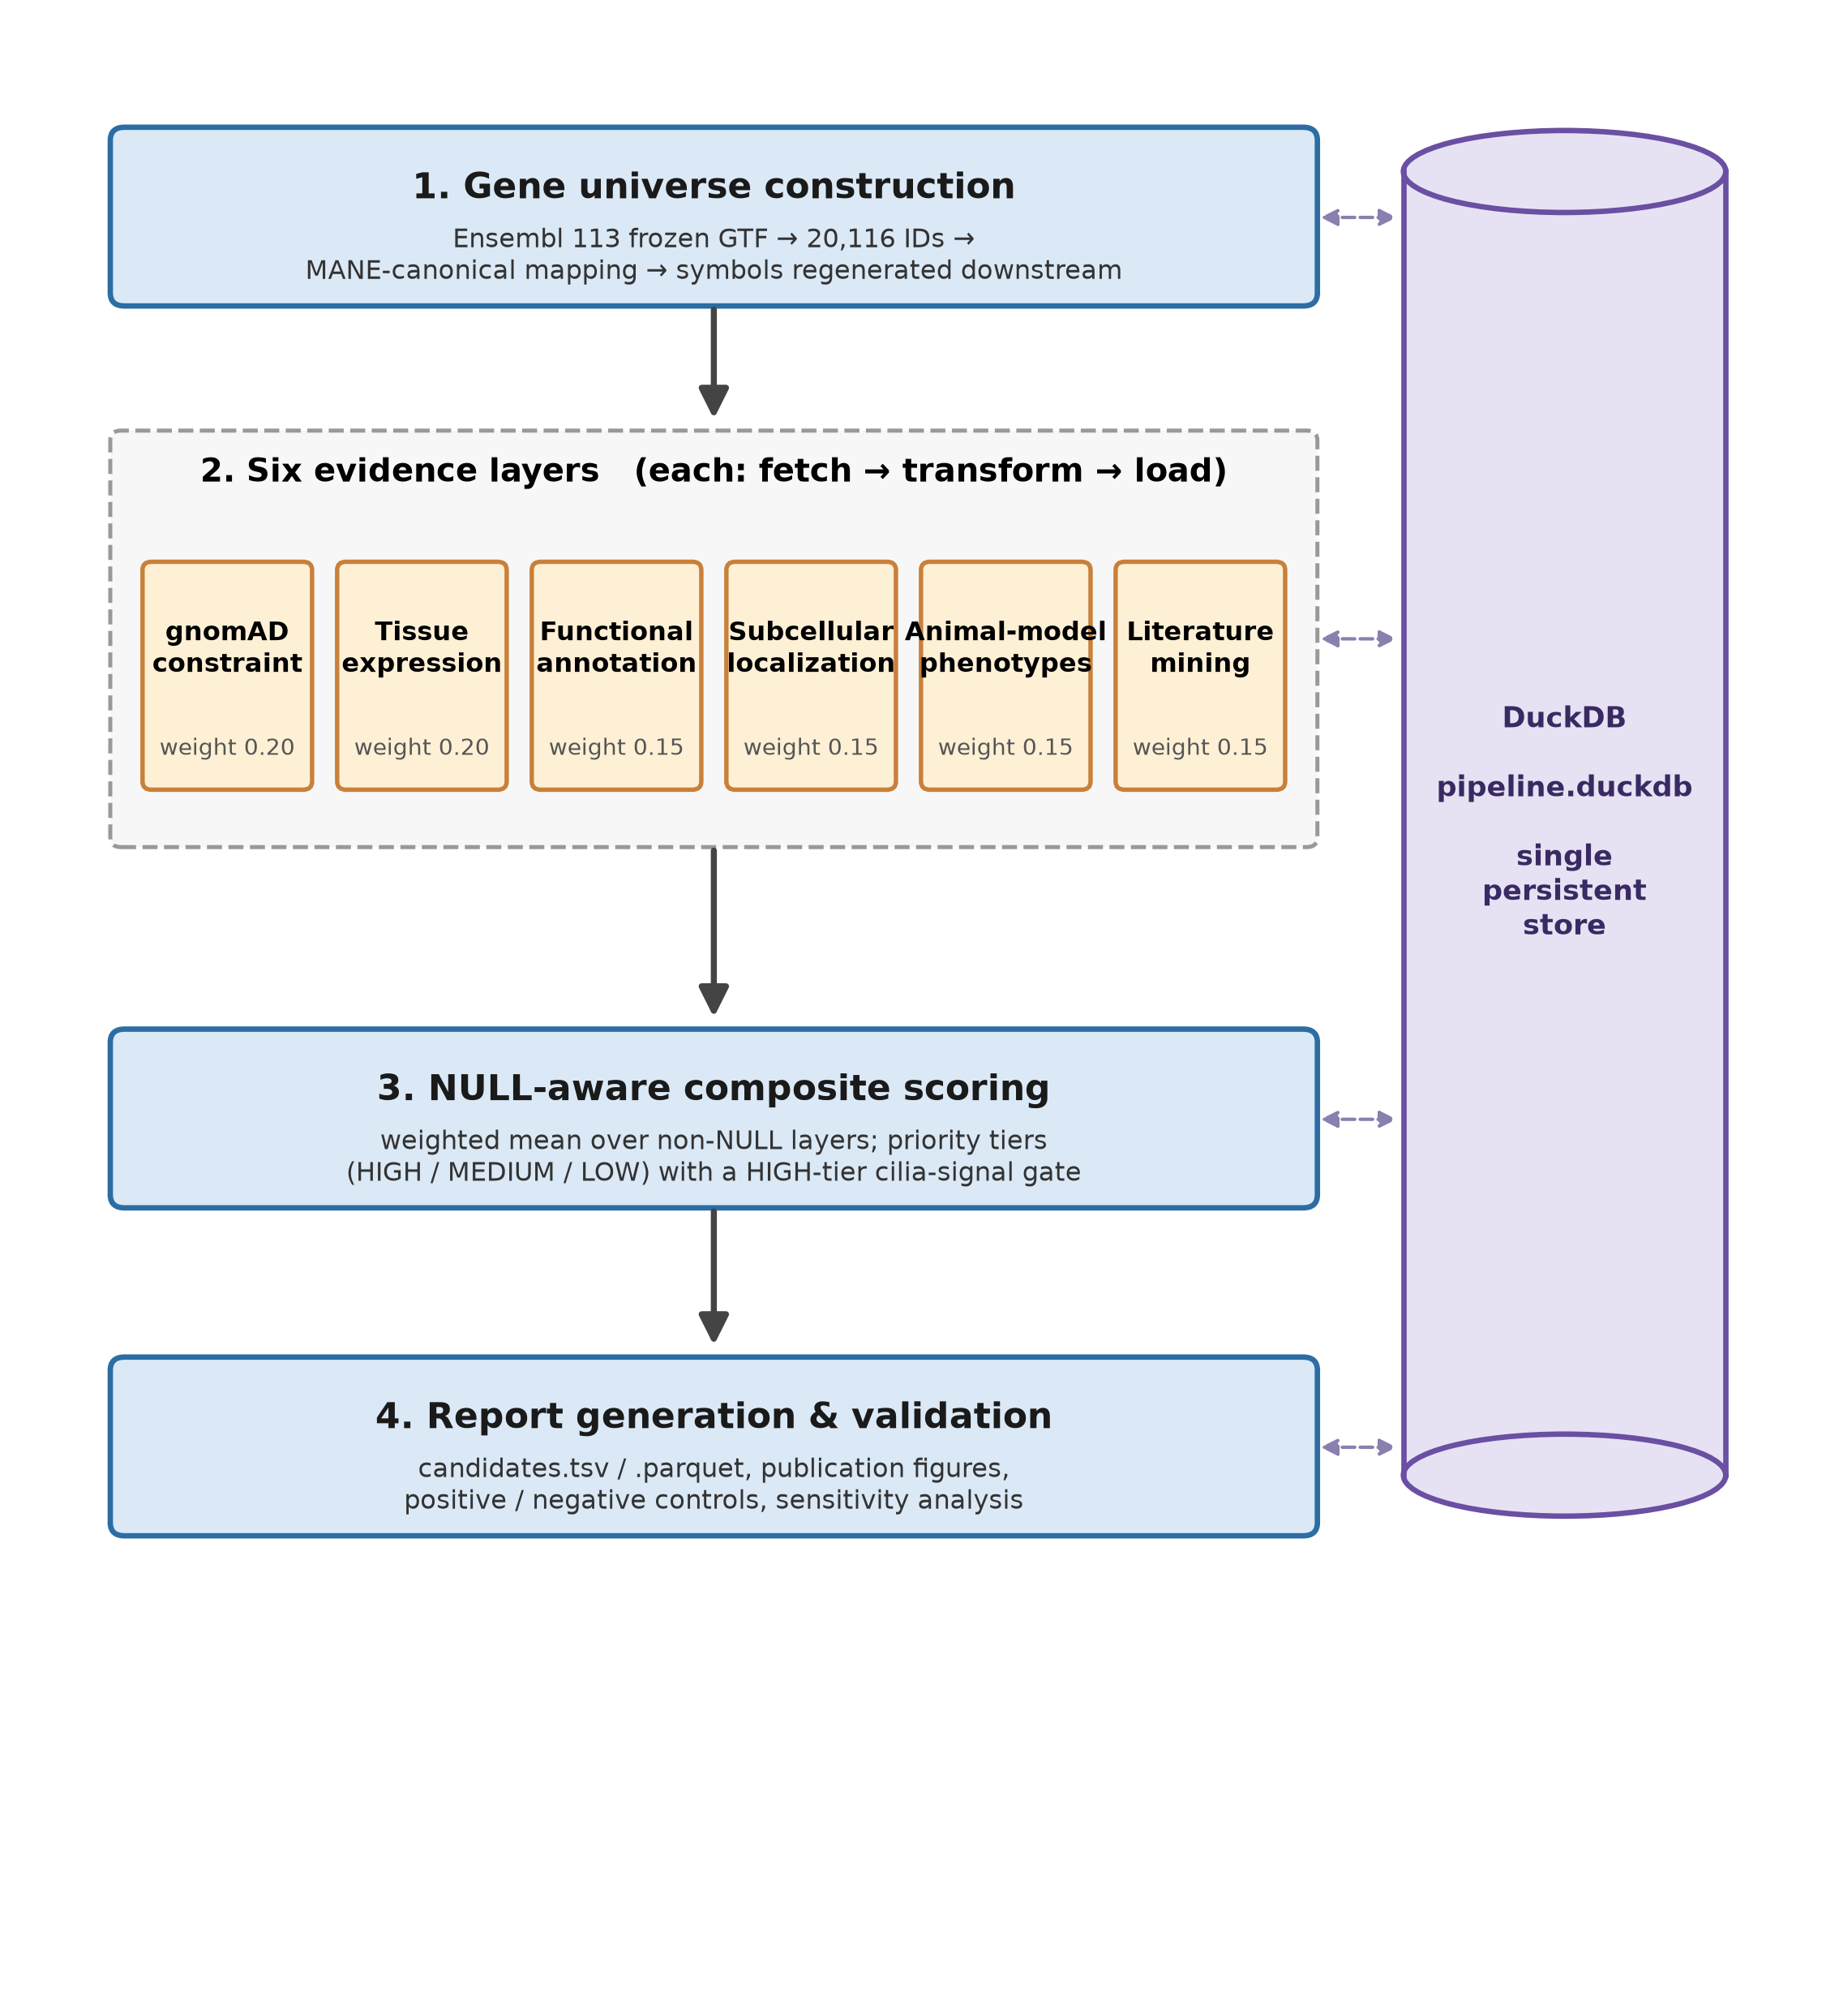
Figure 1. UsherPipe pipeline architecture. The four sequential stages of the pipeline: (1) gene-universe construction from the locally cached Ensembl 113 GTF input, with mygene.info used for annotation; (2) six separately computed evidence layers, each following a fetch–transform–load pattern; (3) NULL-aware composite scoring; and (4) report generation with validation. All pipeline state is held in a single DuckDB database (shown at right), which every stage reads from and writes to. The configured release label does not prove source immutability.
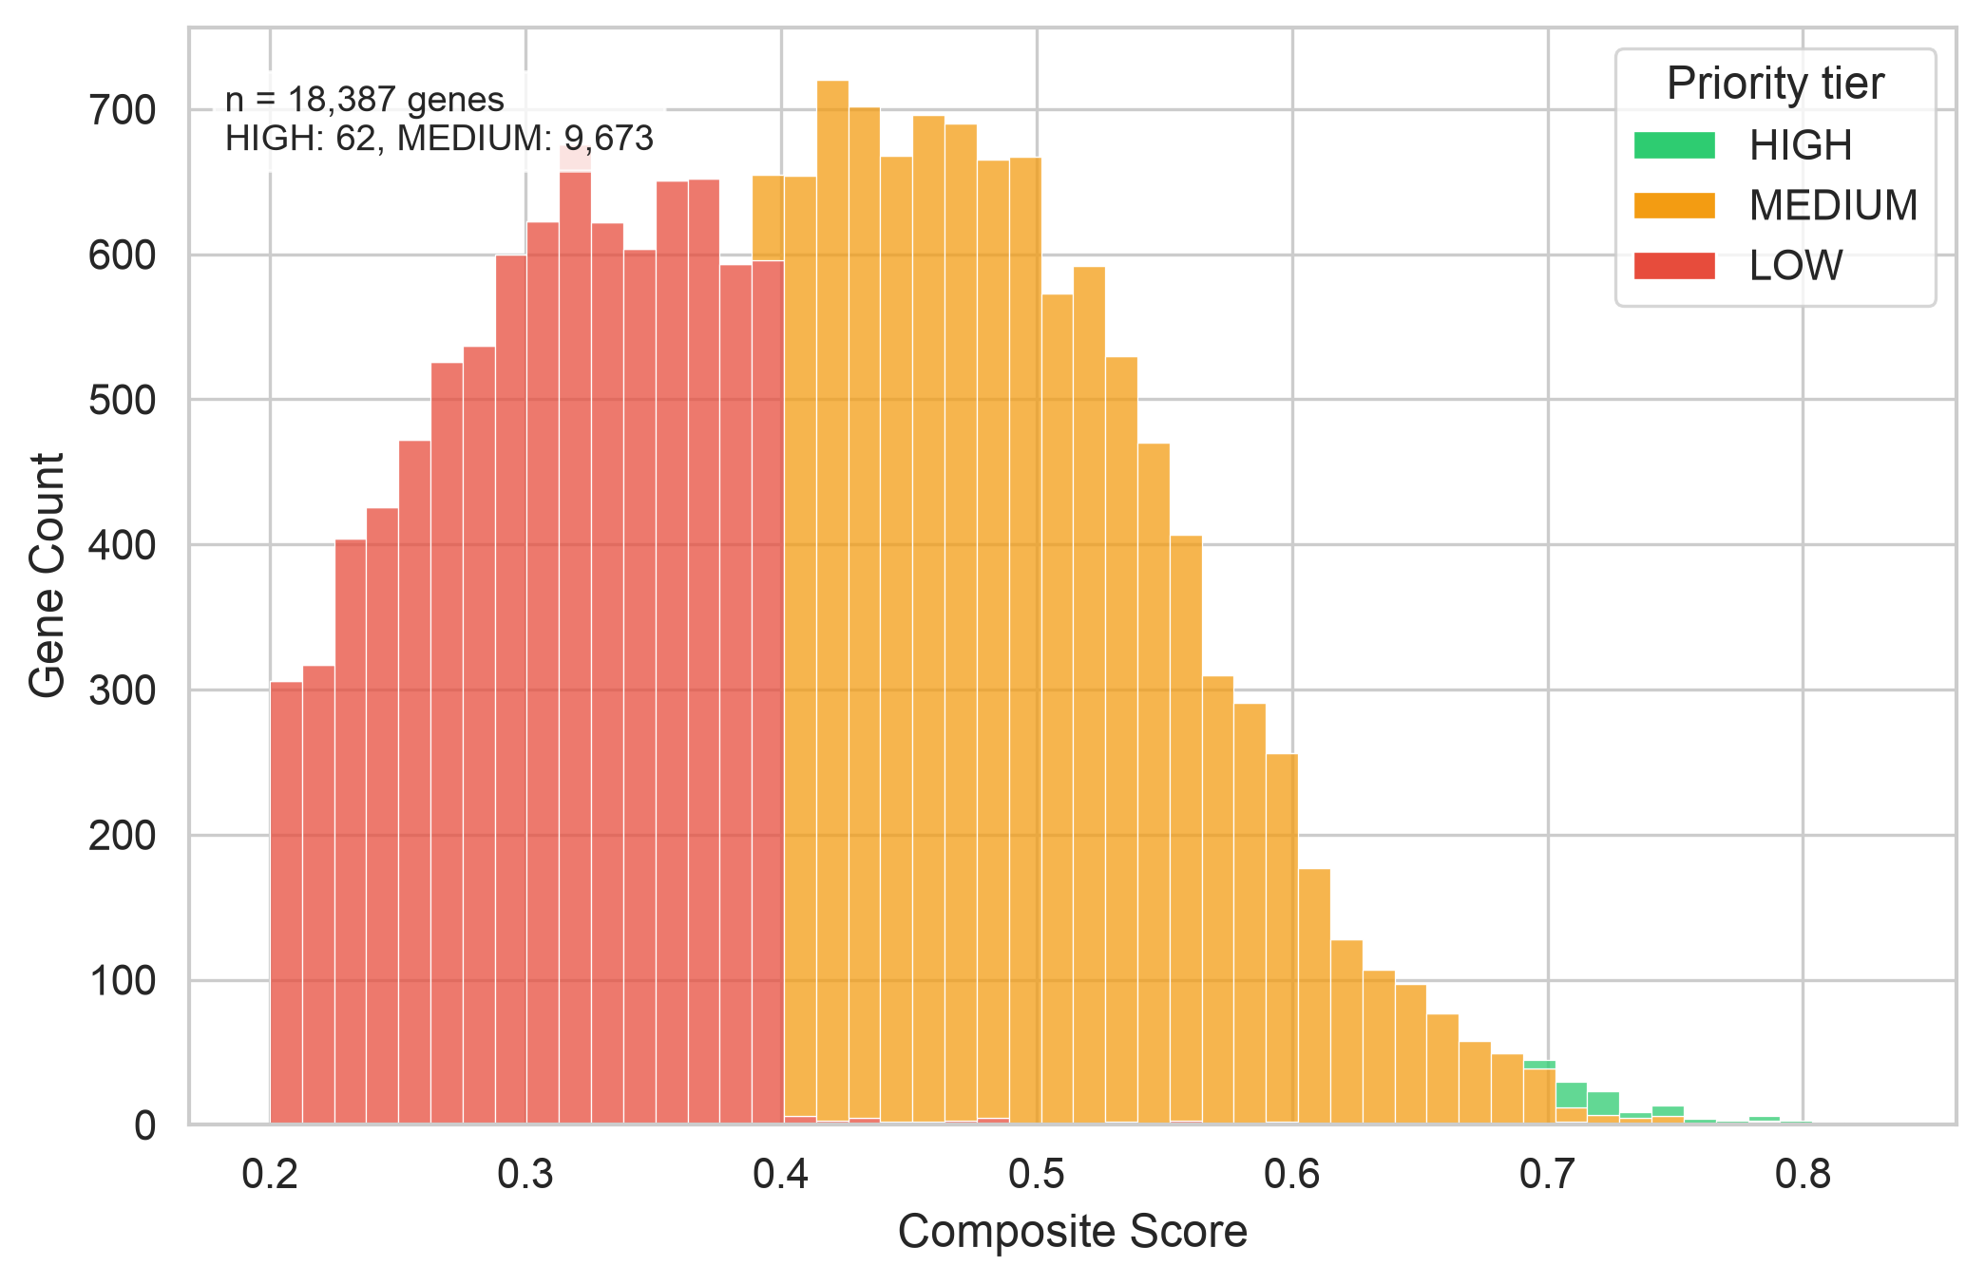
Figure 2. Distribution of composite scores. Stacked histogram of NULL-aware composite scores for the 18,387 tier-classified analysis labels, coloured by priority tier (HIGH, MEDIUM, LOW); labels below the LOW threshold (composite score < 0.2) are excluded and not shown. Most analysis labels fall in the MEDIUM range, and the HIGH tier is a small shortlist at composite score ≥ 0.7 plus the cilia-signal gate.
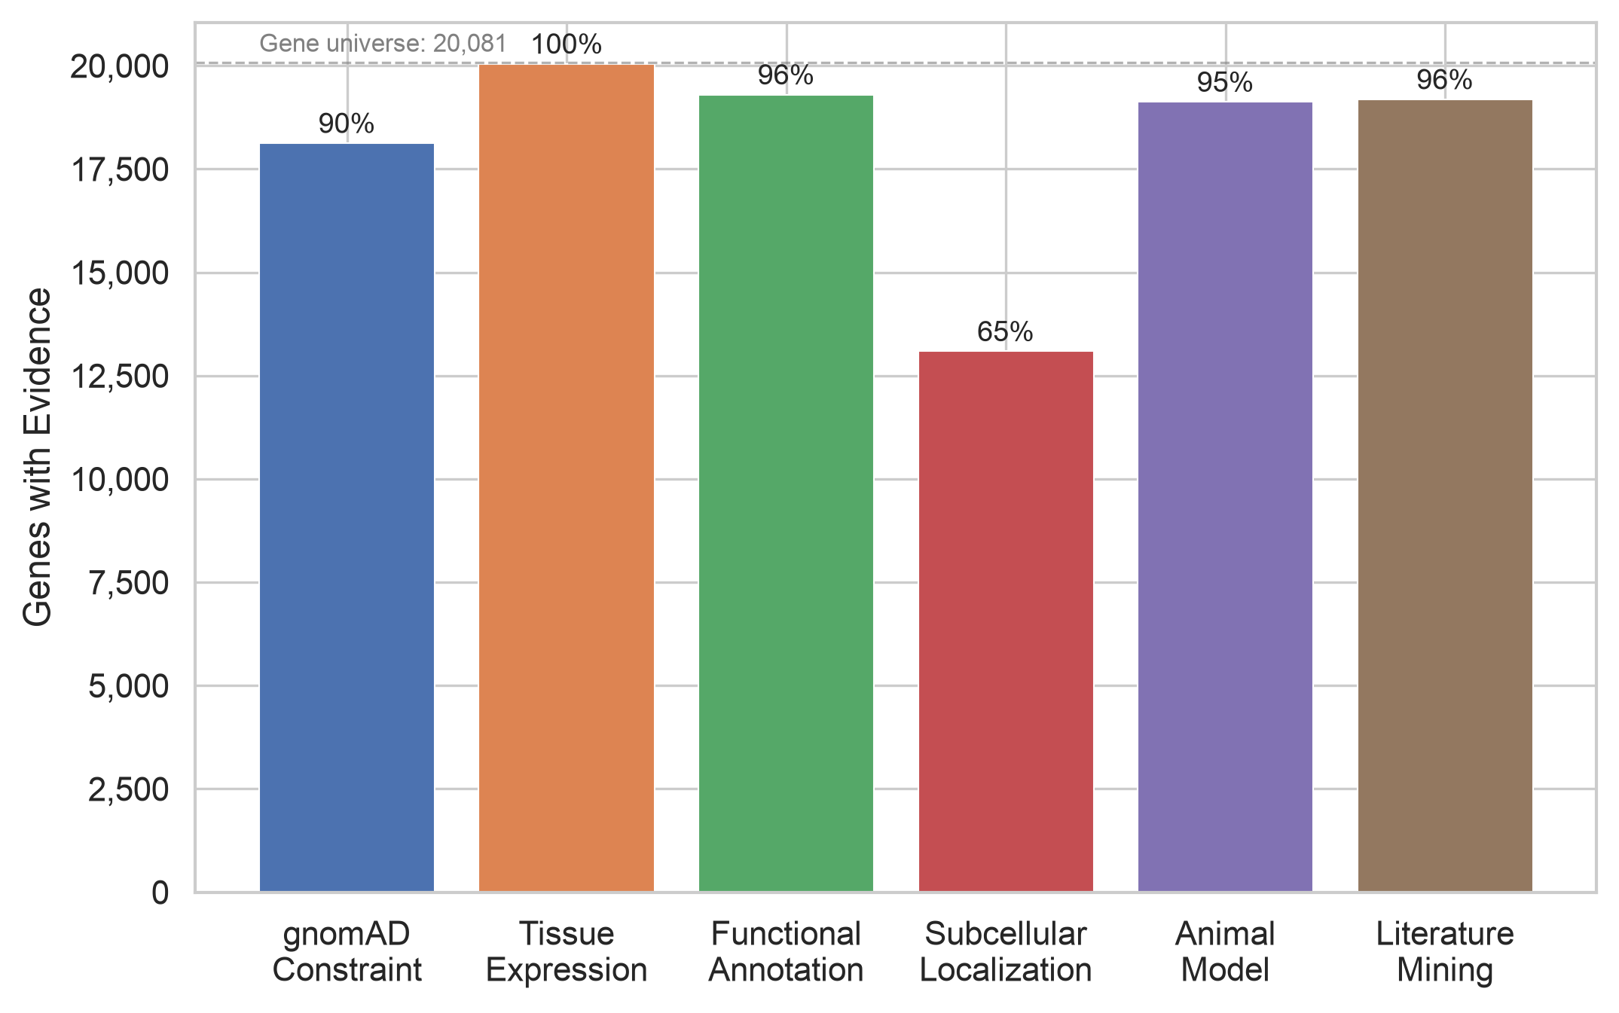
Figure 3. Evidence layer coverage. Number of analysis labels with non-NULL evidence in each of the six evidence layers; the percentage above each bar is coverage relative to the current 20,081-label analysis universe (dashed line). NULL values are retained and are not interpreted as negative evidence.
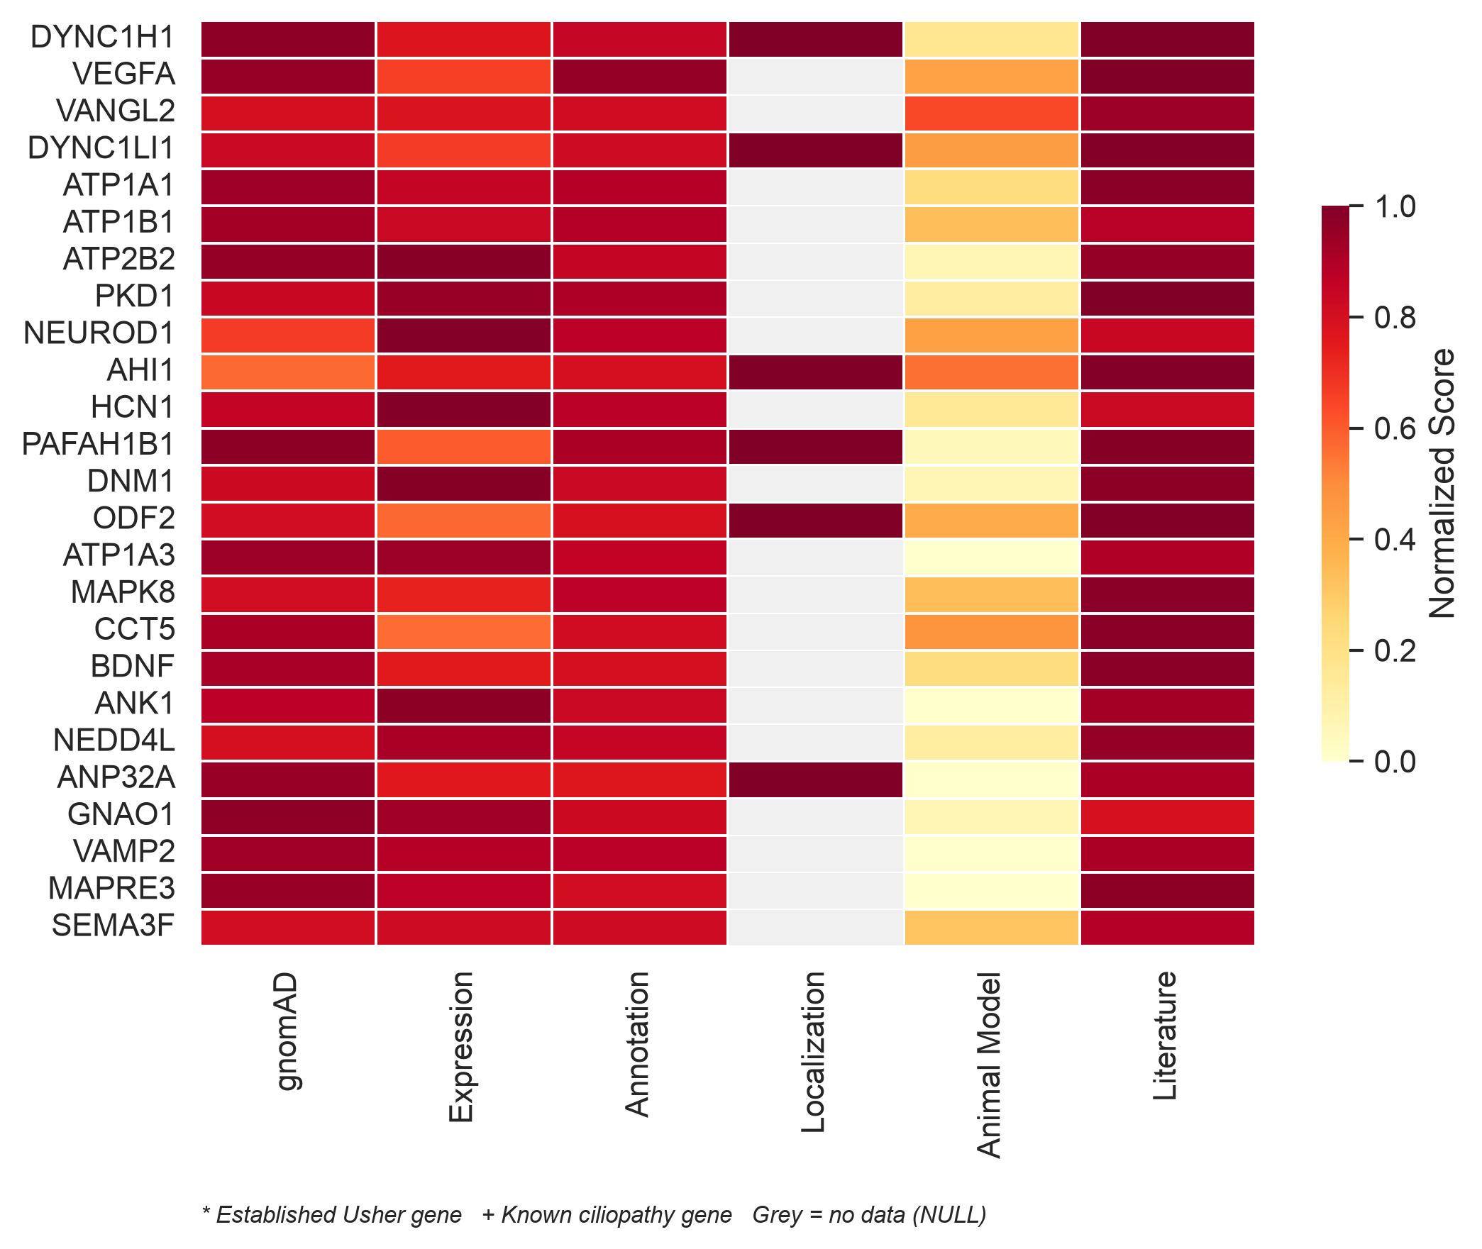
Figure 4. Per-layer evidence profiles of the top 25 candidates. Heatmap of normalized layer scores (0–1) for the 25 highest-scoring genes with sufficient evidence (≥4 layers). Grey cells indicate missing evidence (NULL). An established Usher or SYSCILIA ciliary control appearing among the top candidates is marked with an asterisk or a plus sign, respectively.
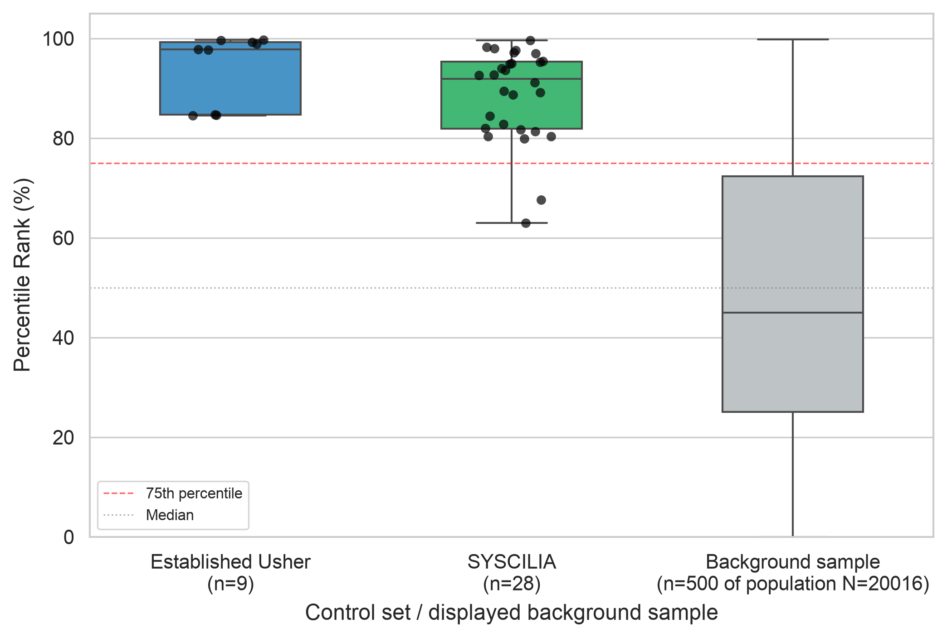
Figure 5. Internal control recovery. Percentile-rank distributions for the nine established Usher genes, the 28 SYSCILIA ciliary genes, and a sample of 500 non-control scored background genes drawn without replacement with numpy.random.default_rng(42) after ordering eligible labels by retained Ensembl ID, shown as box plots with the controls also plotted as individual points. The dashed line marks the 75th percentile and the dotted line the median. The control set is curated and is not an independent validation cohort.
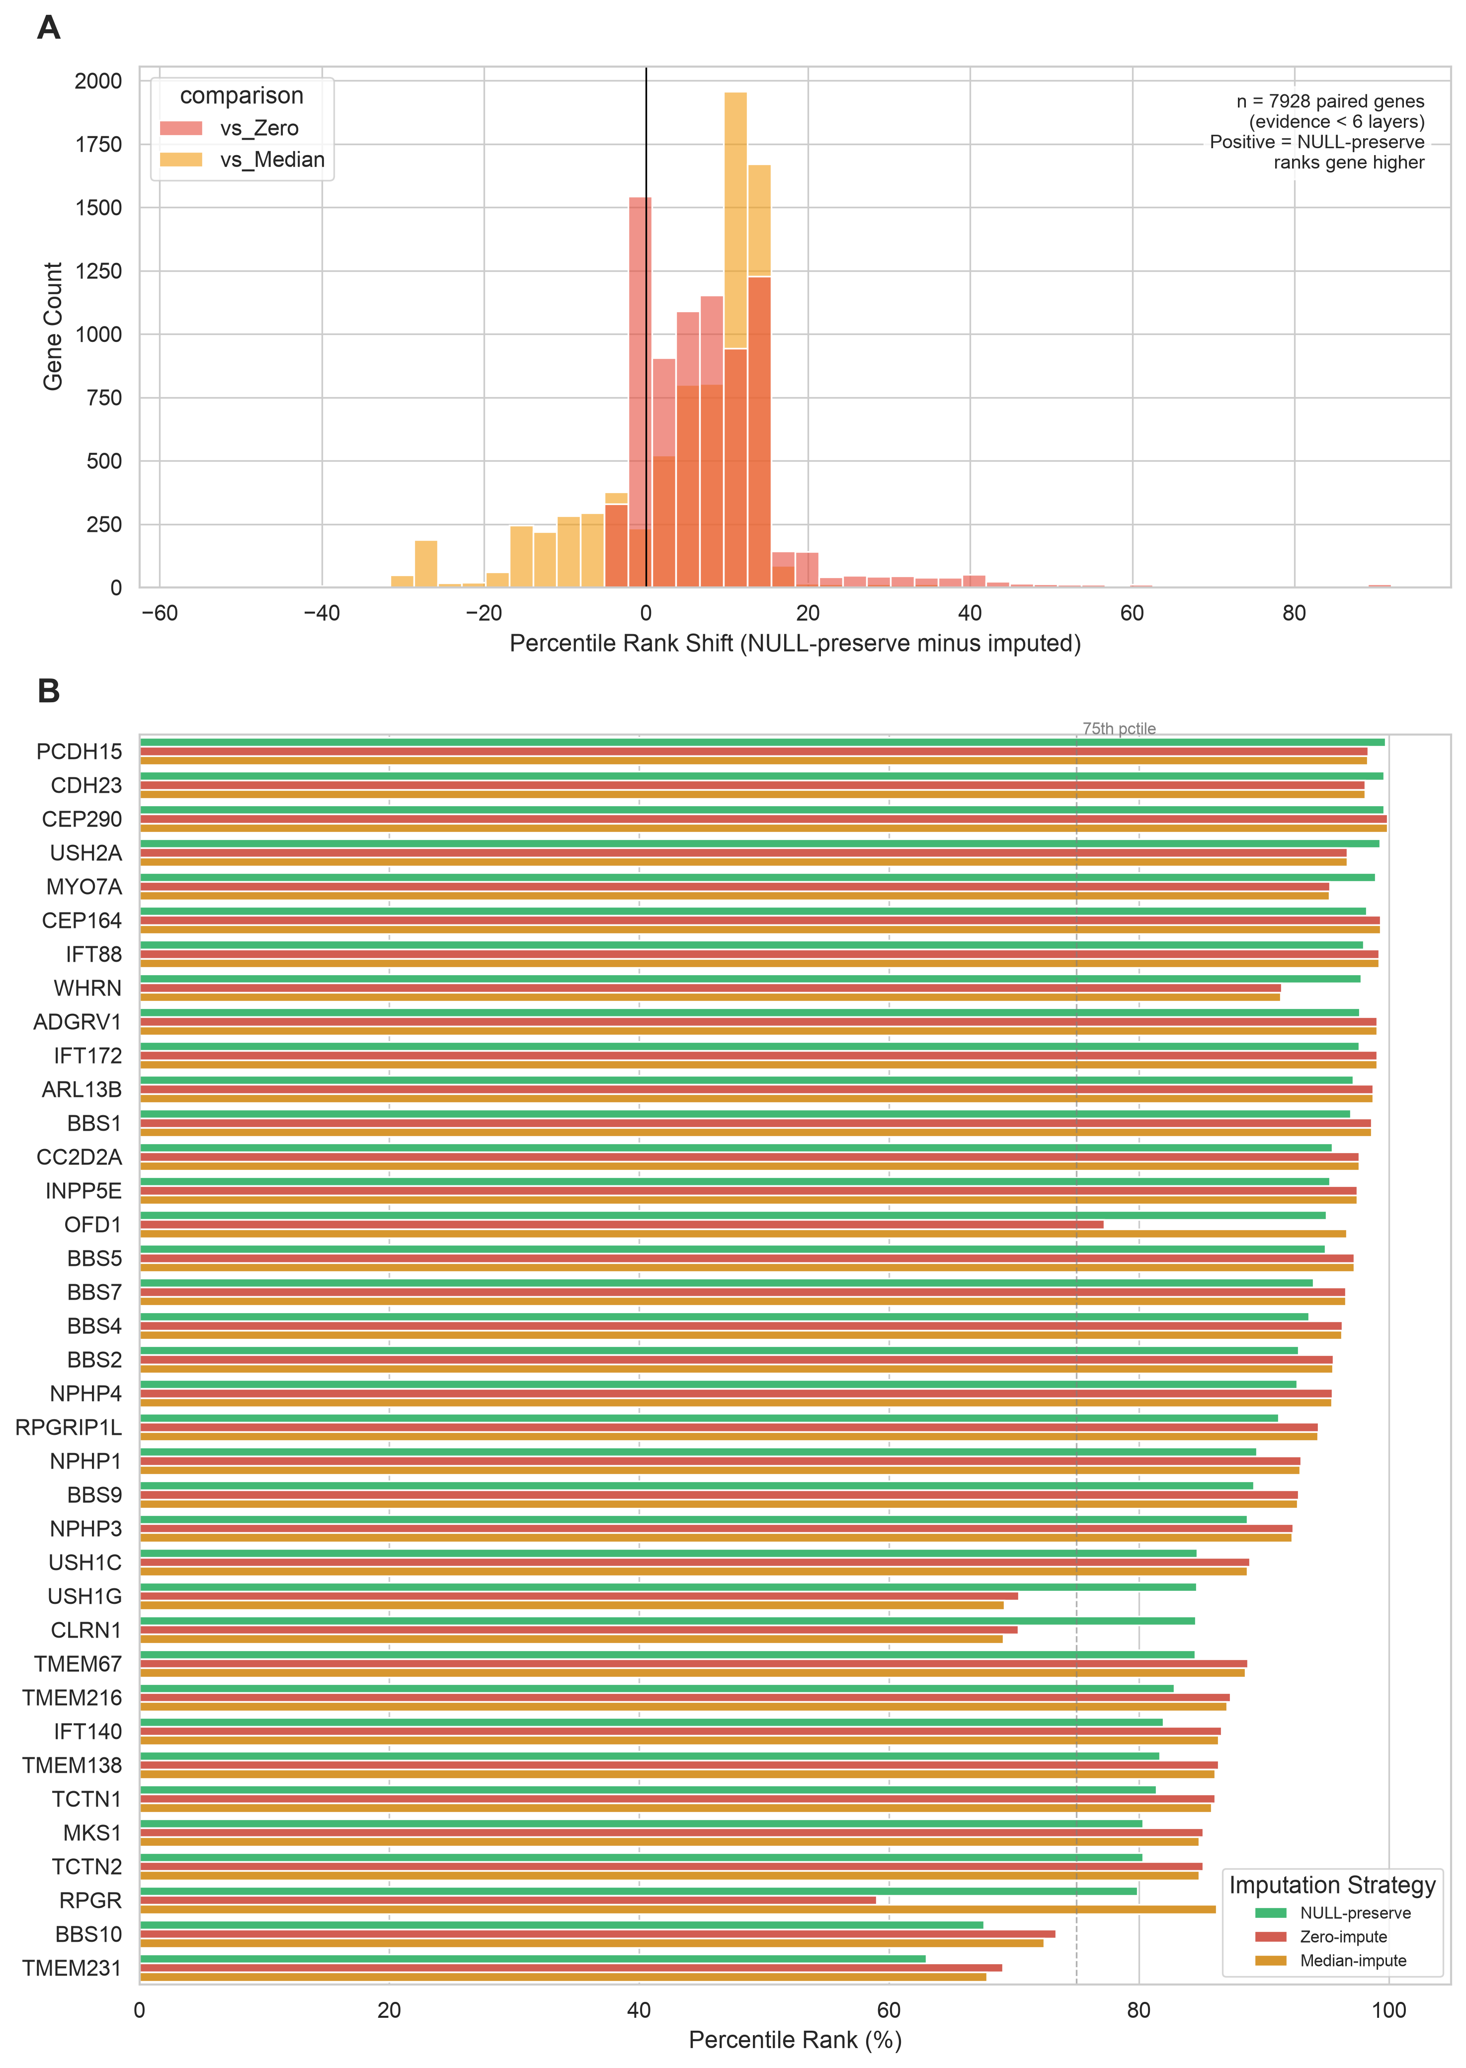
Figure 6. Effect of missing-data handling on rankings. (A) Distribution of percentile-rank shifts for labels with incomplete evidence under NULL-preservation relative to zero imputation and to median imputation; positive values indicate that NULL-preservation ranks the label higher. (B) Percentile rank of selected controls under the three imputation strategies (NULL-preserve, zero-impute, median-impute); the direction and magnitude of change depend on the control’s evidence coverage and the rank denominator.
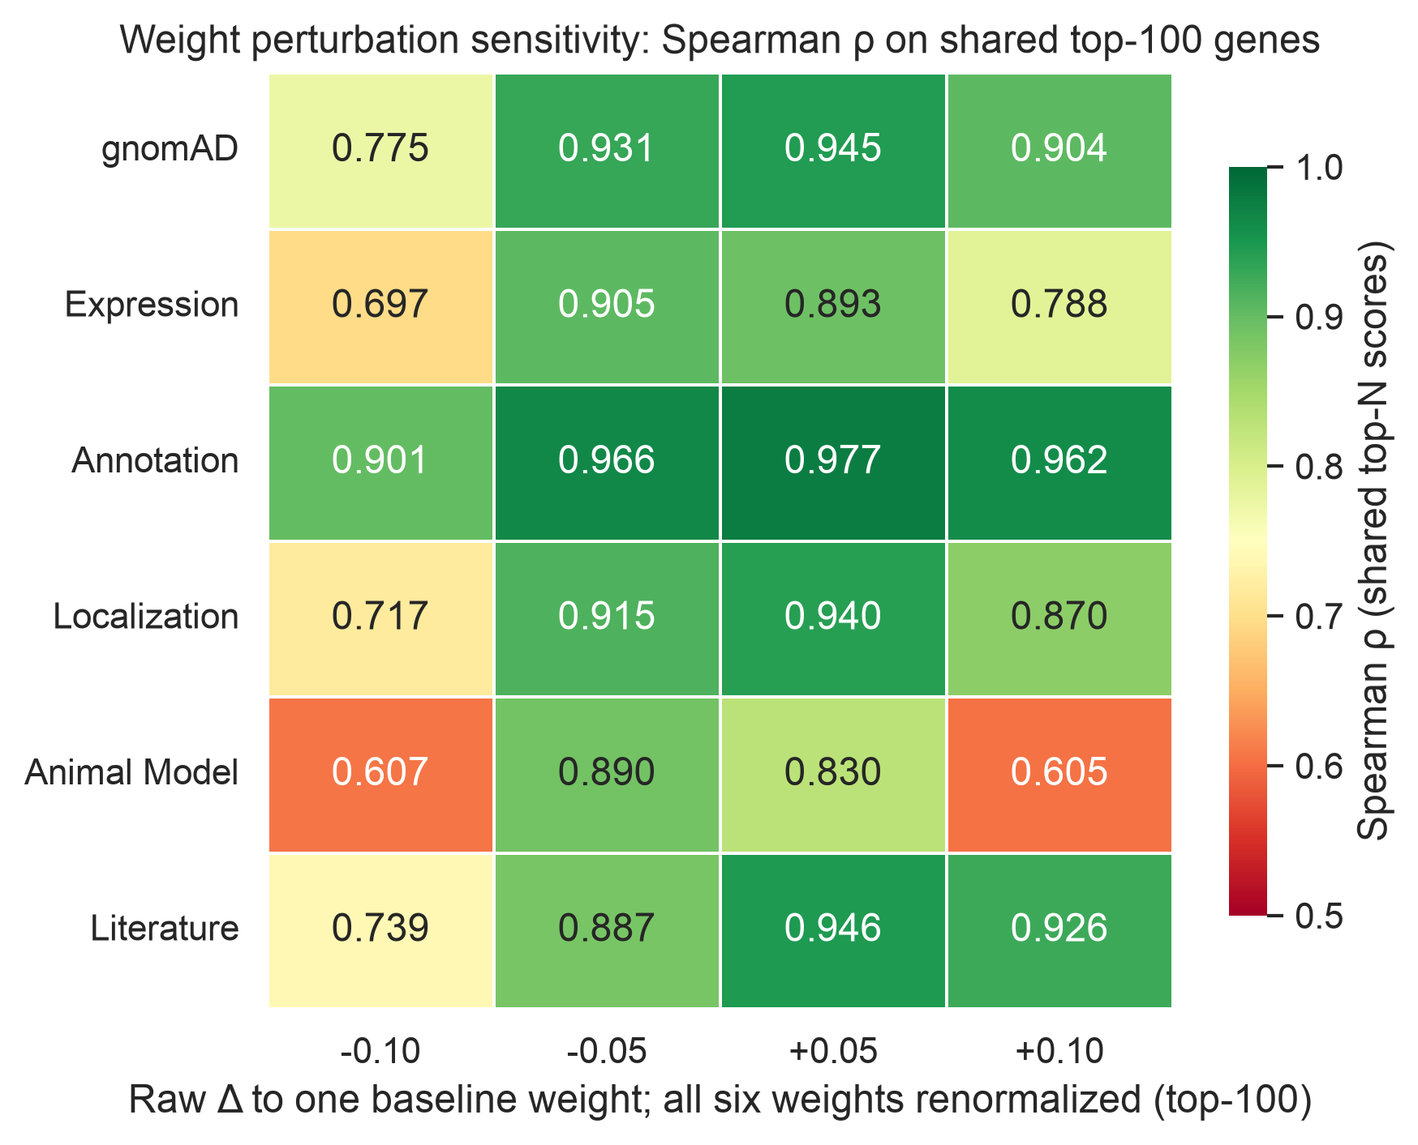
Figure 7. Sensitivity of rankings to weight perturbation. Spearman rank correlation and top-100 overlap metrics under 24 absolute weight-point perturbations (six layers, each changed by ±0.05 and ±0.10). Each raw delta was applied to one weight and then all six weights were renormalized, so the final change is not literally the raw delta and the other weights also change. Sixteen perturbations met ρ ≥ 0.85; mean ρ was 0.8548 and the range was 0.6051–0.9770. On conditional top-100 correlation, animal-model perturbations were the most sensitive and annotation perturbations the least sensitive; this ordering does not describe whole-universe correlation or shortlist overlap; the top-100 Spearman statistic is conditional on overlapping genes.
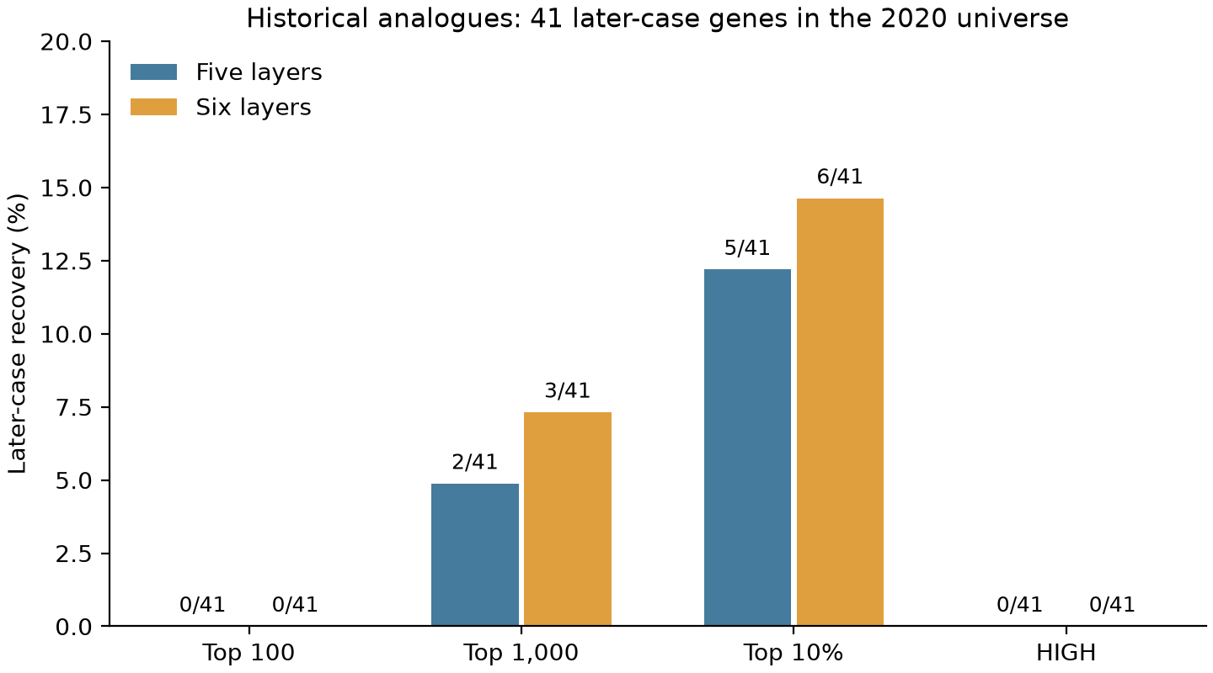
Figure 8. Retrospective recovery of later target associations. Five-layer archived and six-layer literature-augmented historical analogues evaluated the 41 principal cases in the 2020 protein-coding universe. Bars show deterministic top 100, top 1,000, top 10% and HIGH recovery; the numerators and denominator are labeled. Four additional noncoding cases remain failures in the 45-case end-to-end analysis (Table 4). Neither version recovers a principal case at top 100 or HIGH. These are retrospective source-analogue results, with post-cutoff method development and catalog-based ascertainment limitations.
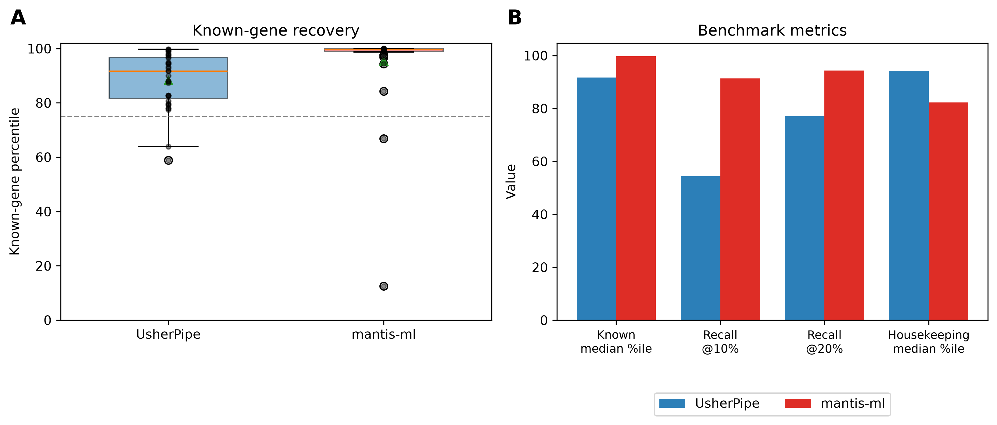
Figure 9. Exploratory benchmark against mantis-ml. (A) Percentile-rank distributions of the 35 curated controls shared by both tools’ gene universes (shared universe: 16,821 labels). Black points show individual controls; boxes show interquartile ranges and median lines, whiskers extend to 1.5 times the interquartile range, open circles mark boxplot outliers and green triangles indicate means. The dashed line marks the 75th percentile. (B) Four cached-output consensus metrics from the six mantis-ml classifier CSVs and the UsherPipe score table: control median percentile (99.7% versus 91.7%), recall at 10% (91.4% versus 54.3%) and 20% (94.3% versus 77.1%), and housekeeping-gene median percentile (82.3% versus 94.2%). Other cached metrics are reported in the main Results. mantis-ml is seed-based (33 of 35 shared controls are training seeds), whereas UsherPipe ranks labels without seed labels; the training run was not recreated, and the comparison does not establish superiority on novel genes.

References
[1] Boughman JA, Vernon M, Shaver KA. Usher syndrome: definition and estimate of prevalence from two high-risk populations. J Chronic Dis. 1983;36(8):595-603. doi:10.1016/0021-9681(83)90147-9.
[2] Géléoc GGS, El-Amraoui A. Disease mechanisms and gene therapy for Usher syndrome. Hear Res. 2020;394:107932.
[3] Gene Curation Coalition (GenCC). CIB2 gene–disease validity curation. Available from: https://search.thegencc.org/genes/HGNC%3A24579. Accessed 14 Aug 2026.
[4] Mathur P, Yang J. Usher syndrome: hearing loss, retinal degeneration and associated abnormalities. Biochim Biophys Acta. 2015;1852(3):406-420.
[5] Bonnet C, Riahi Z, Chantot-Bastaraud S, Smagghe L, Letexier M, Marcaillou C, et al. An innovative strategy for the molecular diagnosis of Usher syndrome identifies causal biallelic mutations in 93% of European patients. Eur J Hum Genet. 2016;24(12):1730-1738. doi:10.1038/ejhg.2016.99.
[6] Strande NT, et al. Evaluating the clinical validity of gene-disease associations: an evidence-based framework developed by the Clinical Genome Resource. Am J Hum Genet. 2017;100(6):895-906. doi:10.1016/j.ajhg.2017.06.002.
[7] Reiter JF, Leroux MR. Genes and molecular pathways underpinning ciliopathies. Nat Rev Mol Cell Biol. 2017;18(9):533-547. doi:10.1038/nrm.2017.60.
[8] Cosgrove D, Zallocchi M. Usher protein functions in hair cells and photoreceptors. Int J Biochem Cell Biol. 2014;46:80-89.
[9] Maerker T, et al. A novel Usher protein network at the periciliary reloading point between molecular transport machineries in vertebrate photoreceptor cells. Hum Mol Genet. 2008;17(1):71-86.
[10] El-Amraoui A, Petit C. Usher I syndrome: unravelling the mechanisms that underlie the cohesion of the growing hair bundle in inner ear sensory cells. J Cell Sci. 2005;118(Pt 20):4593-4603.
[11] Yang J, et al. Ablation of whirlin long isoform disrupts the USH2 protein complex and causes vision and hearing loss. PLoS Genet. 2010;6(5):e1000955.
[12] Sahly I, et al. Localization of Usher 1 proteins to the photoreceptor calyceal processes, which are absent from mice. J Cell Biol. 2012;199(2):381-399.
[13] Lefèvre G, et al. A core cochlear phenotype in USH1 mouse mutants implicates fibrous links of the hair bundle in its cohesion, orientation and differential growth. Development. 2008;135(8):1427-1437.
[14] Schwander M, Kachar B, Müller U. The cell biology of hearing. J Cell Biol. 2010;190(1):9-20. doi:10.1083/jcb.201001138.
[15] Bahloul A, et al. Cadherin-23, myosin VIIa and harmonin, encoded by Usher syndrome type I genes, form a ternary complex and interact with membrane phospholipids. Hum Mol Genet. 2010;19(18):3557-3565.
[16] Wang H, et al. Temporal and spatial assembly of inner ear hair cell ankle link condensate through phase separation. Nat Commun. 2023;14(1):1657. doi:10.1038/s41467-023-37267-5.
[17] Geng R, et al. The mechanosensory structure of the hair cell requires clarin-1, a protein encoded by Usher syndrome III causative gene. J Neurosci. 2012;32(28):9485-9498. doi:10.1523/JNEUROSCI.0311-12.2012.
[18] Nonarath HJT, et al. The USH3A causative gene clarin1 functions in Müller glia to maintain retinal photoreceptors. PLoS Genet. 2025;21(3):e1011205. doi:10.1371/journal.pgen.1011205.
[19] Kremer H, et al. Usher syndrome: molecular links of pathogenesis, proteins and pathways. Hum Mol Genet. 2006;15(Spec No 2):R262-R270. doi:10.1093/hmg/ddl205.
[20] Aerts S, Lambrechts D, Maity S, et al. Gene prioritization through genomic data fusion. Nat Biotechnol. 2006;24(5):537-544.
[21] Chen J, Bardes EE, Aronow BJ, Jegga AG. ToppGene Suite for gene list enrichment analysis and candidate gene prioritization. Nucleic Acids Res. 2009;37(Web Server issue):W305-W311.
[22] Smedley D, et al. Next-generation diagnostics and disease-gene discovery with the Exomiser. Nat Protoc. 2015;10(12):2004-2015.
[23] Birgmeier J, et al. AMELIE speeds Mendelian diagnosis by matching patient phenotype and genotype to primary literature. Sci Transl Med. 2020;12(544):eaau9113. PMID:32434849. doi:10.1126/scitranslmed.aau9113.
[24] van Dam TJP, et al. CiliaCarta: An integrated and validated compendium of ciliary genes. PLoS One. 2019;14(5):e0216705. doi:10.1371/journal.pone.0216705.
[25] Pir MS, et al. CilioGenics: an integrated method and database for predicting novel ciliary genes. Nucleic Acids Res. 2024;52(14):8127-8145. doi:10.1093/nar/gkae554.
[26] Vitsios D, Petrovski S. Mantis-ml: disease-agnostic gene prioritization from high-throughput genomic screens by stochastic semi-supervised learning. Am J Hum Genet. 2020;106(5):659-678. doi:10.1016/j.ajhg.2020.03.012.
[27] Xin J, et al. High-performance web services for querying gene and variant annotation. Genome Biol. 2016;17(1):91. doi:10.1186/s13059-016-0953-9.
[28] gnomAD Production Team. gnomAD v4.1 updates. gnomAD Browser. 2024 May 2. Available from: https://gnomad.broadinstitute.org/news/2024-05-gnomad-v4-1-updates/. Accessed 14 Aug 2026.
[29] Uhlén M, et al. Proteomics. Tissue-based map of the human proteome. Science. 2015;347(6220):1260419. doi:10.1126/science.1260419.
[30] GTEx Consortium. The GTEx Consortium atlas of genetic regulatory effects across human tissues. Science. 2020;369(6509):1318-1330. doi:10.1126/science.aaz1776.
[31] CZI Cell Science Program, Abdulla S, Aevermann B, et al. CZ CELLxGENE Discover: a single-cell data platform for scalable exploration, analysis and modeling of aggregated data. Nucleic Acids Res. 2025;53(D1):D886-D900. doi:10.1093/nar/gkae1142.
[32] Gene Ontology Consortium. The Gene Ontology resource: enriching a GOld mine. Nucleic Acids Res. 2021;49(D1):D325-D334.
[33] UniProt Consortium. UniProt: the Universal Protein Knowledgebase in 2023. Nucleic Acids Res. 2023;51(D1):D523-D531. doi:10.1093/nar/gkac1052.
[34] Kanehisa M, Goto S. KEGG: Kyoto Encyclopedia of Genes and Genomes. Nucleic Acids Res. 2000;28(1):27-30. doi:10.1093/nar/28.1.27.
[35] Gillespie M, et al. The reactome pathway knowledgebase 2022. Nucleic Acids Res. 2022;50(D1):D687-D692.
[36] Yates B, et al. Updates to HCOP: the HGNC comparison of orthology predictions tool. Brief Bioinform. 2021;22(6):bbab155. doi:10.1093/bib/bbab155.
[37] Blake JA, et al. Mouse Genome Database (MGD): knowledgebase for mouse-human comparative biology. Nucleic Acids Res. 2021;49(D1):D981-D987.
[38] Groza T, et al. The International Mouse Phenotyping Consortium: comprehensive knockout phenotyping underpinning the study of human disease. Nucleic Acids Res. 2023;51(D1):D1038-D1045. doi:10.1093/nar/gkac972.
[39] Bradford Y, et al. Zebrafish information network, the knowledgebase for Danio rerio research. Genetics. 2022;220(4):iyac016. doi:10.1093/genetics/iyac016.
[40] Sayers EW, et al. Database resources of the National Center for Biotechnology Information in 2023. Nucleic Acids Res. 2023;51(D1):D29-D38. doi:10.1093/nar/gkac1032.
[41] National Center for Biotechnology Information. GSE135913: single-cell RNA sequencing of mouse and human cochlea. Gene Expression Omnibus. Available from: https://www.ncbi.nlm.nih.gov/geo/query/acc.cgi?acc=GSE135913. Accessed 14 Aug 2026.
[42] RetNet, the Retinal Information Network. https://retnet.org/. Accessed 6 October 2026.
[43] Martin AR, Williams E, Foulger RE, et al. PanelApp crowdsources expert knowledge to establish consensus diagnostic gene panels. Nat Genet. 2019;51:1560-1565. doi:10.1038/s41588-019-0528-2.
[44] Europe PMC Consortium. Europe PMC: a full-text literature database for the life sciences and platform for innovation. Nucleic Acids Res. 2015;43(Database issue):D1042-D1048. doi:10.1093/nar/gku1061.
[45] Menon M, Mohammadi S, Davila-Velderrain J, Goods BA, Cadwell TD, Xing Y, et al. Single-cell transcriptomic atlas of the human retina identifies cell types associated with age-related macular degeneration. Nat Commun. 2019;10:4902. doi:10.1038/s41467-019-12780-8.
[46] Bailly E, Walton A, Borg JP. The planar cell polarity Vangl2 protein: from genetics to cellular and molecular functions. Semin Cell Dev Biol. 2018;81:62-70. doi:10.1016/j.semcdb.2017.10.030.
[47] Henderson DJ, Phillips HM, Chaudhry B. Vang-like 2 and noncanonical Wnt signaling in outflow tract development. Trends Cardiovasc Med. 2006;16(2):38-45. doi:10.1016/j.tcm.2005.11.005.
[48] Kibar Z, et al. Contribution of VANGL2 mutations to isolated neural tube defects. Clin Genet. 2011;80(1):76-82.
[49] Harms MB, et al. Mutations in the tail domain of DYNC1H1 cause dominant spinal muscular atrophy. Neurology. 2012;78(22):1714-1720.
[50] Hertecant J, et al. A novel de novo mutation in DYNC1H1 gene underlying malformation of cortical development and cataract. Meta Gene. 2016;9:124-127. doi:10.1016/j.mgene.2016.05.004.
[51] Smits JJ, Oostrik J, Beynon AJ, et al. De novo and inherited loss-of-function variants of ATP2B2 are associated with rapidly progressive hearing impairment. Hum Genet. 2019;138(1):61-72. doi:10.1007/s00439-018-1965-1.
[52] Street VA, et al. Mutations in a plasma membrane Ca2+-ATPase gene cause deafness in deafwaddler mice. Nat Genet. 1998;19(4):390-394.
[53] Vasquez SSV, van Dam J, Wheway G. An updated SYSCILIA gold standard (SCGSv2) of known ciliary genes, revealing the vast progress that has been made in the cilia research field. Mol Biol Cell. 2021;32(21):br13.
[54] ClinGen. Gene–disease validity expert-curated download. Export file date 6 Oct 2026. Available from: https://search.clinicalgenome.org/kb/gene-validity/download. Exact bytes and download-completion metadata retained in the revision source manifest.
[55] HGNC. Complete approved gene set. Live export frozen 6 Oct 2026. Available from: https://storage.googleapis.com/public-download-files/hgnc/tsv/tsv/hgnc_complete_set.txt. Exact snapshot retained in the revision replay package.
[56] Human Phenotype Ontology. Release v2026-09-01, ontology and gene-to-phenotype annotations. Available from: https://github.com/obophenotype/human-phenotype-ontology/releases/tag/v2026-09-01. Downloaded 6 Oct 2026.
[57] Linnert J, et al. Usher syndrome proteins ADGRV1 (USH2C) and CIB2 (USH1J) interact and share a common interactome containing TRiC/CCT-BBS chaperonins. Front Cell Dev Biol. 2023;11:1199069. doi:10.3389/fcell.2023.1199069.
[58] UsherPipe. Usher syndrome candidate-gene prioritization pipeline. GitHub repository. 2026. Available from: https://github.com/gbanyan/usher-exploring/tree/major-revision-author-review-20261007. Fixed author-review release, 7 Oct 2026; original public code/data version 4cf8c5b; submitted files preserved at ed2d00d.

