General Information
Database: summ2025productinventorydb
ERD - sum2025productinventorydb
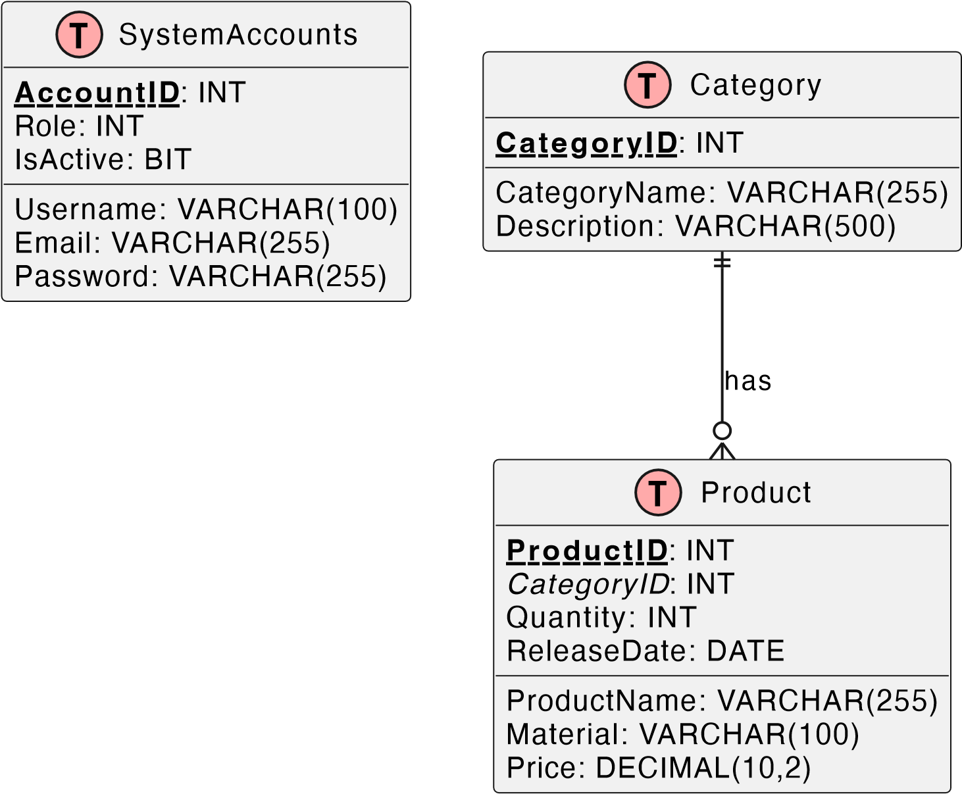

Implementation Tasks

Authentication & Authorization (1.5 point)
Implement login using JWT (email + password). Allowed Roles:
admin, manager : Full access (CRUD + search)
analyst : Read + search only
Others roles: No token issued
Endpoint:
POST /api/auth
Request:
"email": "manager@system.com",
"password": "123456"
}
Response:
{
"token": "<JWT token>",
"role": "admin"
}

Product API Endpoints (4.0 points)
GET /api/products
List all products with category info
Roles: All logged-in roles
Status Codes: 200, 401, 403
GET /api/products/{id}
Get product by ID
Status Codes: 200, 404, 401, 403
POST /api/products
Add a new product
Roles: admin, manager only Validation:
productName : must match ^[A-Z][a-zA-Z0-9\s]{2,50}$ price > 0, quantity ≥ 0
Status Codes: 201, 400, 401, 403 Request Body:

"productName": "SmartWatch Z3",
"price": 149.99,
"quantity": 30, "categoryId": 2
}
PUT /api/products/{id}
Update a product
Roles: admin, manager
Status Codes: 200, 400, 404, 401, 403
{
"productName": "SmartWatch Z3",
"price": 149.99,
"quantity": 30, "categoryId": 2
}
DELETE /api/products/{id}
Remove a product Roles: admin only
Status Codes: 200, 404, 401, 403 Request Body:
GET /api/products/search?name=...&category=...
Filter products by name and category
Results grouped by category Roles: All with valid token
Status Codes: 200, 401, 403

Error Code Format (1.0 point)
Use the JSON error response format below:
"errorCode": "PR40001",
"message": "Product name is required"
}
Error Code |  | HTTP Status | Meaning
PR40001 | 400 |  | Invalid input
PR40101 | 401 |  | Authentication error
PR40301 | 403 |  | Not authorized
PR40401 | 404 |  | Resource not found
PR50001 | 500 |  | Server error

Swagger Integration (1.0 point)
Document all API endpoints
Allow token-based authentication testing
Display schema validation rules

Postman Test Suite (2.5 points)
Create and run at least 6 test cases:
Login success
Login failure
Add product (admin/manager)
Update product
Delete product
Search / Get product by ID Requirements:
Use JWT in request headers Validate status codes and message fields Use appropriate HTTP method/body

Submission Guidelines
❗ Compilation errors = 0 points
File naming must follow _<YourStudentID>_api
Good luck!

