Floating Offshore Wind Turbine Substructure Design and Sensitivity to Tower Top Weight with a Hydrostatic-based Systems Design Tool

Garrett E. Barter, Amy Robertson, and Walter Musial September 30, 2018

# Abstract

This work introduces *FloatingSE*, the floating offshore wind turbine substructure cost, sizing, and analysis module in the Wind-Plant Integrated System Design & Engineering Model (WISDEM) framework. The tool generalizes its geometry parameterization enabling the same set of variables to describe spars, semisubmersibles, tension leg platforms (TLPs), and hybrids of those archetypes. Design evaluation is done by the application of existing codes and standards, hydrostatic principals, and simple beam finite element static structural analysis. With other multidisciplinary WISDEM modules, the inclusion of *FloatingSE* enables the vertical simulation of a floating offshore wind turbine, even a whole plant if desired. To showcase this capability, a two-step optimized-based analysis was carried out. First, three different substructures, a spar, semisubmersible, and TLP, were designed to support a 10 MW reference turbine. Second, a design sensitivity study was conducted where mass in the nacelle was parametrically removed, to simulate the weight reduction that may be achieved from some novel drivetrain or generator technologies, and the design re-optimized. The derived sensitivities were used to ascertain the break-even cost rate of the new technology that reduces the drivetrain mass, but at a cost premium ($1,000 for the spar, $450 for the semisubmersible, and $100 for the TLP). Another noteworthy observation is that mass is poor surrogate for cost in optimization studies, a convention frequently used in conceptual design studies. Due to the many simplifying assumptions and low-fidelity analysis, the optimized design and sensitivity values come with many caveats and are subject to change with following future development.

# Introduction

The US offshore wind gross resource potential is over 2000 GW1, much of which is located near highly popu- lated coastal load centers2 [27]. This vast potential is distributed over a resource area of which approximately 58% is in water that is 60 m deep, or greater, and that proportion rises to 95% on the Pacific coastline [28]. The fundamental wind turbine technology shift for deployment in deep water is the transition to buoyant support structures from conventional fixed-bottom support structures, which become too costly and more technically challenging in deep water (likely greater than 50 m) [24]. Although floating wind turbines present many new technical challenges, they also have many potential benefits compared to shallow-water systems. Wind speeds can be higher in deep-water regions because they are further from shore, although there are exceptions to this trend. Siting floating projects may be easier near large load centers such as the North

1The technical offshore wind resource potential that is greater than 7 m/s annual average wind speed was calculated to be 2058 GW, considering all ocean and lake areas less than 1000 m depth.

2Excludes areas in the Great Lakes deeper than 60 m because technology for floating structures to survive ice conditions has

not been matured yet.

Atlantic, because plants farther from shore may have fewer environmental and human use impacts, including viewshed issues3. Despite the distance from shore, floating systems may also be easier to install since they have the potential to be fully assembled at regional construction ports, commissioned at quayside, and towed out.

Preliminary analysis suggests that, in time, floating technology has the potential to achieve a lower cost of energy than their fixed-bottom counterparts [4]. In fact, the Equinor (formally Statoil) Hywind floating plant recorded a higher capacity factor in its first few months of operation than its fixed-bottom brethren [37]. However, as a nascent technology, the cost of floating offshore wind energy is still high today. Detailed modeling shows that the needed long-term cost reductions are not likely to come from a single breakthrough invention. Instead, significant cost reductions will come from a disciplined combination of complementary innovations, or a technology cost reduction *pathway*.

To produce transformational cost reductions, multiple advancements are needed over the entire system: the turbine, tower, floating platform, moorings, anchors, construction, and logistics. However, the complexities of the physics, manufacturing, installation, and operation of floating wind turbines require a fully integrated systems engineering and techno-economic design approach to achieve these transformational cost reductions. The paper outlines an initial, low-fidelity step towards realizing this vision and an example analysis using this design approach. Note that these results are preliminary and more work is needed to realize the full benefit of this integrated systems engineering approach. As such, the purpose of this paper is to illustrate the methodology and the tools needed to carry out these optimization strategies.

## Multidisciplinary Analysis and Optimization (MDAO)

A systems engineering framework advocates for an *integrated* approach to design, where all disciplines, costs, performance measures, and constraints are considered concurrently. Essentially, an analysis framework for wind plants must capture the entire power path, from the aerodynamics to the generator and grid; the entire load path, from the nacelle through the support structure and mooring system; and the entire balance sheet, from concept through decommissioning. Executing this proposed approach in a closed-loop optimization framework is critical to achieve superior cost and performance gains. A graphical depiction of this idea is shown in Figure 1.



**Resource**

**Rotor**

**Array Effects**

**Gearbox**

**Grid Integration**

**Multidisciplinary analysis and optimization**

**Generator**

**Operations**

**Controls**

**Balance of Station**

**Tower**

**Foundation**

**Substructure**

**Figure 1:** “Integrated” multidisciplinary design analysis and optimization (MDAO) approach.

Multidisciplinary analysis and optimization (MDAO) would be beneficial for all wind turbine systems, but perhaps even more so for floating offshore systems due to their lower level of maturity, compliant nature (motion in all six degrees of freedom), and tight inter-dependencies among their subsystems. The stiffness

3Musial et al 2016 found that human use conflict diminished from 49% inside 3 nm to below 8% outside 50 nm

and damping of the structural members in the load path can impact the power production of the turbine. The characteristics that minimize balance of station costs must be integrated at the outset into the designs of the power generation and load paths. The control systems at the turbine and plant level must balance the demands of immediate power generation versus long-term fatigue of the components.

MDAO has its roots in the aerospace industry with publications reaching back into the 1960s and 1970s [17,](#_bookmark51) [36]. It grew within aerospace and expanded to many more industries with its own dedicated conferences and professional organizations. See Martins and Lambe [25] for a more comprehensive review. With its close ties to the aerospace industry, the wind industry was also a natural application for MDAO practitioners. Ku¨hn et al. [20] performed one of the first cost-based optimizations of an offshore wind plant in 1999. Later, Dykes and Meadows [10] provided a detailed review and position paper on systems engineering and MDAO for wind energy, which triggered the development of the Wind-Plant Integrated System Design & Engineering Model (WISDEM) tool. For instance, Ning and Dykes [31] analytically obtained a cost of energy decrease of 5% for land-based sites and 2% for offshore sites by loosening constraints on rotor tip speed. Fleming et al.

[12] showed the ability to increase the power density of a wind farm by approximately 30%. Concurrently, Maki et al. [23] published one of the first system-level optimizations of a wind turbine and found potential for a nearly 30% decrease in the cost of energy. Ashuri et al. [2] used MDAO principles in a system optimization of an offshore turbine and showed a 2.3% improvement in levelized cost of energy (LCOE) over an NREL 5-MW reference turbine. This work was focused on the aero-structural interactions of the blades, rotor, and tower and had only loose coupling to wind plant and balance-of-system (BOS) models. Bottasso et al.

[6] started developing a research-focused systems engineering framework, with emphasis on the rotor. This work used multiple inner optimizations instead of one global optimization and culminated in an excellent summary paper by Bortolotti et al. [5]. By most accounts, future interest in MDAO will persist, both within the academic and industrial wind energy community. In fact, the number of contributors and papers has grown so large that it was not possible to properly cite all the interesting works in this report.

The International Energy Agency (IEA) has also recognized the need for systems engineering tools. A research task has recently been initiated under the IEA, Wind Task 37 – Wind Energy Systems Engineering: Integrated Research, Design, and Development. This task aims to coordinate international research activities, towards the analysis of wind power plants as holistic systems by improving the practice and application of systems engineering to wind energy research and development. A couple notable publications from this effort include Perez-Moreno et al. [34], describing a research roadmap for MDAO in wind energy, and Perez-Moreno et al. [33], which proposed a reference offshore wind plant, designed with MDAO.

Short of considering the entire offshore turbine, a number of authors have focused on optimization of one or more components using MDAO techniques. Much of this work has centered on the substructure, including both fixed-bottom jackets/monopiles and floating substructures (see [29]). One prominent example was the LIFES50+ consortium, which attempted to develop innovative substructure designs to lower the LCOE of floating offshore wind plants using many MDAO principles [21]. LIFES50+ has examined four candidate floating concepts and is pursuing a rigorous model and experimental performance validation of two down- selected designs. In addition, Damiani et al. [8] showed the application of a systems engineering tool to optimize the cost of building a fixed-bottom jacket structure at various locations in the United States. The optimization itself was only focused on the mass of the structure, but the LCOE of the optimized designs were compared, including the costs of manufacturing and installation. Similarly, H¨aafele et al. [16] examined the optimization of a jacket substructure using a cost function that includes the raw material costs as well as contributions of manufacturing, transport, and installation, and they found the ability to reduce costs by over 20%. Finally, Lozano-Minguez et al. [22] used the TOPSIS (Technique for Order Preference by Similarity to Ideal Solution) tool to incorporate both environmental and lifetime cost considerations to determine the most appropriate support structure for an offshore wind site. Karimi et al. [19] used a genetic algorithm to mix and match geometry components to create optimal hybrid substructures. This is the work that most closely resembles the analysis presented in this paper, with some differences, of course.

## Role of Experience in MDAO for Floating Offshore Wind Energy

One common misconception with MDAO is that the design framework and optimization algorithms replace the engineer and dilute the value of experience. For the application of floating offshore wind energy systems, this statement is far from the truth. The hierarchy of design criteria that sequentially narrow the design space is shown in Figure 2. First, to move to designs that will physically survive and produce net energy, international consensus-based standards through the International Electrotechnical Commission (IEC) and American Petroleum Institute (API) must be met. These standards are encapsulated in design frameworks, such as the one proposed here, through constraints. Most of the floating wind prototype designs would prob- ably meet a basic set of certification requirements, even though internationally recognized standards are still in development. However, even a fully mature certification process would serve mainly to reduce deployment and operational risk, not drive innovation or push the technology towards lower-cost designs. This is the motivation for the second step in Figure 2, which arrives at a smaller (blue) region of the tradespace that encompasses the designs with the potential to be cost-competitive. Concepts in this space satisfy a rubric of criteria focused on low- ering cost learned via experience. Meaning, the real-world lessons gained from floating turbine prototypes and tank tests are also imbued into the design framework. Experience manifests itself in the underlying architecture of the design framework, its parameterization of the geometry, the constraints, design variables, and other options available to the user. Without this experience, the optimized designs that come out of the framework would likely fail to gain credibility among the offshore wind community. Once the tradespace is sufficiently narrowed by standards and experience, then the optimization is used to maximize performance. This allows the engineers and optimization tools to focus their resources on the region of the tradespace that has the greatest cost-reduction potential.

**Design Trade Space**

***Consensus Standards***

**Safe Operation Predictable Performance**

***Intelligent Design Criteria / Constraints***

**Cost-Competitive Potential**

***(Experience)***

***Systems Optimization***

**Mature Cost- Competitive Floating Wind Systems**

**Figure 2:** Narrowing the tradespace to accelerate floating system optimization.

## Modeling Framework

WISDEM is selected as the platform for development of the design framework envisioned in this paper. The Wind-Plant Integrated System Design and Engineering Model (WISDEM), developed by NREL, is a set of integrated modules that creates a virtual, vertically integrated wind plant. The models use engineering principles for conceptual design and preliminary analysis, and link to financial modules for LCOE estimation. The modules can be thought of as templates that can be easily tweaked to answer a wide variety of analysis questions by considering any variable a design variable and any output an optimization objective or constraint. The

WISDEM modules are built around the OpenMDAO library [15], allowing for the modules to be exercised individually for component analysis or in unison for turbine or plant level studies.



**Wind-Plant Integrated System Design & Engineering Model (WISDEM)**

**Turbine Design**

**Turbine Structure**

**Turbine Performance**

**Tower**

**Rotor Substructure**

**Machine Aeroelastic Properties & Controls**

**Turbine Loads & Energy Performance**

**Drivetrain Structure**

**Component Mass Properties, Power, Thrust, Specific Flow**

**Materials & Geometry / Dimensions Noise Curves Plant Energy Output**

**Plant Cost Modeling**

**Offshore Balance of Station**

**Onshore Balance of Station**

**Layout Design**

**Onshore Operational**

**Turbine Costs**

**Plant Costs**

**Energy Production**

**Substructure**

**Floating Substructure**

**Dynamic Simulation**

**Turbine Dynamics**

**Plant Dynamics**

**Turbine Capital Costs**

**Annual Energy Production**

**System Cost Analysis**

**Figure 3:** Update of WISDEM to include floating wind design modules. Yellow denotes an existing module and green colored modules are those that will be developed in this effort (note that fixed-bottom offshore turbines and support structures are already modeled).

WISDEM and the OpenMDAO library provide a solid platform from which to develop the necessary tools for a system-level optimization methodology for floating wind systems. A diagram of WISDEM, with high- lights of the new modules added in course of this project is shown in Figure 3. WISDEM accounts for most of the turbine disciplines and components involved, except most notably the floating substructures. At the plant level, the balance of station economics for floating wind systems from concept through decommissioning was incorporated in WISDEM from other another internal NREL model. No current open-source offshore operations and maintenance module suitable for use in WISDEM is currently available, but development of one is part of future plans.

The key addition to WISDEM to enable floating offshore wind energy systems to be included in its framework is the creation of the *FloatingSE* module. This module handles conceptual cost and sizing design of floating substructures by parameterizing the geometry and analyzing candidate configurations with low- fidelity approximations of loads, stress analysis, mooring system behavior, stability criterion, and compliance with existing codes and standards. A flow chart of the key analysis steps and tools is shown in Figure 4. *FloatingSE* is made available to the broader community via GitHub as an open-source mode.

The next two sections of the paper present the details of *FloatingSE*. Section 2 describes the geometry parameterization in a general manner to enable conceptual design exploration of both classical and novel configurations. Section 3 then describes how a design configuration is evaluated in *FloatingSE*, through the analysis flow shown in Figure 4.

## Analysis Overview

The final two sections of the paper feature an optimization-based design and sensitivity study meant to showcase the capabilities of *FloatingSE* within the WISDEM framework. The application features the conceptual design of three classical floating substructures with *FloatingSE*, guided only by design variable bounds and constraints. After showcasing the designs, a sensitivity study is conducted where the mass of the nacelle is parameterically changed, and the substructure designs re-optimized. The optimization problem formulation and solution methodology for the design and sensitivity studies is described in Section 4. The

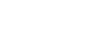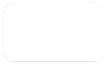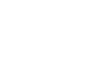

**Aerodynamic loads**

**Geometry and material definition**

**Discretization**

**Hydrostatic loads (Morison, Airy waves)**

**Static structural performance (pyFrame3DD)**

***Output***

**Design Load Cases**

**Mooring system response (pyMAP)**

***User Input***

**API Standards (Bulletin 2U)**

***FloatingSE***

**Figure 4:** Analysis steps and tools in *FloatingSE*, the floating substructure design module within WISDEM.

results of the studies, both the conceptual designs of floating turbine substructures and the sensitivity study, is presented in Section 5.

The analysis presented here helps to quantify the value of weight reduction in floating offshore wind turbines. Weight minimization, and a cost premium, is a classic cost-benefit tradeoff study that is especially germane to floating offshore wind energy systems. Parameterically changing the weight of the nacelle is a simplified method for estimating the impact of possible weight reductions from new drivetrain and generator technologies or innovations on the entire system and subsequently calculating the respective cost premiums. Without a full systems framework, it is difficult for the engineer to make such a tradeoff. Thus, the study here teases some of the types of questions that could be posed and answered with the WISDEM framework to address some of the open questions and challenges for floating offshore wind energy systems.

# Geometry

This section describes the variables and methods used to parameterize the substructure geometry in *Float- ingSE*. Typically, substructure designs have fallen into three classical regimes, which are shown in Figure 5, each of which attains static stability through different physical mechanisms. A spar derives its stability from a deep drafted ballast. A semisubmersible derives its stability from distributed waterplane area, achieved with offset columns spread evenly around a main column or central point. A tension leg platform (TLP) uses taut mooring lines for its stability.

Similar to Karimi et al. [19], care was taken to parameterize the substructure in a general manner, so as to be able to use the same set of design variables to describe spars, semisubmersibles, TLPs, and hybrids of those archetypes. The intent is that this modular approach to substructure definition will enable rapid analysis of the majority of designs currently proposed by the floating wind development community, whether classical or novel in nature. Furthermore, generalizing the substructure definition also empowers the optimization algorithm to search a broad tradespace more efficiently by moving fluidly from one region to another.

With that intent in mind, the general configuration of a spar-type substructure is shown in Figure 6, with nomenclature borrowed from the field of naval architecture. A semisubmersible configuration would have a similar diagram, but with multiple offset columns connected with pontoon elements. A TLP might look similar to a spar or semisubmersible, with taut mooring lines instead of the catenary ones shown.

## Tapered Cylinders (Vertical Frustums)

A number of typical floating substructure designs, such as the spar or semisubmersible, contain vertically oriented columns. In *FloatingSE*, these columns are assumed to have a circular cross-section making them,

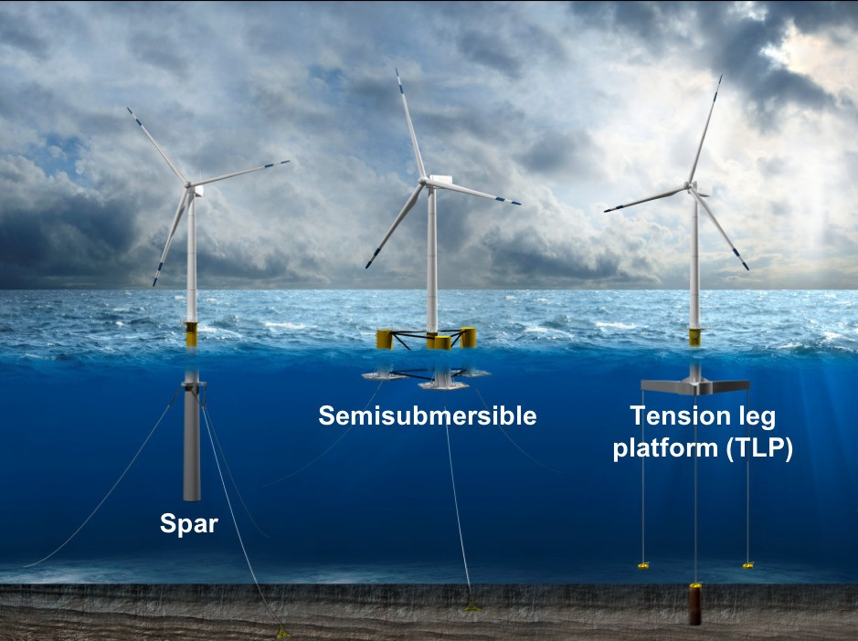

**Figure 5:** Three classical designs for floating turbine substructures.

formally, vertical frustums. These frustums are assumed to be ring-stiffened to support the buckling loads inherent in a submerged support structure. The number of columns, their geometry, and the ring stiffeners are parameterized in the *FloatingSE* module according to the diagrams in Figures 6 and 7. The main column is assumed to be centered at (*x* = 0*, y* = 0), directly underneath the turbine tower (note that off- centered turbines are not yet supported). Other columns are referred to as *offset* columns, and are assumed to be evenly spread around the main column. The material of the vertical columns is currently assumed to be ASTM 992 steel. Future developments will include the option to select one of multiple material options for each section in each cylinder.

## Discretization

To allow for varying geometry parameters along the length of substructure columns, the larger components are divided into sections. The user may specify the number of overall sections, *ns* and the geometry of each section. Some of the geometry parameters are tied to the nodes that bracket each section, such as column diameter and wall thickness, with linear variation between each node. Other parameters are considered constant within each section, such as the spacing between ring stiffeners. The number of sections should resemble the physical number of cans or sections used in the manufacturing of the real article.

#### Ballast

Stability of substructure columns with long drafts can be enhanced by placing heavy ballast, such as magnetite iron ore, at their bottom sections. The user can specify the density of the permanent ballast added and the height of the ballast extent within the column. Variable ballast, as opposed to permanent ballast, is water that is added or removed above the permanent ballast to achieve neutral buoyancy as the operating conditions of the turbine change. A discussion of variable water balance in the model is found in Section 3.5.

#### Buoyancy Tanks (and Heave Plates)

Buoyancy tanks are modeled as a collar around the column and are not subject the same taper or connec- tivity constraints as the frustum sections. They therefore offer added buoyancy without incurring as much structural mass or cost. Moreover, they can also serve to augment the heave added mass like a plate. In



**Rotor Diameter**

**Wind**

**0° direction**

**Hub Height**

***z***

**Wave**

**Freeboard**

***x***

**Mean Water Line**

**Fairlead**

**Draft**

**Current Profile**

**Water Depth**

**Buoyancy tank**

**Mooring**

**Line**

**Mooring Diameter**

**Mooring Line Length (unstretched)**

**Mooring**

**Line**

**Seafloor**

**Anchor radius**

**Figure 6:** Geometry parameterization with common wind turbine and naval architecture conventions.

addition to their diameter and height, the user can adjust the location of the buoyancy tank from the column base to the top. Buoyancy tanks can be added to either the main and/or offset columns.

## Pontoons and Support Structure

Many substructure designs include the use of pontoons that form a truss to connect the different components, usually columns, together. In this model, all of the pontoons are assumed to have the identical thin-walled tube cross section and made of the same material as the rest of the substructure. The truss configuration and the parameterization of the pontoon elements is based on the members shown in Figure 8 with lettered labels. The members are broken out into the upper and lower rings connecting the offset columns (*B* and *D*, respectively), the upper and lower main-to-offset connections (*A* and *C*, respectively), the lower-base to upper-offset cross members (*E*), and the V-shaped cross members between offset columns (*F* ).

## Mooring Lines

The mooring system is described by the number of lines, their geometry, and their interface to the substruc- ture. The mooring diameter is set by the user and determines the breaking load and stiffness of the chain, via correlation, described in Section 3. The mooring lines attach to the substructure at the *fairlead* distance below the water plane, as shown in Figure 6. The lines can attach directly to a substructure column or at a some offset from the outer shell. Note that bridle connections are not yet implemented in the model. The mooring lines attach to the sea floor at a variable distance, the anchor radius, from the substructure centerline, also set by the user.

|  |
| --- |
| **Wall thickn** |
|  |
| **Stif spa** |
|  |
|  |

**ess**

**Ra**

|  |
| --- |
| **dius** |
|  |
|  |
|  |
|  |

**Flange thickness**



**Diameter (at**

|  |  |
| --- | --- |
|  | **Web height** |
| **Web thickness** | |
|  |  |

**section nodes)**

**fener cing**

**Ring Stiffeners**

**Flange width**

**Section heights**

**Buoyancy tank height, diameter**

**Ballast**

* **Water**
* **Permanent (variable density)**

**Permanent ballast height**

1. Vertical column of frustums
2. Vertical cross-section
3. Ring stiffener geometry

**Figure 7:** Vertical frustum geometry parameterization.

By default, the mooring system is assumed to use a steel chain with drag embedment anchors. Other mooring available for selection are nylon, polyester, steel wire rope (IWRC) and fiber-core wire rope. The only alternative anchor type is currently suction pile anchors, but there are plans to include gravity anchors as well. The standard configuration for TLPs is the use of taut nylon mooring lines with suction-pile anchors.

## Mass and Cost Scaling

The mass of all components in the modeled substructure is captured through calculation of each components’ volume and multiplying by its material density. This applies to the frustum shells, the ring stiffeners, the permanent ballast, the pontoons, and the mooring lines. However, the model also acknowledges that the modeled substructure is merely an approximation of an actual substructure and various secondary elements are not captured. These include ladders, walkways, handles, finishing, paint, wiring, etc. To account for these features en masse, multipliers of component masses are offered as parameters for the user as well. Capital cost for all substructure components except the mooring system is assumed to be a linear scaling of the components masses. For the mooring system, cost is dependent on the tension carrying capacity of the line, which itself is an empirical function of the diameter. Default values for all mass and cost scaling factors are found in Table 1. Cost factors are especially difficult to estimate given the proprietary nature of commercial cost data, so cost rates and estimates should be considered notional.

**Table 1:** Default mass scaling factors and cost rates used in *FloatingSE* (notional).

|  |  |  |  |
| --- | --- | --- | --- |
| **Mass factor** | **Value** | **Cost rate** | **Value** |
| Bulkhead, stiffener | 1.0 | Ballast | 100 USD/kg |
| Column outfitting | 1.06 | Column outfitting | 6,980 USD/kg |
| Tapered column | 1.05 | Tapered column 4,720 USD/kg |  |
| Tower outfitting | 1.07 | Pontoons | 6.5 USD/kg |

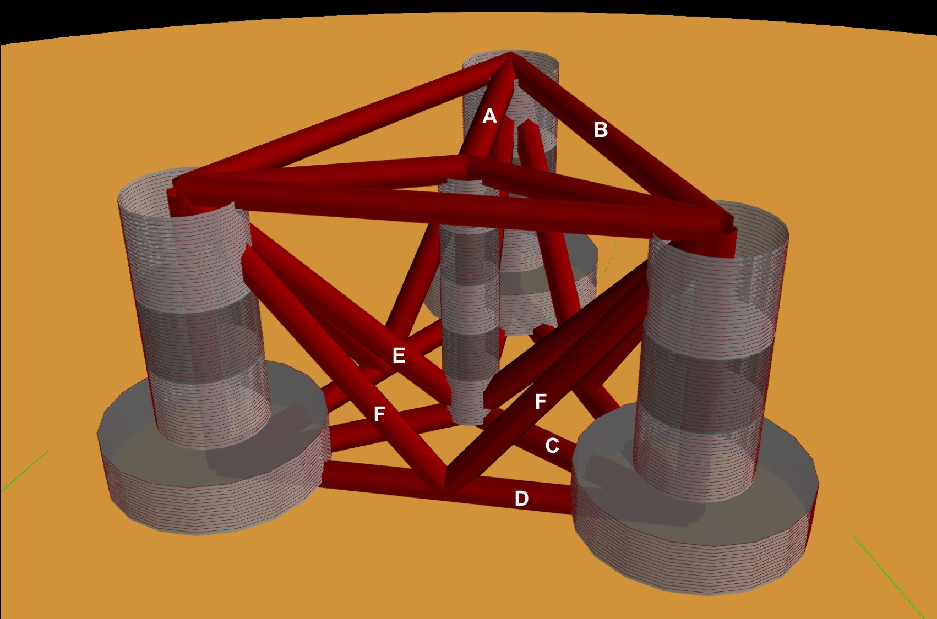

**Figure 8:** Parameterization of truss elements in substructure.

# Design Evaluation

## Design Load Cases (DLCs)

The user must specify the metocean conditions that drive the wind and wave loads upon the floating sub- structure. *FloatingSE* currently only uses the single load case of maximum thrust coincident with maximum wave loading to drive the substructure design. Ideally, multiple DLCs and metocean conditions would be used for design optimization. The capability to optimize over multiple DLCs will be added to future versions of the model.

## Load Path

As with other WISDEM models, the primary simplification in *FloatingSE* is the treatment of all loads as pseudo-static. This approximation reduces computational time and resources, since an accurate calculation of dynamic loads requires more sophisticated numerical tools and simulations. Thus, users must exercise care in selecting loads and safety factors to compensate for the lack of a fully dynamic treatment [8]. Furthermore, fatigue effects and structural lifetime estimates are also excluded for now, but could be incorporated in future developments.

A floating wind turbine undergoes loading from a number of sources. The primary loading source for the tower comes from the aerodynamic loads induced by the rotor. The substructure must resist the combination of both rotor loads and hydrodynamics loads, with the latter becoming more and more important as water depth and wave heights increase. *FloatingSE*, together with other WISDEM modules, accounts for these two dominant load sources, as well as the self-loading of gravity loads. Other sources of loading, such as installation loads, accidental loads, vortex-induced vibrations, ice, and seismic loads are ignored.

#### Wind and Wave Loads

Wind drag loads are applied to the tower body and the upper part of the substructure that extends above the waterline. They are not applied to connecting truss members that may be part of the substructure geometry. These drag loads are computed assuming the tower and columns are smooth circular cross-sections and that

the drag coefficient can be selected as a function of the flow Reynolds number [35]. The aerodynamic drag force is a function of height, since the wind profile and cross-sectional geometry varies along that dimension. For the wind profile, the standard power-law scaling is used,

*Ua*(*z*) = *Uref*

*z α*

*zref*

*,* (1)

where *Ua*(*z*) is the wind velocity as a function of height, *Uref* is a reference wind speed measured at a reference height, *zref* , and *α* is the shear exponent used in the power-law approximation of wind profiles. The wind profile then feeds the aerodynamic drag, Reynolds number, and drag coefficient,

*dF* (*z*) = *ρ U* 2(*z*)*d*(*z*)*c* (*Re*)*dz*; *Re*

1

*ρaUa*(*z*)*d*(*z*)

=

*,* (2)

2 *a a d d µa*

where *Red* is the Reynolds number based on diameter, *ρa* and *µa* are the density and viscosity of air, *d*(*z*) is the diameter of the column as a function of height, *cd* is the 2-D drag coefficient, and *dF* (*z*) is the force per unit length in the z-direction.

Wave drag loads arise from similar processes, but are computed using Morison’s equation, a semi-empirical expression that predicts the total hydrodynamic loads. It is comprised of two components, one for viscous drag contributions and another for inertial effects (which includes incident, diffracted, and radiated wave effects). For flow past structures with circular cross sections, Morison’s equation for force per unit length (*dF* (*z*)) takes the form,

*πd*2(*z*) ˙ 1 2

*dF* (*z*) =

*ρw CmUw* (*z*)*dz* + *ρw Uw* (*z*)*d*(*z*)*cd*(*Re*)*dz ,* (3) 4 2

where *Cm* is the added mass coefficient (assumed to be *Cm* = 2), *Uw* (*z*) is the current speed as a function

of height,

*U*˙ *w* (*z*) is the acceleration as a function of height, and the Reynolds number is computed by

substituting in the appropriate properties for water,

*Red*

*ρw Uw* (*z*)*d*(*z*)

=

*µw*

*.* (4)

To compute Morison’s equation, expressions for local fluid velocity and acceleration are required. Wave particle velocity (not the same as the bulk velocity of the wave) is assumed to follow linear (Airy) wave theory

cosh [*κ* (*z* + *D*)] 2*π*

*U* (*z*) = *aω* cosh (*κx − ωt*) ; *ω* = = *gκ* tanh (*κD*) *,* (5)

*w*

sinh (*κD*)

*T*

where *ω* is the circular frequency, *T* is the wave period, *a* is the wave amplitude (half of the significant wave height), *D* is the total water depth, *g* is the acceleration of gravity, and *κ* is the wave number numerically computed from the dispersion relationship given as the last expression in Equation 5. Note that the horizontal

particle velocity varies in time and space (by the *κx − ωt*) term. Thus, the individual particles in the wave

are also accelerating at different rates,

*U*˙ *w*

(*z*) = *aω*2 cosh [*κ* (*z* + *D*)] sinh (*κx ωt*) *.* (6) sinh (*κD*)

For simplicity, *FloatingSE* only considers the maximum velocity and acceleration at a given height, and makes a conservative assumption that they occur concurrently in time and space. This essentially means

*−*

ignoring the *κx − ωt* term, since the maximum of any hyperbolic sine or cosine term is one.

#### Rotor Nacelle Assembly (RNA) Loads

From a quasi-steady-state point of view, the RNA loads reduce to three forces and three moments along the main coordinate axes [7]. The thrust is the biggest force responsible for the bending moment distribution along the tower and loads on the substructure. There is the additional effect of the gravitational load caused by the offset of the RNA center of mass from the tower centerline. This effect is more pronounced for downwind turbines than upwind turbines, but is included regardless. *FloatingSE* does not compute the force and moment components directly, but rather accepts them as inputs from other WISDEM modules or from the user directly.

## Structural Analysis

The analysis tool, Frame3DD, is an open-source tool for static and dynamic structural analysis of 2-D and 3-D frames and trusses with elastic and geometric stiffness. It computes the static deflections, reactions, internal element forces, natural frequencies, and modal shapes using direct stiffness and mass assembly [13]. The WISDEM toolkit developed a python interface, *pyFrame3DD*, to avoid the use of intermediate input and output text files. The integration of all loads happens within Frame3DD, where the whole floating turbine load path, from the rotor to the keel of the substructure, is modeled with Timoshenko frame elements [39].

#### Discretization

For the finite element structural analysis of the substructure, the discretization of the main columns into a handful of sections is still too coarse to capture the appropriate physics. Long slender components, such as the tower and substructure columns, are broken up into a three-times finer discretization than the physical cans that they are actually made of. The sectional and nodal variables are re-sampled at this finer spacing. These additional discretization points give greater resolution of internal forces and natural frequencies. Substructure pontoons are represented as single frame elements. Frame elements are described by their cross sectional properties (area, moments of inertia, modulus of elasticity, and mass density) and starting and ending nodes. For simple geometries, such as pontoons with tubular cross sections, these properties are straightforward calculations. For the turbine tower, tubular cross section properties are also used, albeit at a finer discretization. For substructure columns, it is assumed that the permanent or variable ballast and bulkheads are not load-bearing, so tubular cross section properties are also used to represent the column shell. However, the material mass density of the frame element is scaled to reflect the true mass of the whole section, including ballast, to ensure that gravity loads are captured correctly.

#### Loads

All of the loads described above are integrated together within Frame3DD. These loads include,

* + - * Rotor-nacelle-assembly loads (thrust, moments, etc.)
      * Mooring line force
      * Wind and wave loading
      * Gravity loads (weight distribution)
      * Hydrostatic pressure loads, including buoyancy

The forces, moments, and mass properties of the rotor-nacelle assembly (RNA) are inputs to *FloatingSE* (mass properties are assumed to be relative to the tower top position). It assumed that the RNA is a rigid body with respect to the tower modes and the mass properties, forces, and moments, are applied to the corresponding node in the model. The forces along each mooring line are applied to the connection point

nodes on the structure. The wind and wave forces per unit length in Equations 2 and 3 are applied as trapezoidally varying loads along the column elements. Other loads applied to the structure include the gravity loads, and the buoyancy acting on the submerged elements.

#### Boundary Conditions

Multiple boundary conditions are applied to the structure. The mooring system stiffness matrix (linearized about the neutral position) is applied at the mooring connection nodes. However, even with the mooring stiffness, the finite element analysis would otherwise still regard the structure as unrestrained and incapable of supporting any static loads. Thus, in order to successfully compute stress and buckling limits in a well- posed problem, an additional rigid boundary condition (in all 6 DOF) is imposed at the bottom node of the main column.

#### Outputs

Structural analysis outputs include mass properties of the structure, member stresses, and summary forces and moments on the body. Mass properties include the total mass of the floating turbine and the mass of the substructure itself. The calculations also allow for easy computation of the center of mass of the structure (not accounting for variable ballast) and the center of buoyancy (centroid of the submerged volume). The first two natural frequencies of the structure are also computed to compare against the range of standard wave frequencies and rotor passing frequencies (1P and 3P). Next, the reaction forces and moments at the boundary node at the keel are taken as the total loading on the structure. These are used later in the static stability calculations to ensure that the mooring lines provide adequate restoring force and moment. Finally, the axial and shear forces within each frame element are extracted and converted to stresses using cross-sectional properties.

Hoop stress of the tower is estimated from the dynamic pressure of the wind loads using the Eurocode method [11]. Hoop stress of the submerged columns is determined using the dynamic and static pressure heads of the water.

*σ* = *k q*

*d − t* ; *q*

= *ρ U* 2

1

(7)

*θ,Euro*

*w max* 2*t*

*max*

2 *a a*

*σ* = (*q* + *p*

*d t*

) ; *q*

*−*

= 1 *ρ U* 2

(8)

*θ,hydro*

*max*

*hydro* 2*t*

*max*

2 *w w*

*phydro* = *ρwg a*

cosh [*κ* (*z* + *D*)]

cosh (*κD*) *− z* (9)

where *σθ* is the hoop stress, *qmax* is the maximum dynamic pressure on a cross-section, and *phydro* is the hydrostatic pressure with contributions from wave motion and the static head. In the Eurocode method, *kw* is the dynamic pressure factor for hoop stress calculation using cylinder dimensions and an external pressure buckling factor. Note that the argument, (*z*), was dropped from many of the terms without losing generality.

#### Code Compliance as Utilizations

Once the stress components of all structural members are computed, they are compared against design code standards for compliance, and serve as design constraints when conducting optimization. Multiple code standards are used across all components. For all columns, the tower, and substructure pontoons, stress components (axial, shear, and hoop) are combined into a von Mises, equivalent, stress,

*σvm* = I*σ*2 + *σ*2 *− σaσθ* + 3*τ* 2

*a*

*θ*

*aθ*

(10)

where *σvm* is the von Mises stress, *σa* is the axial stress, *τaθ* is the shear stress across axial and hoop principle directions. and *σθ* is chosen as the relevant hoop stress. The von Mises stress is compared against the yield

stress, *σy* , and a safety factor as a utilization criterion.

Main column, offset column, and tower segment stresses and geometry are also evaluated against a shell buckling criterion published by European Committee for Standardisation [11] and a global buckling criterion published by Germanischer Lloyd [14]. Note that the implementation of the Eurocode buckling is modified slightly so as to produce continuously differentiable output. See Damiani [7] for a more detailed exposition.

For submerged columns, additional code standard utilization ratios are taken from the American Petroleum Institute (API) [1], Bulletin 2U (specifically the procedure outlined in Appendix B). These standards also apply shell and general buckling criterion with a margin of safety in a manner that accounts for stiffeners and the common buckling modes of submerged structures. Future efforts will also apply Bulletin 2V, the standards for plates, to the legs that support taut mooring lines.

## Mooring Lines

The quasi-steady mooring system analysis is handled by the external Mooring Analysis Program (MAP++) library [26], which has convenient Python bindings to access the simulation output, bundled into the WIS- DEM *pyMAP* module. MAP++ is designed to model the steady-state forces on a Multi-Segmented, Quasi- Static (MSQS) mooring line. Seabed contact, seabed friction, and multi-element mooring lines with arbitrary connection configurations can be analyzed. MAP++ inputs include sea depth, geometry descriptions of the mooring line connections, and material properties of the lines. For chain and rope-based cables, these mate- rial properties are not easily derived and would be typically provided by a manufacturer. We borrow from the approach of the popular Orcina OrcaFlex software [32] and use the following expressions,

*MBL* = 2*.*74 *×* 10 *d* (44 *−* 80*d*) [N]

7 2

*mass* = 19*.*9 *×* 10 *d* [kg*/*m]

(

3 2

*A* = 2 *πd*2*/*4 [m2]

*EA* = 8*.*54 *×* 10 *d* [N]

10 2

*cost* = 3*.*415 *×* 10 *d* [USD]

4 2

where *MBL* is minimum breaking load, *d* is the diameter of a single half-chain link, *A* is the chain cross- sectional area, *E* is the Young’s modulus, *EA* is the axial stiffness. When conducting optimization, the expression for *MBL* is poorly posed due to its limited range of diameter applicability, so a linear fit is used instead,

*MBL* = 1000 max (1*.*0*, −*5445*.*3 + 176972*.*7*d*) (11)

## Hydrostatic Stability

#### Neutral Buoyancy

Any floating body requires enough water displacement to create sufficient buoyancy force such that the body stays afloat in the most extreme loading and environmental conditions. This level of displacement would otherwise be overkill for more benign loading conditions. Since a floating turbine is designed for a constant hub height, variable amounts of ballast are required to maintain a neutrally buoyant system for all operating conditions. The variable ballast is simply ocean water that is pulled in or pumped out of holding areas within the substructure columns.

In *FloatingSE*, the variable ballast water mass is calculated as the difference between the total mass of displaced water and the total mass of the floating turbine. This mass is then divided by the water density to obtain the variable ballast volume, which is then compared to the frustum shell cross section profile above the permanent ballast to determine the height of the water ballast within the column. Once this is determined, the final center of mass of the system can be determined.

#### Surge/Sway Stability

Surge and sway stability is not actively tracked over the coarse of a load case. Instead the total surge force on the structure is calculated at the initial conditions and compared to the restoring force of the mooring system at the maximum allowable surge offset, which is specified by the user.

The surge direction is assumed to be aligned with the wind vector, which is aligned with the *x*-axis. Since

the rotor yaw is assumed to be 0*◦* , the surge forces on the turbine include the rotor thrust and the wind and wave drag on the tower and substructure. The final surge force over the whole structure is taken from the *x*-direction reaction force of the reaction node in Frame3DD.

The restoring force is calculated as the smallest possible restoring force after a displacement in any angular direction in the mooring model. Since the alignment of the mooring lines relative to the incoming wind direction is arbitrary, a maximum offset is simulated at 2*◦* increments around the unit circle. Also recorded in this survey is the maximum mooring line tension in any line, in any direction, for comparison against the minimum breaking load value,

*Fx,restore* = min *Fx,i* T*moor* = max

T*l,i* ; *L* = *{*1*,* 2 *. . . nlines} , a* = *{*0*◦,* 2*◦ . . .* 360*◦}* (12)

*i∈a l∈L,i∈a*

where *Fx* is the surge force and T is the tension. If restoring force at this maximum offset is greater than

the surge force applied, then the system is considered stable in surge. Since the wind and wave profiles are essentially 2-D in the *x − z* plane, the sway stability is given the same status as surge stability.

#### Pitch Stability

The approach to pitch stability determination is similar to that of surge stability. The total pitching moment on the floating turbine is calculated and compared to the restoring moment at the maximum allowable angle of heel. If the restoring moment at this max heel angle is greater than the pitching moment applied, the system is said to be statically stable in pitch.

Similar to the surge force calculation, the total pitching moment is determined from the reaction moment at the boundary condition in the Frame3DD analysis. The pitching moment has contributions from the wind and wave loads on the structure, the rotor forces and torques, the buoyancy forces on the submerged substructure, and the off-center weight of components (e.g. the RNA).

The restoring pitching moment has two primary contributions. The first is from the mooring lines. Similar to the surge force calculation, here the floating turbine is deflected in pitch by the maximum allowable heel angle and the mooring forces are recorded. The restoring moment contribution from the mooring system is

computed as,

**Mmoor** = **rcm***−***l** *×* **Fl** (13)

*i*

where *rcm−l* is the vector from the center of mass to the mooring connection, and *Fl* is the force applied by the *l*-thm˜ ooring line. As above, *Fl* is taken as the minimum set over the possible orientations of the mooring lines relative to the direction.

The second contributing restoring moment comes from the motion of the center of buoyancy away from alignment with the center of mass. This is a standard calculation in naval architecture [38] and is diagrammed in Figure 9. In this diagram, the center of mass is denoted, *G*, the center of buoyancy is *B*, and the metacenter is *M* . In neural conditions (Figure 9a), all of these points are vertically aligned.

As the structure lists or heels, the center of buoyancy shifts toward the side of the structure that is more

submerged (from *B* to *B/* ) and the buoyancy force no longer passes through the center of mass. Instead, the buoyancy force passes through the metacenter with an effective moment arm of *GZ* from the center of mass (Figure 9b). The metacenter is defined as the common point through which the buoyancy force acts as it pitches through small displacements, for bodies with sufficient freeboard margin.

The metacenteric height, *GM* is most easily calculated as an offset from the center of buoyancy (*BM* )



***Buoyant force***

**M) metacenter**

**GM**

**BM**

**G) center of gravity**

**BG**

**B) center of buoyancy**

***Gravity force***



***Buoyant force***

**M G**

**B’**

***Gravity force***

**M**

𝜑

**G**

**GZ (righting arm)**

***Buoyant force***

**CL**

**B’**

**(a) (b)**

**Figure 9:** Static stability of floating offshore wind turbines.

by,

*hmeta*

*Iw*

= *M − G* = *GM* = *BM* + *BG*; *BM* = *V*

(14)

where *BG*, the distance between the centers of buoyancy and gravity is easily calculated, *Iw* is the second moment of area of the substructure waterplane (with units of *m*4) and *V* is the total volume of displacement (with units of *m*3). Note that for semisubmersible type geometries, *Iw* is calculated with the parallel axis theorem for all of the columns at the waterplane,

*Iw* =

*Iw,i* + *Sir*2

*i*

*i*

(

(15)

where *Si* is the waterplane cross sectional area of the *i*-thcolumn and *ri* is the distance from the waterplane centroid to the *i*-thcolumn centroid.

The restoring moment is then the buoyancy force acting through the restoring arm, *GZ*,

*Mmeta* = *FBGZ* = *FBGM* sin *ϕ* (16)

where *ϕ* is the angle of heel.

For this reason, the metacenter must be located above the center of mass for static stability. This condition is imposed on the design as a constraint. Note that the total volume of displacement, and the subsequent buoyancy force, is not recalculated in the perturbed configuration. It is assumed that the angles of deflection are small and that there is sufficient freeboard and design symmetry such that the total displacement is constant.

The total restoring pitching moment is then the sum of two contributions,

*My,restore* = *My,moor* + *Mmeta* (17)

## Hydrodynamic Stability

Floating bodies are typically modeled, for small motions and linearized behavior, as a second-order differential system with mass, damping, and spring stiffness terms,

(**M** + **A**) **x**¨ + **Cx**˙ + **K** = **F** (*t*) (18)

where **x** *∈* R6 is the six-degree of freedom vector (commonly ordered as 1-surge, 2-sway, 3-heave, 4-roll,

5-pitch, 6-yaw), **M** is the mass matrix, **A** is the added mass matrix, **C** is the damping matrix, and **K** is the stiffness matrix. The right-hand side of the equation captures the time-dependent summation of all forces.

As a low-fidelity, quasi-static sizing and cost module, *FloatingSE* does not attempt to capture all of the matrix entries or forcing terms of the hydrodynamics. A more sophisticated time- or frequency-domain solver, where these quantities are calculated, may be linked or included into *FloatingSE* in the future. Nevertheless, it does attempt to compute the diagonal entries of the mass and stiffness matrices in order to derive the rigid body natural frequencies of the system,

*ωi*  1 *K*

*f* = = *, ∀i ∈* [1 *. . .* 6] (19)

*ii*

*i*

2*π*

2*π*

*Mii* + *Aii*

where *fi* are the frequencies of the eigenmodes and *ωi* is the circular frequency. The mass matrix diagonal entries, *Mii*, are simply the mass and moments of inertia of the whole system,

*M*11 = *M*22 = *M*33 = *msys*; *M*44 = *Ixx,sys*; *M*55 = *Iyy,sys*; *M*66 = *Izz,sys*; (20) Where the coordinate system notation is consistent with that of Figure 6.

The added mass matrix diagonal entries are evaluated via standard strip theory for the tapered vertical columns. The added mass for the system is a summation over the columns, using the parallel axis theorem for the rotational degrees of freedom. Pontoon contributions to system added mass are currently ignored. The column quantities are calculated as,

*A*11

= *A*22

1

= *ρV* ; *A*33 = 2

*ρ* max *R*3(*z*) ; *A*44

3

8

= *A*55

= *πρ* (*z − zcb*

) *R*2(*z*)*dz*; *A*66

= 0*.*0; (21)

where *ρ* is the water density, *R*(*z*) is the column radius along its axis, and *V* is the submerged volume. The extra factor of 1*/*2 in *A*33 is included to account for the fact that the top of the column extends above the waterline. Also, the integral in *A*55 is only evaluated along the submerged portion of the column.

The stiffness matrix is comprised of contributions from the mooring and hydrostatic stiffness. The mooring linearized stiffness matrix is output directly from MAP++ and needs no additional processing within *FloatingSE*. The hydrostatic stiffness, for a vertical column, is derived from the same principals described above regarding the metacentric height,

*Kii* = *Kmoor* + *Khydro*; *Khydro* = *ρgSsys*; *Khydro* = *Khydro* = *ρgV hmeta* (22)

*ii ii* 33 44 55

where *Ssys* is the waterplane area of the system.

Once the rigid body natural frequencies (eigenmodes) of the system are calculated, they are compared against the standard wave frequencies range, 0.5–5 Hz, and expressed as a design constraint (with a partial safety factor).

## Validation

The International Energy Agency has sponsored a number of international research collaborations to further the state of wind energy technology and tools. One of these, Task 30: Offshore Code Comparison Collabora-

tion (OC3), shared a spar design among many participants to compare performance as modeled by different tool sets. A description of the OC3 spar is provided in Jonkman [18]. Since it is already a well-studied geometry, the OC3 spar design was selected as the focus of verification for *FloatingSE*. As part of the Task 30 effort, an ANSYS model of the OC3 spar, using shell elements combined with stiffeners and bulkheads, was also generated. This was taken as the *truth* standard for comparison.

The first step in the verification exercise was to ensure that the mass properties of the spar predicted by *FloatingSE* matched those calculated by ANSYS. The comparison showed that the *FloatingSE* summary mass estimates are within 1% error of ANSYS. The second step was a comparison of static loading stresses. The spar was simulated in quiescent air and water (no wind, waves, or current), which isolated the weight of the turbine and hydrostatic pressure forces as the only load sources on the substructure. The effective von Mises stress, as calculated by *FloatingSE*, was compared to the ANSYS model. The *FloatingSE* stress calculation matches that of ANSYS nearly exactly over the top half of the spar, but deviates by approximately 5–10% towards the bottom half of the spar. In the bottom half of the spar, *FloatingSE* actually over-predicts the stress, a more conservative estimate, which is the preferable approach in a low-fidelity cost and sizing model. At this time, more complicated loading cases, with wind and wave loading included, have not been performed.

The rigid body modes predicted by *FloatingSE* were compared against a FAST model of the OC3 spar. FAST was used as the truth solution in this case because it more accurately handles mooring dynamics than the ANSYS structural model and more accurately captures hydrodynamic phenomenon. The errors in the surge, sway, roll, and pitch frequencies are 11-12%. *FloatingSE* actually estimates the heave mode frequency quite accurately, to less than 1% error, but is significantly off in estimating the yaw mode frequency. This was deemed acceptable as there is no focus on the yaw DOF in *FloatingSE*.

# Analysis

## Procedure

Single scenario execution of *FloatingSE* and/or WISDEM is sufficient to explore some simple one-off or comparison analyses between a few runs. However, executing the model within an optimization framework can yield richer and more insightful analyses. There are two layers of optimization-based analyses presented in this paper:

1. *FloatingSE* and WISDEM analyses which were used to design a spar, semisubmersible, and TLP floating substructure for the same turbine configuration;
2. Sensitivity analysis around the optimized designs to assess the impact of weight reduction at the top of the tower by parametrically changing the mass of the nacelle and re-optimizing the substructure.

#### Substructure Design

The first step in the analysis procedure is the conceptual design of a spar, semisubmersible, and TLP floating substructure for the same turbine configuration. Many studies in the literature focus on the optimization of a single substructure design. By showcasing the design of all three classical substructure archetype, we demonstrate the ability of the tool to capture a broad tradespace.

Through its various modules, WISDEM is fully capable of optimizing the entire turbine design, from the rotor through the drivetrain and down through the tower and substructure. However, in an effort to focus on the capabilities of *FloatingSE*, the turbine was held fixed to the DTU 10 MW reference definition throughout the substructure design and sensitivity analysis. The only exception being the deliberate modification of the nacelle mass for the sensitivity study. This isolated the design variables and constraints to be those associated with the substructure exclusively.

#### Sensitivity Studies

Following the successful conceptual design of the floating substructures, a sensitivity study was executed relating the mass at the top of the tower to the mass and cost of the substructure. This was accomplished by parametrically changing the nacelle mass and re-optimizing the substructure designs. Specifically, the

nacelle mass was changed from its nominal value to the perturbations of, [+10%*, −*10%*, −*25%*, −*33%*, −*50%].

For the sensitivity study, the re-optimization was done locally, using the previously optimized designs as a starting point, and not searching over the global tradespace. Then, by comparing the baseline design to the re-optimized designs under the parameterized mass changes, the cost value of mass savings can be determined. Meaning, given the quantified mass and cost removed from the substructure relative to the baseline design, the cost value of the mass savings in the nacelle can be quantified. In this way, a systems framework can determine with the cost premium for the nacelle mass reduction can be recovered through savings as the change is propagated throughout the rest of the system.

The parametric modification of the nacelle mass is not merely an academic exercise to tease out design sensitivities. There are many examples of a new technology or innovation that offers a component mass reduction at a cost premium. By parametrically changing the nacelle mass, the sensitivity study is capturing the implications of moving from a multi-stage geared drivetrain to a single-stage or direct-drive alternative, or for example from a permanent magnet generator to a superconducting generator. In both of these examples, the overall mass of the nacelle would likely decrease, but the new technology would cost more to implement over the legacy system. Conducting an honest cost-benefit tradeoff of this option requires the potential design changes be propagated through the rest of the system. WISDEM is an appropriate framework for posing and answering this type of question.

#### Reference Turbine Selection

For all elements of the optimization studies, attention is given to the substructure and the performance of *FloatingSE*. A reference turbine design was needed as a starting point by which the conceptual design and sensitivity studies could build upon. The Danish Technical University (DTU) 10 MW reference design was chosen as the static turbine to be used throughout this analysis. This selection was made because 10 MW is representative of the most current offshore turbine designs being installed (with fixed-bottom supports) by developers. Additionally, other research efforts, such as the LIFES50+ program, have already designed floating substructures for this turbine. Using the same reference turbine allows for a direct comparison of the designs produced here with the other designs documented in the literature. For a summary of the DTU 10 MW reference turbine, see Bak et al. [3].

#### Metocean Conditions

In addition to choosing a reference turbine, it was also necessary to choose the meteorological and oceano- graphic (metocean) conditions of the environment. As mentioned in Section 3, *FloatingSE* only uses a single DLC, the maximum rotor thrust and metocean loading, for concept evaluation. The metocean condition selected for this DLC is the same as that used in the IEA Wind Task 30 OC3 effort [18], and summarized in Table 2.

## Methodology

In this project, optimization studies start with the formulation of a constrained, nonlinear single-objective optimization problem with mixed-integer design variables,

min *f* (**x**) subject to **g** (**x**) *≤* 0*,* and **x** *∈* **X**

(23)

**Table 2:** Metocean conditions used as the design point in the design and sensitivity studies (adopted from Jonkman [18]).

**Parameter Value**

Wind reference speed 11 *m/s* Wind reference height 119 *m* Water depth 320 *m* Significant wave height 10.8 *m* Significant wave period 9.8 *s*

where,

* **x** is a vector of *n design variables*, the variables that are adjusted in order to find the optimal solution (see Table 3);
* *f* (**x**) is the nonlinear *objective function*, the metric to be minimized by the optimization algorithm;
* **g**(**x**) is the vector of *inequality constraints*, the set of conditions that the solution must satisfy (see Table 4). There are no equality constraints;
* **X** is the design variable *bounds*, the bracket of allowable design variable values.

Note that this problem statement imposes no requirements on the types of variables in **x**. A mixed-integer solution is desired, where some design variables are continuous (*x ∈* R) and others are discrete variables that can only take integer values (*x ∈* Z). An example of an integer design variable in this application is the

number of offset columns or the number of mooring line connections.

#### Objectives

As described above, two objective functions are used in this analysis:

* + - * **Substructure system mass:** The mass of components from the freeboard point and below *except*

mooring and anchor system masses;

* + - * **Substructure system cost:** The capital cost of components from the freeboard point and below

*including* mooring and anchor system costs;

#### Algorithms

Two derivative-free optimization algorithms were applied sequentially to the substructure design problem:

1. **Global design space search and optimization:** Native implementation of the Non Sorting Genetic Algorithm (NSGA)-II genetic algorithm [9] with some modifications for constraint and integer design variable handling;
2. **Local neighborhood design space optimization:** Native implementation of the Nelder-Mead simplex algorithm [30] with some modifications for constraint handling.

The global design space search was performed by a modified implementation of the popular NSGA-II

[9] algorithm. This algorithm is a non-dominating sorting genetic algorithm that solves non-convex and non-smooth single and multiobjective optimization problems. The algorithm attempts to perform global op- timization, while enforcing constraints, using a tournament selection-based strategy where the best solutions are placed into a mating pool. The local modifications of the NSGA-II algorithm include parallelization via multi-threading for faster execution, the use of penalties for constraint handling (described below), and the

handling of integer-based design variables for a fully mixed-integer capable solution. Specifically, a method for integer-coded design variable crossover and mutation, standard genetic algorithm operations, were de- veloped. Crossover of an integer design variable across two population members with integer values *z*1 and *z*2 is simply a random integer in the interval, [*z*1*, z*2]. Similarly, mutation of an integer design variable is a random integer number selected between the lower and upper bounds.

The user selected parameters and initial conditions for the NSGA-II algorithm were selected to foster a broad and fluid search of the entire tradespace. A population size of 30 was initialized with Latin Hypercube sampling across the range of permissible design variable values from the lower bound to the upper bound. Thus, this was truly a *tabula rasa* (blank slate) approach to substructure design. The probability of crossover during the optimization was set to 0.9 and the probably of mutation was 0.4. Both of these values are considered high, in the context of genetic algorithm scientific literature, but again enabled a broad and fluid search of the tradespace.

By design, the NSGA-II algorithm is well-suited to global optimization by traversing a broad span and combination of design variable values. However, for single-objective optimization (such as mass or cost minimization), the crossover and mutation operations, with their inherent use of random numbers, are inefficient at searching a design space neighborhood for local minima. Thus, after the genetic algorithm terminated, another local optimization was performed.

Local optimization was performed with the Nelder-Mead simplex algorithm [30]. The Nelder–Mead method, also referred to as the downhill simplex method, is a derivative-free heuristic optimization method. It uses a simplex, a shape with *n* + 1 vertices in *n*-dimensional space (e.g. a triangle on a plane or a tetrahedron is three-dimensional space), to approximate the objective function behavior. The vertices of the simplex, the test points, are then reflected, expanded, or contracted to move towards the optimal point. The process terminates when the simplex becomes sufficiently small or the test points have nearly identical performance. As with the genetic algorithm, a local implementation of the Nelder-Mead algorithm was used to enable multi-threading and constraint handling via the chosen penalty method. To focus the algorithm purely on local optimization, and not global exploration of other possible floating substructure configurations, only continuous design variables were used. Integer design variables such as the number of offset columns or mooring lines were frozen at their values chosen by the NSGA-II algorithm. Additionally, since this approach is best suited for finding local minima near the initial condition, it is the only algorithm used for the design sensitivity portions of the analysis.

User parameters values and simplex initialization methodology was borrowed from the open source SciPy implementation of the Nelder-Mead algorithm. Initialization was done where each vertex, or test point, in the simplex perturbed one of the design variables by 5%, with the remaining design variables left at their baseline value. As a larger design problem with over 100 design variables (for the semisubmersible), the parameters that govern the iterative modification of the simplex were assigned dimension-dependent values,

1 2 1

*α* = 1*.*0*, β* = 0*.*75 *−* 2*n, γ* = 1 + *n δ* = 1 *− n* ; (24)

where the parameters are *α* for reflection, *β* for contraction, *γ* for expansion and *δ* for shrinkage. These values differ from those originally used by Nelder and Mead [30], but are recommended for high-dimensional optimization problems.

#### Rationale for Derivative-Free Algorithms

Derivative-free optimization algorithms were chosen for a few reasons, despite their known performance drawbacks in terms of wall-clock time. First, to do a complete configuration optimization of the substructure, a mixed-integer capable algorithm is required. No gradient-based optimization algorithm is capable of handling these types of variables directly (unless a rounding approximation is used). This was the primary reason for the selection of a genetic algorithm for the global design space search and optimization step.

Another reason for the selection of derivative-free algorithms is that the analysis flow uses a number of third-party, black box tools or algorithms that do not come with analytical gradients. This includes Frame3DD, MAP++, and some of the API 2U procedures that rely on roots of nonlinear equations. Thus, gradient-based optimization algorithms would be forced to use finite difference approximations around these tools at the very least. However, derivatives approximated with finite differences are expensive to compute accurately. If computed inaccurately, for the sake of reducing computational time, finite difference derivatives can easily lead an optimization algorithm astray, especially in highly nonlinear or tightly constrained regions of the design space. This is another reason for the use of derivative-free algorithms, even when conducting local neighborhood design space optimization and/or sensitivity studies.

#### Constraint Handling

The standard optimization problem statement is modified in this application to use a penalty approach for constraint handling. Instead of treating the set of constraints, **g**(**x**), as *hard* -constraints that absolutely must be satisfied, a penalty method treats them as *soft* -constraints, that are considered in conjunction with the objective function. This is a common approach that involves summation of a constraint violations into a single metric. This metric is then scaled and added or multiplied to the objective function value of each solution. Yeniay [40] provides a nice summary of the use of penalty methods in genetic algorithms. In our implementation, an *adaptive* penalty approach is used where the scaling of the constraint violation summation is dependent on the value of the objective function of the best solution in the population. With this approach, the problem formulation becomes,

min Φ(**x**) = *f* (**x**) + *p* (**x**) subject to **x** *∈* **X**

(25)

where Φ(**x**) is the new objective function and *p*(**x**) is the penalty function. This function is configured as a summation of constraint violations only (constraints that are satisfied add zero to the summation),

*m*

*p* (**x**) = *λ*

*i*

max [0*, gi* (**x**)] ; *λ* = 10floor(log10 min[*f* (*x*1)*...f* (*xk* )]) (26)

and *λ* is the adaptive scaling parameter, which is essentially set to the next order of magnitude above that of the objective function for the best performing solution in the population.

A penalty approach is used in our application of conceptual design of a floating offshore wind energy system because its advantages outweigh its challenges. A standard drawback of the penalty approach is that it can be difficult to find a problem independent method for constraint summation and scaling parameters. First among the advantages of a penalty approach is the fluid searching of the tradespace between the pockets of feasibility. Meaning, our tradespace is like swiss cheese, with pockets of feasibility for spars, semisubmersibles, TLPs, and their hybrids. In between these pockets are many infeasible designs that violate the many constraints involved. A penalty approach allows the optimizer to cross fluidly from one pocket of feasibility to another. The second advantage is that a penalty approach can identify promising designs even when they are not fully compliant with all constraints. Essentially, the constraints involved are truly *soft* constraints and not *hard* constraints. In practice, small violations of constraints in the conceptual design can typically be mended during the detailed design phase. Furthermore, the low-fidelity representation of the physics likely fails to capture all of the nuances involved in the constraint evaluation, so promising designs should not be discarded until fully vetted by higher-fidelity models.

#### Design Variables

In WISDEM, via OpenMDAO, any input parameter can be designated a design variable. The design variables used in this study focused on the geometric specification of the floating substructure and mooring subsystem.

Slightly different design variables and bounds were used for spar, semisubmersible, and TLP optimizations. The complete listing of the design variables for each optimization configuration is shown in Table 3. Note that the integer design variables were only used in the global optimization with the genetic algorithm, not the local search with the simplex algorithm.

**Table 3:** Standard design variables, their size, and units used for optimization in *FloatingSE*. Note that *ns* denotes the number of sections in the column discretization.

|  |  |  |  |  |
| --- | --- | --- | --- | --- |
| **Variable** | **Units** | **Type** | **Bounds** | **Comments** |
| Main col section height  Main col outer diameter Main col wall thickness Main col freeboard | *m*  *m m m* | Float array (*ns*) Float array (*ns* + 1)  Float array (*ns* + 1) Float scalar | 0.1–50  2.1–40  0.001–0.5  0–50 |  |
| Main col stiffener web height  Main col stiffener web thickness Main col stiffener flange width Main col stiffener flange thickness Main col stiffener spacing  Main col permanent ballast height | *m*  *m m m m m* | Float array (*ns*) Float array (*ns*) Float array (*ns*) Float array (*ns*)  Float array (*ns*) Float scalar | 0.01–1  0.001–0.5  0.01–5  0.001–0.5  0.1–100  0.1–50 |  |
| Main col buoyancy tank diameter | *m* | Float scalar | 0–50 |  |
| Main col buoyancy tank height | *m* | Float scalar | 0–20 |  |
| Main col buoyancy tank location (fraction) |  | Float scalar | 0–1 |  |
| Number of offset cols |  | Integer scalar | 3-5 | semi only |
| Offset col section height | *m* | Float array (*ns*) | 0.1–50 | semi only |
| Offset col outer diameter | *m* | Float array (*ns* + 1) | 1.1–40 | semi only |
| Offset col wall thickness | *m* | Float array (*ns* + 1) | 0.001–0.5 | semi only |
| Offset col freeboard | *m* | Float scalar | 2–15 | semi only |
| Offset col stiffener web height | *m* | Float array (*ns*) | 0.01–1 | semi only |
| Offset col stiffener web thickness | *m* | Float array (*ns*) | 0.001–0.5 | semi only |
| Offset col stiffener flange width | *m* | Float array (*ns*) | 0.01–5 | semi only |
| Offset col stiffener flange thickness | *m* | Float array (*ns*) | 0.001–0.5 | semi only |
| Offset col stiffener spacing | *m* | Float array (*ns*) | 0.01–100 | semi only |
| Offset col permanent ballast height | *m* | Float scalar | 0.1–50 | semi only |
| Offset col buoyancy tank diameter | *m* | Float scalar | 0–50 | semi only |
| Offset col buoyancy tank height | *m* | Float scalar | 0–20 | semi only |
| Offset col buoyancy tank location (fraction) |  | Float scalar | 0–1 | semi only |
| Radius to offset col | *m* | Float scalar | 5–100 | semi only |
| Pontoon outer diameter | *m* | Float scalar | 0.1–10 | semi only |
| Pontoon wall thickness | *m* | Float scalar | 0.01–1 | semi only |
| Lower main-offset pontoons |  | Integer scalar | 0–1 | semi only |
| Upper main-offset pontoons |  | Integer scalar | 0–1 | semi only |
| Cross main-offset pontoons |  | Integer scalar | 0–1 | semi only |
| Lower offset ring pontoons |  | Integer scalar | 0–1 | semi only |
| Upper offset ring pontoons |  | Integer scalar | 0–1 | semi only |
| Outer V-pontoons |  | Integer scalar | 0–1 | semi only |
| Main col pontoon attach lower (fraction) |  | Float scalar | 0–0.5 | semi only |
| Main col pontoon attach upper (fraction) |  | Float scalar | 0.5–1 | semi only |
| Fairlead (fraction) |  | Float scalar | 0–1 |  |
| Fairlead offset from col | *m* | Float scalar | 5–30 | TLP only |
| Fairlead pontoon diameter | *m* | Float scalar | 0.1–10 |  |
| Fairlead pontoon wall thickness | *m* | Float scalar | 0.001–1 |  |
| Number of mooring connections |  | Integer scalar | 3–5 |  |
| Mooring lines per connection |  | Integer scalar | 1–3 |  |
| Mooring diameter | *m* | Float scalar | 0.05–2 |  |
| Mooring line length | *m* | Float scalar | 0–3000 | TLP 10–300 |
| Anchor distance | *m* | Float scalar | 0–5000 | TLP 20-100 |

#### Constraints

Due to the many design variables, permutations of settings, and applied physics, there are many constraints that must be applied for an optimization to close. The constraints capture both physical limitations, such as column buckling, but also inject industry standards, guidelines, and lessons learned from engineering

experience into the optimization. As described in Section 1, this is a critically important element in building a MDAO framework for conceptual design that yields feasible results worth interrogating further with higher- fidelity tools. The constraints used in the substructure design optimization and sensitivity studies are listed in Table 4. Where appropriate, some of the constraint values differ from one type of substructure to another.

**Table 4:** Optimization constraints used in *FloatingSE*.

|  |  |  |  |
| --- | --- | --- | --- |
| **Lower** | **Name** | **Upper** | **Comments** |
|  | **Tower / Main / Offset Columns** |  |  |
|  | Eurocode global buckling | 1.0 |  |
|  | Eurocode shell buckling | 1.0 |  |
|  | Eurocode stress limit | 1.0 |  |
|  | Manufacturability | 0.5 | Taper ratio limit |
| 120.0 | Weld-ability |  | Diameter:thickness ratio limit |
|  | **Main / Offset Columns** |  |  |
|  | Draft ratio | 1.0 | Ratio of draft to max value (spar 200 m, semi/TLP 30 m) |
|  | API 2U general buckling- axial loads | 1.0 |  |
|  | API 2U local buckling- axial loads | 1.0 |  |
|  | API 2U general buckling- external loads | 1.0 |  |
|  | API 2U local buckling- external loads | 1.0 |  |
|  | Wave height:freeboard ratio | 1.0 | Maximum wave height relative to freeboard |
| 1.0 | Stiffener flange compactness |  |  |
| 1.0 | Stiffener web compactness |  |  |
|  | Stiffener flange spacing ratio | 1.0 | Stiffener spacing relative to flange width |
|  | Stiffener radius ratio | 0.50 | Stiffener height relative to diameter |
|  | **Offset Columns** |  | *Semi only* |
| 0.0 | Heel freeboard margin |  | Height required to stay above waterline at max heel |
| 0.0 | Heel draft margin |  | Draft required to stay submerged at max heel |
|  | **Pontoons** |  | *Semi only* |
|  | Eurocode stress limit | 1.0 |  |
|  | **Tower** |  |  |
| -0.01 | Hub height error | 0.01 |  |
|  | **Mooring** |  |  |
| 0.0 | Axial stress limit | 1.0 |  |
|  | Line length limit | 1.0 | Loss of tension or catenary hang |
|  | Heel moment ratio | 1.0 | Ratio of overturning moment to restoring moment |
|  | Surge force ratio | 1.0 | Ratio of surge force to restoring force |
|  | **Geometry** |  |  |
| 1.0 | Main-offset spacing |  | Minimum spacing between main and offset columns |
| 0.0 | Fairlead:draft ratio | 1.0 |  |
| 0.0 | Nacelle transition buffer |  | Tower diameter limit at nacelle junction |
| -1.0 | Tower transition buffer | 1.0 | Diameter consistency at freeboard point |
|  | **Stability** |  |  |
| 0.10 | Metacentric height |  | *Not applied to TLPs* |
| 1.0 | Wave-Eigenmode boundary (upper) |  | Natural frequencies below wave frequency range |
|  | Wave-Eigenmode boundary (lower) | 1.0 | Natural frequencies above wave frequency range |
| 0.0 | Water ballast height limit | 1.0 |  |
| 0.0 | Water ballast mass |  | Neutral buoyancy |

# Numerical Results and Discussion

## Optimized Designs

As mentioned earlier, the mass sensitivity study focused on two objective functions, substructure mass and capital cost. It is worth reiterating here that the design variables are only focused on the substructure. From the freeboard (10 m above the waterline in this application) and up, including the tower, nacelle, and rotor, the design was frozen to the DTU 10 MW Reference Turbine [3]. From the freeboard and down, the design was subject to optimization. Furthermore, while this paper has espoused a system approach for an offshore wind energy system, including lifecycle costs and operations, this study is focused purely on traditional

substructure engineering as a first foray into the tool’s capability.

#### Caveats

It should be noted that the arrival at *optimized* designs here, means strictly optimized in the convergence of the optimization algorithm around the WISDEM model of a floating offshore turbine. It is not an optimized design in that it would outperform other designs or be considered ready for manufacturing in its present state. It is merely optimized for the set of preliminary assumptions, load cases, and physics models used by WISDEM. Given the description of *FloatingSE* in this paper, these assumptions and modeling limitations are numerous and include:

* + - * Hydrostatic loading only, no hydrodynamic loads, effects, or considerations (except for eigenmodes). Therefore, design features meant to handle or minimize dynamic loading are not present;
      * Single load case only, the maximum thrust condition. Design features for other DLCs, such as mooring line snap, are not considered yet but may be important;
      * Static load analysis only (except for eigenmodes);
      * Simple beam-based finite element structural analysis. Because of this, and other assumptions in the structural analysis, connecting pontoons appear much larger than they would otherwise have to be;
      * Quasi-static mooring analysis;
      * Simplified capital cost modeling was used which was frequently based on mass scaling. Costs of highly tapered columns, joints, complicated welding connections are not included, yet these features are sometimes introduced by the optimizer;
      * Modeling only included substructure capital costs; no manufacturing, assembly, installation, operations, or maintenance costs were captured. This means that the TLP looks like the lowest cost option for now, but that answer could change when other costs are considered;
      * Incomplete incorporation of existing codes, standards, and best practices.

#### Depiction

Results of the design optimization are shown both visually and in tabular form in Table 5. The optimized substructure designs are shown in Figures 10–12. To understand the visualizations, the sea floor is shown in the light brown beneath the substructure and the ragged aqua plane is the waterline. The alternating dark/light gray colors of the substructure show the different sections in the geometry discretization. The darker brown coloration at the bottom of the columns is the permanent ballast and the blue color shows the water ballast. Mooring lines are shown in green. Pontoons, whether connecting the columns or the mooring lines, are shown in red.

#### Optimized Spar Design

The optimized spar designs are shown in Figure 10, with obvious differences between the mass-optimized and cost-optimized designs. The mass-optimized design has a deeper draft with a narrower diameter and significantly more water ballast. The cost-optimized design has a wider diameter with a shorter draft, more permanent ballast, and less water ballast. The differences are driven by the fact that water ballast is not counted as part of the manufactured mass, so when minimizing mass, the optimizer has traded permanent for water ballast. To ensure stability, since water ballast is less dense than permanent ballast, a deeper draft was needed. In contrast, when optimizing for cost, a shorter draft means less rolled steel columns, which are expensive, and thus the heavier, permanent ballast is required for stability.

**Table 5:** Nacelle and RNA mass perturbations for design sensitivity studies.

|  |  |  |  |  |  |  |
| --- | --- | --- | --- | --- | --- | --- |
| Objective function | **Spar**  Mass Cost | | **Semi**  Mass Cost | | **TLP**  Mass Cost | |
| Substructure mass [1000t] | 10.2 | 15.0 | 16.1 | 16.8 | 4.2 | 6.2 |
| Substructure cost [M USD] | 21692.8 | 18028.0 | 18038.1 | 18100.4 | 3342.5 | 2687.5 |
| Substructure displacement [k*m*3] | 18.6 | 17.2 | 21.5 | 21.6 | 8.2 | 7.9 |
| Substructure main col mass [1000t] | 6.8 | 10.5 | 8.8 | 9.4 | 0.7 | 0.8 |
| Substructure offset col mass [1000t] |  |  | 1.0 | 1.0 |  |  |
| Substructure main ballast mass [t] | 2340.9 | 6895.6 | 8137.7 | 8790.3 | 20.8 | 282.2 |
| Substructure offset ballast mass [t] |  |  | 227.1 | 226.3 |  |  |
| Substructure water ballast [1000t] | 6.0 | 0.8 | 1.7 | 1.2 | 1.5 | 0.1 |
| Main column draft [m] | 131.4 | 91.0 | 13.5 | 13.8 | 15.4 | 9.8 |
| Offset column draft [m] |  |  | 14.0 | 13.9 |  |  |
| Mooring downward force [MN] | 27.4 | 18.2 | 41.0 | 40.4 | 27.0 | 17.6 |
| Main column ave diameter [m] | 12.4 | 13.0 | 11.9 | 11.9 | 10.3 | 8.2 |
| Offset column ave diameter [m] |  |  | 10.1 | 10.1 |  |  |
| Main column ave thickness [mm] | 65.4 | 71.9 | 50.4 | 50.5 | 45.8 | 53.3 |
| Offset column ave thickness [mm] |  |  | 53.3 | 53.2 |  |  |
| Substructure main col costs [M USD] | 21670.8 | 17997.1 | 6297.6 | 6346.7 | 3338.4 | 2671.7 |
| Substructure offset col costs [M USD] |  |  | 3894.3 | 3898.9 |  |  |
| Substructure main ballast cost [M USD] | 234.1 | 689.6 | 813.8 | 879.0 | 2.1 | 28.2 |
| Substructure offset ballast cost [M USD] |  |  | 22.7 | 22.6 |  |  |
| Mooring cost [M USD] | 21.9 | 24.1 | 52.1 | 51.7 | 4.0 | 3.4 |

Both designs have a number of similarities as well. The column diameter narrows slightly near the mooring attachment points. Also, there are three mooring attachment points, with two catenary lines per connection for a total of six lines and anchors.

#### Optimized Semisubmersible Design

The optimized semisubmersible design is shown in Figure 11a–b. In this case, the mass- and cost-optimized designs look nearly identical, so only one is shown (mass-optimized). There are three offset columns that sit

53.8 m away from the central column and are connected with a single pontoon. Near the bottom, the diameter flares to add some permanent ballast without a significant increase in column length. Two catenary mooring lines attach to each offset column. The main column has a bell-bottom shape at the keel with approximately equal volumes of permanent and water ballast.

It is interesting to compare the semisubmersible design created by WISDEM to other semisubmersible designs created for the DTU 10 MW reference turbine. The LIFES50+ project generated a few candidate substructure designs using the same reference turbine, two of which were semi-submersibles. One of those designs, the OO-Star Wind Floater created by Dr.techn.Olav Olsen, a Norwegian marine consulting com- pany, has a similar configuration and is shown in Figure 11c. The similarities are especially interesting given the low-fidelity resolution of the physics and the many simplifying assumptions used in *FloatingSE*. Unfor- tunately, despite the configuration similarities, the OO-Star Wind Floater is made out of concrete, instead of steel, so direct comparison of dimensions and weights is not practical.

#### Optimized Tension Leg Platform Design

The TLP designs are shown in Figure 12, and differences between the mass- and cost-optimized geometries are once again obvious. The mass-optimized design has three legs with two taut mooring lines per attachment and, as with the spar design, extensive use of water ballast. The legs extend 30.5 m from the centerline to the mooring attachment points. In contrast, the cost-optimized design has a single taut mooring line per attachment and requires very little ballast. This difference is driven primarily by the decision to not include

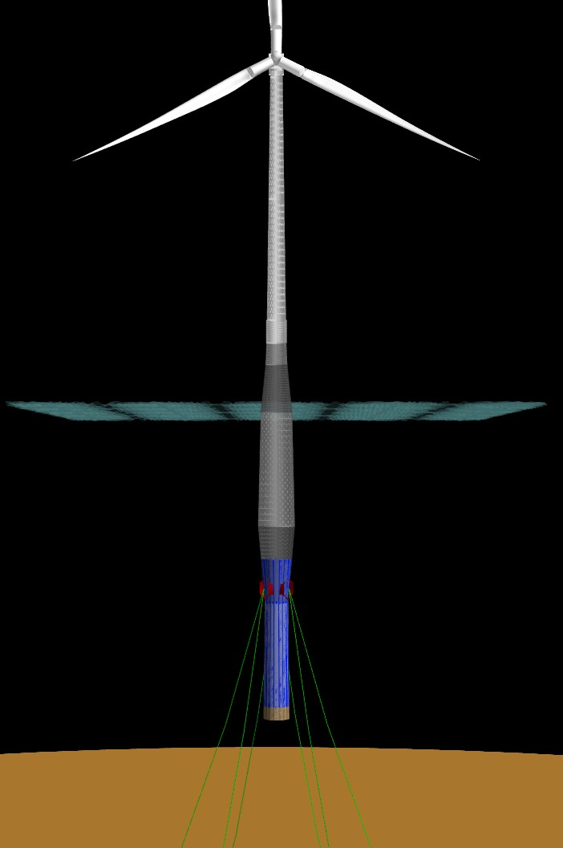 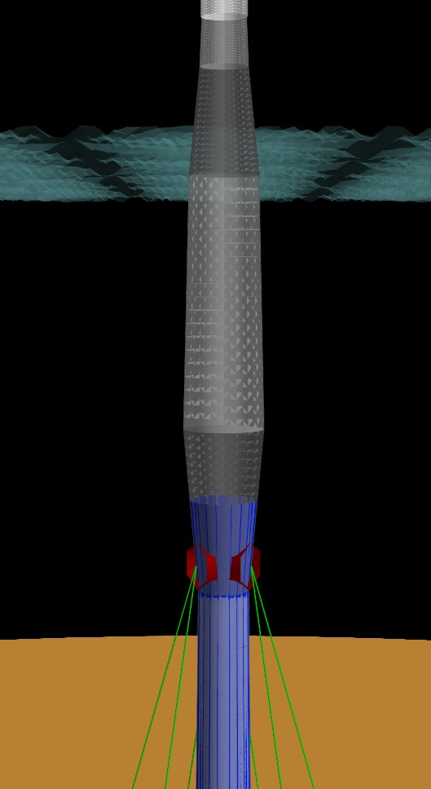 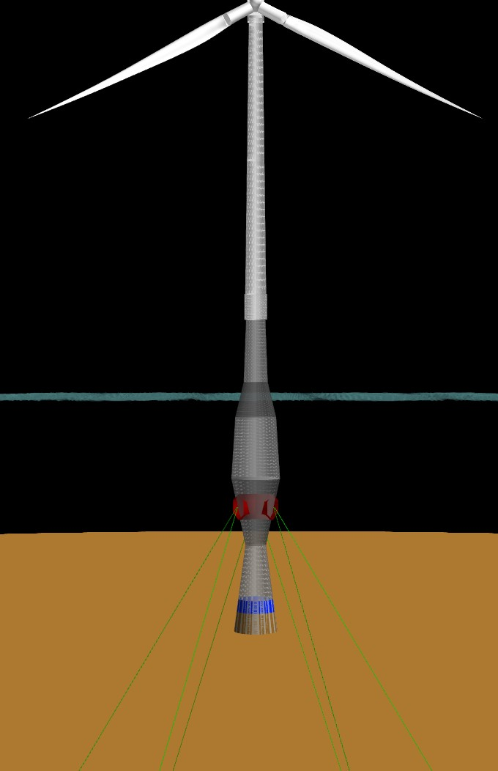 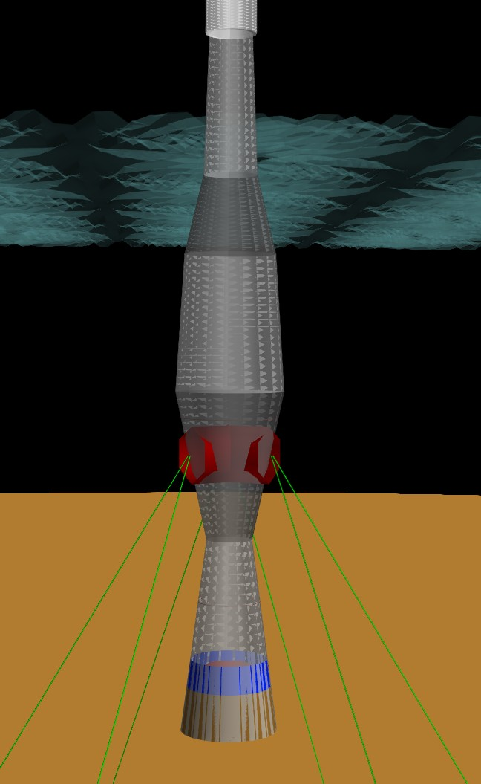

* + - 1. Mass-optimized **(b)** Mass-optimized **(c)** Cost-optimized **(d)** Cost-optimized

**Figure 10:** Views of optimized spar substructure designs.

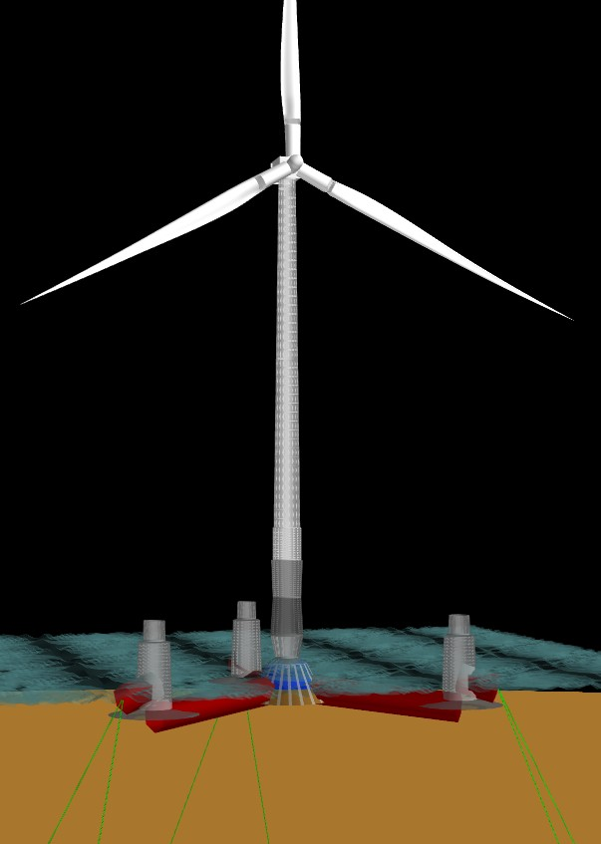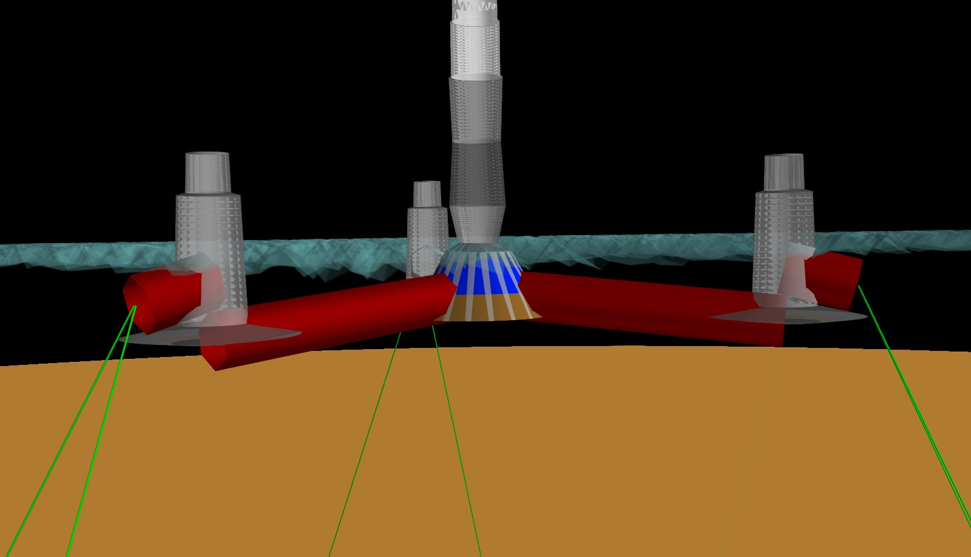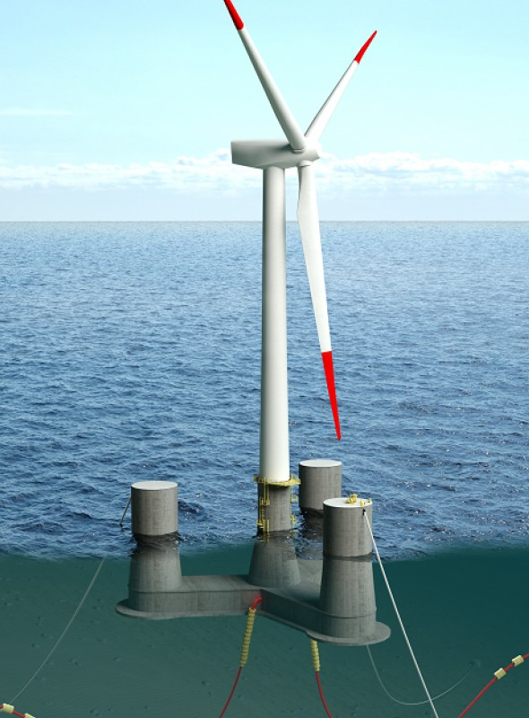

**(a)** WISDEM semisubmersible **(b)** WISDEM semisubmersible **(c)** OO-Star Wind Floater

**Figure 11:** Views of semisubmersible substructure optimized for minimal substructure mass (not including the mooring system) in (a) and (b). OO-Star Wind Floater design by Dr.techn.Olav Olsen for the LIFES50+ project, a European Horizon 2020 funded program, in (c).

the mooring system into the substructure mass budget. Table 5 shows that the total mooring downward force on the structures. Despite needing sturdier legs to support those mooring loads, shifting additional stability burden to the mooring system allows for a lighter structure.

## Sensitivity Studies

For the sensitivity studies, the optimized designs shown above were taken as baseline starting points. Then, the DTU 10MW reference turbine nacelle mass was perturbed away from its nominal value by the param- eterization shown in Table 6. Next, each design was re-optimized at the new nacelle mass value using the Nelder-Mead Simplex algorithm. All continuous design variables, constraints, and their bounds were kept consistent from the baseline optimization. The integer design variables were dropped to focus on a neigh- borhood search. As above, two sets of sensitivity optimizations were performed with different objective functions: one for substructure mass (not including the mooring system), and one for total substructure mass (including the mooring system).

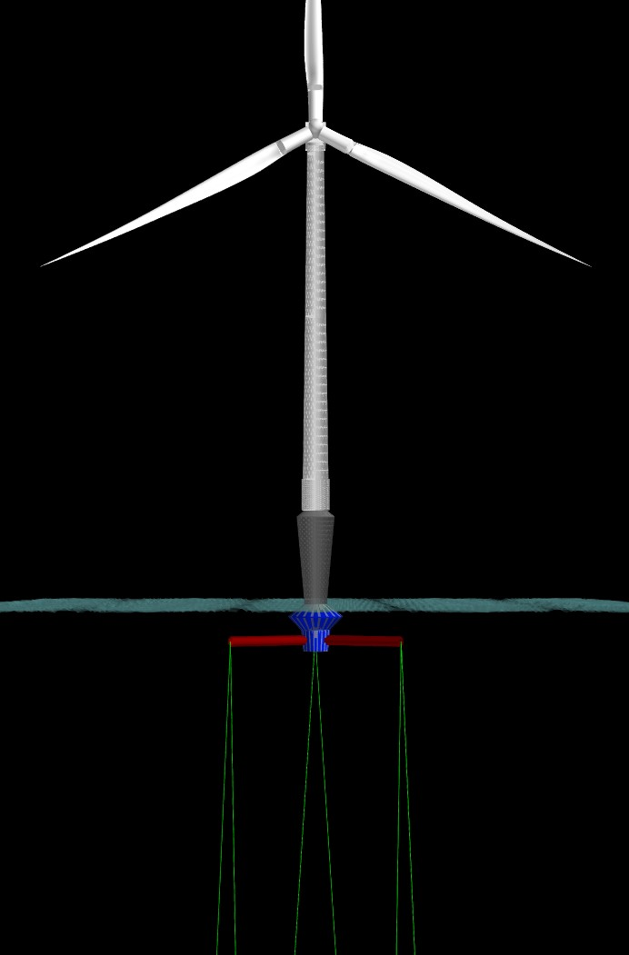

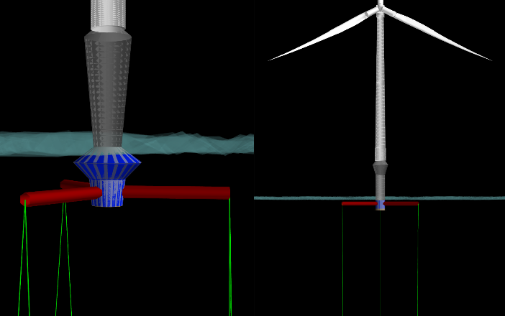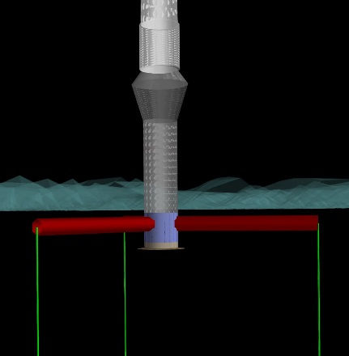

**(a)** Mass-optimized **(b)** Mass-optimized **(c)** Cost-optimized **(d)** Cost-optimized

**Figure 12:** Views of optimized TLP substructure designs.

**Table 6:** Nacelle and RNA mass perturbations for design sensitivity studies.

|  |  |  |  |
| --- | --- | --- | --- |
| **Nacelle Perturbation** | **Nacelle Mass [kg]** | **RNA Mass [kg]** | **RNA Perturbation** |
| Nominal | 446,036 | 672,301 | - |
| +10% | 490,640 | 716,904 | +6.6% |
| -10% | 401,433 | 627,697 | -6.6% |
| -25% | 334,527 | 560,791 | -16.6% |
| -33% | 297,506 | 523,770 | -22% |
| -50% | 223,018 | 449,282 | -33% |

#### Caveats

All of the caveats regarding substructure design mentioned above still apply to the design sensitivity analysis as well. In addition to those, there are a couple of other points to keep in mind when considering the results shown here,

* + - * Design variables did not include the tower, a key structural component that would change with nacelle mass. Had tower design variables been included, the total mass reductions would likely have been

higher;

* + - * Cost sensitivity is for substructure capital cost only. Other costs such as those captured in a balance of station or operational model would likely demonstrate different sensitivities;
      * The cost rates listed in Table 1 are notional, but still determine the priorities of the cost-optimized solutions and break-even cost points. Thus, the final break-even costs should also be considered

notional;

* + - * Just as the optimized designs reflect the assumptions and fidelity of *FloatingSE*, so too do the sensitivity

study results. So, if the underlying assumptions or fidelity improve in the future, the key points determined here may shift.

#### Mass-Optimized Design Sensitivity

The sensitivity of substructure mass (not including the mooring system), for all three substructure types, with respect to changes in nacelle mass is shown in Figure 13. Absolute values of mass changes are shown in Figure 13a and percentage changes are in Figure 13b. Reading from right to left, between the three substructure types, the slopes are all initially similar, but not exactly the same. The slope of the spar

curve appears the most linear and the steepest, with approximately 1.5–2 kg of substructure mass removed for each 1 kg of mass removed from the nacelle. The slope for the TLP is shallower, approximately 1 kg of substructure mass removed for each 1 kg of mass removed from the nacelle. The slope of the semisubmersible curve is the most interesting. For small deviations around the nominal point, the slope of the semisubmersible curve nearly matches that of the spar, but at more significant mass decreases, the slope flattens out and the substructure mass is relatively constant. This implies that the substructure design is more heavily bracketed by constraints and design variable bounds.

0.1

0.0

**Substructure mass [1000t]**

0.1

0.2

0.3

0.4

|  |  |  |  |  |  |  |
| --- | --- | --- | --- | --- | --- | --- |
| SPAR- | MASS |  |  |  |  |  |
| SEMI-  TLP-M | MASS ASS |  |  |  |  |  |
|  |  |  |  |  |  |  |
|  |  |  |  |  |  |  |
|  |  |  |  |  |  |  |
|  |  |  |  |  |  |  |
|  |  |  |  |  |  |  |

0.20 0.15 0.10 0.05 0.00 0.05

**Nacelle mass [1000t]**

2%

1%

SPAR-

SEMI- TLP-M

MASS MASS ASS

0%

**Substructure mass**

-1%

-2%

-3%

-4%

-5%

-6%-60% -50% -40% -30% -20% -10% 0% 10% 20%

**Nacelle mass**

1. Absolute mass changes, mass-optimized **(b)** Percent mass changes, mass-optimized

**Figure 13:** Sensitivity of substructure mass (without mooring system) relative to mass changes in nacelle for mass- optimized baseline designs.

The mass sensitivities, shown in Figure 13, are really summary statistics as the substructure is comprised of multiple components. The percentage change of some other metrics are shown in Figure 14. Note that the curves for these other metrics are not smooth because they were not the objective function, so they were not monitored or controlled by the algorithm. For instance, the total displacement (Figure 14a), the submerged volume of the substructure, does not follow the same trend lines as the mass reductions in Figure 13b. The total displacement of the spar does decrease as the mass of the nacelle decreases, meaning the tapered column becomes narrower, but the trend is not nearly as linear as the mass sensitivity. This is likely due to the fact that the total displacement is closely tied to some of the stability constraints, such as metacentric height, and so cannot vary in the same regard.

Figures 14b–c show the change in the average diameter and thickness of the main column to illustrate how the geometry changes during the parameterized. For the spar, as the mass of the nacelle becomes less, the column becomes both slightly narrower and with slightly thinner walls. For the semisubmersible, the diameter stays roughly constant (or even increases slightly), but the thickness decreases. For the TLP, the diameter decreases sharply, but the thickness increases.

Figure 14d shows the change in permanent (solid lines) and water (dashed lines) ballast as the mass in the nacelle decreases. The percentage changes here are the most pronounced and the shape of the curves most closely resemble that of the overall mass change in Figure 13b. This suggests that further converting permanent ballast into water ballast (which is not counted in the mass budget) is the dominant trend driving the results of the mass-optimized sensitivity study. This is an important trend to keep in mind when interpreting the change in substructure costs presented below.

#### Mass vs. Cost Scaling

The change in substructure cost, including the mooring system, for the mass-optimized designs in the sensitivity study is shown in Figure 15 in both absolute and percentage terms. The results are, at first, quite surprising, but are consistent with the other results shown above. The mass-optimized spar design

0.4%

0.2%

**Substructure displacement**

1%

0.5%

SP

SE

TL

AR-MASS MI-MASS P-MASS

**Main column ave diameter**

0% 0%

SPAR-

SEMI- TLP-M

MASS MASS ASS

-0.2% -0.5%

-0.4% -1%

-0.6% -1.5%

-0.8%

-1%-60% -50% -40% -30% -20% -10% 0% 10% 20%

**Nacelle mass**

**(a)** Displaced volume

2.5%

SP

SE

TL

AR-MASS MI-MASS P-MASS

2%

**Main column ave thickness**

1.5%

1%

0.5%

0%

-0.5%-60% -50% -40% -30% -20% -10% 0% 10% 20%

**Nacelle mass**

* 1. Main column average thickness

-2%

-2.5%-60% -50% -40% -30% -20% -10% 0% 10% 20%

**Nacelle mass**

**(b)** Main column average diameter

12.5%

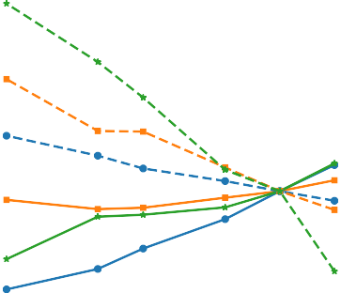

SPAR-

SEMI-

TLP-M

MASS Per

MASS Perm ASS Perm

m Ballast Ballast Ballast

SPAR-

SEMI-

TLP-M

MASS Wat

MASS Wate ASS Water

er Ballast r Ballast Ballast

10%

7.5%

**Substructure Ballast**

5%

2.5%

0%

-2.5%

-5%

-7.5%-60% -50% -40% -30% -20% -10% 0% 10% 20%

**Nacelle mass**

* 1. Permanent (solid) and water (dashed) ballast

**Figure 14:** Sensitivity of other substructure metrics (volume, water ballast, mooring tension, total cost) relative to mass changes in nacelle for mass-optimized baseline designs.

demonstrates a mass reduction slope of 1*.*5 *− −*2 relative to nacelle mass reduction, which is a reflection of decreases in the spar diameter, thickness, and permanent ballast. This leads to a net cost savings of

approximately $150M for a 50% reduction in nacelle mass, which is less than 1% of the total cost and far from the 4% reduction in substructure mass. The mass-optimized TLP design shows negligible cost savings for all nacelle mass perturbations, despite a consistent mass reduction slope of 1. The mass-optimized semisubmersible design has a small margin for overall mass reduction since it is tightly constrained, but nevertheless does achieve measurable reductions over the course of the parameterization. However, Figure 15 shows that this mass reduction actually incurs a cost increase. This is inconsistent with expectations, but can be understood through the results in Figure 14d and Table 1. To reduce the mass, the optimizer has aggressively reduced the amount of permanent ballast in favor of water ballast. To maintain stability despite this change, the column diameter and draft (which was not shown) actually increased slightly. While permanent ballast is heavy, it is also inexpensive per unit mass, whereas rolled steel columns are an order-of- magnitude more expensive. Since the mass-optimized design is blind to cost, the algorithm traded a heavy but cheap ingredient for a lighter but more expensive ingredient. This explains the ostensibly counter-intuitive trends seen in Figure 15.

#### Cost-Optimized Design Sensitivity

For a consistent reduction in both substructure mass and cost with respect to mass reductions in the nacelle, we must look to the cost-optimized design sensitivity results. These results are shown in Figure 16. The

400

**Substructure cost [M USD]**

300

200

100

0

100

3%

2.5%

2%

1.5%

**Substructure cost**

1%

0.5%

0%

-0.5%

-1%

SPAR-MASS SEMI-MASS

TLP-MASS

0.20 0.15 0.10 0.05 0.00 0.05

S S

|  |  |  |  |  |  |  |
| --- | --- | --- | --- | --- | --- | --- |
|  |  |  |  |  | SPAR-MAS  SEMI-MAS  TLP-MASS |  |
|  |  |  |  |  |  |  |
|  |  |  |  |  |  |  |
|  |  |  |  |  |  |  |
|  |  |  |  |  |  |  |
|  |  |  |  |  |  |  |
|  |  |  |  |  |  |  |

**Nacelle mass [1000t]**

1. Absolute cost changes, mass-optimized

-1.5%-60% -50% -40% -30% -20% -10% 0% 10% 20%

**Nacelle mass**

1. Percent cost changes, mass-optimized

**Figure 15:** Sensitivity of substructure cost (with mooring system) relative to mass changes in nacelle for mass- optimized baseline designs.

reductions of platform mass, shown in Figures 16a–b, are quite linear despite the fact that the designs are cost-optimized. The slopes of the lines are actually about equal to those in Figure 13. The spar has a slope of approximately 2, and the TLP still has a slope of about 1. The semisubmersible line, however, has a much steeper slope, 1*.*5, than in the mass-optimized case. It is important to note that these cost-optimized designs have a different baseline starting point than the mass-optimized designs and all changes shown are relative. Thus, while the mass reduction slope for the semisubmersible design is steeper in Figure 16 than Figure 13, the mass-optimized design still achieves a lower overall mass.

The cost reductions for the cost-optimized designs are shown in Figures 16c–d. Here, at least, there is a consistent cost decrease, although by percentage it is still far from the percentage mass decrease. This is once again explained by the difference in cost rates among the different components.

The results shown in Figures 15-16 have some broader applications than for the immediate study pre- sented here. In many engineering studies, mass is used as a surrogate for capital cost since the development of cost models usually requires a different set of expertise and input data than what is required for engineer- ing models. The implications of the result shown in Figure 15 is that mass minimization is not necessarily a perfect surrogate for capital cost minimization in all cases. In our case, the different cost rates for different components means a mass-focused objective function targets different changes than a cost-focused objective function. In other cases, perhaps with sophisticated cost models that account for various alternative manu- facturing and logistical processes, mass is simply no longer an adequate surrogate for cost. Regardless, this observation underscores some of the messages conveyed in Section 1 that advocate for a multidisciplinary systems framework that uses lifecycle costs to ascertain holistic cost reduction pathways.

## Break-Even Cost Point for Nacelle Mass Reduction

One of the more interesting nuggets that can be derived from this type of design sensitivity study is the cost point required for the mass-reducing technology (in this case in the drivetrain) to break-even with the cost changes incurred through the system redesign. Meaning, removing mass from the nacelle through the introduction of a new technology likely comes with a cost premium. This extra cost, however, can be offset when the mass savings are propagated through the rest of the system to reduce structural mass and (hopefully) cost.

The calculated break-even cost points, for both mass- and cost-optimized designs, are shown in Figure

17. For the spar designs, both mass- and cost-optimized, the break-even cost for new drivetrain technology is approximately 700–1400 USD/kg, with a narrower window for the cost-optimized. Meaning, if the cost

* 1. 1% SPAR-

COST COST OST

|  |  |  |  |  |  |  |
| --- | --- | --- | --- | --- | --- | --- |
| SPAR- | COST |  |  |  |  |  |
| SEMI-  TLP-C | COST OST |  |  |  |  |  |
|  |  |  |  |  |  |  |
|  |  |  |  |  |  |  |
|  |  |  |  |  |  |  |
|  |  |  |  |  |  |  |
|  |  |  |  |  |  |  |

SEMI-

TLP-C

0.0

**Substructure mass [1000t]**

0.1

0.2

0.3

0.4

0.20 0.15 0.10 0.05 0.00 0.05

**Nacelle mass [1000t]**

* + 1. Absolute mass changes, cost-optimized

50

|  |  |  |  |  |  |  |
| --- | --- | --- | --- | --- | --- | --- |
| SPAR-  SEMI- | COST COST |  |  |  |  |  |
| TLP-C | OST |  |  |  |  |  |
|  |  |  |  |  |  |  |
|  |  |  |  |  |  |  |
|  |  |  |  |  |  |  |
|  |  |  |  |  |  |  |
|  |  |  |  |  |  |  |
|  |  |  |  |  |  |  |
|  |  |  |  |  |  |  |

0%

-1%

**Substructure mass**

-2%

-3%

-4%-60% -50% -40% -30% -20% -10% 0% 10% 20%

**Nacelle mass**

* + 1. Percent mass changes, cost-optimized

0.5% SPAR-

COST COST OST

SEMI-

TLP-C

0

**Substructure cost [M USD]**

50

100

150

200

250

300

0.20 0.15 0.10 0.05 0.00 0.05

**Nacelle mass [1000t]**

0%

-0.5%

**Substructure cost**

-1%

-1.5%

-2%-60% -50% -40% -30% -20% -10% 0% 10% 20%

**Nacelle mass**

1. Absolute cost changes, cost-optimized **(d)** Percent cost changes, cost-optimized

**Figure 16:** Sensitivity of substructure cost (without mooring system) relative to mass changes in nacelle for cost- optimized baseline designs.

premium to nacelle mass reduction ratio of the new technology is greater than this value, then there would be a net cost increase to the system. If the ratio is less than this range, then there would be a net cost reduction to the system. If the ratio lies within this range, then a little more detailed investigation would be necessary.

The mass-optimized TLP break-even cost ranges from 0–600 USD/kg, which is a significant variation from *never worthwhile* to *worthwhile*. Recall that the cost reduction in Figure 15 for the TLP was essentially flat for reasons already explained. This is what is driving the inconclusive determination of the break-even point. For the same reason, the mass-optimized semisubmersible design hardly appears in the visual region of Figure 17.

For the cost-optimized semisubmersible and TLP, the break-even results are much more consistent. For the semisubmersible, the break-even cost-ratio is approximately 400–500 USD/kg and for the TLP the value is only about 100 USD/kg, a difficult threshold to meet. Thus, the break-even cost point is dependent on the type of substructure for this application, hypothetical drivetrain improvement technologies, and likely other technologies too.

# Conclusions

This paper has introduced the new WISDEM module, *FloatingSE*, for hydrostatic-based sizing and concep- tual design of floating offshore wind turbine substructures. To showcase the capabilities of this module, and

1500

TLP-C

OST

SPAR-MASS

SEMI-MASS

TLP-MASS

SPAR-COST

SEMI-COST

0.225 0.200 0.175 0.150 0.125 0.100 0.075 0.050

1200

**Breakeven cost premium [USD/kg]**

900

600

300

0

### Nacelle mass [1000t]

**Figure 17:** Break-even cost premium for the introduction of new drivetrain technology.

the larger WISDEM framework, a two-step analysis was carried out. First, three different substructures, a spar, semisubmersible, and TLP, were designed for the DTU 10 MW reference turbine using the same set of descriptive configuration variables and analysis tools. This demonstrates the ability of *FloatingSE* to parametrically describe entirely different platform architectures that achieve stability through different underlying mechanisms. Second, a design sensitivity study was conducted where mass in the nacelle was parametrically removed, to simulate the addition of a novel drivetrain or generator technology, and the design re-optimized. The derived sensitivities were used to ascertain the break-even cost rate of the new technology that reduces the drivetrain mass.

The optimization-based analyses yielded a few interesting, and some unexpected results. First, cost reductions in floating offshore wind energy can be achieved by a consideration of the entire engineering, manufacturing, and operation requirements concurrently. Second, mass can be a poor surrogate for cost in engineering design as due to differences in cost rates and complexity in cost models. This underscores the need for a cost-focused multidisciplinary systems framework for floating offshore wind. Finally, the break- even point for drivetrain technologies that offer mass savings for a cost premium are approximately $1,000 for the spar, $450 for the semisubmersible, and $100 for the TLP.

The design sensitivity study was just one of the questions that could be posed of *FloatingSE* and WISDEM to help answer one of the many outstanding questions regarding floating offshore wind technology. Some of the other questions that could be explored in greater depth include,

* What are the cost-benefit tradeoffs of a floating substructure designed to operate in many different regions versus one that is more customized to particular metocean environment?
* What is the impact on floating systems (e.g., weight, cost, scale-ability) due to a new technology? Is that new technology worth the investment?
* What technologies should governments and industry invest in to achieve the greatest cost reduction in floating offshore wind energy?
* Where can alternative materials, such as composites and concrete, be used on the turbine to reduce cost, taking into account regional material and labor cost differences?

The results presented here were prefaced with many caveats due to the many simplifying assumptions and low-fidelity analyses within *FloatingSE*. Hence, there is significant plans for future improvements. Future

plans include accounting for hydrodynamics and additional load cases and a more detailed cost model of the balance of station and operational costs of an offshore floating wind plant in WISDEM. As these improvements are made, the results determined in this paper may change, perhaps significantly. Nevertheless, the improvements on the whole will enable the framework to address a richer set of open analysis questions with greater certainty.

# Acknowledgments

The authors would like to thank Patrick Gilman, Alana Duerr, Gary Norton, Daniel Beals, Eric Lantz, and Jason Jonkman for their valuable input in reviewing results and drafts of this paper.

NREL’s contributions to this work were supported by the US Department of Energy under Contract Number DE-AC36-08GO28308 with the National Renewable Energy Laboratory.

# References

1. American Petroleum Institute (API). “Bulletin on Stability Design of Cylindrical Shells.” Report API Bulletin 2U, 3rd Edition, Washington, DC, 2004.
2. Ashuri, T., Zaaijer, M.B., Martins, J.R.R.A., vanBussel, G.J.W., and vanKuik, G.A.M. “Multidisciplinary design optimization of offshore wind turbines for minimum levelized cost of energy.” *Renewable Energy*, 68:893

– 905, 2014. doi: https://doi.org/10.1016/j.renene.2014.02.045.

1. Bak, Christian, Zahle, Frederik, Bitsche, Robert, Kim, Taeseong, Yde, Anders, Henriksen, LC, Andersen, Pe- ter B, Natarajan, Anand, and Hansen, Morten Hartvig. “Design and performance of a 10 MW wind turbine.” *Wind Energy*, 124, 2013.
2. Beiter, Philipp, Musial, Walter, Smith, Aaron, Kilcher, Levi, Damiani, Rick, Maness, Michael, Sirnivas, Senu, Stehly, Tyler, Gevorgian, Vahan, Mooney, Meghan, and Scott, George. “A Spatial-Economic CostReduction Pathway Analysis for U.S. Offshore Wind Energy Development from 2015–2030.” Report NREL/TP-6A20- 66579, National Renewable Energy Lab.(NREL), Golden, CO, September 2016. URL [https://www.nrel.gov/](https://www.nrel.gov/docs/fy16osti/66579.pdf) [docs/fy16osti/66579.pdf](https://www.nrel.gov/docs/fy16osti/66579.pdf).
3. Bortolotti, Pietro, Bottasso, Carlo L., and Croce, Alessandro. “Combined preliminary–detailed design of wind turbines.” *Wind Energy Science*, 1(1):71–88, 2016. doi: 10.5194/wes-1-71-2016.
4. Bottasso, Carlo L., Campagnolo, Filippo, and Croce, Alessandro. “Multi-disciplinary constrained optimization of wind turbines.” *Multibody System Dynamics*, 27(1):21–53, Jan 2012. doi: 10.1007/s11044-011-9271-x.
5. Damiani, Rick. “JacketSE: An Offshore Wind Turbine Jacket Sizing Tool.” Report NREL/TP-5000-65417, National Renewable Energy Lab.(NREL), Golden, CO, February 2016. URL [https://www.nrel.gov/docs/](https://www.nrel.gov/docs/fy16osti/65417.pdf) [fy16osti/65417.pdf](https://www.nrel.gov/docs/fy16osti/65417.pdf).
6. Damiani, Rick, Dykes, Katherine, and Scott, George. “A comparison study of offshore wind support structures with monopiles and jackets for US waters.” In *Journal of Physics: Conference Series*, volume 753, page 092003. IOP Publishing, 2016.
7. Deb, K., Pratap, A., Agarwal, S., and Meyarivan, T. “A fast and elitist multiobjective genetic algorithm: NSGA-II.” April 2002.
8. Dykes, Katherine and Meadows, Rebecca. “Applications of systems engineering to the research, design, and development of wind energy systems.” Report NREL/TP-5000-52616, National Renewable Energy Lab.(NREL), Golden, CO, December 2011.
9. European Committee for Standardisation. “Eurocode 3: Design of Steel Structures—Part 1-6: General rules— Supplementary rules for the shell structures.” Report EN 1993-1-6: 20xx, European Committee for Standardis- ation, 1993.
10. Fleming, Paul A., Ning, Andrew, Gebraad, Pieter M. O., and Dykes, Katherine. “Wind plant system engineering through optimization of layout and yaw control.” *Wind Energy*, 19(2):329–344, 2016. doi: 10.1002/we.1836.
11. Gavin, Henri P. and Pye, John. *Frame3DD version 0.20140514+*. Duke University, Durham, NC, November 2015. URL [http://frame3dd.sourceforge.net](http://frame3dd.sourceforge.net/).
12. Germanischer Lloyd. “Guideline for the Certification of Offshore Wind Turbines.” Report IV – Part 2, Chapter 6, Germanischer Lloyd, 2005.
13. Gray, Justin S., Hearn, Tristan A., Moore, Kenneth T., Hwang, John, Martins, Joaquim, and Ning, Andrew. “Automatic Evaluation of Multidisciplinary Derivatives Using a Graph-Based Problem Formulation in OpenM- DAO.” In *15th AIAA/ISSMO Multidisciplinary Analysis and Optimization Conference*. American Institute of Aeronautics and Astronautics, 2014/07/08 2014. doi: doi:10.2514/6.2014-2042.
14. H¨aafele, Jan, Rolfes, Raimund, et al. “Approaching the ideal design of jacket substructures for offshore wind turbines with a Particle Swarm Optimization algorithm.” In *The 26th International Ocean and Polar Engineering Conference*. International Society of Offshore and Polar Engineers, 2016.
15. Haftka, Raphael T. “Optimization of flexible wing structures subject to strength and induced drag constraints.”

*AIAA Journal*, 15(8):1101–1106, 1977.

1. Jonkman, Jason. “Definition of the Floating System for Phase IV of OC3.” Report NREL/TP-500-47535, Na- tional Renewable Energy Lab.(NREL), Golden, CO, May 2010. URL [https://www.nrel.gov/docs/fy10osti/](https://www.nrel.gov/docs/fy10osti/47535.pdf) [47535.pdf](https://www.nrel.gov/docs/fy10osti/47535.pdf).
2. Karimi, Meysam, Hall, Matthew, Buckham, Brad, and Crawford, Curran. “A multi-objective design optimization approach for floating offshore wind turbine support structures.” *Journal of Ocean Engineering and Marine Energy*, 3(1):69–87, Feb 2017. doi: 10.1007/s40722-016-0072-4.
3. Ku¨hn, M., Bierbooms, W. A. A. M., vanBussel, G. J. W., Cockerill, T. T., Harrison, R., Ferguson, M. C., G¨oransson, B., Harland, L. A., Vugts, J. H., and Wiecherink, R. “Towards a mature offshore wind energy technology—guidelines from the opti-OWECS project.” *Wind Energy*, 2(1):25–58, 1999.
4. Lemmer, Frank, Mu¨ller, Kolja, Yu, Wei, Guzman, Ricardo Faerron, and Kretschmer, Matthias. *Optimization framework and methodology for optimized floater design*. Number Deliverable D4.3. LIFES50+, December 2016.
5. Lozano-Minguez, E., Kolios, A.J., and Brennan, F.P. “Multi-criteria assessment of offshore wind turbine support structures.” *Renewable Energy*, 36(11):2831 – 2837, 2011. doi: https://doi.org/10.1016/j.renene.2011.04.020.
6. Maki, Kevin, Sbragio, Ricardo, and Vlahopoulos, Nickolas. “System design of a wind turbine using a multi-level optimization approach.” *Renewable Energy*, 43:101 – 110, 2012. doi: https://doi.org/10.1016/j.renene.2011.11. 027.
7. Maness, Michael, Maples, Benjamin, and Smith, Alex. “NREL Offshore Balance-of-System Model.” Report NREL/TP-6A20-66874, National Renewable Energy Lab.(NREL), Golden, CO, January 2017. URL [https:](https://www.nrel.gov/docs/fy17osti/66874.pdf)

[//www.nrel.gov/docs/fy17osti/66874.pdf](https://www.nrel.gov/docs/fy17osti/66874.pdf).

1. Martins, Joaquim RRA and Lambe, Andrew B. “Multidisciplinary design optimization: a survey of architec- tures.” *AIAA Journal*, 51(9):2049–2075, 2013.
2. Masciola, Marco, Jonkman, Jason, and Robertson, Amy. “Implementation of a multisegmented, quasi-static cable model.” In *The Twenty-third International Offshore and Polar Engineering Conference*. International Society of Offshore and Polar Engineers, 2013. URL <https://nwtc.nrel.gov/MAP>.
3. Musial, Walt, Heimiller, Donna, Beiter, Philipp, Scott, George, and Draxl, Caroline. “2016 Offshore Wind Energy Resource Assessment for the United States.” Report NREL/TP-5000-66599, National Renewable Energy Lab.(NREL), Golden, CO, September 2016. URL <https://www.nrel.gov/docs/fy16osti/66599.pdf>.
4. Musial, Walter, Beiter, Philipp, Tegen, Suzanne, and Smith, Aaron. “Potential Offshore Wind Energy Areas in California: An Assessment of Locations, Technology, and Costs.” Report NREL/TP-5000-67414, Bureau of Ocean Energy Management and National Renewable Energy Lab, Golden, CO, December 2016. URL [https:](https://www.boem.gov/2016-074/)

[//www.boem.gov/2016-074/](https://www.boem.gov/2016-074/).

1. Muskulus, Michael and Schafhirt, Sebastian. “Design optimization of wind turbine support structures-a review.”

*Journal of Ocean and Wind Energy*, 1(1):12–22, 2014.

1. Nelder, John A. and Mead, Roger. “A Simplex Method for Function Minimization.” *The Computer Journal*, 7 (4):308–313, 1965. doi: 10.1093/comjnl/7.4.308.
2. Ning, Andrew and Dykes, Katherine. “Understanding the Benefits and Limitations of Increasing Maximum Rotor Tip Speed for Utility-Scale Wind Turbines.” *Journal of Physics: Conference Series*, 524(1):012087, 2014.
3. *OrcaFlex Documentation (version 10.2b)*. Orcina, Durham, NC, 2018. URL [https://www.orcina.com/](https://www.orcina.com/SoftwareProducts/OrcaFlex/Documentation) [SoftwareProducts/OrcaFlex/Documentation](https://www.orcina.com/SoftwareProducts/OrcaFlex/Documentation).
4. Perez-Moreno, S Sanchez, Dykes, K, Merz, K O, and Zaaijer, M B. “Multidisciplinary design analysis and optimisation of a reference offshore wind plant.” *Journal of Physics: Conference Series*, 1037(4):042004, 2018.
5. Perez-Moreno, S Sanchez, Zaaijer, M B, Bottasso, C L, Dykes, K, Merz, K O, R´ethor´e, P-E, and Zahle, F. “Roadmap to the multidisciplinary design analysis and optimisation of wind energy systems.” *Journal of Physics: Conference Series*, 753(6):062011, 2016.
6. Roshko, Anatol. “Experiments on the flow past a circular cylinder at very high Reynolds number.” *Journal of Fluid Mechanics*, 10(3):345–356, 1961.
7. Schmit, Lucien A. “Structural Design by Systematic Synthesis.” In *2nd Conference on Electronic Computation*, pages 105–132, Pittsburgh, PA, September 1960. ASCE.
8. Statoil. “World class performance by world’s first floating wind farm.” February 2018. URL [https://www.](https://www.statoil.com/en/news/15feb2018-world-class-performance.html) [statoil.com/en/news/15feb2018-world-class-performance.html](https://www.statoil.com/en/news/15feb2018-world-class-performance.html).
9. Thiagarajan, KP and Dagher, HJ. “A review of floating platform concepts for offshore wind energy generation.”

*Journal of Offshore Mechanics and Arctic Engineering*, 136(2):020903, 2014.

1. Timoshenko, S.P. and Goodier, J.N. *Theory of elasticity, 3rd Edition*. McGraw-Hill, 1970.
2. Yeniay, O¨ zgu¨r. “Penalty Function Methods for Constrained Optimization with Genetic Algorithms.” *Mathemat- ical and Computational Applications*, 10(1):45–56, 2005. doi: 10.3390/mca10010045.