## Analytics – Overview

Retina’s powerful analytics module includes two distinct areas: Dashboards and Reports.

Reports serve as data sources for widgets. Widgets are used to display data to users on dashboards. Retina ships with pre-configured Role-based Dashboards for medical device development. Take them as samples to create ones that best serve your users and assign it to them with ease. Dashboards are to reach their final form via individual tailoring if required.

You grant dashboard access to a user through the admin » Members and Roles page.

Reports are queries generated in cbQL language, that is very similar to SQL. Retina features an intuitive, graphical report builder and allows you to view / change the query statement directly in advanced mode. Special “Dashboard Visualization” type widgets are used to display report results in Calendar-, Chart or Table format.

# Workshop - Create a Requirements Manager Report

1. Navigate to the Report Builder and select the “New Report” option.

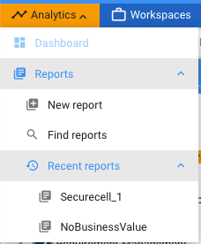

1. Select an applicable workspace and the System Requirement Specifications tracker.
2. Hit the “Go” button under the conditions pane!
3. Review the previous screenshot for a quick description of the Report Builder

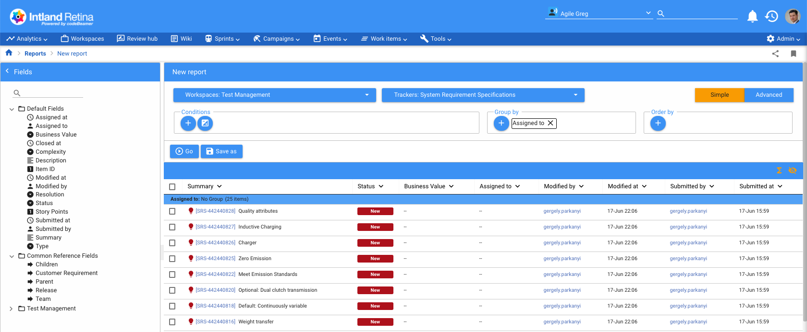

Mode selector

Order by

Groups

Filters

Results

Fields

*The mode selector is where you can choose between the current “Simple” mode, where you can create the report with the above tools-, and the Advanced mode that will rely on your cBQL (codeBeamer Query Language) skills. This training will focus on the former.*

1. Now let’s add a Group by: Assigned to, and hit the Go button again.
2. You might have to scroll down to the bottom of the screen to adjust the number of visible records!



1. Drag and drop the “Type” from the left side to the column header section, next to the Business Value.

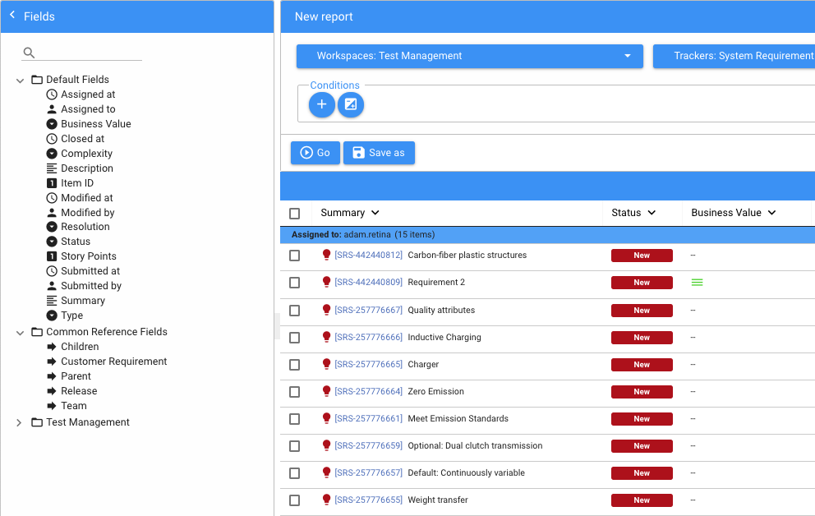

1. Hit Go again.
2. Add the Type to the Group by clause, and hit “Go”



*Now let’s experiment a bit with Conditions!*

1. Remove the Group by conditions, and hit “Go”
2. Add an “Assigned to:” filter. Now add a “Business Value” filter!

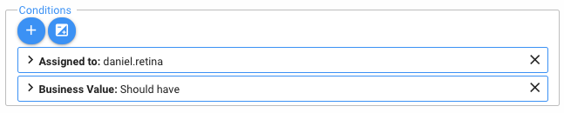

*By default such conditions are joined together with the AND logic – for a record to show in the “Results” list both conditions have to be true.*

1. Select the AND/OR logic button
2. Enter 1 OR 2

*As you are typing you will get a hint on the correct syntax:*

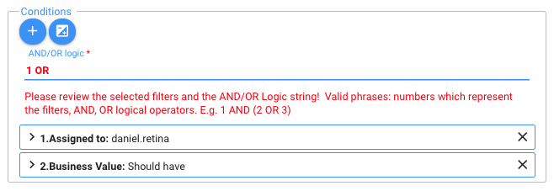

1. You will not be able to run the Query until after the red message changes to a green font:

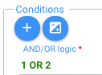

1. Hit “Go”. Toggle between the AND / OR logic.
2. Remove the filters and add back the “Assigned to” and “Business Value” group by conditions. We will need them as we create widgets later.
3. The report is now ready. Hit the ‘’Save as” button in the middle of the screen.

* Name, Description: Requirements Manager Report
* Workspace: your current workspace
* Role: Project Admin
* Access: WRITE

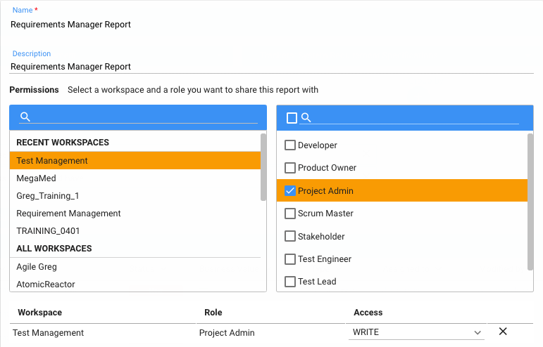

1. Hit “Save” to finish creating your first report.

# Workshop – Report Jobs

Once a report is ready, you may want to automate its execution with a Report Job. It is especially useful for exception-tracking reports, for example:

“Show me all requirements without business value!”

“What are the test cases with a suspected link?”

Navigate to Analytics » Reports » Find Reports

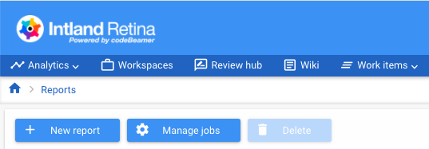

Then hit the “Manage jobs” button to review the Report Jobs you currently have access to. The configuration takes place in the System admin Menu:

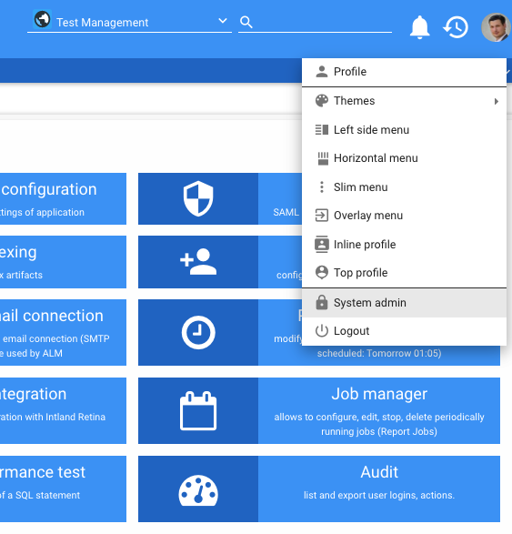

# Workshop – Create your first Dashboard

Dashboards contain widgets to display all the information required to fulfill a role effectively. Let’s create a new one for training purposes!

1. Navigate to Analytics » Dashboard
2. Use the + button to add a new Dashboard

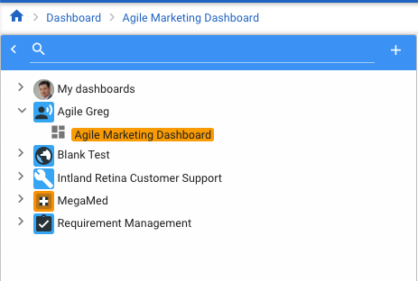

* 1. Name: Analytics
  2. Workspace: MegaMed
  3. Description: Analytics Dashboard
  4. Project Admins have Write Access

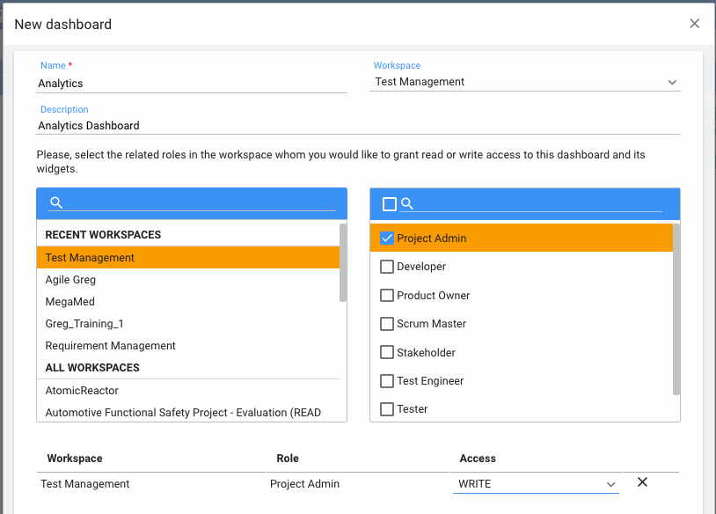

1. Hit the “Save” button
2. The new dashboard displays in the “tree” menu on the left.

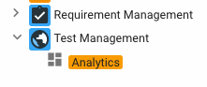

# Workshop – Adding Widgets to a Dashboard

There are three main types of widgets:

a) **Standard**: Pick pre-defined widgets from four categories: Workspace, Agile, Test and Other. These can be customized in their appearance and data source only.

b) **Custom**: you can use development tools to create your own widgets, but it is beyond the scope of this training.

c) **Report visualization**: take the information from a simple / advanced report and display in one of the four available formats:

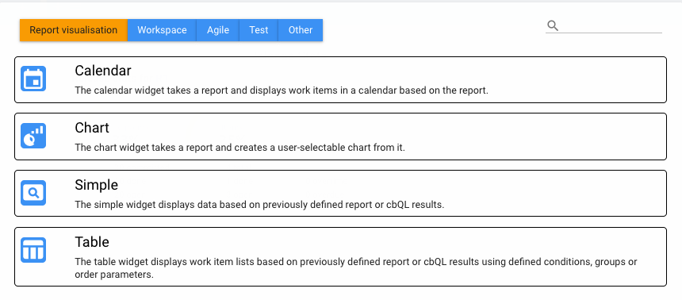

## Standard Widgets

1. Select your new “Analytics” dashboard, and then hit the + in the “Widgets” area to add a new one with the following details:

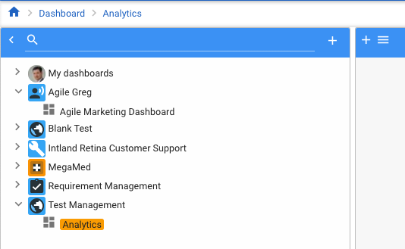

* + Type: Agile
  + Title: Release Stats

Then a new window will pop-up where you can specify the appearance of the new widget:

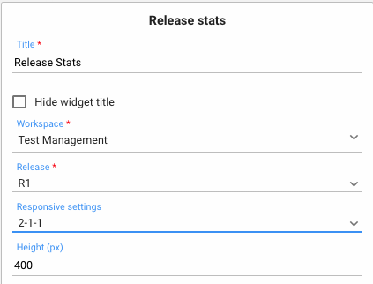

2) Hit the “Save” icon. Your release stats will appear:

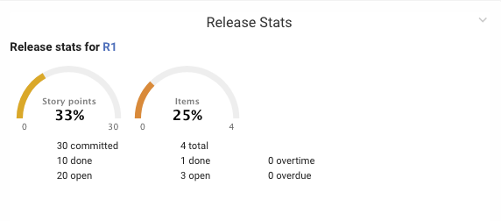

## Report Visualization Widgets

Add a widget to display the “Requirements Manager Report”

* 1. Add Table widget
  2. DataSource: Requirement Manager Report
  3. Responsive Settings: 1-1-1
  4. Hit Save

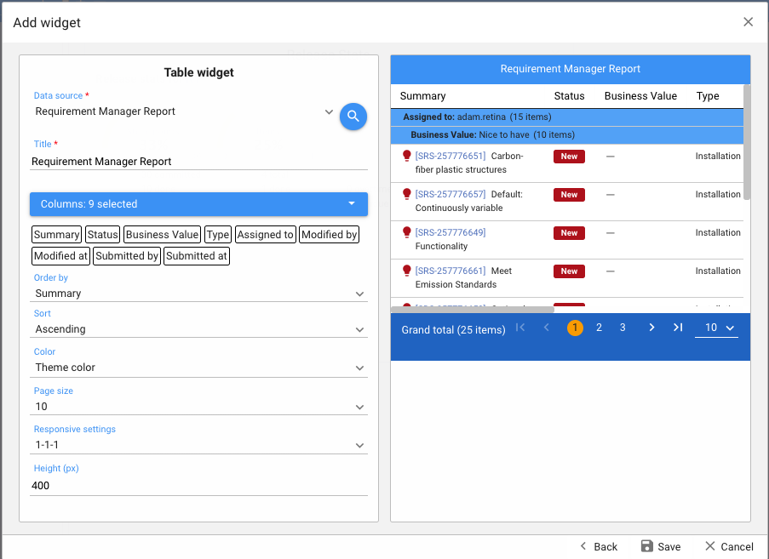

* 1. Review dashboard and widget
  2. Click: “Show Datasource” to get back to report

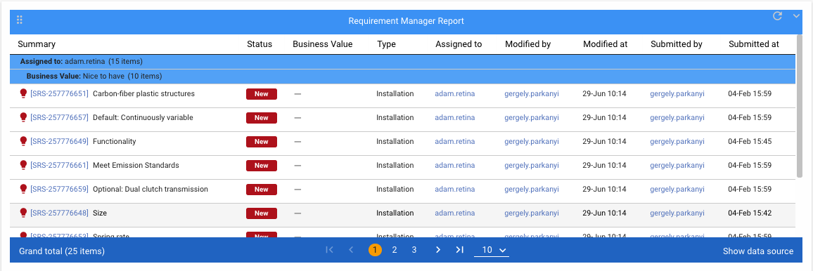

*Now we will add Charts to improve the look of our new dashboard! This widget will display the number of requirements by assignee!*

* 1. Add Widget » Report Visualization » Chart
  2. Select the “Requirement Manager Report”
  3. Choose the Chart type “Pie”
  4. Grouping field: Assigned to
  5. Select the Show values checkbox

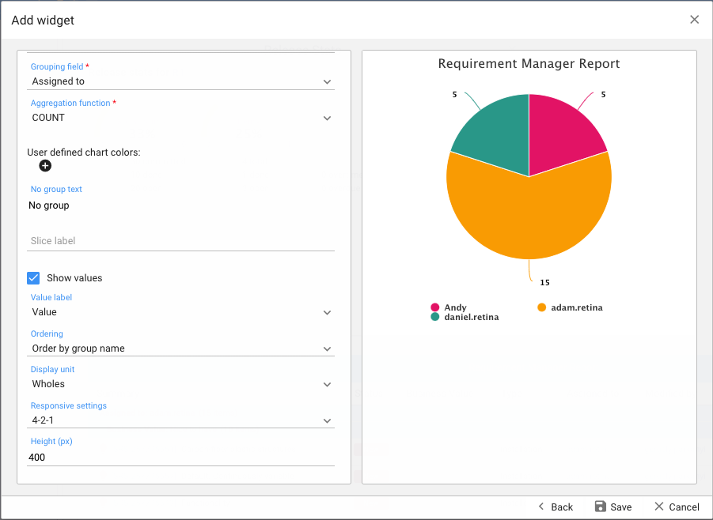

* 1. Change the visualization to Stacked column. This would only work if you have exactly two group by fields:

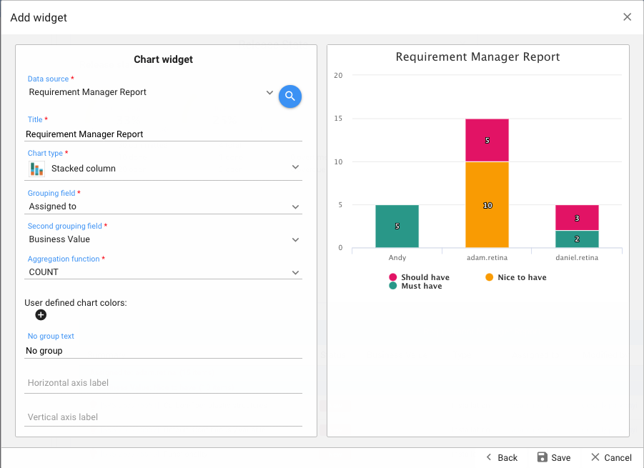

Hit Save, and review the final Dashboard! Drag and drop widgets to improve the look!

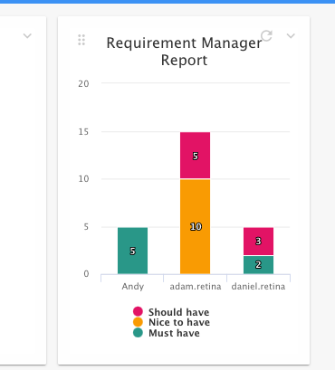

Use the six dots to drag widgets around!

