# Lecture 10 – Working with Cloud Infrastructure

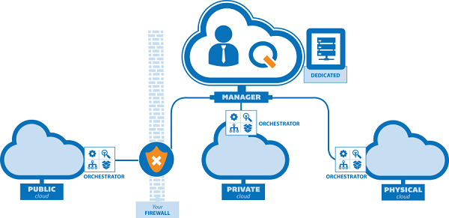

When building or when planning to build cloud infrastructure, there are several key requirements which are needed to achieve your goals and ensure that the right solutions are chosen. With the number of hosting providers currently operating in the cloud domain, a good amount of effort must be invested in evaluation to make well informed product decisions.

With the product decisions come a plethora of services offered. Cloud services come in all shapes in sizes. We’ve reached a point in time where practically any service involving IT can be a cloud-based solution. But how do we know where to go, what to choose and what features are mandatory? We’ll be evaluating several platforms and looking at case studies from some of biggest names in the industry have released for the public domain to use to inform oneself on the decision-making process.

## What is the cloud?

To put it simply, cloud computing is a term to refer to services, be it – storage, databases, software, analytics, intelligence and any other service that computers are known to provide – delivered over the Internet. They are nothing more than a technology service which comes from a datacenter, like one of AWS’s many locations, delivered to your network or application for use. Think of your GBLearn account, that is a machine located somewhere with FTP configured.

Instead of buying bare-metal servers to store data as one commonly would have to 10-15 years ago, we are no longer married to the expensive hardware initially purchased. Previously if business requirements exceeded the resources available on the hardware which we thought to be efficient, we’d have to order new hardware. When business needs start to grow, new hardware would had to have been purchased. With cloud computing, we can scale our computational resources as our business demands grow or decline on-the-fly and automatically.

For cloud-based infrastructure to get rolled out or piecemealed into an organization, it can be quite a shift from the traditional way businesses think about IT resources. To simplify this transition, let’s break cloud-based infrastructure down into 7 categories that would incentivize a company to make the change or even, if a change is needed.

Cost

Since cloud infrastructure does not involve up-front expenses on server racks, installations, server, switches, routers, etc. A significant portion of what use to be considered common expenses are eliminated. This allows for businesses to allocate their funds in other areas for use. If DevOps practices are properly implemented, round-the-clock costs for cloud services can be automated and the service will only be expensed to the consumer as needed.

Reliability

Relying on infrastructure from companies like Amazon, Google or Microsoft removes some concern for things like outages and downtime which were once common concerns keeping operations up at night. The need for an engineer to be woken up for mission-critical situations has gone down with guarantees like AWS’s “%99.9999” uptime continuity. Aside from infrastructure managed by tech giant professionals, services for disaster recovery, automated data backups and auto-scaling policies can be leveraged by consumers for further redundancy.

Speed

Capacity planning is not what it once when decision making time came for selecting adequate infrastructure solutions. Speed can be accommodated on demand allowing vast amounts of computing resources to be provisioned within minutes. If a service is not performing due to an increase of traffic, policies can handle the scalability of the underlying infrastructure to ensure something like speed is managed at the click of a button or so abstracted to the point where the momentary lack of resources goes unnoticed. Thresholds can be defined for infrastructure to scale up or down as needed with common cloud platforms like GCP, AWS or Azure.

Performance

When using tech-giant cloud infrastructure you can be sure that they take care of things like regular updates and maintenance of their hardware and services. They also use the latest generation of fast and efficient computer hardware offering several benefits over a single corporate datacenter. Reducing network latency and far greater economies of scale due to services being made available worldwide.

Security

Cloud computing provides consumers with a lowered threat model from threats. Many providers offer a robust set of policies, technologies and controls that help strengthen a client's security posture overall. Taking things, a step further, clients can create their own security policies and leverage things like virtual firewalls and the ability to black list IP’s and close ports as needed. Since infrastructure is their business, their security engineers work tirelessly to ensure that infrastructure is not compromised.

Global Scale

One of the major benefits of cloud computing is the ability to scale elastically. In cloud talk, this means the right amount of computational resources at the right time. Infrastructure is designed to scale on-demand to ensure that applications do not perform poorly when serving clients at vast geographical distances from where the development was completed and deployed.

Productivity

Lastly, productivity is dramatically increased given no need for the traditional “racking and stacking” network administrators once had to complete for services and setup. No more patching and other time-consuming IT chores are required as the cloud service provide handles this for us. It allows business to focus more on what they need to do, and less time spent on the administrative side. This has a compounding effect of increased productivity when looked at long-term

Now that we know some of the common reasons to encourage the use of cloud service providers and benefits gained from usage, let’s examine some commonly used models for cloud computing along with services leveraged from their usage.

You’ll be hard pressed to find identical cloud infrastructure ad there isn’t a one size fits all solution for cloud computing. There are different types of models, types and services which have evolved in an effort to help engineers find the right solution for different types of business problems.

Cloud computing architecture and deployment types must be taken into consideration and properly determined to know what services to implement in the cloud. There are three cloud types to which services can be deployed to.

Public cloud

Owned and operated by third-part cloud service providers, public clouds deliver computing resources such as servers and storage over the Internet. Google Cloud Platform is an example of a public cloud service. To use GCP as an example, if one was to use them for public cloud services, all hardware, software and other supporting infrastructure would be owned and managed by Google. With Azure, AWS or GCP, you access the services and manage accounts through a web browser.

Private cloud

If there is a business requirement for exclusive use for internal operations, a single business or organization can use create their own cloud infrastructure. A private cloud can be physically located on the company’s on-site datacenter. All services and infrastructure would be maintained on a private network.

Hybrid cloud

Combining both public and private cloud services, their use can be bound together technologically which allows for data and applications to be shared between them, offering a hybrid solution. When data moves between applications hosted on public and private clouds, a hybrid solution can offer more flexibility, more deployment options, and helps optimize existing infrastructure security, and compliance.

## Types of cloud services: IaaS, PaaS, serverless and SaaS

Most cloud computing services fall into four broad categories: Infrastructure as a service (IaaS), platform as a service (PaaS), serverless, and software as a service (SaaS). Some engineers will refer to these services bundles together as the “cloud computing stack” because of their ability to build on top of one another. When working in the cloud domain, it’s important to know what each service offers and capable of deciphering the differences between each component of the stack. Armed with this knowledge, it’ll make things easier to accomplish your business goals.

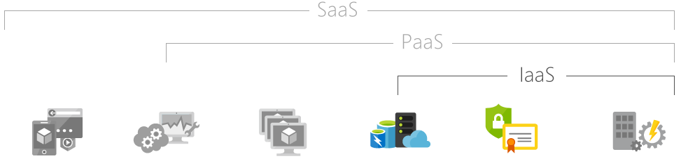Hosted Apps . Dev tools, dbs, analytics. OS’s. servers and storage. security. data center

## Infrastructure as a Service (IaaS)

Comprised of servers, storage, networking, firewalls and security, Infrastructure as a Service (IaaS) is an instant computing solution which is provisioned and managed over the internet. It’s of the four pillars of cloud services. IaaS allows for rapid scaling on demand, offering pay-as-you-use infrastructure solutions. Avoiding the expense and complexity of buying and managing your own physical infrastructure, each resource is offered as a separate service component, and you only need to “rent” a service as it’s needed.

For testing and development with IaaS, teams can quickly provision and tear down development environments which allows for applications to be expeditiously released. We previously covered Chef, Puppet, Ansible and CloudForm. With these tools, working with IaaS allows a DevOps engineer to provide environments on demand and at a low cost due to the nature of the way IaaS is billed to the consumer.

We’ve looked at some options previously for hosting like Netlify and Zeit. Using IaaS provides the ability for businesses to create their own hosting services. Depending on the type of the server, costs can be reduced through intelligent hosting with IaaS by provisioning servers that meet the exact needs of your application.

IaaS offers a vast range of computational of resources for sale. It could be a static hosting service like Zeit or a complex computational problem which involves millions of variables or calculations. An example of the strength IaaS can offer for high-performance computing would be something like one of the many financial modeling software solutions out there that help give currency and day trades an edge or upper hand in the market.

When it comes to security, more than often you’re going to have a better-defined solution using IaaS. Remember, IaaS is most commonly a Google, Amazon or Microsoft datacenter at the end of the day when dealing with public or hybrid cloud platforms in an enterprise environment. Chances are, their security teams will have more resources at their disposal than an in-house solution.

## Platform as a Service (PaaS)

Engineers can create on-demand environments for testing, developing, deploying and managing software applications with PaaS. If one has a task to complete and they want to remove the mundanity of setting up or managing the underlying infrastructure of creating web apps, PaaS is a great tool to get the job done. Platforms as a Service abstract the provisioning of databases, network services and storage which allow developers to get directly to work.

With a PaaS, you are gifted with a ready to use cloud-based development and deployment environment. Regardless of the applications intent being something simple like developing a quick proof of concept or an enterprise grade application, you can purchase the needed resources from a cloud service provider just as you would with IaaS.

PaaS brings the infrastructure components that are encapsulated with in IaaS and includes additional resources stacked on top of it. Middleware, development tools, business intelligence services and database management systems are some of the additional features a PaaS will couple with what's available in an IaaS.

With the additional components a PaaS stacks on top of an IaaS, it provides a complete and total suite ready for developer use and completes the web application lifecycle. Fundamental phases which we’ve touched upon such as testing, deploying, managing and releasing application updates.

Think of a Platform as a Service similarly to how you’d imagine a development framework because at its core, it is a framework. Only, instead of focusing on source code to make development easier, it provides configured and ready to go infrastructure. With the additional built-in software components, it provides the cloud-based infrastructure needed to create a salable, highly-available applications while reducing the amount of coding and configuring a developer would normally have to complete.

## Serverless computing

Without spending time continually managing servers and infrastructure, serverless computing focuses on application functionality while abstracting the need for servers. How could something like this be possible? Well, just as IaaS and PaaS is modeled, serverless computing is based as well on the notion of pay-as-you-use resources. The cloud provider takes care of server provisioning, service configuring and any necessary management for you. That's the abstraction layer. You are only working with code that’s executed as needed.

The takeaway from the concept of serverless computing is that it only uses resources when a specific function or trigger occurs. If an application is architected in an event-driven fashion, having specific functions or triggers to handle operations in the cloud, a high-scalable product can be produced.

If we were to look at how mobile applications work, there is a client side which contains UI components that trigger actions to engage in communication with a backend API typically on a server running 24/7. Instead of having an API living the on a server which is constantly up, core computational resources can be isolated and rewritten in a fashion where the API endpoint is only available on demand. For example; a mobile application can capture an image, and then call an Azure cloud function which triggers a specific operation and returns the result to the client device making the request.

## Software as a Service (SaaS)

Have you used anything like Gmail or Hotmail? Then you’ve experienced a form of Software as a Service. The software for Gmail is located on Google’s network and your messages are stored there too. Being able to access this suite from any machine with an Internet connection is an example of SaaS in action.

Again, SaaS is a pay-as-you-use subscription model where computational resources are only billed to the client as their used. Using Gmail as example, they offered limited configurations and storage but if you decide to pay for a subscription service, like their business suite, it will provide more functionality for you. You’re using software but you didn’t have to install anything necessarily, nor are updates, maintenance or hardware upgrades required for your additional storage.

SaaS can be extremely beneficially for work environments and really empower the workforce with the ability to have access to these recourses on demand. Unlike traditional software, all you need is an Internet connection and typically a browser to utilize the products capabilities. The workload can be mobilized, and employees can access their resources from wherever they are regardless of the OS their running, unlike desktop software. No more worrying about hard drive failures and data losses as everything stays put in the cloud with whatever redundancy strategies the provider has in place. Let them worry about that kind of stuff.