Cloud Capture Documentation

1.1

Contents
Main Screen
Frame Rate Indicator
Control Screens
Video Pipeline
Library
Cut
Filter
Retime
Setup
iPad User Interface
Release Notes

Main Camera View
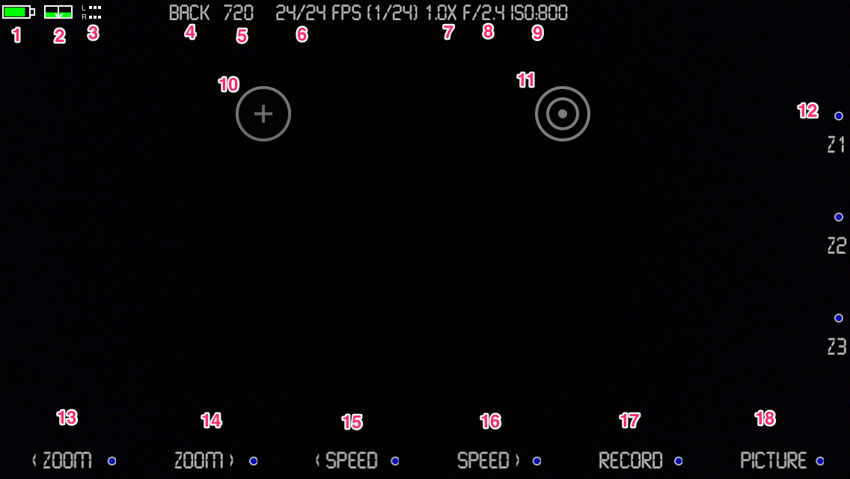
- Battery Level  - Available Storage  - Audio Meter  - Front/Back Camera Indicator  - Resolution  - Frame Rate Indicators  - Zoom Level  - F-Stop  - ISO Rating | - Focus Reticle  - Exposure Reticle  - Zoom Level Presets  - Zoom Out  - Zoom In  - Decrease Zoom Speed  - Increase Zoom Speed  - Start Recording Video  - Capture Still Image

Frame Rate Indicators
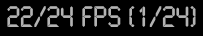
This display shows the currently observed frame rate, the requested frame rate and the camera shutter speed. Should too many filters be enabled while the resolution and frame rate are at high values, the camera will not be able to process all of the data in sufficient time to keep up. This will be shown as a an observed frame rate being less than the requested frame rate and a message will be displayed:

Control Screen
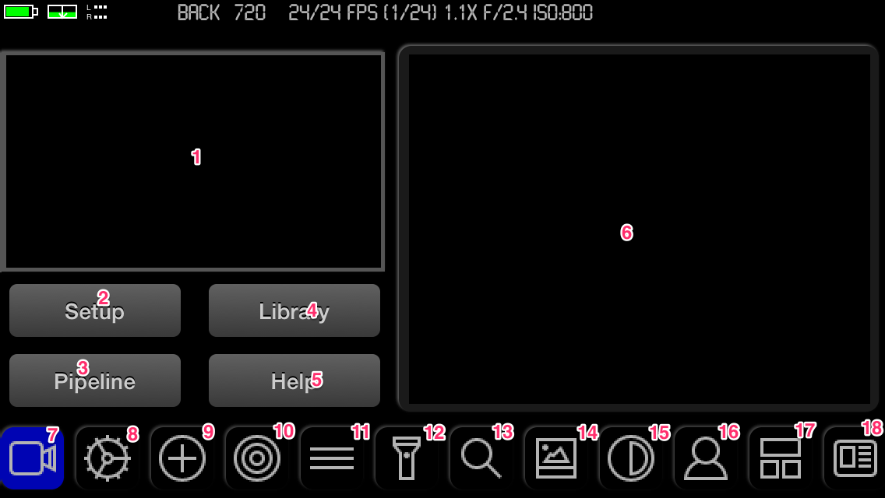
- Video Preview  - Setup Screen  - Audio/Video Pipeline  - Library  - Help  - Detail Options Area  - Camera Controls  - Resolution and Frame Rate  - Focus | - Exposure and White Balance  - Framing and Leveling Guides  - Torch / Histogram  - Zoom Preset Setup  - Image Effect Filter Options  - Color Control Filter Options  - Chroma-Key Filter Options  - Titling Page Options  - Saved Preset Options

7) Camera Controls
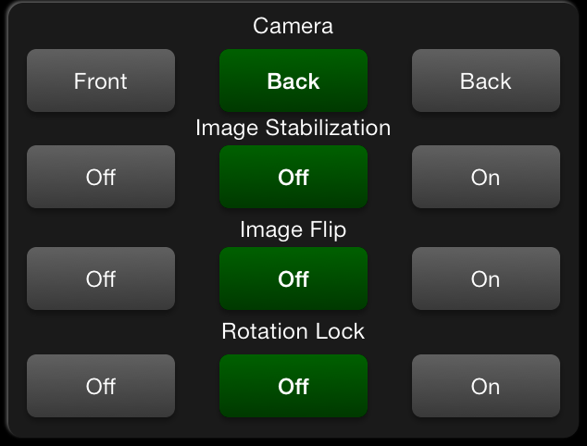 | Camera – Select front or back camera  Image Stabilization – When enabled, the camera will reduce the field of view and continually adjust the frame within it to minimize unstable motion effects.  Image Flip – Used to flip an upside-down image appearing from lens adapter attachments.  Rotation Lock – Lock the ability to rotate from the current orientation. Rotation is automatically locked while recording.

8) Resolution and Frame Rate
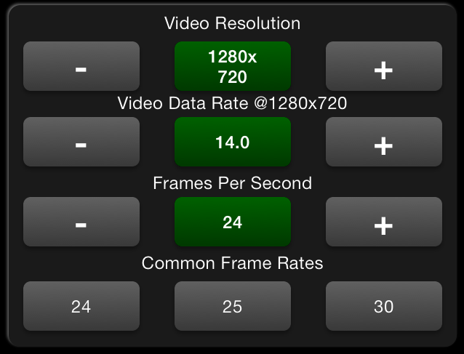 | Video Resolution – Higher resolutions use more disk space and processing power.  Video Data Rate – Adjust the rate to increase image quality or decrease space requirements.  Frames Per Second – The rate at which the camera captures images for storage into a video clip.  The most common frame rate for video is 24 fps.

9) Focus
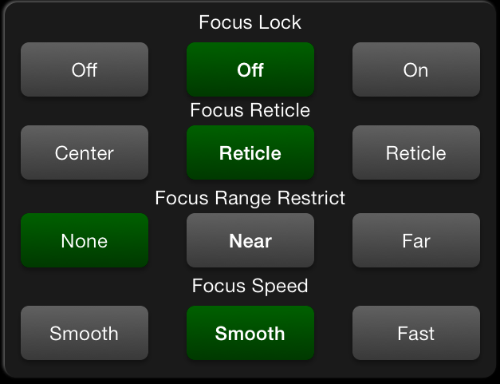 | Focus Lock – Lock the focus mechansim at the current state.  Focus Reticle – The on-screen focus reticle can be positioned to cause the camera to focus on a particular area.  Focus Range Restrict – Restricting the focus to near or far will reduce the amount of focusing attempts when filing moving scenes.  Focus Speed – Set to smooth for video to avoid the large focus changes that the fast method employs.

10) Exposure and White Balance
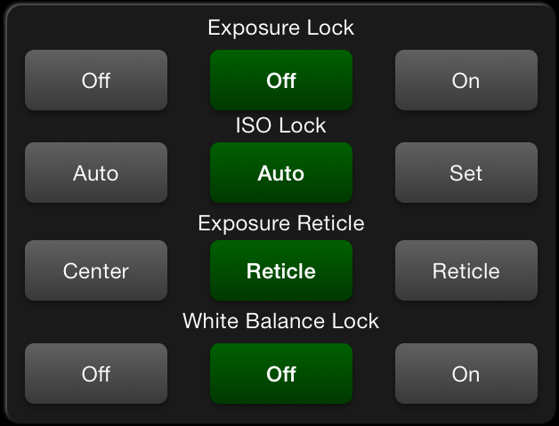 | Exposure Lock – Lock the exposure mechanism a the current state.  ISO Lock – Set the current ISO state. The camera will prompt to adjust lighting to return to that settting when the camera is reset.  Exposure Reticle - The on-screen exposure reticle can be positioned to cause the camera to look at a particular area for exposure level.  White Balance Lock – Lock the white-balance setting at the current state.

11) Framing and Leveling Guides
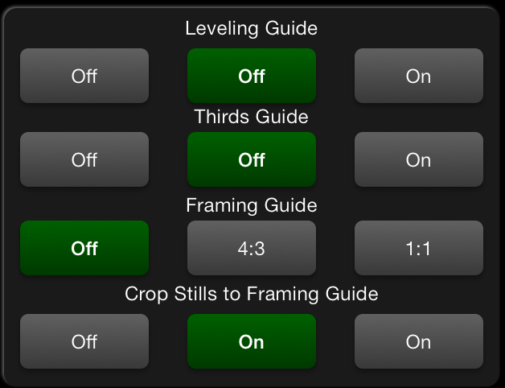 | Leveling Guide – An on-screen guide that shows the current position of the camera relative to the horizontal axis.  Thirds Guide – Displays a 3x3 grid overlay on the screen.  Framing Guide – Displays two vertical lines at 4x3 or 1x1 on the screen.  Crop Stills to Framing Guide – When enabled, stills will be cropped to the guide positions.

12) Torch
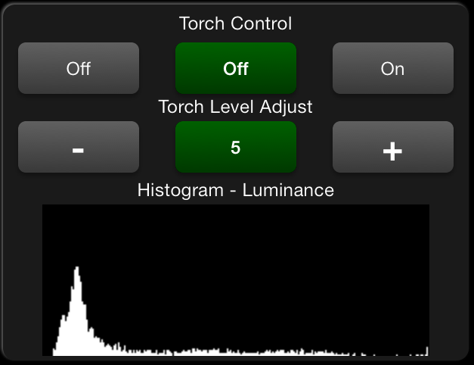 | Torch Control – Light or Extinguish the torch.  Torch Level Adjust – Adjust how much light the torch eminates.  Histogram – Tap to cycle between: red, green, blue, RGB and luminance histograms. The histogram does not update while recording video.

13) Zoom Preset Setup
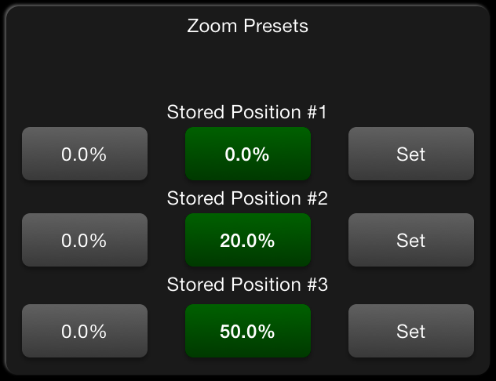 | Stored Positions – The settings correspond to the zoom buttons on the main screen (#12 in main screen depiction.)  Pressing “Set” stores the current zoom position into the corresponding preset.  Pressing “0.0%” stores a fully zoomed out position into the corresponding preset.

14) Image Effect Filter Options
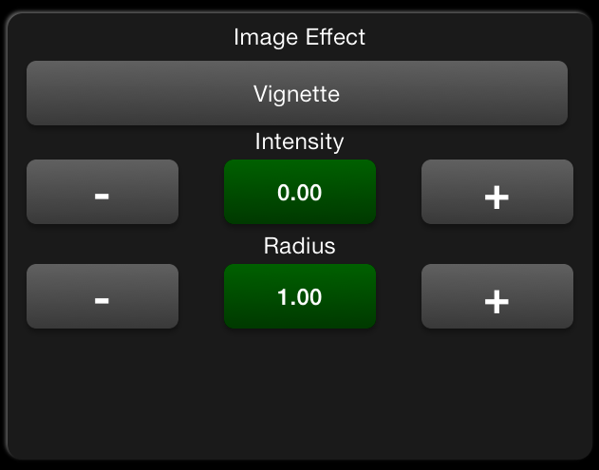 | Image Effect – Select an effect from the list that opens when the button is tapped.  Each effect may have zero or more options that can be adjusted to modify the effect.  In the example, the “Vignette” filter allows the Intensity and Radius of the effect to be adjusted.

15) Color Control Filter Options
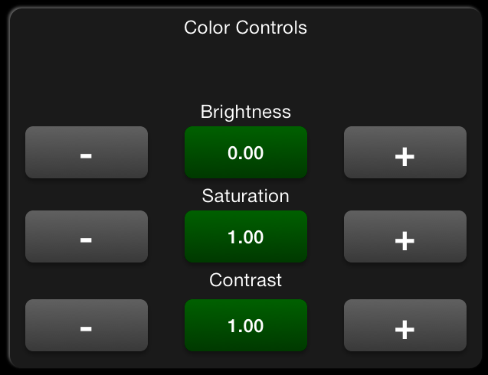 | These filters are intended to improve a poorly lit scene.  Tap the “-” button to reduce the value.  Tap the “+” button to increase the value.  Tap the green button to return to the default value.

16) Chroma-Key Filter Options
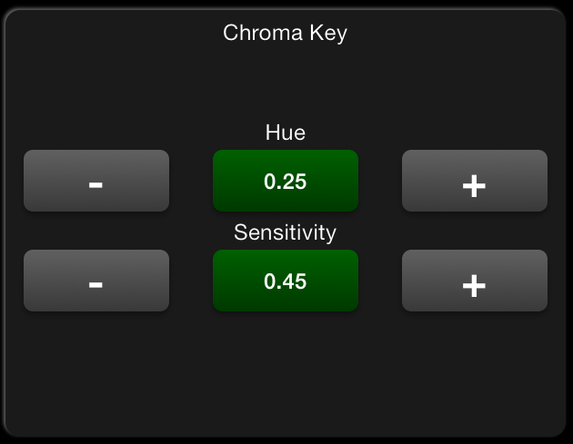 | This filter is used to replace the background in the video with an image taken from your camera roll.  Quality output requires a uniform green or blue background and attention to lighting requirements.  Adjust the hue to change the color that is replaced.  Adjust the sensitivity to match your lighting  See the pipeline screen to supply the background image.

17) Titling Page Setup
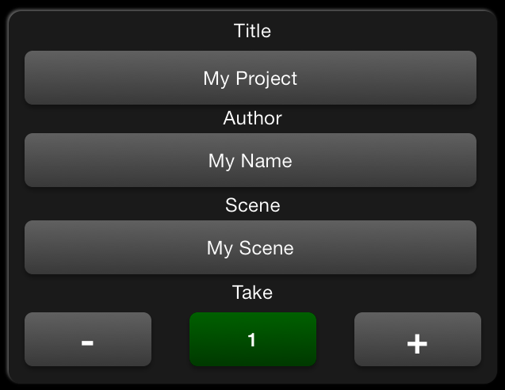 | The values in the following fields are used to create a custom title page at the start and/or end of your clip.  See the pipeline screen to create custom title pages.  The Take option will be increased each time a recording is made.  Tap the green button to reset to 1.

18) Saved Preset Options
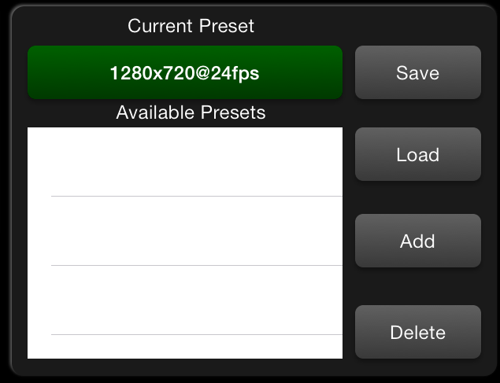 | Tap “Save” to save the current setttings to the current preset.  Tap a listed preset, then tap “Load” to load that preset.  Tap “Add” to create a new preset using current settings and make it the current preset.  Tap a listed preset, then tap “Delete” to remove that preset.

Audio/Video Pipeline
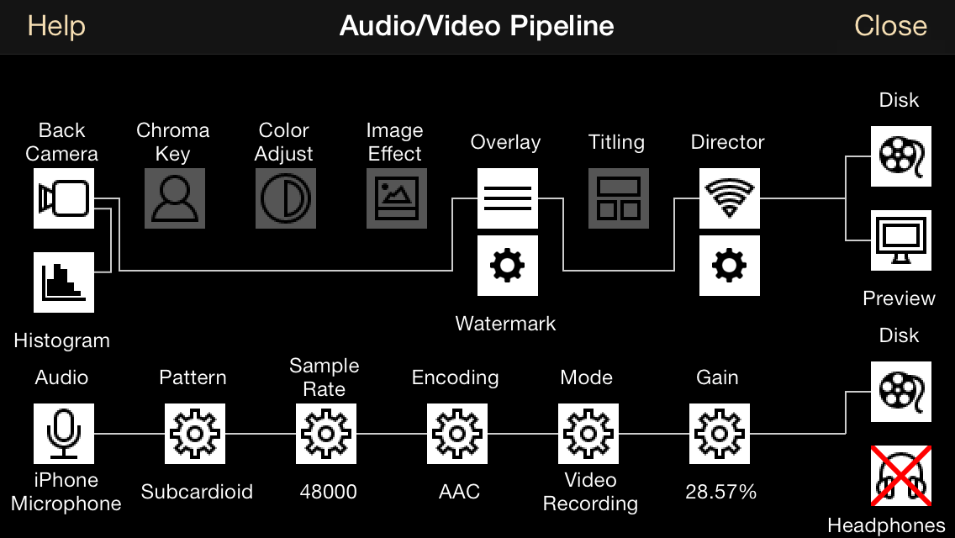
This screen depicts two paths, one for video and one for audio.

For the video path, various filters may be added and removed from the pipeline, by tapping on them. The visual depiction will update to show the path video frames will take.

Tapping the “Camera” provides the ability to switch the camera between regular and fast-capture mode, which allows 1280x720 capture at up to 60 fps (120 on an iPhone 5S.) The regular mode supports up to 1920x1080 at 30fps. Note that in all cases where you are not requiring > 30 fps, the regular mode should be considered the superior choice.

You may also edit the background for the chroma-key feature, choose an overlay matte and edit custom titling pages by tapping the gear icon under the corresponding feature.

The “Director” feature is configured by tapping the gear under the Director icon. In this screen you may change the password and choose whether or not to temporarily display the password on the device a connection attempt is made by a different device.

For the audio path, the various entries allow customization of how audio is handled.

The “Audio” entry allows selection of the input devices available on your device as well as various accessories to be used as the sound source for your recordings.

The “Pattern” entry allows selection of a polar pattern for input devices that contain processing circuitry for this feature. This is employed to cancel unwanted noise.
The “Sample Rate” entry allows the choice of how much audio data is collected, which affects quality and disk space requirements.

The “Encoding” entry allows the selection of PCM or AAC output in recorded movie files. AAC quality is also adjusted here. AAC audio is compressed and will use less disk space. AAC is recommended unless you need the uncompressed audio.

The “Mode” entry allows selection of “Default”, “Measurement” and “Video Recording” modes. This affects signal processing of incoming audio. Use “Measurement” mode to disable audio processing features.

The “Gain” mode allows adjustment of incoming audio level.

The “Disk” entry toggles between recording sound and not recording sound.

The “Headphone” entry toggles routing a copy of incoming audio out to the headphones or other connected audio output device (not all device types are supported at this time.)

Library
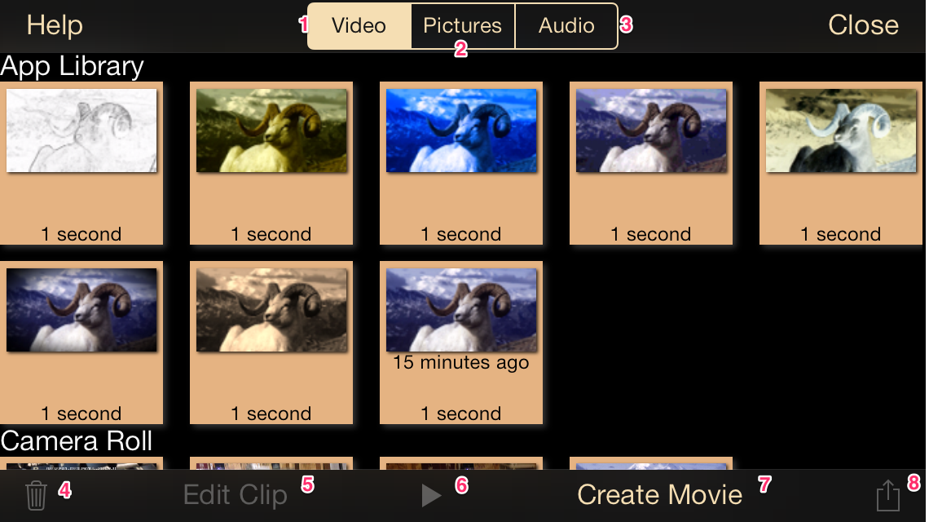
- Display Video Clips
- Display Pictures
- Display Audio and Music
- Trash – Select one or more clips from the App Library to permanently delete them. To delete items from the camera roll or photo albums, use the Photos app included with iOS 7.
- Edit Clip – Select one clip and then tap this button to edit it.
- Play – Select one clip and then tap this button to cause it to play.
- Create Movie – Tap this button to turn an assemblage of clips into a movie.
- Share – Select one or more clips and tap this button to share them.

Note: If the app does not have permission to access the Camera Roll/Photo album, the picture feature will not be available and clips stored in the camera roll will not be shown. See the setup screen for information on permissions.

Edit Clip - Cut
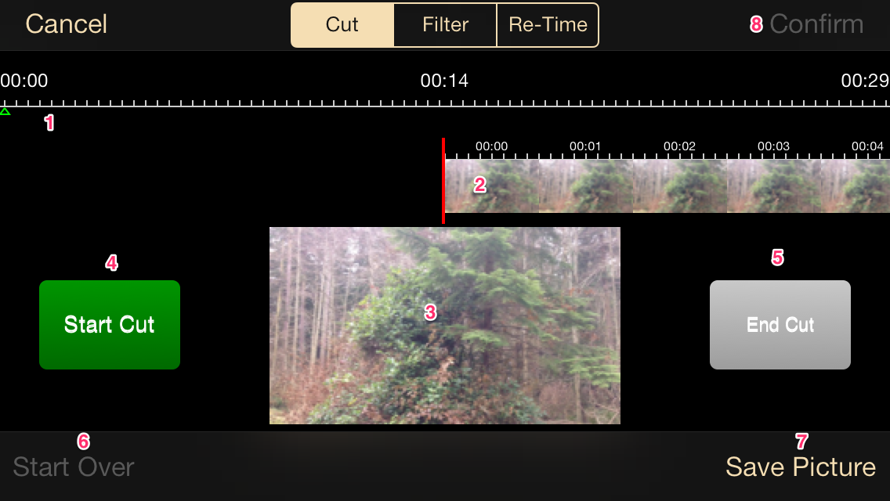
- Scrubber Bar – Tap to jump to the section of the clip corresponding to the time tapped.
- Time Line – Scroll the time line to select a start or stop position at the vertical red line in the center.
- Thumbmail – Shows a larger version of the current clip position. Swipe left/right in the thumbnail for more precise adjustment.
- Start Cut – Begin a cut operation.
- End Cut – End a cut operation. The cut will be shown as a darkened area in the time line.
- Start Over – Clear all cuts
- Save Picture – Save a picture of the current clip position to the camera roll.
- Confirm – Show the confirmation screen and process the cut operation.

- You may repeat the Start Cut/End Cut process to select multiple regions to cut.

Cut Confirmation
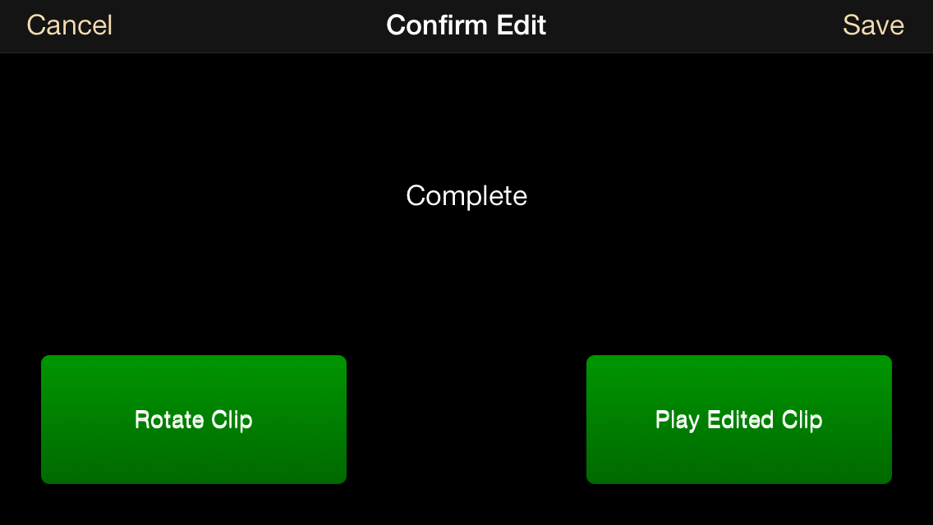
Once processing is complete, the confirmation screen allows you to preview the clip, rotate and re-encode the clip, or to cancel (and return to the cut screen) or save (and return to the library screen.)

Edit Clip - Filter
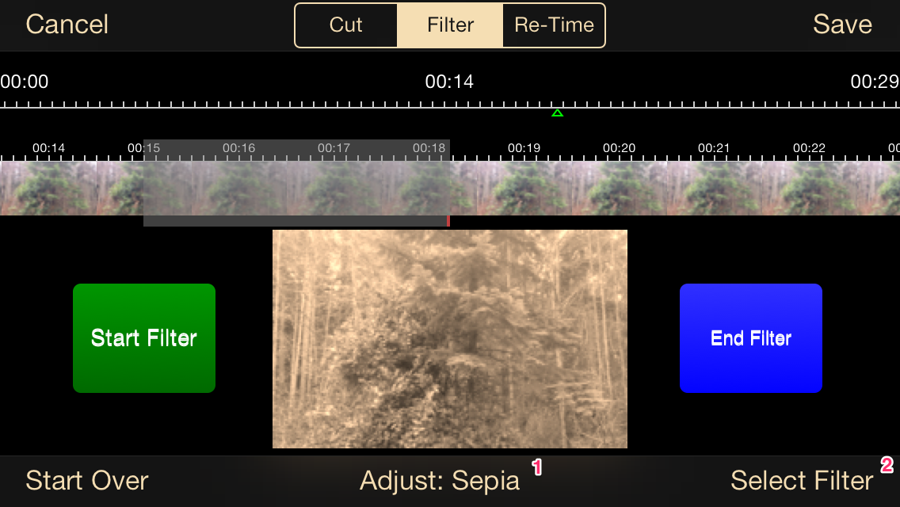
- Filter attribute adjustment
- Filter Selection

The Filter screen operates in the same manner as the cut screen, in that areas of the clip are selected.
For filtering, select a filter and modify it's attributes, then select an area of the clip to apply that filter to.
You may apply multiple filters and multiple selections on the timeline; though none may overlap.

Once complete, tap “Save” to process the clip.

Edit Clip - Re-Time
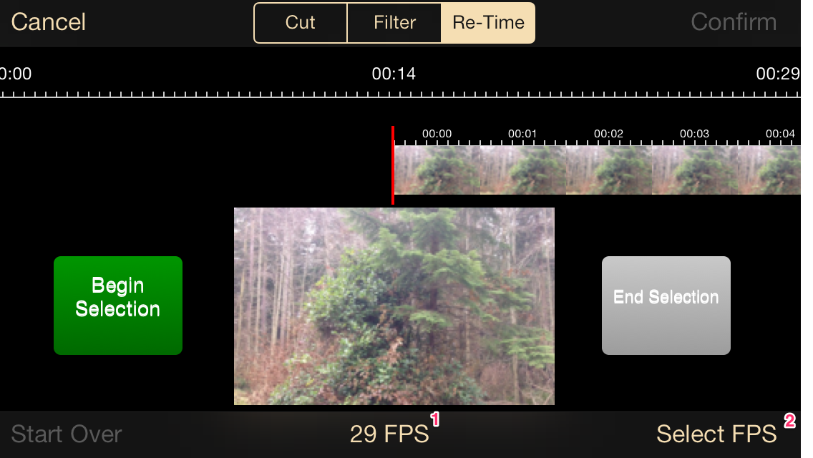
- Currently selected frame rate
- Select frame rate

The Filter screen operates in the same manner as the cut screen, in that areas of the clip are selected.

For re-timing, select a frame rate, then select an area of the clip to apply that frame rate to.

You may combine frame rate operations onto the time line.

When complete, tap “Save” to process the re-time. You will be presented with a confirmation screeen allowing the options of “Play”, “Cancel” and “Save”.

Create Movie
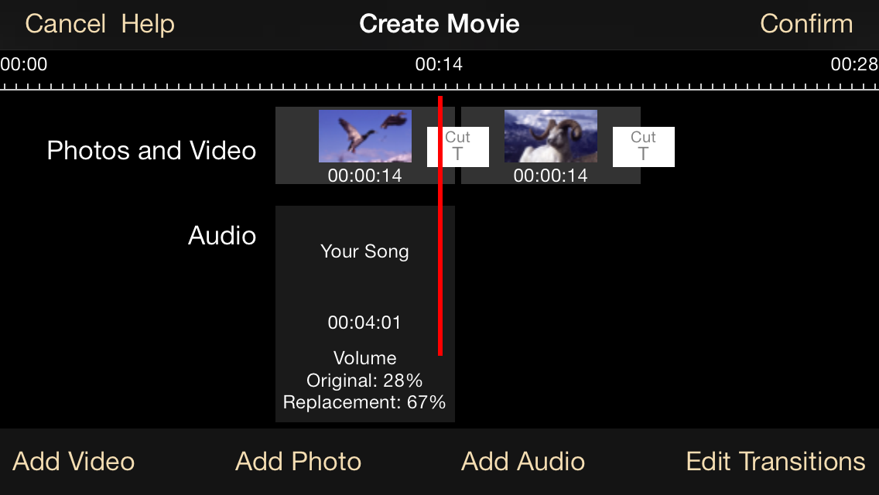

A movie is a collection of video, photos and audio assembled into a single file.

Adding video is accomplished by tapping the “Add Video” buttons. After selecting items, they will appear on the “Photos and Video” timeline, as depicted above.

Adding photos is accomplished by tapping the “Add Photo” button. After selecting one photo, a prompt for the amount of time the photo should appear on-screen will be shown. After selection the photo will appear on the “Photos and Video” timeline.

Adding audio is accomplished by tapping the “Add Audio” button. Selected audio tracks will be presented in the “Audio timeline.” Tap an audio timeline entry to modify the volume of the original video clip audio track and the newly added audio track.

Cut and Fade transitions may be selected by tapping the “Edit Transitions” button. A bar will appear that shows the currently selected transition for the video track that appears under the red bar in the center of the “Photos and Video” timeline. Tap a transition to make it active. Tap “Edit Transitions” againt to close the transition edit bar.

Tap “Confirm” to proceed to the confirmation screen. Here you will be prompted for the size of the movie to create. Once selected, tap Start to process the movie.

Once processing is complete, you may review the movie with the “Play Movie” button, cancel the operation with the “Cancel” button or save the completed movie with the “Save” button.

Audio Editing Tools
The audio tab of the library screen lists all audio clips stored in the App Library as well as all audio items stored in your media library (songs, etc.) Note that only items that are present on the device and marked as composable by the system will be listed.
From this screen you may play audio items, edit existing audio items and create new audio items.
The edit screen acts the same as the video cut screen.

Audio Recorder
The “+” button on the audio screen opens the audio-only recorder. This tool allows capturing of interviews, narration, etc with selectable audio recording options as in the Audio/Video Pipeline.

Silent Audio Track
From the audio recorder it is possible to create a silent audio track up to 2 hours in length. This is currently useful as a spacer between replacement audio tracks in a movie.

Setup

The screen is divided into categories:

About – Shows version, license status, credits and the buy/restore license buttons.

Permissions – Shows status of the Microphone, Photo Album/Camera Roll and Location permissions.

Clips – Allows configuration of the movement of clips from the App Library to the camera roll as well as whether or not to store GPS location information in recorded clips.

Interface – Allows the ability to blank the video preview and/or user interface after a period of inactivity as well as configuring the location of the zoom preset buttons (Main screen #12.)

Help and Support – Contains options to view this help file, access the app website or send the developer a request for assistance.

iPad User Interface

The iPad user interface closely matches the iPhone user interface.

There are some additional features and differences:

- Rotating the device to portrait when not recording will cause the library interface to appear. To avoid this, use the rotation lock feature in the controls screen, camera options.

- The location of controls on the controls screen is customizable. Press and hold on the control bar, button bar, controls pane or video preview window to drag it to a new position. Note that the video preview window can also be resized with a pinch gesture.

Release Notes
- Histogram not available on iPad in this release.

