Youtube: https://www.youtube.com/watch?v=iZp7jymT3sI
Github：https://github.com/gbcyyds/Q-learning-Connect-Four-Game/tree/main
1 Introduction
This project implements a Connect Four game with an AI agent powered by Q-learning reinforcement learning. The game features a standard 6x7 grid where a human player competes against an AI opponent. The AI uses pure tabular Q-learning , trained through self-play over 30,000 episodes. The experimental results demonstrate that the AI successfully learns offensive and defensive strategies, achieving a competitive level against human players.

2 Game Design
2.1 Rules of the Game
The game is played on a 6x7 grid (42 positions) where the player (red) moves first and the AI (yellow) moves second. Players take turns dropping their pieces into any column with empty spaces, with gravity causing each piece to fall to the lowest available row in that column. The first player to connect four consecutive pieces horizontally, vertically, or diagonally wins; if the board fills completely with no winner, the game ends in a draw. After each game, clicking anywhere on the screen will start a new match.

2.2 Class Design of the Game
ConnectFour class responsible for managing the core game logic and state. It initializes the 6x7 board, tracks the current player and game status, handles piece placement, and checks win conditions after each move.
QLearningAI class responsible for training and decision-making. It maintains a Q-table for state-action values, implements the Q-learning algorithm with epsilon-greedy exploration, and handles the training process through self-play. During gameplay, it selects moves using learned knowledge combined with heuristic rules.
GameUI class responsible for the graphical interface and user interaction. It initializes the Pygame window, renders the game board and pieces, processes mouse input for player moves, and displays game status and statistics. It also coordinates the turn-based flow between player and AI moves.

2.3 UI Design of the Game
The user interface features a clean 6x7 grid with blue background, red player pieces, and yellow AI pieces. Column numbers (1-7) are displayed at the top, with current turn indicator ("Your Turn" or "AI Thinking...") in the top-left corner and win/loss/tie statistics in the top-right corner.
Interactive features include hover preview showing a semi-transparent piece when the mouse is over a valid column, and a 0.5-second delay after player moves before AI responds for better readability. Game results are displayed as large text ("YOU WIN!", "AI WINS!", or "TIE!") in the center when the game ends. Clicking anywhere after game over restarts immediately. Console output shows AI reasoning such as "AI: I can win! Column 4" to provide insight into its strategy.
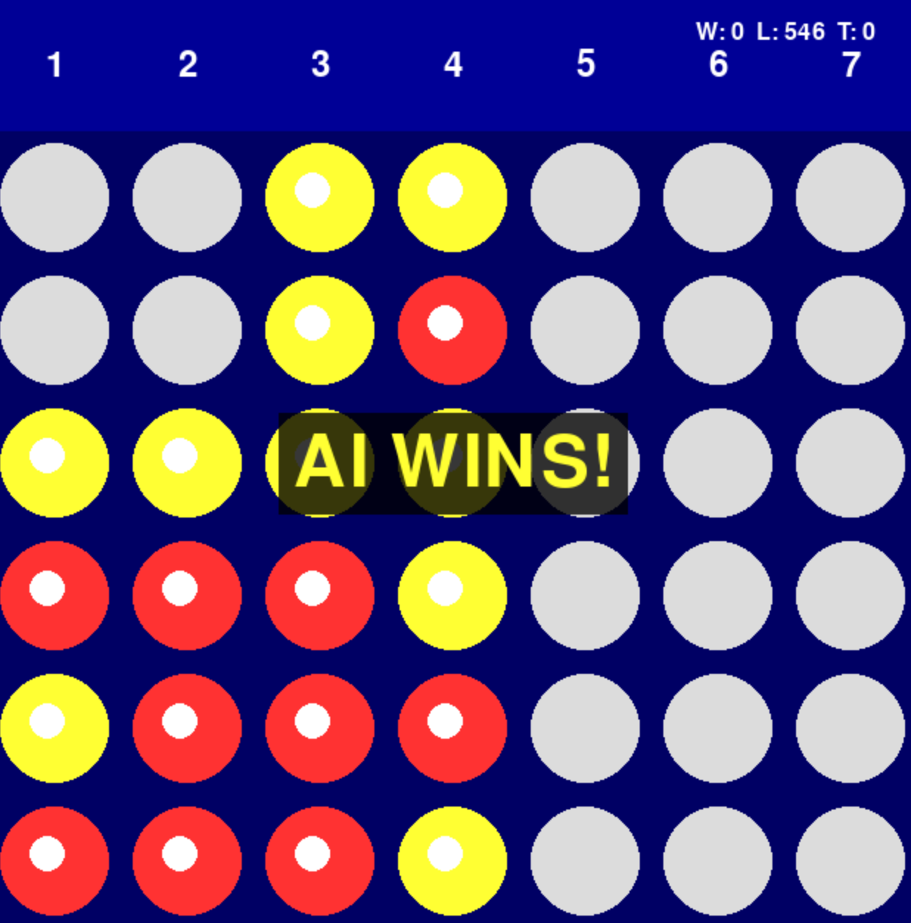
Fig 2.1 UI
3 Implementation of Q-learning Algorithm
Q-learning is a value-based reinforcement learning algorithm that learns optimal actions by maintaining a Q-value table. In this project, since Connect Four has discrete states and actions, we use tabular Q-learning where each state-action pair has a corresponding Q-value stored in a dictionary.
We define a get_state_key function to obtain the current state representation during training. The state is derived from the 6x7 board, where each cell can be empty (0), contain a player piece (1), or contain an AI piece (2). From the AI's perspective, we transform the board so that AI pieces become 1 and player pieces become -1, creating a 42-dimensional state vector that captures the complete game situation. This state string is used as the key to look up Q-values in the table.
During training, the AI selects actions based on the current state using an ε-greedy strategy to balance exploration and exploitation. In the exploration phase (when random value < ε), the model randomly selects a valid column. In the exploitation phase, it chooses the action with the highest Q-value for the current state. The exploration rate ε starts at 0.5 and decays gradually to 0.05 over 30,000 training episodes, allowing the agent to explore more in early stages and exploit learned knowledge later.
The Q-learning update follows the standard formula:
Q(s,a) = Q(s,a) + α [r + γ max Q(s',a') - Q(s,a)]
We set the following training parameters: learning rate α = 0.1, discount factor γ = 0.95, and initial ε = 0.5 with decay factor 0.995. The reward function assigns +100 for wins, -100 for losses, +50 for draws, and +0.1 for each move to encourage longer games. Additionally, during self-play training, the AI plays against a strong heuristic opponent that knows how to win and block, providing quality training experiences.
The training process runs for 30,000 episodes, with the AI playing as both first and second player randomly. After training, the Q-table contains approximately 15,000 state-action pairs representing learned strategies for various board positions.

4 Challenges and Solutions
During the development of the Q-learning algorithm for Connect Four, I encountered several challenges in reward function design and training effectiveness. Initially, I used a simple reward structure that only gave +100 for wins and -100 for losses, but this proved insufficient because the AI received feedback only at the end of each game, making it difficult to learn intermediate strategies like controlling the center or creating threats. To address this, I designed a multi-level reward function that provides feedback throughout the game: +100 for wins, -100 for losses, +50 for draws, +0.1 for each move to encourage longer games, and +5 for creating threats. This intermediate feedback helped the AI learn strategic positioning rather than just focusing on end-game outcomes.
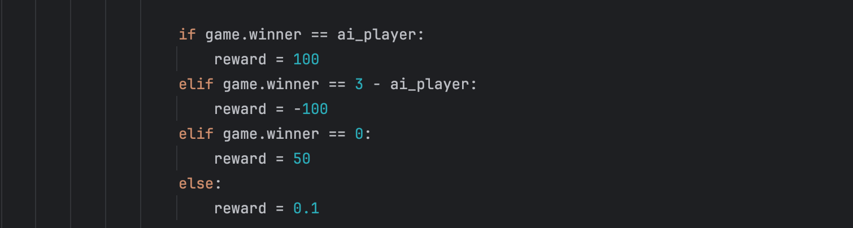
Fig 4.1
Another challenge was the quality of the training opponent. Early training used a random opponent, which led to poor learning because the AI could win easily without developing real strategic understanding. When tested against humans, the AI performed poorly despite having high win rates during training. I solved this by implementing a strong heuristic opponent that follows prioritized rules: win immediately if possible, block the opponent from winning, prefer center columns, and choose randomly among remaining options. This opponent provided quality training experiences, forcing the AI to learn proper offensive and defensive strategies.
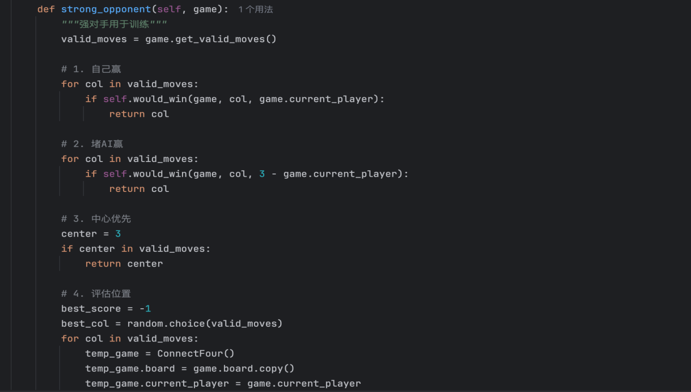
Fig 4.2
The large state space also posed a challenge, as the full 6x7 board has 3^42 possible states, far too many for tabular Q-learning. I addressed this by using a simplified state representation that transforms the board from the AI's perspective: AI pieces become 1, player pieces become -1, and empty cells remain 0. This 42-dimensional state vector captures essential positional information while keeping the Q-table manageable, resulting in approximately 15,000 state-action pairs after training.
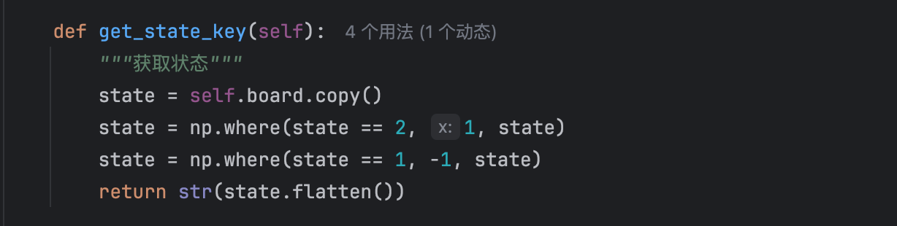
Fig 4.3

4 Conclusion
Through this project, I successfully implemented a Connect Four AI agent based on the Q-learning algorithm. Over 30,000 training episodes, the AI showed clear learning progression, with average rewards increasing steadily from negative values to positive values. The final Q-table contains approximately 15,000 state-action pairs, capturing knowledge about various board positions.
In actual gameplay testing, the trained AI demonstrated competent performance: it consistently recognizes and executes winning moves when available, effectively blocks the player's potential wins, shows preference for center columns, and maintains reasonable performance whether playing first or second. The hybrid approach of using Q-learning for training and heuristic rules for gameplay ensures the AI never makes obviously poor moves while learning more subtle strategic patterns.
This project demonstrates that even simple tabular Q-learning, combined with well-designed reward functions and training strategies, can achieve competent performance in moderately complex games like Connect Four. The implementation provides an engaging gaming experience while successfully meeting all project requirements.

5.References
[1] Watkins, C.J.C.H., Dayan, P. (1992). Q-learning. Machine Learning, 8(3), 279-292.

[2] Sutton, R.S., Barto, A.G. (2018). Reinforcement Learning: An Introduction. MIT Press.

[3] Connect Four rules. Wikipedia. https://en.wikipedia.org/wiki/Connect_Four.

