POST 1

Before I could forecast the fog, I had to build the labels

A forecast for the BBQ
I’ve always been fascinated by the weather. As a kid, I kept sporadic logs of temperature, humidity, and precipitation. My record-keeping was less consistent than my curiosity.
Living in San Francisco gave that curiosity a practical use. It might be 75°F and sunny in Dogpatch, but 60°F and foggy at Ocean Beach. Planning a weekend outing can become a search for sunshine. I became a regular visitor to fog.today, which displays recent satellite imagery in a replayable 24-hour loop.
Then I would attempt to do the forecasting in my head. Will the fog clear at Crissy Field, or should we move the BBQ to Dolores Park? Will Ocean Beach stay clear through sunset, or will the fog roll back in first? The loop showed me where the clouds had been. I wanted to know where they were going.
That became Fogcast: a project to predict clear and cloudy conditions on a sub-kilometer grid, hour by hour. I hadn’t found a tool that answered the question at the level of detail I wanted, so I decided to build one. Before predicting an afternoon’s beach weather, though, I needed a reliable picture of the current cloud cover.

First, define “clear”
The motivation was fog, but I chose a broader target: whether a satellite pixel is clear or contains detectable cloud at any height. Visible imagery alone cannot reliably tell me whether a cloud is low or high, so Fogcast predicts cloud presence in general rather than ground level fog specifically. Here, “clear” means the cloud classifier detects no cloud in that pixel.
The goal is ten maps per forecast, one for each hour from +1 to +10, throughout the day and year.
The forecasts cover a 200 × 200 km area around San Francisco, divided into 400 × 400 grid cells, each 500 m across. The original model uses data from this same area. A later version adds a 50 km margin on every side, giving it a 300 × 300 km view of the surrounding weather while keeping the forecast area unchanged.
To build this regular grid, I convert WGS84 latitude and longitude into UTM Zone 10N (EPSG:32610), which expresses positions in meters.
Training the forecast also required labels identifying each pixel as clear or cloudy. Raw satellite images record brightness, so turning them into cloud-cover labels takes additional processing. I considered three data sources, each offering a different balance of spatial detail, coverage, and label quality.

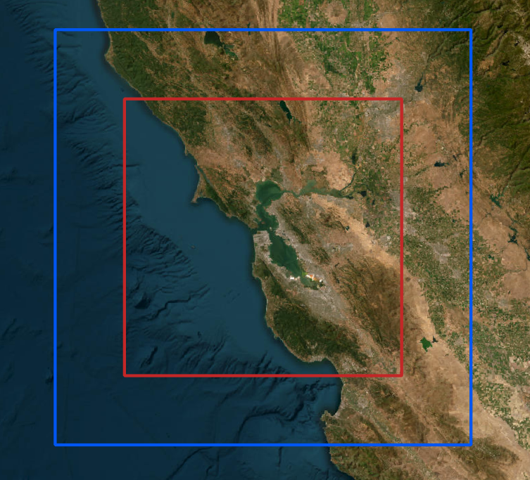

Figure P1-F1. The forecast area and its surroundings. Red: the 200 × 200 km input and output domain for Model A. Blue: the 300 × 300 km input domain for Model I; its output remains the central red square.

Table P1-T1. Three data sources, three different compromises. Resolutions are nominal at nadir; satellite footprints grow away from the point directly beneath the sensor.
Name | Source / exact product | Resolution | Timing | Usable coverage | Fit and limitation
GOES B2 | GOES-17/18 ABI Band 2, 0.64 µm reflectance imagery. | 500 m | 5-minute regional scans | Daylight only | Fine image structure, but brightness must be converted into a cloud label
GOES CSM | GOES-17/18 ABI Level-2 Clear Sky Mask (ABI-L2-ACMC). | 2 km | 5-minute regional scans | Day and night | Coarse clear/cloud labels
NASA VIIRS | NASA VIIRS Collection 002, daytime I-band mask. | 375 m | Polar-orbiting overpasses; intermittent local coverage | Usable local scenes cluster in the afternoon | Fine labels, but sparse in time. Shoreline patterns warranted closer inspection.

Learning the wrong answer
My first attempt used a small U-Net-style convolutional neural network to classify GOES Band 2 (B2) pixels as clear or cloudy. Its inputs were B2 reflectance and the cosine of the solar zenith angle, a measure of illumination. Its training labels came from the 375 m daytime I-band mask in NASA’s VIIRS cloud-mask product.
After training the first version on the limited VIIRS data available, I noticed a recurring problem: the model labeled parts of the coastline as cloudy even where the raw satellite imagery appeared clear. I initially suspected a problem with the network. But when I inspected the VIIRS training labels, I found the same shoreline errors. The model had learned to reproduce incorrect classifications already present in NASA’s cloud mask.
The San Pablo Bay example below shows the problem. In the June 14, 2026 afternoon comparison, both the VIIRS mask and my classifier mark parts of the shoreline as cloudy. The B2 image suggests clear conditions there, and the GOES Clear Sky Mask (CSM) labels the shoreline as clear. That comparison sent me back to the labels, rather than straight into another round of network tuning.

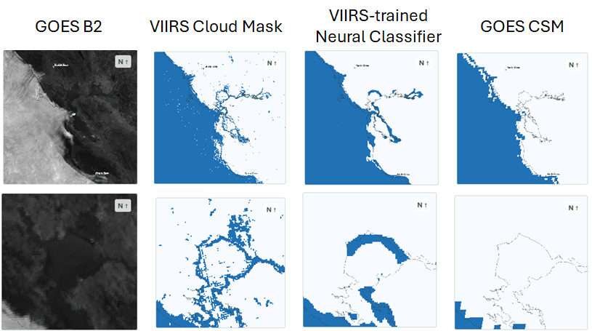 Figure P1-F2. A suspected label artifact echoed by the neural classifier. From left: GOES B2 reflectance, NASA VIIRS cloud mask, the VIIRS-trained classifier, and GOES CSM. The lower row zooms into the San Pablo Bay shoreline. June 14, 2026, around 2:00 p.m. PDT.

Better coverage, different compromises
The shoreline errors were only part of the problem. As Figure P1-F3 shows, usable VIIRS labels in the project archive were far less numerous than GOES observations and were concentrated in the early afternoon. GOES offered more frequent coverage throughout the year: B2 supplied detailed imagery during daylight, while CSM provided cloud labels both day and night.
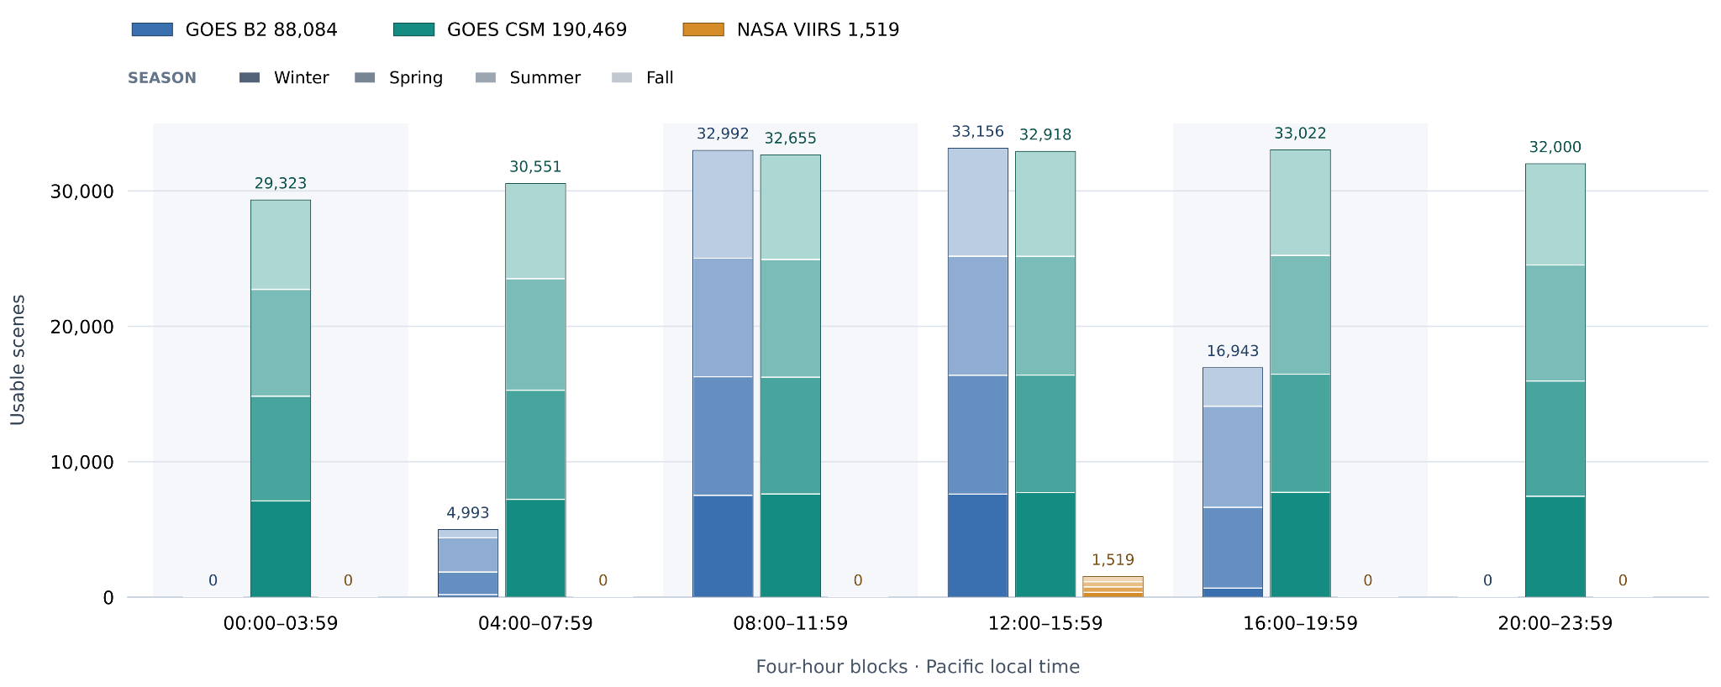 Figure P1-F3. Usable scenes in the project archive, grouped into four-hour intervals in Pacific local time and stacked by season. These counts describe the data that passed this project’s availability and quality filters, rather than every observation the satellites acquired.

I needed the coverage of CSM without throwing away the finer structure visible in B2.
CSM provided the training labels for a new daytime classifier. Its nominal 2 km pixels cannot supply independent 500 m truth, but they can identify broad regions that are consistently clear or cloudy. I used clear CSM regions to estimate how each B2 pixel should look without clouds. Then I fitted a classifier to the difference between the observed image and that clear reference. B2 supplies the fine spatial structure; CSM supplies the training labels.
At night and when the sun is low, the forecast model learns directly from CSM labels at their native footprint scale. Its fine-grid probabilities are averaged over each accepted CSM footprint before comparison with the corresponding label. This coarse training loss receives one-quarter the weight of the daytime fine-pixel loss. Together, these two sources of supervision allow the model to learn from both daytime and nighttime observations, supporting forecasts around the clock.

The first forecast problem was a labeling problem
I had set out to predict the next ten hours. First, I had to decide what counted as a cloud right now. The solution became a two-step daytime pipeline: estimate the clear surface under the current sun and season, then look for departures from it. The next post follows that process all the way to a cloud mask.

