POST 2

Teaching the satellite what “clear” looks like

Part 1: estimate the view without clouds

A bright pixel is not automatically a cloud. The surface has its own brightness, and that brightness changes with sunlight and season. The idea was to predict what B2 should see under clear conditions, then subtract that reference from the observation. The result is a residual: ideally near zero for clear pixels and positive when clouds make the scene brighter.
This approach gives me something concrete to inspect at every step: the predicted clear scene, the residual, the cloud score, and finally the binary mask. When a shoreline looks suspicious, I can follow the mistake through those fields. I can also generate labels from frequent daytime B2 observations, instead of waiting for another VIIRS overpass.

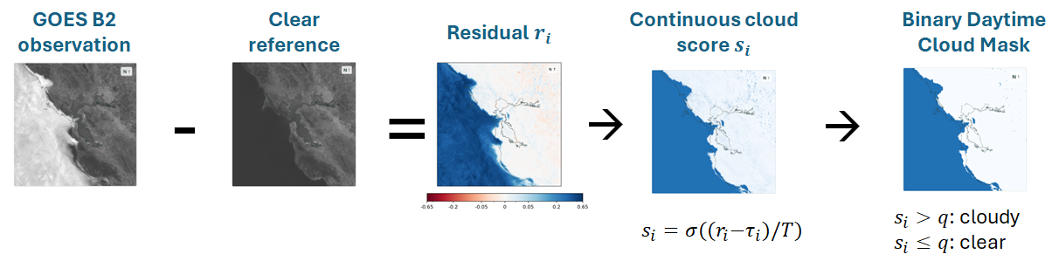 Figure P2-F1. From brightness to a daytime label. Subtract the clear reference from observed B2 reflectance, pass the residual through a fitted sigmoid, then apply the fixed cutoff.

Give each pixel a model of its clear-sky appearance
The clear-sky reference should capture the surface reflectance, even when the light and season changes. I used a small regression at each grid cell, with terms for illumination, time of day, and season.
Each cell uses the same 11-term basis $φ$, but learns its own coefficients. GOES-17 and GOES-18 share those coefficients, with an additional cell-specific offset for GOES-18: 12 fitted values in all. The offset can absorb a persistent difference between the two satellite records.
The basis terms have simple jobs. The solar cosine c describes the sun’s angle relative to a horizontal surface. The signed solar-hour term p distinguishes morning from afternoon, which can have the same solar cosine but different illumination directions, as illustrated in Figure P2-F2. Annual sine and cosine terms let the reference vary smoothly through the year. Their interactions allow the daily brightness pattern to change with the season. For readers who want the exact recipe:

$$R_{clear} = β_{x,y} · φ(c,p,d) + b_{18,x,y} I(GOES 18)$$
$$φ = [1, c, c^{2}, p, cp, sin(d), cos(d), c sin(d), c cos(d), p sin(d), p cos(d)]$$
$$c = cos(SZA) p = sin(π(h_{solar} - 12)/12)$$
$$d = 2π(D_{UTC} - 1)/N_{days}$$
Here, h_{solar} is local solar hour, computed from UTC with longitude and an equation-of-time correction; D_{UTC} is fractional UTC day of year; and N_{days} = 365.2425, matching the implementation. The annual phase is d. The coefficient vector β and satellite offset b18 vary by cell, and I(GOES 18) equals one for GOES-18 and zero for GOES-17. The geometry motivates the terms; the observations determine their coefficients.
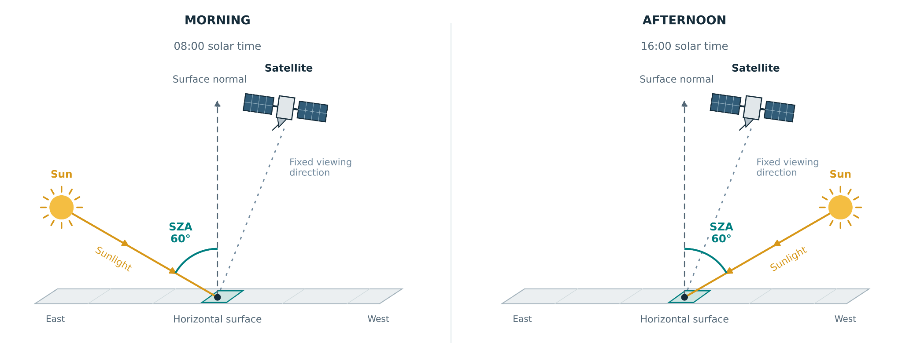
Figure P2-F2. Same solar zenith angle, different direction. Morning and afternoon can have equal solar zenith angles while illuminating the surface from different directions. The signed solar-hour term p lets the fitted reference capture that difference.
The reference fit used conservatively selected clear observations: a clear 3 × 3 neighborhood on the native CSM grid in the matched scan and its bracketing scans.The fitting archive contains about 88,000 candidate scenes from 2019–2026 and four billion accepted pixel observations. That is a lot of data, but neighboring pixels and repeated scans are correlated; it is not 4 billion independent examples.
A cell needed at least 12 accepted clear observations on 12 distinct UTC dates to retain its own fit. Where local evidence was insufficient, the completion scheme used nearby supported cells with similar land/water composition, with broader fallbacks if suitable neighbors were unavailable. In practice, only 48 of the 160,000 grid cells (0.03%) needed completion, and only for the GOES-18 brightness offset. Every cell had enough local observations to fit the shared solar and seasonal pattern.

Table P2-T1. Clear-reference error on held-out observations. MAE is the mean absolute error; RMSE gives larger errors more influence. Both are in B2 reflectance units, and lower is better. The models share coefficients across GOES-17 and GOES-18, with a cell-specific GOES-18 offset. The 3–11-term rows are unstabilized fits; the last row applies the stabilization procedure described below.
Basis | Terms added at this stage | Held-out MAE |  | Held-out RMSE
 |  | GOES-17 | GOES-18 | GOES-17 | GOES-18
3 terms | Constant, c, c² | 0.011737 | 0.010682 | 0.018420 | 0.015869
5 terms | Morning–afternoon p and cp | 0.010298 | 0.009064 | 0.017056 | 0.013982
7 terms | Annual sine and cosine | 0.008781 | 0.006439 | 0.014815 | 0.010056
9 terms | Illumination × annual phase | 0.007974 | 0.005495 | 0.013929 | 0.008876
11 terms | Morning–afternoon × annual phase | 0.007510 | 0.005101 | 0.013666 | 0.008443
11 terms, stabilized | Same basis | 0.007526 | 0.005227 | 0.013709 | 0.008511

Adding time-of-day and seasonal terms reduced the held-out error in this comparison. For GOES-18, MAE fell from 0.010682 with three terms to 0.005101 with eleven, a reduction of about 52%. GOES-17 improved by about 36%. This evaluates clear-sky brightness prediction on accepted clear observations; cloud-classification performance is a separate question.
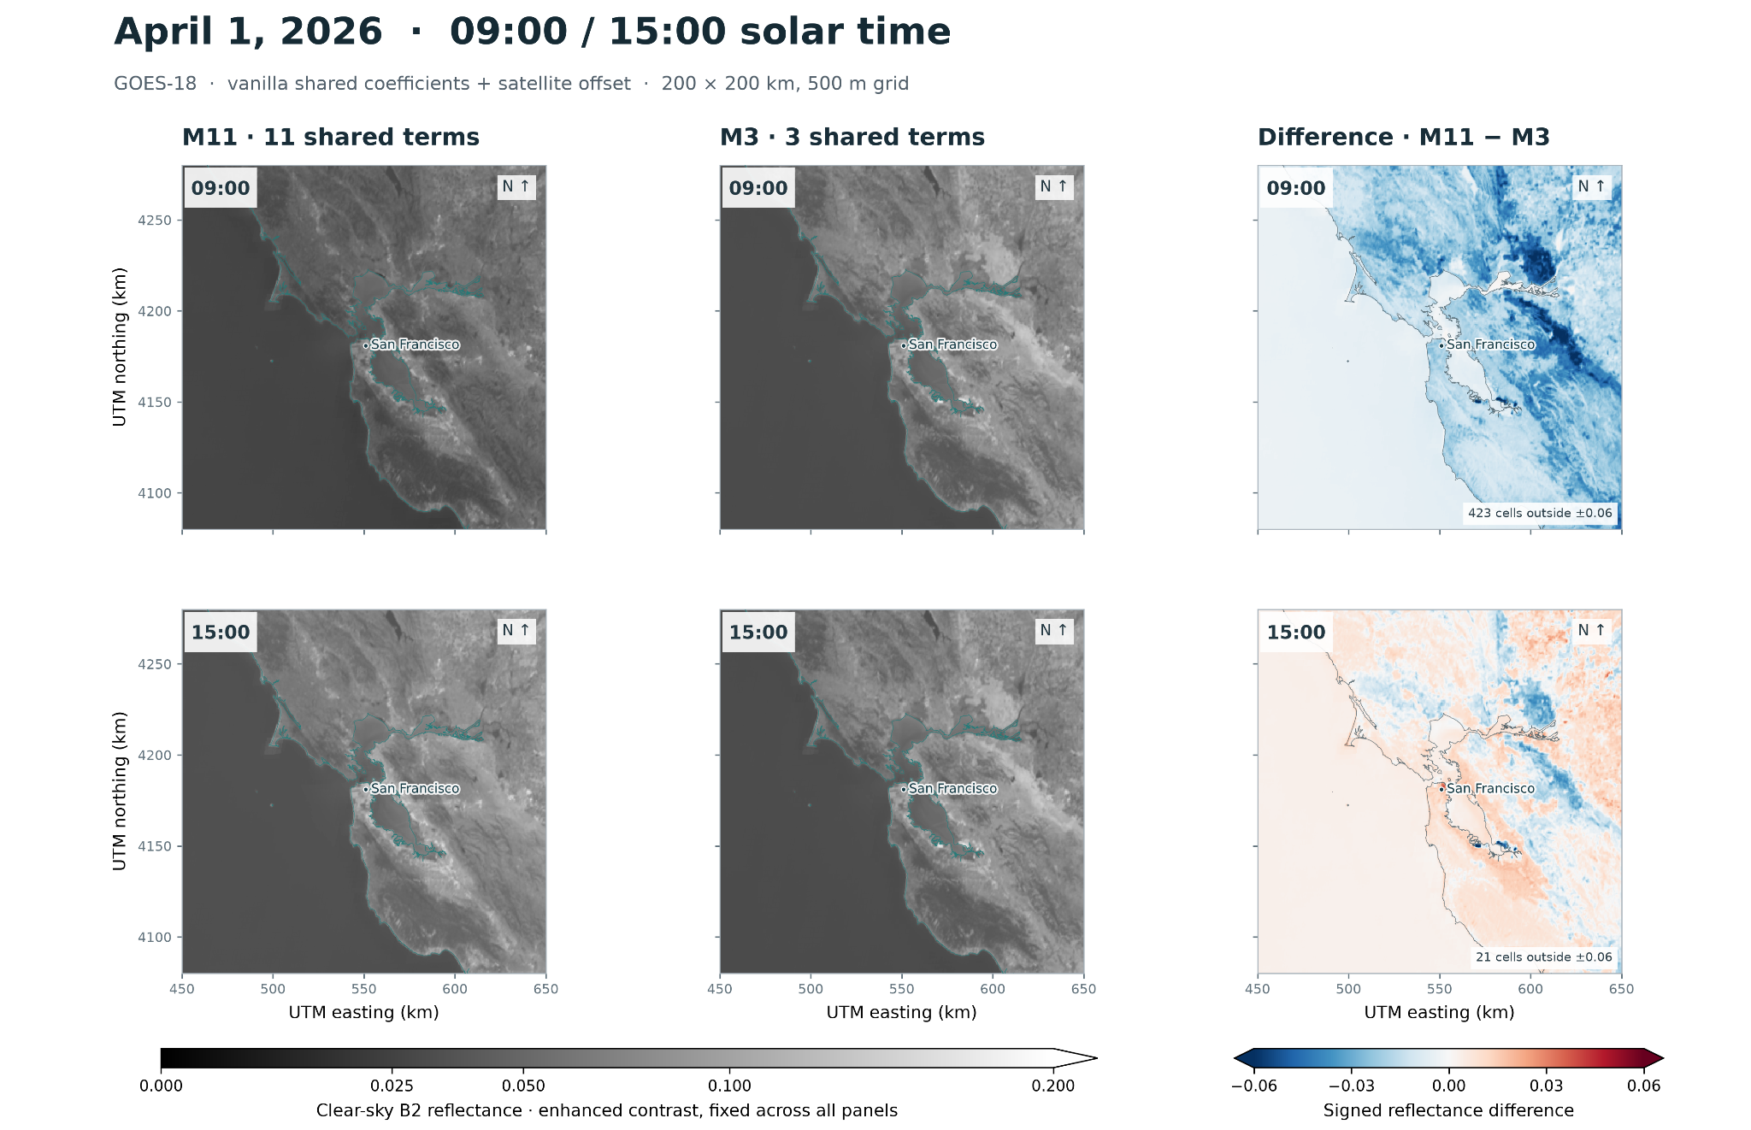
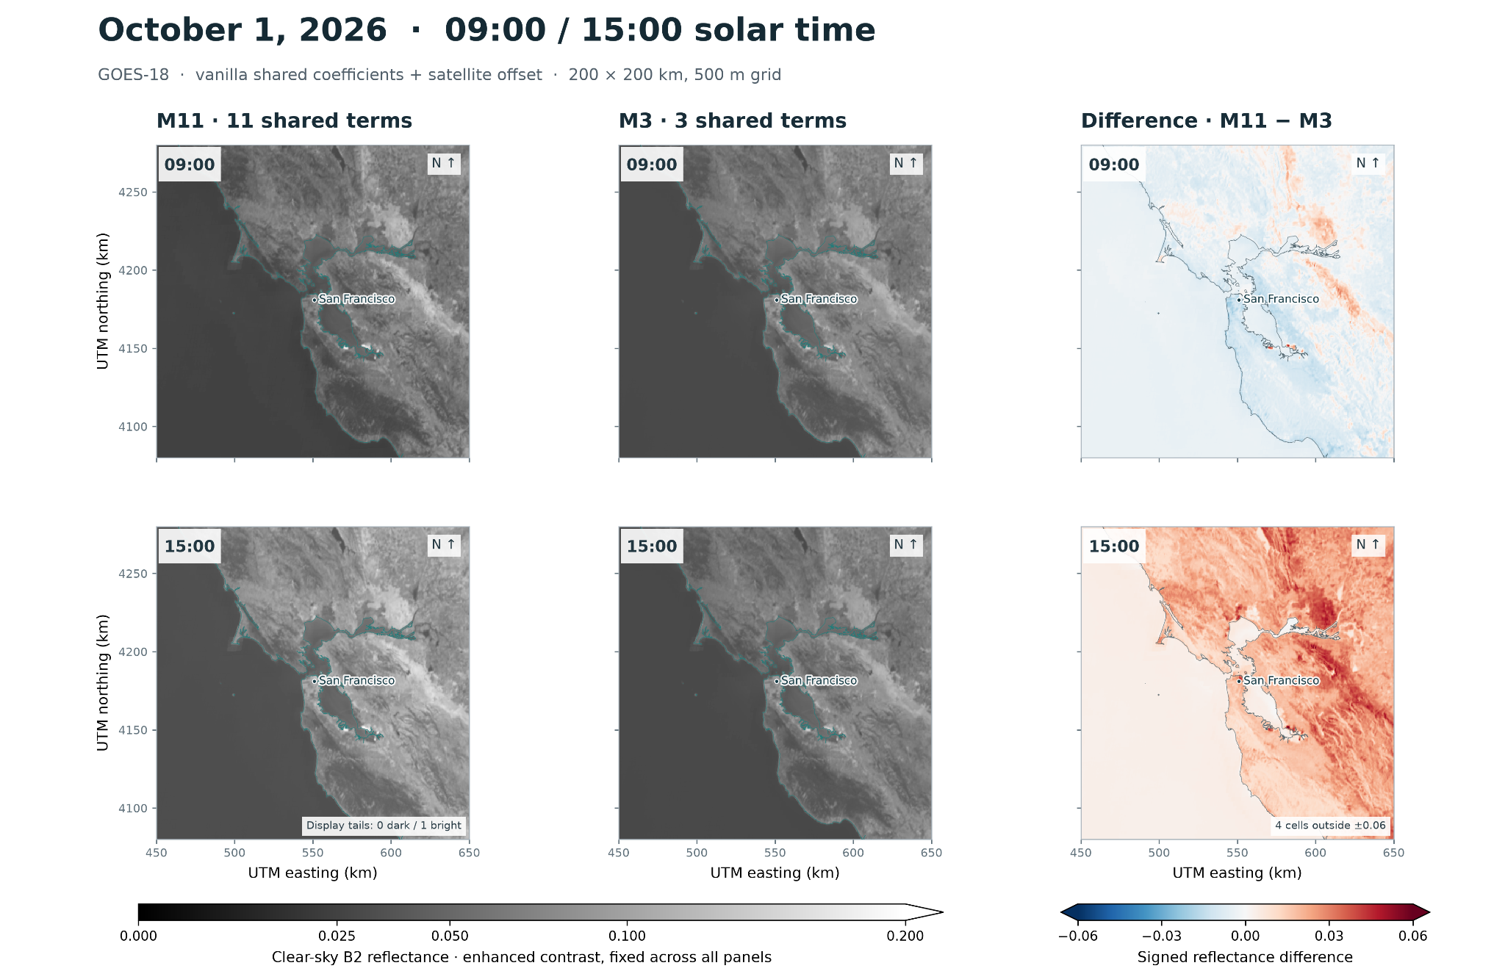 Figure P2-F3. What the extra terms change. M11 and M3 references for GOES-18 on April 1 and October 1, 2026, at 09:00 and 15:00 local solar time. The difference maps show where the two fits disagree; they are not error maps against an observed clear scene.

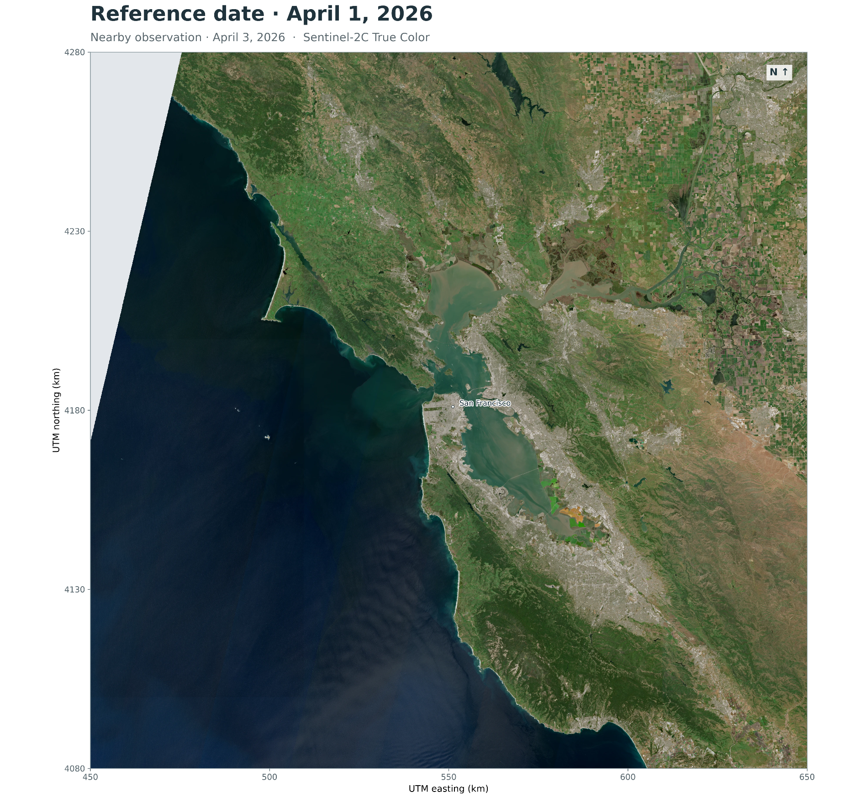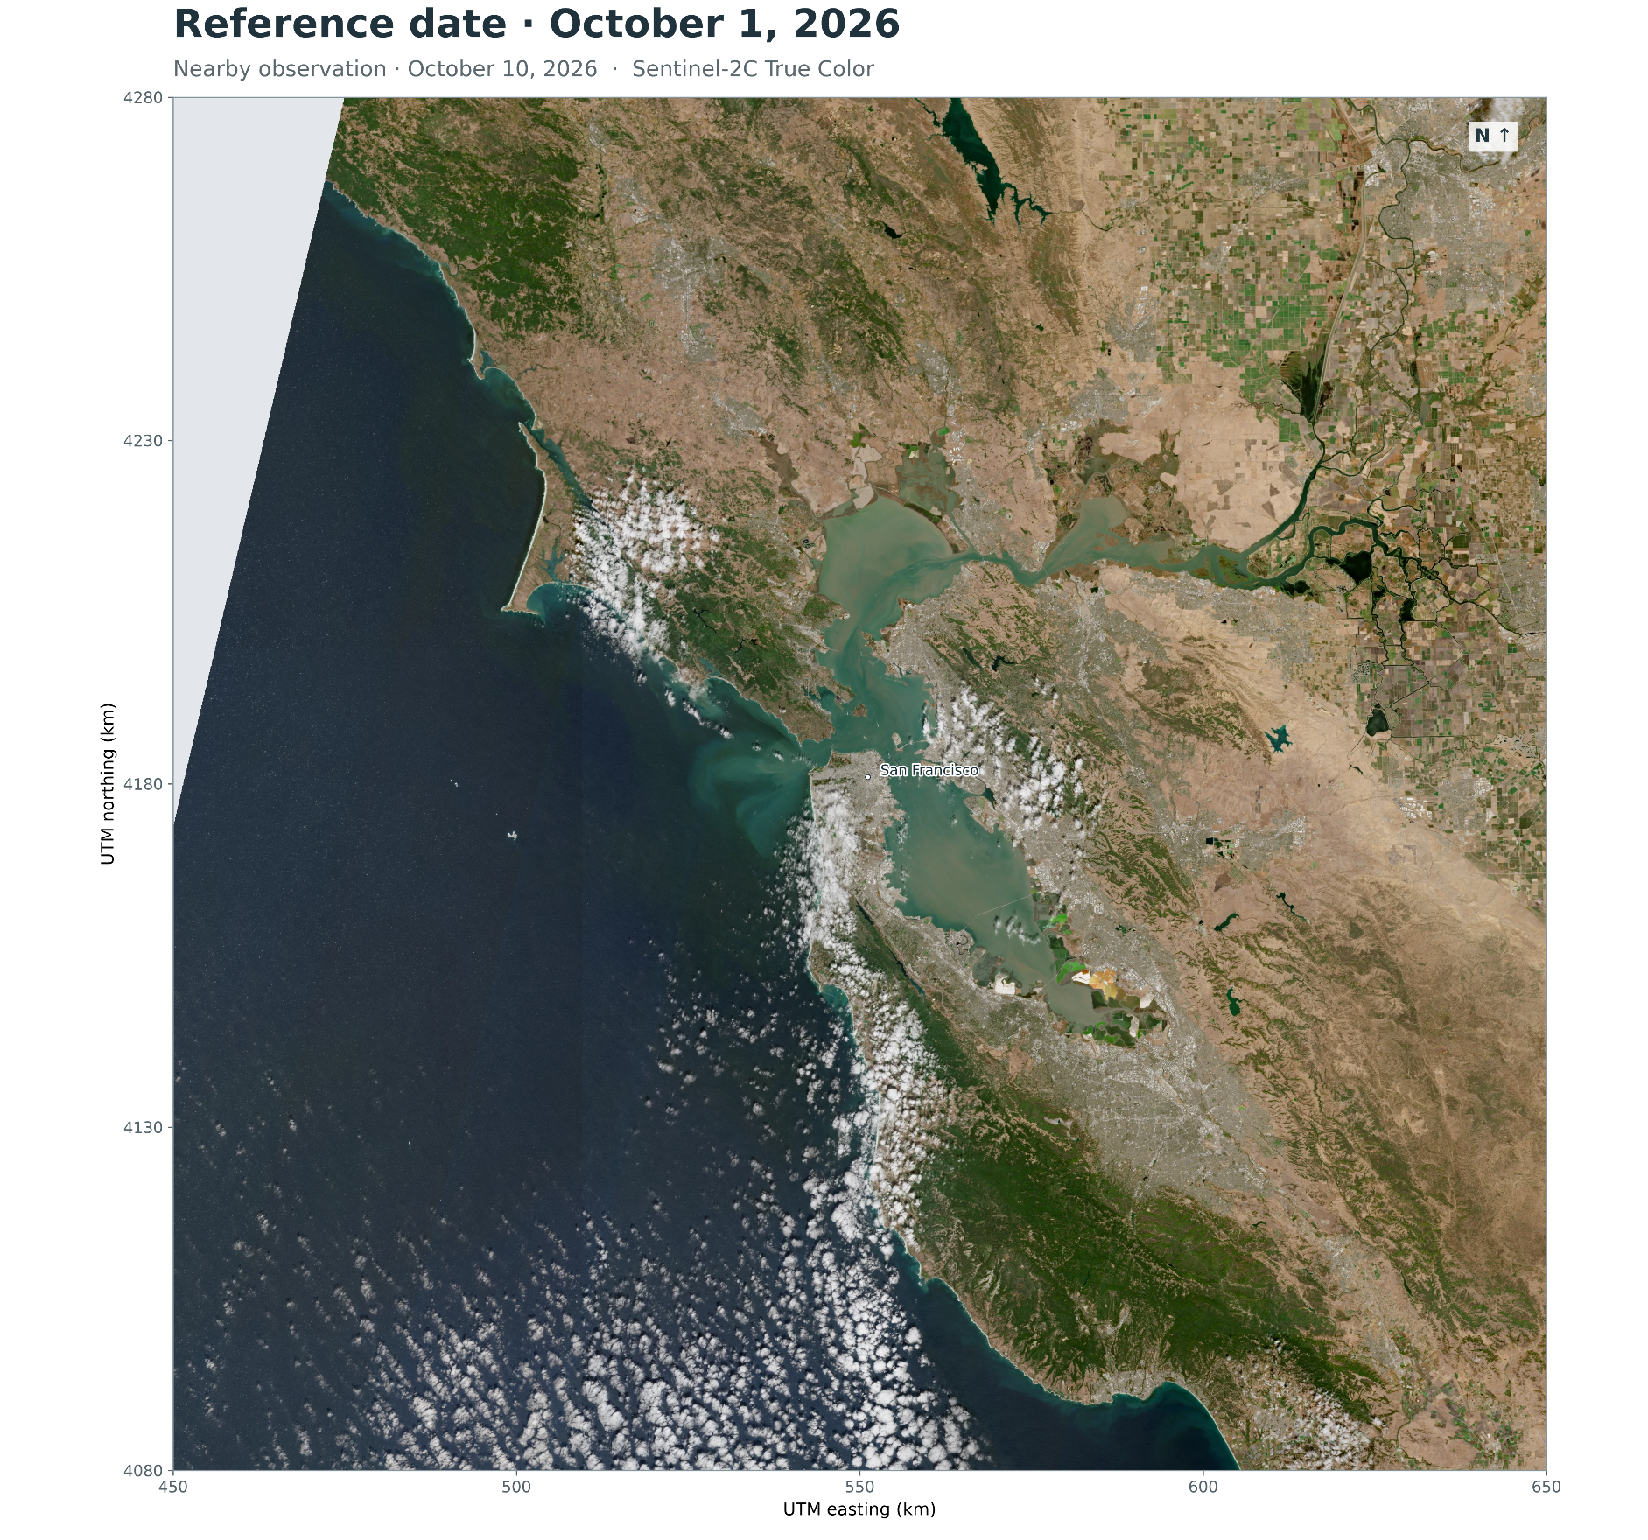
Figure P2-F4. The landscape changes with the seasons. True-color Sentinel-2 scenes acquired near April 1 and October 1, 2026, from Copernicus Browser. The greener spring landscape and drier autumn appearance motivate seasonal terms qualitatively.

Putting stabilization to the test

With a separate fit at every pixel, a few unusual observations can pull the coefficients around, especially where clear observations are scarce. I tested a stabilized version with three safeguards. First, I gave each UTC date equal initial weight within each pixel’s satellite record, so days with more images would not dominate. Next, I applied ridge regularization to discourage large solar and seasonal coefficients, leaving the baseline brightness and satellite offset unpenalized. Finally, I refitted once with Huber weights, reducing the influence of observations more than 0.03 reflectance units from the initial prediction.

The extra safeguards slightly worsened both held-out error measures for both satellites (Table P2-T1). For GOES-18, mean absolute error rose from 0.005101 to 0.005227, an increase of 2.5%, while RMSE rose from 0.008443 to 0.008511, about 0.8%. The differences were small, but the simpler fitting procedure had the edge. I kept the unstabilized 11-term fit.

Part 2: turn the residual into a cloud score

Learn how much brightness counts as cloudy
Once the reference is subtracted, the classifier asks whether the remaining brightness exceeds a fitted threshold $τ_{i}$. That threshold has a global quadratic dependence on solar cosine and a local offset $Δ_{x,y}$ for each pixel. Regularization pulls those local offsets toward zero unless the fitting data support a departure. The equations are compact:

$$r_{i} = {B2}_{i} - R_{clear,i}$$
$$τ_{i} =τ_{global}+ Δ_{x,y}$$
$$τ_{global}= a_{0} + a_{1}c_{i} + a_{2}c_{i}^{2}$$
$$s_{i} = σ((r_{i} - τ_{i})/T)$$
The sigmoid σ turns the residual’s distance above or below $τ_{i}$ into a score s between zero and one. The fitted positive temperature T controls how gradual the transition is. The selected classifier uses T ≈ 0.01323 reflectance units and calls a pixel cloudy only when its residual exceeds the threshold. A score of 0.8 is not automatically an 80% real-world cloud probability: that calibration has not been independently established. The fit minimizes:
$$L = \sum_{i}{w_{i} BCE(y_{i}, s_{i})} + (λ/P) \sum_{j}{Δ_{j}^{2}}$$
Here, y_{i} is the CSM label: 0 for clear, 1 for cloudy. Binary cross-entropy, BCE(y_{i}, s_{i}), penalizes confident mistakes. The weights w_{i} are built in two steps: base weights sum to one within each pixel and UTC date, then class normalization gives clear and cloudy observations half the total fitting weight each. The final weights sum to one overall, not necessarily within each pixel-date. The second term shrinks the local offsets Δ toward zero; P is the number of offsets, and $λ$ = 100 for the selected classifier.
For this classifier fit, a candidate’s center and all eight neighbors on the current native CSM grid must pass quality checks and agree on clear or cloudy. This favors homogeneous regions and reduces ambiguity when pairing coarse labels with finer B2 observations. It also makes a blind spot explicit: broken cloud and cloud edges are less well represented by these fitting candidates. Agreement with the CSM labels is therefore useful evidence, but not independent proof of accuracy at 500 m.
The example below shows the intended payoff: a daytime mask with finer spatial structure than native CSM, and broad visual agreement with the cloud bank in B2.
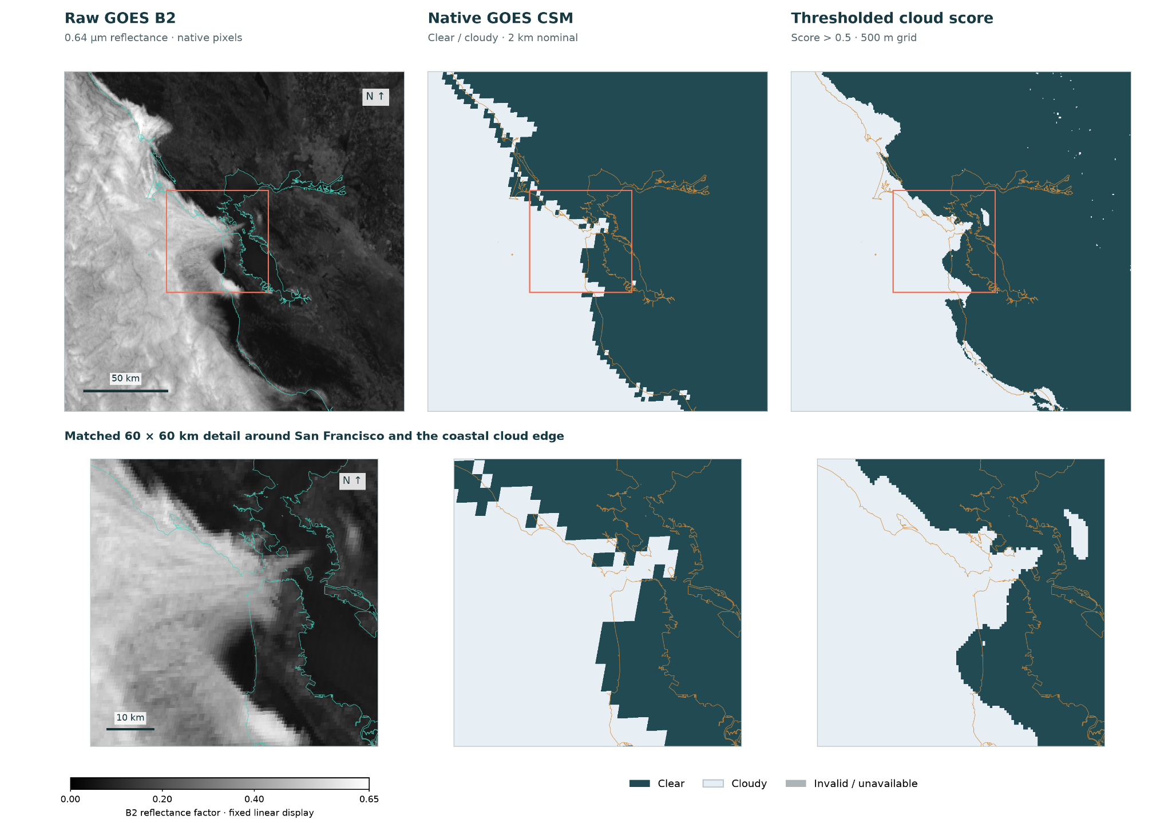
Figure P2-F5. A coastal cloud bank on June 14, 2026, around 12:30 p.m. PDT. Left: observed GOES-18 B2 reflectance. Center: native CSM. Right: the cloud score thresholded at 0.5 on the project’s 500 m grid. The lower row shows the same area near San Francisco at closer range.

Because B2 fields lose more and more contrast the less sun there is, I had to choose a cutoff for the solar zenith angle. Figure P2-F6 shows the classifier performance as a function of that angle. It can be seen that at more than >~80 degrees, performance degradation is severe. Based on that, I chose a cutoff of 82 degrees, which is NOAA’s daytime/nighttime cutoff for cloud optical-property retrievals .

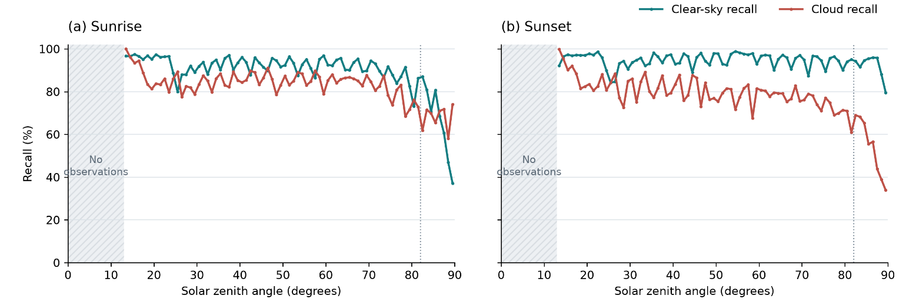

Figure P2-F6. Clear-sky and cloud recall of the GOES B2 classifier versus solar elevation. Panels show sunrise (a) and sunset (b), with clear-sky recall in teal and cloud recall in red, measured against native GOES cloud-mask labels. Each point represents a 1° elevation bin; lines connect the bin estimates. Recall is the percentage of reference clear or cloudy footprints correctly classified. The dotted line marks the existing 8° operational threshold, and shading indicates no observations at 77–90°. The highest populated bin, 76–77°, contains observations from only one week per panel. Curves show descriptive test-week results without confidence bands.

I now had a way to turn frequent daytime images into inspectable cloud labels, plus coarser supervision after dark. The remaining challenge was the one that started the project: turning a map of the present into a useful forecast of the next ten hours.

https://www.ncei.noaa.gov/metadata/geoportal/rest/metadata/item/gov.noaa.ncdc:C01508/html

