FOGCAST NOTES · PART 3

What should a neural network learn when a weather forecast already exists?
  - Combining high-resolution satellite data with an existing forecast to predict the next ten hours.
By the end of the last post, I could turn daytime satellite images into maps of clear and cloudy conditions. But the question that started this project was still waiting: would the clouds clear before we got to the beach?
An existing weather forecast already has something to say about that. The National Blend of Models (NBM) provides hourly cloud-cover forecasts. Meanwhile, the satellite shows the cloud pattern over the Bay Area right now, with much finer spatial detail. I wanted a model that could use both: the high-resolution local observations and a forecast of how the weather might evolve.
That led to a residual U-Net. Its design follows three practical questions: what information can I give it, how can it combine different spatial scales, and how can I teach it when the available labels change between day and night? This post follows those choices for the baseline model, Model A.

Ten maps for the next ten hours
The output is simple: ten maps, one for each hour from +1 to +10. Each covers a 200 × 200 km area around San Francisco on a 400 × 400 grid, with cells 500 m across. As in the first two posts, “clear” means no detectable cloud in the satellite label, at any height. That is the target Fogcast learns to forecast.
For every cell and hour, the network produces a real-valued score (logit). A sigmoid converts it into a clear-sky probability between zero and one. Values near one favor clear conditions; values near zero favor cloud. Keeping the output as a probability lets the model express uncertainty near a cloud edge or about when a cloud bank will retreat. Whether those probabilities are well calibrated is a question we’ll answer later. During training, a differentiable loss on the network’s continuous scores provides gradients that guide learning. Applying a hard clear/cloudy cutoff before computing the loss would prevent useful gradients from reaching the network’s weights.
All ten maps come from one forward pass. The +2-hour forecast is produced alongside the +1-hour forecast, rather than by feeding the first prediction back into an autoregressive model.

A close-up of now, a broader view of what comes next
The inputs fall into two groups, both covering the same 200 × 200 km domain. The fine group uses the 500 m grid. It contains the current B2-derived clear score, its validity mask, land fraction, elevation, and current solar incidence: five channels in all. Here, a channel is simply one map supplied to the network.
The current clear score is continuous: it is one minus the cloud score developed in Post 2. This retains information about how strongly the classifier favors clear or cloudy conditions. Future daytime training labels, by contrast, are binary masks made with the fixed classifier cutoff. The validity mask tells the network where the current score is usable.
The coarse group uses a 100 × 100 grid with 2 km cells. It contributes 25 channels: eleven NBM cloud-cover maps, ten maps of future solar incidence, the current GOES Clear Sky Mask (CSM) with its validity mask, and annual sine and cosine terms. Figure 1 puts the inputs beside the future observations used as training targets.
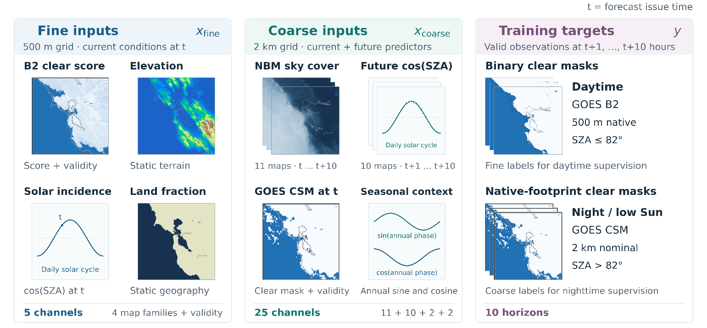
Figure 1. What the model sees, and what it learns to predict. Current satellite fields, geography, solar geometry, and existing NBM forecasts enter as inputs. Observations at +1 through +10 hours provide the training targets. SZA denotes solar zenith angle.
Table 1. The baseline input recipe. Fine inputs have 400 × 400 cells; coarse inputs have 100 × 100 cells. Both span the same 200x200 km domain.
Grid / input group | Fields | Channels | What they contribute
Fine · current observation | B2-derived clear score + validity mask | 2 | Current daytime cloud structure and usable coverage
Fine · geography | Land fraction + elevation | 2 | Coastline and terrain context
Fine · solar context | Solar incidence at issue time | 1 | Current illumination
Coarse · external forecast | NBM total cloud cover, t through t+10 h | 11 | Predicted cloud-cover evolution
Coarse · solar context | Solar incidence, t+1 through t+10 h | 10 | Daylight geometry at each forecast hour
Coarse · current observation | CSM clear mask + validity mask | 2 | Current cloud structure, including at night
Coarse · season | Annual sine + cosine at issue time | 2 | Smooth seasonal context

What could I actually know at 1 p.m.?
Some inputs describe the future. That can sound like cheating, but there is a crucial distinction: a forecast for 5 p.m. can already exist at 1 p.m.; a satellite observation taken at 5 p.m. cannot. I therefore separate the forecast’s issue time, t, from the times its inputs and outputs describe.
For current satellite inputs, the scan must have finished by t, and its midpoint must be no more than 20 minutes old. The distinction matters because a GOES scan takes roughly 160 seconds: its midpoint is about 80 seconds earlier than its end. A recent midpoint alone does not mean the scan was complete when the forecast was issued.
For NBM, the preferred input is one complete cycle initialized two hours before t. I chose this lag to allow time for the forecast series to be generated and published before Fogcast uses it. Its eleven maps cover t through t+10 hours. In the historical replay, I apply this two-hour availability allowance consistently.
Table 2. A forecast issued at 1 p.m. Future observations are targets for training and evaluation.
Data | Selection rule | 1 p.m. example
Current B2 and CSM inputs | Latest eligible scan: end no later than t; midpoint from t−20 min through t. | Midpoint between 12:40 and 1 p.m.; scan completed by 1 p.m.
NBM inputs | Prefer initialization at t−2 h; take all eleven valid times t through t+10 h from that cycle. | Use the 11 a.m. cycle forecasts valid from 1 through 11 p.m.
Future B2 / CSM targets | Nearest eligible observation with midpoint within ±6 min of each target hour. | The +1-hour target has a midpoint between 1:54 and 2:06 p.m.
This boundary defines the task the architecture must solve. The model receives observations of the present and forecasts that have already been issued. Later satellite observations provide the answers it learns from.

Zoom out for context, zoom back in for detail
A cloud boundary is local, but its evolution depends on patterns from a wider region. I chose a U-Net to combine those scales: its encoder builds broader features, then its decoder reconstructs a detailed forecast (Figure 2).
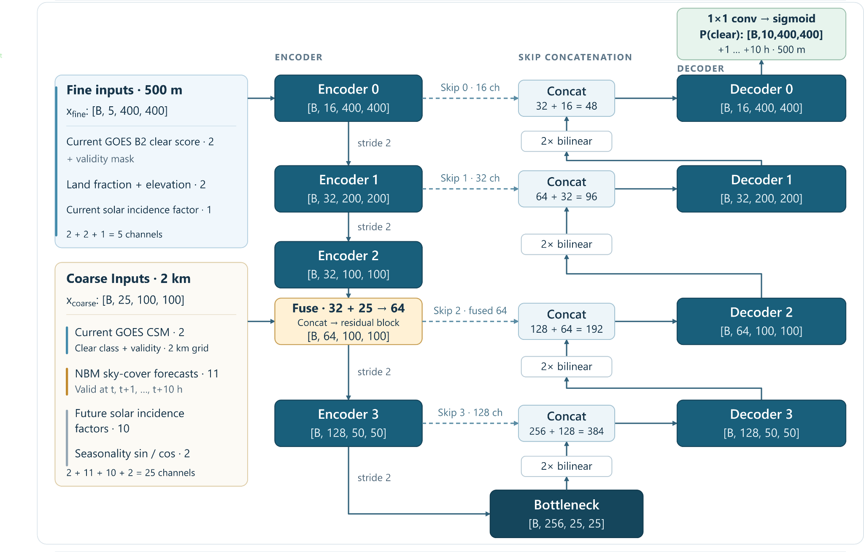
Figure 2. The route from inputs to ten forecasts. Fine and coarse inputs meet at 100 × 100 cells. The 25 × 25 bottleneck is sixteen times coarser in each direction than the fine grid. Four skip connections return encoder features to the decoder. The output contains ten clear-sky probability maps. B denotes batch size.
In Model A, the fine inputs begin at 400 × 400 cells. After two downsampling stages, their learned features reach 100 × 100, matching the coarse input grid. That is where the network joins them: 32 learned feature channels are concatenated with the 25 coarse channels, then processed into 64 channels.
The bottleneck represents the scene at 25 × 25 cells. Successive convolutions with 3 × 3 kernels combine neighboring features, while downsampling lets those kernels operate over progressively larger areas of the original scene. Together, these operations allow deeper features to capture broader spatial context. On the way back up, the decoder uses bilinear upsampling and joins features from the matching encoder level. Those U-Net skip connections carry spatial information that would likely be harder to recover from the bottleneck alone.
Convolutions also reuse the same learned filters across the map. A useful local pattern can therefore be recognized in different places. Geography channels let the model interpret that pattern in the setting of ocean, shoreline, or elevated terrain. This is the design assumption: shared ways of recognizing patterns, informed by local context.

Two kinds of shortcuts
The word “residual” in “residual U-Net” refers to shortcuts inside each processing block. U-Net skip connections carry spatial detail from the encoder to the matching decoder level, helping reconstruct a detailed forecast. Residual shortcuts carry a version of a block’s input around its convolutions and add it to the transformed features. This lets each block retain useful information while learning how to change it, making the network easier to train.
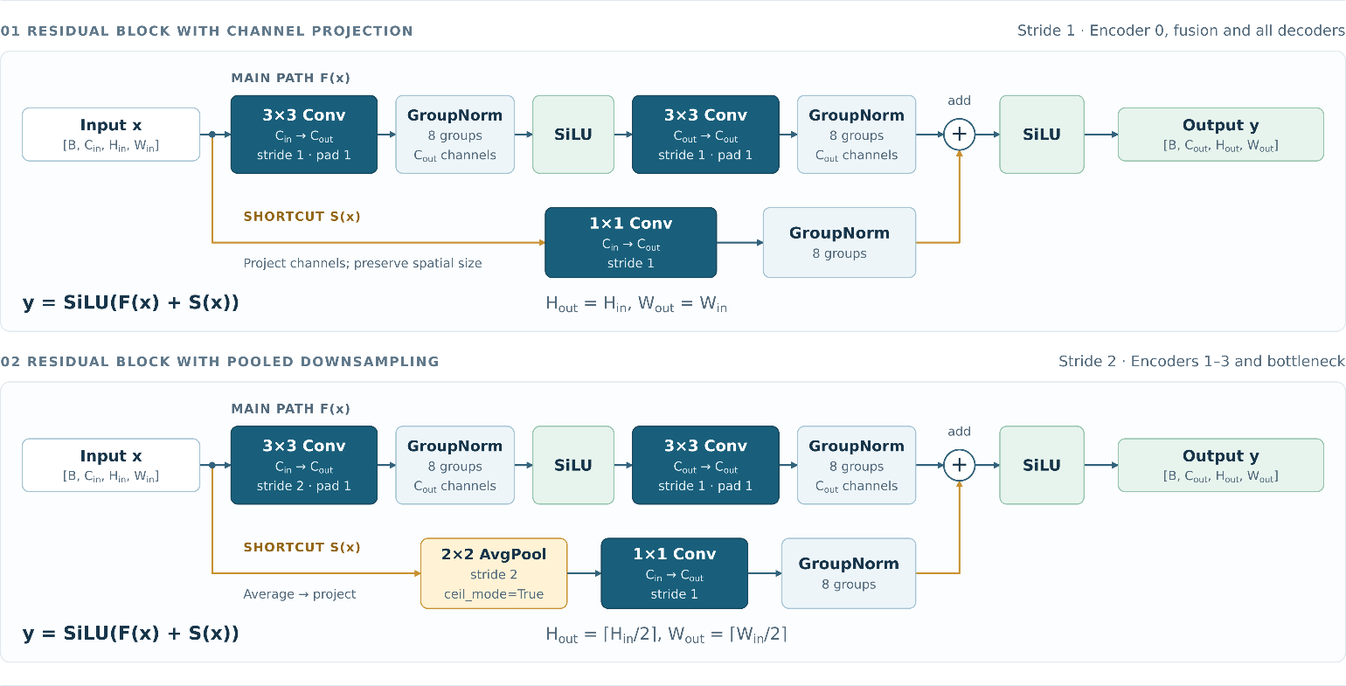
Figure 3. Inside the residual blocks. Both main paths use two 3 × 3 convolutions with eight-group normalization and an intermediate SiLU activation. The upper shortcut projects channels with a 1 × 1 convolution and normalization. The lower shortcut averages over 2 × 2 cells before projection and normalization. Each block adds its two paths, then applies SiLU.

Learning from labels that change with the light
The network always predicts on the 500 m grid, but the observations used to evaluate it have different resolutions. In usable daylight, the B2 classifier provides fine binary labels. At night, CSM provides labels on its original, coarser satellite footprints. The training loss must capture that difference.
For both sources, I use binary cross-entropy (BCE). Writing y = 1 for clear and y = 0 for cloudy, the per-label loss is:
$$BCE(y, p) = -y log(p) - (1 - y) log(1 - p)$$
In daylight, that comparison is made separately at every valid fine pixel. Fine labels are used at solar zenith angles up to 82°, in other words the Sun being at least 8° above the horizon. A forecast issued in daylight can have nighttime targets later in its ten-hour window, so the supervision regime is determined at each target hour.
For a nighttime CSM label, I first average the model’s fine-grid probabilities over the label’s native footprint, weighting each grid cell by its area of overlap. I then compare that pooled probability with the binary CSM label. The averaging happens after the sigmoid: it pools probabilities, rather than logits. Figure 4 shows the geometry behind the weights.
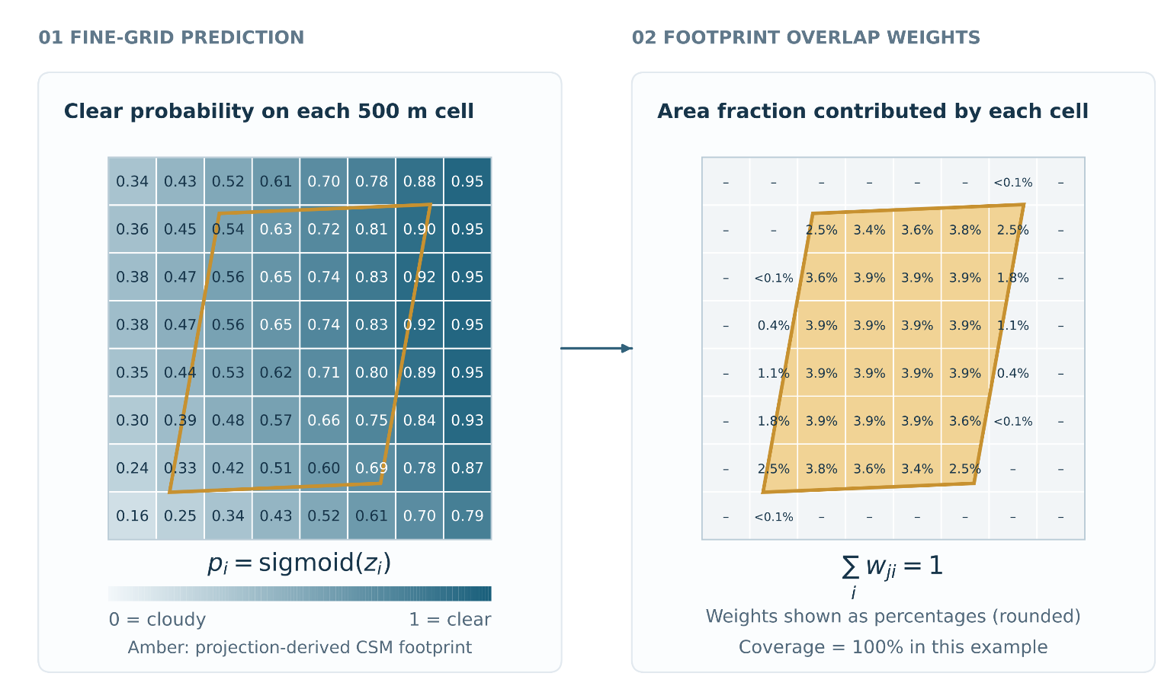
Figure 4. Judging the fine-scale prediction on the CSM label’s coarse grid. The orange outline is a native CSM footprint; the right panel shows how much of its area each fine cell contributes. The weighted mean of the predicted clear probabilities is compared with its binary label. Values are illustrative.
The overlap mapping is precomputed for each grid geometry and reused during training. Gradients pass through the weighted average to the fine predictions.
Pooling lets the model learn from coarser labels without treating one CSM footprint as many independent 500 m answers. It also sets a limit on what those labels can teach: several different fine-scale patterns can have the same footprint average. Therefore, it cannot, by itself, show whether the finer cloud patterns within each footprint are correct.

Combining the two sources of supervision
The source of supervision depends on sunlight at the forecast target location and time. Valid daytime pixels contribute to the fine loss; nighttime CSM footprints contribute to the coarse loss. These two routes never overlap. The coarse term receives one-quarter the weight of the fine term:
$$F_{h} = \frac{1}{N_{F,h}}\sum_{i}{BCE(y_{i,h}, p_{i,h})}$$
$$C_{h} = \frac{1}{N_{C,h}}\sum_{j}{BCE(y_{j,h}, {p̄}_{j,h})}$$
$$L = \frac{1}{N_{H}}\sum_{h ∈ H}{(F_{h} + 0.25 C_{h})}$$
For each horizon, I collect the valid fine-pixel losses across all examples in the batch and divide their sum by the total number of valid fine pixels. The same was done separately for CSM footprints. Averaging the two sources separately prevents the greater number of fine pixels from determining their relative influence; the factor 0.25 sets that balance explicitly. Finally, I compute the total loss L by averaging Fₕ + 0.25Cₕ over all horizons h.

The design is completed. How good is the forecast?
The architecture is now fully specified. Current satellite fields supply local evidence, NBM supplies a forecast of cloud-cover evolution, and the U-Net combines them across scales. Daytime and nighttime labels train the same ten-hour output, with each comparison made at the scale the observations support.
That brings me back to the beach question! I have specified what the model can see, what it must predict, and how it learns from a mistake. The next question is whether those choices produce a useful forecast: does it improve on an existing forecast, or simply assuming the current clouds will stay where they are? We now have something concrete to test.

