FOGCAST NOTES · PART 4

Which inputs actually help a fog forecast?
  - What survived a few plausible ideas that did not all pay off.
Adding one more input to a neural network is easy to justify. A previous satellite image might reveal cloud movement. An uncertainty map might tell the model when to distrust an existing forecast. Attention might connect weather patterns across the map.
While each idea had the potential to be useful, they did not all end up making the forecast better.
In the last post, I described Model A: a residual U-Net that combines current satellite observations, NOAA’s National Blend of Models (NBM) total cloud cover forecasts, and geography to predict the next ten hours around San Francisco. In this post, I am testing changes to the recipe. Through 10 experiments, I tested adding or removing ingredients. Most of the changes failed to improve the forecasts.

One change at a time
The experiments cover ten architectures, including Model A, plus two three-model blends. For tractability, each architecture differs from A in one specific way. I trained the variants from scratch using the same learning-rate and regularization recipe, and selected checkpoints by validation binary cross-entropy (BCE). That tests each change under a common training setup; but it does not give every architecture its own search for ideal settings.
The comparisons use all 5,219 TEST forecast issues. I score the continuous clear-sky probabilities with the Brier score: the mean of (predicted probability − observation) ². A perfect forecast would score zero, i.e., lower is better.
Daytime predictions are judged against valid 500 m B2-derived labels. At night, the 500 m predictions are averaged over native Clear Sky Mask (CSM) 2 km footprints before scoring. The cutoff is 82° solar zenith angle (SZA).
A difference is not automatically a conclusive result. Figure 1 includes approximate uncertainty intervals for the paired differences from Model A. Below zero means lower error; an interval crossing zero means the result is inconclusive.
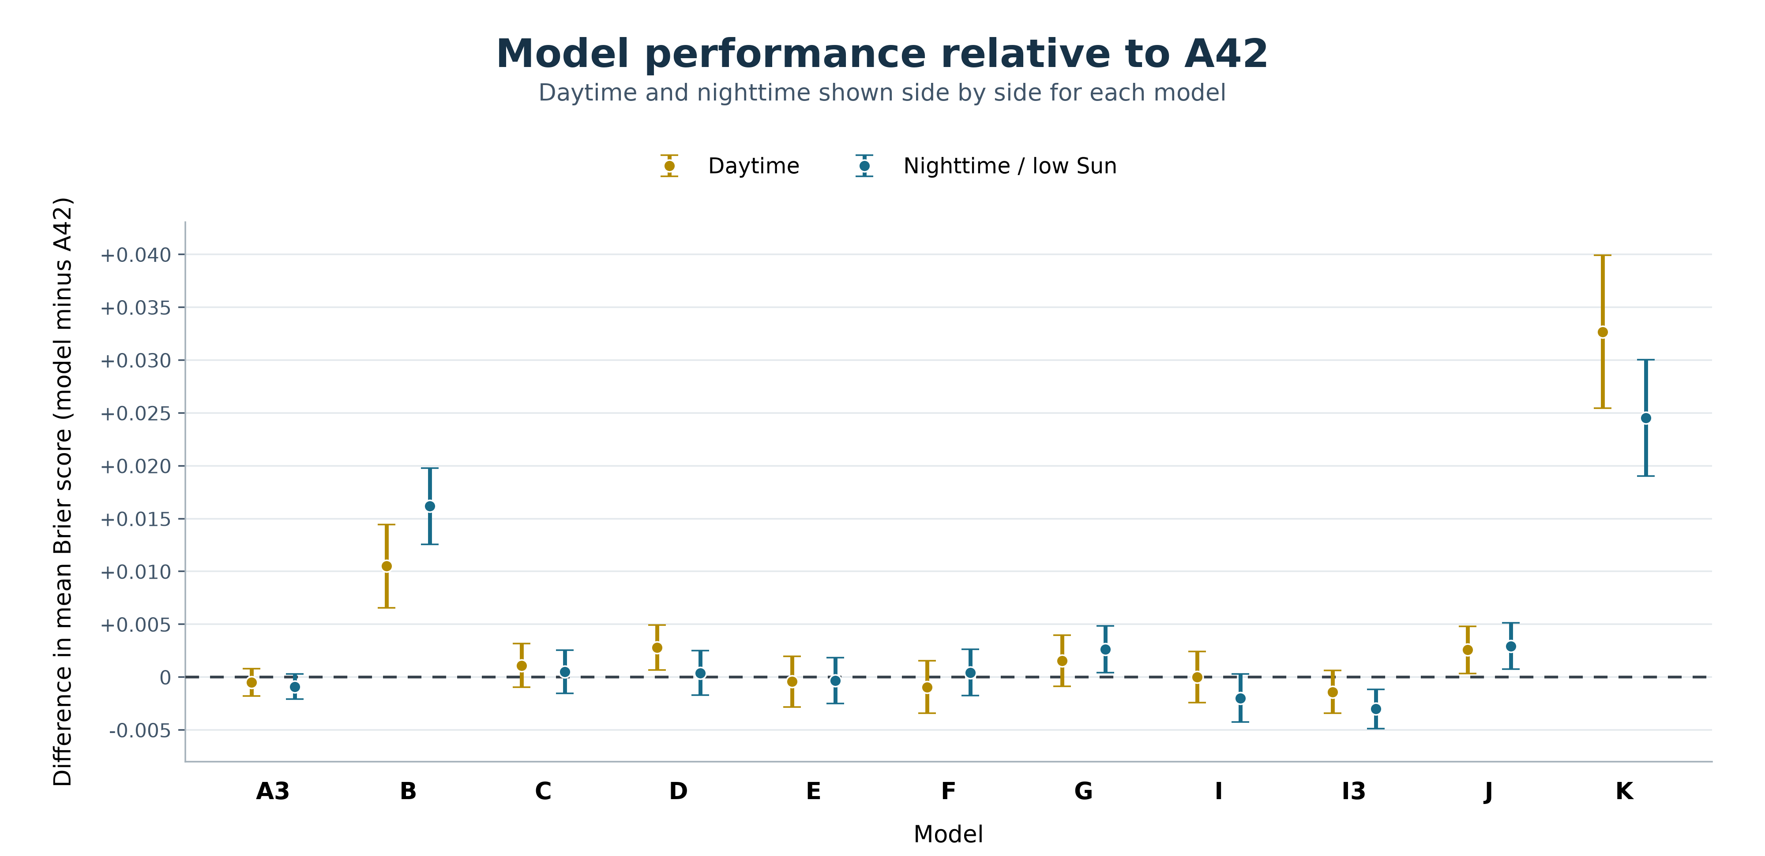
Figure 1. Changes in test score relative to A, seed 42 (A42). Gold is daytime; blue is nighttime. Bars combine weather-sampling and training-seed uncertainty. A3 and I3 are 3-seed ensembles.

Start with the satellite observations
Model B removes both current satellite inputs and their validity masks. It still gets the NBM weather forecasts, terrain, and solar and seasonal context. It can learn something useful from those fields, but it has lost its high resolution view of the clouds right now.
The penalty is clear in both regimes: mean Brier rises by 0.0105 in daytime and 0.0162 at night relative to A. As it can be seen in Figure 2, the gap is largest at short leads, where a recent observation should be most valuable.
Model D asks a narrower question. It removes the 500 m B2-derived clear score while keeping 2 km CSM observations. Daytime error rises by 0.0028, with an interval entirely above zero. The nighttime difference is small and unresolved. Compared to Model B, Model D fares much better. Fine daytime imagery helps most where the fine daytime labels are also used to score the result.
For comparison, the plots also show “direct NBM”: the NBM cloud-cover forecast used on its own, without Fogcast’s neural network. I convert its cloud-cover percentage to a clear-sky score as 1 − cloud cover/100.
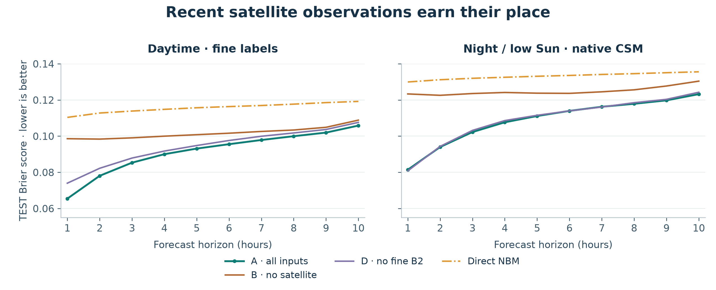
Figure 2. Removing all satellite observations (Model B) hurts most at short leads. Keeping coarse CSM but removing fine B2 (Model D) retains much of Model A’s performance, but with a clear penalty in daytime.

The satellite cannot carry the whole forecast
Model K goes the other way: it keeps the satellite observations but removes all eleven NBM cloud-cover forecast maps. I expected that to hurt, especially at long leads.
And it did hurt. At the first few leads, K still beats direct NBM. Around four hours ahead, that advantage disappears. Its error then climbs much faster than A’s. Over all ten horizons, removing NBM raises mean Brier by 0.0327 in daytime and 0.0245 at night, the largest penalties among these experiments.
The pattern so far helps explain why the combined model works. The satellite provides a detailed starting point; weather guidance supplies information about what may happen next. A snapshot is especially valuable nearby in time, but it cannot substitute for a forecast throughout the ten-hour window.
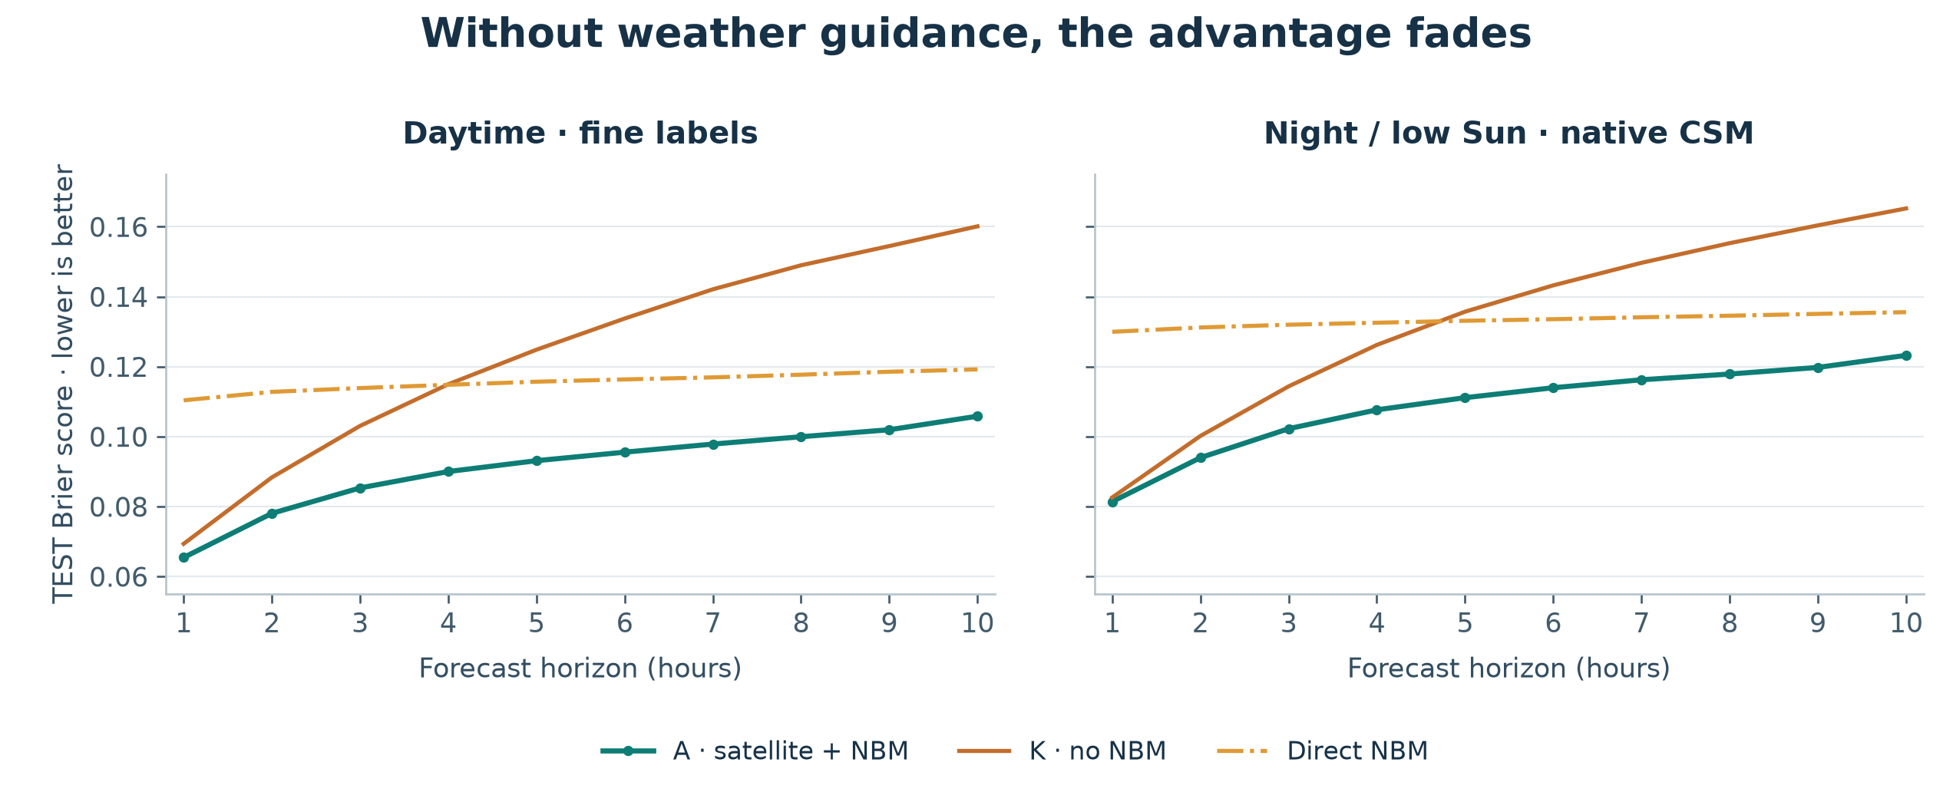
Figure 3. Without NBM guidance, K loses its advantage over direct NBM around the fourth forecast hour. A, which combines observations and guidance, stays below both curves at every evaluated horizon.

Give the network a topographic map
Model J removes land fraction (fraction of the cell that is covered by land) and elevation. Those are static maps, and the intuition to feed them to the model in the first place, is that a cloud pattern over the ocean is not necessarily a useful analogue for the same pattern over Mount Tamalpais.
Removing these two inputs raises mean Brier by 0.0026 in daytime and 0.0029 at night; both reductions in performance are conclusive, i.e., the interval excludes zero. The shared convolution filters benefit from explicit geographic context. While these experiments do not identify the specific physical mechanisms at play, they provide a practical reason to keep these two static maps.

Three useful-sounding variations that didn’t move the needle
Model C adds the previous hour’s satellite fields. The hope was that having two snapshots would help the network infer how things were evolving: cloud movement, growth, and dissipation. However, its scores are slightly worse than A’s, and both intervals cross zero, such that this experiment did not establish a benefit. It is possible that the NBM total cloud cover forecasts are already supplying a lot of the useful information in terms of cloud evolution.
Model E adds NBM ensemble sky-cover spread (or uncertainty), giving the network a cue about disagreement in the weather guidance used to assemble the NBM ensemble. Model F adds probabilities for a low cloud ceiling below 3,000 ft, alongside the total-cloud cover fields already present in A. However, neither E nor F produced a conclusive improvement over A.

More context, or more flexibility?
Looking at its learned convolution paths alone, Model A has a one-sided reach of roughly 43 km in the cardinal directions, which is much smaller than the domain dimension of 200 km in each cardinal direction. That motivated two different tests of spatial context.
Model G adds spatial attention at the bottleneck, allowing features from distant locations to interact directly. It ends up worse at night: the mean Brier increase is 0.0026, with an interval above zero. Its daytime difference remains unresolved.
As shown in Figure 4, the learning curves offer a clue. G eventually achieves lower training loss but higher validation loss than A. That is consistent with fitting relationships that do not generalize. Another possibility is that A’s training recipe simply suits G poorly.
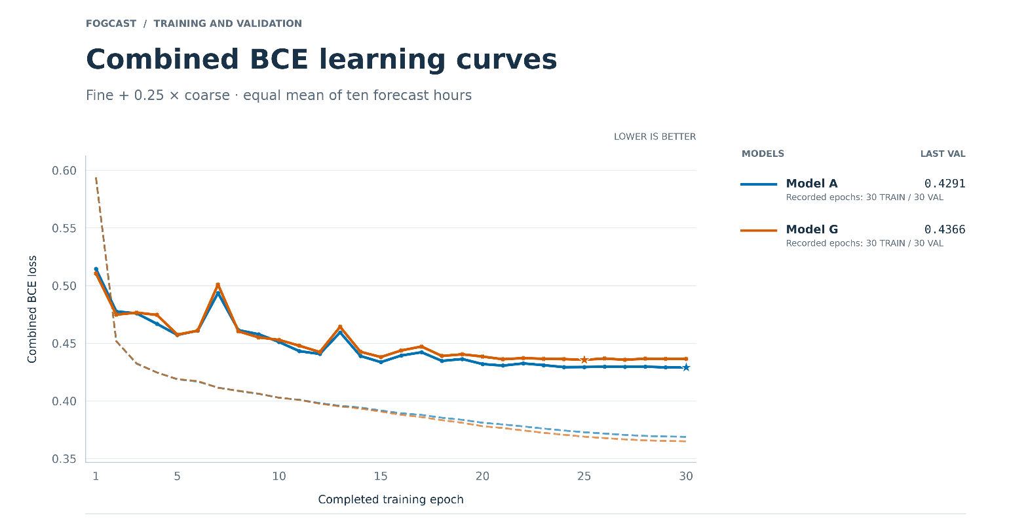
Figure 4. A versus G during training. Dashed curves show training loss; solid curves show validation loss. G’s lower eventual training loss is accompanied by higher validation loss. The combined objective is fine BCE + 0.25 × coarse BCE, averaged over the ten horizons; stars mark the checkpoints selected on validation BCE.
Model I makes a simpler change: it adds a 50 km input margin on every side. The network sees 300 × 300 km while still forecasting the central 200 × 200 km. Approaching clouds and weather near the output boundary now have more surrounding context. The boundary effects are mostly eliminated on the central 200 x 200 km forecasting domain.
The nighttime forecast improves, but I’s interval relative to A still crosses zero. So the wider domain is promising; this comparison alone does not establish that boundary effects were a problem.

Average the forecasts before judging them
I also trained A and I with three random seeds each. The resulting blends, A3 and I3, average the three clear-sky probability maps at every location and hour, which is then used for scoring.
Averaging their probabilities can soften a confident error made by one member of the ensemble. It need not beat the best member on every sample, but it gives the forecast a useful way to reduce disagreement.
Both blends have lower point scores than the single-seed A. A3’s intervals still cross zero in both regimes. I3 has the clearest improvement: its nighttime interval is all below zero.
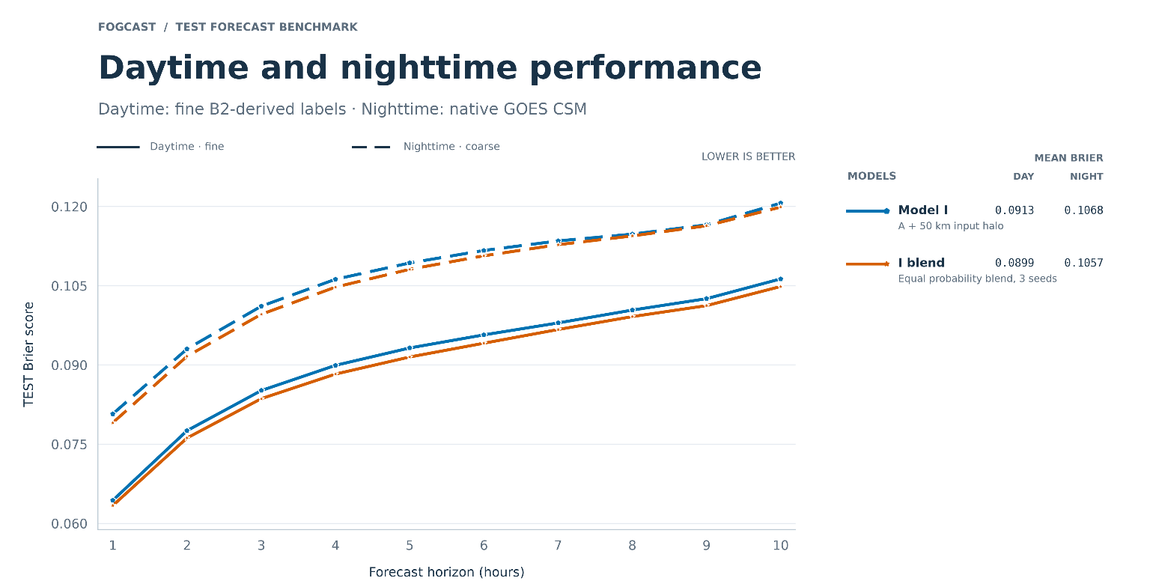
Figure 5. An individual I run (seed 42) versus the three-seed probability blend. The blend has lower point errors across the displayed horizons. This single-run illustration is distinct from I’s three-run mean score in Figure 1 and Table 1.
Based on these results, I chose to retain I3. It presents a modest refinement of the original model, with the strongest evidence at night.
The ingredients that survived are straightforward: a recent view of the clouds, a forecast of their evolution, solar angle information, and maps of the landscape. Extra inputs and architectural flexibility had to compete with that combination, and most did not show a clear gain.
Now that the model has been selected, the next question is the one that matters most: how much better is this than an existing forecast?

The experiment ledger
Table 1. Each change is relative to A. Entries are mean Brier differences from A42, followed by approximate 95% intervals. Negative is better. The self-comparison for A42 is zero.
Model | Change from A | Daytime difference  [95% interval] | Night / low-Sun difference  [95% interval]
A3 | Blend three A probability maps | -0.0005  [-0.0018, +0.0008] | -0.0009  [-0.0021, +0.0003]
B | Remove both satellite inputs + masks | +0.0105  [+0.0066, +0.0144] | +0.0162  [+0.0126, +0.0198]
C | Add previous-hour satellite inputs + masks | +0.0011  [-0.0010, +0.0032] | +0.0005  [-0.0016, +0.0025]
D | Remove fine B2 score + mask; keep CSM | +0.0028  [+0.0007, +0.0049] | +0.0004  [-0.0017, +0.0025]
E | Add NBM ensemble sky-cover spread + mask | -0.0004  [-0.0028, +0.0020] | -0.0003  [-0.0025, +0.0018]
F | Add NBM low-ceiling probabilities + masks | -0.0009  [-0.0034, +0.0016] | +0.0004  [-0.0017, +0.0026]
G | Add four-head bottleneck attention | +0.0015  [-0.0009, +0.0040] | +0.0026  [+0.0004, +0.0048]
I | Expand input domain to 300 × 300 km | +0.0001  [-0.0020, +0.0023] | -0.0015  [-0.0035, +0.0004]
I3 | Blend three I probability maps | -0.0014  [-0.0034, +0.0006] | -0.0030  [-0.0049, -0.0012]
J | Remove land fraction + elevation | +0.0026  [+0.0004, +0.0048] | +0.0029  [+0.0007, +0.0051]
K | Remove all eleven NBM cloud-cover maps | +0.0327  [+0.0255, +0.0399] | +0.0245  [+0.0190, +0.0300]

A note on the uncertainty
The intervals combine two sources of uncertainty. Weather uncertainty uses 10,000 paired TEST resamples, stratified by season. All models receive the same weather selections.
Training-seed uncertainty is estimated from three runs each of A and I, with a common spread borrowed for variants that have only one run. Weather and seed variances are assumed to be orthogonal and thus are simply added; the interval is the paired difference ± 2.78 times the combined standard error. That multiplier comes from four degrees of freedom in the pooled seed estimate. This is meant to produce a conservative approximation of the confidence interval.

