FOGCAST NOTES · PART 5

Does Fogcast forecast better, or just draw a sharper map?
  - Testing the forecast against persistence, historical cloudiness, and the weather guidance it learns from.
A forecast on a fine 500 m grid can look persuasive. It has a coastline, narrow gaps in the clouds, and enough detail to suggest that the model knows what will happen with fine-resolution accuracy. But this needs to be established quantitatively.
In the previous post, I selected a three-seed blend of Model I: the original residual U-Net with a wider input domain. Most of the other variations I tested failed to show a clear benefit. Now I wanted to answer a very practical question: does the resulting network improve on forecasts already available?

Three forecasts to beat
All three references are shown in Figure 1. The first reference is persistence: take the current cloud pattern (the same one that is fed to neural network) and hold it fixed for all ten hours, i.e., assume no change in cloud cover over the horizon.
Persistence is deliberately simple, but it is a serious opponent one hour ahead. The latest satellite image can be a better guide to the immediate future than an older weather forecast.
The second reference is climatology. For each location, I estimate the historical frequency of clear conditions for the target month and hour, using only TRAIN labels. It knows that an ocean pixel at 8 a.m. in July has a different history from an inland pixel at 4 p.m. in October. It knows nothing about today’s cloud bank.
The third is the National Blend of Models (NBM), used directly. I convert forecast total sky cover C, expressed as a percentage, into a clear score: 1 − C/100. I align the target-hour field with the verification grid and score it as-is, without a learned correction. This is the weather guidance supplied to Fogcast, used on its own.
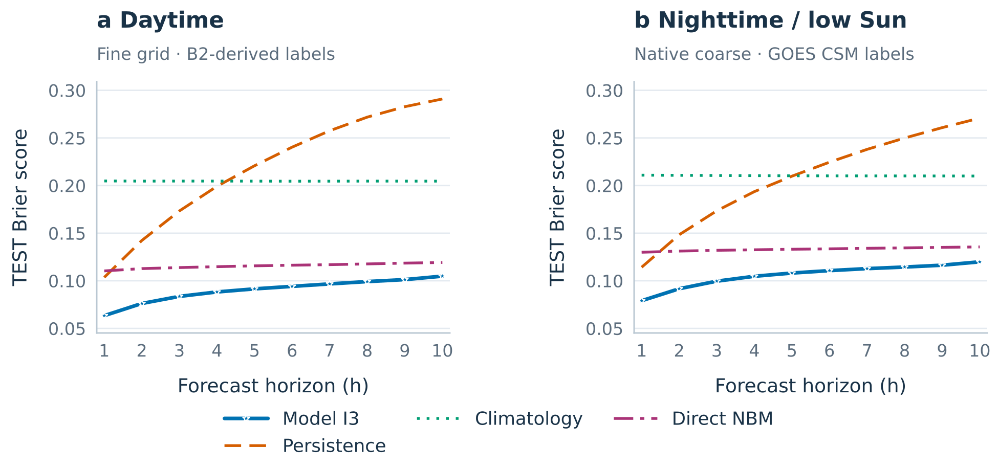
Figure 1. Test performance by horizon.

Compare what was available at the same time
The age of the information matters. In this historical replay, NBM cycles are initialized at least two hours before the Fogcast issue time to allow for forecast availability. At 1 p.m., the preferred cycle is therefore 11 a.m. Its prediction for 2 p.m. is already a three-hour forecast, even though Fogcast calls that target “one hour ahead.”
Persistence uses the latest eligible satellite observations. Fogcast has those observations and the earlier NBM forecast. That difference helps explain the short-lead results: Fogcast’s job is partly to improve existing guidance using newer, finer observations.

Score the confidence, not just the cloud outline
The main metric is the Brier score, the mean squared difference between a clear-sky probability and a binary label: 1 for clear, 0 for cloudy. If the label is clear, a forecast of 0.8 contributes 0.04; a forecast of 0.2 contributes 0.64. Confident mistakes are expensive, similarly to the BCE loss function.
I scored the unthresholded probabilities. A hard clear/cloudy map discards the difference between a tentative prediction and a confident one, which is exactly the distinction I wanted to assess.
For each horizon, I divided the total squared error by the total valid support, then average the ten horizon scores equally. The 5,219 TEST issues provide roughly 380 million valid fine pixel–target pairs and 17 million native coarse pairs per horizon.
Table 1. Mean TEST Brier over +1 through +10 hours. Lower is better.
Forecast | Daytime · fine | Night / low Sun · native coarse
Persistence | 0.2183 | 0.2084
Climatology | 0.2046 | 0.2103
NBM predictions | 0.1156 | 0.1332
Model I · three-seed blend (I3) | 0.0899 | 0.1057

The satellite detail pays off, especially in the first few hours
Direct NBM is the strongest reference when averaged across the ten horizons. But persistence has the edge at +1 hour, then deteriorates as the clouds evolve. Climatology stays nearly flat: advancing the forecast hour changes the historical lookup, without giving it any new knowledge of today’s weather.
Model I3 already has lower Brier scores than all three references at every evaluated horizon, day and night. Its advantage over direct NBM is largest near issue time and narrows toward +10 hours.
The pattern fits the ablations in the previous post. Removing the satellite hurts most at short leads. Removing NBM hurts most at long leads. The neural network uses both sources of information across a window where their relative value changes.

One sample up close
Figure 2 shows what a sample forecast looks like. Persistence keeps repeating the morning’s cloud pattern. Climatology follows a typical day for that place and month. NBM is the NOAA’s forecast. Model I combines weather guidance with the satellite view.
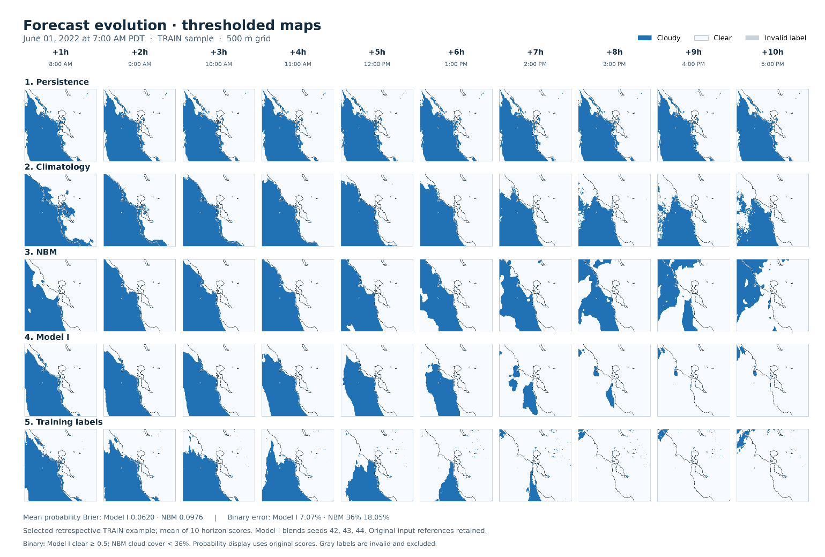
Figure 2. Forecast issued June 1, 2022, at 7 a.m. PDT; targets run from +1 to +10 hours. Blue is cloudy. We maps show the binary results for ease of visualization: I3 is clear at probability ≥0.5; NBM is clear at total cloud cover <36%.

Does 70% clear mean clear about 70% of the time?
The architecture post left this question open. A sigmoid produces a number between zero and one, but that alone does not make it a trustworthy probability.
A reliability diagram groups predictions with similar probabilities and compares their average with the observed clear frequency. If predictions near 70% clear correspond to clear labels roughly 70% of the time, that part of the curve lies near the diagonal.
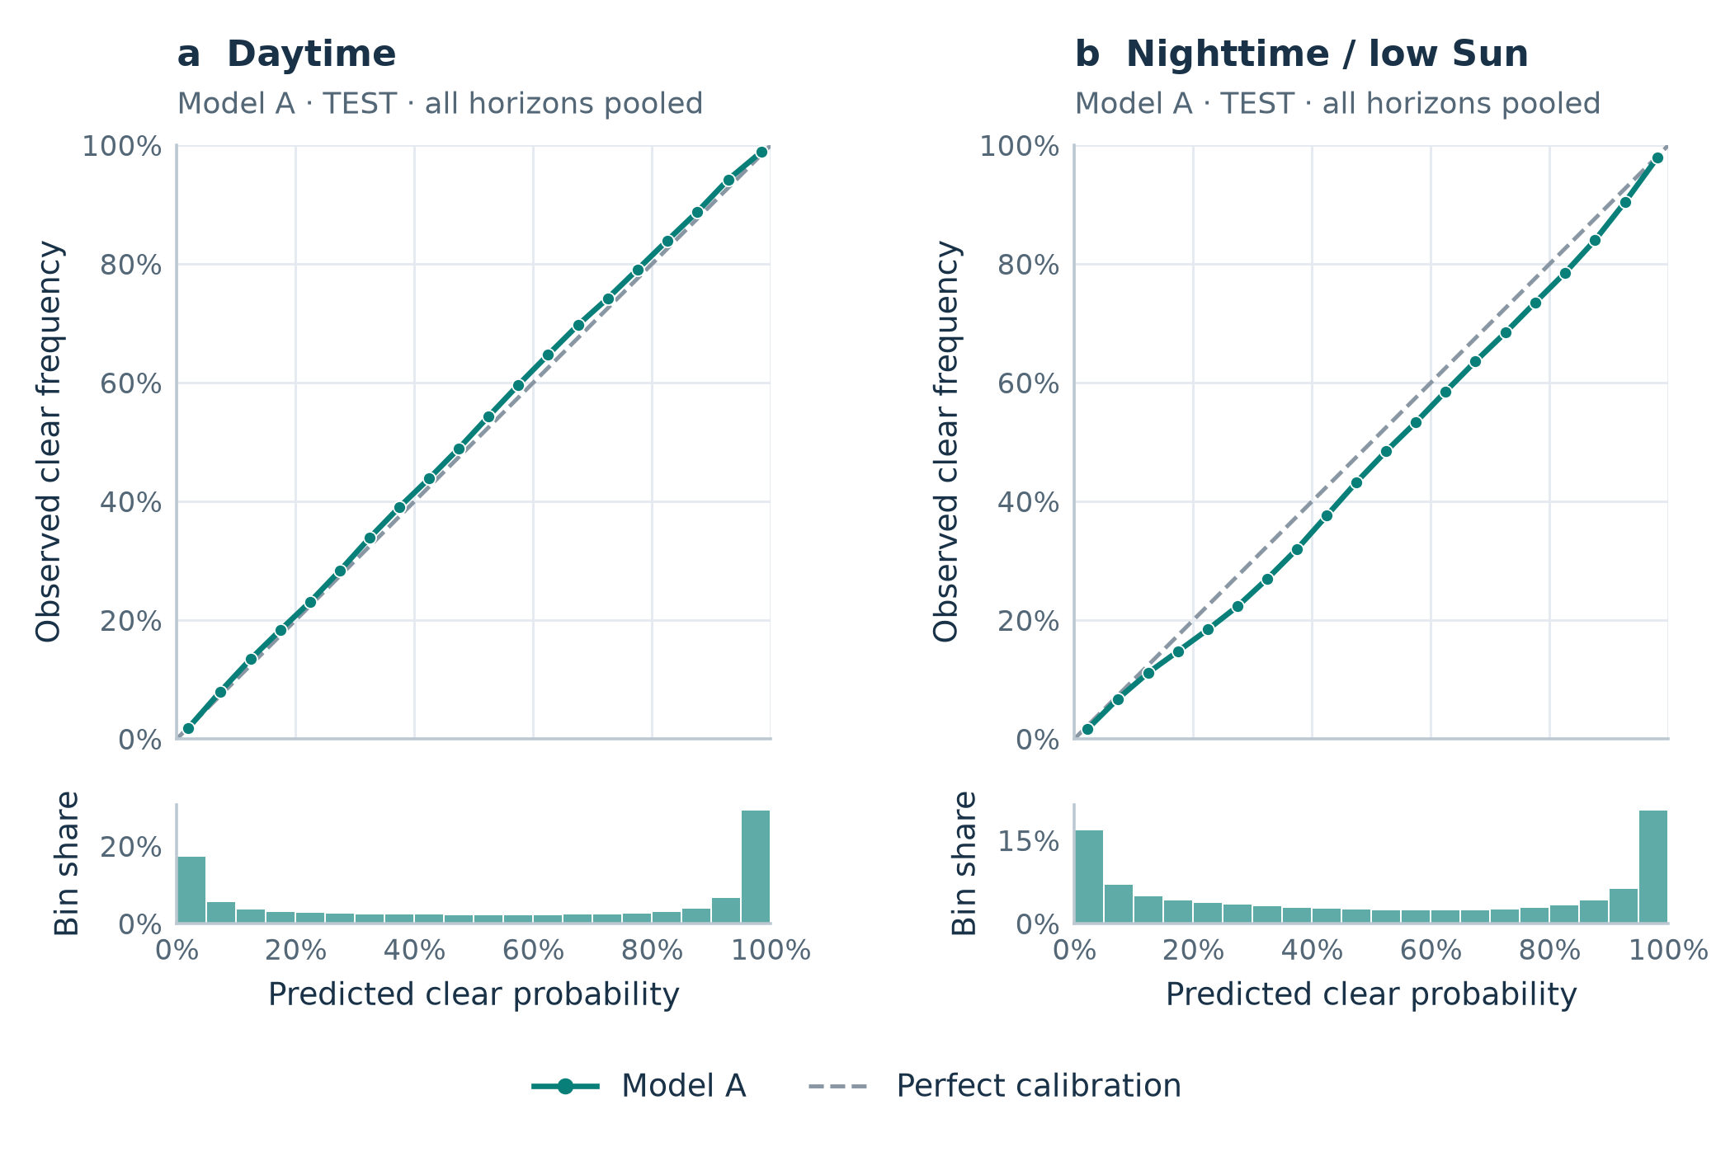
Figure 3. Reliability for Model I3, on TEST, pooling all ten horizons into 5-percentage-point bins. The dashed line is perfect calibration; histograms show the share of valid forecast–target pairs in each bin.
Model I3’s daytime curve tracks the diagonal fairly closely. The nighttime curve sits below it through much of the middle range: the model tends to predict clear conditions slightly more often than the CSM labels justify.

The takeaway
Combining recent satellite observations with NBM guidance showed improvement in clear/cloud forecasting over persistence, climatology, and direct NBM.
The limits follow directly from how the model was built. “Cloudy” includes detectable cloud at any height; it does not specifically mean fog at ground level. Daytime accuracy is measured against my B2-derived labels, which can carry their own errors. At night, coarse labels cannot independently verify every 500 m cloud edge inside a 2km CSM footprint. A fine output grid should not be mistaken for equally fine evidence everywhere.
For planning an afternoon, though, I now have something more useful than replaying a satellite loop and guessing. I can look at how the predicted clear probability changes at Ocean Beach through sunset, compare it with Dolores Park, and decide how much uncertainty I am willing to accept.

