POST 4

Which inputs actually help?
Central question: Which plausible additions survive a controlled experiment?

1. Ten different model variations
Table P4-T1 shows the ten different models that were trained. Model A is the reference model, and the nine other models are various ablations meant to answer targeted questions, and each is defined in relation to Model A.

Table P4-T1. Input and architecture ablations for the fog forecast model. Each variant modifies reference model A as described. TEST-set Brier scores use unthresholded probabilities and are averaged equally across forecast lead times of 1–10 hours; lower values indicate better performance. Daytime scores use valid fine-resolution B2-derived labels, while nighttime/low-Sun scores use native CSM labels. The paired difference cells are colored according to whether they show improvements over Model A: yellow is inconclusive, green is improved, and red is worse performance.
Model label | Change from A | Expected change/benefit | Average daytime Brier score | Average nighttime Brier score | Paired daytime difference from A [95% CI] | Paired nighttime difference from A [95% CI]
A | Reference model | N/A | 0.0913 | 0.1088 | 0.0000 [0.0000, 0.0000] | 0.0000 [0.0000, 0.0000]
A3 | Equal probability blend of 3 A seeds | Averages predictions across training seeds, potentially improving performance beyond the best individual run. | 0.0908 | 0.1079 | -0.0005 [-0.0018, 0.0008] | -0.0009 [-0.0021, 0.0003]
B | Remove both satellite inputs and masks | Test the contribution of satellite observations; expect weaker knowledge of the initial cloud stat | 0.1018 | 0.1249 | +0.0105 [0.0066, 0.0144] | +0.0162 [0.0126, 0.0198]
C | Add previous-hour satellite inputs / masks | Provide recent cloud evolution to help infer movement, growth and dissipation | 0.0924 | 0.1092 | +0.0011 [-0.0010, 0.0032] | +0.0005 [-0.0016, 0.0025]
D | Remove B2-derived score and its mask | Isolate the contribution of fine-resolution daytime observations while retaining CSM cloud information | 0.0941 | 0.1092 | +0.0028 [0.0007, 0.0049] | +0.0004 [-0.0017, 0.0025]
E | Add NBM ensemble sky-cover spread and a shared validity mask | Provide ensemble disagreement as an uncertainty cue for adjusting reliance on NBM guidance | 0.0909 | 0.1084 | -0.0004 [-0.0028, 0.0020] | -0.0003 [-0.0025, 0.0018]
F | Add low-cloud (below 3,000 ft) probability maps and masks | Provide targeted low-cloud cover predictions that cannot be recovered from total cloud cover alone | 0.0904 | 0.1092 | -0.0009 [-0.0034, 0.0016] | +0.0004 [-0.0017, 0.0026]
G | Add four-head bottleneck spatial attention | Enable interactions between distant cloud features and improve spatial coherence | 0.0929 | 0.1114 | +0.0015 [-0.0009, 0.0040] | +0.0026 [0.0004, 0.0048]
I | Expand input to 300 × 300 km | Capture approaching cloud systems and provide additional context near output boundaries; expect better predictions especially close to the domain edges | 0.0913 | 0.1068 | +0.0001 [-0.0020, 0.0023] | -0.0015 [-0.0035, 0.0004]
I3 | Equal probability blend of 3 I seeds | Averages predictions across training seeds, potentially improving performance beyond the best individual run. | 0.0900 | 0.1057 | -0.0014 [-0.0034, 0.0006] | -0.0030 [-0.0049, -0.0012]
J | Remove direct land-fraction and elevation inputs | Test the contribution of explicit coastal and terrain information to local cloud patterns; expect weaker predictions | 0.0939 | 0.1117 | +0.0026 [0.0004, 0.0048] | +0.0029 [0.0007, 0.0051]
K | Remove all eleven NBM total-cloud-cover maps | Test the contribution of numerical forecast guidance; expect weaker prediction especially at longer lead times | 0.1240 | 0.1333 | +0.0327 [0.0255, 0.0399] | +0.0245 [0.0190, 0.0300]

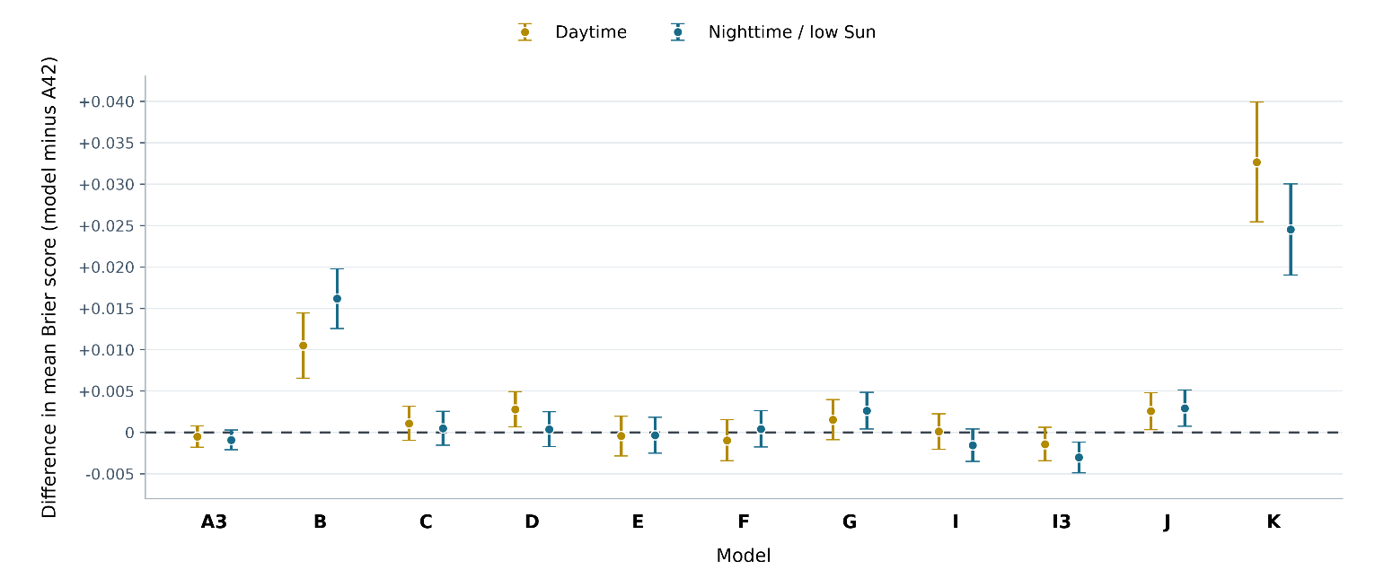
Figure. Model performance relative to Model A.

2. Are the satellite inputs useful?
Model B was designed to assess forecast performance without either coarse- or fine-scale satellite inputs. It uses the NBM forecast alongside ancillary inputs such as solar incidence angle, land fraction, and elevation. Table P4-T1 reports that Models B and D both have conclusively reduced performance. This is shown in Figure P4-F1, where Model B can be seen to slightly outperforms the NBM forecast itself (Direct NBM) during both daytime and nighttime. However, it performs substantially worse than Model A, which includes both satellite inputs, and Model D, which includes only the coarse satellite input. These differences are especially pronounced at short forecast horizons.
Model D differs from Model A only in its omission of the fine-scale satellite-derived input. This omission reduces daytime performance but has little effect on nighttime performance. This pattern is consistent with the training targets: the fine-scale B2-derived score during daytime and coarse CSM observations at night. The results therefore suggest that the fine-scale input is particularly valuable for daytime forecasts, when predictions are evaluated against a target derived from the same satellite product.
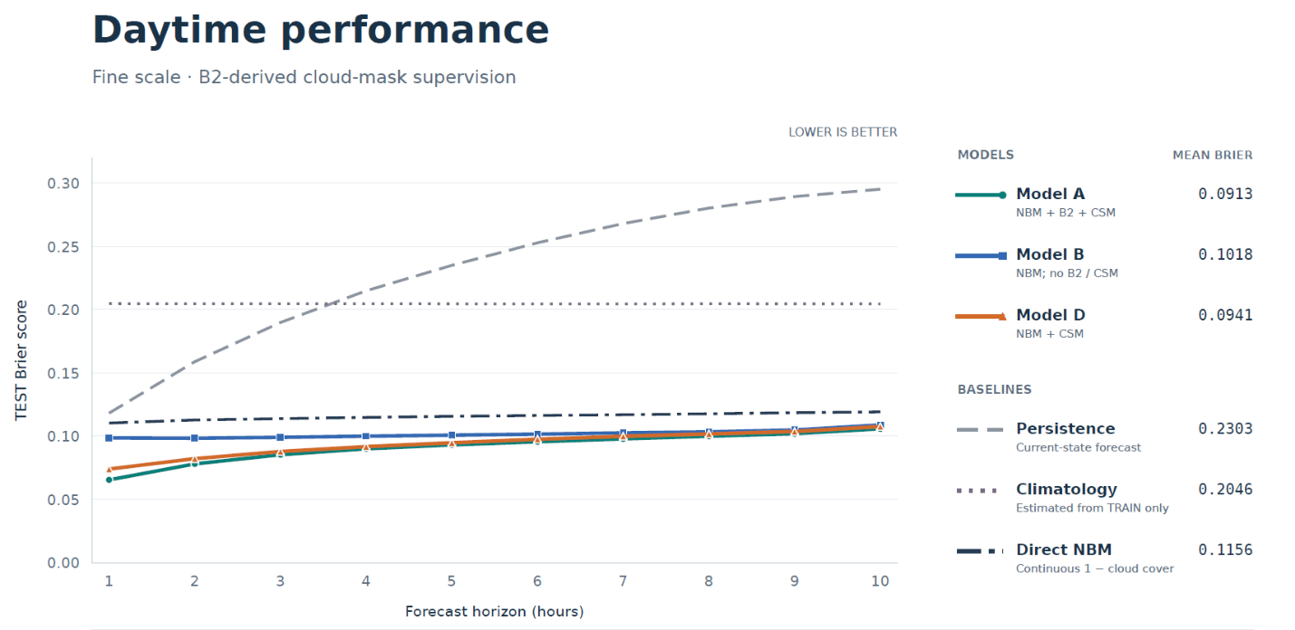
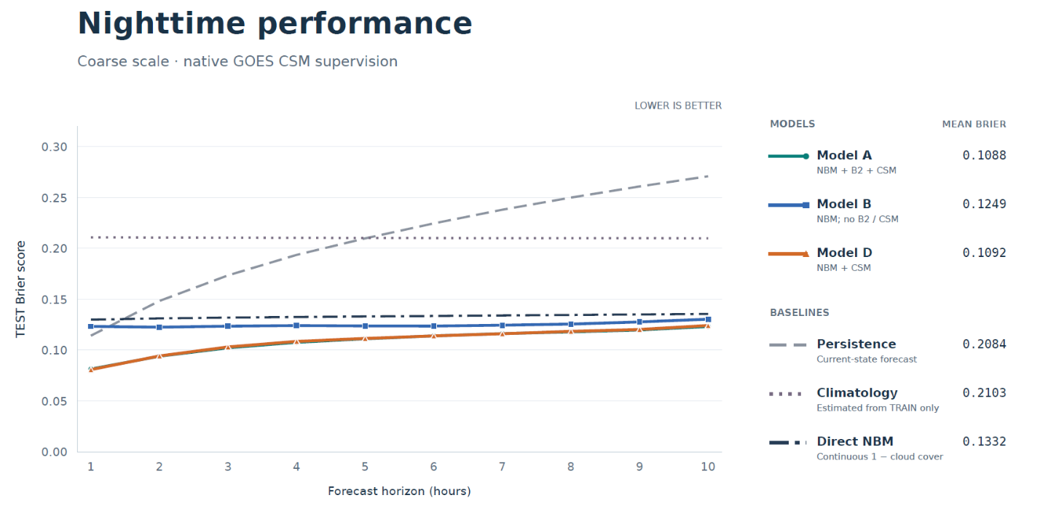
Figure P4-F1. Daytime and nighttime forecast performance across lead times for reference Model A, Model B with both current satellite inputs removed, and Model D with only the fine-scale satellite input removed. Three additional benchmarks are shown for comparison. Removing both satellite inputs degrades performance most strongly at short lead times, with the gap narrowing at longer lead times. Removing only the fine-scale input modestly degrades short-lead daytime forecasts but has little effect on nighttime performance. Fine-scale satellite observations are available only during daylight.

3. Impact of a larger input domain and spatial attention
The one-sided convolutional reach is about 43 kilometers, meaning that through the learned convolutions, a prediction at a given point is influenced by inputs as far as 43 kilometers in any of the 4 cardinal directions. Two ablations will test whether this convolutional reach is sufficient, and whether associated boundary effects are problematic:
- Model G adds a spatial attention block at the bottleneck, enabling a prediction at a given location to be influenced by any other location. As reported in Table P4-T1, the addition of a spatial attention block conclusively decreased nighttime performance, while it is inconclusive with regards to daytime performance. This is illustrated per forecasting horizon in Figure P4-F2. While theoretically, Model G could recover Model A performance by using Model A’s weights and setting the Model G corrections to zero, such performance is not guaranteed, as Model G weights were initialized from scratch. A few possibilities for the degradation:
  - the same training settings (regularization and learning rate recipe) were used for both A and G, and they don’t fit G as well.
  - Extra flexibility can hurt generalization: Figure P4-F2-2 shows the combined BCE loss as a function of training epoch. It can be seen that Model G achieves lower training loss eventually, but that it is accompanied by a higher validation loss. Thus, the 25% additional parameters might be learning relationships that hold in the training dataset, but fail elsewhere.
- Model I adds a “halo” of 50 km in each cardinal direction for the input domain, resulting in a 300x300 km2 domain, while keeping the output domain the same. This should remove most of the boundary effects, if there were any, by exposing more of the surrounding weather patterns. It is therefore a targeted test to determine whether boundary effects are significantly harming performance for the baseline 200x200 km2 input domain. Indeed, as reported in Table P4-T1, Model I is conclusively better than Model A for nighttime predictions. This is illustrated in Figure P4-F3, which clearly shows the nighttime improvement.

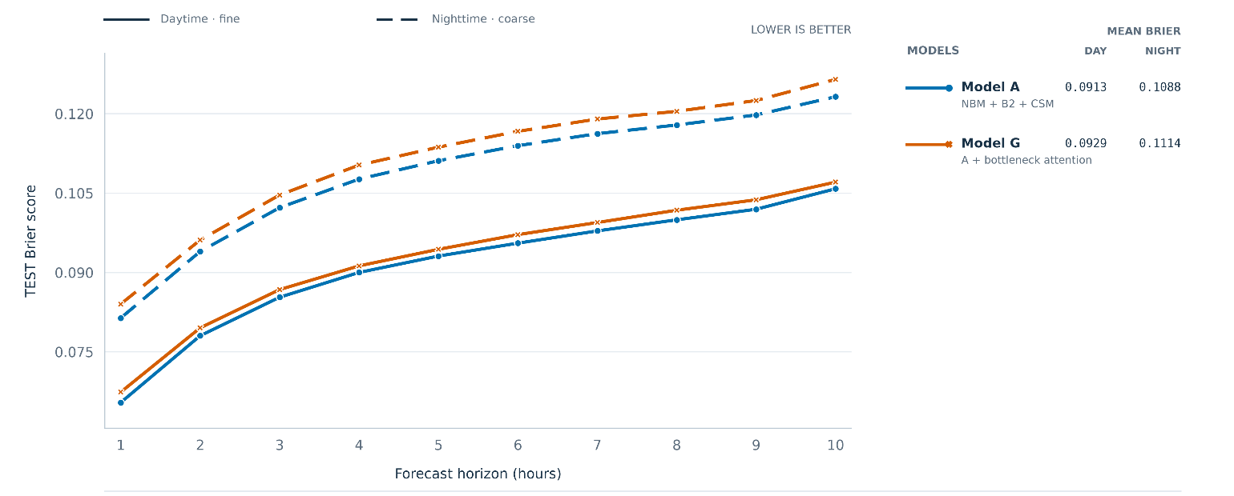
Figure P4-F2. Daytime and nighttime forecast for Model A (reference) and Model G (addition of spatial attention block right after the bottleneck). The dashed and solid lines represent nighttime and daytime forecast performance, respectively.

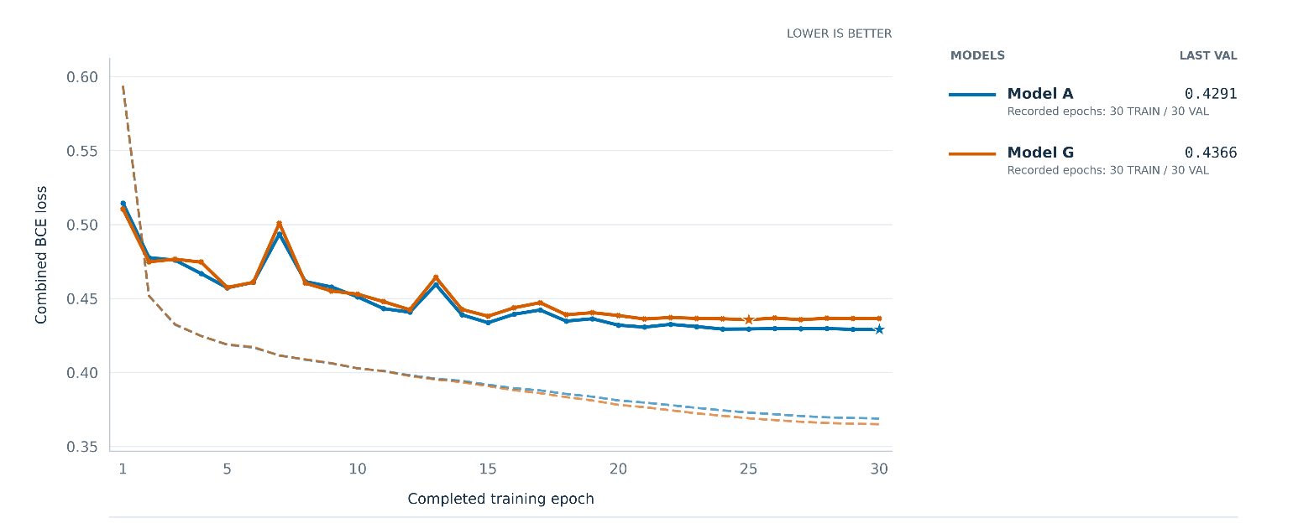
Figure P4-F2-2. Combined BCE learning curves for Models A and G. The solid line shows the validation loss, while the dashed line shows the training loss. The starts show the checkpoints selected by BCE computed on the validation set.

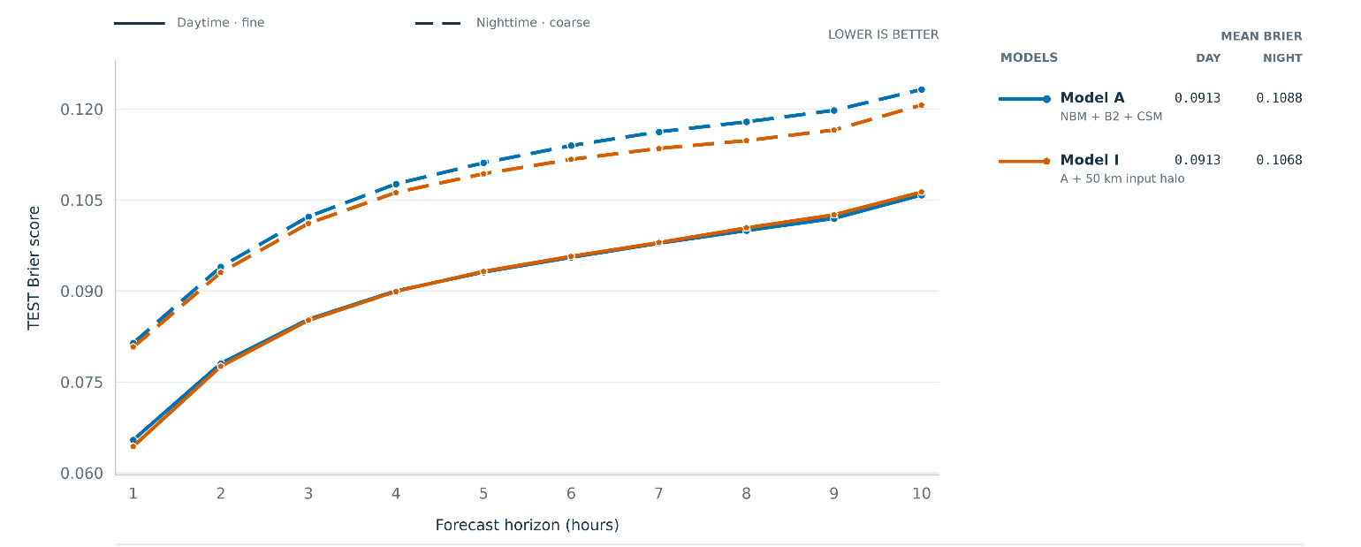
Figure P4-F3. Daytime and nighttime forecast performance for Model A (standard 200x200 km2 input domain) and Model I (larger 300x300 km2 input domain). The dashed and solid lines represent nighttime and daytime forecast performance, respectively.

4. Are the forecast inputs useful?
How well would the reference model perform without the NBM forecasts? This is what motivated the Model K ablation. Model K is the same architecture as Model A, except the NBM forecasts are not included. Model K is trained from scratch using the same regularization and learning rate recipe. It was expected that Model K will perform much worst than Model A, however it wasn’t obvious how that degradation would be as a function of forecast horizon. It was expected that the degradation would be most pronounced at long horizons, where it is expected that the model relies most heavily on the forecast inputs.
Figure P4-F3 shows that, while Model A performs significantly better than the NBM baseline for all horizons day and night, Model K performs better than the baselines for forecast horizons up to about 4 hours, and performs significantly worse for longer horizons. This is a useful ablation to understand the relative importance of the information provided by satellite images and forecast inputs, as a function of the forecast horizon. As reported in Table P4-T1, Model K conclusively performs worse for both daytime and nighttime predictions.
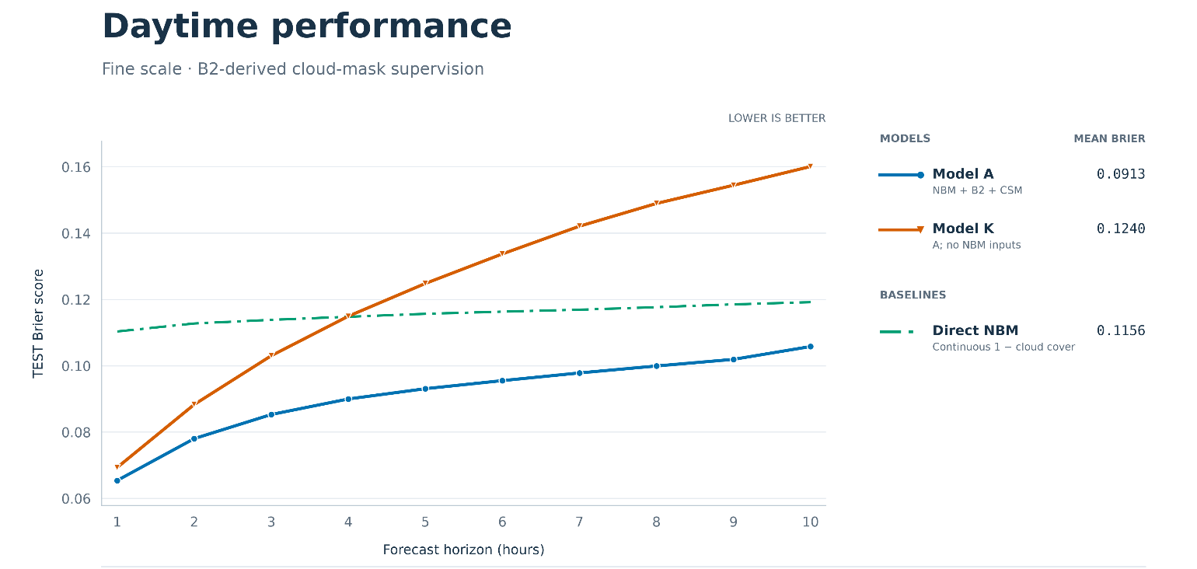
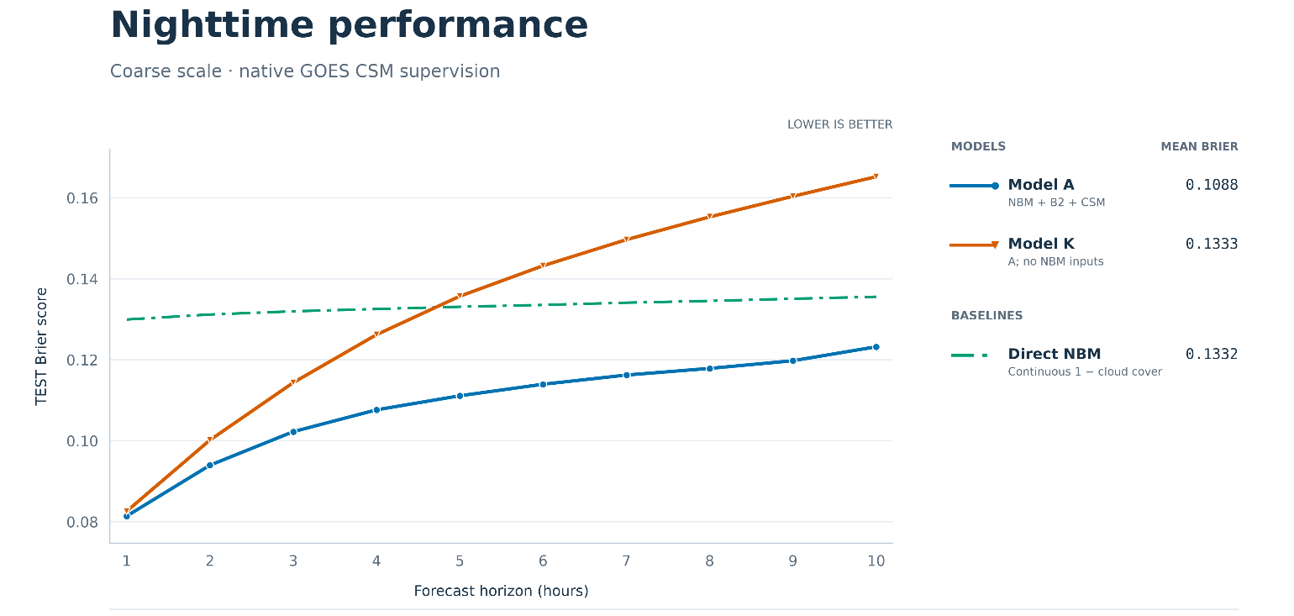
Figure P4-F3. Daytime (top) and nighttime (bottom) performance for Model A (reference, solid blue) vs Model K (Model A without the NBM forecast inputs, plotted in solid red). The NBM baseline is also shown using a green dashed line.

5. Are the static landscape inputs useful?
In the reference Model A, at the fine-scale input level, two static input feature maps are fed, the normalized elevation and land fraction. This addition is based on the assumption that cloudiness at a given location is correlated with its elevation as well as whether it is land or water, as well as changes in these properties in the location’s neighborhood. In other words, it is assumed that these two static input maps provide useful information to the model because different locations with similar land fraction and elevation patterns in their neighborhood, share more similar cloudiness patterns because of that, compared to two given locations that do not share such similar patterns.

Figure P4-F4 shows that indeed this appears to be the case, with Model J performing more poorly than Model A day and night, across all horizons, with deterioration more pronounced at longer forecasting horizons. Table P4-T1 corroborates this observation, with Model J conclusively worse than Model A for nighttime prediction.

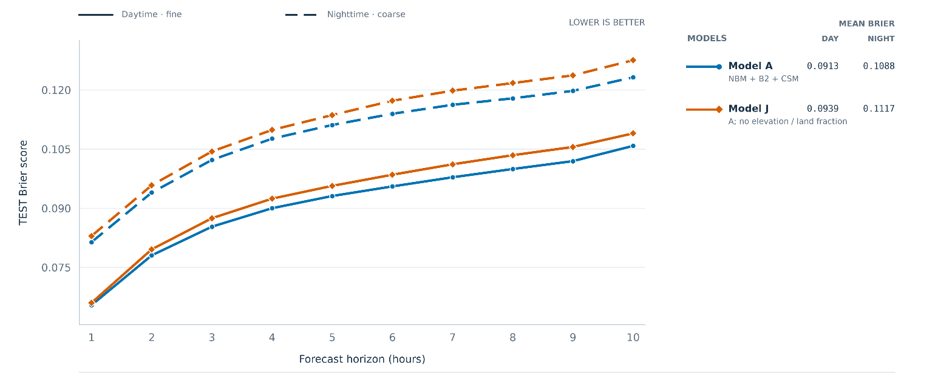
Figure P4-F4. Daytime and nighttime forecast for Model A (reference) and Model J (removal of static land feature inputs [elevation and land fraction]). The dashed and solid lines represent nighttime and daytime forecast performance, respectively.

6. Is additional recent cloud evolution useful?
In reference Model A, only the current satellite image is provided. In Model C, the previous-hour satellite image is also provided, which is meant to test whether providing recent cloud evolution in the form of previous-hour satellite images, would help the model infer cloud movement, growth, and dissipation.

As shown in Figure P4-F5, Model C performed worse than Model A, signifying perhaps that the addition of the previous-hour satellite image doesn’t provide the model with more useful information about the future, than is already contained in the NBM hourly forecast inputs.

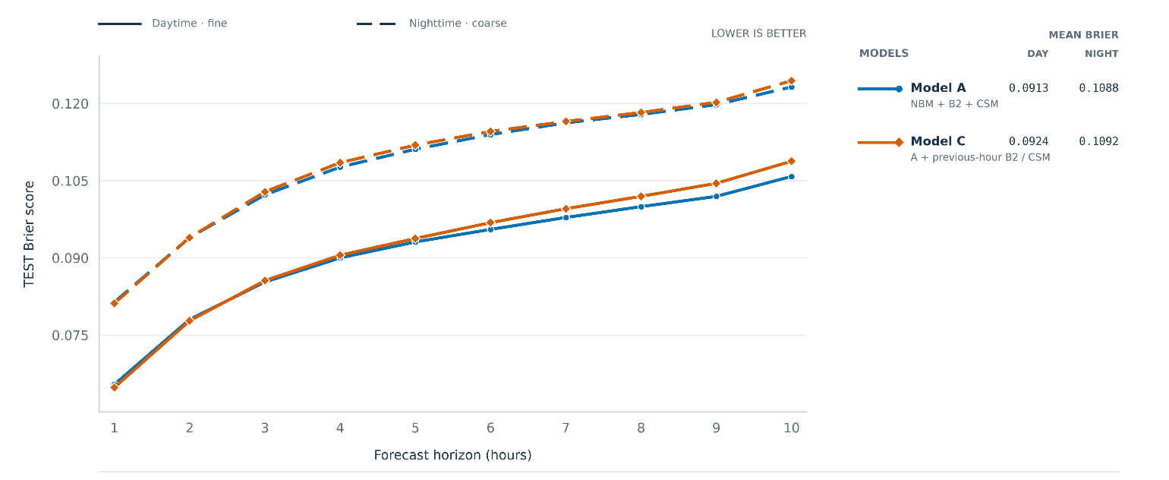
Figure P4-F5. Daytime and nighttime forecast for Model A (reference) and Model C (Model A with the addition of previous-hour satellite image, in addition to the current satellite image). The dashed and solid lines represent nighttime and daytime forecast performance, respectively.

7. Are additional forecasting inputs useful?
Models E and F tested whether adding more granularity to the NBM hourly forecast inputs would help the model make accurate predictions. Model E is almost the same as Model A, with the addition of the NBM forecast input uncertainty, i.e., for each forecast and spatial location, how certain the NBM model is about the cloudiness at that time and location. The hypothesis was that this could provide ensemble disagreement as an uncertainty cue for adjusting the model’s reliance on NBM guidance. Model F is also almost the same as Model A, but with the addition of low-cloud (below 3,000 ft) probability maps and masks, in addition to the total-cloud cover probability maps and masks already provided in Model A. The hypothesis was that providing targeted low-cloud cover predictions that cannot be recovered from total cloud cover alone, could help the model adjust its predictions depending on the height of the cloud cover.

Figure P4-F6 illustrated the the Brier score on the test set for these two ablations. In both cases, given the CI reported in Table P4-T1, improvement over Model A is inconclusive.

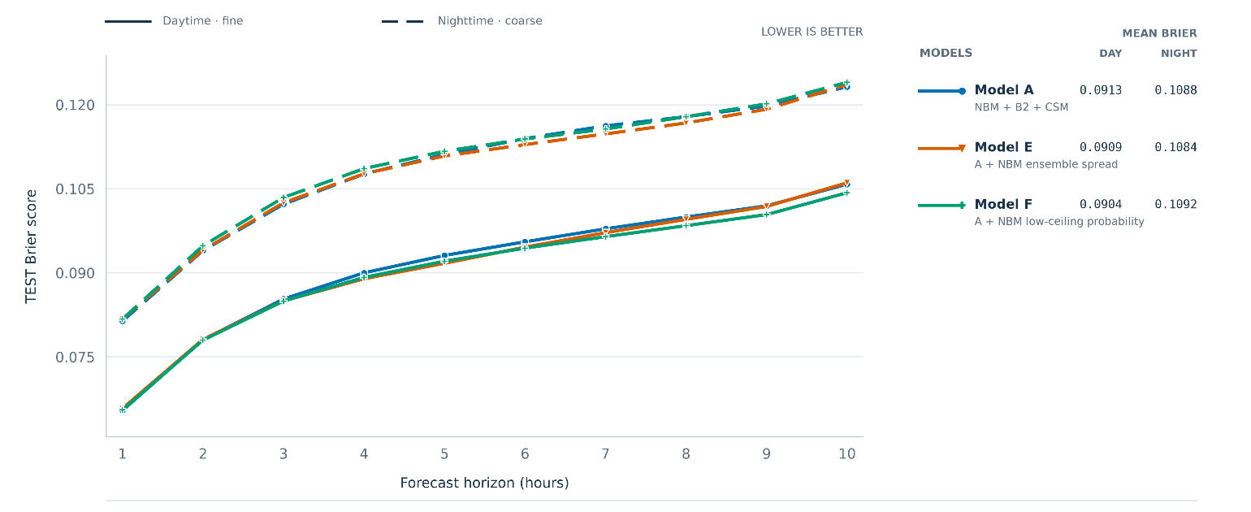
Figure P4-F6. Daytime and nighttime forecast for Model A (reference), Model E (Model A with the addition of NBM forecast uncertainty maps), and Model F (Model A with the addition of NBM low-ceiling cloud probability [in addition to NBM total cloud probability which is provided in Model A]. The dashed and solid lines represent nighttime and daytime forecast performance, respectively.

7. What about blends of different seeds?

Averaging predictions from neural networks with the same architecture trained using different random seeds can improve predictive performance relative to individual runs (Hansen and Salamon, 1990; Lakshminarayanan et al., 2017). To test this, for both Models and I, we trained two additional models from scratch using a different seed, for a total of 3 runs (seeds) per model. The performance reported for A3 and I3 in Table P4-T1, shows that we can conclusively say that the blends perform better than the individual seed. In fact, we verified that they perform better than any of the 3 seeds individually. Figure P4-F7 shows a three-seed blend for Model I vs the single-seed model, and it can be seen that it performs better than the single-seed Model I across the board.
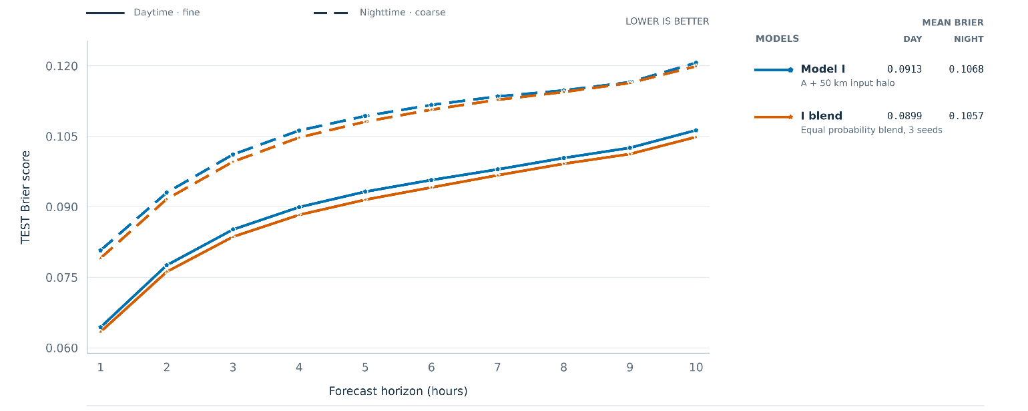
Figure P4-F7. Daytime and nighttime forecast for single-seed and three-seed-average Model I blend. The dashed and solid lines represent nighttime and daytime forecast performance, respectively.

But how good is it really?
We’ve looked at a total of 10 different model ablations. We’ve selected Model I three-seed blend. Now, the most important question remaining is: how good is it compared with selected baselining forecasting references? This is the focus of the next post.

Addendum: How the 95% CI is estimated
Two sources of uncertainty are considered:
- Test-set or weather uncertainty: how the estimated Brier score would change with a different sample of weather conditions.
- Seed uncertainty: how the Brier score changes when the same model is retrained with different random initial weights and training order.
Weather uncertainty is estimated from 10,000 resamples of the test dataset, approximately preserving the number of dates in each season and using identical selections for all models.

Pooled reference seed variance is computed from three training runs each of Models A and I and is assumed to be similar across all models. For comparisons between different models, each model’s seed variance contribution is the pooled reference seed variance divided by its number of training runs. The two seed variance contributions are then added.
For model comparisons, weather variance is estimated from the paired score differences between the two models. Seed variance is calculated using the number of training runs for each model and the pooled reference seed variance estimated from Models A and I.
The weather and seed variances are added, and the square root of their sum gives the combined standard error. The approximate 95% CI is then:
Paired score difference ± 2.78 × combined standard error
The factor 2.78 is the Student’s t multiplier for four degrees of freedom, corresponding to the degrees of freedom used to estimate the pooled reference seed variance from Models A and I. Applying this multiplier to the combined standard error is an approximation intended to be conservative.
This calculation assumes independent, additive weather and seed effects, with seed effects also independent between models.

POST 5

Does Fogcast forecast better, or just draw maps with a finer discretization?

A fair comparison
Table P5-T1 describes the three forecast references that were used to benchmark the neural networks trained. Persistence is a standard and utmost-simple reference for forecasting models, as it assumes that the current state will persist for all future times.

Table P5-T1. Description of the three forecast references used for baselining against the neural network results.
Baseline | Forecast construction | Information used | Mean TEST Brier score
Baseline | Forecast construction | Information used | Daytime fine grid | Nighttime coarse grid
Persistence  Current-state forecast | Hold the current continuous B2 clear score fixed at every lead. Where B2 is unavailable, use current CSM, then neutral 0.5 if both are unavailable. | Issue-time B2 + CSM;  no future observations | 0.2183 | 0.2084
Climatology  Historical frequency | Use the TRAIN-only clear frequency at each location, indexed by target month and Pacific local hour, with prior smoothing. | Historical TRAIN labels;  target calendar month + hour | 0.2046 | 0.2103
NBM Predictions  Using forecast labels directly | Convert NBM total sky cover C (%) to a clear score: 1 − C/100. Align the target-hour field to the verification grid | NBM forecast available at issue time;  typical lag of 2 hours (i.e., +1 hour forecast uses NBM predictions from 3 hours ago) | 0.1156 | 0.1331

Figure P5-F1 illustrates for a sample time, the base neural network model (Model A) and reference forecasts, as well as corresponding training labels. All fields are thresholded for ease of visualization, but in practice all shown fields except for persistence, are continuous fields from 0 to 1.
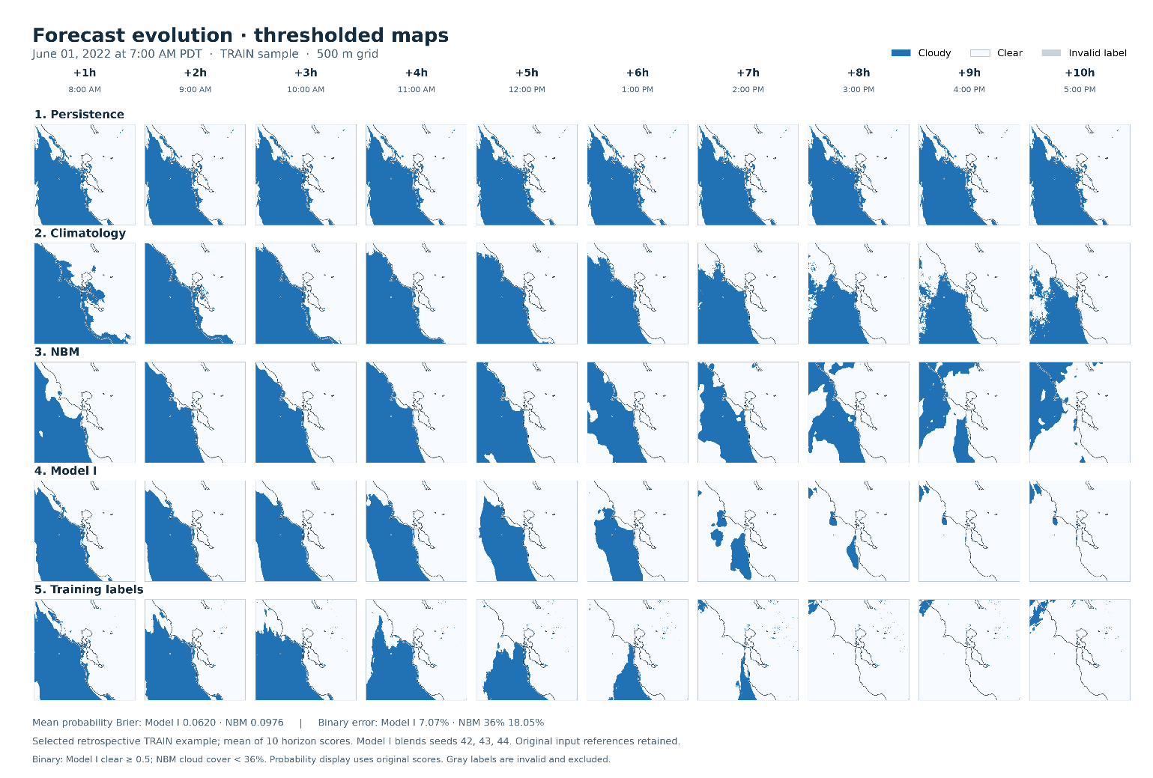
Figure P5-F1. Sample Model I and reference forecasts, as well as corresponding training labels, all thresholded for ease of visualization. Data timestamp: 2022-06-01 at 7:00AM PDT.

Figure P5-F2 compares the base model (Model A) with three reference forecasts: persistence, climatology, and direct predictions from NOAA’s National Blend of Models (NBM), which provides total cloud cover forecasts on a coarser grid. Among the reference forecasts, persistence achieves the lowest Brier score at the +1-hour horizon, but its performance deteriorates as lead time increases. Climatology remains nearly constant across forecast horizons, while direct NBM achieves the lowest mean Brier score across the ten horizons.

Persistence’s advantage over NBM at +1 hour may partly reflect the difference in information age. This evaluation uses NBM cycles initialized two hours before each forecast issue time to account for availability delays. Consequently, the NBM prediction for one hour ahead is a three-hour forecast from that earlier cycle. Persistence instead carries forward the latest available satellite-derived state. Access to more recent observations may therefore contribute to its stronger performance at the shortest lead time.

Model A achieves lower Brier scores than all three reference forecasts at every evaluated horizon. Its advantage over NBM, the strongest reference overall, is greatest at short lead times and narrows as the forecast horizon increases. This pattern is consistent with the benefit of incorporating recent, high-resolution satellite-derived clear-sky information: current observations provide valuable detail for near-term forecasts, but become less informative about future conditions as lead time increases. The NBM forecasts supplied to Model A may therefore play a larger role at longer horizons.

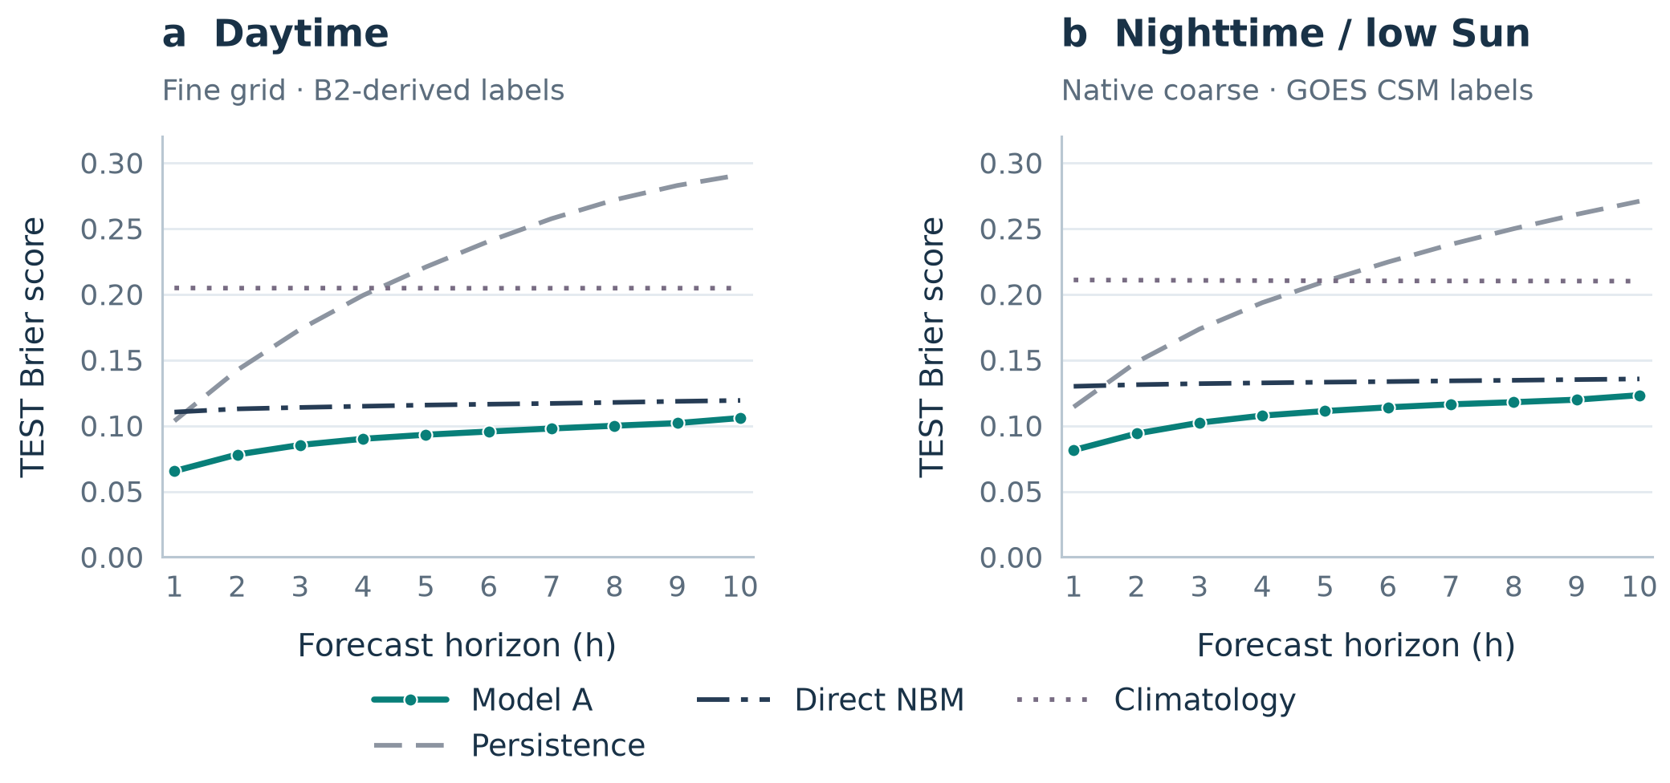
Figure P5-F2. Forecast performance of Model A compared with three reference forecasts: persistence, climatology, and direct NBM.

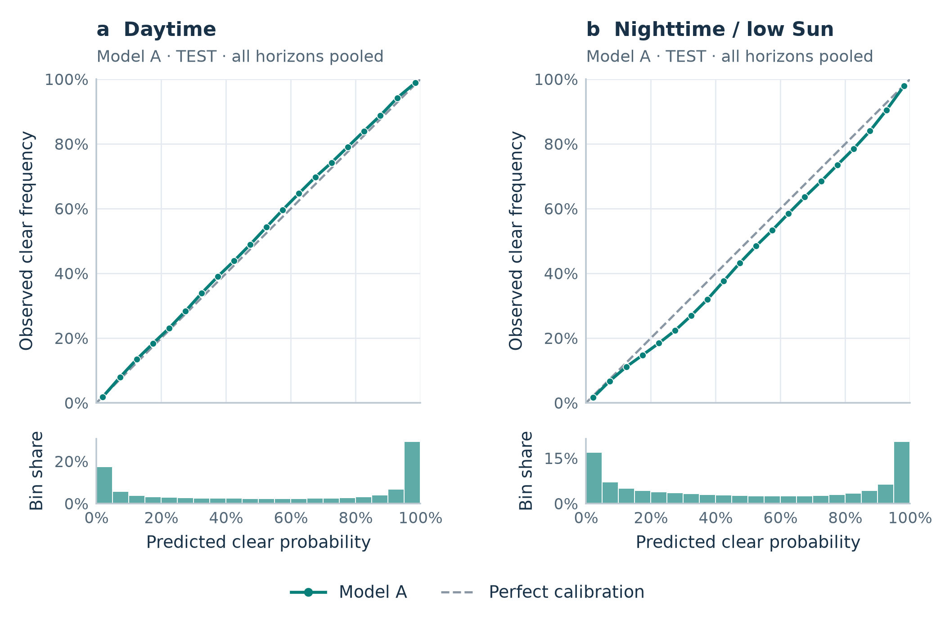
Figure P5-F3. Reliability plot for Model A, combining all 10 forecast horizons and using 5% bins.

5. The honest assessment

Some of the model variations (Models B, D, J, K) were ablations meant to verify the usefulness of having certain inputs feed the model. They all conclusively performed worse than the reference Model A, and thus showcased the usefulness of incorporating each of the Model A inputs.

Other model variations (Models C, E, F, G, I) were attempts at improving the “fogcasting” accuracy. However, all but one (Model I; expanded 300x300 km2 input domain) of these improvement attempts failed to show conclusively an improvement over the reference model.

Therefore, the final retained model, the blend of 3 seeds of Model I, is very similar to the Model A, and performs conclusively better, however only slightly better. The good news is that the retained model significantly outperforms all 3 selected baselines (persistence, climatology, and NBM total cloud cover predations), at all forecasting horizons. It is thus, as far as I’m concerned, the tool I will use to plan my next picnic in San Francisco, in assessing whether Ocean Beach will likely clear up before sunset, or whether I should move it to Dolores Park.

