|  |  |  |
| --- | --- | --- |
| **Document No:** | **Document Name:** | **Pages:** |
| **Revision No:** | **Revision Date:** | **Area Supervisor:**  Brenda Goodman |
| **Issued Date:** | **Prepared by:** G. Beechum | **Approved by:** |

1. **Purpose:** To provide instructions for machining UMC adapters.
2. **Scope:**  To standardize the machining process of the #” UMC adapters to meet design requirements.
3. **Responsibility:** To be performed by trained operator, department leader, or supervisor.
4. **Terminology/Defined terms:**
   1. MDI: Manual Data Input
5. **Tools:**
6. **Safety:** Follow all Globe Fire Sprinkler machine safety requirements.
7. **Procedure:**

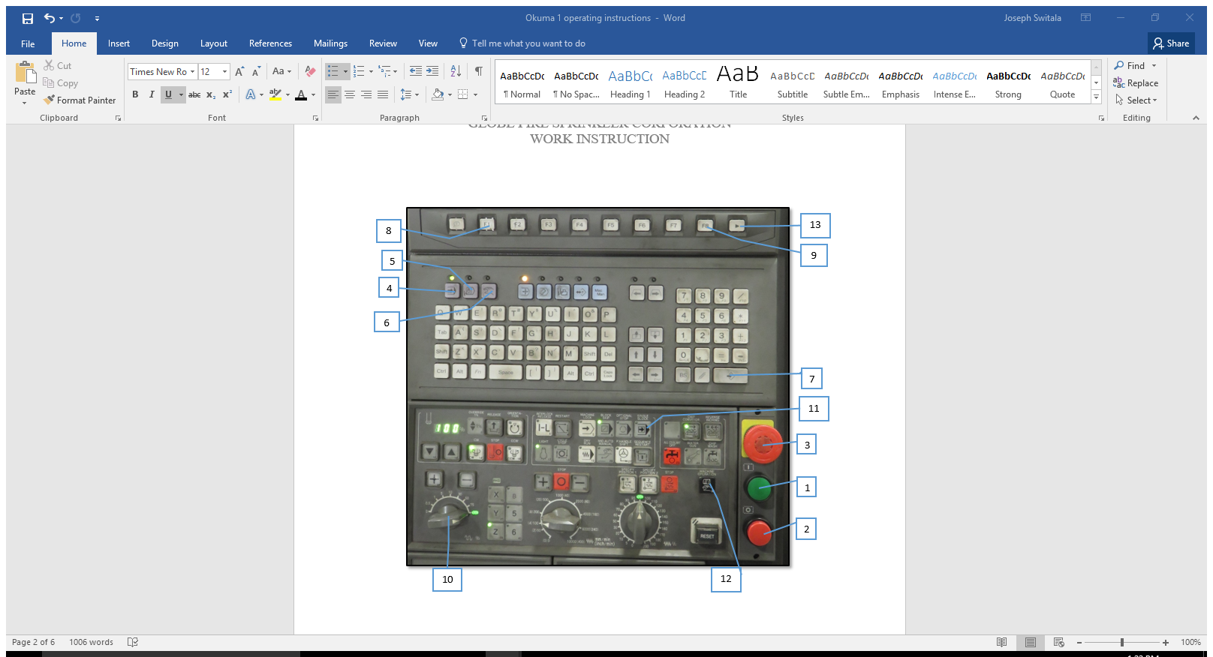

**Figure 1: Main Control Panel**

**1. Cycle Start 2. Feed Hole 3. Emergency Stop 4. Auto 5. MDI 6. Manual 7. Enter 8. F1**

**9. F8 10. Speed Dial 11. Single Block 12. Manual Machine Operation 13. Screen Over**

* 1. Machine Startup
     1. Refer to document No. ## for instructions on machine startup.
  2. Selecting the program
     1. Press “MDI” then “F1” (Program Select). A list of all the programs will show. Use the arrow keys to scroll through and highlight the desired one. Press “Enter” to select it.
        1. The title of the program is the last three digits of the part number. This can be found on the container that the parts are received in.
        2. For example, if the part number is 317841, the program name is 0.000841
     2. If changing the program and/or changing products, a complete tool check must be completed.
        1. Refer to document No. ## for instructions on performing tool checks.
  3. Securing the adapter in the fixture for the first operation
     1. Use the air hose to blow off any debris and/or coolant from the fixture.
     2. Jaws used – Abbot KTT8S on Jaw 3. V cut in front. 6 roots showing.
  4. Securing adapter for second operation
     1. Use the air hose to blow off any debris and/or coolant from the fixture.
     2. Special Fixture – Jaws = H&R MFG 149 25 OP 5 roots showing
        1. Jaw #1 has centered arrow
     3. Place adapter into fixture and rotate clockwise.
     4. Tighten jaws.
     5. Close the door and press the cycle start button
  5. Removing valve from second op fixture
     1. Open the loading door.
     2. Before removing adapter, air hose the entire adapter to remove debris and minimize coolant loss.
     3. Loosen jaws.
     4. Rotate adapter counter-clockwise then remove from fixture.