Dear All,

I have been analyzing the evolution of the Integral orbit, in terms of AOS/LOS visibilities and the expected trends in the radiation environment and have the following recommendations:

* Lower belts exit to 50000km from end-August. This would be pending a change to the mission agreement with scheduling office to increase our default coverage and the continued favorable evolution of the radiation levels.
* This would mean that, for the revolution with the shortened visibility, the instrument activation would be slightly delayed relative to the other two by 20 -30 mins for the first few months as the AOS visibility improves.
* Maintain belts entry at 56000km until at least Q4 2019 pending further monthly evaluation of both visibility and radiation evolution.

We would also perform a full end to end mission planning test in order to determine if there are any unexpected consequences, although we believe this to not be the case after assessing the placement of keyword events that drive the placement of certain instrument EDs.

Please let me know if you concur with my below analysis.

***********************************************************

**AOS/LOS Times (see longitude plots below for 8 day orbit cycle, blue line corresponds to reference orbit, each dotted line corresponds to one revolution AOS/LOS, purple line when longitude meets coverage requirements)**

The current minimum ground station coverage requirement is based upon maintaining ground station TC visibility between the dashed black lines defined in 2015 based on the max visibility at that time.

* Figure below shows the current coverage situation around perigee.

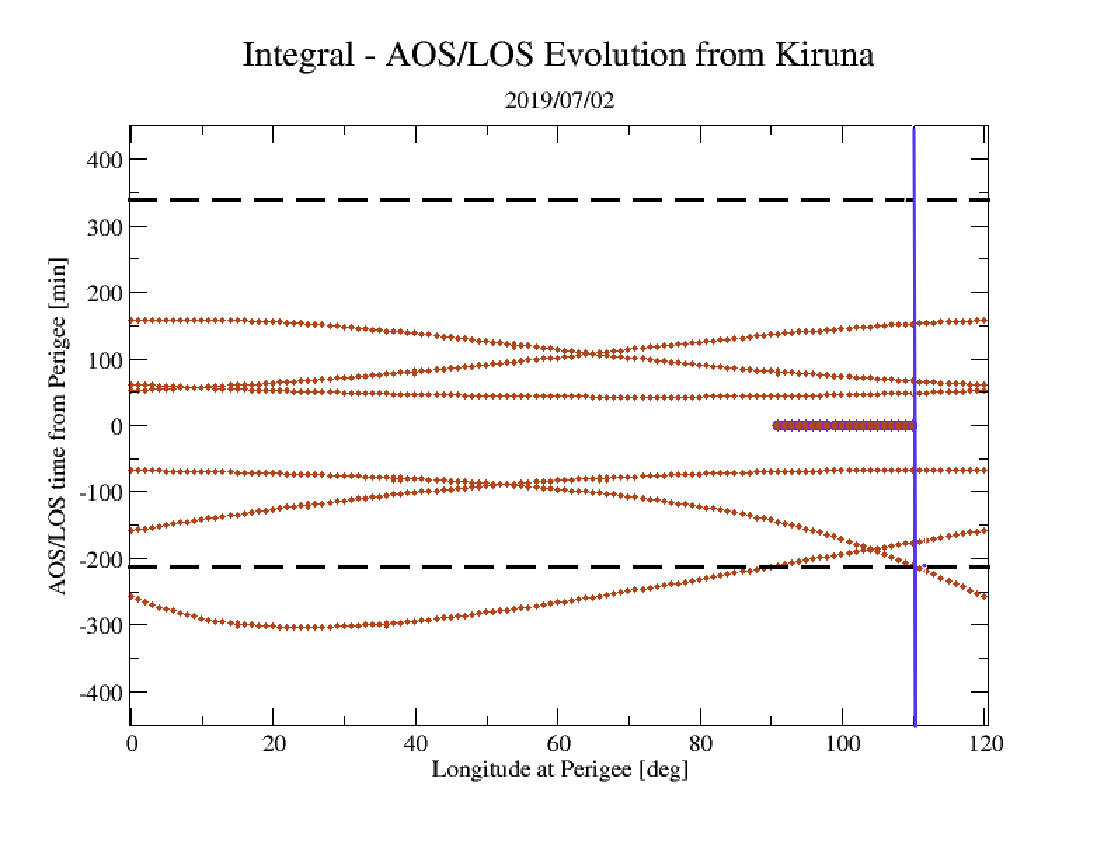

**Mid_2019_Visibility**

* Figure below shows that from mid-2020 it will be impossible to meet the current requirement for visibility on the descending arc (LOS) for all revolutions irrespective of the longitude at perigee that is maintained (currently targeted at 110 degs). AOS times will fall to between 40 - 90 mins after perigee for all revolutions

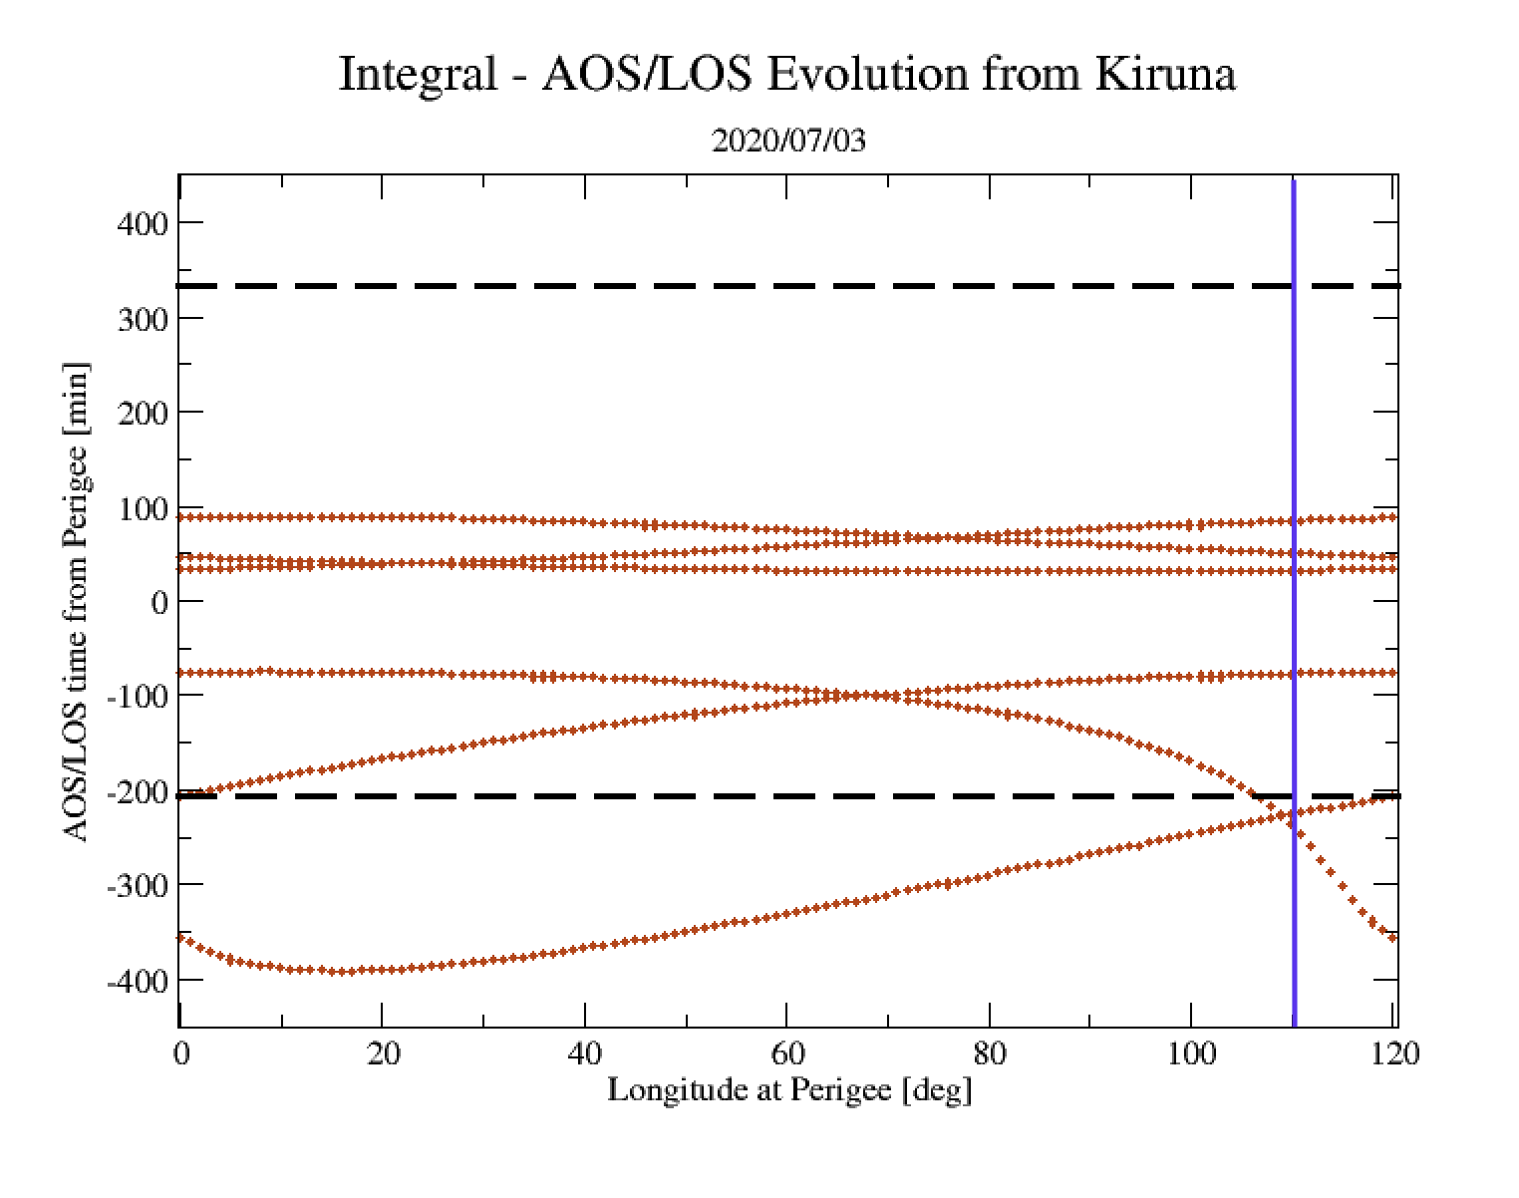

**Mid_2020_Visibility**

* From mid-2020 to mid-2021 time LOS will tend to ~270 mins (55000km) for 2 of the 3 revs (figure below). In the same time period AOS times will fall to between 40 - 60 mins after perigee for all revolutions .

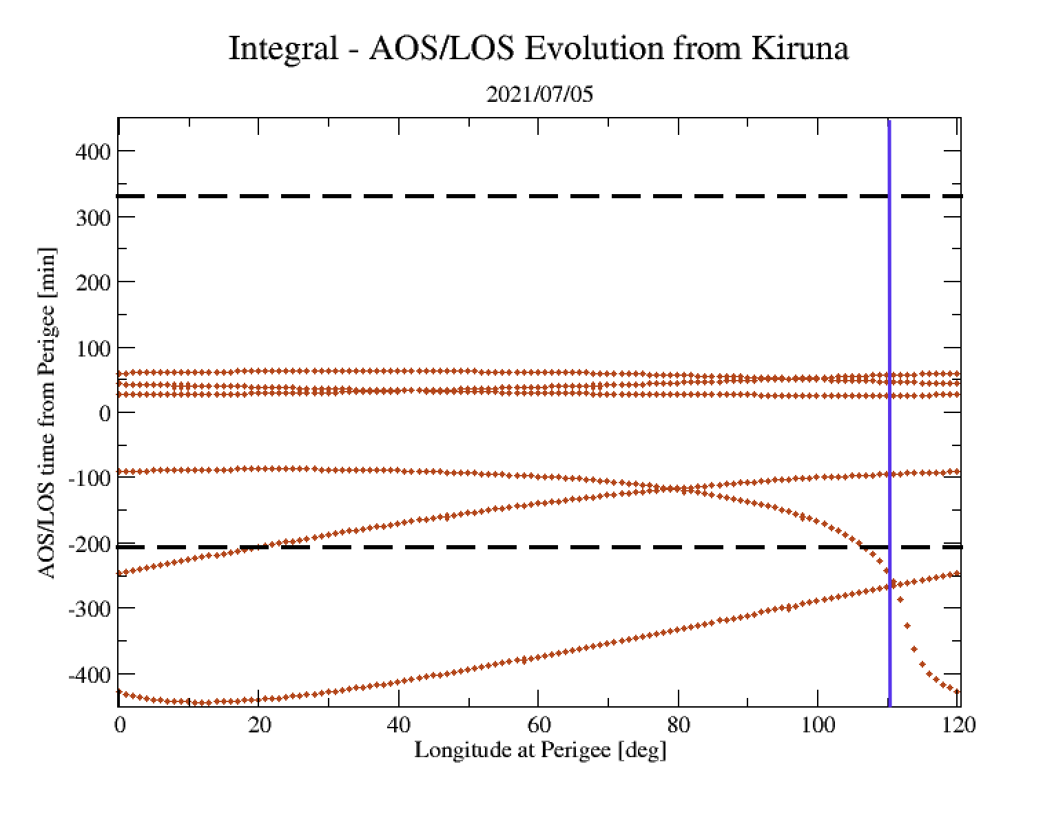

**Mid_2021_Visibility_Onwards.png**

* The situation then remains largely stable until mid-2023 past which it will be possible to again meet the current requirements by altering the longitude at perigee to ~20 degs (figure below)

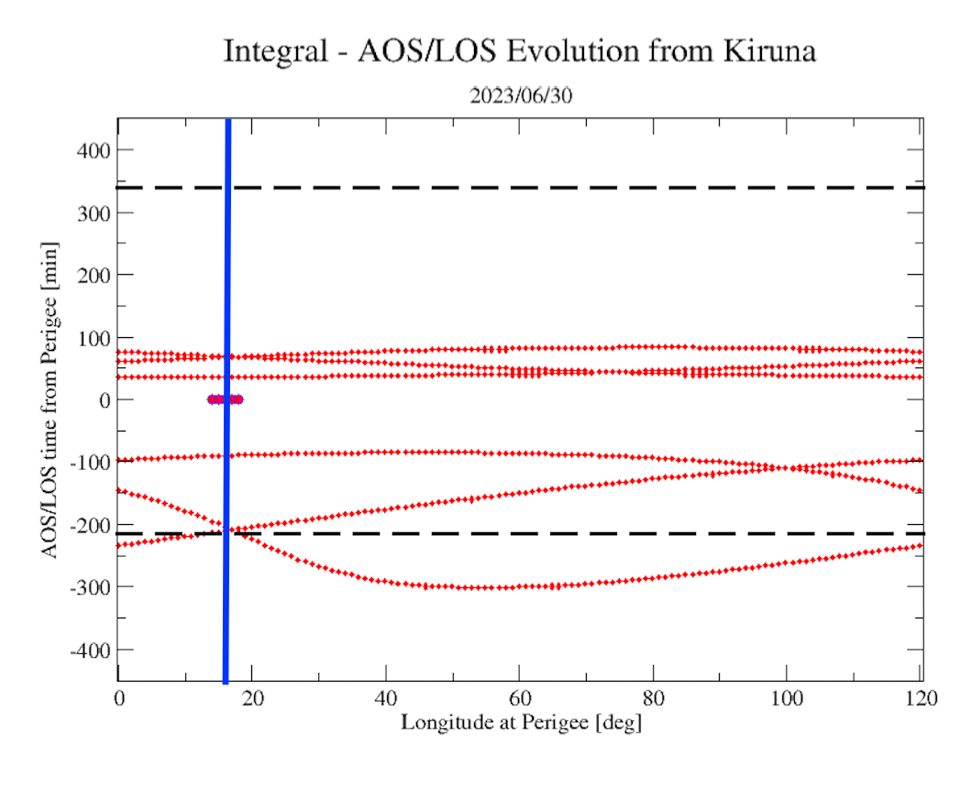

**mid_2023_Visibility.png**

A reassessment of the visibilities should be performed annually in order to determine if the new strategy can be maintained. Past mid-2023 AOS will rise again towards current altitudes and LOS fall towards current altitudes.

**Radiation environment (see figure 6 from Lionels belts_predict paper below)**

* The smoothed radiation environment on the descending arc (belts entry) appears to be rising towards 50 - 55000km. In reality there will likely be a much larger spread in the observed flux resulting in the need to set the altitude much higher than this. The same trend can be seen in recent ISDC data
* The smoothed radiation environment on the ascending arc (belts exit) appears to be falling dramatically to altitudes well below 40000km. The same trend can be seen in recent ISDC data

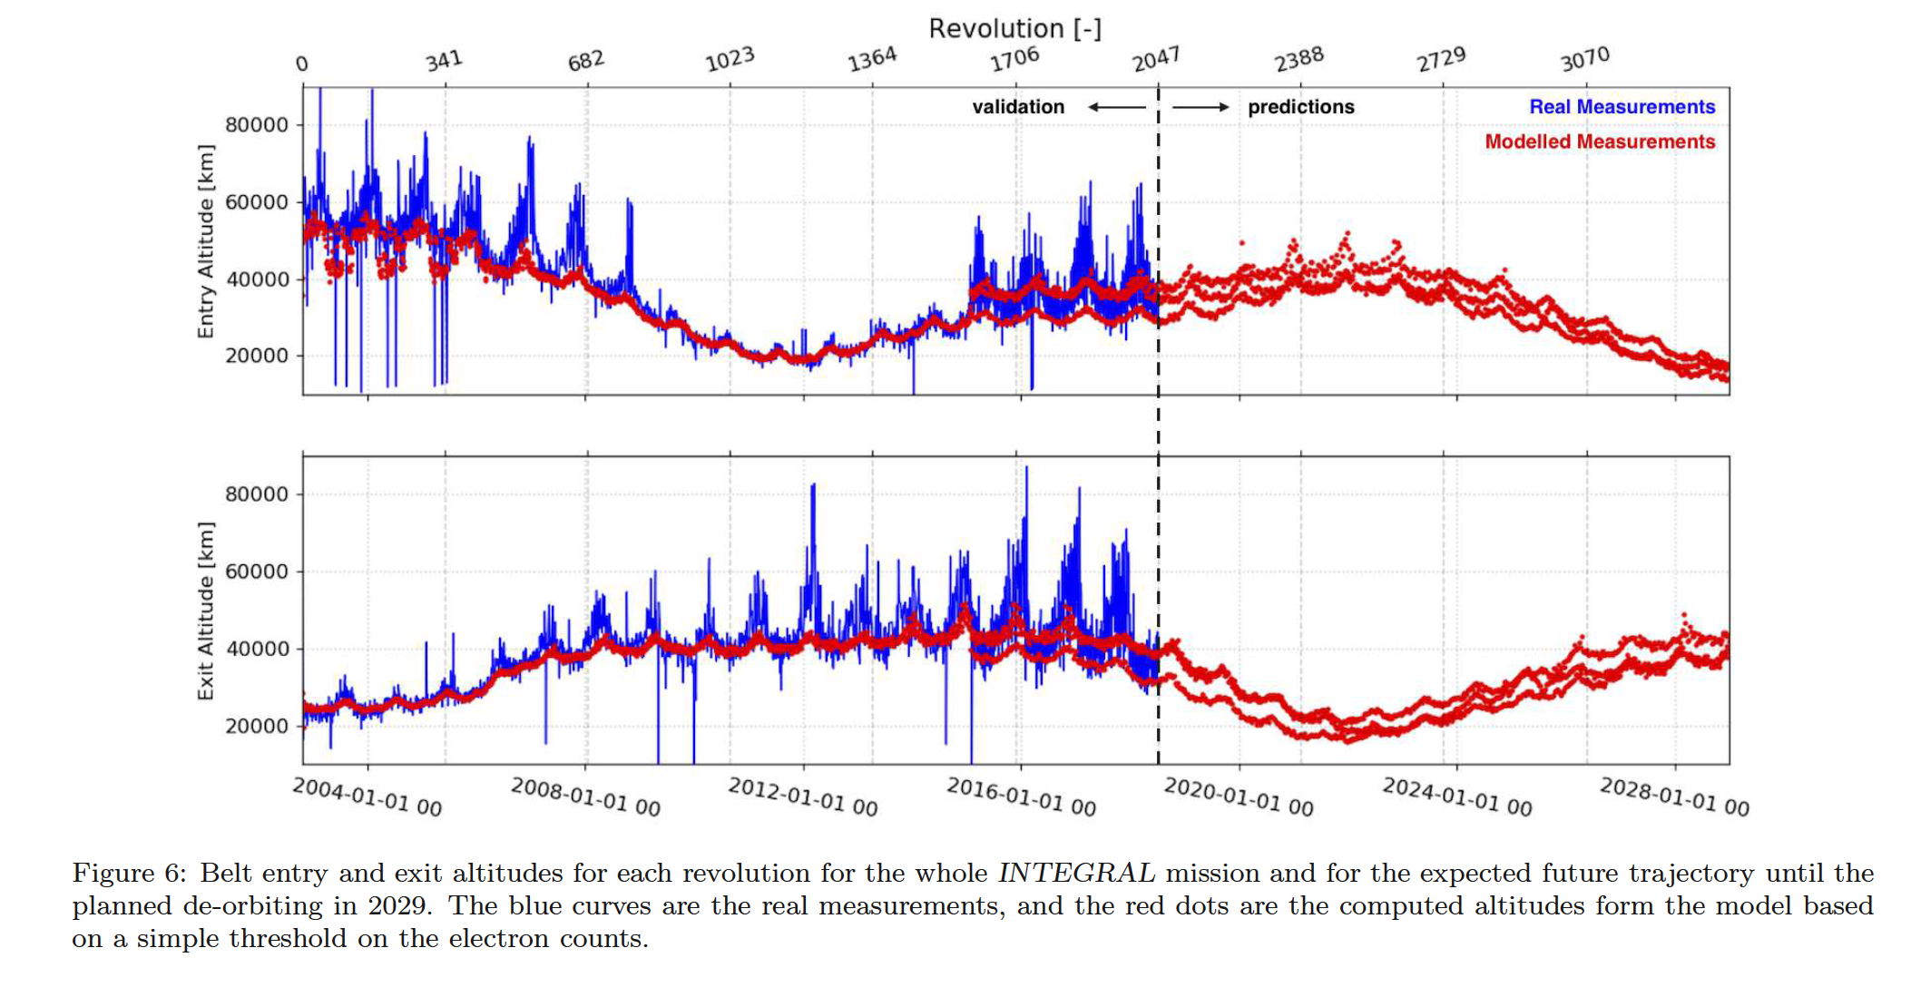

**Belts_Predict.png**

**Current Scheduling Agreement**

* Routine : limit support to visible time between 135 minutes before “56000 Km ascend” event and 60 minutes after 56000 Km descend”event. The 135 minutes is the maximum amount of time to perform all activities at the beginning of the rev (AOS_CHK, RWB, SATENG etc)
* Eclipse : limit support to visible time between 150 minutes before "56 000 Km ascend" event and 60 minutes after "56 000 Km descend" event. The 150 minutes is the maximum amount of time to perform all activities at the beginning of the rev (AOS_CHK, RWB, SATENG etc)

What this means is that, serendipitously, the loss of coverage towards the end of revolution is largely mitigated by a high radiation environment at a higher altitudes while the improving coverage at the beginning of the revolution can be fully taken advantage of due to the opposite effect.

I would estimate that we can realistically hope to lower the belts exit time progressively down towards 45000km over the next 2-3 years while maintaining a longitude at perigee of ~110 degs, which should potentially recover between 60 - 90 mins or so of observing time during the period 2020 - 2023, driven by the actual radiation environment.

I have created three images to help visualize this, showing the sequence of events for the AOS/LOS and belts entry/exit times & altitudes. All times referenced in the slides correspond to the blue line in the above figures and represent the revolution with the most constrained visibility and the average deltaT across the eclipse and sunlight season. However, in order to continue to fulfil the rule that we must have 60 mins between belts entry and LOS, in case of DPE crash, the belts entry altitude will need to be raised to ~65000km for several years (2021 - 2023).

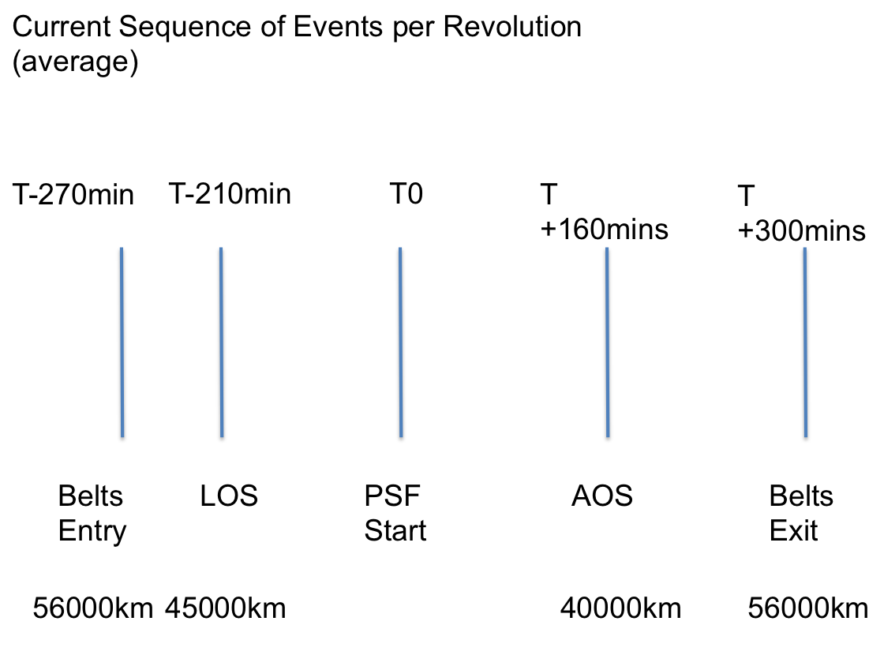

**Current_Seq_Events.png**

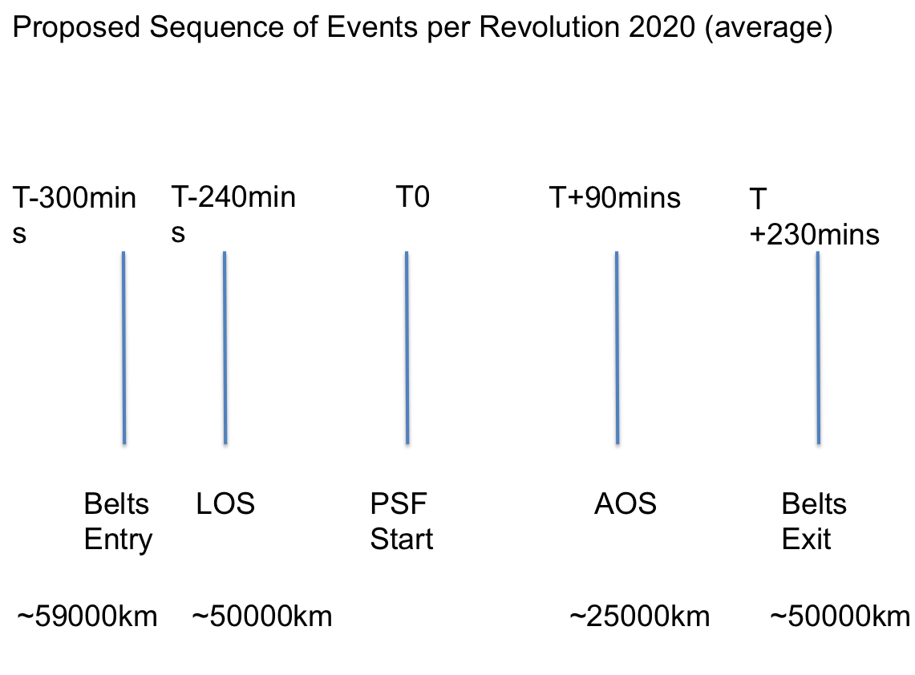

**Seq_Events_Rev_2020.png**

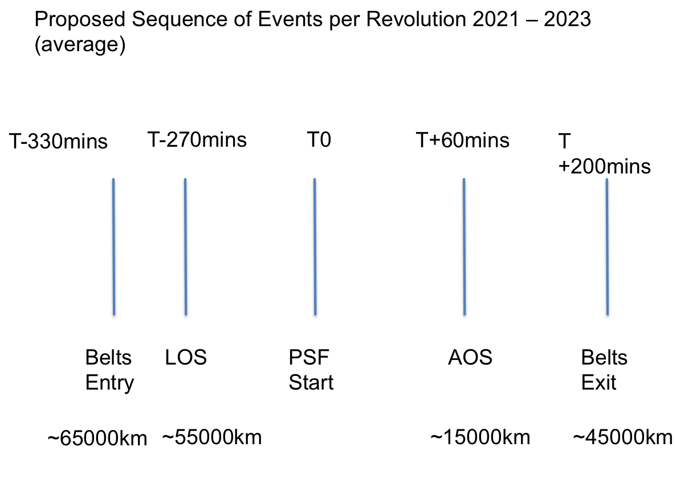

**Seq_Events_Rev_2021_onwards.png**