SECURITY ASSESSMENT REPORT
Grand Marina Hotel — Replay Attack Defense
Prepared for: Marcus Webb, General Manager
Prepared by: Oluwagbemileke Adesiyan, Cybersecurity Extern — Hydroficient
Date: March 16, 2026
1. THE PROBLEM
Even after encrypting the pipeline and verifying every device’s identity, an attacker could record a legitimate sensor reading and replay it later — causing the system to accept stale, outdated, or deliberately falsified data as if it were a live reading.

In practical terms for Grand Marina: if a pipe bursts and the HYDROLOGIC sensor sends a danger reading, an attacker sitting on the hotel network could replay a previously captured ‘normal’ reading on top of it. The alert system would see normal pressure and flow — and stay silent — while the damage spreads.

This is not a theoretical risk. Our testing confirmed it. Within seconds of capturing five legitimate sensor messages, we replayed them against the unprotected subscriber — and all five were accepted without a single error or warning.

2. WHAT WE TESTED
We ran 12 controlled experiments across four defense configurations and three attack types to identify exactly which combination of protections is required.

Defense Configurations Tested
Configuration | What It Does
No Defense | Baseline — no validation on incoming messages
Timestamp Only | Rejects messages older than 30 seconds
Sequence Counter Only | Rejects messages with a duplicate or old sequence number
All Three Defenses | Timestamp + Sequence Counter + HMAC signature verification

Attack Types Simulated
Attack Type | Description | Real World Scenario
Immediate Replay | Message replayed within 5 seconds of capture | Attacker intercepts and instantly resends a reading
Delayed Replay | Message replayed after 60 seconds | Attacker waits for a critical moment then replays old data
Modified Replay | Sensor values tampered before replay | Attacker injects false flow rate to hide a pipe burst

3. WHAT WE FOUND
The results were clear: no single defense is sufficient. Each individual protection has a blind spot that attackers can exploit. Only the combination of all three achieved complete protection.

Defense | Immediate Replay | Delayed Replay | Modified Replay | Overall
No Defense | 0% blocked | 0% blocked | 0% blocked | ❌ Fully exposed
Timestamp Only | 0% blocked | 100% blocked | 0% blocked | ❌ Blind spots
Sequence Counter Only | 100% blocked | 100% blocked | 0% blocked | ❌ Blind spots
All Three Defenses | 100% blocked | 100% blocked | 100% blocked | ✅ Fully protected

The most dangerous blind spot: timestamp and sequence counter alone cannot detect a tampered message. An attacker who modifies the sensor readings — for example, changing the flow rate to 0.0 to mask a burst pipe — will pass both checks. Only HMAC signature verification catches this, because any change to the message content produces a completely different signature that the subscriber rejects immediately.

Defense Comparison Chart
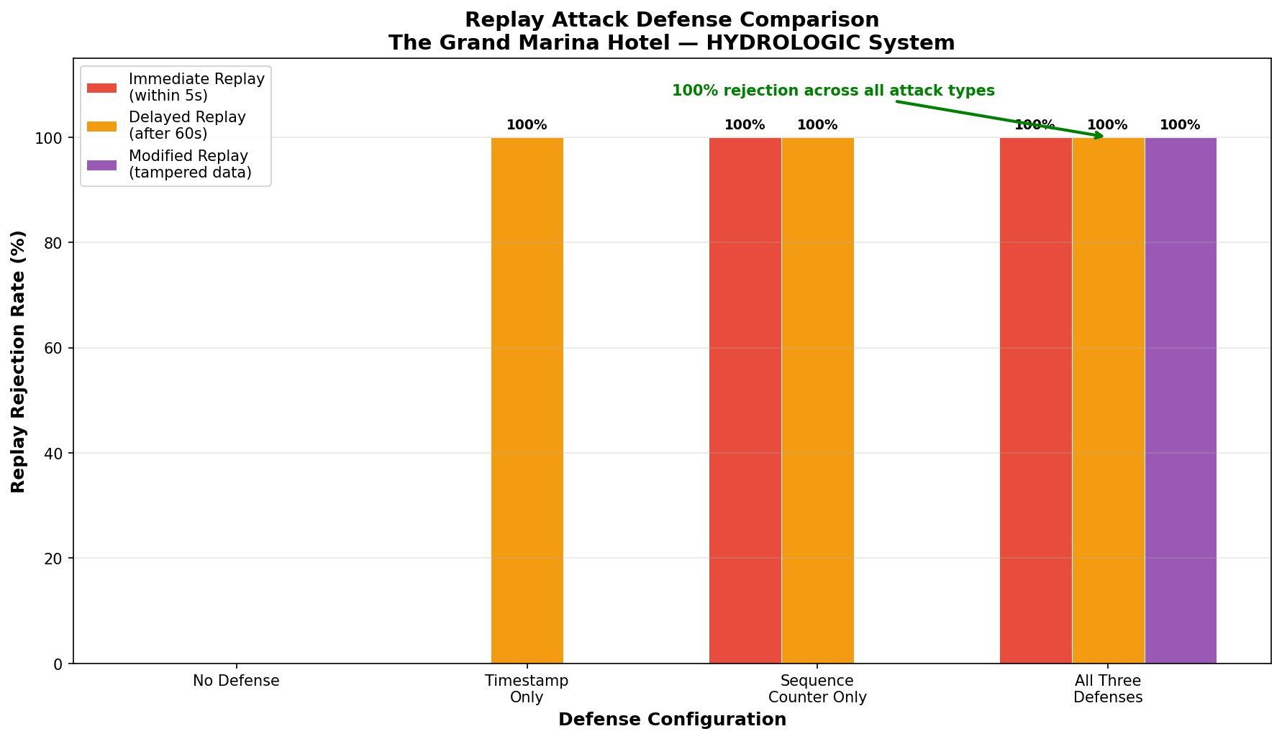
Figure 1: Replay rejection rate by defense configuration and attack type

4. RECOMMENDATION
Deploy all three replay defenses permanently on the Grand Marina HYDROLOGIC pipeline.

- Timestamp validation:
Automatically rejects any message older than 30 seconds. An attacker cannot replay a captured reading after this window has passed.
- Sequence counter:
Every message carries a unique incrementing number. Any duplicate is rejected immediately — even if the attacker replays a message within the 30 second window.
- HMAC signature:
Every message is signed with a shared secret key. Any tampering — including modified sensor values designed to hide a leak — is detected and rejected before the reading is processed.

The operational impact is negligible. All three defenses combined add less than one millisecond of processing time per message — invisible against Grand Marina’s five second publish cycle. The system continues to handle peak load without any slowdown.

Without these defenses, the $4.2 million water damage incident Grand Marina previously experienced could be replicated deliberately — not by a pipe failure, but by an attacker who knew exactly how to silence the system that was supposed to catch it.

5. NEXT STEPS
Immediate (This Week)
- Enable all three defenses on publisher and subscriber permanently
- Store the HMAC shared secret in a secure environment variable — never in source code
- Confirm all three HYDROLOGIC devices are publishing with defense fields included

Short Term (Next 30 Days)
- Build a real time dashboard to visualize rejected messages — giving the operations team immediate visibility when an attack or anomaly occurs
- Set up automated alerts when rejection rate spikes above normal — a sudden increase in rejected messages may indicate an active attack

Longer Term
- Migrate HMAC secret management to AWS Secrets Manager for automatic rotation and access logging
- Expand replay protection to cover the remote shutoff command channel — preventing attackers from replaying a captured shutoff command

Prepared as part of the Hydroficient Cybersecurity Externship — Grand Marina Hotel IoT Security Project, 2026.

