DATA MANAGEMENT PROJECT
OULAD Dataset
Task 2: Conceptual ERD and Logical Relational Schema
Prepared by: Edem Komla Gbena
Database platform: MySQL 8.4 / MySQL Workbench
Design scope: Entities, relationships, keys and integrity constraints
Report date: 20 July 2026

Design status: The conceptual and logical models are complete for all seven OULAD files. Final profiling of studentVle.csv is still in progress; this affects later validation of click-specific range constraints, not the entity structure or relationships defined here.

Executive Summary
This report presents a conceptual entity-relationship design and a logical relational schema for the Open University Learning Analytics Dataset (OULAD). The design represents module presentations, students, registrations, assessments, Virtual Learning Environment (VLE) resources, student assessment results and daily VLE interactions. It was produced from the organisation described by the case study and from the structures and quality findings observed during Task 1.
Seven relations are used. Module presentation and student are principal entities; registration records a student's participation in a particular presentation; assessment and VLE resource describe learning objects attached to that presentation; student assessment and student VLE interaction record operational events. Composite keys preserve the natural module-presentation and enrolment grains, while foreign keys prevent orphan records and enforce contextual consistency.
Key design decision: age_band is stored in registration rather than student because Task 1 identified 72 students whose age band changes between presentations. Stable attributes remain in student, preserving normalization without losing historical age context.

1. Requirement and Design Scope
Task 2 requires a conceptual ERD and a logical relational schema showing entities, relationships, keys and constraints, together with a justification based on the case-study organisation and the actual dataset. The conceptual design explains the business view. The logical design translates that view into implementable MySQL relations and integrity rules.
The scope includes the seven supplied CSV files. Staging tables are excluded from the ERDs because they are temporary ETL structures rather than permanent organisational entities. The design is intended for the cleaned relational layer that will be implemented in Task 3.

1.1 Source-to-entity mapping
Source file | Logical relation | Role
courses.csv | module_presentation | One module delivery and its duration
studentInfo.csv | student + registration | Stable student attributes and presentation-specific enrolment facts
studentRegistration.csv | registration | Registration and unregistration timing
assessments.csv | assessment | Assessment definitions, deadlines and weights
vle.csv | vle_resource | VLE resources and optional planned-use weeks
studentAssessment.csv | student_assessment | Student submissions, banking status and scores
studentVle.csv | student_vle_interaction | Daily student-resource interaction totals

Table 1. Mapping from the supplied OULAD files to the proposed relational design.

2. Conceptual Entity-Relationship Design
The conceptual model describes the organisation without implementation details. The Open University offers module presentations. Students register for presentations, presentations contain assessments and VLE resources, and registered students produce assessment results and VLE-interaction events.
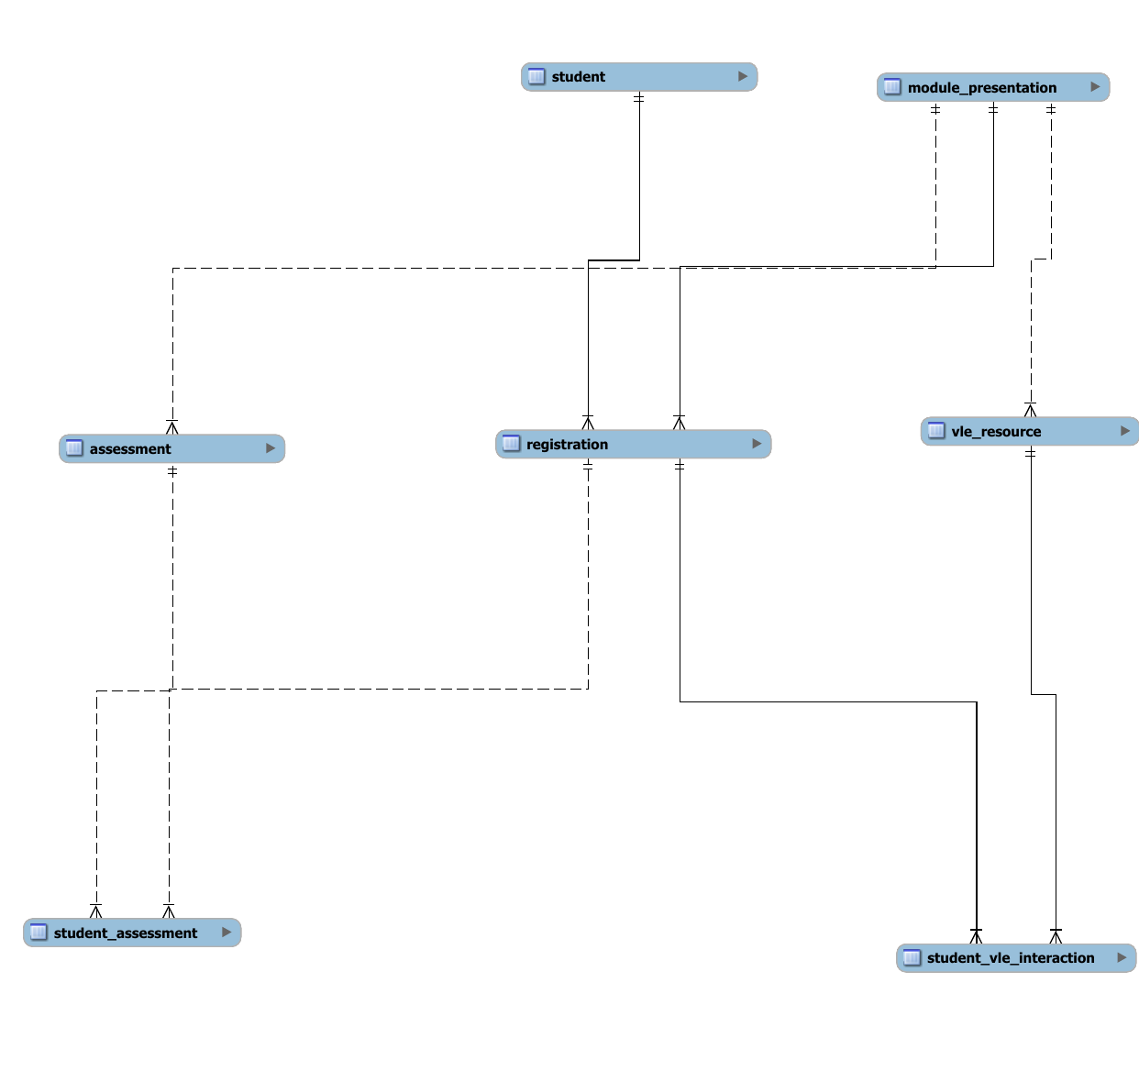
Figure 1. Conceptual ERD showing the principal OULAD entities and their relationships.

2.1 Entity meanings
Entity | Business meaning
Student | An anonymised learner with attributes stable across observed presentations.
Module Presentation | A particular delivery of a module, identified by module and presentation codes.
Registration | One student's enrolment in one module presentation.
Assessment | A TMA, CMA or Exam belonging to one module presentation.
VLE Resource | A learning material or activity made available in one presentation.
Student Assessment | A student's submission or banked result for an assessment.
Student VLE Interaction | A student's aggregated clicks on one resource on one relative day.

Table 2. Conceptual entity definitions.

2.2 Relationships and cardinalities
Relationship | Cardinality | Interpretation
Student - Registration | 1:M | A student can have many registrations; each registration belongs to one student.
Module Presentation - Registration | 1:M | A presentation accepts many registrations; each registration is for one presentation.
Module Presentation - Assessment | 1:M | A presentation contains many assessments; each assessment belongs to one presentation.
Module Presentation - VLE Resource | 1:M | A presentation provides many resources; each resource belongs to one presentation.
Registration - Student Assessment | 1:M | A registration can produce many results; each result is tied to one registration context.
Assessment - Student Assessment | 1:M | An assessment can receive many student results; each result refers to one assessment.
Registration - Student VLE Interaction | 1:M | A registration can generate many daily interactions.
VLE Resource - Student VLE Interaction | 1:M | A resource can receive interactions from many registered students.

Table 3. Relationship cardinalities and their organisational interpretation.

3. Logical Relational Schema
The logical model adds attributes, datatypes, primary keys and foreign keys. Key symbols in the diagram identify primary-key columns; relationship connectors are generated from the foreign-key definitions in the MySQL Workbench model.
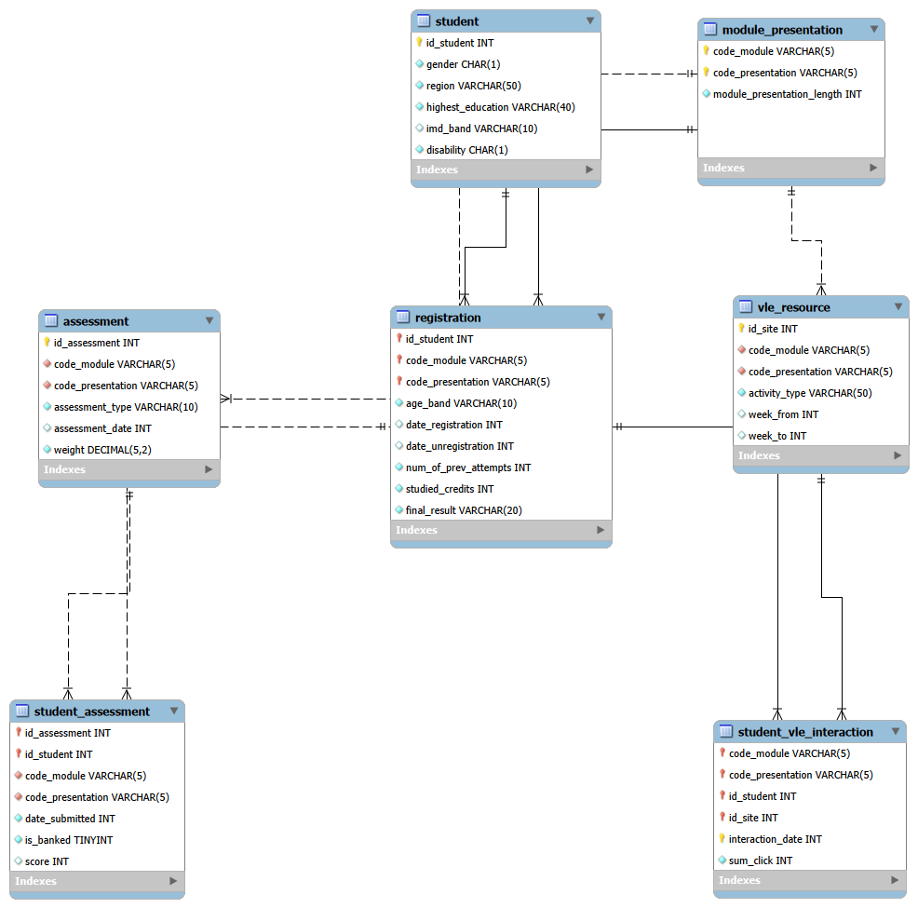
Figure 2. Logical ERD reverse-engineered from the Task 2 MySQL CREATE script.

3.1 Relation definitions

3.1.1 module_presentation
Represents one delivery of an anonymised module and records its duration in days.
- Primary key: (code_module, code_presentation)
- Foreign keys: None; this is the central presentation parent.
- Source: courses.csv

3.1.2 student
Stores one row per anonymised student and the attributes found to be stable across the inspected dataset.
- Primary key: id_student
- Foreign keys: None.
- Source: Distinct student attributes from studentInfo.csv after quality cleaning.

3.1.3 registration
Represents one student's enrolment in one module presentation. It combines presentation-specific fields from studentInfo.csv with dates from studentRegistration.csv.
- Primary key: (id_student, code_module, code_presentation)
- Foreign keys: id_student -> student; (code_module, code_presentation) -> module_presentation.
- Source: studentInfo.csv joined one-to-one with studentRegistration.csv.

3.1.4 assessment
Stores each assessment definition, including its type, relative deadline and weight.
- Primary key: id_assessment
- Foreign keys: (code_module, code_presentation) -> module_presentation.
- Source: assessments.csv

3.1.5 vle_resource
Stores VLE learning materials and their optional planned-use week range.
- Primary key: id_site
- Foreign keys: (code_module, code_presentation) -> module_presentation.
- Source: vle.csv

3.1.6 student_assessment
Stores one student's result for one assessment. Module and presentation context is derived from assessment during ETL and retained to enforce registration consistency.
- Primary key: (id_assessment, id_student)
- Foreign keys: (id_assessment, code_module, code_presentation) -> assessment; (id_student, code_module, code_presentation) -> registration.
- Source: studentAssessment.csv plus assessment context from assessments.csv.

3.1.7 student_vle_interaction
Stores a student's aggregated daily interaction count for one VLE resource.
- Primary key: (code_module, code_presentation, id_student, id_site, interaction_date)
- Foreign keys: (id_student, code_module, code_presentation) -> registration; (id_site, code_module, code_presentation) -> vle_resource.
- Source: studentVle.csv

4. Keys and Referential Constraints
Relation | Primary key | Justification
module_presentation | code_module + code_presentation | Natural composite identifier for a module delivery
student | id_student | Anonymised permanent student identifier
registration | id_student + module + presentation | One enrolment per student and presentation
assessment | id_assessment | Unique in the inspected assessment file
vle_resource | id_site | Unique in the inspected VLE resource file
student_assessment | id_assessment + id_student | One result per student and assessment
student_vle_interaction | module + presentation + student + site + date | Daily resource-interaction grain

Table 4. Primary keys and the real-world grain they enforce.
Foreign keys implement the eight conceptual relationships. Parent records must exist before child rows are loaded. Deletion should normally use RESTRICT/NO ACTION so that academic history cannot be removed accidentally. Cascading deletion is not recommended for students, registrations, results or interactions.
Integrity evidence: Task 1 found no unmatched presentation keys in assessments, VLE resources or student information; studentInfo and studentRegistration matched exactly in both directions; all tested student-assessment records matched valid assessments and registrations. Student VLE integrity will be rechecked after its import completes.

5. Domain, Nullability and Check Constraints
Attribute | Constraint | Evidence / rationale
module_presentation_length | NOT NULL; > 0 | Observed range 234-269 days
gender | M or F | Only these categories were observed
disability | Y or N | Only these indicators were observed
imd_band | NULL allowed; standard bands | 1,111 missing values; normalize '10-20' to '10-20%'
age_band | 0-35, 35-55 or 55<= | No missing values; presentation-specific
num_of_prev_attempts | >= 0 | Observed range 0-6
studied_credits | > 0 | Observed range 30-655; high values retained
final_result | Distinction, Pass, Fail or Withdrawn | Four consistent categories
registration dates | NULL and negative values allowed | 45 missing registrations; negative values mean before start
assessment_type | TMA, CMA or Exam | Three consistent assessment categories
assessment_date | NULL allowed | 11 Exam dates are missing
weight | 0-100 inclusive | 56 valid-looking zero-weight assessments
week_from / week_to | Both NULL or both present; 0 <= from <= to | 5,243 paired gaps; no partial or reversed ranges
is_banked | 0 or 1 | Binary indicator
score | NULL or 0-100 | 173 missing scores; available scores within range
interaction_date | Negative values permitted | Dates are relative to presentation start
sum_click | NOT NULL; range rule pending | Final studentVle profiling is still incomplete

Table 5. Proposed constraints derived from the actual data-quality findings.

6. Normalization and Design Justification

6.1 First normal form
Each relation contains atomic values and no repeating column groups. Daily clicks are stored as one aggregate value per student-resource-date rather than as repeated click columns.

6.2 Second normal form
Attributes that describe a whole composite key remain with that relation. Registration dates, attempts, credits, result and age band depend on the complete student-module-presentation enrolment key. Student attributes that were stable in Task 1 are separated into student and depend only on id_student.

6.3 Third normal form
Assessment definitions and VLE-resource descriptions are stored once and referenced by event tables. Module-presentation length is not repeated in registrations, assessments or interactions. This reduces update anomalies and prevents conflicting copies of the same descriptive fact.
Controlled contextual columns: student_assessment includes code_module and code_presentation even though they are derived from id_assessment. This deliberate, controlled redundancy enables composite foreign keys to verify both the assessment context and the student's matching registration. ETL must derive these values from assessment rather than accept independent user entry.

6.4 Organisational justification
- The university offers modules through dated presentations, so module_presentation is the central academic parent.
- A student can study several presentations, so student identity is separated from registration history.
- Assessments and VLE resources are owned by presentations because their deadlines, weights and availability differ by delivery.
- Results and VLE clicks are high-volume events and are separated from their descriptive parent entities.
- Natural composite keys reflect the actual file grains and allow duplicate detection during ETL.
- Nullable columns preserve documented missing or optional data rather than replacing it with misleading zero values.
- Restrictive foreign keys protect academic history and prevent records from being assigned to nonexistent presentations, registrations, assessments or resources.

7. Assumptions and Limitations
- The model represents the supplied dataset and does not introduce unsupported entities such as tutors, departments or qualification programmes.
- A separate module table is not required because the source contains no module-level attributes independent of a presentation. It can be added later if module title, school or credit value becomes available.
- The stable student attributes are based on the inspected dataset. If the organisation needs historical demographic changes, a dated student-profile relation should be introduced.
- The studentVle entity and key are defined from the source structure, but final duplicate, orphan, click-range and temporal validation remains pending until import completion.
- Cross-table timing rules that require values from another relation, such as submission after module end, are better implemented as ETL quality checks or triggers rather than ordinary CHECK constraints.

8. Conclusion
The proposed design satisfies the Task 2 requirement by providing a conceptual ERD, a logical relational schema and documented keys, cardinalities and constraints. It reflects how the Open University organises module presentations, registrations, learning resources, assessments and student activity, while incorporating the quality evidence observed in Task 1.
The design is ready to guide Task 3 implementation after the raw values are cleaned. Parent relations should be loaded first, followed by registrations, assessments and VLE resources, then student results and VLE interactions. All row counts and orphan checks should be repeated after loading the constrained schema.

Appendix A. Relational Schema Notation
MODULE_PRESENTATION(code_module PK, code_presentation PK, module_presentation_length)
STUDENT(id_student PK, gender, region, highest_education, imd_band, disability)
REGISTRATION(id_student PK/FK, code_module PK/FK, code_presentation PK/FK,
age_band, date_registration, date_unregistration,
num_of_prev_attempts, studied_credits, final_result)
ASSESSMENT(id_assessment PK, code_module FK, code_presentation FK,
assessment_type, assessment_date, weight)
VLE_RESOURCE(id_site PK, code_module FK, code_presentation FK,
activity_type, week_from, week_to)
STUDENT_ASSESSMENT(id_assessment PK/FK, id_student PK, code_module FK,
code_presentation FK, date_submitted, is_banked, score)
STUDENT_VLE_INTERACTION(code_module PK/FK, code_presentation PK/FK,
id_student PK/FK, id_site PK/FK, interaction_date PK,
sum_click)

References
Kuzilek, J., Hlosta, M., & Zdrahal, Z. (2015). Open University Learning Analytics dataset [Data set]. UCI Machine Learning Repository. https://doi.org/10.24432/C5KK69
Kuzilek, J., Hlosta, M., & Zdrahal, Z. (2017). Open University Learning Analytics dataset. Scientific Data, 4, Article 170171. https://doi.org/10.1038/sdata.2017.171

