DATABASE IMPLEMENTATION REPORT
OULAD Relational Database
Implementation and Learning Analytics
Task 3 | MySQL 8.4 | Database: oulad_db
Item | Completed evidence
Relational implementation | Seven final tables in InnoDB
Data loading | All seven OULAD CSV sources loaded via staging
Integrity | Primary keys, foreign keys, checks and unique constraints
Analytics | Three practical learning-analytics queries
Status | Completed and validated

Submission scope: This report documents requirement (iii): implementation of the relational database, data loading, integrity controls and practical SQL analytics.

1. Executive Summary
The Open University Learning Analytics Dataset (OULAD) was implemented as a normalized MySQL 8.4 database. Seven raw CSV files were first preserved in staging tables, then transformed into seven clean relational tables with explicit primary keys, foreign keys, unique constraints and domain checks.
The most material implementation finding concerned student VLE interactions. The raw file contained 10,655,280 rows, but the proposed student–resource–day key was not unique. SQL profiling identified repeated daily keys, so the clean load grouped the records at the intended daily grain and summed sum_click. This produced 8,459,320 clean interaction records and consolidated 2,195,960 duplicate raw rows.
All final constraints were successfully created. Three analytics queries then compared completion outcomes, assessment performance and VLE engagement. The results show a clear descriptive relationship between engagement and achievement: distinction students recorded the highest click activity, active days and resource use, while withdrawn students recorded the lowest.
Outcome: Task 3 is complete: the database is populated, integrity-controlled, analytically usable and supported by reproducible SQL.

2. Implementation Context
Property | Implementation
DBMS | MySQL 8.4 using MySQL Workbench
Schema | oulad_db
Storage engine | InnoDB
Source | Seven OULAD CSV files
Load pattern | CSV → staging → cleaning/transformation → final tables
Final relations | 7
Analytics questions | 3

3. Implemented Relational Design
The implementation follows the logical design produced in Task 2. Module presentations and students are independent parent entities. Registration resolves the many-to-many relationship between them and stores presentation-dependent attributes. Assessments and VLE resources belong to module presentations, while student assessment and VLE interaction tables capture student activity at transaction grain.
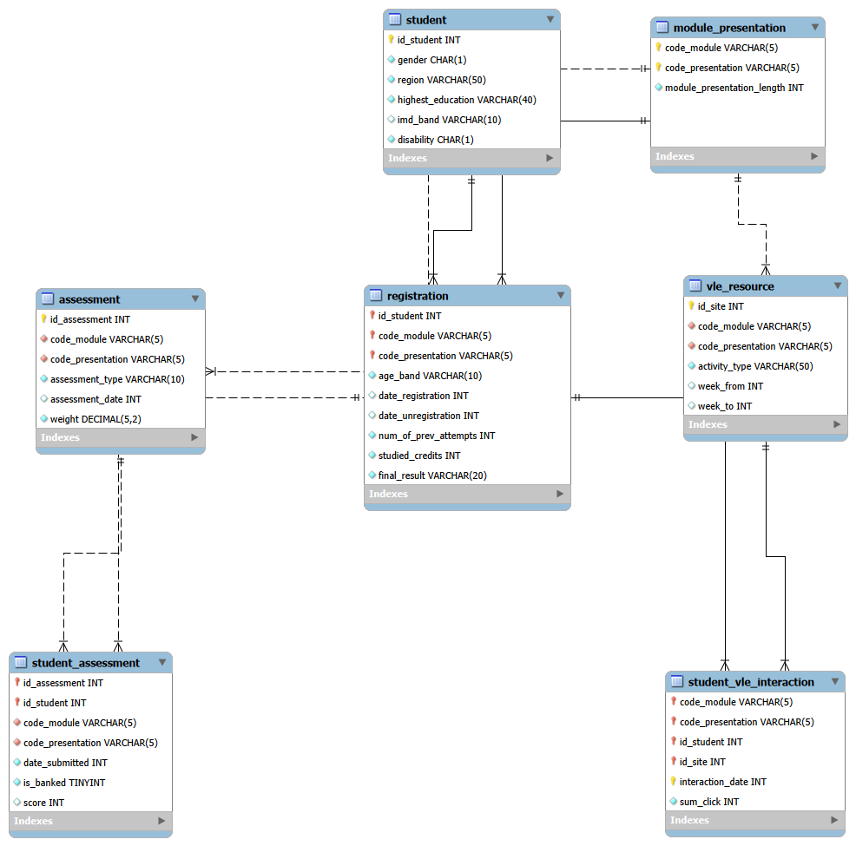
Figure 1. Implemented OULAD logical relational schema.

4. Data Loading and Transformation
Staging tables retained the raw CSV representation so that missing markers, inconsistent labels and duplicates could be inspected before constraints were applied. The final load used set-based INSERT … SELECT transformations rather than row-by-row editing.
Transformation | Rule applied
Missing markers | Converted '?' and blank strings to SQL NULL where permitted
IMD category | Standardized '10-20' to '10-20%'
Numeric values | Converted staging text to INT, TINYINT and DECIMAL types
Student attributes | Kept stable demographics once per student
Age band | Stored per registration because 72 students changed band across presentations
VLE duplicate keys | Grouped by module, presentation, student, site and day; summed clicks

4.1 Interaction de-duplication
INSERT INTO student_vle_interaction (...)
SELECT code_module, code_presentation, id_student, id_site,
date AS interaction_date,
SUM(sum_click) AS sum_click
FROM stg_student_vle
GROUP BY code_module, code_presentation, id_student, id_site, date;
Measure | Rows
Raw studentVle rows | 10,655,280
Clean daily interaction rows | 8,459,320
Duplicate raw rows consolidated | 2,195,960

The resulting interaction dates range from −25 to 269 days relative to presentation start. Cleaned click totals range from 1 to 6,977, with no nonpositive click totals.

5. Final Data Volumes
Final table | Row count
module_presentation | 22
student | 28,785
registration | 32,593
assessment | 206
vle_resource | 6,364
student_assessment | 173,912
student_vle_interaction | 8,459,320

6. Integrity Controls
Integrity was implemented at database level so invalid relationships and domain values are rejected independently of application code. Successful creation of both interaction foreign keys also validates that every cleaned interaction matches a registration and a contextual VLE resource.
Table | Primary/unique controls | Foreign-key relationships | Checks
module_presentation | Composite PK | — | Length > 0
student | PK: id_student | — | Gender, disability, IMD band
registration | Composite PK | Student; presentation | Age, attempts, credits, result, dates
assessment | PK; contextual unique key | Presentation | Type; weight 0–100
vle_resource | PK; contextual unique key | Presentation | Paired, ordered week range
student_assessment | Composite PK | Assessment; registration | Banked flag; score 0–100
student_vle_interaction | Composite PK | Registration; VLE resource | Validated click/date profile

Constraint evidence: The final schema contains seven primary keys, ten foreign keys, two unique contextual keys and domain checks appropriate to the clean relations.

7. Learning Analytics Results

7.1 Question 1 — Completion outcomes
Question: Which module presentations have the strongest completion outcomes? Successful completion was defined as Pass or Distinction divided by all registrations in the presentation.
Presentation | Registrations | Pass | Distinction | Withdrawn | Success rate
AAA 2013J | 383 | 258 | 20 | 60 | 72.58%
AAA 2014J | 365 | 229 | 24 | 66 | 69.32%
GGG 2013J | 952 | 451 | 141 | 66 | 62.18%
DDD 2014B | 1,228 | 360 | 119 | 490 | 39.01%
CCC 2014B | 1,936 | 471 | 192 | 898 | 34.25%

AAA 2013J achieved the highest success rate at 72.58%, followed by AAA 2014J at 69.32%. CCC 2014B had the lowest rate at 34.25%. CCC 2014J had the largest cohort (2,498 registrations) but a 40.63% completion rate and 1,077 withdrawals. These are descriptive differences and do not establish causality.

7.2 Question 2 — Assessment performance
Question: How do submission volume, average score, missingness and banked-result rates differ by module presentation and assessment type?
Presentation/type | Submissions | Missing | Average score | Banked rate
BBB 2013B CMA | 5,049 | 0 | 88.35 | 0.40%
GGG 2013J CMA | 3,749 | 0 | 87.19 | 0.00%
EEE 2014J TMA | 3,229 | 2 | 82.46 | 1.21%
DDD 2014J TMA | 7,063 | 12 | 72.63 | 3.94%
DDD 2013B Exam | 602 | 0 | 56.35 | 0.00%

CMA averages are generally higher than TMA and recorded exam averages. BBB 2013B CMA achieved 88.35, while DDD 2013B Exam recorded the lowest displayed average at 56.35. The corrected query identified 173 missing scores, all associated with TMA submissions. Banked rates were low overall, peaking at 3.94% for DDD 2014J TMA. Presentations with no exam submissions correctly report zero submissions and zero missing student scores.

7.3 Question 3 — Engagement and final result
Question: How does VLE engagement differ across final-result groups? Engagement was aggregated per registration before group averages were calculated.
Final result | Registrations | Avg clicks | Avg active days | Avg resources
Distinction | 3,024 | 2,666.76 | 110.04 | 102.45
Pass | 12,361 | 1,921.81 | 87.04 | 89.06
Fail | 7,052 | 651.85 | 33.18 | 43.08
Withdrawn | 10,156 | 313.95 | 16.29 | 24.23

A strong monotonic engagement gradient is visible. Distinction students averaged 2,666.76 clicks, 110.04 active days and 102.45 resources, whereas withdrawn students averaged 313.95 clicks, 16.29 active days and 24.23 resources. Pass students also substantially exceeded fail students across all three measures. The pattern supports engagement as a useful descriptive indicator for further early-warning analysis, but does not by itself prove that additional clicks cause higher achievement.

8. Reproducibility and Operational Notes
The final SQL script is organized into numbered sections: staging preflight, final schema creation, six smaller loads, large interaction cleaning, validation, constraint creation, evidence queries and analytics. Sections are intended to be executed sequentially during a full rebuild. On the completed database, only the read-only evidence and analytics sections should be rerun.
Important: The complete script begins by dropping and recreating final tables. It should not be executed again on the completed database unless a deliberate full rebuild is required.
Long-running inserts and ALTER TABLE operations continued on the MySQL server even when Workbench returned Error 2013. PROCESSLIST was therefore used to monitor server-side completion and prevent accidental repeated execution.

9. Limitations
The analytics are descriptive summaries of historical OULAD records. They do not control for module difficulty, assessment design, prior attainment, demographic factors or the timing of withdrawal. VLE click volume is also an activity proxy rather than a direct measure of learning quality. Future work should add time-windowed engagement features and multivariable modelling before making predictive or intervention claims.

10. Conclusion
Task 3 successfully implemented the OULAD relational database in MySQL, loaded and cleaned all seven source datasets, protected data integrity through database constraints and demonstrated practical learning analytics. The final schema is normalized, reproducible and suitable for subsequent transaction-control, tuning and ETL/ELT tasks. The strongest analytical result is the consistent association between higher VLE engagement and stronger final outcomes, accompanied by substantial variation in completion rates across module presentations.

References
Kuzilek, J., Hlosta, M., & Zdrahal, Z. (2017). Open University Learning Analytics dataset. Scientific Data, 4, 170171. https://doi.org/10.1038/sdata.2017.171
UCI Machine Learning Repository. (2015). Open University Learning Analytics Dataset. https://doi.org/10.24432/C5KK69

