DATABASE TRANSACTION REPORT
OULAD Transaction Control
and Integrity Protection
Task 4 | MySQL 8.4 | Database: oulad_db
Requirement | Implemented evidence
Controlled workflow | Temporary insert followed by a controlled correction
Transaction control | START TRANSACTION, SAVEPOINT, ROLLBACK TO SAVEPOINT and ROLLBACK
Integrity protection | Gender CHECK constraint rejected invalid value X
Final condition | Temporary record absent; final and source counts both 28,785

Submission scope: This report satisfies requirement (iv): apply transaction concepts using a controlled insert/update workflow and show how constraints and transaction control protect integrity.

1. Executive Summary
A controlled transaction was performed against the OULAD student table using a deliberately temporary student identifier. The workflow inserted a valid record, established a savepoint, corrected the region value, deliberately attempted an invalid gender update and then reversed the changes. MySQL rejected the invalid value with Error 3819 because the chk_student_gender constraint only permits M or F. A savepoint rollback restored the earlier region value, and a full rollback removed the temporary student. Final validation confirmed that the student table and the unique source population both contained 28,785 students.
Outcome: The workflow proved that constraints prevent invalid states while transaction control makes valid but uncommitted changes safely reversible.

2. Controlled Transaction Workflow
The test used id_student 99999999 after a pre-check confirmed that the identifier was unused. No production student record was edited. The transaction was intentionally rolled back rather than committed because the purpose was integrity testing, not a permanent data correction.
Stage | Operation | Observed result
1 | Pre-check temporary identifier | No existing row
2 | Insert valid temporary student | Row visible inside transaction
3 | Savepoint and region correction | Test Region changed to Scotland
4 | Invalid gender update to X | Rejected by CHECK constraint; Error 3819
5 | Rollback to savepoint | Region restored to Test Region
6 | Full rollback | Temporary student removed
7 | Final reconciliation | 28,785 final = 28,785 unique source students

2.1 Controlled insert
The valid temporary student was inserted after START TRANSACTION, followed immediately by SAVEPOINT student_inserted. The selected row below confirms that the insert was visible within the active transaction.
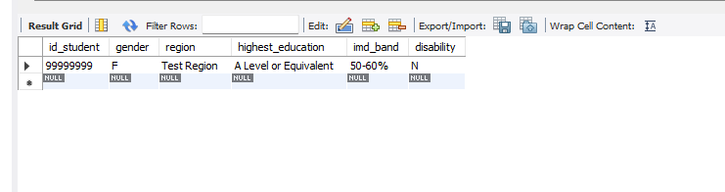
Figure 1. Valid temporary student visible inside the transaction.

3. Controlled Correction and Constraint Protection

3.1 Controlled update
The region of the temporary student was changed from Test Region to Scotland. Limiting the UPDATE with the primary key ensured that only one known row was affected.
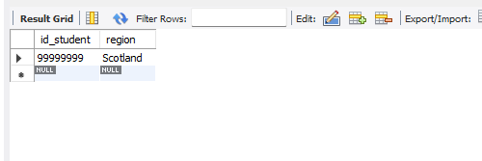
Figure 2. Controlled region correction completed within the transaction.

3.2 Constraint-enforced rejection
An invalid update attempted to set gender to X. The table-level chk_student_gender constraint permits only M or F, so MySQL rejected the statement before the record could enter an inconsistent state.
UPDATE student
SET gender = 'X'
WHERE id_student = 99999999;
Figure 3. Error 3819 confirms enforcement of chk_student_gender.
Integrity interpretation: The failed statement did not invalidate the transaction and did not replace the valid gender F. The database, rather than application code, enforced the domain rule.

4. Transaction Recovery

4.1 Rollback to the savepoint
ROLLBACK TO SAVEPOINT student_inserted reversed the valid region correction while retaining the original temporary insert. The result returned to gender F and region Test Region, demonstrating selective recovery within an active transaction.
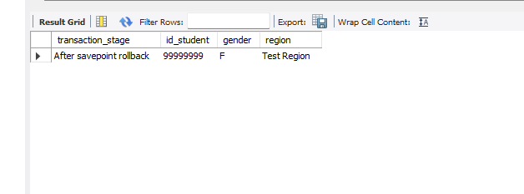
Figure 4. Savepoint rollback restored the earlier region value.

4.2 Full rollback
The final ROLLBACK reversed the entire transaction, including the original temporary insert. A targeted count for id_student 99999999 returned zero.
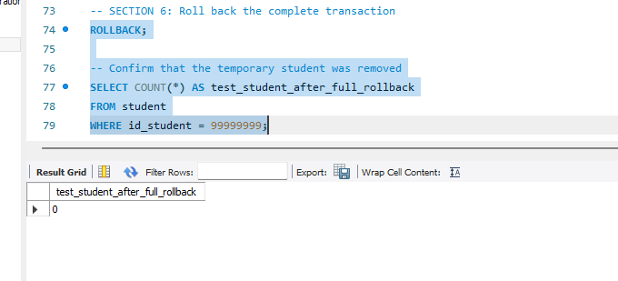
Figure 5. Full rollback removed the temporary test student.

5. Final Validation
A read-only comparison reconciled the final student table against distinct numeric student identifiers in stg_student_info. Both counts were 28,785, confirming that the controlled workflow left the production population unchanged.
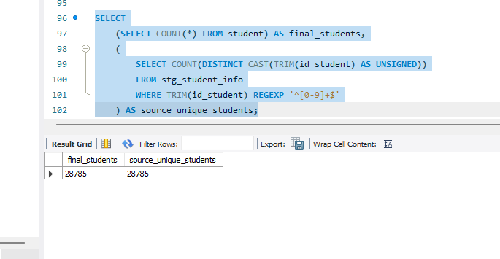
Figure 6. Final student count equals the unique source-student count.
Validation note: An earlier result grid briefly displayed 28,786. Subsequent targeted verification showed that student 99999999 was absent, no final student lacked a source record, and the authoritative reconciliation returned 28,785 on both sides. The final reconciled query therefore supersedes the preliminary display.

6. Integrity and Transaction-Control Discussion
Control principle | Evidence from the workflow
Atomicity | Full rollback removed the temporary insert and all associated changes.
Consistency | chk_student_gender prevented an invalid domain value from being stored.
Controlled recovery | The savepoint reversed only the correction while retaining the earlier insert.
Scope control | The primary-key predicate restricted updates to id_student 99999999.
Auditability | Before, intermediate and final query results were captured as evidence.

Durability was not tested because the demonstration deliberately avoided COMMIT. This was appropriate for a controlled coursework test whose required end state was no permanent change to the production dataset.

7. Conclusion
Task 4 was completed successfully. The transaction combined a controlled insert, a controlled correction, constraint validation, a savepoint rollback and a full rollback. The CHECK constraint rejected invalid data, and the rollback operations restored the database to its original state. Final reconciliation against the staging source confirmed a clean student population of 28,785 records.

Appendix A — Reproducible SQL
The following script reproduces the transaction demonstration. It is intentionally designed to finish with no permanent data change.
USE oulad_db;
SELECT COUNT(*) AS existing_test_student
FROM student
WHERE id_student = 99999999;
START TRANSACTION;
INSERT INTO student (
id_student, gender, region,
highest_education, imd_band, disability
)
VALUES (
99999999, 'F', 'Test Region',
'A Level or Equivalent', '50-60%', 'N'
);
SAVEPOINT student_inserted;
SELECT *
FROM student
WHERE id_student = 99999999;
UPDATE student
SET region = 'Scotland'
WHERE id_student = 99999999;
SELECT ROW_COUNT() AS rows_corrected;
-- Expected Error 3819: invalid gender rejected
UPDATE student
SET gender = 'X'
WHERE id_student = 99999999;
ROLLBACK TO SAVEPOINT student_inserted;
SELECT id_student, gender, region
FROM student
WHERE id_student = 99999999;
ROLLBACK;
SELECT COUNT(*) AS test_student_after_full_rollback
FROM student
WHERE id_student = 99999999;
SELECT
(SELECT COUNT(*) FROM student) AS final_students,
(
SELECT COUNT(DISTINCT CAST(TRIM(id_student) AS UNSIGNED))
FROM stg_student_info
WHERE TRIM(id_student) REGEXP '^[0-9]+$'
) AS source_unique_students;

