DATABASE PERFORMANCE REPORT
OULAD Query Tuning
and Index Optimisation
Task 5 | MySQL 8.4 | Database: oulad_db
Requirement | Completed evidence
Three important queries | Completion, assessment and VLE-resource analytics
Baseline evidence | EXPLAIN ANALYZE plans captured before indexing
Index tuning | Three retained covering/reporting indexes
Statistics | ANALYZE TABLE executed after index changes
Evaluation | Identical queries rerun and timing changes quantified

Submission scope: This report satisfies requirement (v): tune at least three important queries, capture baseline plans, revise indexes, refresh statistics, rerun the queries and explain the changes.

1. Executive Summary
Three reporting queries were tuned using baseline and post-index EXPLAIN ANALYZE plans. The completion-outcomes query improved from 111 ms to 13.1 ms, assessment performance improved from 543 ms to 163 ms, and VLE-resource analysis improved from 19.6 ms to 3.02 ms. The retained indexes enabled covering access and removed temporary aggregation from two queries. One experimental student-assessment index was not selected by the optimizer and was removed to avoid unnecessary storage and write-maintenance overhead.
Outcome: All three queries retained the same logical results while total measured execution time fell by 70.0% to 88.2%.

2. Method
Each query followed the same controlled tuning cycle: run EXPLAIN ANALYZE, record the baseline plan and actual time, add a purpose-built index, refresh table statistics, rerun the identical SQL and compare access methods. Result-group counts were also checked so performance improvements were not achieved by changing query semantics.
Query | Business purpose | Rows examined | Result groups
Q1 | Completion outcomes by presentation | 32,593 | 22
Q2 | Assessment performance by presentation/type | 173,912 | 41
Q3 | VLE resource availability and week quality | 6,364 | 232

2.1 Overall performance change
Query | Baseline | Tuned | Reduction | Speed-up
Q1 | 111 ms | 13.1 ms | 88.2% | 8.5×
Q2 | 543 ms | 163 ms | 70.0% | 3.3×
Q3 | 19.6 ms | 3.02 ms | 84.6% | 6.5×

3. Query 1 — Completion Outcomes
The query groups registrations by module and presentation and calculates the percentage of Pass and Distinction outcomes. The baseline used fk_registration_presentation, but final_result was not stored in that index, requiring additional table access.
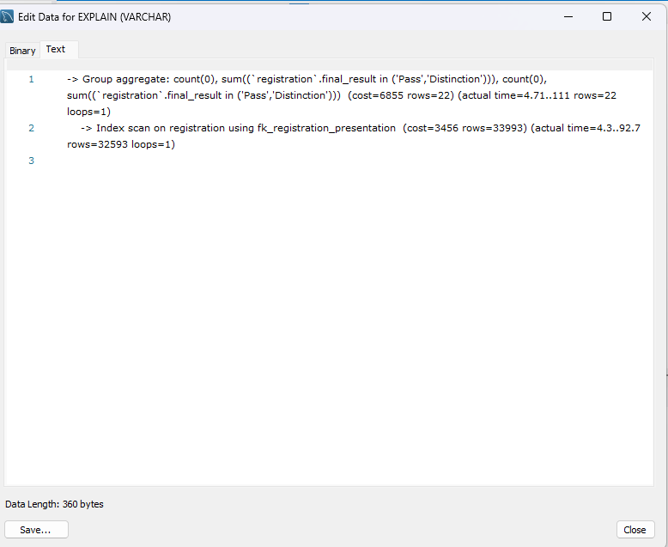
Figure 1. Query 1 baseline: non-covering index scan, 111 ms.
A covering index on code_module, code_presentation and final_result allowed the entire aggregation to be answered from the index. ANALYZE TABLE refreshed optimizer statistics after creation.
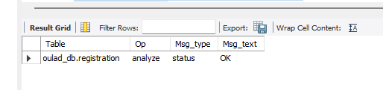
Figure 2. Statistics refresh completed successfully for registration.
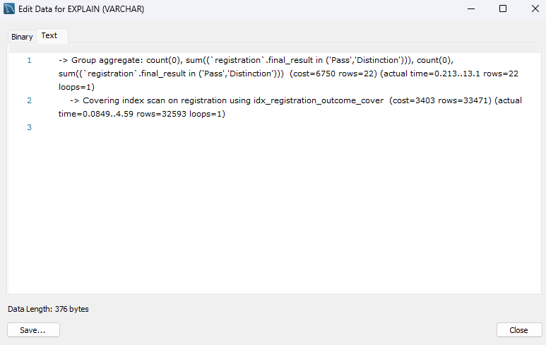
Figure 3. Query 1 tuned: covering index scan, 13.1 ms.
Plan element | Baseline | Tuned
Access path | Index scan | Covering index scan
Index | fk_registration_presentation | idx_registration_outcome_cover
Scan completion | 92.7 ms | 4.59 ms
Total completion | 111 ms | 13.1 ms

Interpretation: The covering index eliminated base-table lookups for final_result. Total execution fell by 88.2%, while the 22 presentation results—including AAA 2013J at 72.58%—remained unchanged.

4. Query 2 — Assessment Performance
The second query joins 206 assessments to 173,912 student-assessment rows and calculates submission counts, average scores, missing scores and banked-result rates. The baseline plan built and scanned a temporary aggregation table.
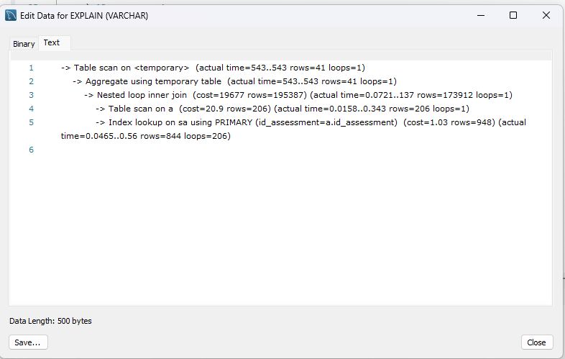
Figure 4. Query 2 baseline: temporary aggregation, 543 ms.
The retained idx_assessment_reporting index orders assessments by module, presentation and assessment type before id_assessment. This allowed an ordered covering scan of assessment and removed the temporary aggregation stage.
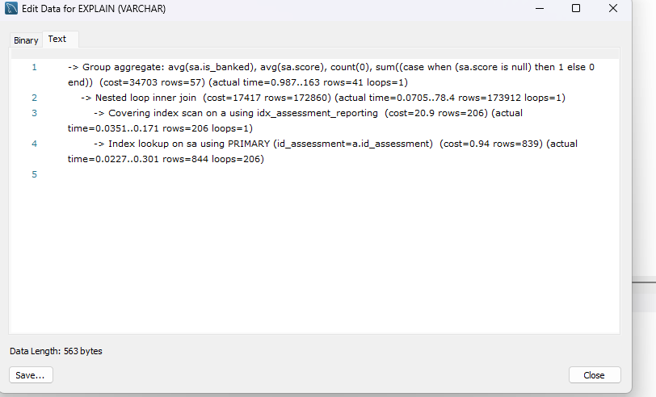
Figure 5. Query 2 tuned: direct aggregation, 163 ms.
Plan element | Baseline | Tuned
Aggregation | Temporary table | Direct group aggregate
Assessment access | Table scan | Covering index scan
Join completion | 137 ms | 78.4 ms
Total completion | 543 ms | 163 ms

Index review: A candidate idx_student_assessment_metrics index was tested, but MySQL continued to prefer the existing primary key for student_assessment lookups. The unused candidate was therefore removed after testing.

5. Query 3 — VLE Resource Availability
The third query summarises VLE resource counts, missing week information and the earliest/latest resource weeks by presentation and activity type. The baseline scanned all 6,364 rows and materialised 232 groups in a temporary table.
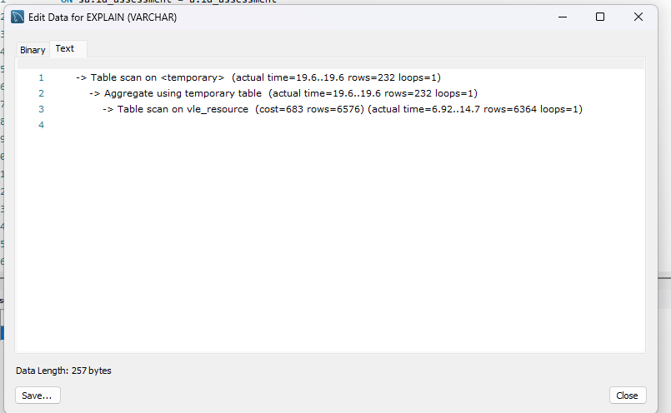
Figure 6. Query 3 baseline: table scan and temporary aggregation, 19.6 ms.
The idx_vle_resource_reporting index matches the complete grouping prefix and includes week_from and week_to, making the query fully covering and allowing streaming group aggregation.
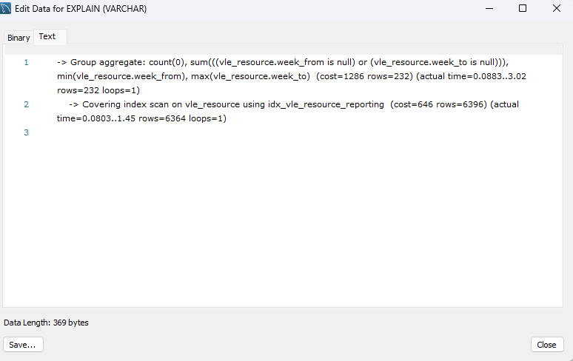
Figure 7. Query 3 tuned: covering index scan, 3.02 ms.
Plan element | Baseline | Tuned
Aggregation | Temporary table | Direct group aggregate
Access path | Table scan | Covering index scan
Scan completion | 14.7 ms | 1.45 ms
Total completion | 19.6 ms | 3.02 ms

Interpretation: The covering index removed both the base-table scan and the temporary grouping step. Total execution fell by 84.6% while the same 232 groups were produced.

6. Statistics Refresh and Final Index Set
Statistics were refreshed after index changes so the optimizer could compare new and existing access paths. After the unused student-assessment candidate was removed, ANALYZE TABLE student_assessment completed successfully.
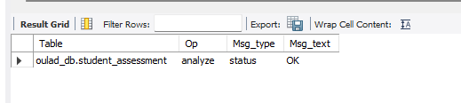
Figure 8. Statistics refresh after final index cleanup.
The final inventory retained exactly three task-specific reporting indexes.
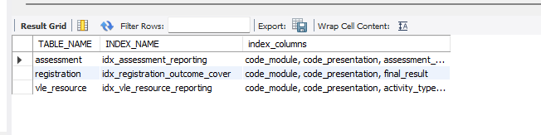
Figure 9. Final retained reporting indexes.
Table | Index | Ordered columns
assessment | idx_assessment_reporting | code_module, code_presentation, assessment_type, id_assessment
registration | idx_registration_outcome_cover | code_module, code_presentation, final_result
vle_resource | idx_vle_resource_reporting | code_module, code_presentation, activity_type, week_from, week_to

7. Evaluation and Limitations
EXPLAIN ANALYZE executes each query and reports actual observed timing, but measurements can vary with cache state, concurrent work and hardware. The before-and-after plans were captured in the same database environment and used identical SQL, making them suitable for comparative evaluation. Indexes improve read performance at the cost of storage and additional work during INSERT, UPDATE and DELETE operations; this trade-off motivated removal of the unused candidate index.

8. Conclusion
Task 5 was completed successfully. Three important analytical queries were baselined, indexed, re-analysed and rerun. Covering indexes reduced total measured execution time by 70.0% to 88.2%, while the queries continued to process the same rows and produce the same result groups. The final design retains only indexes demonstrated to improve an important reporting workload.

