DATABASE MANAGEMENT COURSEWORK
OULAD Task 6
ETL/ELT Pipeline Implementation Report
Raw OULAD files → staging tables → cleaned relational tables → analytics layer
Report item | Value
Dataset | Open University Learning Analytics Dataset (OULAD)
Implementation | Python 3.11.9 and MySQL 8.4.9
Target schema | oulad_etl
Report date | 21 July 2026
Overall status | PASS — 31 checks passed, 0 failed

Prepared as evidence for Task 6 of the database coursework

Executive Summary
A repeatable hybrid ELT pipeline was implemented in Python and MySQL to move seven raw OULAD CSV files through raw staging, constrained cleaning and analytics layers. Python orchestrates validation, bulk loading, transformation, logging and report generation, while MySQL performs set-based transformations and aggregation. A separate schema, oulad_etl, protects the completed oulad_db implementation from accidental changes.
The pipeline reconciled 10,900,970 raw rows, transformed the data into seven cleaned relations and consolidated 2,195,960 repeated student-resource-day interaction rows. The final interaction relation contains 8,459,320 unique daily-grain records. Four reusable analytics tables were then produced, including one row for each of 32,593 registrations. The final quality stage recorded 31 passed checks, zero failures and seven documented source characteristics.
Outcome: The implementation satisfies the Task 6 requirement for a pipeline from raw files to staging tables, cleaned tables and an analytics layer, together with repeatable data-quality checks and a short data-quality report.

1. Requirement and Scope
Task 6 required an ETL/ELT pipeline that begins with raw files, loads staging tables, produces cleaned tables and creates an analytics layer. It also required data-quality checks and a concise quality report. The implementation uses ELT for scale: extraction and bulk loading are controlled by Python, while the large transformations run within MySQL close to the data.
- Input: seven original OULAD CSV files stored unchanged in the local data folder.
- Staging: seven stg_* tables preserve source values as text for traceability.
- Cleaning: seven clean_* tables apply data types, transformations and relational constraints.
- Analytics: four analytics_* tables expose reporting-ready measures at useful grains.
- Quality: 38 checks/results are persisted in MySQL and exported to CSV and Markdown.

2. Architecture and Tools
Tool | Purpose
Python 3.11.9 | Pipeline orchestration, file validation, logging and report export
MySQL 8.4.9 | Bulk storage, set-based cleaning, constraints and analytics
VS Code + Workbench | Project execution, schema inspection and independent verification
SQLAlchemy + PyMySQL | Database connection, SQL execution and long-operation timeout support
python-dotenv 1.2.2 | Loads credentials from a local .env configuration file

Pandas was initially installed, but a Windows Application Control policy blocked one of its compiled DLLs. The pipeline was therefore designed with Python's built-in csv module for source validation and MySQL LOAD DATA LOCAL INFILE for loading. This removed the dependency on pandas and improved the large-file loading path.

2.1 Layered pipeline design
Layer | Objects | Purpose
Raw | 7 CSV files | Immutable source evidence
Staging | 7 stg_* tables | Lossless raw ingestion as text
Clean | 7 clean_* tables | Typed, standardised and constrained relations
Analytics | 4 analytics_* tables | Reusable learning-analytics summaries
Quality | data_quality_results + exports | Reconciliation, validity and lineage evidence

Safety boundary: Every script verifies that MYSQL_DATABASE equals oulad_etl before changing data. The coursework schema oulad_db is never modified by the Task 6 pipeline.

2.2 Reproducibility controls
- The .env file separates credentials from code, and every script verifies the oulad_etl target schema.
- LOAD, CLEAN and ANALYTICS confirmations guard predictable truncate-and-reload operations.
- Expected counts stop incomplete runs; etl_run_log records lineage, timing, status and messages.
- Two-hour read/write timeouts support large MySQL operations without Workbench disconnections.

3. Extract and Load: Raw Files to Staging
The preflight program checks that all seven source files exist and that their headers exactly match the documented OULAD structure. It reads only the header, so even the 432.81 MB studentVle.csv file is validated quickly. The staging loader then creates raw text tables and uses LOAD DATA LOCAL INFILE for efficient ingestion.
Source file | Staging table | Rows | Seconds | Status
courses.csv | stg_courses | 22 | 0.07 | SUCCESS
assessments.csv | stg_assessments | 206 | 0.04 | SUCCESS
vle.csv | stg_vle | 6,364 | 0.08 | SUCCESS
studentInfo.csv | stg_student_info | 32,593 | 0.45 | SUCCESS
studentRegistration.csv | stg_student_registration | 32,593 | 0.40 | SUCCESS
studentAssessment.csv | stg_student_assessment | 173,912 | 1.70 | SUCCESS
studentVle.csv | stg_student_vle | 10,655,280 | 142.92 | SUCCESS

All seven row counts matched the source profiles. The total raw load was 10,900,970 rows. The largest source, studentVle.csv, loaded 10,655,280 rows in 142.92 seconds; the remaining six sources loaded in 2.74 seconds combined.
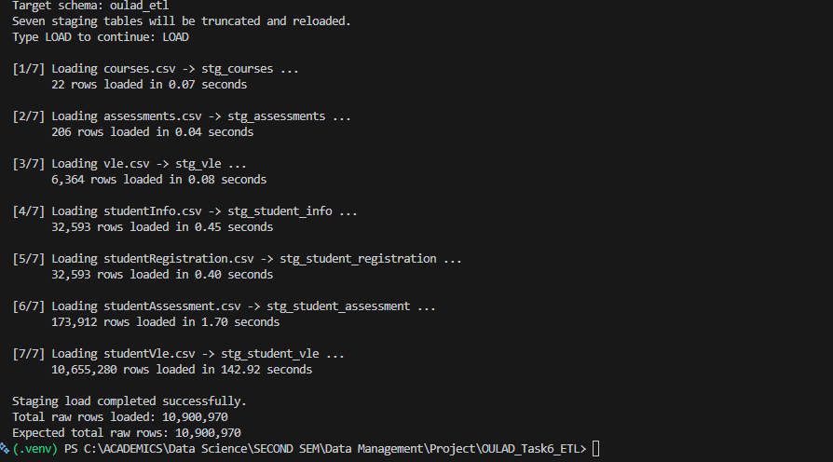
Figure 1. Successful bulk loading and reconciliation of all seven staging tables.

4. Transform: Staging to Cleaned Relations
The cleaned layer converts raw strings to appropriate numeric and categorical data types, implements the logical relational design and applies business rules. The transformation is set-based so MySQL can process the large interaction table efficiently.
Rule | Implementation
Missing markers | Convert ? and blank values to SQL NULL only in nullable fields
IMD band | Standardise the inconsistent 10-20 label to 10-20%
Student grain | Create one student row per id_student while retaining registration-specific age in registration
Registration | Join studentInfo and studentRegistration at student-module-presentation grain
Assessment | Preserve missing Exam dates as NULL and missing scores as NULL
VLE grain | Group by module, presentation, student, resource and day; sum repeated click rows
Integrity | Apply primary keys, foreign keys, unique keys and CHECK constraints

Cleaned table | Rows | Load seconds | Status
clean_module_presentation | 22 | 0.01 | SUCCESS
clean_student | 28,785 | 0.77 | SUCCESS
clean_registration | 32,593 | 1.67 | SUCCESS
clean_assessment | 206 | 0.01 | SUCCESS
clean_vle_resource | 6,364 | 0.12 | SUCCESS
clean_student_assessment | 173,912 | 7.41 | SUCCESS
clean_student_vle_interaction | 8,459,320 | 248.22 | SUCCESS

The large staging index was created in 85.08 seconds. Consolidation produced 8,459,320 clean interaction records in 248.22 seconds, removing 2,195,960 repeated daily-grain rows. The composite primary key, supporting indexes and two foreign keys were then applied in 344.00 seconds.
Integrity result: Nonpositive click totals: 0; interactions without a registration: 0; interactions without a contextual VLE resource: 0.
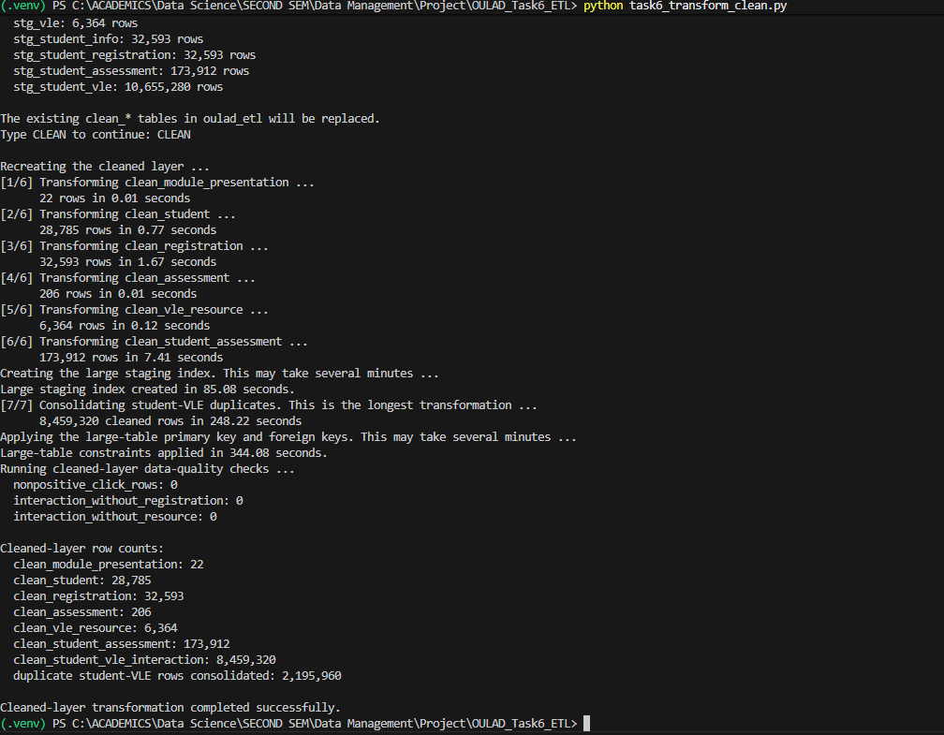
Figure 2. Completed cleaned-layer transformation, constraints and integrity checks.

5. Analytics Layer
The analytics layer denormalises frequently used measures into reporting-ready tables. This avoids repeatedly scanning and regrouping 8.46 million interaction rows for common learning-analytics questions.
Analytics table | Grain | Rows | Seconds
analytics_student_engagement | One row per registration | 32,593 | 78.74
analytics_completion_by_presentation | One row per module presentation | 22 | 0.18
analytics_assessment_performance | One row per presentation and assessment type | 57 | 0.82
analytics_engagement_by_result | One row per final-result category | 4 | 0.11

The registration-level engagement summary was the only material analytics build, taking 78.74 seconds. The three smaller reporting tables completed in 1.11 seconds combined. Both presentation and outcome summaries reconcile to all 32,593 registrations.
Final result | Registrations | Avg clicks | Avg active days | Avg resources
Distinction | 3,024 | 2,666.76 | 110.04 | 102.45
Pass | 12,361 | 1,921.81 | 87.04 | 89.06
Fail | 7,052 | 651.85 | 33.18 | 43.08
Withdrawn | 10,156 | 313.95 | 16.29 | 24.23

Engagement is strongly ordered by outcome group: Distinction registrations show the highest average clicks, active days and resource use, while Withdrawn registrations show the lowest. This is an association useful for monitoring and intervention design; it does not by itself establish that engagement causes the final result.
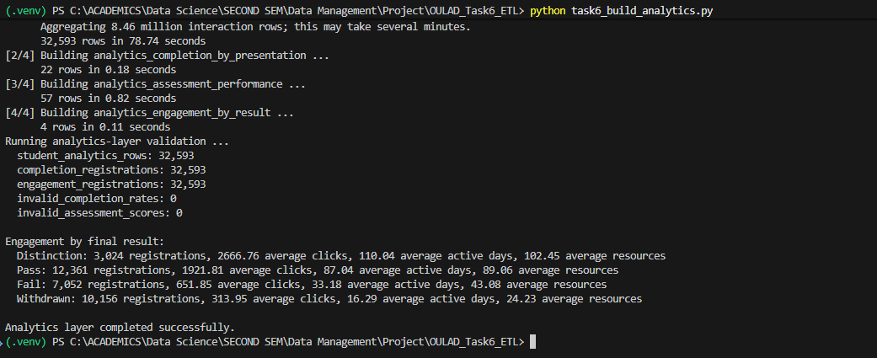
Figure 3. Successful analytics build, reconciliation and engagement-by-result output.

6. Data-Quality Checks and Report
The final program runs checks across staging, cleaned and analytics layers, stores the results in oulad_etl.data_quality_results and exports a machine-readable CSV, a short Markdown report and the pipeline log. The final outcome was PASS: 31 checks passed, zero failed and seven INFO results documented legitimate source characteristics.
Source table | Finding | Count | Treatment / meaning
stg_assessments | missing assessment dates | 11 | Eleven Exam records have no scheduled date; these become SQL NULL.
stg_vle | resources with both week fields missing | 5,243 | Missing resource-week ranges are retained as SQL NULL pairs.
stg_student_info | missing IMD-band values | 1,111 | Unknown IMD bands are standardised to SQL NULL in the cleaned layer.
stg_student_info | nonstandard 10-20 IMD labels | 3,516 | The nonstandard label is transformed to 10-20%.
stg_student_registration | missing registration dates | 45 | Missing registration dates are retained as SQL NULL.
stg_student_registration | missing unregistration dates | 22,521 | A missing unregistration date normally means no withdrawal was recorded.
stg_student_assessment | missing assessment scores | 173 | Missing scores are retained as SQL NULL rather than treated as zero.

Quality area | Evidence | Result
Staging reconciliation | 7/7 source files matched expected counts | PASS
Required values | 0 missing required course or interaction values | PASS
Cleaned relations | 7/7 tables matched expected grain and count | PASS
Value validity | 0 invalid scores, date orders or click totals | PASS
Referential integrity | 0 orphan interaction registrations or resources | PASS
Analytics reconciliation | 32,593 registrations represented in both summaries | PASS

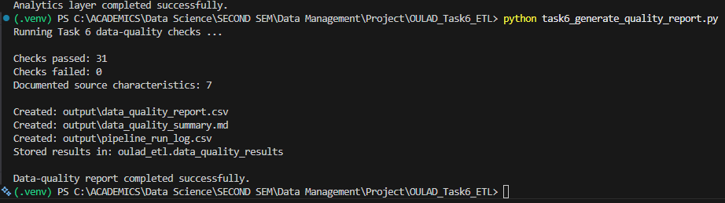
Figure 4. Final quality report generation: 31 passed, 0 failed and 7 informational findings.

7. Pipeline Execution and Evidence
The implementation is separated into small programs so each stage can be understood, tested and evidenced independently. The required execution order is shown below.
python test_connection.py
python inspect_raw_files.py
python task6_load_staging.py
python task6_transform_clean.py
python task6_build_analytics.py
python task6_generate_quality_report.py
Stage | Rows written | Logged seconds | Outcome
Raw loading | 10,900,970 | 145.66 | Seven CSVs reconciled
Clean transforms | 8,700,202* | 258.21** | Seven constrained clean tables
Analytics | 32,676 | 79.85 | Four reporting tables

* Sum of table row counts; relations have different grains and should not be added as a business total. ** Excludes the 85.08-second staging-index build and 344.00-second large-table constraint build, which are displayed separately by the transformation program.

8. Requirement Traceability
Requirement | Implementation | Evidence
Raw files | Seven original CSV files in data/ | Preflight output and Figure 1
Staging tables | Seven stg_* tables; 10,900,970 rows | etl_run_log and Figure 1
Cleaned tables | Seven clean_* relations with keys and constraints | Figure 2 and quality checks
Analytics layer | Four analytics_* reporting tables | Figure 3 and reconciliation checks
Data-quality checks | 31 PASS, 0 FAIL, 7 INFO | data_quality_results and Figure 4
Short quality report | CSV and Markdown reports plus pipeline log | output/ directory

9. Limitations and Future Improvements
- LOAD DATA LOCAL INFILE must remain enabled on the MySQL server and client connection.
- The scripts are intentionally run one stage at a time for teaching and evidence; a future wrapper could execute all stages with one command.
- The 2.20 million repeated interaction rows are consolidated at the documented daily grain. If a finer event grain becomes available, the aggregation rule should be reconsidered.
- The engagement summaries describe association with outcomes and should not be interpreted as causal models.
- Production deployment would add scheduled execution, encrypted secret storage, automated backups and alerting on failed quality checks.

10. Conclusion
The Task 6 pipeline provides a complete and reproducible route from the raw OULAD files to validated analytics outputs. It combines fast bulk ingestion, traceable raw staging, explicit cleaning rules, relational integrity, reusable analytics tables and automated quality reporting. All source and layer counts reconciled, all integrity checks passed and no quality check failed. The implementation therefore meets the stated ETL/ELT and data-quality requirements while remaining isolated from the earlier coursework database.

Appendix A. Deliverable Inventory
File | Purpose
inspect_raw_files.py | Validates all filenames and CSV headers
task6_load_staging.py | Creates and loads the raw staging layer
task6_transform_clean.py | Creates typed, constrained clean relations
task6_build_analytics.py | Builds four reporting-ready analytics tables
task6_generate_quality_report.py | Runs checks and produces report outputs
data_quality_report.csv | Detailed machine-readable quality-check results
data_quality_summary.md | Short human-readable quality report
pipeline_run_log.csv | Stage-level lineage, counts, timings and statuses

Appendix B. Key Database Objects
Layer | Objects
Staging | stg_courses; stg_assessments; stg_vle; stg_student_info; stg_student_registration; stg_student_assessment; stg_student_vle
Clean | clean_module_presentation; clean_student; clean_registration; clean_assessment; clean_vle_resource; clean_student_assessment; clean_student_vle_interaction
Analytics | analytics_student_engagement; analytics_completion_by_presentation; analytics_assessment_performance; analytics_engagement_by_result
Audit | etl_run_log; data_quality_results

