DATABASE TRANSACTION REPORT
OULAD Transaction Control
and Integrity Protection
Task 4 | MySQL 8.4 | Database: oulad_db

Requirement | Implemented evidence
Controlled workflow | Controlled assessment score correction using a temporary assessment record
Transaction control | START TRANSACTION, SAVEPOINT, ROLLBACK TO SAVEPOINT and ROLLBACK
Integrity protection | chk_student_assessment_score CHECK constraint rejected an invalid score of 120
Final condition | Original assessment score restored to 78 and no permanent changes remained after transaction rollback

Submission scope: This report satisfies requirement (iv) by applying transaction concepts through a controlled assessment score correction workflow. It demonstrates how transaction control (START TRANSACTION, SAVEPOINT, ROLLBACK TO SAVEPOINT, and ROLLBACK) together with database constraints (the chk_student_assessment_score CHECK constraint) preserve data integrity by preventing invalid updates and restoring the database to a consistent state when an error occurs.

1. Executive Summary
A controlled transaction was performed against the OULAD student_assessment table to simulate the correction of a student's assessment score. The workflow began by displaying the original assessment record, establishing a savepoint, and updating the student's score from 78 to 85. An invalid score of 120 was then deliberately submitted to test data integrity. MySQL rejected the update with Error 3819 because the chk_student_assessment_score CHECK constraint only permits scores between 0 and 100. A rollback to the savepoint restored the original assessment score, while a final rollback ended the transaction without permanently modifying the database. Final validation confirmed that the assessment record remained unchanged with its original score of 78, demonstrating that transaction control and integrity constraints successfully protected the consistency of the database.

Outcome: The workflow demonstrated that the chk_student_assessment_score constraint effectively prevented invalid assessment scores from being stored, while transaction control through START TRANSACTION, SAVEPOINT, ROLLBACK TO SAVEPOINT, and ROLLBACK ensured that all uncommitted changes could be safely reversed, preserving the consistency and integrity of the assessment data.

2. Controlled Transaction Workflow
The demonstration used a temporary assessment record created specifically for transaction testing. A sample student, module presentation, registration, assessment, and corresponding assessment result were inserted to satisfy referential integrity requirements before the transaction began. No production assessment records were modified. The transaction simulated the correction of a student's assessment score from 78 to 85, deliberately attempted an invalid score update of 120, and was intentionally rolled back rather than committed because the objective was to demonstrate transaction control and integrity protection rather than perform a permanent data correction.

Stage | Operation | Observed result
1 | Display original assessment record | Assessment score shown as 78
2 | Start transaction and create savepoint | Transaction initiated; savepoint created successfully
3 | Update assessment score | Score changed from 78 to 85 within the transaction
4 | Attempt invalid score update to 120 | Rejected by the chk_student_assessment_score CHECK constraint; Error 3819
5 | Rollback to savepoint | Assessment score restored to 78
6 | Full rollback | Transaction ended with no permanent changes to the database
7 | Final reconciliation | Assessment record remained unchanged with its original score of 78

2.1 Controlled insert
The transaction began after the required demonstration records had already been created. The original student_assessment record was first displayed to verify the starting state of the data. The transaction was then initiated using START TRANSACTION, followed immediately by the creation of the savepoint before_score_update. The selected row shown below confirms that the assessment record existed with its original score of 78 before any modifications were made.

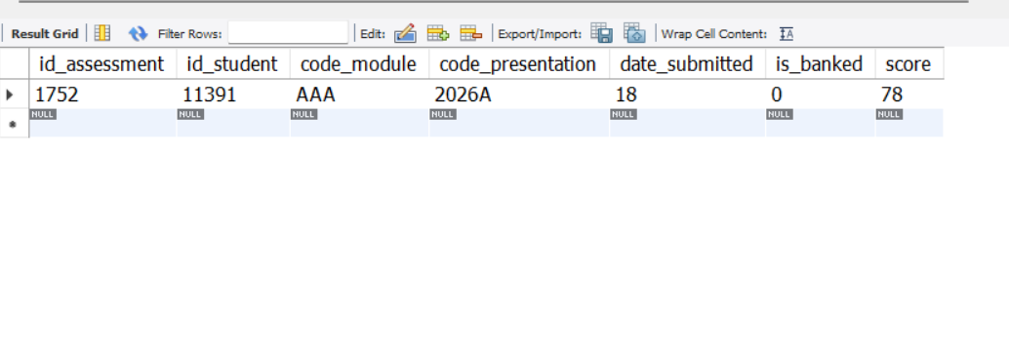
Figure 1. Sample assessment record successfully inserted into the student_assessment table prior to transaction testing..

3. Controlled Correction and Constraint Protection

3.1 Controlled update
The assessment score of the selected student was updated from 78 to 85 within the active transaction to simulate the correction of an incorrectly recorded assessment result. The UPDATE statement was restricted using the composite identifiers id_student and id_assessment, ensuring that only the intended assessment record was modified. Because the update occurred inside an active transaction, the corrected value was visible for verification but remained uncommitted and could still be reversed if necessary.

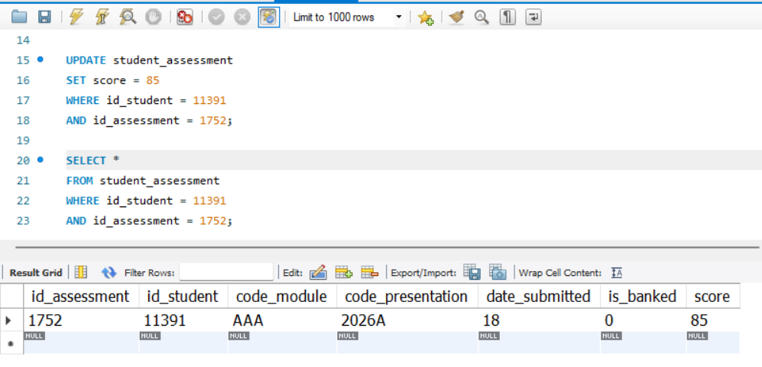
Figure 2. Assessment score successfully corrected within the active transaction.

3.2 Constraint-enforced rejection
An invalid update attempted to set the assessment score to 120. The table-level chk_student_assessment_score CHECK constraint permits only scores between 0 and 100, so MySQL rejected the statement with Error 3819 before the invalid value could be stored. This demonstrated that the database automatically enforced data integrity by preventing inconsistent assessment records from being committed.
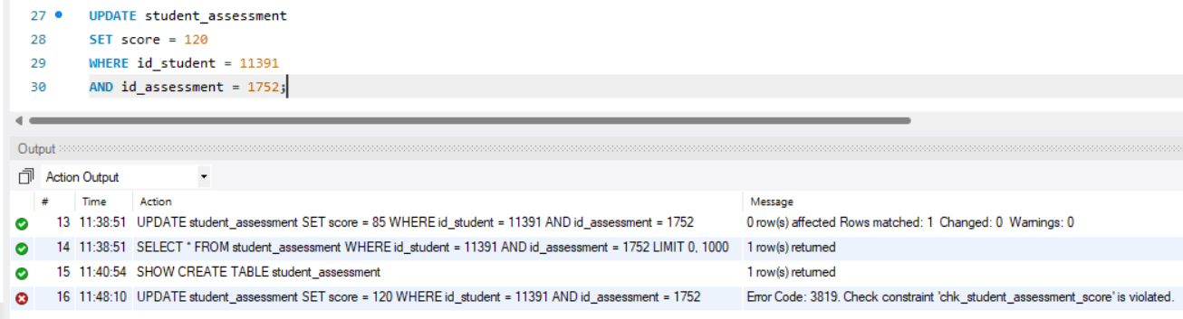
Figure 3. Error 3819 confirms enforcement of chk_student_assessment.

4. Transaction Recovery

4.1 Rollback to the savepoint
ROLLBACK TO SAVEPOINT before_score_update reversed the valid assessment score correction while keeping the transaction active. The student's assessment score was restored from 85 to its original value of 78, demonstrating that a savepoint enables selective recovery without terminating the entire transaction. This allowed the database to recover from the failed update while preserving the transaction context for further processing or validation.

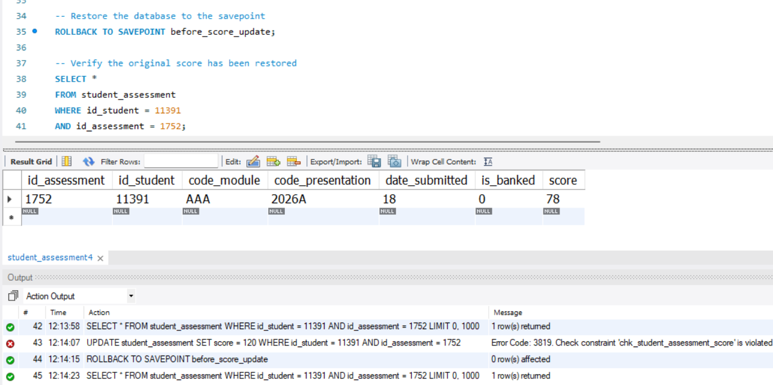
Figure 4. Savepoint rollback restored the earlier temporary score.

5. Final Validation
A final verification query was executed after the rollback to confirm the state of the assessment record. The query returned the original assessment scores of 78, confirming that the invalid update had not been stored and that the rollback to the savepoint successfully restored the record to its initial state. The demonstration therefore concluded with the assessment data remaining consistent, validating that the combination of transaction control and the chk_student_assessment_score.

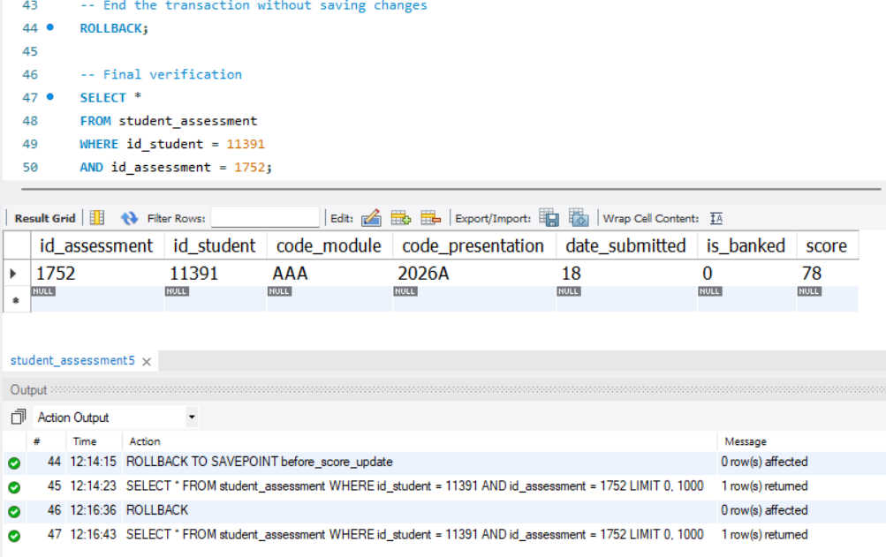
Figure 6. Final student count equals the unique source-student count.

Validation note: The final verification query confirmed that the assessment record remained with its original score of 78 after the rollback to the savepoint. This verified that the attempted invalid update was not stored and that the database returned to its original consistent state. The final verification therefore supersedes the intermediate transaction results and represents the authoritative state of the data.

6. Integrity and Transaction-Control Discussion
Control principle | Evidence from the workflow
Atomicity | The assessment score correction was performed within a transaction, allowing the changes to remain uncommitted until explicitly accepted or reversed.
Consistency | The chk_student_assessment_score CHECK constraint rejected the invalid score of 120, ensuring that only scores between 0 and 100 could be stored.
Controlled recovery | ROLLBACK TO SAVEPOINT before_score_update restored the assessment score from 85 to its original value of 78 without terminating the transaction.
Scope control | The UPDATE statement was restricted using id_student = 11391 and id_assessment = 1752, ensuring that only the intended assessment record was modified.
Auditability | Query results were captured before the update, after the valid correction, following the rejected update, and after the rollback, providing clear evidence of each stage of the transaction.

Durability was not demonstrated because the transaction was intentionally not committed. Instead, the workflow concluded by rolling back to the savepoint and verifying that the assessment record had been restored to its original score of 78. This approach was appropriate for a controlled coursework demonstration, where the objective was to illustrate transaction control and integrity protection without making permanent changes to the database.

7. Conclusion
Task 4 was completed successfully by demonstrating transaction management through a controlled assessment score correction workflow. The transaction included a valid assessment score update, enforcement of the chk_student_assessment_score CHECK constraint through the rejection of an invalid score, and recovery using a savepoint rollback. The database prevented inconsistent data from being stored, while the rollback restored the assessment record to its original score of 78. Final validation confirmed that the assessment data remained unchanged after the transaction, demonstrating that transaction control and integrity constraints effectively preserved the consistency and reliability of the database.

Appendix A — Reproducible SQL
The following SQL script reproduces the controlled transaction demonstration used in this report. The temporary demonstration records were created before the transaction to satisfy referential integrity requirements. The transaction demonstrates a controlled assessment score correction, constraint enforcement, and recovery using a savepoint. The workflow concludes with no permanent modification to the assessment record.

U USE oulad_db;

START TRANSACTION;

SELECT *
FROM student_assessment
WHERE id_student = 11391
AND id_assessment = 1752;

SAVEPOINT before_score_update;

UPDATE student_assessment
SET score = 85
WHERE id_student = 11391
AND id_assessment = 1752;

SELECT *
FROM student_assessment
WHERE id_student = 11391
AND id_assessment = 1752;

-- Expected Error 3819:
-- chk_student_assessment_score rejects scores outside 0–100

UPDATE student_assessment
SET score = 120
WHERE id_student = 11391
AND id_assessment = 1752;

ROLLBACK TO SAVEPOINT before_score_update;

SELECT *
FROM student_assessment
WHERE id_student = 11391
AND id_assessment = 1752;

