eZ publish
Google Website Optimizer Extension
(aplgwo)

Developed by: Aplyca

Table of Contents
Table of Contents 2
1 Overview 3
2 Installation 3
3 Experiment Tutorial 4
4 Other Resources 21

Overview

This guide covers setting up different types of experiments for Google Website Optimizer with Aplyca’s aplgwo extension for eZ publish.

Installation
Download and unpack the extension into your /extension directory.

Using the admin area Package manager, install the package found in the /package directory

If you get a message indicating duplicated classes, click on the option to ‘Keep existing and create a new one’.

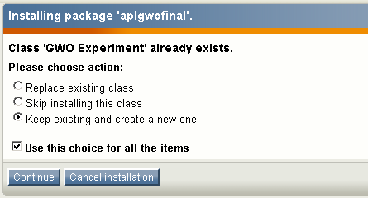

VERY IMPORTANT.

Paste the include files in your pagelayout as follows:

{include uri='design:aplgwo_header.tpl'} goes just before the head closing tag.

{include uri='design:aplgwo_footer.tpl'} goes just between the footer and the body closing tag.

Experiment Tutorial

Creating a AB Experiment

Log in to your Google Analytics Account and click on Website Optimizer. Alternatively use the url http://www.google.com/analytics/siteopt


Create a new Experiment

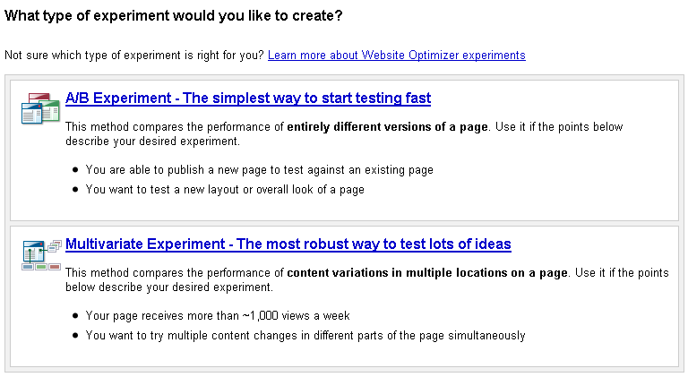

In Google Website Optimizer select an A/B experiment.


Define Experiment name, test and conversion pages.

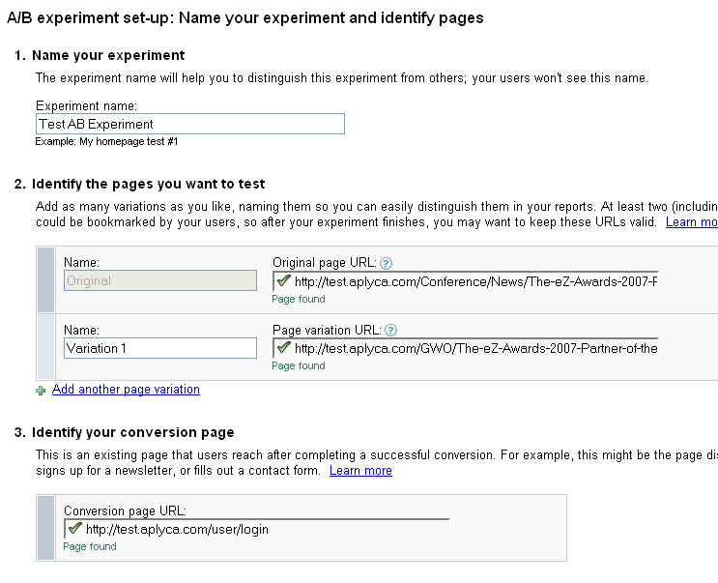

Select ‘You Will install and validate the JavaScript tags’
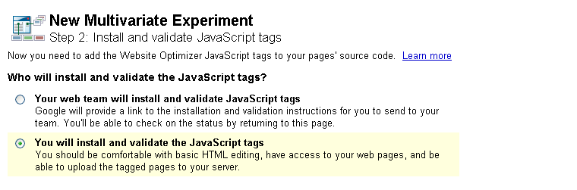

Get Experiment ID from the control script box. It is the string of numbers just after the ‘k=’ in the box. In this case ‘2669830351’.

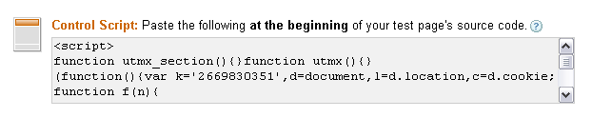
Get Tracker ID from the conversion script box. In this case ‘UA-59880198-1’.
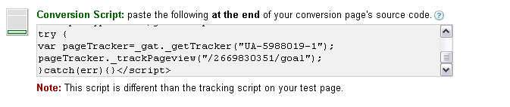



In eZ publish



Log into you your admin area.

Make sure the extension is active in Setup->Extensions and that you have installed the Class Package found in the /packages folder


The first time you use the extension, create a GWOFolder object. This will keep all your experiment information neatly organized.

In eZ create a GWO A/B Experiment Object and set the experiment ID, the Tracker ID and the original and variation pages.

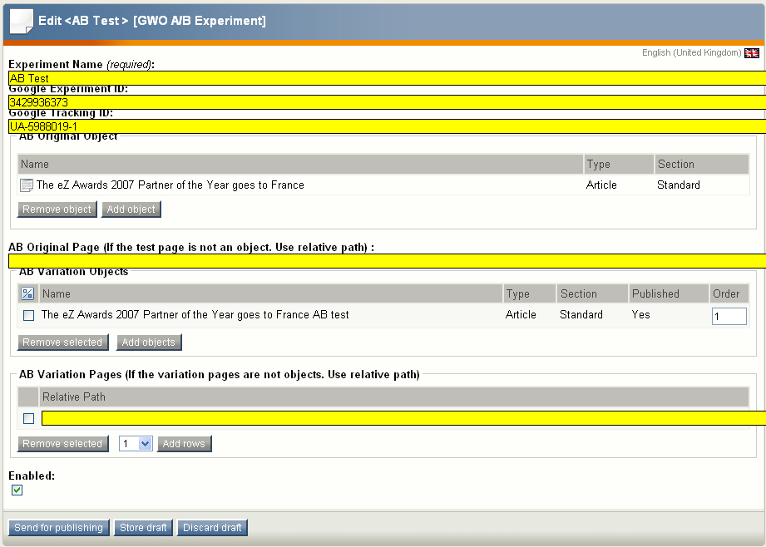

Note:
There are two ways to set the experiment original page, in one hand you can relate an object using the attribute ‘Ab Original Page’. In this case your original test page is an object. In the other hand you can set the direct url using the ‘AB Original Page’ as follows:

‘/myfolder/myoriginalpage’ You have to use a relative path with leading slash

This case is used for non objects pages, like modules as user/register.

Setting the variation pages is a similar process, you can relate multiple variation pages as objects using ‘AB Variation Objects’ attribute or you can add direct urls with the attribute ‘AB Variation Pages’ or both.

The direct urls most follow the same rules as the Original Page case.

Define Conversions
Create a GWO Conversion Object. This object defines what actions will trigger a conversion call to GWO. You can set it’s attributes like this:
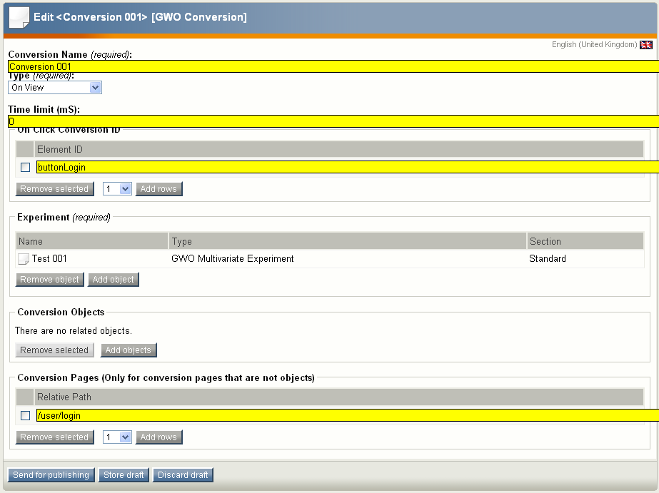

Conversion Use the same conversion page set for the Google experiment.
Validate the JavaScript code in Google Website Optimizer.
Conversion Pages allows you to set up URL’s that will be used to track conversions. This is set-up as a URL to allow for module views in addition to content objects.

The experiment is set! You can now validate your experiment in Google Webiste Optimizer.

Click on the Validate Pages link:

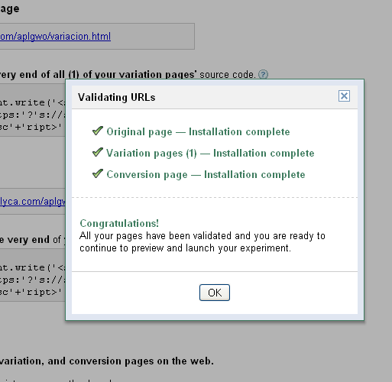

If you get errors, go back to eZ publish and make sure your GWO Objects are correctly set up.

Preview and Launch the Experiment

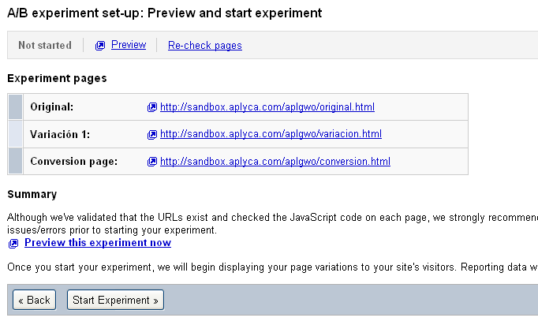

You can click on the Preview link before launching the experiment. This shows you how each variation looks like.

Creating a Multivariate Experiment
Log in to your Google Analytics Account and click on Website Optimizer. Alternatively use the url http://www.google.com/analytics/siteopt

Create a new Experiment

In Google Website Optimizer select a Multivariate experiment.

Define Experiment name, test and conversion pages.
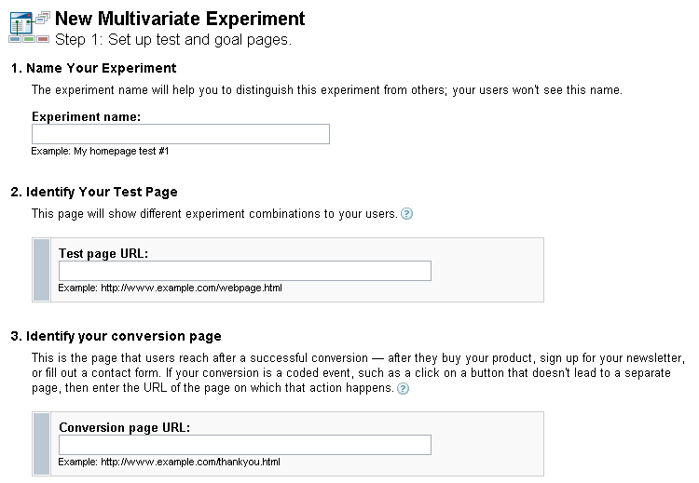

Note: If you have multiple test pages (eg. A sitewide variation) or multiple conversion pages, simply put the URL of a single valid example of each one.


Select ‘You Will install and validate the JavaScript tags’
Get Experiment ID from the control script box. It is the string of numbers just after the ‘k=’ in the box. In this case ‘2669830351’.
Get Tracker ID from the conversion script box. In this case ‘UA-59880198-1’.

In eZ publish

Log into you your admin area.

Make sure the extension is active in Setup->Extensions and that you have installed the Class Package found in the /packages folder

The first time you use the extension, create a GWOFolder object. This will keep all your experiment information neatly organized.

In eZ create a GWO Multivariate Experiment Object and set the experiment ID and the Tracker ID.

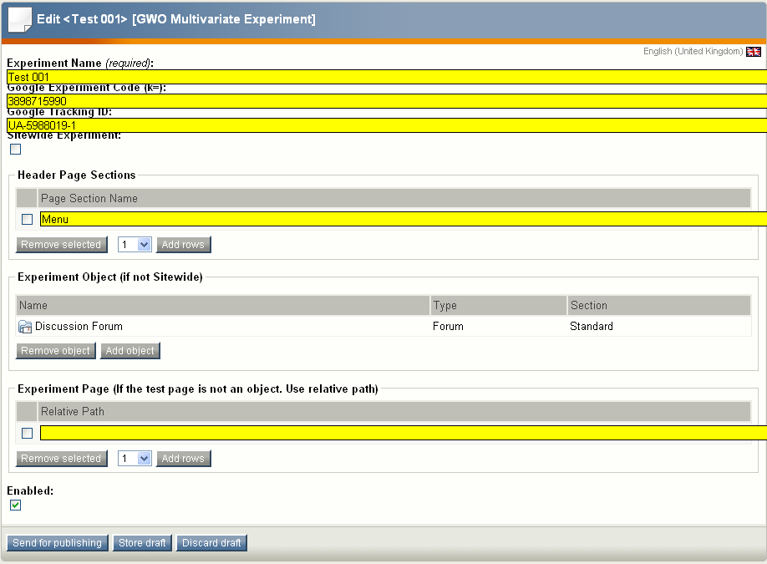

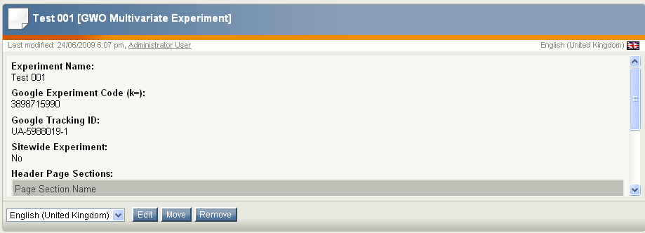

Define Page Sections

Style Variations

The Header Style variation attribute is a Matrix that allows you to create one or more GWO Page Sections in your header. This is especially useful to test multiple CSS style variations on a Google Experiment.
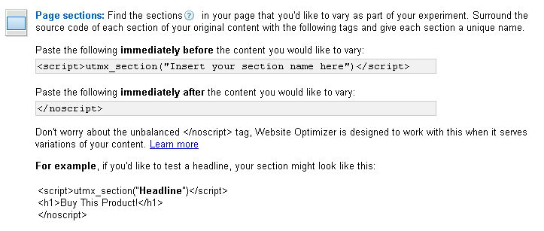

Content Variations

If you want to have variations in content which cannot be achieved through a CSS override, you should edit your site’s templates to surround each element with the a simple Page Section Script

<script>utmx_section(“Insert your section name here”)</script>
eZ template code here
</script>

For every utmx_section defined, you will be able to add different versions of content inside Google Website Optimizer at the experiment creation time.

We have found that to mark variable sections in eZ publish you will need to edit your templates and define the override conditions. This requires editing the templates to include the Page Section code surrounding each of the areas we want to test. There are different strategies:

- Create a template override for the node or nodes you wish to test
- Create an datatype based override

Notes:
- Do not worry about the unbalanced </script> tag, it is meant to be this way.
- Keep in mind that while the ‘Original’ version of the content is produced by eZ, the variations are stored directly in Google’s servers. You can work around this by using some of the advanced techniques described in the Google Website Optimizer Tricks Blog (http://www.gwotricks.com/)
- You can override a specific datatype template.

Define Conversions
Create a GWO Conversion Object. This object defines what actions will trigger a conversion call to GWO. You can set it’s attributes like this:

Conversion Use the same conversion page set for the Google experiment.
Validate the JavaScript code in Google Website Optimizer.
Conversion Pages allows you to set up URL’s that will be used to track conversions. This is set-up as a URL to allow for module views in addition to content objects.

The experiment is set! You can now validate your experiment in Google Webiste Optimizer.

Click on the Validate Pages link:

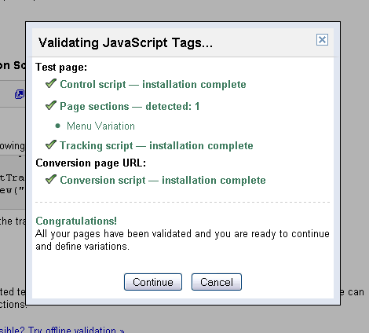

If you get errors, go back to eZ publish and make sure your GWO Objects are correctly set up.

Create the Experiment Variations
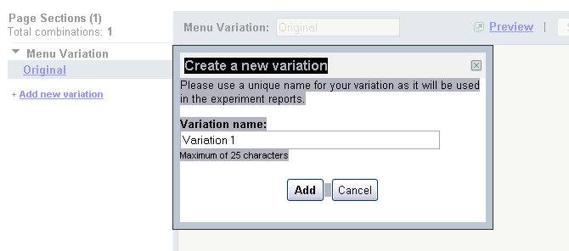
Name each variation to be easily identifiable. Eg. Green Header Background or ‘Sign up now for a free trial’.

This screen shows a variation in one of the Header Page Sections. It includes the <style> tags and a simple change of color for an h2 element.

The beauty of Header Page Sections is that they are the last styling attributes loaded. They will override any previous CSS properties in preceding .css files.
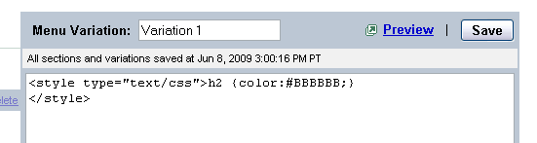

Tip: The Firebug extension for Firefox will let you change the CSS properties

Save and continue through each of your ‘Page Sections’.

Preview and Launch the Experiment

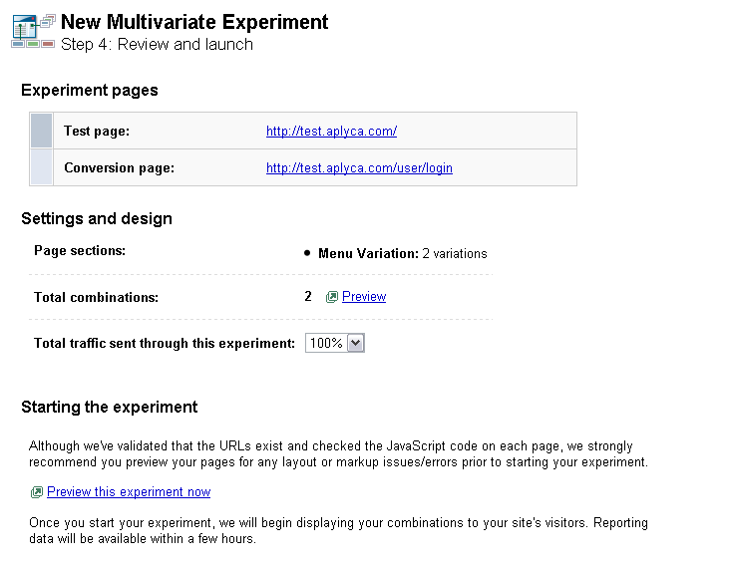

You can click on the Preview link before launching the experiment. This shows you how each combination or ‘recipe’ looks like.

Define the Total Traffic sent through this experiment. Depending on your traffic, number of GWO Page Sections and number of Variations you may want to put more or less traffic to reduce the length of the experiment.

Debugging your Test

In order to check your extension settings you can activate the debug option by adding the following Get variable to your url:

?gwodebug=on

Eg. To check the settings in the conversion page
‘http://www.yourdomain.com/user/register’

Use:
http://www.yourdomain.com/user/register?gwodebug=on

Analyzing Cookies
There are two cookies set for each visitor. Utmx and utmxx. Only utmx is used by GWO at this point. The cookie will allow GWO to ‘remember’ which variation was assigned to a specific user, and display it consistently for the duration of the experiment. The cookie expires after 2 years.

Let’s take a look at the cookie value:
54653691.00003884894166368064:1:0-1-0
54653691. – Domain
00003884894166368064 – Experiment
0-1-0 - Variation

Note: If you run multiple experiments on the same site, a dot will separate the additional experiment and variation details.

Tip: You can manually change the Cookie Values of your browser to simulate different variations. The Web Developer Toolbar in Firefox will let you do this easily.

Manually Previewing Variations on a Running Test
Append a URL like this to any of your experiment pages. Copy the utmxid from the Preview features. Change the utmxpreview variable to the different variations on your Page Sections. If there are multiple sections, separate the variations by a dash. Remember, zero is always the ‘Original’, while each variation is assigned an incremental number. Therefore in a three page section experiment, the variable utmxpreview=0-0-0 would show the original, while utmxpreview=1-2-2 would show variation #1 of the first page section, and variation #2 of Page Section 2 and Page Section 3.
#utmxid=EAAAAJZaMwKe1lm-wr4amAG3eyA;utmxpreview=1;utmxreload=0

Analyze the Results

You can learn to analyze your results in the ‘Understanding Reports’ section of GWO.
http://www.google.com/support/websiteoptimizer/bin/topic.py?hl=en&topic=14328

After a High Confidence Winner has been found, you can create an additional ‘follow-up’ experiment that validates the results with a test of only the winning combination and the original. This is useful to validate the results.

Other Resources
Website Testing and Optimization is a lengthy subject. The APLGWO extension will allow you to create tests with minimum technical requirements.

Web

Website Optimizer Help | http://www.google.com/support/websiteoptimizer/?hl=en
Google Website Optimizer Tricks | http://www.gwotricks.com/
Official Website Optimizer Blog | http://websiteoptimizer.blogspot.com
Techie Guide to Google Website Optimizer | http://www.google.com/websiteoptimizer/techieguide
Books

Landing Page Optimization – The Definitive Guide to Testing and Tuning for Conversion | Tim Ash
a/b Always be Testing – The Complete Guide to Google Website Optimizer | Bryan Eisenberg, John Quarto-vonTivadar

