Bring Me The You From You
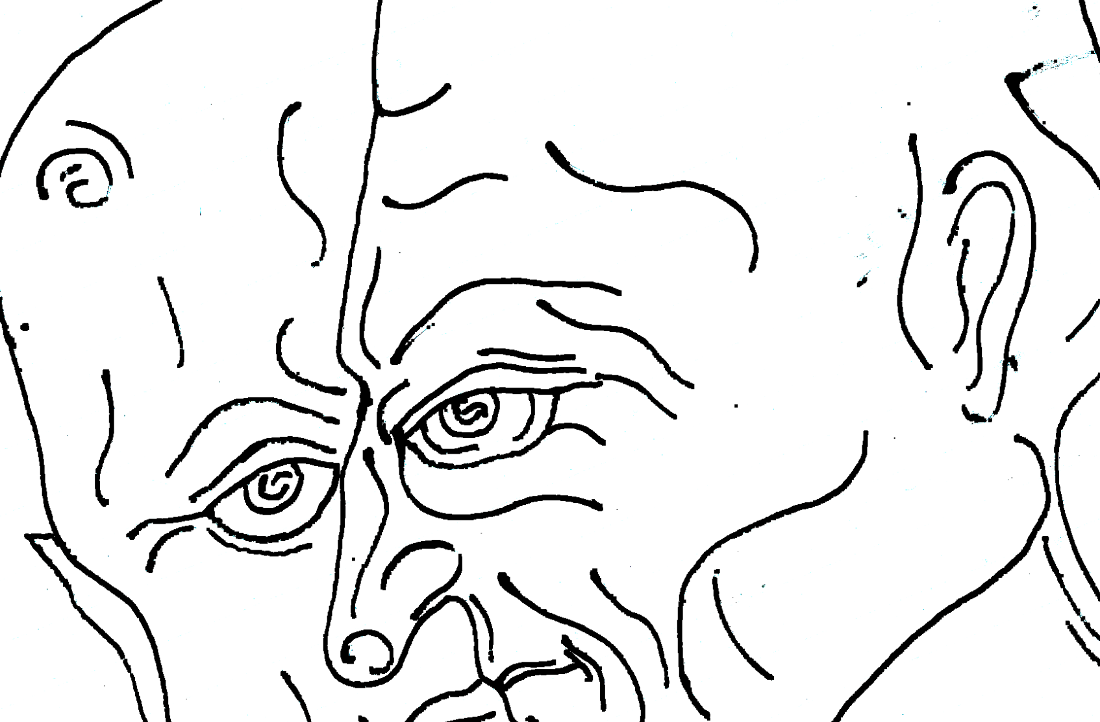
Aleksander Hardashnakov

November 29, 2012 – January 5, 2013
Opening Reception: November 29, 6 – 8 pm

Martos Gallery
540 W 29th Street
New York, NY 10001
www.martosgallery.com
212 560-0670
info@martosgallery.com

FOR IMMEDIATE RELEASE

Martos Gallery is pleased to present Aleksander Hardashnakov’s first solo show in New York City.

“This is your bed, these are your brothers and your husband and your daughter and your mother, your father... you have no sister, you have no son, these are your clothes, this is your house, your street, your room, toilet soap glass kitchen plate fork toothpick towel tree Christmas lights rings pear apple and orange, banana and ham scarf bobby pin thumb tack telephone necklace flowers. You were born there, grew up there, lived there and now you’re here.” She picked up the spoon and said “it’s me” she picked up the shoe and said “it’s me” she picked up the burger and said “it’s me” and it went on like that. Everyone agreed “yes, that’s you and so is that and that and that.”

For further information please contact 212 560-0670 or info@marosgallery.com

