Andy Cross
House Painter

September 6 – October 6, 2012
Opening Reception: September 6, 6 - 8 pm

Martos Gallery
540 W 29th Street
New York, NY 10001
www.martosgallery.com
212-560-0670
info@martosgallery.com

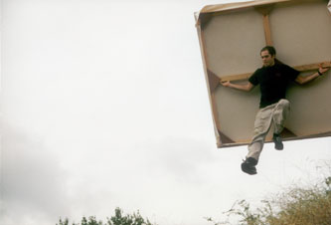
FOR IMMEDIATE RELEASE

Martos Gallery is pleased to begin its fall season with “House Painter,” an exhibition of new work by Andy Cross. Form and function have never felt so at home—“House Painter” is literally a house made out of paintings. Over eighty paintings cover the exterior, all done by Mr. Cross throughout the last six years. Plein-air, portraits, self-portraits, nudes, still-lifes, photo-based, imaginative, abstract, and text paintings combine (like any other building material) to construct a classic cottage. It has a pitched roof, a door, three windows, a skylight, and even a little front porch.
Despite the physical walls of Andy’s house defining space in our gallery, his construction/painting approach physically breaks down the mental barriers we have erected between disciplines and styles. Architecture, sculpture, and painting, all blur into one message: that of pure possibility.
As Mr. Cross has written of the project, “Recycle the painting: flip it over and start anew; cut it up and collage the parts onto another painting. Screw a few paintings together to create a larger surface and then paint on top of it all over again. Or, combine paintings together and make a house…” The main piece in this exhibition has taken the form of a house, but overall, his varied work acts more like a bridge. Unabridged he paints and paints, connecting opposing sides: inside and out, high and low, personal and public. At its best, his work attempts to re-attach the severed silver strings that connect the material back to the spiritual.
Viewing Life as a continual artistic residency, Mr. Cross will occupy the “house,” turning it into his studio for the duration of the exhibition. All are welcome: come by and watch the artist paint inside his own paintings. Time may even allow him to work on your portrait. Or join Andy outside, on the front porch, watching the trends and traditions change like the traffic and construction projects on West 29th Street.

For further information please contact 212-560-0670 or info@martosgallery.com

