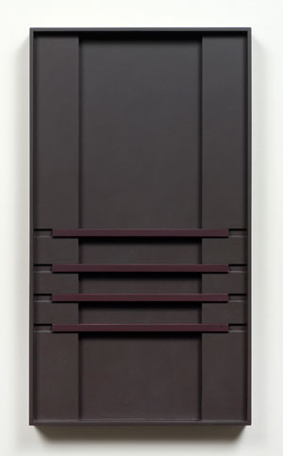

Aaron Aujla
Charles Harlan
John Pittman

January 11 – February 16, 2013
Opening Reception: January 11, 6 - 8 pm

FOR IMMEDIATE RELEASE

John Pittman's paintings are also reliefs, a field for light as much as they are a field for shadow. A trained frame maker, Pittman meticulously crafts variations of depth within the surfaces of his work. And as light is limited by its inability to fold, so the color within the field of Pittman's paintings is intensified only when it can be reached. Pittman's practice, while dedicated to painting and sculpture, is ultimately observations of subtleties. Pittman was born in 1948 in Detroit, Michigan and lives and works in Chicago.

Aaron Aujla's installations, despite their ambition in size are equally subtle in detail. Aujla constructs floor to ceiling installations of rooms within rooms. The walls are painted with high-end domestic house paints, each piece titled according to their Benjamin Moore names, with vaguely romantic connotations such as "Nimbus" and "Francesca." "As 'gentleman prefer blondes,' so everyone has preference for certain colors and prejudices against others" and Aujla's work makes this only more clear. The variations that Pittman makes upon a ¼-inch relief, Aujla constructs at the architectural level—a room void-like it becomes a view unto itself. Aujla was born in 1986 in British Columbia, Canada.

Charles Harlan's sculptures, like Aujla's installations, are constructed from materials found in the American domestic landscape. For his pieces in this exhibition Aujla investigates shades of paint, and the origins of "Chelsea Grey" verses "Divine Pleasure." Harlan on the other hand is invested in the materials themselves -- the progression from clay, to concrete, to steel, and the implications of those materials to the civilizations that invented them. Harlan's newest work presented here are horizontal concrete sculptures that are cast from vinyl siding. Humorously they recall third degree brutalist architecture: concrete cast from a mold composed of vinyl that is meant to look like woodgrain. Their surfaces physically trace the transformation of material as it passes through time. Harlan was born in 1984 in Atlanta, Georgia.

For further information please contact 212-560-0670 or info@martosgallery.com

Albers, Josef. "Interaction of Color". Yale University Press. 2006 p.17

