
Shoot The Lobster – New York City
540 W 29th St.
New York, NY 10001
212 560-0670
contact@shootthelobster.com
www.shootthelobster.com

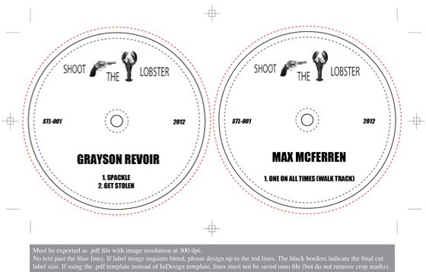
New York City - 540 W 29th Street
Shoot The Lobster Recordings
Grayson Revoir
August 15 - September 1, 2012
Artists Reception: August 15, 6 - 8 pm

FOR IMMEDIATE RELEASE

It fills me with great pleasure and pride to announce the beginning of the next extension of Shoot The Lobster, Shoot The Lobster Recordings. STLR will function as a record label with a monthly agenda of releases focusing on dance floor music. (Due to the ever expanding nomenclature that evolved from "disco," "house," and "techno" it's fitting to call what will be released on STLR "dance floor" to avoid the headache that arises from attempting to explain the nuances of the three classic genres.)

I am incredibly excited to say that the first release is now available. The first two tracks were produced by me. They are erratic, bass heavy interpretations of 4-on-the-floor. Spackle is like sharp cheddar, and Get Stolen sweats like Monterey Jack in the sun.

The third track, One On All Times (walk track), was produced by Max McFerren. This is what he has to say about it:

I want this track to sound like a Mobile tank yacht with Panorama Bar on the top floor. Like rust under an electron microscope; ethereal and hard at the same time; smoky but not weed. This song is the devils dance. I want it to rattle your bones.

STLR’s inaugural release is currently available for digital download at
http://soundcloud.com/shoot-the-lobster

12” LPs of the recordings, pressed on 150g vinyl, are forthcoming.

Please join us at Shoot The Lobster this Wednesday, August 15, from 6 – 9 pm for the announcement reception.

-Grayson Revoir

For further information please contact 212-560-0670, contact@shootthelobster.com, or grayson@shootthelobster.com

