

Shoot The Lobster – Toronto @ Clint Roenisch Gallery
944 Queen St. W
Toronto, ON M6J 1G8
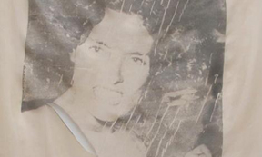
Canada
416-516-8593

contact@shootthelobster.com
www.shootthelobster.com

Orange Joyce
Servane Mary
July 5 – July 28, 2012
Artist Reception: July 5, 7 – 9 pm

FOR IMMEDIATE RELEASE

Shoot The Lobster is pleased to announce a show of selected works by Servane Mary at Clint Roenisch Gallery. Mary’s prints of defamed actresses and singers on silk evoke the complicated private/social faces of notoriety.

An Artist Reception will inaugurate the show on Thursday, July 5 at 7pm.

For further information please contact: contact@shootthelobster.com or 212-560-0670

Shoot The Lobster Headquarters:
540 W 29th Street
New York, NY 10001

