**Please read the content very carefully and follow the steps as mentioned to make the Python code works perfectly**

Step 1: Download DSSAT 4.7 latest version. Old versions such as DSSAT 4.6 will not work. Go to <https://dssat.net/> website and download the latest version software on request to Dr. Gerrit Hoogenboom.

After DSSAT V4.7 download and installation has been completed

Step 2: Download Python 3.8 latest version. The python pyc file has been developed using python 3.8 version. The code works only with python 3.8 Only

Download from the link

<https://www.python.org/ftp/python/3.8.3/python-3.8.3.exe>

or

<https://drive.google.com/drive/u/2/folders/1JQX7Zu5kx-aZlIYaF7eIU7zzIOZ35XbL>

Step 3: Download the required script from <https://github.com/gbgohain26/> and extract the required zip file to C drive only. Don’t extract to any drive

Step 4: After python 3.8 version installation has been completed and Environment Variables has been set please install the following package in python ( if it doesn’t exist )

Step 5: To install the python go to windows--> start🡪type cmd🡪after the command prompt has been displayed type🡪pip install package_name

*Package name are :- numpy, pandas, xlrd, openpyxl, csv, shutil, thinker

**To run the code one must have a fair knowledge of the DSSAT crop model and its terminology to understand how the code works**

There are two modules published in this paper. Details about the folder and module description are mentioned below

1. **DSSAT_MODULE**

Folder

* ACTUAL_YIELD
* DIST_FORECAST
* DSSAT_SNX
* DSSAT_V47
* EXPERIMENTAL_FILE
* SIMULATED_YIELD

Script

* DSSAT_FILE_MANAGER
* DSSAT_V47_BATCH
* DSSAT_SIMULATED
* DSSAT_COMPARE
* DISTRICT_FORECAST

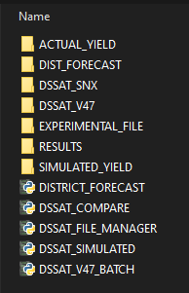

1. **WEATHER_CONVERTER**

Folder

IMD_DAILY_GRIDDED

Folder

* DAILY_DATA_LIST
* DAILY_GRID_DATA
* DATA_CROP_MODEL
* STATION_LIST

Script

* DAILY_WEATHER

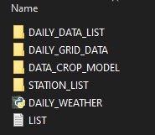

IMD_GRIDDED_1980_2015

Folder

* DSSAT_WEATHER
* GRID-DATA
* STATION_LIST

Script

* YEARLY_GRID

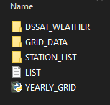

Script

* DOWNLOAD_DAILY_GRID_DATA

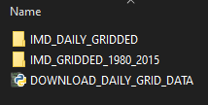

**DSSAT_MODULE: -**

**Please follow the steps to set up the folder and the code.**

After the DSSAT_MODULE.zip file has been downloaded from

<https://github.com/gbgohain26/DSSAT_MODULE/>

Extract the DSSAT_MODULE.zip file and unzip the file in C:\ Drive. After extraction, inside the folder and the python code with different subfolders. Inside folder DSSAT_MODULE we have 7 subfolders as mentioned below

1. **ACTUAL_YIELD: -** Observed yield to be filled by the user which will be required to compare the observed yield and simulated yield. The file name should be named as STATENAME_ACTUAL, e.g. if we are analyzing MAHARASHTRA, we have to put as MAHARASHTRA_ACTUAL, the file extension should be in.XLSX. The state name should be same as the name mentioned in the LIST_STATE.DAT under EXPERIMENT_FILE folder

Filename as (MAHARASHTRA_ACTUAL.XLSX)

For filling the actual yield for each state or study area please keep the sheet name as OBS_YIELD. Please run each season separately.

1. **DIST_FORECAST: -** This folder contains the district level yield forecast. We don’t need to do anything in this folder. Processed data will be stored in this folder
2. **DSSAT_SNX: -** This folder contains the list of SNX (Seasonal) files. For any state, we may have one file with multiple numbers of seasonal lists
3. **DSSAT_V47: -** This folder will have DSSBatch.V47 files which contain all the season files to be simulated simultaneously
4. **EXPERIMENT_FILE:-** This folder will contain the experimental excel file. Each excel file will contain the state/Study area with all the details required to simulate a crop simulation model. Before executing the DSSAT_FILE_MANAGER fill the LIST_STATE.txt file for which state or location you want to simulate. The format to put in the file is

FILE_NAME,CROP_NAME (DSSAT Crop Code)

e.g. MAHA_SG. If we want to run multiple state/locations then just add below

MAHA_SG

ASSM-RI

The define FLNAME is a combination of the weather station and start year. Please fill this FLNAME accordingly. Don’t put any formula in an excel sheet. While reading the excel sheet in python this code doesn’t consider formula.

The sample file is attached. Before filling for another file please take the reference of this file

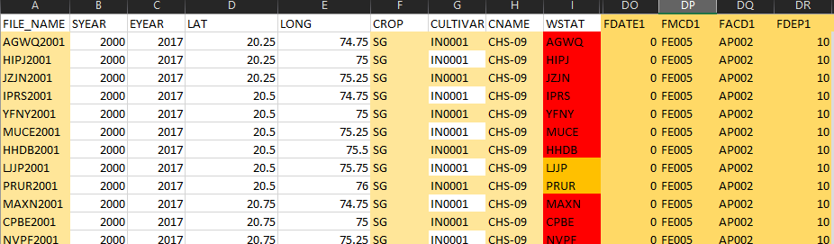

1. **RESULTS: -** This folder will have files with simulated and observed yield merged along with simulated yield deviation from observed
2. **SIMULATED_YIELD:-** This folder will contain simulated yield extracted from an overview summary file (.OOV). The files will have simulated yield, planting date, maturity date, and LAI

** An user need to fill the experiment excel file in EXPERIMENT_FILE folder and Observed Yield under ACTUAL_YIELD folder**

A description of the script is mentioned in the paper. Please read it carefully to function the code properly

If any queries please email me at gbbgohain@gmail.com