**Please read the content very carefully and follow the steps as mentioned to make the Python code works perfectly**

**WEATHER_CONVERTER: -**

**Please follow the steps to set up the folder and the code**

After the WEATHER_CONVERTER.zip file has been downloaded from

<https://github.com/gbgohain26/WEATHER_CONVERTER/>

Extract the WEATHER_CONVERTER.zip file and unzip the file in C:\ Drive. After extraction, inside the folder and the python code with different subfolders. Inside folder WEATHER_CONVERTER we have 2 subfolders as mentioned below

1. **IMD_DAILY_GRIDDED**

**Sub Folder**

1. **DAILY_DATA_LIST**

**Inside the folder, we have LIST-DATA.xls, we have to fill the F_NAME (Filename ), JDAY (Julian Day), and JDAY_MERGE (merge last two digits of the year and Julian day) eg. If the file name for maximum temperature is max12062020.grd the F_NAME will be 12062020, so for every file, we have to assign only the date of data captured and the sheet name should be the year**

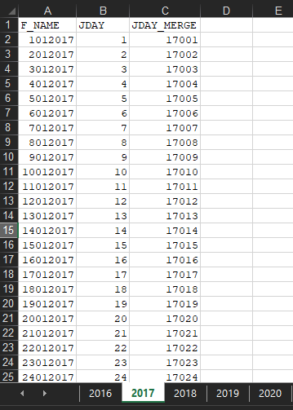

1. **DAILY_GRID_DATA**

**This folder contains the daily data downloaded from** [**http://www.imdpune.gov.in/Seasons/Temperature/temp.html**](http://www.imdpune.gov.in/Seasons/Temperature/temp.html)

**it has three subfolders**

* **MAXIMUM-for storing maximum gridded data**
* **MINIMUM-for storing minimum gridded data**
* **RAINFALL-for storing Rainfall gridded data**

**If you already have the data you can place it here else use the DOWNLOAD_DAILY_GRID_DATA.pyc file to download the data. It will store automatically in the folder assigned.**

1. **DATA_CROP_MODEL**

**This folder saves the DSSAT weather files**

1. **STATION_LIST**

**We have to prepare an excel sheet for each state. The state may contain different grids**

**Eg:- A sample file is mentioned below**

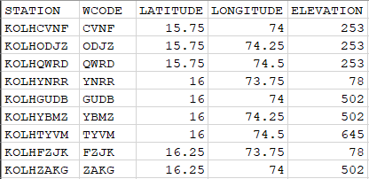

**STATION:- is the Weather station or GRID name**

**WCODE:- is the weather station code that will be assigned to the weather file ( it will be a specific grid or specific location or weather station)**

**LATITUDE – Assign the latitude for the location**

**LONGITUDE – Assign the longitude for the location**

**ELEVATION – It’s the above sea level**

**Script**

* **DAILY_WEATHER:- it will convert the gridded data to the DSSAT model format**

**File**

* **LIST.txt:- we have to assign which states or which location has to run and the location excel sheet name should be same as mentioned in the LIST.txt**

**eg:-**

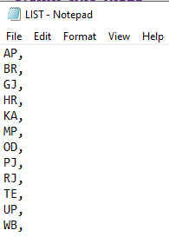

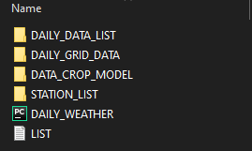

1. IMD_GRIDDED_1980_2015

**Sub folder**

1. **DSSAT_WEATHER**

**This folder saves the DSSAT weather files**

1. **GRID_DATA**

**This folder contains the yearly data downloaded which can be downloaded from**

<http://www.imdpune.gov.in/Clim_Pred_LRF_New/Grided_Data_Download.html>

**The rainfall data is available at 0.250X 0.250 from 1901 to 2019**

**The temperature data is available at 10X 10 from 1901 to 2019, if you want data at 0.50X 0.50, we have to put a request to IMD, Pune**

**it has three subfolders**

* **MaxT-for storing maximum gridded data**
* **MinT-for storing minimum gridded data**
* **Rainfall-for storing Rainfall gridded data**

1. **STATION_LIST**

**We have to prepare an excel sheet for each state. The state may contain different grids**

**Eg:- A sample file is mentioned below**



**STATION:- is the Weather station or GRID name**

**WCODE:- is the weather station code that will be assigned to the weather file ( it will be a specific grid or specific location or weather station)**

**LATITUDE – Assign the latitude for the location**

**LONGITUDE – Assign the longitude for the location**

**ELEVATION – It’s the above sea level**

**Script**

* **DAILY_WEATHER:- it will convert the gridded data to the DSSAT model format**

**File**

* **LIST.txt:- we have to assign which states or which location has to run and the location excel sheet name should be same as mentioned in the LIST.txt**

**eg:-**



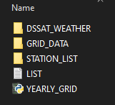

DSSAT soil at 10km can be downloaded from

<https://dataverse.harvard.edu/file.xhtml?persistentId=doi:10.7910/DVN/1PEEY0/CIMWRJ&version=2.6>

0.250 X 0.250 shapefile is included in the github , with State name, District name, DSSAT soil ID, unique Weather code, Latitude and Longitude, altitude and Nitrogen amount.

A description of the script is mentioned in the paper. Please read it carefully to function the code properly

If any queries please email me at gbbgohain@gmail.com