**OUTPUT:**

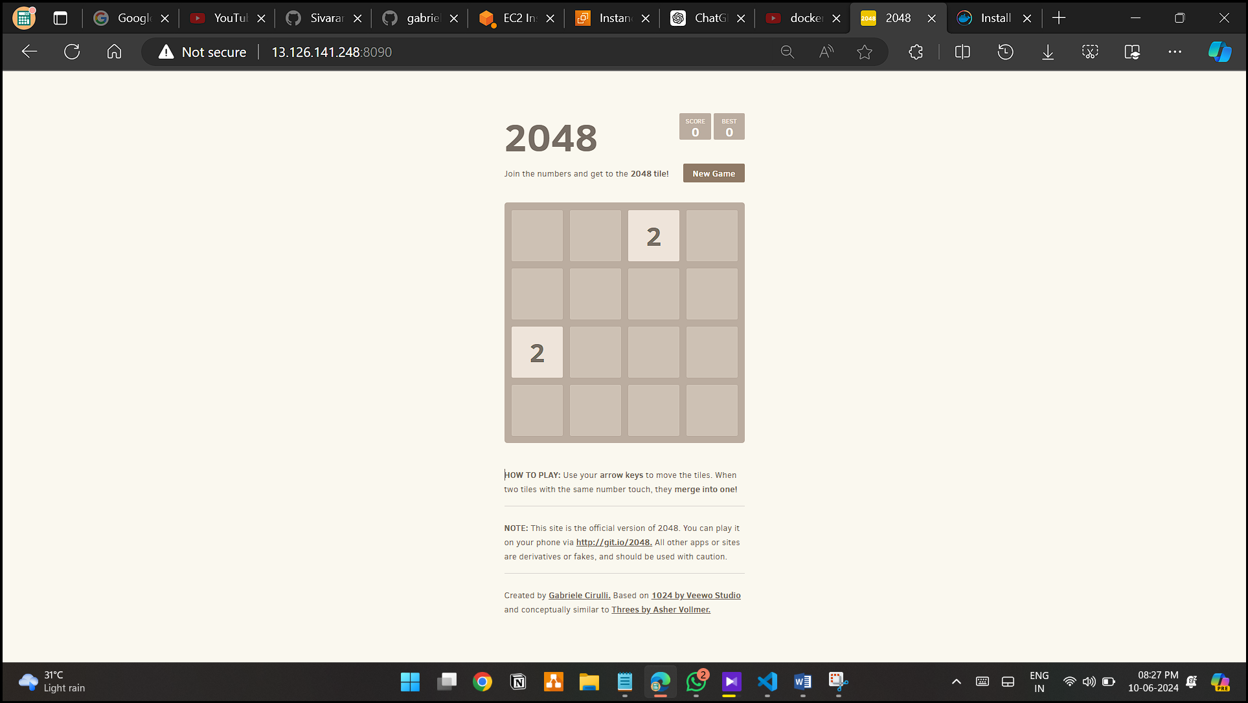

**Step 1: Create EC2 machine With Ubuntu AMI**

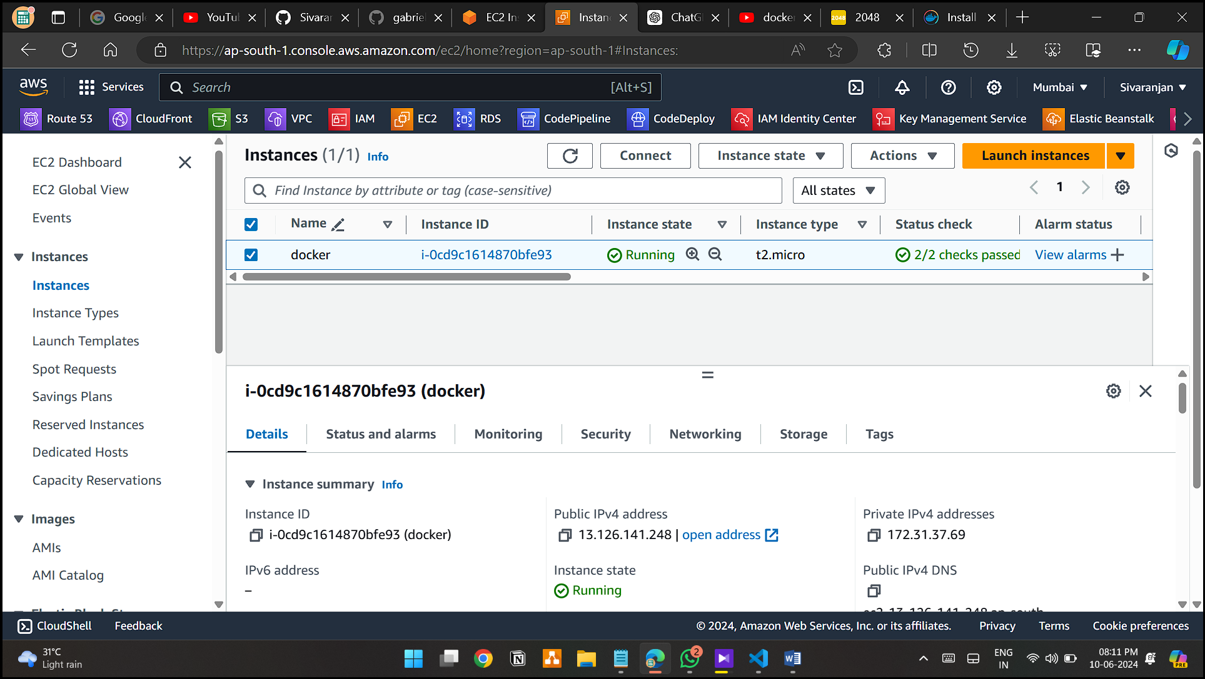

**Step 2: Install Docker**

1. **# Add Docker's official GPG key:**

**sudo apt-get update**

**sudo apt-get install ca-certificates curl**

**sudo install -m 0755 -d /etc/apt/keyrings**

**sudo curl -fsSL https://download.docker.com/linux/ubuntu/gpg -o /etc/apt/keyrings/docker.asc**

**sudo chmod a+r /etc/apt/keyrings/docker.asc**

**# Add the repository to Apt sources:**

**echo \**

**"deb [arch=$(dpkg --print-architecture) signed-by=/etc/apt/keyrings/docker.asc] https://download.docker.com/linux/ubuntu \**

**$(. /etc/os-release && echo "$VERSION_CODENAME") stable" | \**

**sudo tee /etc/apt/sources.list.d/docker.list > /dev/null**

**sudo apt-get update**

1. **# Install the Docker packages.**

**sudo apt-get install docker-ce docker-ce-cli containerd.io docker-buildx-plugin docker-compose-plugin**

1. **Verify that the Docker Engine installation is successful by running the hello-world image.**

**sudo docker run hello-world**

**Step 4 : Create Dockerfile**

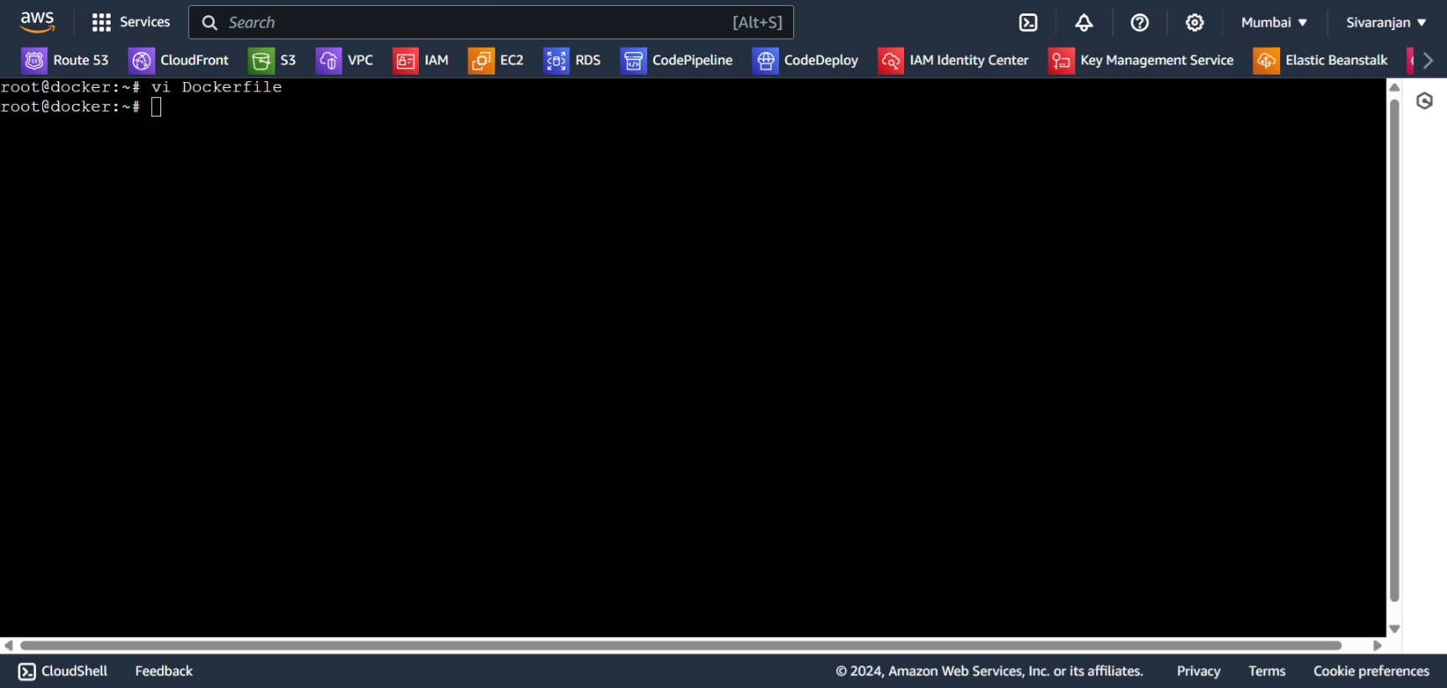

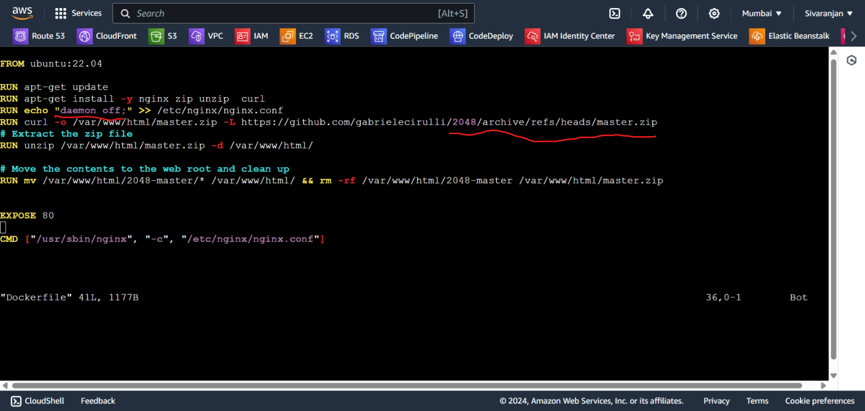

**Step 5: Build Image**

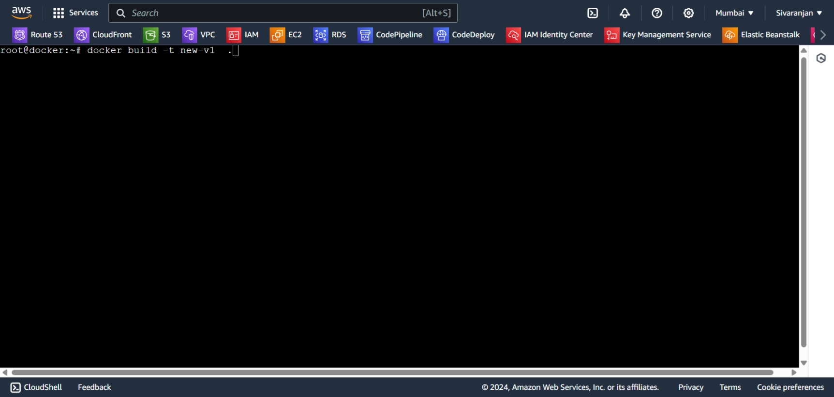

**Step 6 : Check Docker images**

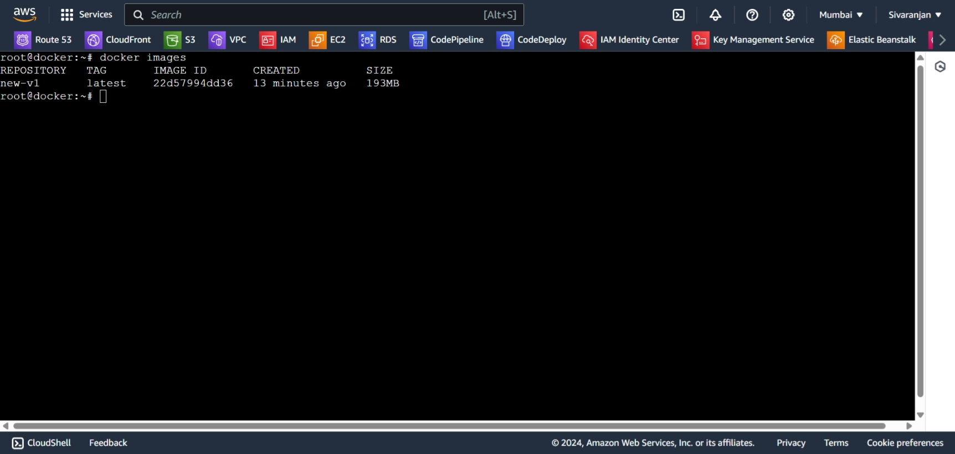

**Step 7: Run Container**

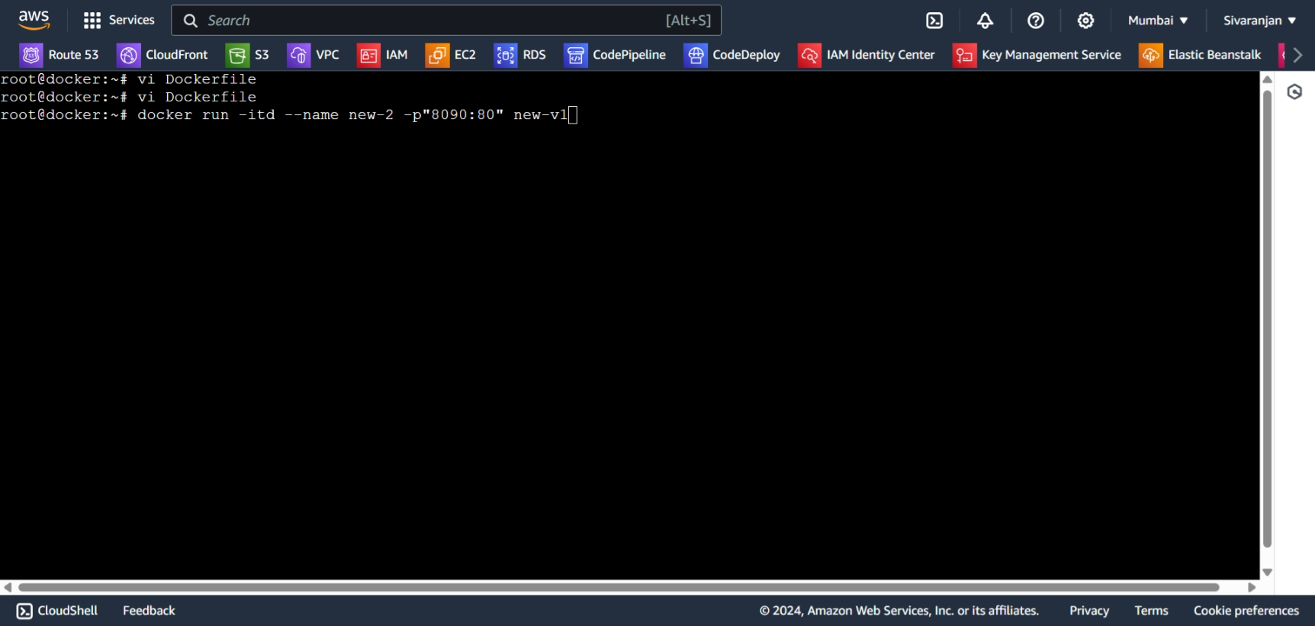

**Step 8 : Check container**

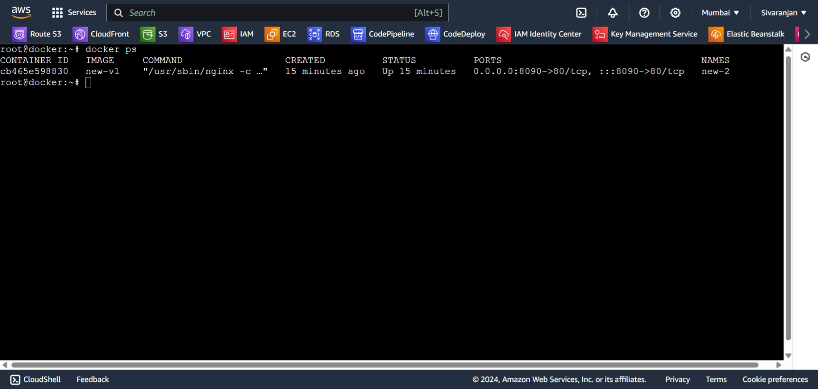

**Step 9: hit ip on browser**

